Hello,
I don’t wish to share my python code, but I will try to explain a (fairly) quick and easy way to create your own CSV file of news events from the FF calendar, using only MS Excel (or an Excel lookalike). I use Google Chrome as my web browser, but I’ve also tried this with Microsoft Edge and Mozilla Firefox, and as far as I can tell, the process is the same.

There might seem to be a lot of steps here, but it’s not difficult, and it’s a LOT quicker than manual typing !!!!!

First, load the FF calendar webpage into your web browser, and select the relevant time period. I like be efficient and process a whole month at the time (this is the longest period that FF allows, as far as I’m aware), so use the left and right arrow buttons « ‹ › » and also the downward pointing arrow at the left of ‘S M T W T F S’ to load up a whole month’s news.

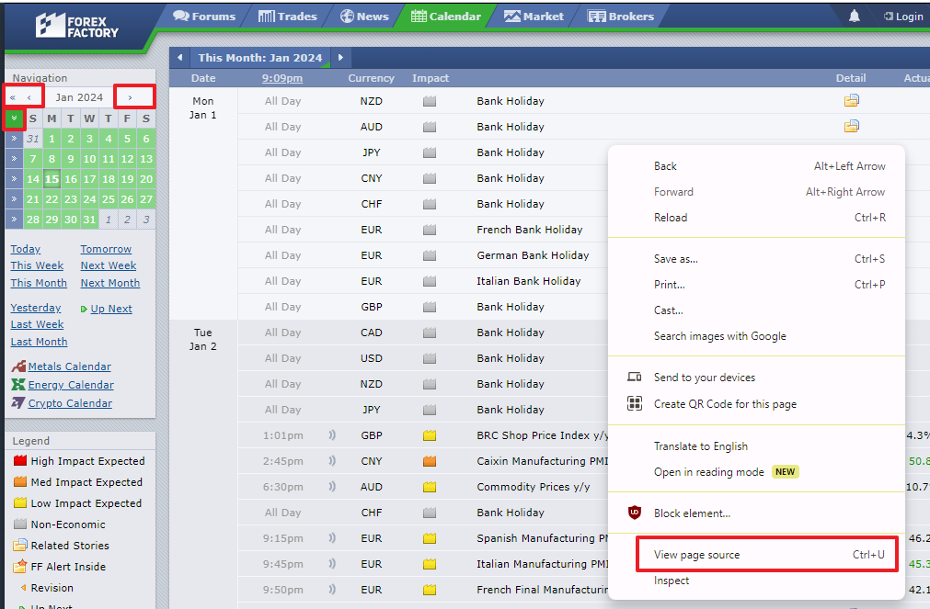
Showing the calendar navigation keys. Also showing the drop down menu (this is the menu in Google Chrome) and the ‘View page source’ option (see instructions immediately below).

Then right click in the middle of the web page and click ‘View page source’ (Chrome and Edge seem to allow the hotkey Ctrl-U if you prefer).

Then scroll down to around lines 87 thru 90. One of these lines should start with the text
days: [{
Drag the mouse down to select that entire line, and then type Ctrl-C to copy it. You want to copy only the one line.

(See image on next page).

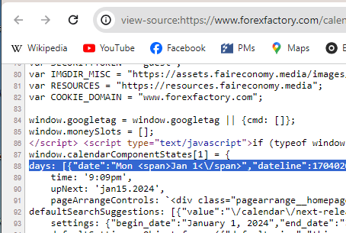
Showing the calendar’s underlying HTML code. After you have highlighted the correct line (88 in the image), your screen should look like that shown in the image.

Open the web page https://data.page/json/csv in your browser, click in the ‘or Paste your JSON text (or url) here’ box, then type Ctrl-V to paste it.

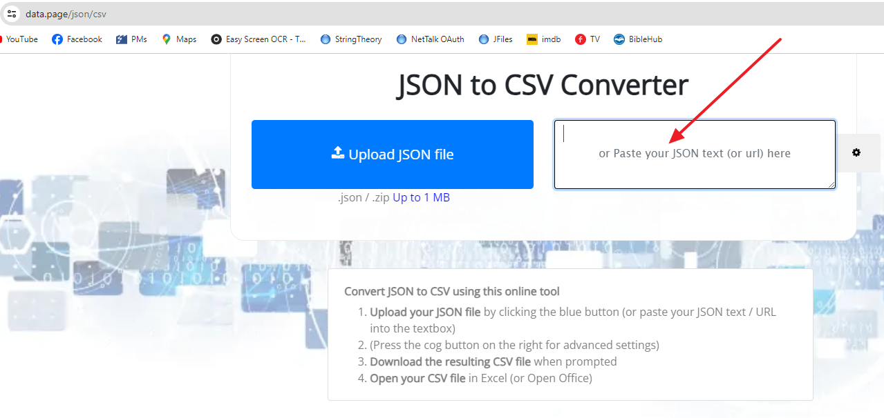
Showing the web page, and the box where you should paste the HTML code from the previous step.

Click the button ‘or Excel File (XLSX)’. Open the Excel file. It will probably be in your Downloads folder and be called results.xlsx

(See image on next page).
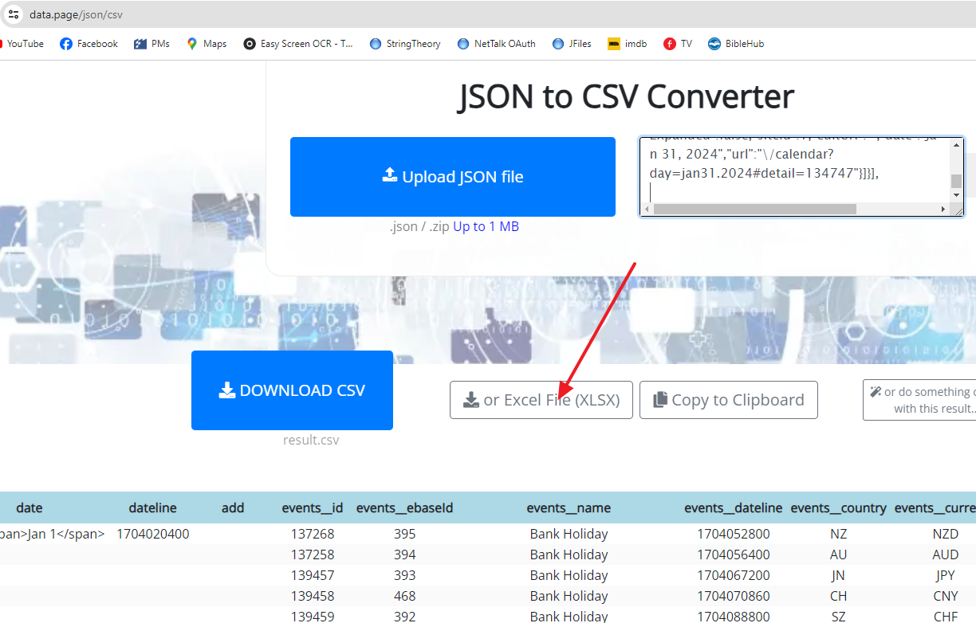
Showing the button you need to click. Note how the webpage has already very intelligently started to break up the HTML into readable news events at the bottom of the image. It does all of the hard work for us!

(Optional: I usually type Ctrl-A and then Alt-O C A to autofit all of the column widths so that I can see everything).

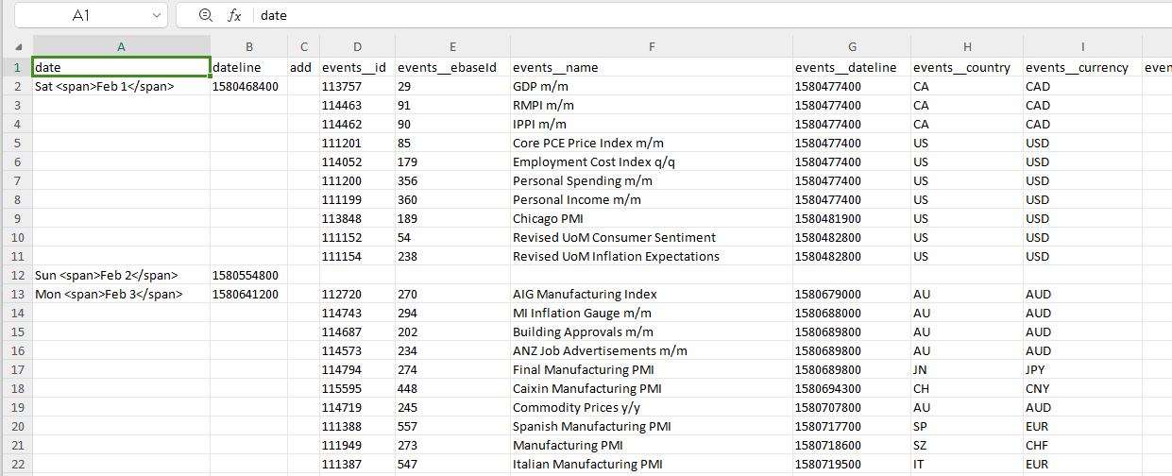
At this point you should have a spreadsheet that looks something like that shown above (with different data, of course).
(Note: I’m using the free version of WPS Office, which is a Microsoft Office lookalike).

Go to cell A1 and insert 3 columns to the left of cell A1.

Copy and paste the following formula into (the new) cell A1 (press F2 to edit the cell and then paste the formula):
=IF(ISERR(B1),"",IF(H1<1,"",SUBSTITUTE(B1,CHAR(39),CHAR(34))))

Copy and paste the following formula into cell B1 (press F2 to edit the cell and then paste the formula**):
=TEXT((((J1/60)/60/24)+C1/24+DATE(1970,1,1)),"'yyyy.mm.dd','hh:mm'")&",'"&L1&"','"&LEFT(Y1,1)&"','"&I1&"','"&AA1&"','"&AD1&"','"&IF(LEN(AC1)>0,AC1&"','"&AB1,AB1&"','"&AC1)&"','"&G1&"','"&H1&"','"&AF1&"','"&AG1&"'"

This will cause a ‘VALUE!’ error in the headings row, but that doesn’t matter.

** if you try to paste the formula directly, you could end up with K1 instead of J1, Z1 instead of Y1, etc in the formula as Excel attempts to ‘smart-modify’ it.

Then simply copy and paste these formulae in A1 and B1 downward throughout columns A and B respectively as far as you need to.

(Optional: at this point I usually type Ctrl-A and then Alt-O C A to autofit all of the column widths so that I can see everything). Again!

Now you should be able to see something worthwhile in column A!

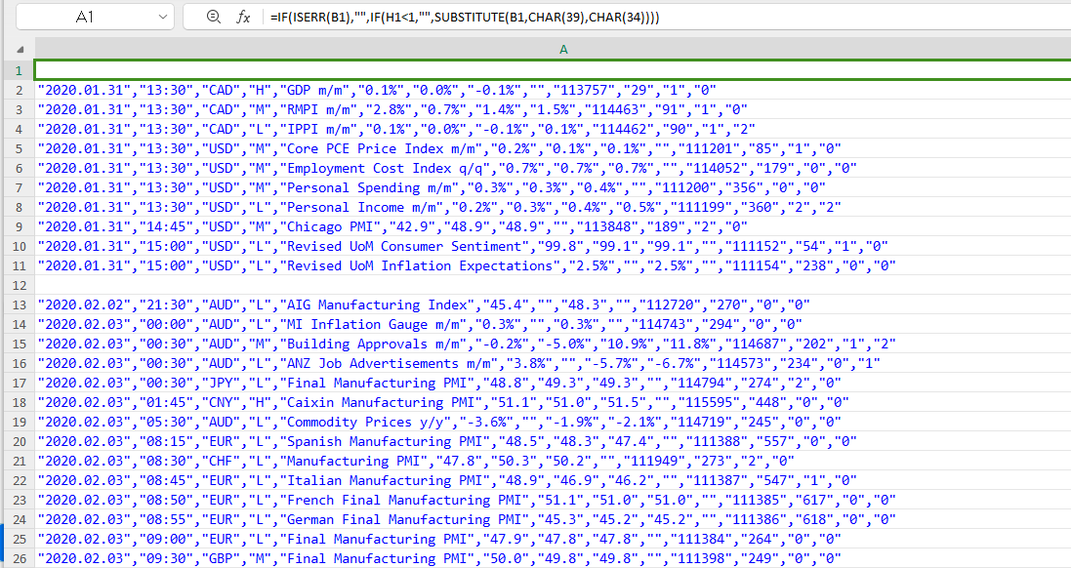
Showing what you should now be able to see in column A (your data will differ to mine, of course).

Important: The date/timestamps should be UTC regardless of what your personalized settings in Forex Factory are.
You can enter value(s) into column C to shift the date/timestamps of any news event(s) forward or backward X any number of HOURS from UTC. X can be a positive or negative integer or decimal value. Let’s use New York as one possible example. It is UTC–5 during winter and UTC–4 during summer. So you would need to find out when daylight saving began and ended in New York, and copy –5 or –4 throughout the relevant rows. e.g. https://www.timeanddate.com/time/change/usa/new-york
Note: 0.5 = 30 minutes, 0.25 = 15 minutes, etc.
Of course it doesn’t have to be New York, it can be any timezone(s) anywhere in the world.
The process is made easier because the dates are conveniently all shown in column D.

(See image on next page).

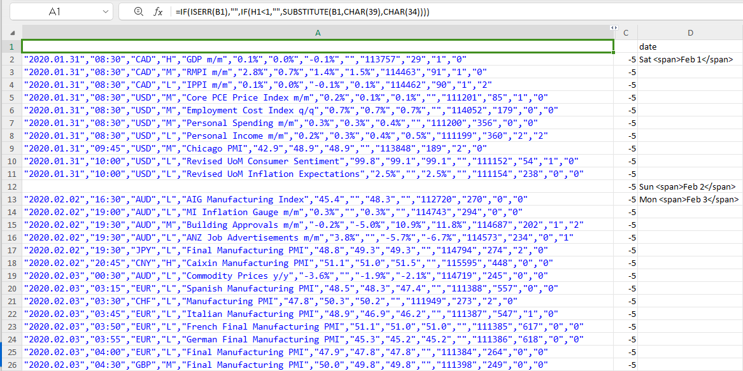
You can see how I’ve copy/pasted -5 all the way down column C here. Note how the timestamps are 5 hours earlier than those in the previous image. (I’ve hidden column B and adjusted the column widths to fit the screenshot on the page).

You can repeat the whole process to add several more rows with additional months worth of news events to the same workbook page (paste into column D now, because of the columns you added), and then copy the formulae in columns A and B downward as need be.

Finally, copy all of the CSV values that you need from column A into an empty file in a text editor (like Notepad). If you have a smart text editor like Notepad++, you will be able to instruct it to automatically remove all of the unnecessary blank rows. Or you could use a webpage like this: https://codebeautify.org/remove-empty-lines#

Save the file and you have your CSV file of news events (in date/timestamp order).

The 13 columns are:
"date(yyyy.mm.dd)","time(hh:mm)","currency","impact","description","actual_value","forecast_value","previous_value","revised_from_value","event_id","group_id","actual_better_or_worse",""revised_better_or_worse"

Then you can load your CSV file into Excel to filter, sort or otherwise manipulate the data however you wish.

I’ve a attached a sample results.xlsx file for December 2023’s news.

So now you good people should be able to do everything you need for yourselves, and I can disappear again. :)

“Give a man a fish, you feed him for a day. Give him a fishing pole, you feed him for a lifetime”
https://www.forexfactory.com/thread/post/10229460#post10229460
LOL -- please excuse my twisted sense of humor!!

Anyway, good luck! Best wishes to everybody.

DL

