FTR
http://readthemarket.com/index.php/forum/trading-articles-discussions/1976-ftr?limitstart=0
1. Introduction
Before solving the puzzle of price action and before being able to read it successfully, one must discover and understand the individual pieces the puzzle is made of. After all, every eye-catching building is made of individual bricks and stones. For most of us at RTM, the beauty of price action is just as stunning a structure as the cathedral of Chartres or Sagrada Familia in Barcelona. The only difference is that bricks and stones of real buildings are represented by price caps, FTRs, engulfs, fakeouts, quasimodos, diamonds etc. Of the building blocks of the price structure nothing is more important than engulfs and FTRs!
In my article I am going to explain one of the two most important pieces of price action – FTR. Together we will explore what is looks like, where it can be found and what is its role in the structure of price action.
FTR must be learned properly before one can advance further. Please take your time, don’t rush; learning price action is an amazing journey, so enjoy it.
2. What is FTR?
So, what actually is FTR? FTR means ‘Failure to Return’. But wait… Who wants to return? Where do they want to return? And why on earth do they fail?
These three important questions must be answered, so let’s do it.
It’s a well known fact that price, once it reaches a certain barrier, either bounces of it or breaks it. Once it breaks it, two possible scenarios occur: it either returns back below/above the barrier and goes on in the direction against the break or fails to return and keeps going in the direction of the break. In the latter scenario, a FTR is made. ALWAYS! And it is of vital importance to be able to identify it!
Why? Well, there is such a strong buying or selling pressure aka supply / demand at the FTR that the price just cannot return, it must go on in the direction of the break.
Hint 1: the selling / buying pressure always remains at FTR after price has left. Can you see the implication? J
Now let’s take a look at the anatomy of FTRs.
In the following picture you can see a diagram showing some basic variations of FTRs. Look at them carefully, you will see that they may look a bit different but remember: they are absolutely the same in terms of the structure.
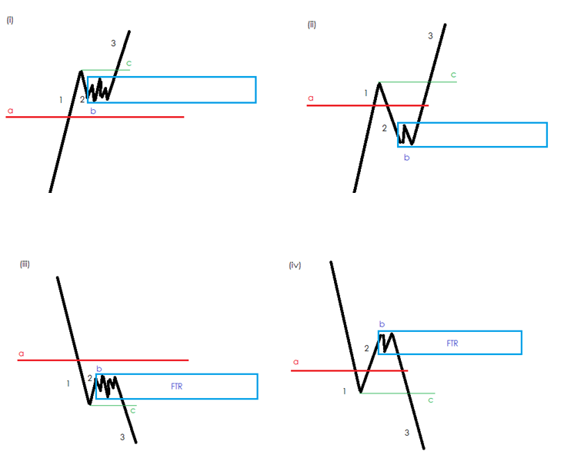
The red line (a) represents a barrier. It can be a SUPPORT / RESISTANCE, a FTR in opposite direction (will be explained later) or limit of a PAZ (Price Action Zone).
Price action breaks the barrier (1) and retraces (2). It is irrelevant whether price action crosses the barrier again or not (as in examples (ii and iv above). At the extreme of the retrace a base is very often made (b).
Then, price action continues in the direction of the break (3). FTR is confirmed after price action breaks the high / low (c) which formed after the break of the barrier. Only after the break of (c) we can say that price action indeed failed to return.
Now, when the FTR is confirmed, we draw a rectangle at the base (b) and protract it to the right.
Hint 2: for information how to draw the blue rectangles see the article Caps on Price at RTM Marketpedia.
Now that we have studied the diagrams above, we can look at real life examples of FTRs.
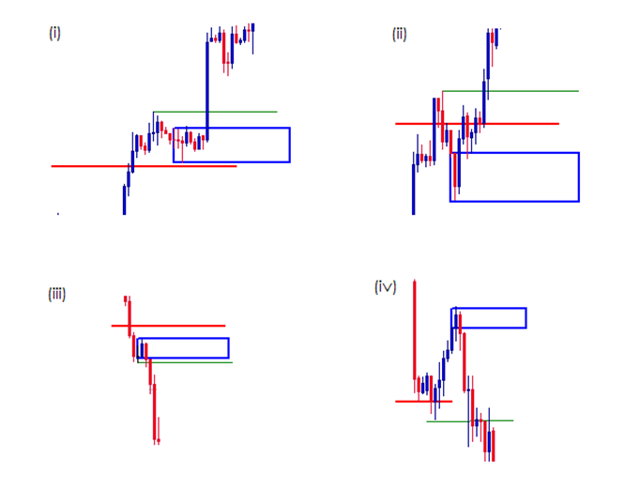
3. FTR after the break of SUPPORT / RESISTANCE
FTRs after the break of support / resistance are very common. They are simply everywhere in the chart and you will learn to spot them.
You certainly know that there are major support resistance lines as well as minor ones… the more important the S/R line is, the more significance we must assign to the FTR that follows.

Major S/R line
Ok, let’s start with the major ones. I assume that you already know how to distinguish a major SR from minor SR...
In the following chart you can see the brown RESISTANCE line. The RESISTANCE is a major one, it has been respected many times in the past (not just those two touches seen in the picture). Suddenly, the R line is broken. Is it just a fakeout or genuine break? How will we know it? Yes, right! We will wait for a FTR to be formed.
And voila, a spectacular FTR is made! The price then rushes away from the R line. Now it’s going to be interesting! Such FTR is an amazing place to trade on the first visit. The first visit occurred in approximately one week. And look at the reaction! The first visit to an FTR is called FTB (First Time Back).
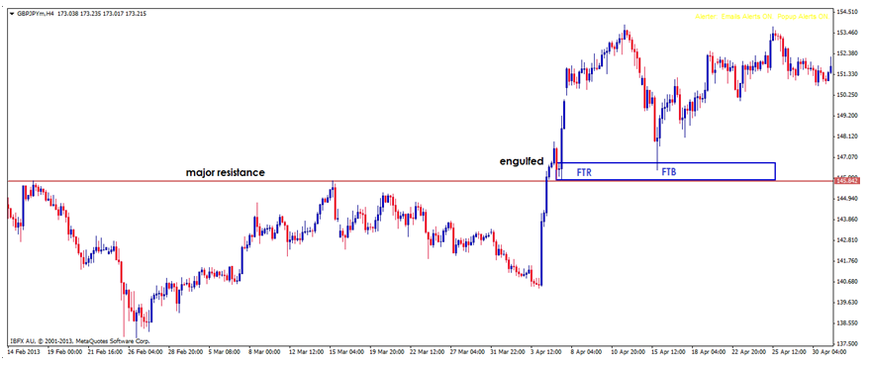
Hint 3: Upon return to the FTR the price is falling in a free fall, everyone is happily jumping into trend because “it’s going to go on and on…” but beware, predators are patiently waiting in FTR level, and so should you…!
For your convenience, there are two more examples:
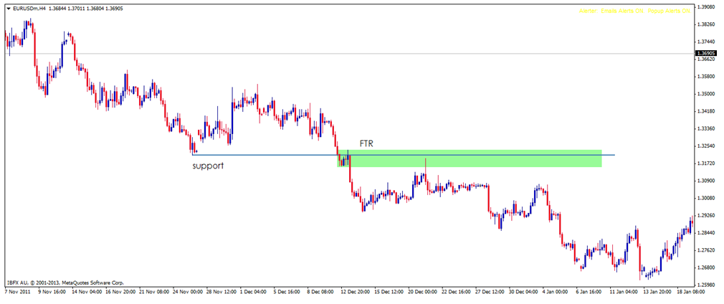
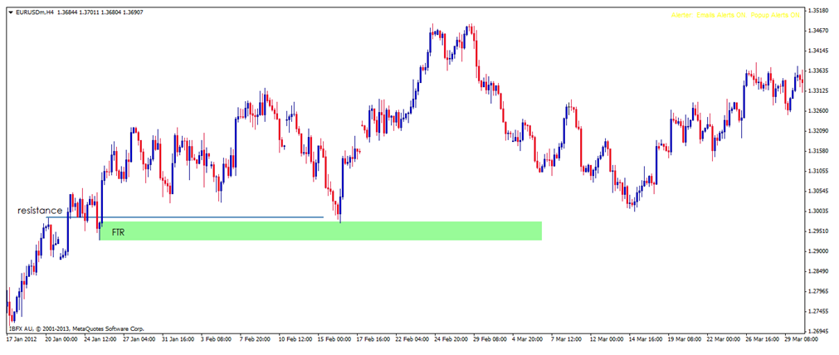
Now open your trading platform or Forex Tester and see for yourself how often this works!
Minor S/R line
It’s important to know that the FTRs in the above three charts are actually not the only FTRs that can be spotted. Far from it! Every time price breaks a minor support/resistance, fails to return and goes on, a new FTR is made!
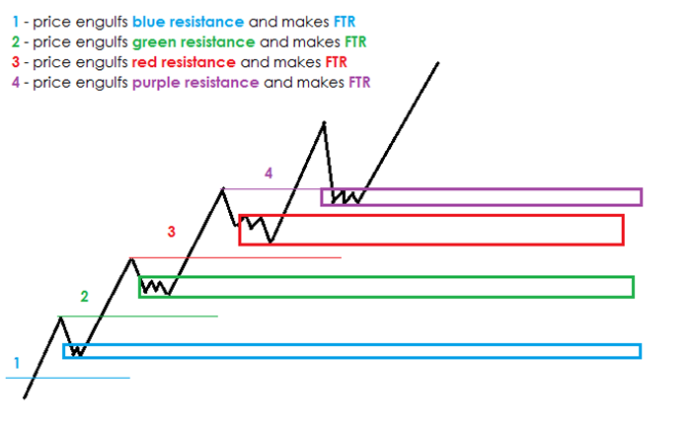
In real life, however, the chart seldom looks so neat and clean as in the above diagram. In the following chart you can see the above principle in a real chart (in a down trend).
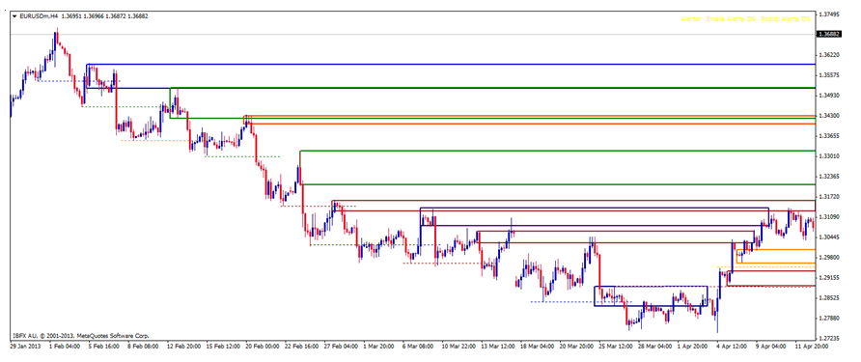
Please take your time and study the above chart, you may notice that I haven’t marked absolutely ALL FTRs because the chart would be very messy.
Open a chart in your platform and mark all FTRs. Practise! Mark a swing high/low, find where it was engulfed, then find the FTR. Repeat with next high/low.
Remember, the purpose of the article is not to tell you that each and every FTR is tradable but to teach you how to spot FTRs and how to mark them. Let me repeat: it is of paramount importance!

4. FTR after the break of a FTR in opposite direction
FTRs are formed after engulfing of a barrier. We already know this. One of such barriers is an FTR in opposite direction. Look at the diagram below, I think it is self-explanatory.
FTR d is engulfed and FTR 1 is made, and so on.
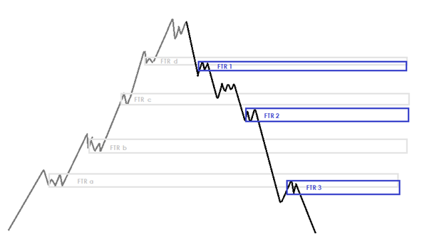
And a real life example.
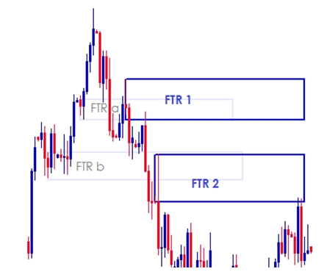
Hint 4: FTR 1 is a great confirmation of a reversal. For more information on this see my journal starting with post 304 on page 13 (sweet FTRs).

5. FTR after the break of a PAZ limit
The limit of a PAZ is another barrier, the break of which results in extremely important FTRs! This is, however, rather advanced and it goes beyond the scope of this article on the FTR basics.
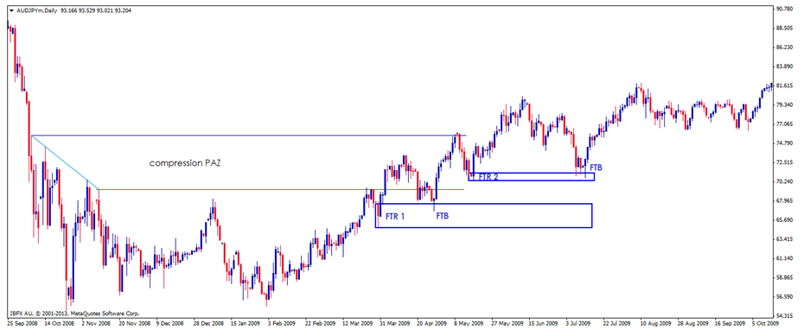
6. Conclusion
In my article I tried to introduce a very important building block of price structure – FTR. We have learned that FTRs are formed after the break of a price barrier. It is important to realise that FTRs are places where institutional traders open / close their positions. This makes them ideal places for looking for trade setups or targets.
However, it must be stressed that FTRs on their own are not enough for trading, one must master other important building blocks, engulfing being the most important one.
Les_Paul
cico wrote:
sorry Les Paul i have a question. which is the difference between a suuply/demand level and a Ftr
because in S/D level too the price could be broken in a strong way against a important barrier. when i draw them i don t see the diffrence.
thanks a lot
Dear cico, if price breaks something and fails to return, it's simply FTR which is at the same time SUPPLY / DEMAND level
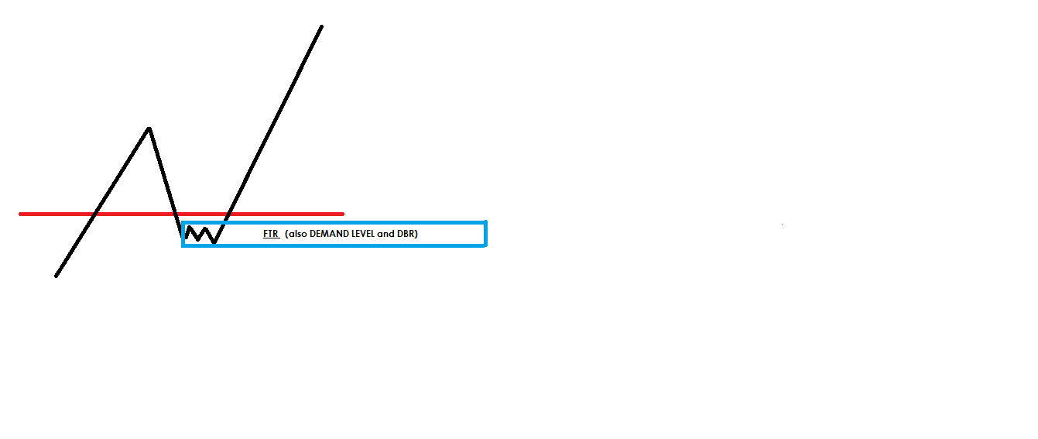
Hi Nego,
I am seeing great progression here.... Excellent - keep up the good work.
-- 1. You have studied the FTR pattern and understand what an FTR is.
-- 2. You have discovered that FTRs are everywhere you look, on every time frame.
-- 3. You have discovered in back testing that not all FTRs are tradable on return.
-- 4. No doubt you are about to discover that its not just the potential trade from an FTR that is important, it is equally important, if not more important what it means when a FTR breaks / fails.
Every FTR holds some significance, but where they form is important; and understanding the context of bigger picture is critical. Also, never forget IF's golden rule - Only Trade from the Edge. If you keep pushing, you will get there.
As a suggestion, you could try this....
First, read my post here. Its not about the FTR, but applies equally to your study on FTRs.
Then,
-- 1. Read the FTR Marketpedia article again. I read the articles over and over at different times. Sometimes you see something which did not click in a previous read of the article.
-- 2. Read Les_Pauls Journal, specifically when he starts talking about his Sweet FTR.
-- 3. Read Pedini's Jorunal, specifically when he starts talking about the break of an FTR.
-- 4. Read the FTR Marketpedia article again.
--5. Study your charts again.
-- 6. Post back here in the thread what you learnt.
madwt

The Quasimodo is a beautiful and powerful Price Action structure.
It gives a big sign that the big money is ready to change price direction. It often serves to trick the uninitiated into giving up good positions to them, allowing them to get big orders filled.
We look for them at areas of Supply and Demand, where we look for all our trades, and use them as confirmation that price has turned, due to the engulf that occurs in their formation
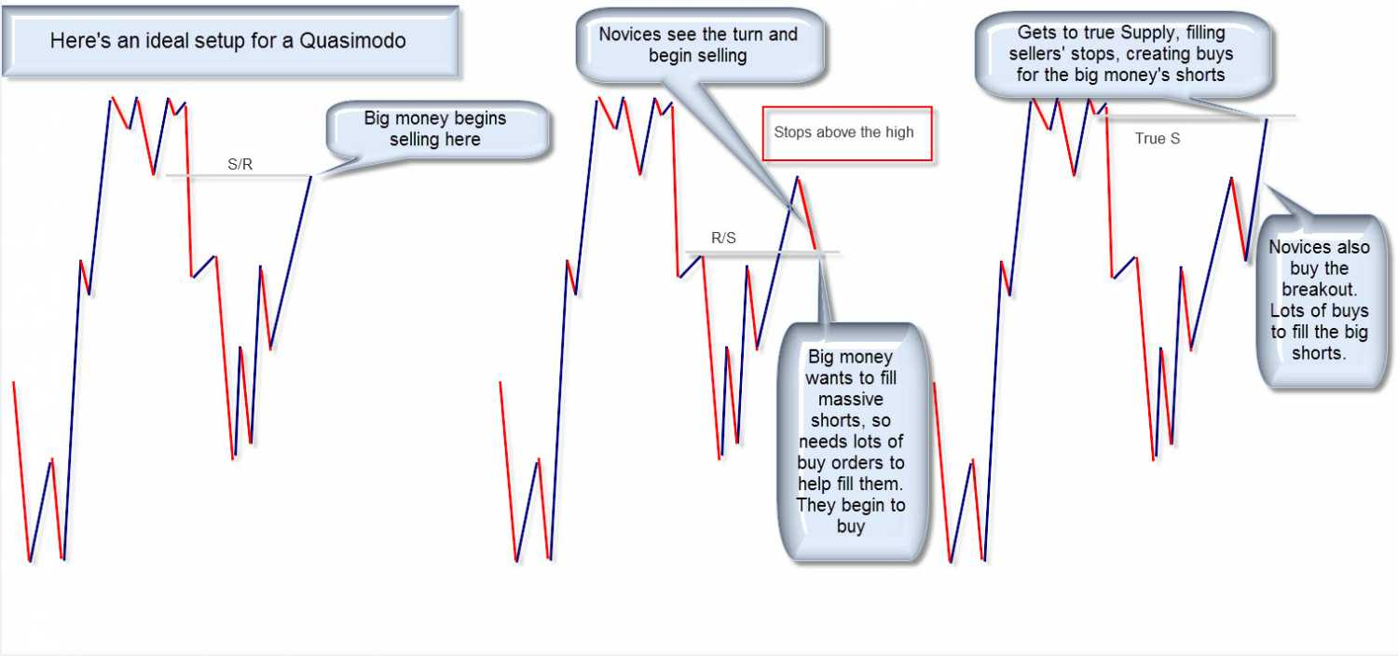
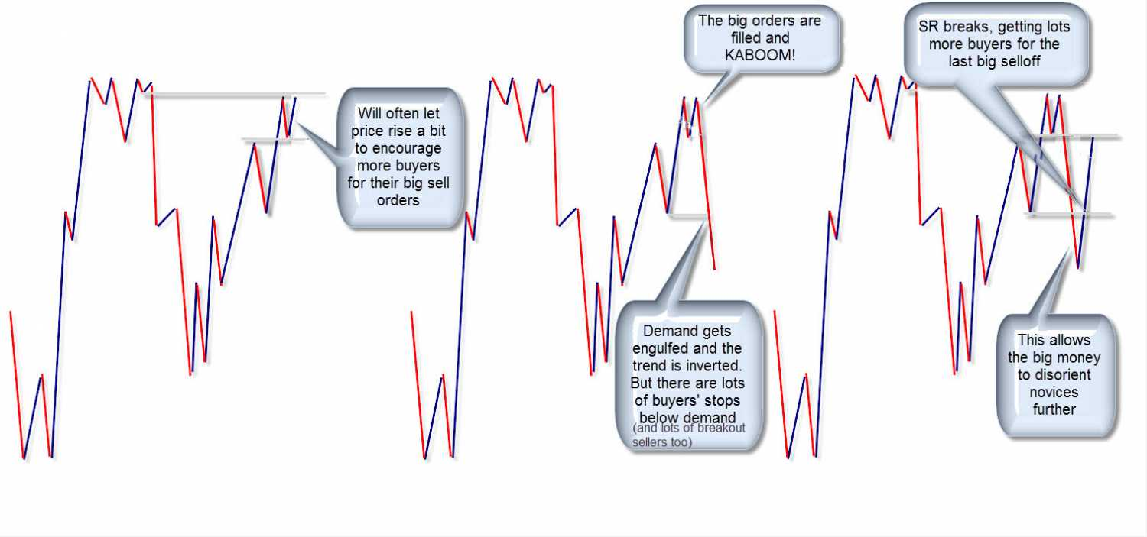
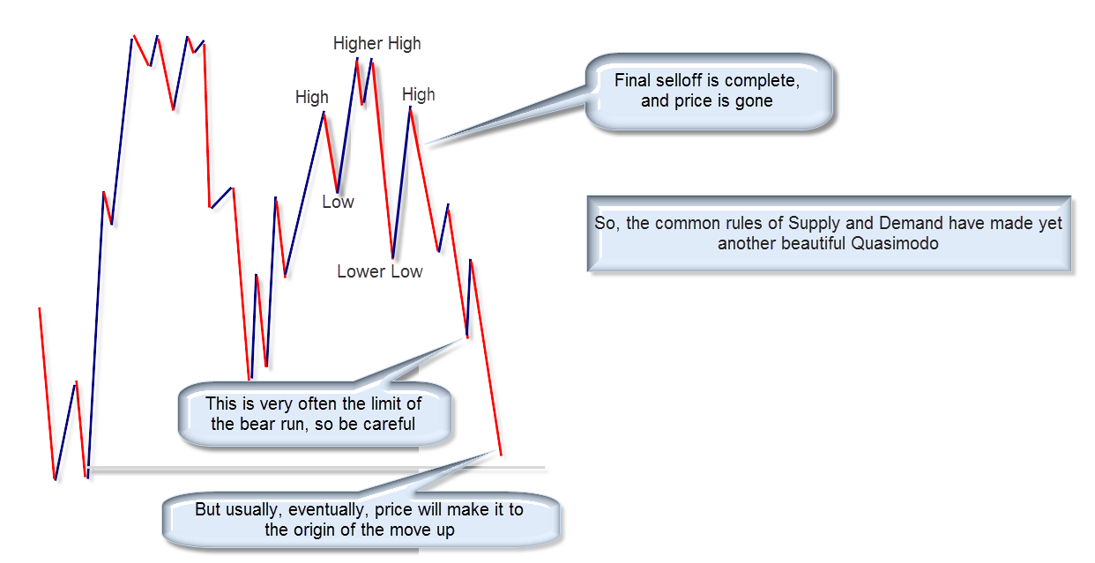
Here's an example
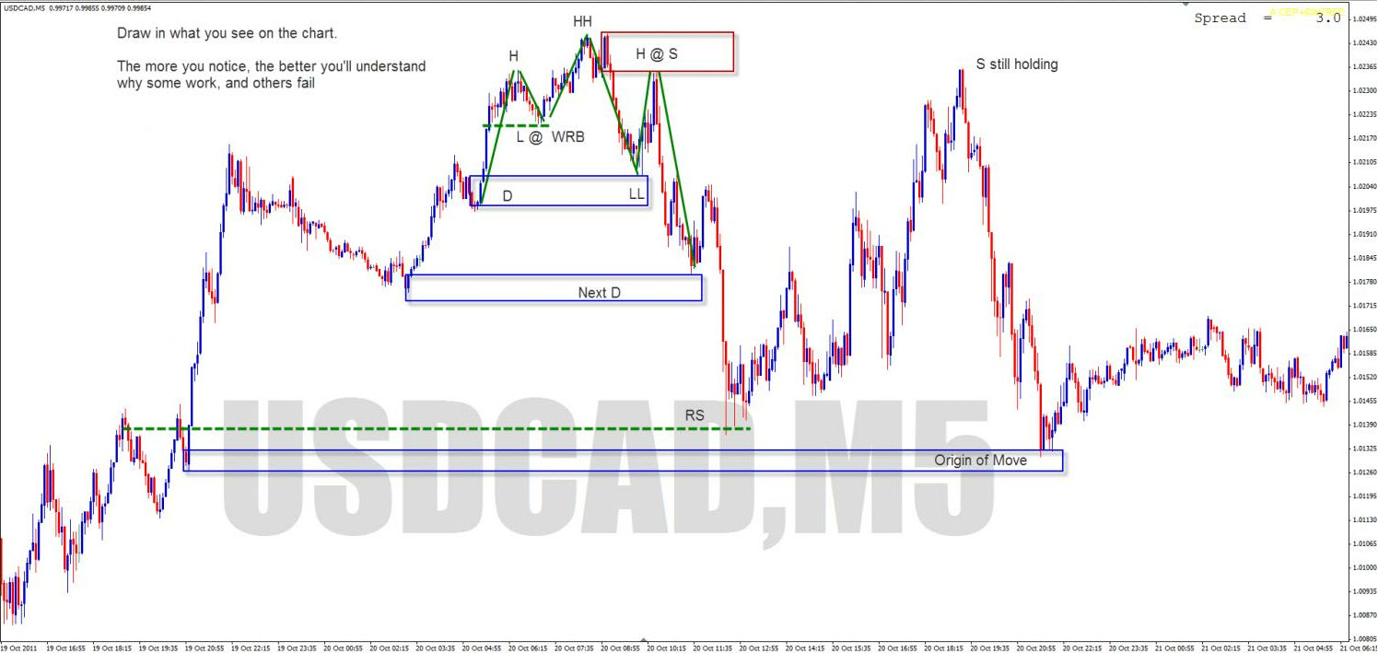
and the HTF in which it occurs


