Trading with Heikin Ashi Candles
By Dale Woods May 3, 2016

Heikin Ashi candlesticks are another clever invention from the minds of great Japanese traders…

The Anatomy of a Heikin Ashi Candle
Translated from Japanese, Heikin Ashi means “average bar” and you will see why.
They are the result of applying some average math directly to the candlestick structure.
One main goal of Heikin Ashi candlesticks is to eliminate noise on the chart. This is achieved through the way the Heikin Ashi charts are built through the equation.
The formula for their construction is designed to create a “smoothing” effect; filtering out the irrelevant moves while maintaining the display of the dominant price action.
Heikin Ashi candlesticks require data from the previous HA candle, meaning they essentially build off of one another. It is this chaining effect that gives a really unique view into the market.
The Classic candlesticks we’re all used to have a high, low, open, and close price. Their figures are taken directly from the raw price action.
Heikin Ashi candles have the same 4 data points, but they each have some unique math behind them – which is important to understand if you’re going to use them.
- High Price = highest price out of the current candle’s high, open, or close price
- Low Price = lowest price out of the current candles’s low, open, or close price
- Close Price = (open + high + low + close) / 4
- Open price = previous candle (open + close) / 2
To summarize, the high and low prices are nothing special. The Heikin Ashi candle will just show the highest and lowest data point achieved while it was active.
What you will find in strong bullish conditions is that the open and low price are the same, and during bearish momentum, the open and high price are equal.
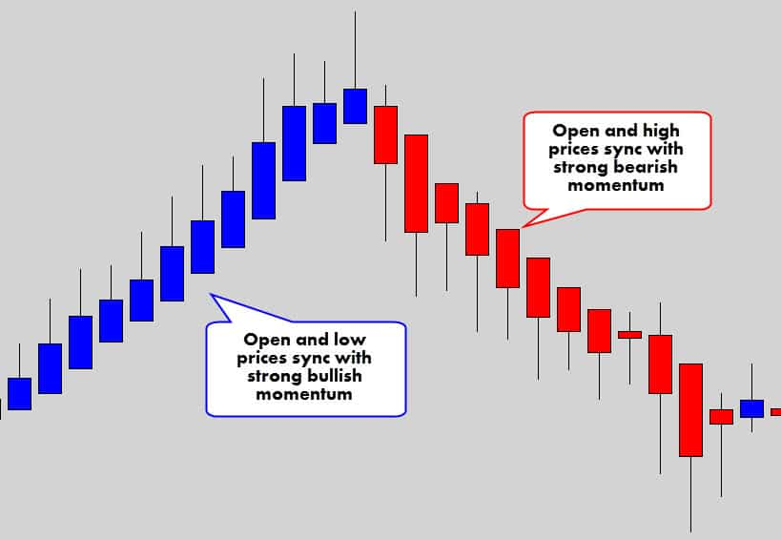
When the open price syncs up with the high or low, you know you you’ve got some good market momentum.
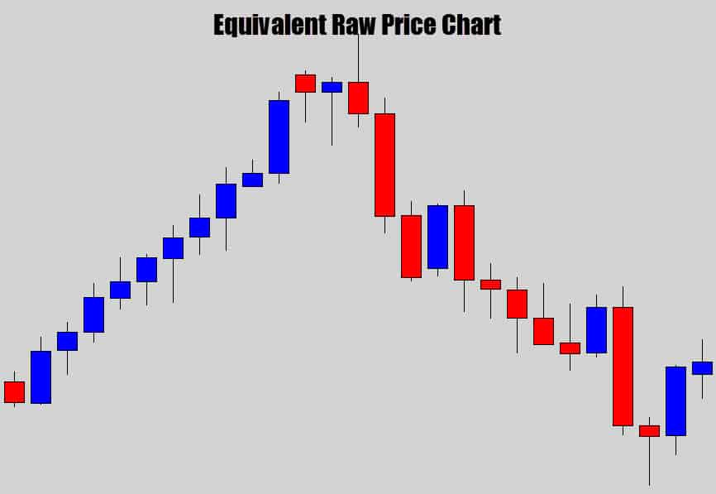
You can see, when you compare the two charts together, how the Heikin Ashi chart helps filter out those counter trend movements and keep the dominant trend in display.
It’s the way open and close prices are calculated that gives this filtering effect.
The open price is derived from the previous candle’s open and close prices.
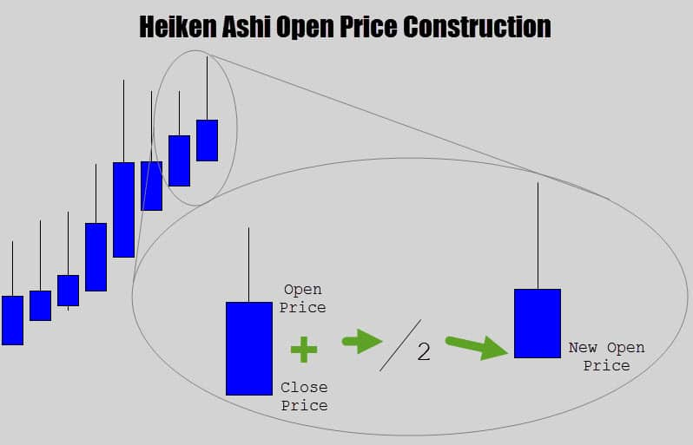
If you look at the formula carefully, it makes each new Heikin Ashi candle open in the middle of the previous candle’s body’s range.
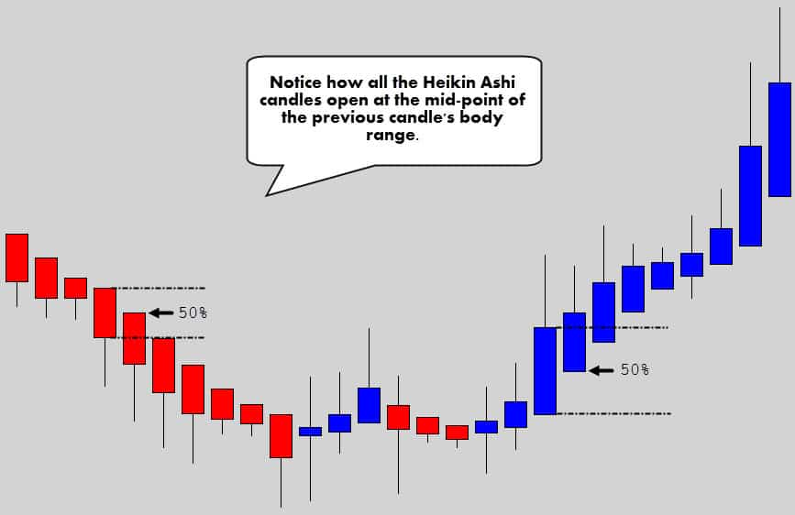
One of the main reasons these charts look so neat and orderly is the way the open price is being printed.
The close price is the other interesting aspect of the Heikin Ashi candlestick anatomy.
It takes all 4 data points of the candle, adds them together – then divides that figure by four to spit out an average price of all the candle data points.
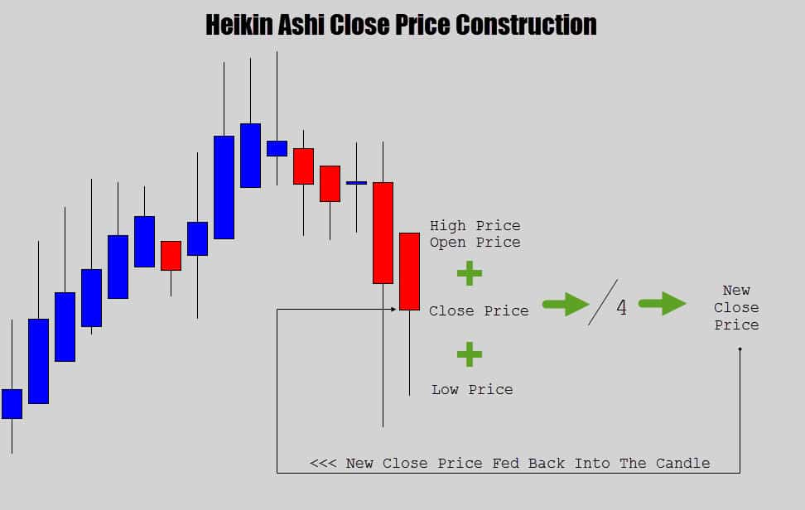
The close price is basically the average point of all the prices in the candle.
It’s important to understand that the close price also means the current candle price while the candle is active. When the candle closes, the last close price will be cemented in as the final close price.
Every time the market receives a new price tick, the Heikin Ashi formula is executed again, all the prices are recalculated and the candle anatomy is updated appropriately.

Checkpoint
Heikin Ashi are a unique kind of ‘average’ candlestick which build off one another to create a smoothing effect. This gives a new perspective of the price action, opening up the door for some unique technical analysis.

Benefits of Heikin Ashi Charts
There are many benefits a Heikin Ashi chart can provide to your technical analysis.
Obviously, the main purpose of these charts is to clean up the noise and display dominant trend strength.
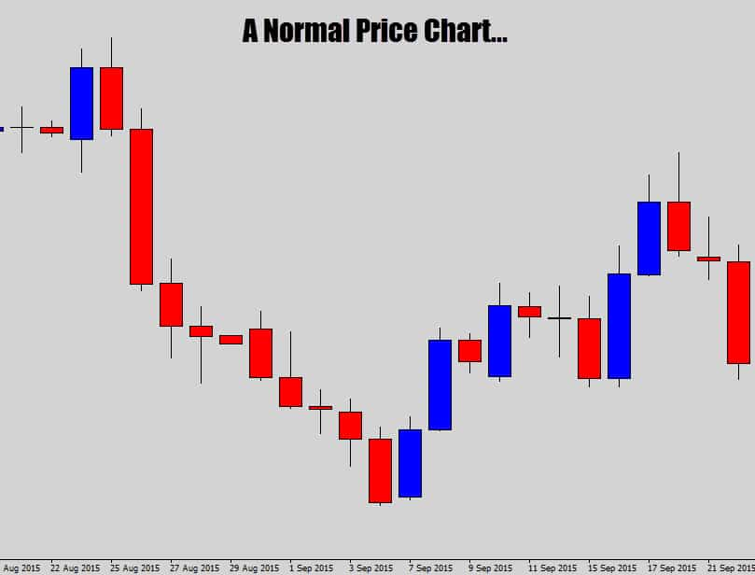
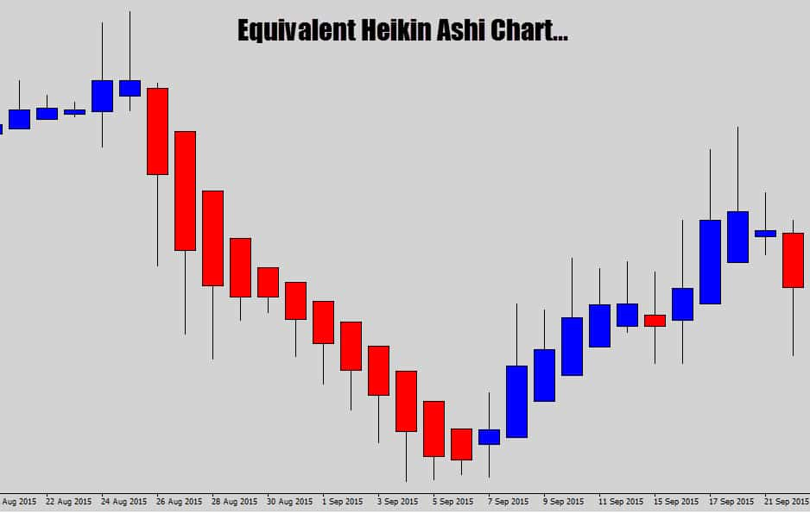
Notice how the Heikin Ashi charts print out a lot smoother price action, helping draw out the main market movement.
Check out what happens during strong trending markets.
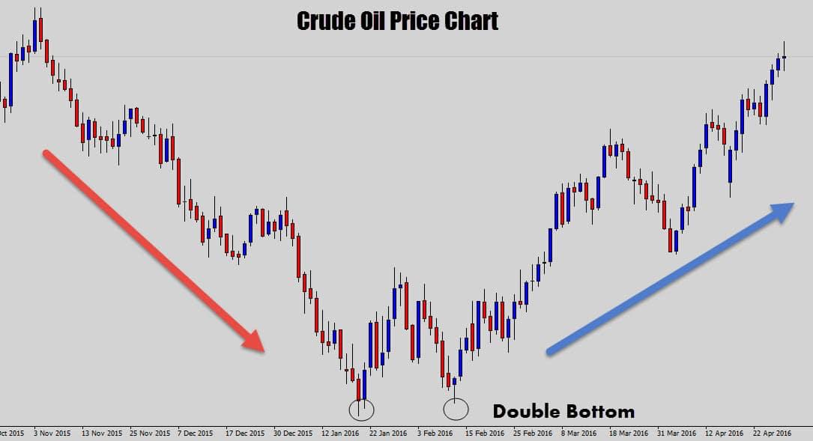
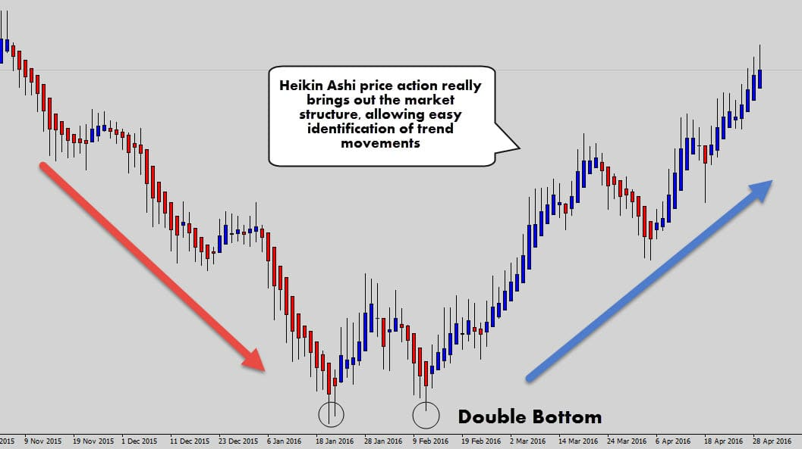
Although the price chart is fairly easy to read, you can’t deny that the Heikin Ashi chart does a very good job at straightening out the market structure.
We can easily see where the core trend movement is and where the counter trend corrections are occurring.
Even the double bottom pattern looks a lot cleaner.
If you’re having trouble determining the trend, these charts could be a good aid for you.
They are also great for keeping you in a trend trade longer. It is common to believe price is moving against you, and find out you got spooked out by a counter trend retracement soon after.
I know there are a lot of traders who ‘cut their profits short’ in these scenarios.
Check out how Heikin Ashi charts may help with the psychological problem of ‘price moving against you’…
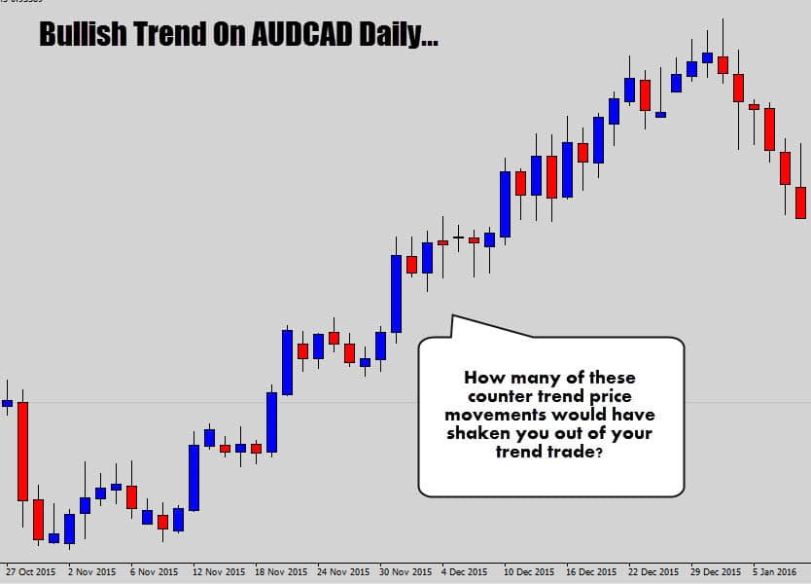
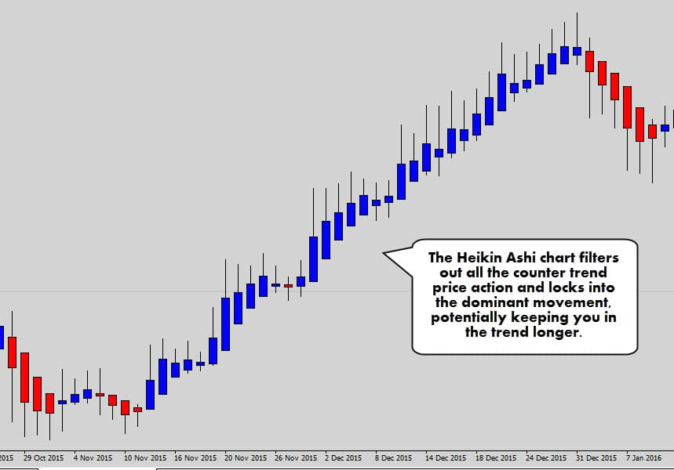
This is one of the key advantages of HA candlesticks, the ability to ‘cut the crap’ when the market is trending.
Look how well of a job they did in the AUDCAD example above. You basically only see blue candles until the trend dies out, and then a larger red candle is printed.
Charts like these maybe just the thing you need to stop those early exits.
Reversals can be much easier to spot, especially with the classic ‘color change’ in the Heikin Ashi candles…
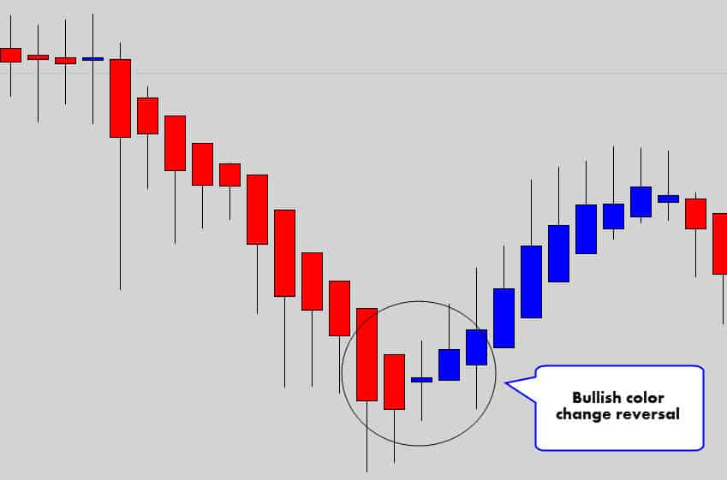
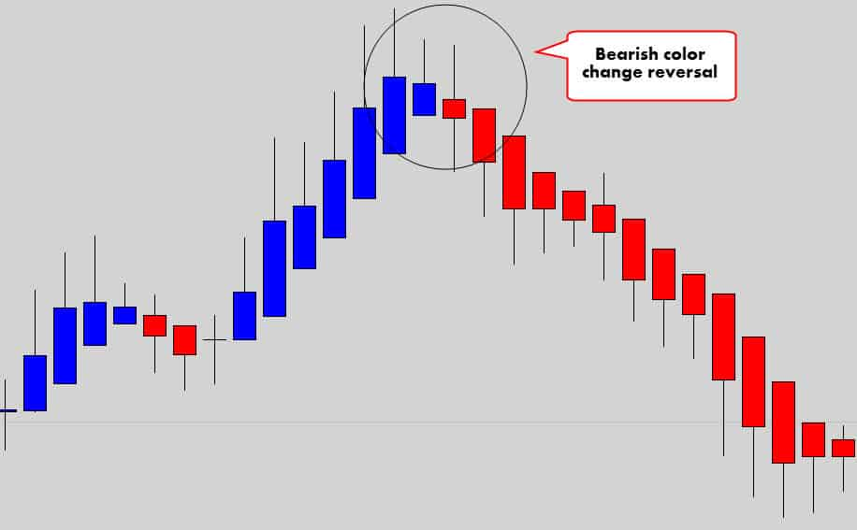
You can see that when the candles change dramatically from bullish to bearish, there can be a large follow through reversal.
Obviously, it wouldn’t be profitable to trade every single-color change because when the market falls into consolidation, you will get eaten alive.
These reversals tend to be more potent after a large bullish or bearish move has already occurred before leading into the color change signal.
Checkpoint
The filtering effect of Heikin Ashi candlesticks allows for a very clear view of the market structure and dominant trend movement. This allows traders to spot trends easily, ride them out longer to their full potential, and also spot reversal opportunities when they die out.

How to Read Heikin Ashi Candles
So far, we’ve looked at how the HA candles can help provide a better visual experience for traders and collectively help with market analysis.
Now let’s dive into the individual Heikin Ashi candles and learn how to read them individually:
- If the body of the candle is bullish – it reflects a bullish environment.
- If the body of the candle is bearish – it reflects a bearish environment.
- If the body of the candle is thin, and there are wicks protruding out both ends of the body, the market is indecisive, has stalled, or is consolidating.
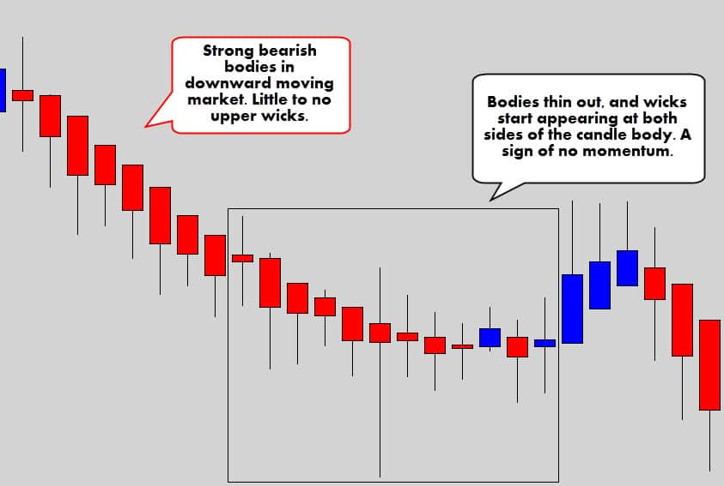
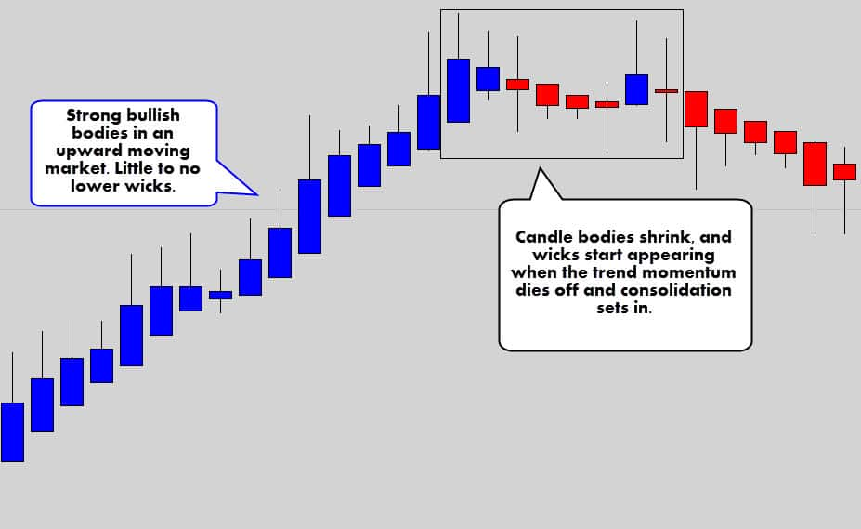
If a strong trend is underway, the candlesticks become a gauge to the current trend strength.
Remember the close price is the average of all the data points in the candle, so if the close price is very high, then you have strong bullish pressure in the market.
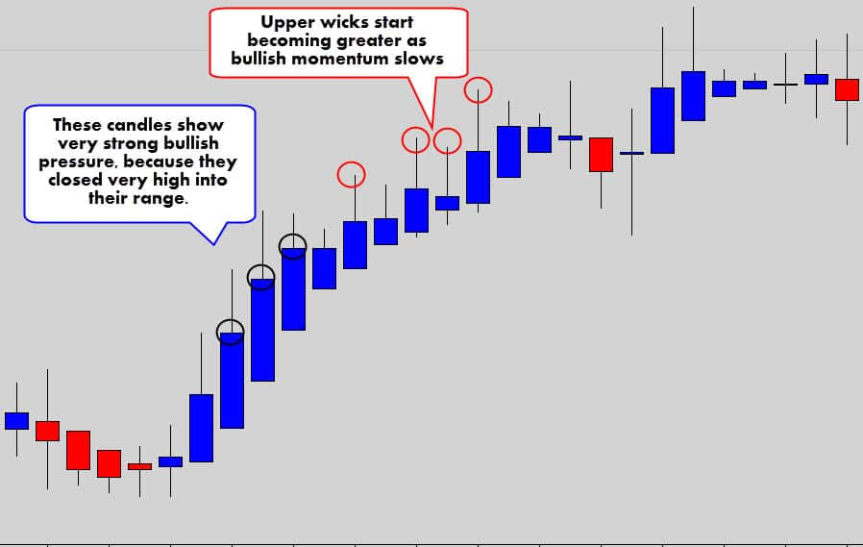
Upper wicks will start to appear when the bullish momentum slows down, and more bearish pressure starts to enter the market.
Same obviously applies to bearish conditions. The candles will close lower into the candle range under strong bearish trends.
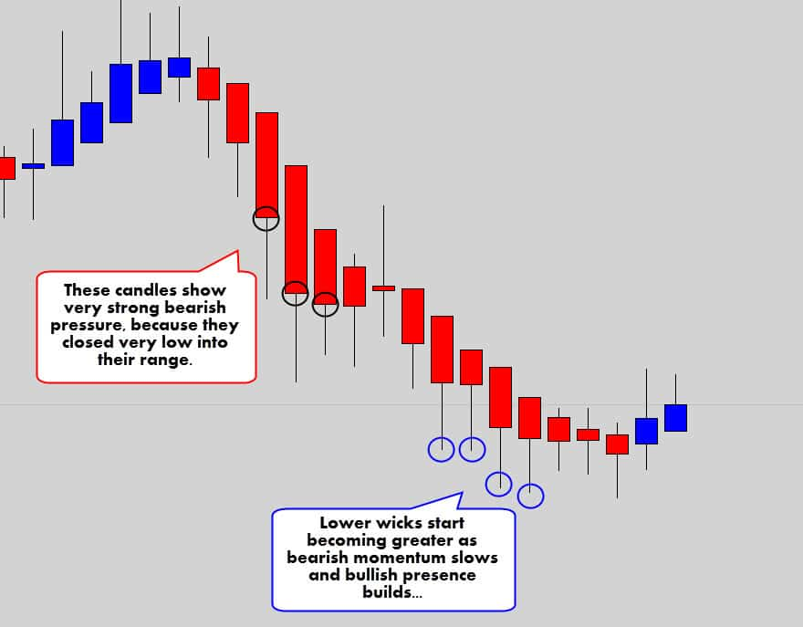
Remember:
- Big candle range + big candle body = Strong momentum
- Small candle ranges + small candle body = Weak momentum
Because these candlesticks change drastically when the market conditions shift, it’s very easy to see when the markets fall into consolidation, when you don’t really want to be in the market.
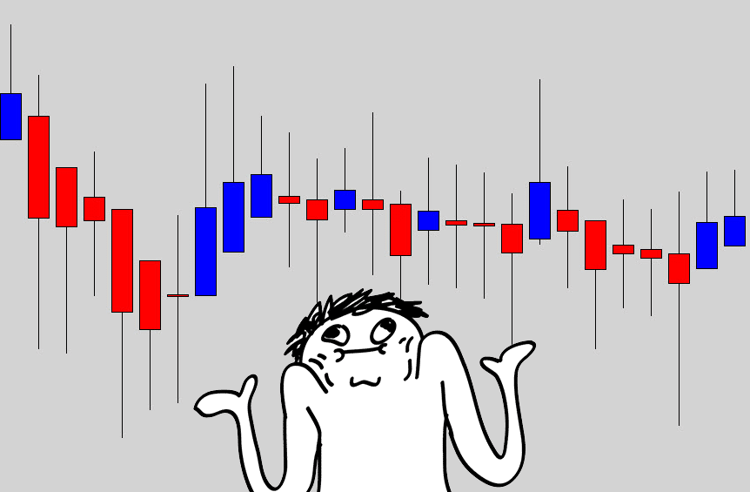
It’s fairly easy to spot dangerous market conditions with Heikin Ashi price action.
Try to stay out of the market when you start seeing doji like candles, especially large ones.
When these charts go into nasty sideways action, there will be a lot of candles with wicks coming out of both ends of the body – a warning sign to be on the side lines.
I always say, if you can’t make sense of the chart, then simply don’t trade it!
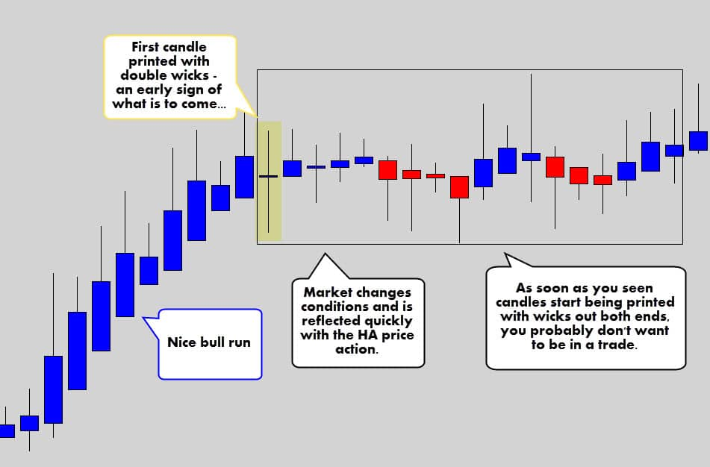
The chart above shows how these charts can do a great job of displaying the change in market conditions.
One Doji formation – a double wicked candle – was a warning sign of dangerous consolidation to come.
Like on classic candlestick charts, Doji patterns are a reflection of indecision, consolidation or unstable volatility. The effects of Doji candles on HA charts are more emphasized.
Checkpoint
The HA candles change dramatically in appearance when price conditions change – making them an aesthetically easier chart to understand. Big body candles generally mean good trending strength, small double wicked candles generally mean bad trading conditions.

Warning: Heikin Ashi Candles Can be Visually Misdirecting
When you look at these charts, you will imminently think it is a gold mine. But we all know there is no free lunch 🙂
If you remember the calculations we went through before on how a Heikin Ashi is formed… you might have picked up that Heikin Ashi candles do not always reflect the current prices in the market.
In a Classic candlestick, the close price is the current price in the market.
In a Heikin Ashi candlestick, the close price is an average of all the candle data. This means the close price of a Heikin Ashi candle is going to be different to the current market price.
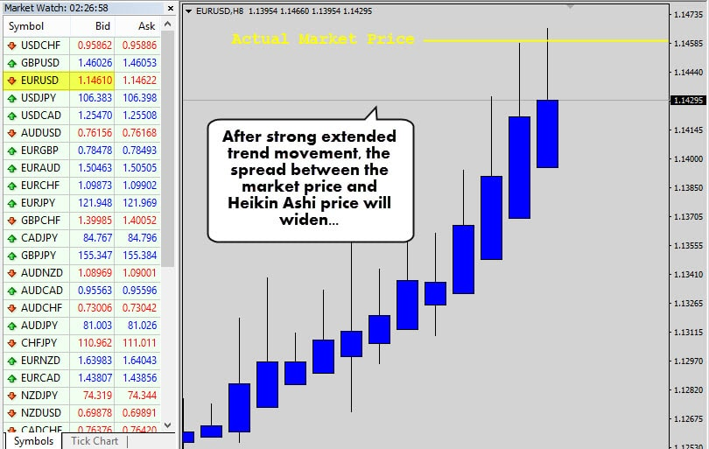
As a trend develops, the Heikin Ashi candles really start to build momentum off one another as price is driven higher or lower – the spread between the actual market price and the HA price will expand dramatically.
I actually like this mathematical outcome because it punishes traders for buying too high and selling too low – which is a common problem for novice trend traders.
When the market settles down, the distance between real price and HA price will contract significantly.
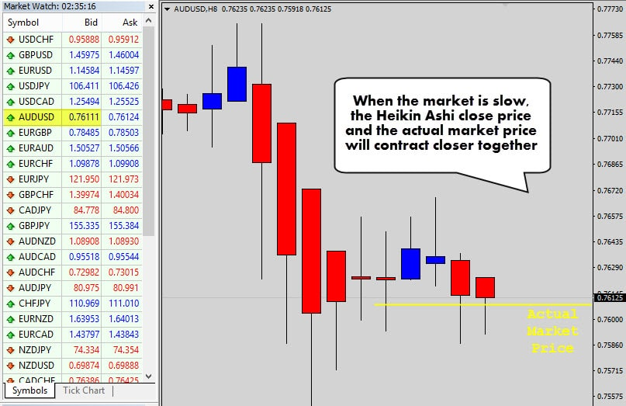
Notice how the prices are fairly aligned in the chart above. The trending conditions have stopped and the market is drifting sideways, allowing the market price to catch up with HA price.
Now when a trading opportunity occurs, you will be able to get in closer to the market bid.
Just remember, when you’re taking a Heikin Ashi trade, to check where the real market price is. This is important because you need the real market price to execute correct risk management calculations.

Checkpoint
Heikin Ashi charts can be misleading when compared to the actual price of the market due to the average math in the construction of these candles. The spread between HA price and real market price widens after strong momentum and contracts when the market stalls. This discourages buying the tops, and selling the bottoms.

How to Trade Heikin Ashi – Some Trade Ideas
Allow me to give you some ‘food for thought’ to get started with trading Heikin Ashi charts.
Traditional forms of technical analysis, and your classic chart patterns are still going to be relevant.
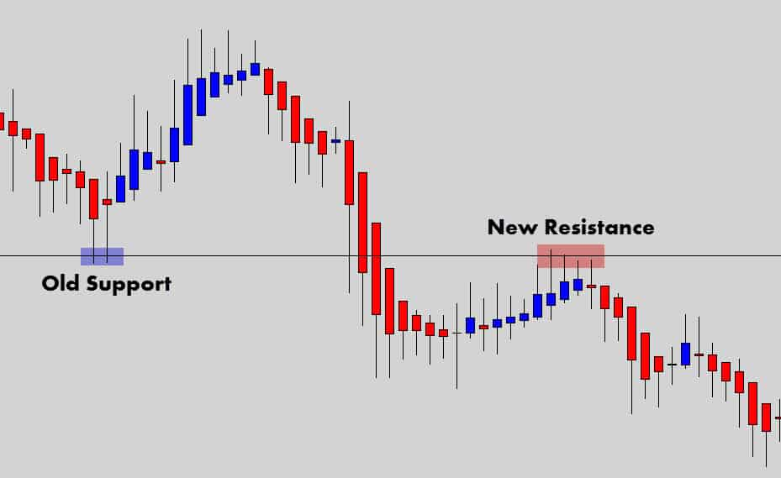
We can see above the classic swing level still being relevant. Look how well HA displays the ebb and flow off support and resistance levels.
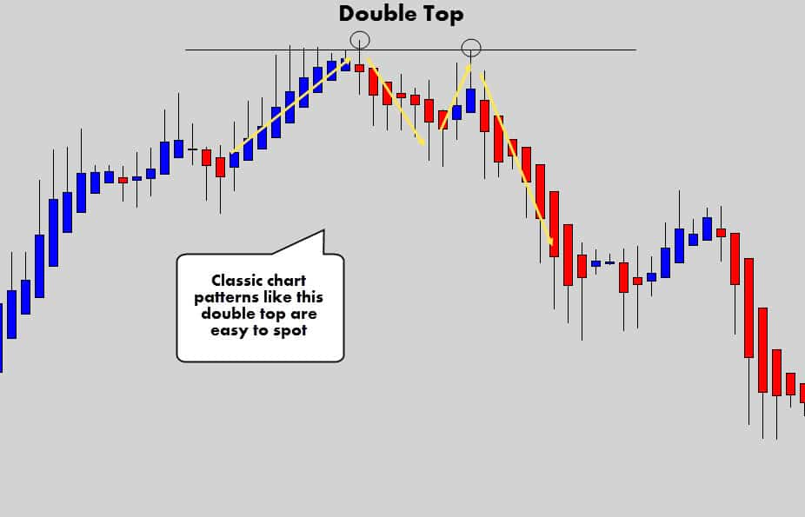
Classic patterns like the double top, and the head & shoulders patterns can be easily spotted and traded as per your plan.
Consolidation breakouts are also easy to spot and work out well.
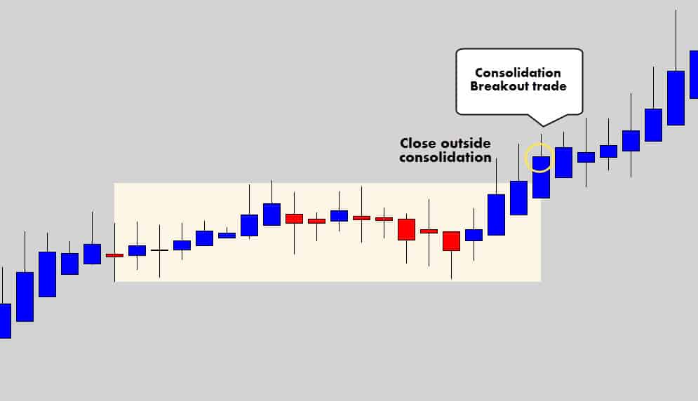
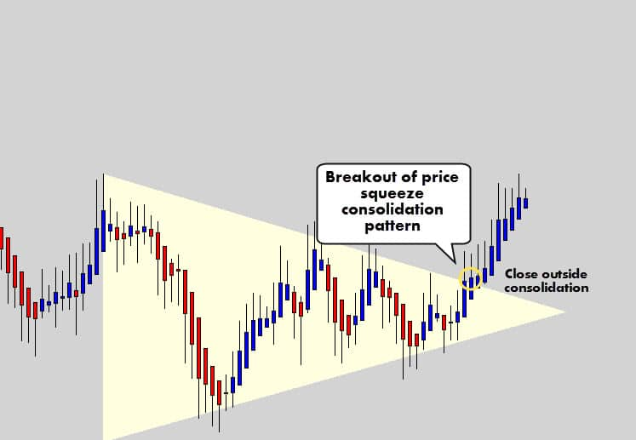
Whenever a Heikin Ashi candle closes outside of these consolidation structures, it is a good indicator that a breakout is underway.
It may even be beneficial to watch lower swing trade time frames to catch an intra-day HA breakout for an earlier entry – because you’ve always got to keep in mind the spread between the HA price and the real market price.
Another example of effective structure breakouts are simple trend line breaks.
Due to the market structure being easy to see with Heikin Ashi charts, trend lines are easier to mark. Watch for the break of obvious trend lines. (Ascending or Descending breaks of VTL’s by their Order/Degree)
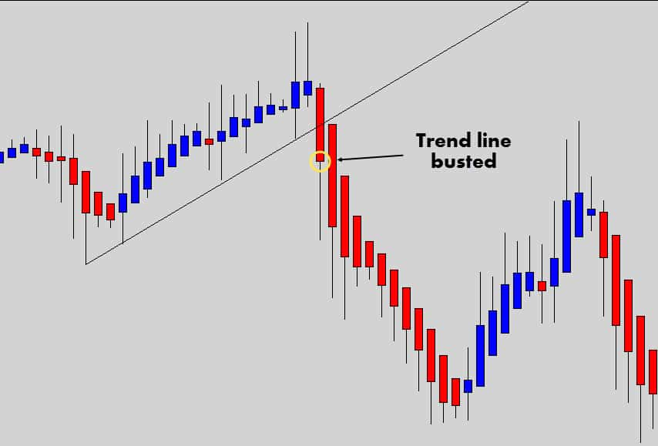
These charts are also an excellent opportunity for trailing stops… especially during strong trends.
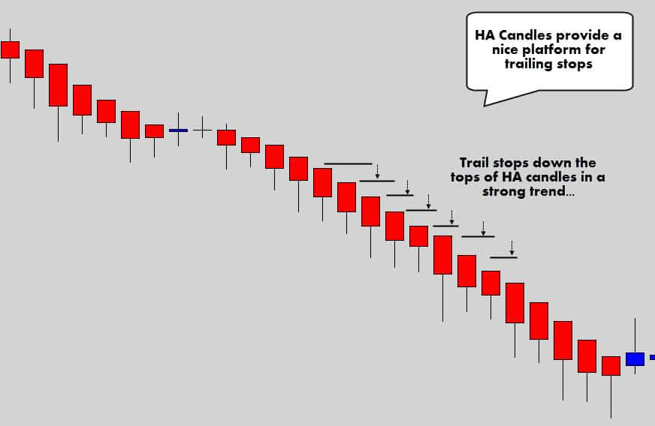
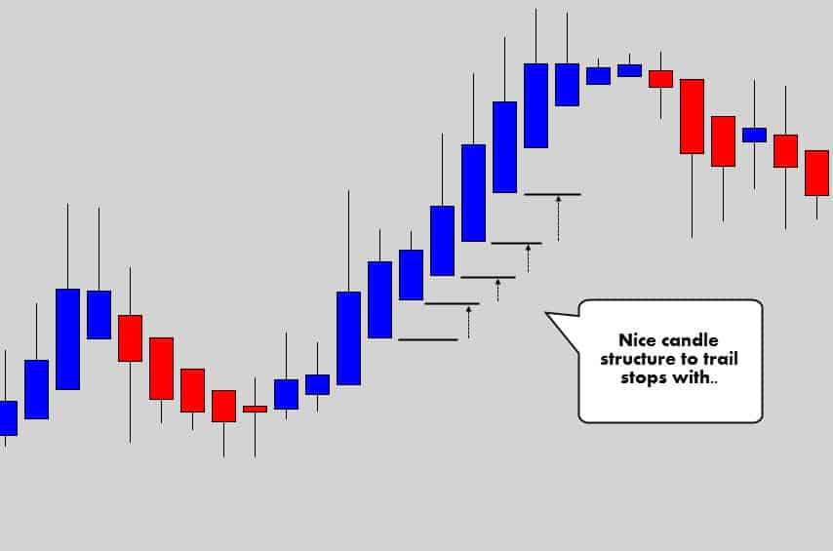
When the open price aligns with the high or low of the candle in a trend, this may the opportunity for you to trail your stop if you’re into that.
Trailing a stop behind the previous candle’s low or high may be a little aggressive – consider trailing the stop behind the high or low of two candles ago.
The stacking trend candles may also be used with scale in strategy, adding to your position as the trend develops.
Careful with this though – because the HA / Market price spread is going to increase as the trend develops, making it more difficult to scale in as the trend extends out.
Checkpoint
Heikin Ashi charts really open up the door for some unique strategies, while still maintaining use of classic technical analysis. Market structure and consolidation periods are simpler to spot. Therefore, breakout trades are more obvious. The structure of HA candles also opens up the door for some clever money management strategies.

