Here is Dean Malone's "Synergy" Heiken Ashi bars or "Average Price Bars".
They are exactly the same as the traditional Heiken Ashi but I like these because they change colours and warn you of a possible reversal and the wicks change colour to Grey if the trend is becoming choppy or weak.
I used these years ago when I was new at trading and they helped a lot with trend trading.
I've modified and removed the yellow price action channel that comes default so we can apply these to our own systems:
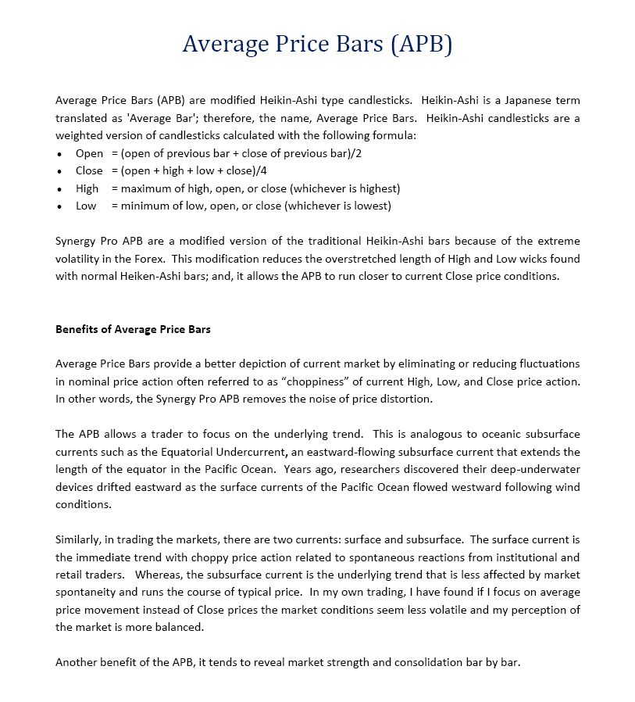
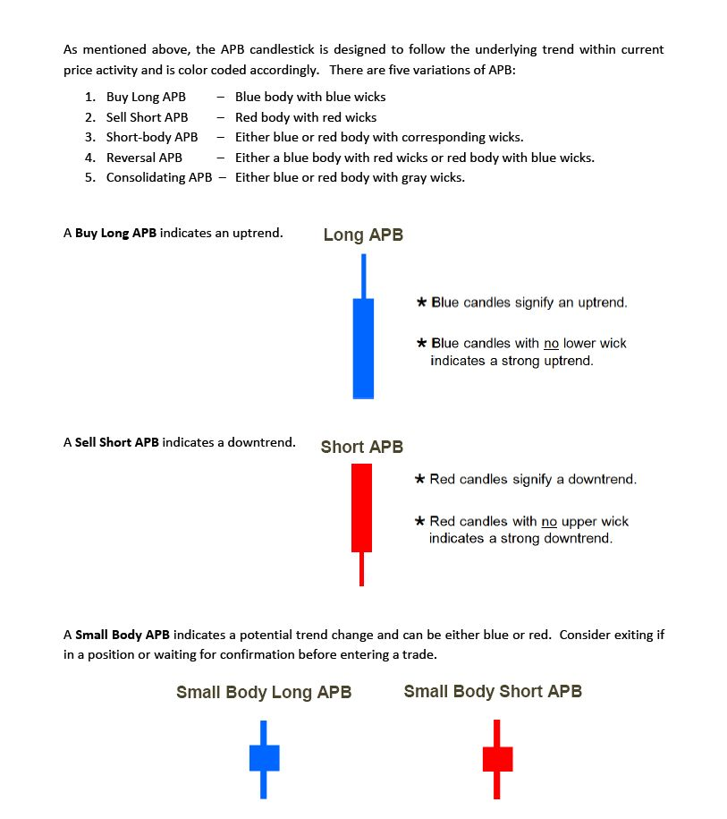
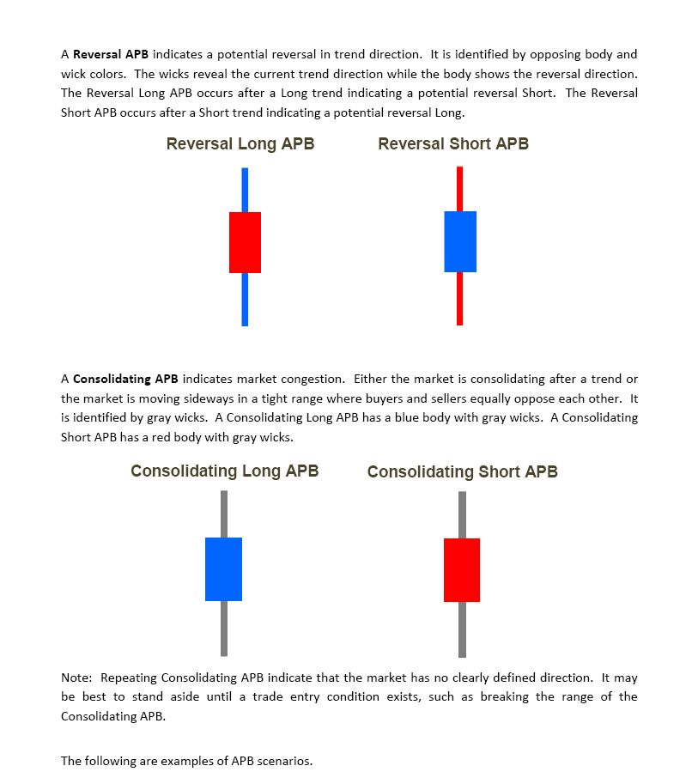
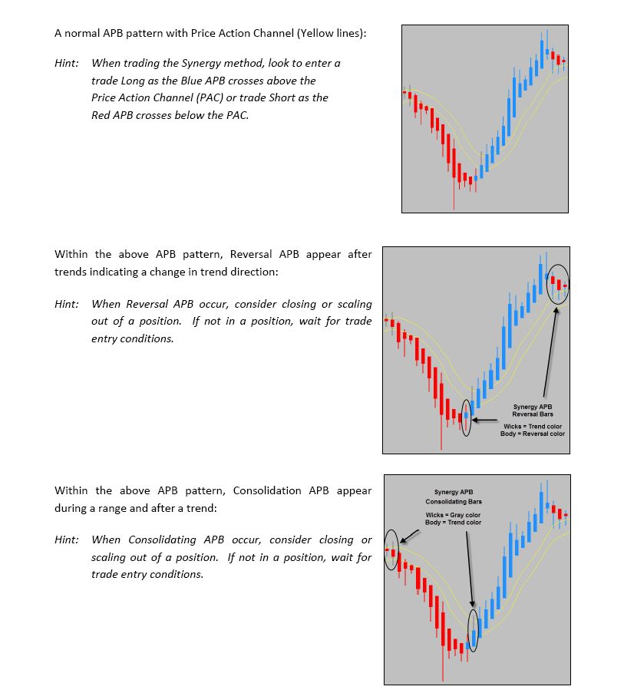
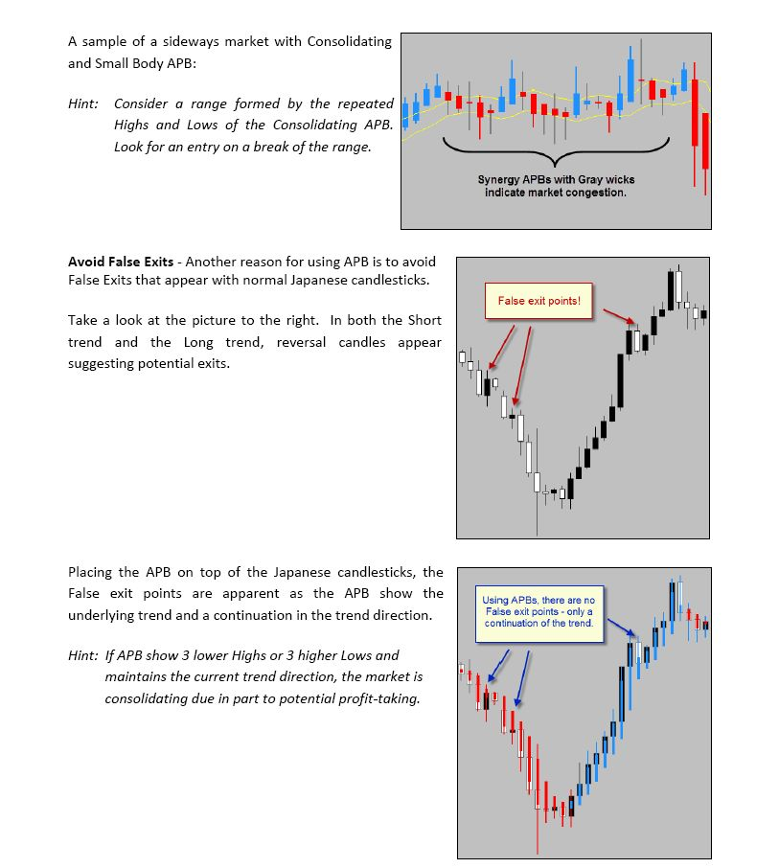
Synergy Pro-indicators-Synergy_Pro_APB-No-Channel.mq4
(6.19 KiB) Downloaded 3274 times

