- Can you please modify this Display EA or indicator to accommodate my idea of finding pairs with bilateral positive or negative correlations?
2. If you can reproduce all symbols list filtered by a margin or tick value in base currency, Open Hours, Closing Hours, High Low Range, % daily change in value or pips of the previously closed candles, preferably yesterday daily high and low, etc. or a choice of last four daily candles high and low or ADR%
2. Hanover has done a good job but only for currency strength. Same visulisation for CFD list will be excellent. But it is not updated for current mt4. If it can be updated and changed to show CFDs rather than currencies

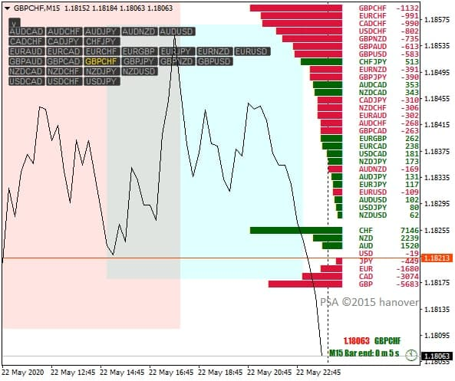
3. I had requested an amateur for help and supplied him with an indicator that shows currency strength to change it as a CFD strength indicator and suggested this format. I saw your thread only today. Had I seen earlier, I would have approached you.
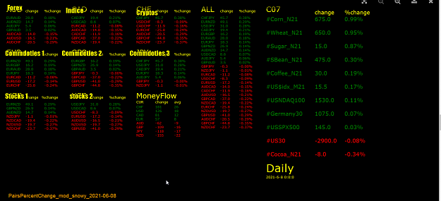
- He has done his best. First his test for symbol labels with 10 digits easily.

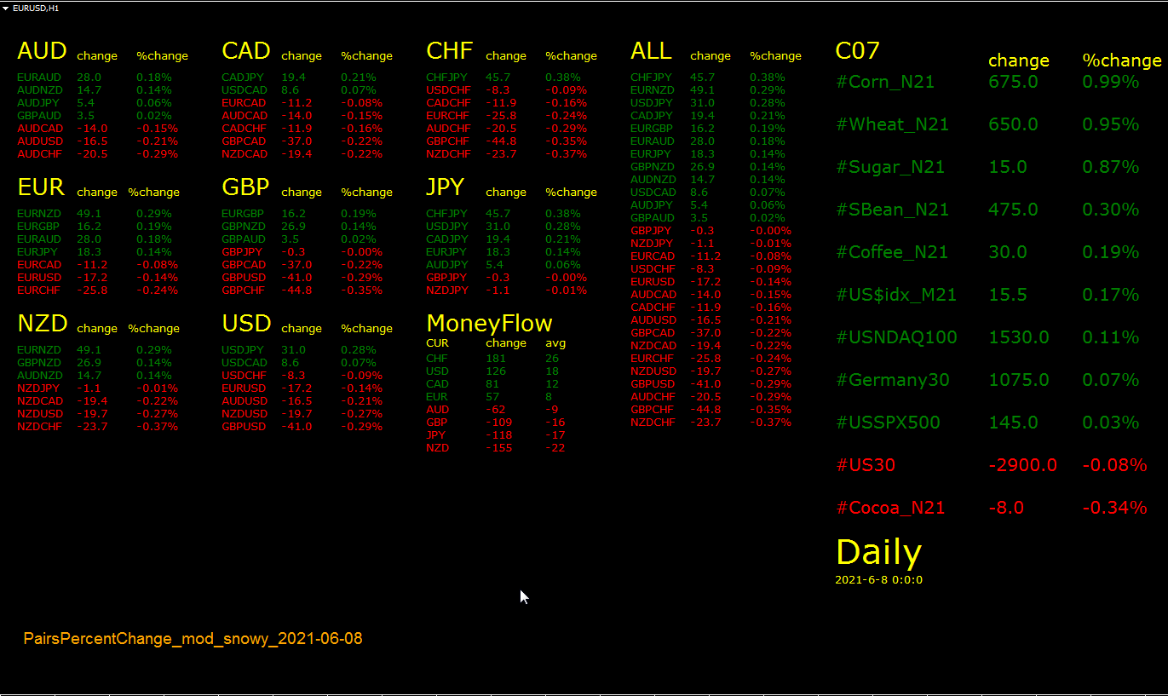

- The daylight dashboard has done a good job of providing inputs for displaying symbols. Beyong this he can’t handle.

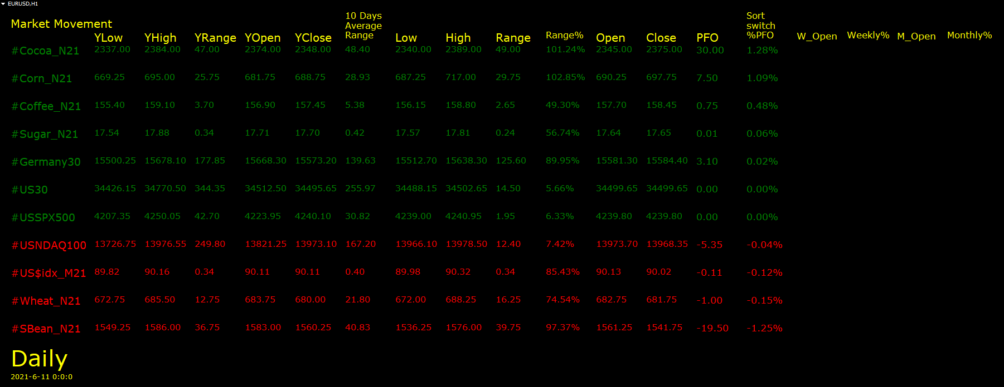
6.
My suggesttions :
If all symbols can’t be entered with margin, tick value, open hours, Closing hours, high low range, % daily range, in value or pips, then an indicator to display information based on filters/inputs selected may be used



