Multi Time Frame Analysis: How to Confirm BBMA OA Indicator.

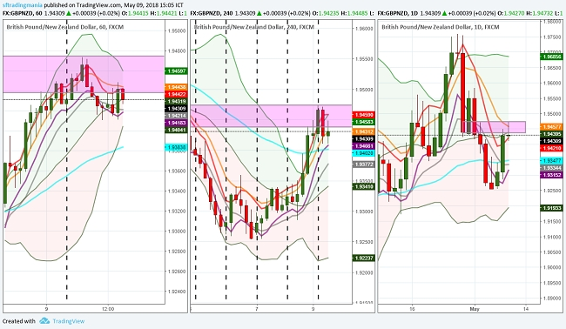
The BBMA indicator can be used for all types of traders and in any Time Frame. If you are able to run it with patience and discipline, then I think you are now able to get consistent profits from your trading. Then, how have you done so far in trading with BBMA OA?

Basic Analysis of Multi Time Frame

Multi Time Frame Analysis is a method that uses more than one Time frame to analyze prices in the forex market. The amount of Time Frame used varies, but in the BBMA OA indicator, it is at least required to use at least 2 Time Frames.
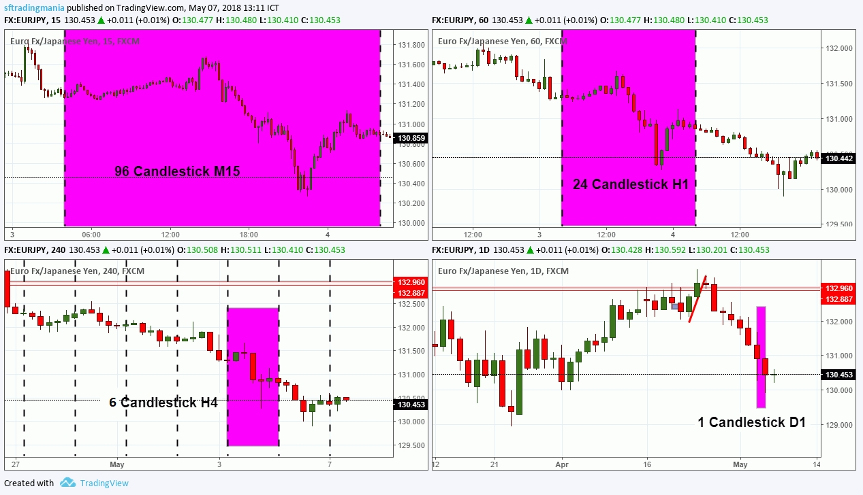
If you understand and observe price movements and the process of forming candles on the market, a candlestick on a large Time Frame is formed from the arrangement of several smaller Time Frame candlesticks . Look at the example below. A candlestick in H1 Time Frame, consists of 4 constituent candlesticks in M15 Time Frame. That means if 3 candlesticks in H1, there are 12 candlesticks in M15 Time Frame.

The process of forming a candlestick in a large Time Frame is also often called a candle trip .From one Doji fruit that is formed on D1 Time Frame, the seller and buyer strength levels will be searched for small Time Frames such as H4, H1, and M15. Following analysis of the candle journey:
- 1 candlestick in D1 Time Frame is formed of 6 candlesticks in H4 Frame Fime .
- 1 candlestick in H4 Time Frame , formed from 4 candlesticks in H1 Time Frame. That means, 1 D1 or 6 candlestick H4 candlestick is formed from 24 H1 candlesticks .
- 1 candlestick in Frame Time H1 , formed from 4 candlesticks in M15 Time Frame. That means 1 D1 candlestick, or 6 H4 candlestick, or 24 H1 candlestick formed from 96 M15 candlesticks .

Take a look at the picture above, 1 candlestick in D1 Time Frame, able to present another story on its smaller Time Frame. For example in the H4 Time Frame, there is a Doji candlestick and a Pin Bar. In H1 Time Frame, a Bullish Engulfing candlestick pattern is formed , while at M15 Morning Star candlestick pattern is formed . However, does the price stop the trip after that? Not really. When viewed from H1 Frame Time, the small increase is only a pullback to the Support level that was just broken, so the price can continue its decline further. Without looking at Time Frame H1, is it possible you know that candlestickThe Pin Bar is invalid ?

Multi Time Frame Analysis with BBMA OA Indicator

If the basics and instructions in the Multi Time Frame analysis are clear, let me explain the application to the BBMA OA indicator. With the analysis of Multi Time Frame, the signals and setup in the BBMA OA indicator can be confirmed. The analysis itself uses at least 2-3 pieces of Time Frame. You can even use 6 frames at a time. So let's start the discussion in each signal and setup the BBMA OA indicator.

Confirm Extrem

Let's repeat a little from the previous material, Extrem is the situation when the MA 5/10 comes out of the Top or Low BB . A good extreme has the following conditions:
- 5/10 MA that exits BB.
- Close Candle Reversal in BB or MA 5/10.
- There is a retest candle .

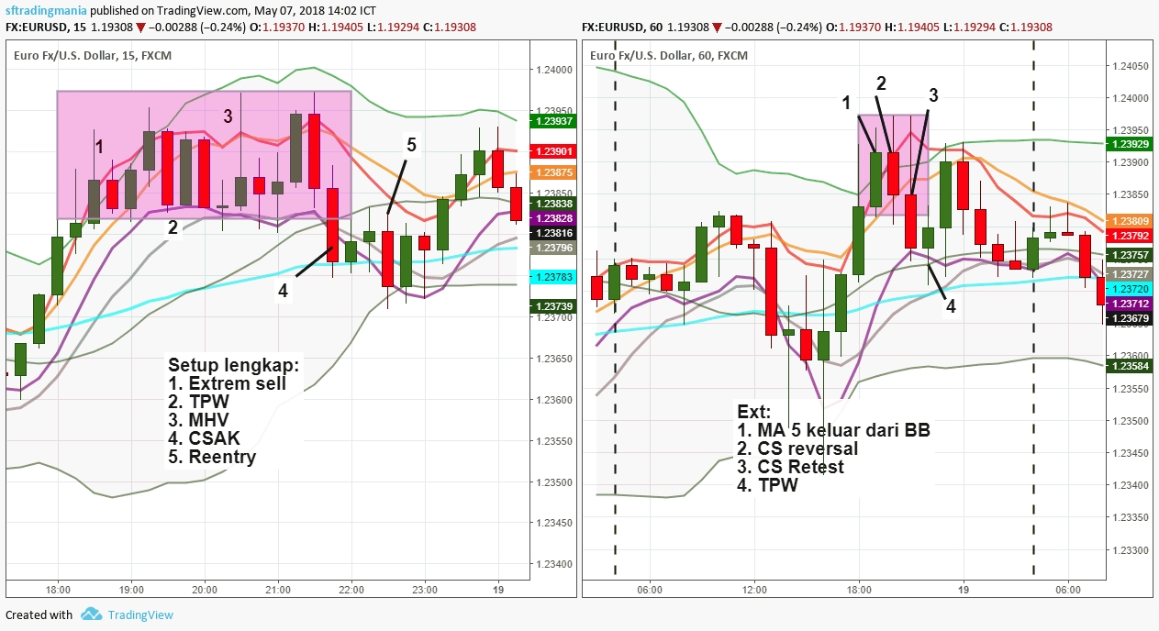
How do you confirm the signal Extrem when viewed from the Multi Time Frame analysis? Extrem signal confirmation can be obtained when the price in a smaller Time Frame shows a complete BBMA setup . Do not believe? Try now to look at the chart and make sure. Or if confused, please see an example of a comparison of the M15 vs H1 chart.

MHV confirmation
Occurs after Extrem, MHV (Market Lost Volume) is a condition when the price is no longer able to continue its journey . In the BBMA OA indicator, MHV occurs when the price cannot continue its momentum in the Top / Low BB. MHV itself has many forms and is very difficult to recognize.
Then how to confirm the MHV signal when viewed from the Multi Time Frame analysis? In a valid MHV signal, exactly one Time Frame below will be the Extrem signal . Try to look at your chart or see the following eexample.
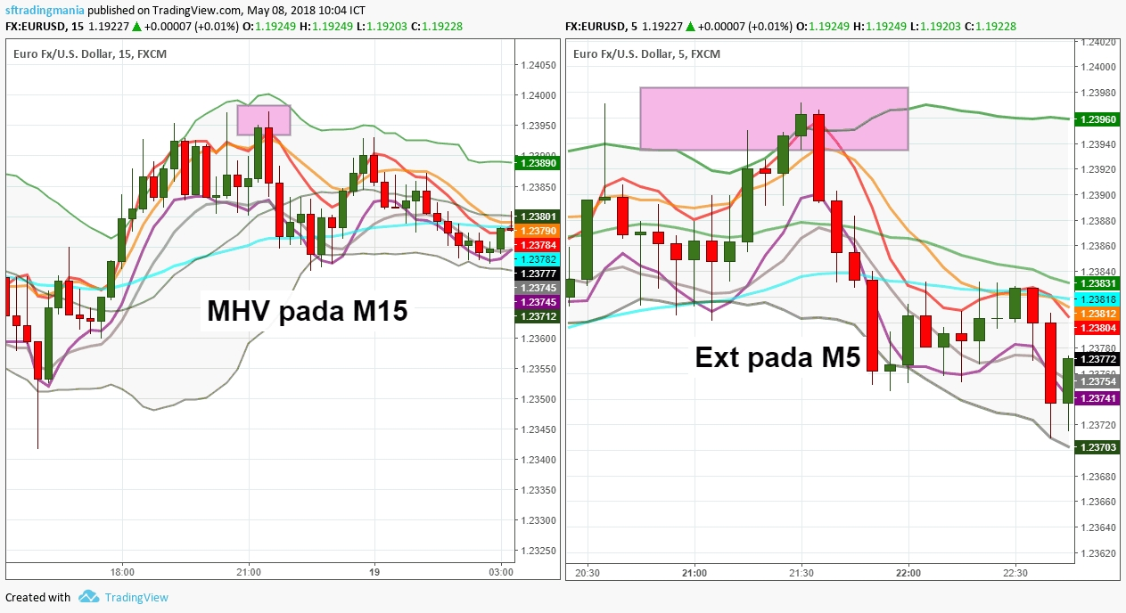
This can also mean, when MHV occurs and Extrem occurs in the Time Frame below it, the Extrem can also be confirmed by a full BBMA setup.
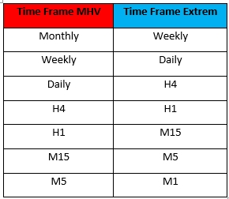
Following is the MHV confirmation correction table.

CSAK confirmation
Sturdy Candlestick (CSAK) is the initial signal of price changes that usually occur after Extrem and MHV. In the BBMA OA indicator, CSAK is also one of the guides in determining where the market will move.
How do you ensure that a CSAK is valid? Just like MHV, you only have to observe one Time Frame below it. Make sure that one Time Frame below does not occur Extrem signal . The Time Frame sequence is the same as MHV.
In a valid CSAK, one Time Frame below will experience momentum in the Top / Low BB, while the one experiencing Extrem is considered a failure and will turn around.

Confirm Reentry
Reentry is an entry that you must have been waiting for now. There are 2 types of Reentry at BBMA, that is, Reentry after CSAK, as well as momentum Reentry. When viewed from the behavior of the candle, Reentry is a pullback that occurs after the price breakout at the Support level and a certain balance zone. In BBMA OA it is the same: Reentry only exists after CSAK (price shift from Top to Low BB or vice versa), and CSM ( pullback that occurs after the breakout of Top / Low BB).
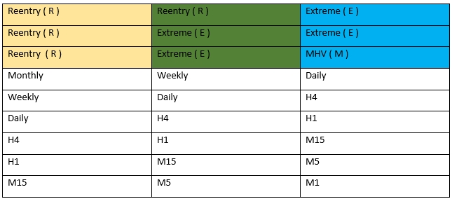
Then what about Reentry confirmation with Multi Time Frame analysis? For Reentry this is a bit troublesome. Before I discuss more deeply, the following I give first the confirmation correction table.

Now let me explain the code in the table above. Confirmation code Reentry on the BBMA OA indicator is RRE, REE, and REM . R is Reentry, E represents Extrem, and M refers to MHV. Suppose there is Reentry on H4 Time Frame, then Reentry is valid with the following conditions.
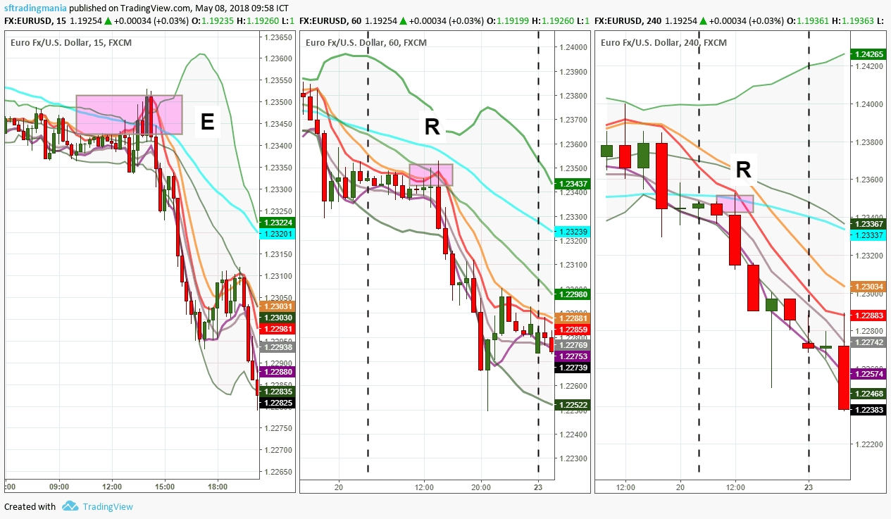
- Code RRE = H1 is Reentry, M15 is Extreme.

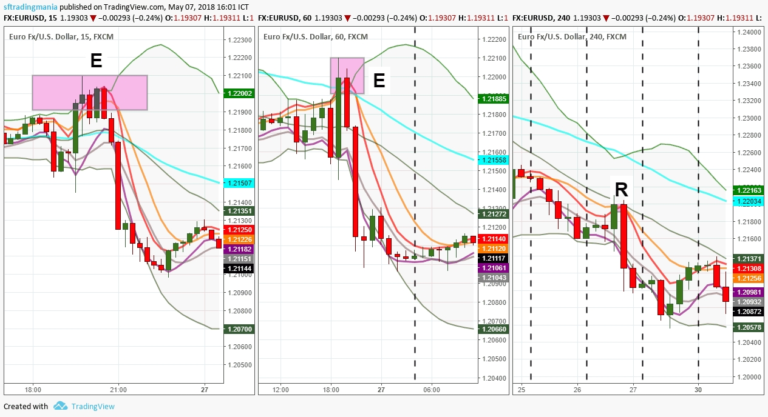
REE = H1 code is Extreme, M15 is Extreme

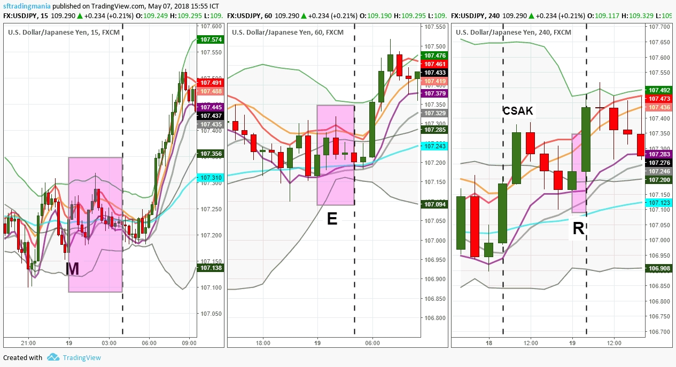
REM code = H1 is Extreme, M15 is MHV

The yellow column contains Time Frame Reentrywhich will be used as an open position reference. While the green and blue columns contain Time Frame which is used for signal validation of Reentry. Of course you can also confirm Extreme and MHV on the Time Frame below, but according to Cikgu teachings (....), this 3 Time Frame analysis is enough to generate profits with accurate entry and high success rates.

No need to bother, the important thing is patience and discipline
How? Difficult and complicated right? If you think Multi Time Frame analysis is easy, then you are wrong. The level of patience and discipline needed to be able to understand and master this knowledge is very high.
Patience and discipline are one of the most difficult to master trading components. If all traders are patient and disciplined, of course no one will experience the Margin Call or Stop Out at this time. But in fact it's not right? In the BBMA OA indicator too, you have been asked to be patient, patient, patient in waiting for the signal and complete setup , but still trying to enter in each Extrem and MHV that is formed. This curiosity sometimes makes a profit, but maybe more often results in big losses for you.
I understand and understand your desire to make a lot of money quickly. Especially after seeing the magic of the BBMA OA indicator while on the market. However, that alone is not enough. The knowledge you learn on that basis is nothing more than a leaf on a large tree. I understand because I also experienced the same time as you. Moreover, if you have seen the Buy / Sell Extrem that occurred. The hands feel itchy because they want to get into the marketimmediately to make quick money.
So what is the solution? Can I not enter every setup and signal in the BBMA OA indicator? Do you have to wait until the full BBMA setup appears and can you trade? Well, that's why the Multi Time Frame analysis is discussed; so you can use it to confirm the BBMA OA indicator. You can also combine this indicator with the analysis method Supply and Demand or Support and Resistance , to facilitate the mapping of Take Profit and Stop Loss points.

