The report presents a summary of all upcoming and recent fundamental events as well as technical analysis for the major markets.
DAILY REPORT – 11Th Sept. 2020

Britain’s recovery from the coronavirus pandemic continued as shops reopened and manufacturing activity resumed, but the economy has grown slowly. GDP now stands at 18.6% which is a little higher than the previous low ebb in April. However, it remains 11.7% below the levels indicated in February 2020 before the infection transmission to Britain.
European stock markets were opened mixed on Friday, with investors having an eye on a comparatively optimistic ECB and new weakened statistics of the Wall Street. The pan-European Stoxx 600 declined by 0.91% to 367.12. In the Cash Markets, the CAC 40 was trading lower by 0.38% at 5028.43 and the DAX declined by 0.26% to 13,202. Euro Stoxx 50 declined 0.36% to 3,312.09, at the time of writing.
Stocks in Asia-Pacific were trading mixed in early trade session today as the drop in the movement of the regional technology stock sector stateside. Mainland Chinese stocks were also mixed by the afternoon, with the shanghai compostite inched down 0.21% whereas the Shenzhen Component rose moderately. Hong Kong’s Hang Sang Index edged up 0.42%.
Meanwhile, in Japan, the Nikkei 225 rose 0.35% to 23,207.5, in the afternoon trading session. While the Topix index inched up 0.47% to 1620.75. South Korea’s Kospi inched down 0.65% to 315.45. And Australia’s S&P/ASX 200 dropped 0.74% to 5849.0.
Overnight in the United States, The Dow Futures is up by 0.56% to 27,753 while Nasdaq 100 futures declined by 2.12% and S&P 500 futures decreased 1.76% to 3,33987 respectively.
In corporate news, Shares of major Mier Rio Tinto dipped around 0.8% after the firm announced its chief executive Jean-Sébastien Jacques, who led the mining giant since 2016, will be stepping down by mutual agreement
On the Data front, GBP Manufacturing Production that measures the change in the overall inflation-adjusted value of output produced by manufacturers released today at 2:00 local time today. The actual rate is 6.3%, which is higher than the 5.05 forecast. EUR ECB President Lagarde Speak is scheduled at 5:30 local time today. From the USA, USD Core CPI Mom for the month of August will be released later in the day.
In the currency markets, the U.S. Dollar Index edged down 0.12% to 92.882, after an earlier high of 93.352. The USD/JPY gained 0.04% to 106.16. The AUD/USD was up by 0.37% to 0.7284 and the NZD/USD pair edged up by 0.24% to 0.6665. The USD/CNY pair inched down to 6.8833. The GBP/USD pair inched up 0.0027% to 1.2827, at the time of writing.
In the Commodity Markets, Gold prices fell on Friday as the U.S. dollar rebounded, spot Gold was down 0.8% at $1,938.53 per ounce by 0308 GMT, after hitting its best level since September 2 at $1,965.94 on Thursday. Gold has gained 0.4% this week. U.S. gold futures fell 0.8% to $1,948. Elsewhere, silver dropped 1.2% to $26.61 per ounce and palladium lost 0.7% to $2,278.86. Platinum eased 0.4% to $922.43, but was heading for its best week since week-ending August 7, up 3%.
Oil prices were lower in the afternoon of Asian trading hours, U.S. crude futures traded 0.3% lower at $37.19 a barrel, while the international benchmark Brent contract fell 0.4% to $39.89. Both major benchmarks are down around 6.5% for the week and headed for a second week of declines.
In the Cryptocurrency Markets, BTC/USD inched down 0.49% and was trading at $10,283.6. Ethereum edged down 1.34% to $363.15. Litecoin fell 0.80 to $48.157, and Dash inched down 0.43% to 75.21. Ripple edged down 0.17% to 0.2353, at the time of writing.

TECHNICAL SUMMARY
EUR/USD
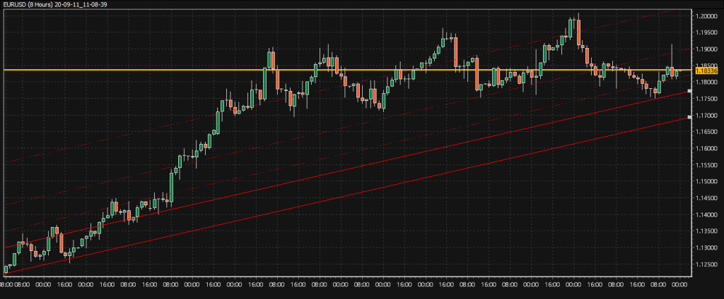
EUR/USD D1
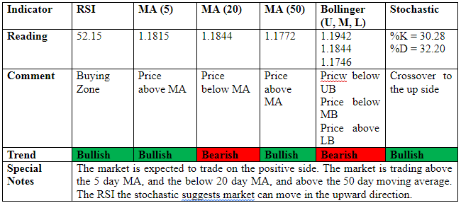
SELL SUGGESTION- BUY AT 1.18325, TAKE PROFIT AT 1.19135 AND STOP AT 1.17515
GBP/USD
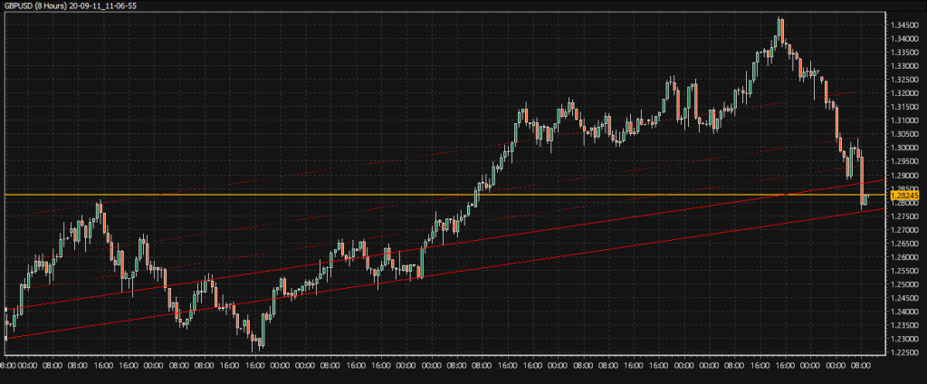
GBP/USD D1
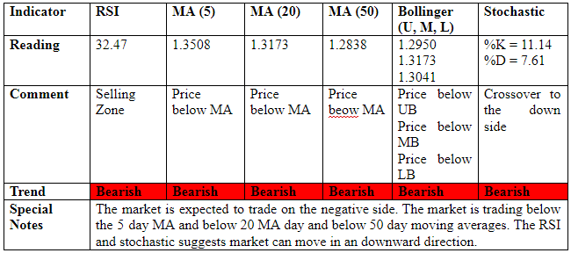
TRADE SUGGESTION – SELL AT 1.29615, TAKE PROFIT AT 1.27775 AND STOP AT 1.31455
USD/JPY
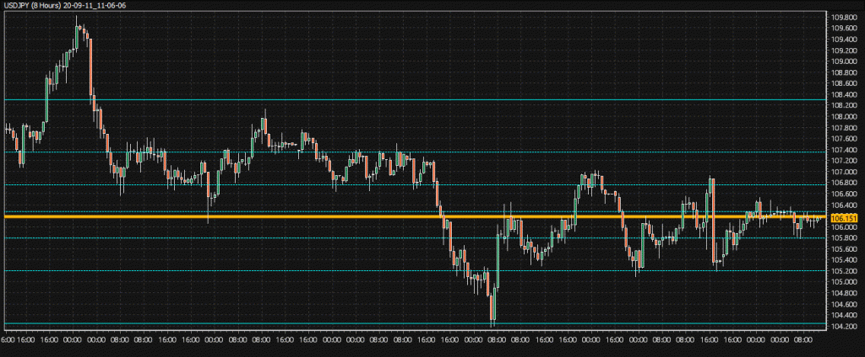
USD/JPY D1
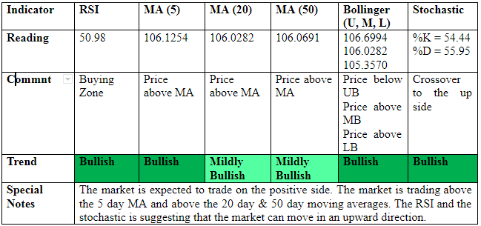
TRADE SUGGESTION- BUY AT 105.942 TAKE PROFIT AT 106.288 AND STOP AT 106.288
USD/CHF
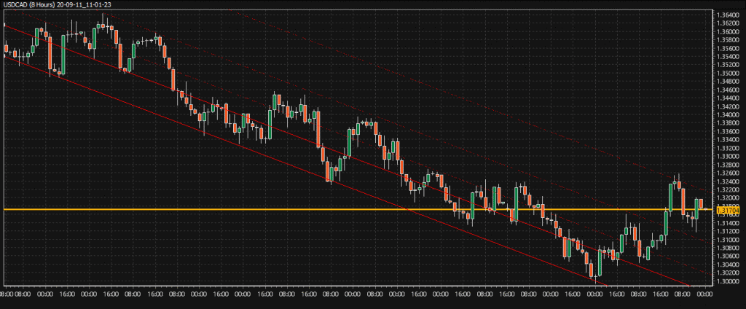
USD/CHF D1
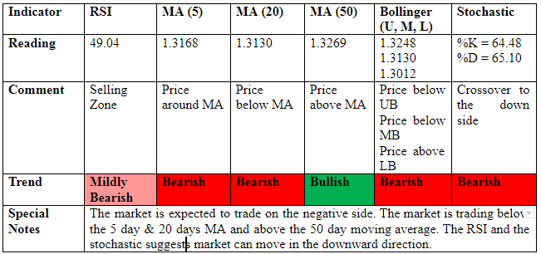
TRADE SUGGESTION- SELL AT 0.91074, TAKE PROFIT AT 0.65978 AND STOP AT 0.91782
S&P 500
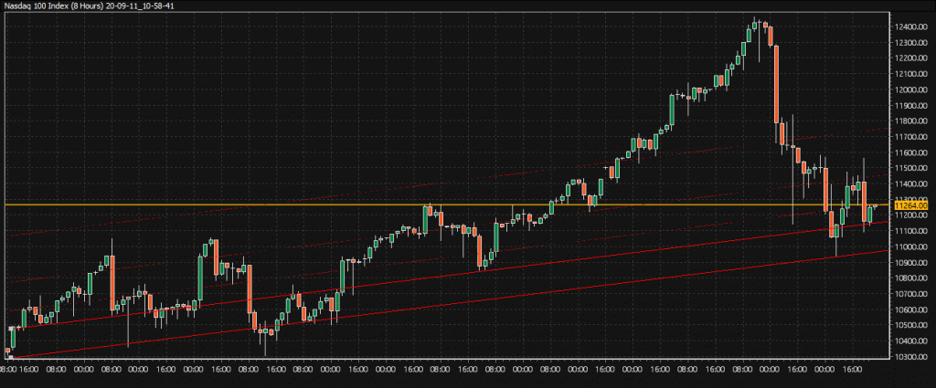
S&P 500 D1
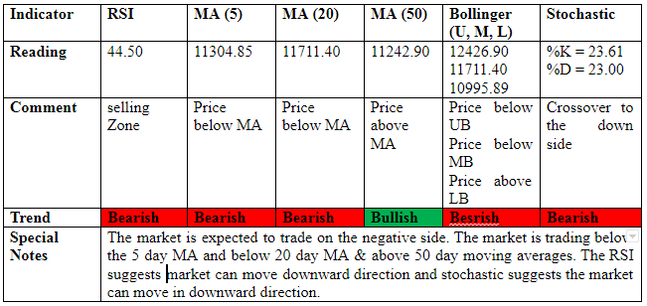
TRADE SUGGESTION- BUY AT 3446.00, TAKE PROFIT AT 3576.25 AND STOP AT 3576.25
BRENT CRUDE
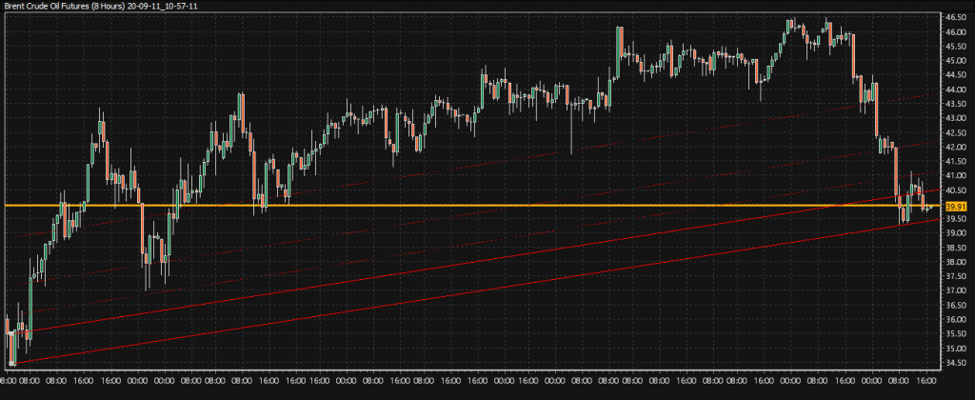
BRENT CRUDE D1
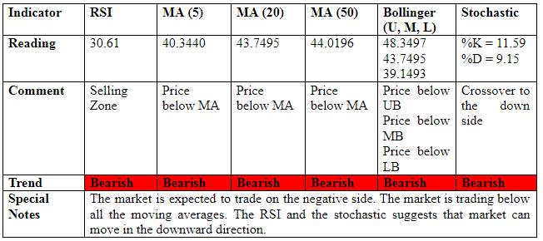
TRADE SUGGESTION- SELL AT 41.17, TAKE PROFIT AT 39.34 AND STOP AT 42.97
GOLD
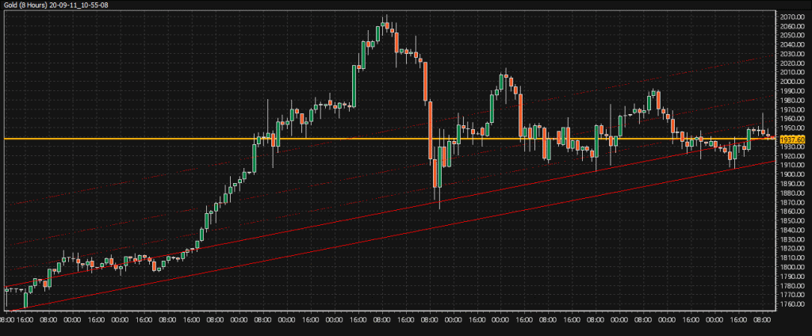
GOLD D1
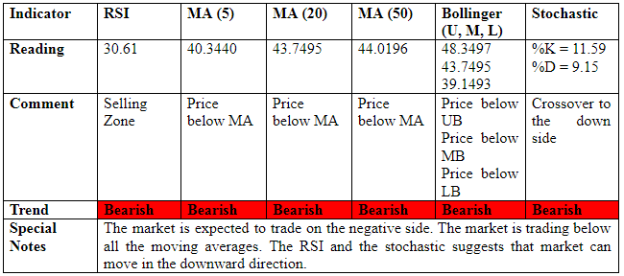
TRADE SUGGESTION- BUY AT 1949.55, TAKE PROFIT AT 1971.75 AND STOP AT 1973.75
DASH
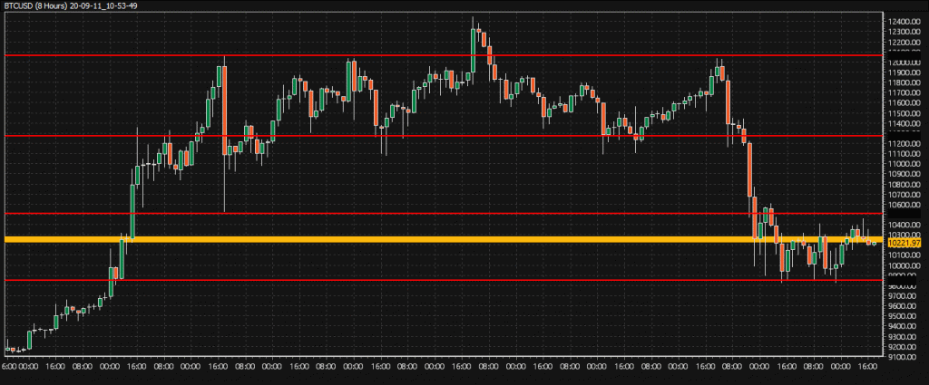
DASH D1
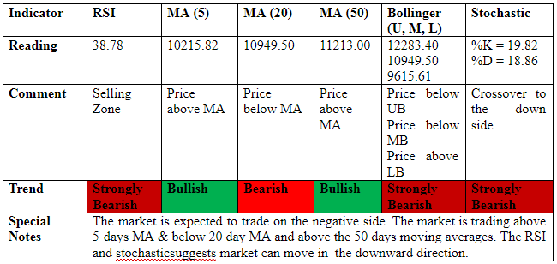
TRADE SUGGESTION- SELL AT 78.576, TAKE PROFIT AT 69.429 AND STOP AT 78.576
Click Here For More Signals
Click Here For Register Now
Capital Street Intermarkets Limited is fully licensed and regulated by the FSC Mauritius, as a Full Services Investment Dealer (excluding underwriting), under the license number C112010690.

