HEDGE TRADE PANEL EA
This very versatile EA can be used to place different types of manual trades in Metatrader 4 and to manage them in ways which are very unique and unconventional.

The original EA was posted by FF member Nicholishen but it has evolved since then and it now has many other features which make it a very useful trading tool. Unfortunately, traders who use US brokers will not be able to use the hedging features and FIFO is not supported.
Features:
- One-click trading,
- Placing orders: BUY, SELL, BUY LIMIT, SELL LIMIT, BUY STOP, SELL STOP
- Can have 1 fixed TP + several other levels of TP
- Can set 1 fixed SL Or a Hedging SL (places opposite trade at SL distance)
- Fixed Or Automatic position sizing based on pip value
- Buttons to Add or subtract position sizing at will to manage overall net exposure
- Reverse net position instantly
- Close net position instantly
- Lock order management to Panel orders only so you won't interfere with other orders (like alt EA orders)
- Instant Hedging Button
- Break Even and Instant Break Even button
- CLOSE HEDGED button to reconcile transaction on our schedule so we won’t get slipped on many open positions plus it won't slow down rapid scalping in a fast market
- Status in window. Includes last action status with order latency and slippage reporting as well as the overall net position.
- Can minimize or Move window anywhere on screen for convenience
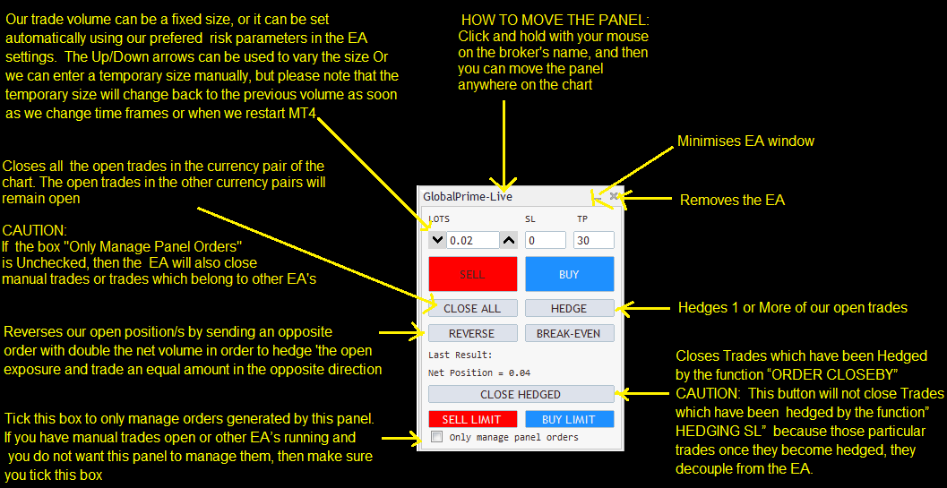

HOW TO APPLY THE EA TO THE CHART
BEFORE you drag the EA on to the chart, make sure that
the Auto Trading button is green
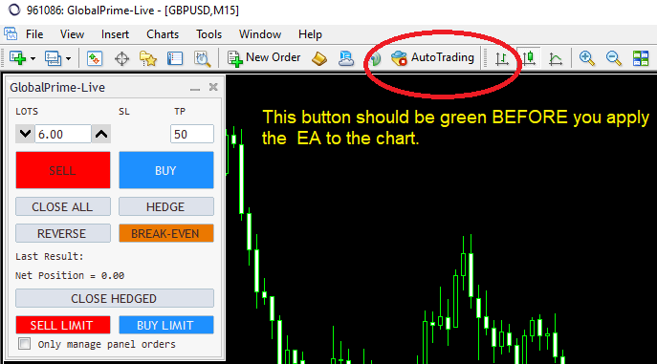
BEFORE you load the EA, I suggest you also update your MT4’s historical data.
This EA uses historical data to calculate take profit targets for the symbol basket subroutine.
Place the file " Force History Download " into your MT4/Scripts folder.
Restart MT4
In MT4, click on VIEW, NAVIGATOR, SCRIPTS
Locate the new script file and drag and drop onto any chart.
(this only needs to be done once, and while the MT4 Auto Trading button is green),
This step is needed so that your MT4 downloads historical data for all the currency pairs which are in the EA settings.
When you apply the script to the chart click on the Expers tab of your MT4 terminal window and you will see the currency pairs being updated 1 by one.
When the script finishes updating your MT4 history it will remove itself from the chart.
Note: If you only trade 1 currency pair (or only a few), then I suggest you edit the EA settings and remove all the currency pairs which are not needed.
This will make your MT4 more responsive.

Don’t forget to tick the following boxes
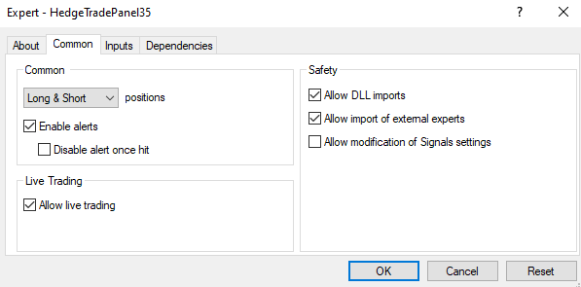
When you are applying the EA to the chart click on the tab “COMMON” and tick the boxes shown in the above picture
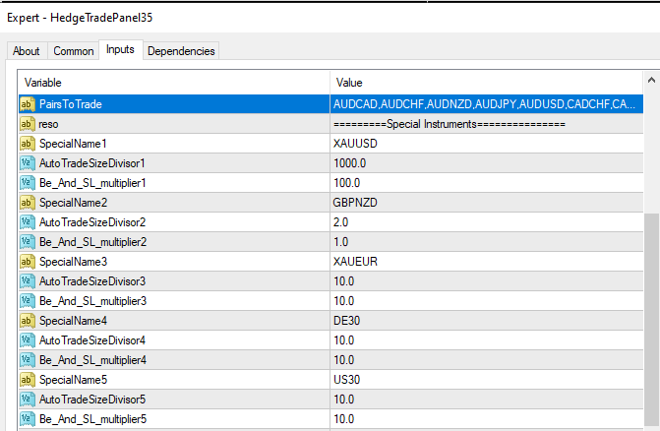
I suggest you remove any currency pairs you are not using from the input PairsToTrade. This will make your MT4 more responsive.
Make sure all the remaining currency pairs shown in the input PairsToTrade actually exist in your MT4 and are not mispelled.
Note: there is a comma separating each currency name

If any of the currencies don’t exist in your MT4 then remove them from the EA inputs or if they are special instruments you can change them to a different one which exists. For example, if your MT4 does not have DE30, then it would have GER30 or UK100 etc. etc

When you finished editing your settings, and you click OK the EA should load on the chart. Make sure the chart is showing the EA’s name and the smiley is happy
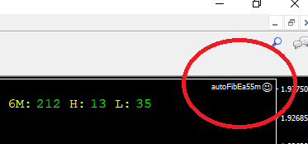

If the MT4 Auto Trading button was Not green when you applied the EA then the MT4 will have a sad smiley icon next to the name of the expert and the EA would have Live Trading disabled in its settings.

For trouble shooting
please see the next page

TROUBLE SHOOTING
- If the EA’s name is Not visible on the right hand side of your chart , then you have probably forgotten to tick the box “allow DLL” when you applied the EA to the chart and in this case I suggest you close that chart, open a new chart and apply the EA while following all the required steps.

- If the EA’s name is visible on the right hand side of your chart ,
and the MT4 Auto Trading button is GREEN
but the smiley is still showing unhappy,
Then Right click with your mouse on the chart and select
EXPERTS/PROPERTIES then Click on COMMON
Tick the box "allow Live Trading”
Then Click OK

The smiley should now be showing as happy
- This EA is using multiple ways of taking profit and if your trades close unexpectedly it is probably due to the symbol basket closure function
If you don’t know what this is, I suggest you read some of my earlier posts.
Symbol closure is a very powerful technique in the right hands but it isn’t necessary for plain vanilla style trading and it can be annoying for trend traders who want to keep their trades open for many days so it can be disabled by switching the following inputs to = false.

SymbolBasketTradesBelongToBasket1=false
SymbolBasketTradesBelongToBasket2=false
SymbolBasketTradesBelongToBasket3=false
SymbolBasketTradesBelongToBasket4=false
SymbolBasketTradesBelongToBasket5=false
SymbolBasketTradesBelongToBasket6=false

- If your trade close almost instantly then your Break Even (BE) or stop loss (SL) are probably being placed too close to your entry.
This is because you are trying to trade a special instrument which has a different pip count, or because you have edited the EA settings and entered an ordinary currency pair in the SPECIAL INSTRUMENT inputs.
If you are trying to trade gold (XAUUSD) then you will most likely need to set the input AutoTradeSizeDivisor to something other than 10, possibly 100 ( depends on yoru broker so experiment with this on demo and see what setting you’ll need)
You might also need to change input BE_And_SL_Multiplier to something else. Possibly 1000?

EXAMPLE: I trade GBPNZD and I want my trade size to be halved because this is a crazy pair and can travel long distances.
Therefore, I would enter the GBPNZD under 1 of the special inputs and set the input AutoTradeSizeDivisor to 2 and the BE_And_SL_Multiplier I would set it to 1
I would set it to 1 because the pip count for currencies is normal but if the special instrument was UK100 the multiplier would probably need to be 1000 or more (depends on your broker)
So if you do trade special instruments please take a few moments to set this up correctly and you will be very happy.
If you experience anything unusual let me know and I will investigate it.

