

DISCUSSIONS ON ORDER FLOW & VOLUME

Aurthur: DonPato on Forex Factory

November 2019

Hello Friends
I am starting a new thread to (hopefully) generate some productive discussions on the above subject Order flow/Volume. I have long wanted to have a thread dedicated to this subject but whenever I start it I am sidetracked by other issues or just rude insulting people that want to come in an "nay say" everything brought up. I hope if you are one such person you will kindly move along. I have addressed this issue (Order flow/Volume) in several different threads each relating to either how to recognize and anticipate price movements or how to recognize and anticipate 'exhaustion' in an ongoing price movement, which may eventually lead to a swing point and/or reversal.
Yesterday a member who's opinion I have come to respect wanted to delve deeper into this subject but I declined at the risk of "hi-jacking" someone else's thread who was asking for commentary on how to develop a "higher probability" trading method. And this really brings me to the point of this new thread, and that is; Trading in terms of mathematics will ultimately fail. I know I'll get some push back on this and understand why. This kind of business attracts many kinds of people, but is especially attractive to those who like numbers...specifically numbers games.
This is where many get the idea that trading and markets are similar in nature to gambling or gaming. Nothing could be farther from the truth. My point is this however, is NOT to discuss the differences or similarities between trading and gambling. My point in this thread is to discuss the very basis of market interactions from a structural point of view.
By this I mean actual structure (some call it mechanics - who are obviously mechanically inclined). As I have stated before on many different threads, the market is made up of four main structural components: (1) Time; (2) Order flow; (3) Volume; (4) Price.
You may have noticed that PRICE is the final component. This is true because of one undeniable and immutable fact. Price is the end result of the other three structural components. This fact must become crystal clear in your mind because without recognizing this fact anything else you do will ultimately end in ruin.
It is my hope that we can explore these structural components together in a collegiate atmosphere based on mutual respect for each other's ideas and concepts fully understanding that while we may visualize it differently, the hard fact is that this is how each and every market works...from your grocery store and local farmer's market, to Wall Street and everything else in between.
Please Understand: If you wish to come in and extol the virtues of some complicated or even simple mathematical formula that can predict and/or present an "edge". Or compare market function with some "scientific" fact, like Newtonian physics, or some psychological methodology, please move on. It is my intention to discuss Market Structure. Not "price structure" with cute little pictures of butterflies, bats and triangles. Or some idea that draws a cute little line (or box) on a chart that somehow indicates price MUST move up to then away from this area...move on to the other "technical analysis" sites.
This thread will not be discussing any particular methodology but rather impart and discuss the working of market structure at its most basic level. We may (if there is enough interest) move on to practical application of these truths but that remains to be seen if there is even enough interest in this thread.

------------------------------------------------------------------------------------------------------------------------------------------
I will start with a quote that I posted on another thread:
My epiphany came when I understood HOW the market works. Here is a brief summation: (1) Anyone and everyone who wishes to participate in the market must do so by placing orders. (2) These orders are made up of two different types. Passive - also known as "liquidity"; and aggressive - also known as "market" orders. (3) These orders are matched with each other at agreed upon prices buys with sells until the liquidity at a particular price is gone. Then price will move higher (or lower) depending on the surplus of orders remaining unfilled. (Higher with more buying, and lower with more selling). (5) These orders are constantly coming and going into and out of the market and create a "flow" which will vary in its intensity and "net" direction (buy or sell). It is the waxing and waning of this order flow that creates price movement and at times will actually precede it.
Anyone who learns to "see" and "read" this order flow has an automatic "edge" on the rest of the market. This is because there is literally no math formula, or computer algorithm that can accurately predict human behavior. In fact, the data required to make accurate calculations will always lag behind the actual market and its price movements and always have the trader who relays on this data at least 2-3 steps behind the market. Yes even price lags behind order flow, (if only slightly).
Unless you leave behind all the rest of the losing technical analysis theories and concentrate your efforts solely on learning the market structure and how it effects price movement...you will lose overall. I would save you that pain and anxiety. Start anew and learn the ideas and concepts behind trading the four structural components of the market itself. Time; Order flow; Volume; Price.
If you are going to engage in this possibly financially ruinous profession...do it right from the start and don't waste your time and money with any of the above mentioned, math (indicators, oscillators, formulas, algorithms).
With your indulgence I would like to take each of those enumerated points above and delve into them one at a time:
(1) Anyone and everyone who wishes to participate in the market must do so by placing orders.
It would seem this is self evident but I will comment none-the-less. It is said that the market is a great equalizer - I think whoever said that was referring more to leverage but the point is still taken. You, me, or anyone else who wishes to participate in the market must do so by placing an order. Yes your retirement account and your savings account and any other "non liquid" account does this via a means of some brokerage. CD's Bonds, everything MUST go through the order process. These brokers are the "gate keepers". One cannot enter an order or engage in the market in anyway except through some access medium. This is either a broker, a banker, or your neighborhood "Edward Jones". While these institutions all make a big deal out of telling you they are "keeping your money safe", or "investing conservatively or aggressively" or what ever they think you want to hear to get your business, the bottom line is: If you want to invest, transact, or in any other way "engage" with the markets you have to find a way to place an order. Period!

Now on to the second point listed above:
(2) These orders are made up of two different types. Passive - also known as "liquidity"; and aggressive - also known as "market" orders.
There are really only two general categories of orders. (1) Passive, which are also referred to as liquidity, and (2) Aggressive, mostly referred to as "market" orders. So what is the difference?
Let’s start with "Passive" orders. These are the orders that are placed in the market "ahead" of the price movement. The correct term is "limit order". These orders must meet certain requirements: (1) a price "in advance" of the current market, and (2) volume (how big is the order).
- Price "in advance" of the market means this...if the market is at 1.500...you can only place a SELL order above this price and likewise you can only place a BUY order below this price. These are LIMIT orders...they are considered "passive" because the participant agrees to wait for their order to be filled in the price and quantity specified.
- Each order must have a volume also specified. 1 lot; 1 share; 1 contract. It is this size that constitutes the volume contained in most exchanges (except FX). When you see 100 Lots (or shares, or contracts) placed at a certain price this literally means a certain amount of money (or "liquidity") is available at this price to anyone who wishes to take the opposite side of this transaction.
A few things to note...you cannot place a buy limit order at a price that is above the current market price and you cannot place a sell limit order at a price that is below the current market price.
Probably the most common use of a limit order is a take profit order that many place in their trading. If someone enters a Long position (which is a buy) often time they will also place a Limit Order (which is a sell) where the participant wants to take profit and exit the market. Obviously in order to make profit in a long position, you want the price to rise. And when it reaches a certain point your limit order is activated and someone else takes buys (to match your sell). The volume of your limit order is added to the rest of the liquidity at this same price level and will be transacted as soon as there is sufficient volume on the opposing side of your order.
While this occurs literally thousands of times every day, we often do not think about this enough. Remember that for every buyer there must be a seller, and vice versa. In order for your "sell limit" (above the market) to be filled, two things must happen. (1) The quoted price (market price) must rise to that level and, (2) Another party must transact at this price with the same or larger volume to fill your order. If either one of these two conditions are NOT met, your order will not be filled.
OK, let’s move on to "aggressive" or market orders. A market order is just that...an order to buy or sell at the currently quoted market price. It is considered "aggressive" because, the participant is choosing to transact in that moment without waiting. This kind of transaction is treated as follows:
- Each an every order is treated as "first come - first served". If there are other orders ahead of you (and there ALWAYS are) your order goes into a queue and is processed by the date and time it came in.
- Buy and Sell orders are matched with available "liquidity" (or passive orders) at the current market price. Each buy with selling liquidity and each sell with buying liquidity.
- The price will stay at this level until all the liquidity is "used up". In other words, the volume of each market order is subtracted from the volume of available liquidity until it reads "0".
- While rare, it does happen that two opposing market orders can be matched together assuming they agree on price and volume. It does not occur very often but it is not unheard of either.

Examples of "aggressive" orders:
- Market orders (obviously). This is when you hit the buy (or sell) order on your platform without declaring a level (as a passive order). You are agreeing to put your order in the queue and wait to be filled at whatever price the market is quoting when it comes to your order. "Get in the back of the line" - literally.
- Stop orders - Stop orders are orders that are contrary to limit orders in that, you are placing a buy ABOVE the current market price (where only sell orders are allowed), and a sell order BELOW the current market price (where only buy orders are allowed). While these orders seem passive in nature, they are not. They are "triggers" nothing more. A stop order tells your broker to enter a Market Order if the current price reaches a certain level. And, like all market orders, it is placed in the queue, and you go to the back of the line. This is why your stop is often "slipped". It is because when you go to the back of the line often times the price has used up the liquidity at the level you wanted out, before your order was processed. This is not some grand conspiracy it is how the market structure works.
- SAR (Stop and Reverse) orders - These orders are really executing a single market order but at sum of declared volume for both orders. Is that complicated enough? Lets use this illustration: You have along position and (for whatever reason) you wish to STOP your long and enter a short at the same time. BOTH of these transactions is a sell. So you must sell enough volume (lots, contracts, etc) to close out your original long, AND add in more volume to leave you with a remaining short position. Thus if you have a 1 lot long that you stop and reverse, you must transact a market order of at least 2 lots. (1 to close your long and 1 to open your short). Bottom line is that you are once again transacting, "at the market", meaning your order goes to the back of the line for processing.
I hope this will be helpful to someone out there...I know I was confused by it for awhile. But I think it is a "Must Learn" for anyone who wishes to engage with markets to understand what exactly it is you are doing and don't go blaming your broker or your market provider for a mistake you made simply because you don't fully understand what you're doing.

------------------------------------------------------------------------------------------------------------------------------------------

Now we move unto point #3 above:
(3) These orders are matched with each other at agreed upon prices buys with sells until the liquidity at a particular price is gone. Then price will move higher (or lower) depending on the surplus of orders remaining unfilled. (Higher with more buying, and lower with more selling).
Now that we know the basic difference between order types, passive vs aggressive, we can start to put thing together to show how order flow/volume actually moves prices. First, a confession. I am a "visual learner" and sometimes it helps me understand more concretely if I can visualize a concept, even if it is a bit abstract. So let look at the following.

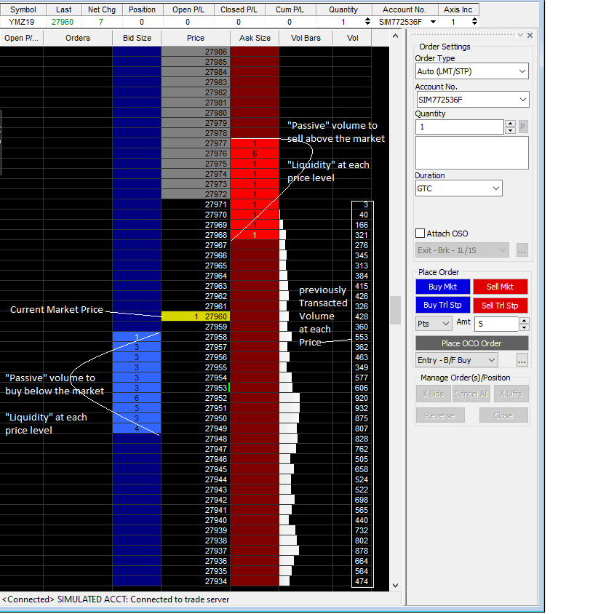

I have marked the pertinent areas on this graphic which is the actual order flow on YM at this moment (prior to the open). You can clearly see that at each price level there is volume listed (in contracts) and also clearly see where the volume was transacted from the previous day (Friday).
At the moment of this screen shot you can clearly see that where price is being quoted (27,960) there is NO liquidity. So if I was to hit the buy market button (blue button on right) at a volume of
1 contract my fill price would immediately jump to 27968. This is the FIRST available liquidity and I would be "slipped" 8 pts and this single transaction would cause the quoted price to rise so my order could be filled.
Likewise, if I was to hit the sell market button (red button on left) my sell price would immediately fall to 27958 were the liquidity of 1 contract would be matched. With me so far?
So lets think about this now...if my volume is greater than 1 contract in either of these situations my fill price would be spread out across the price points where the liquidity was able to fulfill my order. Lets say for sake of argument my order was 3 contracts. On the buy side, I would not finish filling until price point of 27970. And I would "eat" up or absorb the liquidity of price points 27968 - 27970, and the next quoted price to buy would be 27971...because that is the last lowest price where someone is willing to sell or has placed their passive sell order. Understand?
Likewise, if my sell order was 3 contracts, my fill order would absorb and neutralize the buying at 27958 and price would drop again to fill the remaining volume at 27957 leaving still one contract at that price left for any other market sellers. So the end result would be a buying quote (ask) would be 27971, and a selling (bid) quote would be 27957. (a 14 pt spread).
This is why your spread waxes and wanes (gets bigger and smaller). It is NOT the market maker screwing you...it is the lack of liquidity. In these circumstances people withdraw their liquidity orders and a single buy or sell order can create a huge rise or fall in the market because no one is willing to be the counter party (liquidity) to any market orders.

------------------------------------------------------------------------------------------------------------------------------------

Finally we come to the fifth and final point I was trying to make above:
(5) These orders are constantly coming and going into and out of the market and create a "flow" which will vary in its intensity and "net" direction (buy or sell). It is the waxing and waning of this order flow that creates price movement and at times will actually precede it.
Orders both passive and aggressive, whether buying or selling, are constantly flowing into and out of the market depending on how each individual participant deems warranted. Take a moment and think about how many participants big and small are sending and withdrawing orders in any period of time while the market is open. Truly think about this...
Doesn't seem a bit silly to think that some little line you put on your chart will cause price to move in any direction? Isn't arrogant to think that you or some really smart mathematician can "predict" or create a "statistical edge" on the entire market price movement based on some math formula? No matter how sophisticated. It is just nonsense (IMHO).
If you learn to just look at and read the order flow (and how price responds to it) you will have an automatic "edge" because you will be seeing that liquidity is drying up in one direction, or that liquidity is "dense" in a certain area. Or that the active (or enthusiastic) participation is waning and for each of these circumstances you can develop a plan or engage with the market and be accurate in your trading direction and timing without having to place much of your funds at risk. And the reason is this: If you were incorrect, you loss can be kept small because you will be able to "see" the price level that created your trading thesis. And you can either get out quickly or keep a very small stop. If you are right, you will be on the "train" as it crashes through everyone else's lines, triangles, and moving averages and accelerates away because you recognized where the deep pockets in the market where absorbing order flow.
Order flow/volume is the "truth" of how the structure of the market works. It is what creates price movements both large and small. It can, at times, "precede" price movement (if only slightly) giving you that moment to cash in or cash out BEFORE the big wave comes. More importantly price's reaction to order flow can be "predictive" in a way. I will try to explain this next.
------------------------------------------------------------------------------------------------------------------------------------------

Quoting Cools81
{quote} everything you need is in the price action / volume and deltas.

Its one thing to see price and quite another to view it from the order flow/volume point of view...case in point. Let look at this pair of candles:
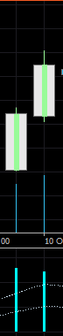
You can see what a price action trader would call "two strongly bullish" candles. The reasoning would go something like this. Both opened at or near their lows, and closed very near the highs, on rising volume with a strong "delta" reading indicating the majority of the price action was buying.
So far so good...however, there is nothing here to indicate what price level that buying occurred...whether it was at the low of the day, middle price or high. But most people would look at this and pile on the buys because it is "strongly bullish"...well let take at a look at the next candle.

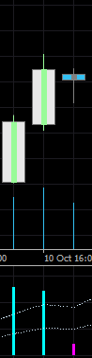
Oops what happened? I thought this was strongly bullish!! But now it looks like price has stalled...what's going on? Will price continue or is this the proverbial "hanging man" supposedly predicting a reversal? Again the "good" technician would start drawing lines for "support/resistance"..."supply/demand"...they would say well volume is dropping and the delta has not only fallen dramatically, it has turned negative.
Now let look again at those first two candles using the order flow:

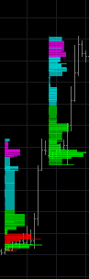
Here you can see those same two candles and SEE where the majority of the buying (in green) occurred...it was at the lows. This and you can also see that while the price action technician was correct the buying continued throughout the day, the buying was much weaker (indicated by the agua) and ended in selling at the tops of each of these days. Of special interest on the second day is the area where the major buying changed characteristics (and color) from major to minor. Also note the top of the day showed more selling still weak(ish) but it was enough to stop price advance and push prices back before the close. Does THIS speak of "strongly bullish"? I would argue not...in fact I would suspect some kind of pull back to retest the area where strongly buying turned weaker...still buying but much less volume.
And Voila!!

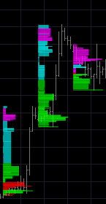
The very next day selling strengthened, and pushed price down but not where the "strong" buying comes back in...at the lows, in fact this buying is what held the lows...and in fact considering the vast difference in strength between the buying seen here and the selling, it is a very logical conclusion to anticipate this aggressive buying will send price higher the very next day...and

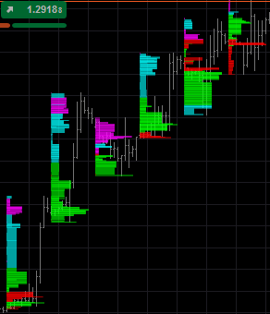
Price does continue rising and with each rise there is a pull back that "tests" the strength of each new (and higher) area of aggressive buying. Finally on the last candle, note how this order flow has "inverted". The buying is now at the top of the day (where before it was at the bottom). And the selling is at the bottom. This usually portends a reversal or at least a major range is about to form.
So you see, while the normal data points of open, high, low, close, and volume that form your "price action" are very useful...order flow allows you to "see" inside each candle and detect "issues" in the order flow LONG before the price action produces your typical pattern...which by that time is too late to really exit or enter consistently or efficiently.
-----------------------------------------------------------------------------------------------------------------------------------------

Quoting failinforex

In retail forex it is manipulation...

It is this (forgive my word here) paranoia that creates failure (IMHO). Again I repeat the market is made up of Trillions (with a "T") dollars. It would require all the money of the top 5-6 richest people in the world to create the kind of manipulation you speak of. And you think they are doing this for your tiny little micro lot or mini lot position...really?? Think logically. I have spent several long and well thought out posts to try and explain this to all of you. It is not necessary you believe me...but the truth is the truth. It doesn't work any other way. The truth doesn't require you to believe in it..it just is.
To use an analogy. You can tell me how many different colors the sky is made of...and even show me pictures of the sky at sunset and at dawn and show me the various and pretty colors...but the truth is the sky is blue and even though I explain to you the "prism effect" of the atmosphere and tell you that while yes in this instance it seems the sky is many colors it is really the effect of the sunlight being split by the atmosphere. But underneath that, the sky is still blue.
It doesn't matter if the you don't believe it...the sky is still blue. It doesn't matter if you don't believe the structure of the market is what causes prices to rise and fall...it still does.
------------------------------------------------------------------------------------------------------------------------------------------

OK...lets review:
- "The Market" is simply a computer that matches orders, buys with sells, aggressive with passive when two parties agree upon a price to transact.
- For everyone that wishes to interact with "the market" you must do so by placing orders via a broker or a bank
  - No order will be accepted until it has BOTH a price and size (volume)
- There are literally thousands of orders coming into the market every second of every minute during the session of any given market
- This "flow" of orders and their respective volumes are matched together and when combined (Market orders with Liquidity) leave some surplus market orders still waiting to be executed because liquidity has been used up.
- This surplus creates price movement, be it ticks, or major moves.
  - Surplus buys waiting to be filled will create up-ticks or rises in price
  - Surplus sells waiting to be filled will create down-ticks or falls in price
That's it!! How simple is that...This is the entire "structure" of the market. While we'd like to make it more complicated, it just isn't.

------------------------------------------------------------------------------------------------------------------------------------------
So now lets talk a bit about "Delta"
Delta - A fancy term meaning "net" volume. I just love how we as humans love to make something out of nothing!! We create complicated sounding terms to somehow impress out peers with our "great knowledge" when this concept couldn't be more simple.
There are many uses for this concept but simply put it is this: In any given candle there are always sellers and buyer who are participating. These participants engage both as active (aggressive) and as passive (liquidity). Imagine the trader who opens his Long with a market buy order but also sets a sell limit order at a specific target. His/her entry is "aggressive" yet his exit is "passive". This trader has contributed to only ONE side of the delta order flow...the entry. Most delta volume (especially in FX) is registered on the aggressive side (or market order side). So let me explain it to you this way.
Our trader above, decided (however he decided) to enter the market "RIGHT NOW". And as a consequence transacted using a market order which was placed in the queue and transacted against available liquidity. A buy "tick" was registered at this transaction. But why a "buy" if there were both seller AND buyer. The buy is registered because it was the active request to transact "right now". Where as the passive participant placed their order long before and had no time constraint on how quickly her/his order was filled. (Remind me to talk in a future post about "time").
So because of the "urgency" or "enthusiasm" or "aggressiveness" of the buyer, the tick was registered as a buy. Now our trader has a long position and is waiting to exit the market at his target. If his target hits...he is out and the "tick" that took him out was ALSO a buy!! WHAT??
Yes!! Remember that his take profit order is a "LIMIT" order. Meaning it is passive and he is willing to wait to sell. He/she has declared this as soon as he posted the order. Therefore the opposing side (counter party) that filled her/his sell order was also a Market buy. So because his/her passive order was filled with an aggressive market order the tick that closed his/her trade. Take a moment and think about this. Active entry, passive exit. This is a very common scenario.
So what does this have to do with DELTA?
What if we could look at a given candle and "see" which side of the order flow was most dominant? Would that effect your decision making? Further, what if you could look "inside" this candle and "see" which price level was the area where buying (or selling) established its dominance? What if you had decided you wanted to enter a buy order (to go long) but were able to see that at that moment in time selling was most dominant? Would that cause you to rethink your decision?
Delta gives us this ability. First of all in this way: The entire candle. This data point is taken when ALL the ticks of the course of an entire candle are added up and then compared. Lets say it this way; buying ticks = 30 and selling ticks = 10; This gives us a NET (or delta) of +20. With me so far. Clearly buyers were more dominant than sellers. And because these are all aggressive transactions or market orders it would seem clear that we should expect prices to have rising during this candle. Thus if prices did indeed rise all is well with the universe. However if prices did NOT rise something is amiss... got it?
Let look at this again:
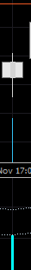

Down at the very bottom is "delta" you see that buying was more dominant than selling AND price rose as a result.

Here is an example of a selling dominant candle:

so on the surface all seems well. Selling dominance...prices fall. The market is doing its job

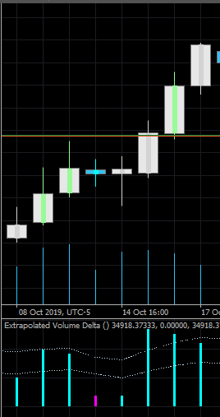

In addition to the above, Delta volume can also be calculated at each and every price level. Again to review, we are looking at the "aggressive" side of the market so when we see aggressive buying we expect it to cause prices to rise. Likewise when we see aggressive selling we expect to see prices falling. ANYTHING else is anomalous and aberrant. You will soon see that these aberrancies are big clues to price inflection points. But I digress
So what if we can "see" the order flow dominance at each and every price point within a given candle? Would that be valuable information? Lets look again at a series of three candles:

Again we see buying dominance especially on the leading edge. You can see that right in the middle, price stalled for two bars, then continued. Also of note is that the buying delta at the end was markedly higher than the buying delta that preceded the stall. All looking good and "bullish". But what if I told you that there was some trouble brewing in those last two candles? Would you call me crazy? Lets look INSIDE those candles:

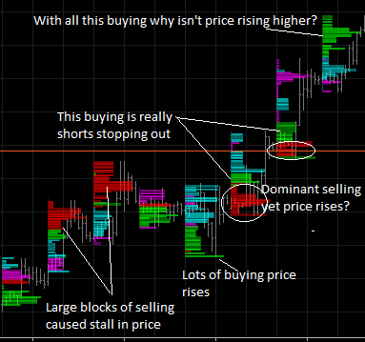

Same candles (each histogram is one candle) But now INSIDE we can "see" what is really going on. We can see that it was large blocks of selling that created the stall in price...yet those candles on the price chart show BUYing delta. While buying was clearly the more dominant order flow...there was sufficiently strong aggressive selling to stop price advance and stall it for two days. As price fell buying came back in aggressively and price not only rise but then started stopping out the short positions (causing another wave if market buying to hit the market). And while price did advance it was not "new" longs that were advancing the market it was really shorts stopping out...lots of them. So many in fact that the delta on each price bar was significantly greater than before the stall.
The final straw is the last candle. The aggressive sellers have given up. They may have even Stopped and Reversed. All the aggressive buying is at or near the highs of the candle. No selling (or very little) seen at all...so here is the question: With all this aggressive buying, why isn't price skyrocketing higher?
The answer will be in the next post...mid-morning for me...daily trade is done...time for more coffee!!
Let me leave you with this question. Can you see the value of reading and seeing the order flow inside each and every candle? If you were long on this scenario...and you knew there might be trouble ahead with price continuing to advance...wouldn't you just exit and keep your profits?

Quoting Han2019
.... I just want to delve deeper and perhaps explore a bit regarding market manipulation since this is quite a controversial topic, a bit difficult to wrap my head around and I am 50/50 on this...

I find it extremely difficult to understand WHY people are so obsessed with this topic. But to indulge this for just a moment let us look at it this way. Let just say this DOES happen, regularly. How are these larger institutions going to create these "manipulative" movements? Take your time and think about this....
ALL participants...ALL of them. Yes even the market manipulators MUST do so by using and entering ORDERS into the system. They cannot call XYZ exchange and say start quoting prices at 1.xxx. They have to participate using legitimate orders with the liquidity to back it up. Those large orders by definition will come across the order flow and you will SEE it.
So to return to this question of market manipulation...does it or doesn't it exist? WHO CARES!! If you can use see those orders come across the order flow and watch price respond to it YOU have the advantage and you didn't have to use millions (or billions or Trillions) to accomplish it.
------------------------------------------------------------------------------------------------------------------------------------------

Quoting Han2019
.... It is hard to believe that professionals places their orders in completely arbitrary levels, so I believe that they most likely also look at major support and resistance levels to place their orders. ...
These "professionals" have the same access to the same order flow as we do. They simply have more sophisticated data feeds, and at times a direct data feed coming direction off the exchange. You and I have access via a broker. This does constitute an advantage of sorts - milliseconds at best. But "major support/resistance levels"...it is their order flow that creates these levels in the first place. It is their absorption of selling (via passive liquidity) that creates "support"...and likewise for resistance. These Professionals don't look at support they create it. The concept of "deep" or "dark" liquidity pools comes to mind here. These are levels where large concerns have "hidden" orders of deep liquidity that are activated via OSO orders. To briefly explain. An OSO order is an "Order Sends Order" You can set up an order to trigger at a certain price (much like a stop order). But instead of activating a market order it activates more limit orders at prices just above or below the market (which ever way price is going). These "pools" have large sizes..."deep liquidity" which require many many many market orders to use up...in fact most time they are NOT used up and once the aggressive market orders peter out...price moves away from these areas.
The professional manipulators don't look at these levels...they actually create them.

Quoting failinforex
{quote} Let said Feb and the billionaire club is one single entity (syndicate), they are happily making money - HENCE manipulation does occur...and who is the biggest offender the will never be punished Let said 2 smart alec found a way to beat them - THEN It was (and is) illegal and these people when caught were arrested and punished.

OK...OK...OK...lets not get sidetracked here.
If you want to believe that there is some malevolent entity out there stalking your mini lot trade then WHY trade? Why not take your money and invest it in something else? If this is your theory then it makes zero sense to pursue this business at all.
The point of this thread was for me to impart some common sense and truth to all of you about what trading is and ISN'T. I'd really like to be done with this subject. It does not affect my trading day by day and I'm reasonably sure it won't affect yours as well. But if you want to continue down this path, I'm afraid this is not the thread for you...I think there are others out there along side the Elvis is still alive on Jupiter conspiracy threads.
Lets please be done with the subject of manipulation...stop hunting...and any other paranoid conspiracy theories. Lets concentrate on markets and how they work and adjust our behavior to use that information to our advantage. HMMM?
------------------------------------------------------------------------------------------------------------------------------------------

Yesterday, I wanted to mention the subject of TIME but felt it might derail the discussion about Delta...so I have left it for today. As I'm sure you are all aware, TIME is probably the most essential structural component of the market function. When I list these components I always list TIME first. To review the structural components of the market are (1) TIME, (2) Order flow, (3) Volume, (4) Price. Because the middle two are so inextricably linked together I always list them as such...(Order flow/volume). The reason for this is simple. You cannot have one without the other. Once cannot place an order without also listing its size (lots, contracts, shares...etc.) But lets begin a discussion about time.
Oddly enough we hardly even think about this as a component in the market yet every time you look at a chart there it is...TIME running along the bottom on the x axis of your chart. In forex and stocks, TIME doesn't seem to be as much an influencing factor but in futures, options, and commodities, TIME is a huge factor. Lets look at the idea of contracts. In futures very three months, there is a major roll over of contracts. This is because futures deals mostly with "deliverable" items. This means that if you hold a contract for 100 bushels of soy beans at the end of the contract you must either take delivery of those bushels or "roll over" the contract into the next period. The same is said for options. Each options contract has a "time decay" associated with it meaning the contract becomes less and less valuable with time (assuming it is still "out of the money"). Finally with commodities, TIME as in time of year, is extremely important when determining the value of your commodity...as an example: I was recently trading Natural Gas (CFD's) and this is a commodity whose price will fluctuate with weather reports. Obviously the time of year has a great deal to do with that.
In addition. TIME is a personal issue. Many enter trades expecting the price to move in their direction "right now" and if it doesn't do that within their personal confines of "right now" the trader becomes anxious and this anxiety may cause him/her to take action that was not previously anticipated. As well each and every participant has a "Time horizon" in the back of their minds, as to how long they anticipate holding a trade or position to expect or maximize profit potential.
Finally, for those who trade with leverage (which I think is most of us), each leveraged position generates a cost associated with time in the position as part of the cost for "borrowing" your leverage. Not to mention a swap rate (for us FX traders) that generates at the end of each 24 cycle. Sometimes this rate is actually a positive number (generating interest) but mostly it is a daily charge against your position, that slowly eats away your profit if you hold for long periods of time.
TIME is also a monthly cycle event for those of us who favor fundamental and economical news announcements. All of these issues with time effect the order flow/volume which intern effects price.
I would like to be able to say something wise and sophomoric at this point but I'm afraid it is just this: Time can be your best friend or your worst enemy. As you are looking for opportunities in the markets TIME must be one of your chief concerns. I can't tell you how many times I have looked at the e-mini futures market and seen just sluggish and apathetic price movements and unusually LOW volume until I suddenly wake up and realize that the new contract has rolled over...and I am trading the Old contract...Then getting out of that trade is quite nerve racking as well, because you are waiting for someone more stupid than you to take the other side of your exit.
In addition if you are unaware of the timing of news and economic announcements you may be going happily along on your trade until BAM!! That news hits and the volatility took your STOP, not your TP. (isn't that always how it works?)
But these are things that can be readily adjusted by simply double checking your calendar and news feeds BEFORE you start looking at things. I am more inclined to speak with you about TIME as it relates to your personal interpretation of "right now" and how that is effected by TIME CHARTS. Whether we are conscious of it or not, every candle that ticks across your chart represents time. Indeed for most trader (myself included) time is the x-axis of our charts. So when we see things (again consciously or not) we see a "rhythm" that effects us. I wish to make you aware of this because the market is completely UNAWARE of time. WE divide prices into times...not the market. The order flow is irrespective of this but is ultimately effected by it because it is HUMANS that enter orders. And each of us has something that creates an "urge" to engage, and this something is largely effected by time.
Sometimes we see price moving rapidly and try to "catch" it. Or sometimes price is simply ranging and not advancing as fast we we'd like and we get impatient, and start "adjusting" our orders.
So how can we use TIME to our advantage? Here are some suggestions and things to look for. Sometimes prices will move to a point and then just sit there...and you will see this, especially if you trade small time frames. Price will not move higher or lower and it seems it is suspended in time...THIS is a major clue of absorption. I will explain this concept in more detail a little later, but if you see this understand that the order flow is going gang busters underneath this stalled price movement and expect something significant to happen.
Another thing one can do is to move away from time based charts. While I do NOT do this on larger (daily/weekly) charts, I do this very thing on my futures day trading charts. I use constant tick and constant volume charts. This takes the element of time completely out of the candles and they only advance when a set number of ticks or contracts have been transacted. That way during a slow market, you will not see candles upon candles going by doing nothing and leading you to thing a "range" has formed..when really its just a low volume environment that will move again when more volume comes in. Like during gap times.
Some use renko or range bars. Which only advance when a certain price range has been completed. Again the advantage here is to keep time in its place, which also helps you psychologically and keeps your mental edge sharp.
I hope these ideas about time will help you and want you to completely understand this connection: Time effects people --> people effect order flow/volume --> order flow/volume effects price.
------------------------------------------------------------------------------------------------------------------------------------------

Quoting MichaelMM

What program do you use to see this delta charts?
In longer term trading which is mostly seen here I use cTrader. This includes FX, spot gold, and CFD's. On the futures side I use TradeStation.
On my cTrader the vertical delta is a program that I had coded for myself using my data and formula. The histogram delta volume is publicly available for cTrader.
------------------------------------------------------------------------------------------------------------------------------------------

Quoting jusiur
Don Pato, now that concepts are being clarified, I want to ask you something please. Is it a myth or reality that the volume in forex does not exist, specifically in MT4?
Contrary to popular belief, volume does indeed exist in the FX market. Again I repeat...one cannot place an order without also declaring a volume. What is lacking in the FX market is a central exchange.
There is no central clearing house for transactions in the FX market because it is inter-bank. The transactions are between major banks and only the minimum is reported to government agencies. Thus the volume data we have access to are transaction counts (ticks) and not the size of the transaction like you would for the futures or stock markets.
I have addressed this in detail and ad nauseum in my thread:. Hey...what about volume. Tick volume can be used to your advantage we just need to understand what it is and adjust our thinking when trading this market. I use it in almost identical ways and have done just fine.
------------------------------------------------------------------------------------------------------------------------------------------

Hello again friends...
Well...That didn't take much time at all. You see? Understanding market structure is no great "mystery" nor is it some dark secret that only the initiated know. It is simple logic, and much better, there is a calmness about it that will finally fill your worried mind when you start to watch price movement with this reality in your consciousness. You will now understand (no matter what time frame you watch) that each and every little tick of price up and down has a reason and you understand that reason is simply order flow matching with liquidity. And this order flow is constant, unyielding, and ALWAYS doing the most efficient thing. Up for aggressive buying - using up passive selling, and Down for aggressive selling - using up passive buying. THAT's IT!!
So here is a practicality of this structure and I will try to illustrate it with a personal story from my previous life as a police officer.
As a new "rookie" officer, I was required to spend about 6 months with various different more experienced officers after I had graduated the police academy. This is called "Field Training". You are riding with a more experienced officer to show you HOW to do the most basic patrol functions...especially in the middle of the night when most new officers are assigned.
One of these "FTO's" (Field Training Officer) who also became a trusted friend gave me some advise for patrol that has followed me in just about every walk my life has taken me. It happened when it was about 3:00 am and I was sleep deprived and bored to tears driving around our patrol area street by street. I was enthusiastic and wanted "action" and the thought of just driving around all night every night was disappointing (to say the least). My FTO told me to look at every house in its "natural" state...over and over every night. Observe the conditions in the neighborhood. Take note of who comes home late, who goes out late, who turns the lights off early, and who leaves them all all night. In short - learn what "normal" looks like.
And the only way to learn what that looks like is to drive around and look at it over and over. He actually knew the area so well that once while I was driving around he was in the front seat with his eyes closed...I thought he was snoozing. We hadn't spoken for at least an hour. At one place I rolled through a stop sign as it was late and there was no traffic. Out of the darkness my FTO spoke without even opening his eyes. "You missed that stop sign at cedar and 5th", he said. I apologized and then we spoke a bit. But here is the point of this story.
The more you see something in its "normal" state the more accustomed you will be to it and it will "feel" right. The more familiar you are with something the more you KNOW when something is NOT right. My FTO knew exactly what street he was on...and were the traffic control was...and how I was driving all while he was half asleep with his eyes closed. He knew that neighborhood so well, that if the lights were off on a particular house he knew the occupant was "away on vacation". Or if a garage door was left open that something was amiss. And he kept his "beat" clean and knew everyone...EVERYONE who was walking around at night and what they were doing. Boring?? He was a patrol genius!!
So it is with US in our trading endeavors. We must be so familiar with what the market "normally" looks like and operates that when something is not quite right we can literally "feel" it. We will be able to "see" when there is something amiss with the order flow and then realize that when these subtle little changes occur the price is going to be affected as well. And THAT is when we enter or exit or do what ever we are planing on doing. It comes from many hours (and yes, years) of just watching the order flow and how price reacts to it. Once we have a good grasp of "normal" and the more we see what that is...the more we will just "KNOW" when something is NOT normal and our accuracy will skyrocket.
Now is every rookie officer required to have that same level of familiarity with patrol work to be cleared to work on his own? Of course not. And neither are you required to absolutely be intimate with the order flow to understand it and take appropriate action. But I think it is something to strive for AND can only result in a "clean" work product. Pulling money out of the market seemingly at will. You don't get there by studying lines and math, and fundamental economics. Or by drawing pretty pictures on your chart, and declaring to the world that "probable statistics" will eventually recover all your losses. You just sit...calmly, and observe the market, in real time. Be as observant as possible. Watch what happens when price approaches your areas of interest. Take note of 'normal' price advance and watch it stall. Don't enter, exit or take any action...just watch!!
Can you do that?
------------------------------------------------------------------------------------------------------------------------------------------

Quoting hefei
{quote} Thank you DonPato , to give such great explanations on this topic. for attached software screenshots here, i have questions: 1> if my platform cannot provide order flow infomation like this, could i make a order-flow based analysis and how? 2>as i do not use the software before, i wonder that the order flow graph of each bar appears in Real-time or End-of-day mode?
There usually a software add-on for most platforms to get this information. The only one I am not aware of is MT4 and frankly (this is only my opinion) one should stay as far away from this software as possible.
In so far as your platform providing this information...this comes from your data feed which you can find various different feeds to get this information. However, just to be clear. The FX market volume data is tick data but can be used in a very similar manner. But the volume information on just about every other market has @bid and @ask data points, that can then be used by your add-on software provider to calculate order flow and delta charts.
------------------------------------------------------------------------------------------------------------------------------------------

Quoting deanoracer
... I can Elliott Wave my ass off and have blow a lot of minds with my Fibonacci know-how (my Fibonacci mentor included!). I have even taught technical analysis at times. Up till now, my results in live trading still accurately show something continued to be missing! This amazing thread - and DonPato's uncanny ability to articulate order flow - have the lightbulb in this trader's mind shining brighter...

This is very similar to my story as well. I started out with technical analysis and ignored all the people who told me I was literally trying to be "clairvoyant". I said to myself, if I can just get the probabilities on my side...I can make this work. I, like you I imagine, tried every single combination of math, indicators, lines, etc...and there was always this piece missing that, like the "missing link" in evolution. would bring everything into focus. Now that I can clearly see and understand order flow all of the rest just seems foolish in my view. While I am certainly NOT an expert, I can now "see" (when my head is screwed on right) and am no longer groping in the dark.

------------------------------------------------------------------------------------------------------------------------------------------

Quoting deanoracer
...My question takes us back to January 15, 2015. ... I was never able to explain 'technically' why the huge drop in just an hour or two. No technical analysis could comfort me (or thousands of others I assume)...
I remember this day with distinct clarity. It was only by chance that I too was not involved in this trade. To further add what was going on. The SNB decided (I can't exactly remember why) to actively defend the 1.2 EUR/CHF level and every time price dipped into this area, the central bank actively bought the EUR artificially keep the CHF from gaining value. They did this across the CHF board, and this effected every cross. The end result is that no one placed liquidity orders below that point. There was no reason to. Since the central bank of a "safe haven" country was going to keep a currency pegged capitalists looking for better returns went elsewhere. And liquidity dried up to almost nothing and price went sideways for (I think) two years. I guess this is the effect they wanted.
But what happened with they lifted the peg with ZERO warning...all those people who had buys on, fully expecting the SNB to step in an lift their offers, were stunningly disappointed. With now buying liquidity below the 1.2 level, the very next sell order had to drop...WAY down to be filled. Of course as you have mentioned you also wanted out...meaning you also placed aggressive sell orders into the market which, with no liquidity to fill them, languished in trading hell until the buying liquidity came back into level things out.
The reason why this crash occurred was simply this: No liquidity! None!! Once the SNB stopped supporting that level it took awhile for the other participants (big and small) to come in with liquidity to put the market back up on its feet again. This is what happens...with little or no liquidity, (in this case on the buy side), prices started to drop looking for a level where there were buyers. Of course those who where already holding longs are seeing their positions tank and not even their stops are getting them out...all these stops are more market sell orders flooding the system. In addition I imagine there are many panicked people hitting the sell market button trying anything to get out. No liquidity...no one to take the buy side of your sell order...and more panicked sell orders flooding the market.
Oddly enough a mini version of this happens almost every day in some market somewhere. Certainly NOT to this extent, but consider this scenario: You are waiting for an NFP announcement and the market is moving in a tight range, awaiting the announcement. Just prior to this happening the price starts to get volatile, taking out the stops on both sides of this range. This action is usually the result of people exiting their positions just before the announcement. Then...the news comes out and is completely the opposite that was anticipated. Instead of being a good or moderately good announcement it is BAD...REALLY BAD! And instantly prices gap down 150 pips. Price oscillates there, then BAM, back up 200 pips, price oscillates at this higher price then starts is slow and steady grind back down...and down...and down.
These gaps happens when the big liquidity providers (usually running some kind of algorithm) pull their liquidity out of the market suddenly when the news doesn't fit their expectation. Then some other liquidity provider comes back in to fill that gap...and prices gap again this time the other way, until the liquidity provider finally return to their "normal" operation after the initial shock is over.
Think about a simple break out of a range. All of the sudden price skyrockets higher...only to return to where it started again, and then may (or may not) grind higher. This is all the same phenomenon of a large "rush" of market orders combined with a diminishing liquidity commitment and price goes bonkers.
Fortunately some of these things (like the range break) can be anticipated and even used to your advantage. Others are completely unforeseen and are therefore termed, "Black Swan" events.

------------------------------------------------------------------------------------------------------------------------------------------

Quoting deanoracer
... Finally, I remain thankful to this day that I didn't bet the farm on that trade and made it out alive and 'schooled' on what can happen in this market and am so thankful for DonPato and this thread!! Sincerely...
I too am very thankful you survived this event as many large institutions went belly up on this. Contemplating this kind of scenario makes me think back on a lesson plan that I teach all my students. Disaster Recovery. One should always have a plan for this kind of worse case scenario. This is in keeping with the disaster plans I was used to making and enacting when I was in public service. Write one...and practice it...OFTEN...so it can be done without thinking when it needs to be employed.

Hello hefei...you ask some excellent questions and I hope I can answer them to your satisfaction.

Quoting hefei
... First issue. I would like to talk about what I think is the limitation of using order flow in this course.... Because the order flow is created by people, and why do people place orders in some way is because they judge the direction of the market will go up or down according to some theories such as fundamentals, technical analysis, or other things/theories etc..

Ah yes...the "chicken and the egg", which came first? It goes like this. Order flow is generated by people --> order flow creates price movement --> price movement attracts the attention of other people who in turn place more orders.
The basic question is why do people place orders how they do? I have highlighted it in your question above. The question seems logical because if we can know the "WHY" of their actions perhaps we can then preempt them and get in early and make even more profit. The problem is this: Out of the literally hundreds of thousands of participants that are actively placing orders every day, how is it possible to know the motive of each person? More to the point, IS it possible at all? I would say, "NO."
But let’s look just a bit deeper. What is it you really want to understand by finding the "why"? Is it perhaps to position your trade at the most advantageous place BEFORE the big move begins? In other words, at or near the swing low...to take profit at or near the swing high? Or is it to accurately judge which direction the price will move in the near to distant future? In other words, "I'm tired of entering long only to have price turn and move against me..." Is this not the idea of "trends" and fundamentals, or the concept behind the saying, "buy low and sell high"?
Many of these things (technical analysis and fundamental analysis) try to answer this very question but often forget the idea that the market, and more specifically the order flow, just doesn't care. We may never know the "why" of each and every participant and even if we did, how would that help? If each and every person has a slightly different reason for entering the way they did...you will quickly become lost and confused. Instead let their collective actions speak for themselves.
Yes it IS possible to find and enter very close to swing points. Yes it IS possible to find entry and exit points that go in your favor quickly. But you will NEVER find this with these techniques... The best way I've found to do this is to watch for and detect EXHAUSTION in one direction...I have discussed various ways of finding this at the practical level in my thread, Hey...what about volume

------------------------------------------------------------------------------------------------------------------------------------------

Quoting hefei
... In addition, ... the market may give you some "hidden signals", which are completely different from the traditional price-based signals. The existence of such hidden signals was introduced by a pro in my domestic forum. So now in my own trading system, I don't consider any price-based signals at all, but I want to find 'something' that can "reveal" the potential market direction before the price changes...
This is the very point of using and trading order flow. However these signals are not "hidden". They are in plain sight of everyone out there. The only difference is they are either misinterpreted, or overlooked as "noise". Often times people will discount the very "signal" you refer to. They say it is just noise and then wait for something called "confirmation", meaning they want to see price react FIRST before they place an order. Of course by the time that "confirmation" actually comes, its way too late to get in at a good level. So then they are left with placing a HUGE stop, and of course being good technicians...try to set a limit that is 2x or 3x their risk...and guess what? Price never gets to their limit. So when they look back they now (in retrospect) see what that signal was...and call it "hidden".
I will be the first to admit that order flow signaling is subtle and many will miss the signals. Still others simply look at some indicator like a Delta indicator and then substitute this for something else like RSI...its just not the same. One cannot take the same approach to trading and interpreting order flow...it is NOT some more advanced form of technical analysis. In order for this to work you must literally change the way you think about price movements and market structure.

------------------------------------------------------------------------------------------------------------------------------------------

Quoting hefei
... I want to find these hidden signals by mastering VSA and orderflow trading...
I'm sorry to say if you take this approach you will likely never reach your goal. VSA is just another substitute form of technical analysis. Order flow trading (on very small time frames) accomplishes the same thing only using a mind numbing array of numbers and colors all being launched in your direction at lightning fast speeds, absolutely overwhelming your visual cortex until you are a babbling blob of putty in your office chair....There is an easier way. But first you must know what a "normal" order flow looks like, acts like, and "feels" like. Yes it is unique to every market, and yes it takes time...but I repeat. The more you know what "normal" is, the more you will know when it is NOT normal. There will be very little if any "signaling" it will just be a "change" in the order flow.
I apologize. I do NOT mean to turn this into some weird mysticism sounding, Ghuru promoting religion. That is not the case at all. However it has been my personal experience, and those of many of my students, that when first introduced to these ideas, they simply "change gears". They adopt this "order flow idea" as some new and superior form of technical analysis technique. And ultimately end up very frustrated. Since order flow/volume are the structure (the very basis) for price movement, one must find a way to clearly understand what is happening behind each and every price tick. And yes there are tools to do this with, but it can also be done using only price charts...but it is a bit more inaccurate. I look forward to speaking more about this...but I think I should take the week-end and think it over well, so as to state it succinctly yet accurately.

Quoting hefei
...traders always read various kinds of trading books and use the above techniques to trade. We know what technology they are using (such as some classic technical analysis), so we can know how they will react to the market...
This is precisely true and reminds me of what my friend and mentor (Jason Alan Jankowsky) often said. "Losers watch the market, and winners watch the losers..." What he meant by that is that the market watchers, whom you have described very well above, are using some kind of technical analysis technique that, according to their technique or methodology, will place orders inline with these methods and therefore we "know" how they should react under xyz condition. In other words what we have is a "self fulfilling" prophecy. Fibonacci works because everyone piles on the orders at the 61.8 level retracement...or the 38.2 level...or...whoops I guess not ALL traders read the same book.
I see nothing wrong with learning about and studying these methodologies, but I dare say if you depend on them to make your trading decisions, then you will be giving your money to the rest of us who are watching you...via the order flow.
------------------------------------------------------------------------------------------------------------------------------------------

Quoting hefei
...Once we know that lots of people will do something together (not very accurate) at the roughly the same time, this group of people's behavior has meaning, and they can be analyzed as a group...
This statement is accurate but not in the way you mean it. If you speculate that due to some "golden cross" of average prices (which ALWAYS lag behind the market) that the participants in mass will do something...think again. Take a look at any chart with this set up. Let look at this chart with the typical "Golden Cross":

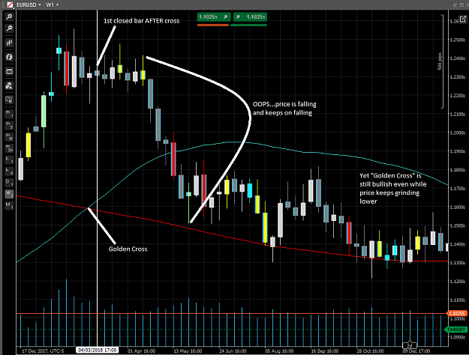
You can clearly see this cross was the result of a large move higher in prices...and because the averages lag behind even price (no to mention the order flow) the group you mention as using technical analysis methods are taught that they should be entering longs (if they haven't already). The first closed candle that shows this cross is indicated by a white vertical line. You can see that at that point price was clearly going sideways, and continued sideways long after that...until prices FELL...they didn't rise...even as prices fell, this cross shows a "bullish" indicator...Anyone and everyone who is holding long is either stopped out, or is having a very difficult time with this long position.
Now lets look at that same chart, but this time with the order flow:

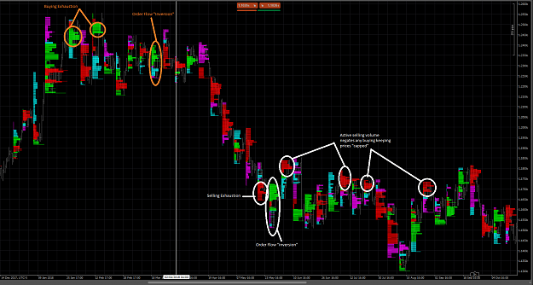

I have drawn a line at the same place that the previous chart showed the golden cross. But you can see clearly that BEFORE the cross the order flow was showing signs of exhaustion even while the technical indicators were telling you to buy...LONG before the smart money was selling their longs to the technical analysts and even though they were en mass, the volume of those buys was absorbed by the smart money now entering short (indicated by the order flow inversion). But their entries were limit orders that the technical analysts were executing against with their "aggressive" market orders. ALL of this occurring BEFORE the cross...
Of course you can also see the same thing repeat itself again at the bottom of this movement, while the people following the cross were still trying to enter buys...the sellers keep coming in and negating their volume...all the while the "golden cross" is showing bullish bias. Is this really how we want to trade?

Quoting hefei
...Then we probably (not exactly ) know which groups may take action and what kind of action they will take (enter long or short?) , and we can judge which side has a better chance of winning by comprehensively comparing each of their entry reasons. This is what I want to express and i think the way of thinking like this is very meaningful... it's 2 o'clock this morning ,have to sleep now,,the rest will be sent tomorrow if any. Thanks.
We don't need to do any of this...all we have to do is read what orders are actually coming into the market and watch how price is reacting to those orders. I makes no difference who is acting on what technique, or why. All that matters is that they must enter orders and when that happens we can then see how price responds to their order flow.
Again I repeat, this is NOT another form (or some superior form) of technical analysis...it is simply the truth as I stated in the beginning of this thread. (1) Anyone who wants to participate MUST do so by placing orders. (2) These orders are processing in a grand machine called "the market". (3) The result of surplus unprocessed orders and their corresponding volume are what create price movements, and, (4) At times even the price movement itself lags behind the order flow that created it.

------------------------------------------------------------------------------------------------------------------------------------------

Some Important books by Jason Alan Jankowsky
- Time Compression_.pdf
- Trading Rules that Work_The 28 Essential Lessons Every Trader Must Master.pdf
- The Top Ten Mistakes Forex Traders Make.pdf
------------------------------------------------------------------------------------------------------------------------------------------

Hello again Friends...There has been a small lapse in my posts simply because (as I stated before) I wanted to let the information presented here to "sink in". I hope that you can now clearly see HOW the market works and just as with each small tick in price (up or down) also larger movements work in exactly the same manner. It is ALWAYS order flow/volume-within the context of time-that produces price. While many people see price as its own entity, it is not. Price is a RESULT of the market structure in operation.
Now I know that this concept (yes, ever here in this thread) will meet with some resistance. This is mostly because we as "uneducated" traders have been taught that "price is king". That there is nothing closer to the market than price and price action. I hope that by now, on page 5 of this thread, that you can see perhaps this may not necessarily be so. But for a moment let us look at this thinking because it will help us understand a very important concept in the order flow that seems to grab much attention. Again, I will illustrate with a story from a very common experience.
Lets assume for a moment that you have decided that you are going to enter a long position with a buy order. (However you came to that decision is not important right now). But at the moment price is ranging. If you are a "good student" you understand that your decision to buy must first be "confirmed" by the market. So you wait - patiently. You are seeing price rise, (which drives an even greater urge to buy NOW), but price has not surpassed the line you drew on your chart which means "confirmation", but you are very close... You have drawn this line because you feel if price rises above this line, then it "should" keep going and you will have the start of a new bullish trend. And if price does NOT rise above this line then you have dodged the bullet on a losing trade.
Price comes up to your line...pulls back...advances...pulls back...then BAM! Rockets higher. So now you are well beyond the line and you feel confident that NOW you can trade and your trade should succeed. You enter you buy order and immediately price falls...and falls...and moves right to the point where you placed your stop, (which was just on the other side of that line). You are stopped out, and as soon as that happens, price once again moved in the direction you entered...and does just as you anticipated it would...except you are left with a loss and a gaping hole in your account. WHAT HAPPENED??!! I know this is a common story...and I know that you have tried it over and over again with every variation of this condition and yet no matter WHERE you place your stop...the market finds it...then moves in the direction you originally thought. This has happened to me so many times I have a name for it...I call it the "crazy Ivan" or the "FU stop". Its as if the market has turned into some version of Seinfeld's "Soup Nazi"..."No money for you!!"
So now lets look at this from the perspective of Order flow/Volume. This demonstrates a concept that I want to drive home emphatically and hope you will never forget this: There are only two states present in the order flow. (1) Balance; and (2) Dominance. That's it...two. And what's more, one always ends in the other. Balance will always end with dominance and dominance will always end in balance. This is perhaps the easiest way to visualize the order flow from the perspective of "price action" only. Our above scenario represents a very typical transition from one to the other. Lets start with a "balanced state":
The order flow/volume is typically "balanced" when there roughly an equal volume of market buyers and market sellers. And thus neither one can really cause price to move very far. Typically this is a low volume environment so the group of buyers can only push price up so far, and then a group of sellers will come in, balance their volume, and send price lower, but they too are limited. So price moves up...down...up...down...and forms a price range. Buyers at the bottom (typically) and sellers at the top (typically). This range may extend the edges a bit (read "head fake") but then the move poops out and price returns to this back and forth. The order flow is (for lack of better term) "Balanced". I KNOW you have seen this many times. Now let me ask you this question: "If there are participants holding positions (long or short), where do you think their stops are going to be?"
So now lets talk about how a "balanced state" ends. Something happens...a news announcement, session open, or just someone with volume who has decided to enter. (We will speak about the long side since that is what I presented earlier, but this can happen on either side). Somewhere there is enough buying volume to send price higher, and drive it into the stops for the shorts. Remember that stops for the shorts are really executed as "market buy" orders. So the participants that drove the price into the stops now see a flood of market orders pushing price even higher. This onslaught of orders eats up all the liquidity that was present during the low volume period and price goes skyrocketing higher. I affectionately call this the "whoosh". This is what technicians call "the break out". This rapid price movement is what drew your attention and "confirmed" your idea to go long. But what happened? Price didn't continue...
So lets break this down: (1) most ranges are "balanced" because the environment is LOW VOLUME. Like all things in the market this isn't ALWAYS the case but it explains the majority of them. Look at when ranges form. In "gap time", between or just ahead major market sessions, just prior to major news announcements (think NFP). (2) Low volume environments lead to low liquidity. Not only are the participants "weak" because they are small time with now volume, but also the liquidity is absent simply because the provider doesn't want to get "caught" on the wrong side.
So it doesn't take a great deal of volume (comparatively speaking) to send price in one direction or the other. And as soon as price digs into those stops, its all over. "WHOOSH!!".
So now, lets look at the next step. Once the "whoosh" happens, then what? Ok price moved higher but then...nothing!! Think about this from the order flow/volume stand point. Everyone that is going to participate long is already in. And all the opposing order flow was just stopped out. Not to mention that all the passive order flow (liquidity) was used up (that's why price advanced so quickly). So who's left to continue buying? Remember for price to continue to rise you need a fresh round of market buyers to jump in and use up even more liquidity...but that's not happening. So price starts ticking down...to attract more buying. All of the sudden price is MOVING down, most likely because those sellers that stopped out are now actively selling again. (But remember they didn't have very much volume). All of this up and back has now attracted the attention of the liquidity providers and they are now putting in liquidity. So here is the question...WHERE (what price) do you think the densest liquidity will be offered?
If you think it will occur somewhere near where the stops were triggered...you would be right!! Price returns to the area where the buyers "broke out" and new buyers start to pile on. Now...there is liquidity and price starts to "grind higher"...as it takes more volume now to use up the denser liquidity. And guess what? Some of that volume was the stop you placed on your long because you placed it "just below" your "line of confirmation". However now that all of this has occurred the order flow has now changed...it is now a buying dominant order flow. The balanced state is over and most of the market orders coming in are buys...except the market is moving without your position. Further it is a "grinding" relentless advance. It is not a "whoosh" but a slow steady grind that eats up sell stop after sell stop. And because of this "price action" you never see a "signal" or get a definitive "cross" on your oscillator. In fact it is most likely pegged near the top showing divergence signal after divergence signal...all "false" and losers.
However now you can see that this is really order flow dominance that will continue until at some point...EVERYONE who wants to be long has bought, and they're in. So what do you think will happen now?
Volume to buy gets weaker and weaker, because all the longs have already established their positions. Volume to sell is now "shy" because they've already been burned and any shorts will be (again) low volume. Perhaps now we are also coming to the end of the session (or day). No one is willing to commit anymore. Any selling at this point will only be profit taking on earlier longs...not establishing short positions. So, we return to a low volume environment, longs holding, shorts shy, and VIOLA!! another range forms and the order flow balances again.
I have just taken you through the course of a typical day, that many might describe as a "bullish trend". But this can happen on any time frame, and go longer than anyone thinks. But I hope you will see what causes these two states and that now you might be better able to recognize these states based simply on the price pattern you see on your chart. NOT a "price action" pattern but simply the state of price.
Remember, (1) People must interact with the market through order placement, (2) This resulting order flow causes prices to move in a certain way, and (3) These price movements produce recognizable patterns are are easy and simple to see in real time.
For more on how to use this in a very practical way please see my earlier thread: Price-Structure-Order Flow
Enjoy the rest of your week end.

Here are some screen shots to illustrate what I spoke of in my previous post.

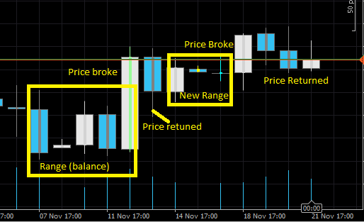

Note here how price balances, breaks, balances again, and breaks again, and has at the end balanced once again.

Now take a look at this same area but this time using the order flow charts:

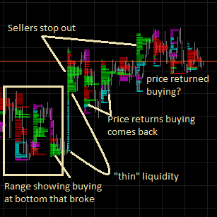

Quoting bjpumping
.... Can i ask what broker you use for your order flow feeds? Bjpumping

I use cTrader for the data feed for most of the charts I am showing here. You can get it for free with just a public beta or find a cTrader Broker. There are several to chose from. In addition for the futures, TradeStation provides both my brokerage and data feed.
In my daily market activities I use the futures market, and TradeStation is both my broker and my data provider. I went to futures because of the regulated transparency of that market and the majority of my interaction with the market is through them.
In my other market activities I have an account to trade with but that is NOT my data provider. While I see nothing wrong with having your data provider and your broker as one agency, the broker I use does not provide the tools I want to help me trade better. So I use cTrader's data feed and charting. I then place the trades with my broker. Its a bit more confusing at first but works out OK. Since cTrader just doesn't care what I do with my data, I feel the data provided is a little bit more "honest" from the standpoint of the order flow that I see through them. They are not quoting me any prices and their spread make no difference whatsoever. My broker, only sees my orders and nothing else. The data feed from them does not compromise my view of the market because my view doesn't come from them. This is how I've chosen to resolve the perceived issue of "conflict of interest" with my broker. As I am a small time trader, my positions are carried by the broker who is my counter party and because they are so small they are largely ignored...which is just fine by me.
I would add to this that we not engage in the recommendation or discussion about which broker may be "good vs bad". This not only distracts from the theme of this thread, it also creates an air of liability for anyone (including me) who "recommends" or "advises against" any particular broker. I would only add this: That you diligently research your broker for yourself using the standards that you feel are most important for your trading.

------------------------------------------------------------------------------------------------------------------------------------------

Price Exhaustion - What is it REALLY?
Again, I begin with a story, one that is all too familiar. You turn on your computer and you are looking for opportunities to trade. (Again I will use a bullish scenario). You see price is moving down (yes DOWN). This grabs your attention because you are really interested in buying so as you watch price decline you see your entry price getting more and more appealing. Think of it like your favorite iPhone is on sale for 50% off...now 55% off...etc. However, the following words are screaming at you in the back of your head, "Don't try to catch a 'falling knife'!" So as you watch price fall, you begin to wonder if price will ever turn around and perhaps your buying idea isn't such a good one after all. All your indicators are shouting, "Sell...Sell".
Price begins to accelerate down and you SEE this. So you say to yourself, "OK, good thing I didn't buy perhaps I should sell instead". So you sell into this "bearish strength". Your position goes positive immediately and you smile to yourself...AhA!! I got it right this time!!Then unexpectedly price starts to rise. The candle you traded finishes and it looks a lot like those pin bars and hammers you studied. But your position is still slightly positive. So you hold. This price rises above your "hammer/Pin bar". And you think, "OK, price has now "confirmed" this pin bar". So you close out your position at a loss and enter long. Just as soon as this happens, price again begins its precipitous drop and you stop out!...frustrated you sell to short again. Now with 2 losses, you are anxious that this trade be a winner. Only to find out that price is once again rising and has not only surpassed your pin bar but now closed above it and accelerating higher. You are now given an choice...close out your third loss or "hope" price will return to the "trend" you see on your indicators. Meanwhile your account is once again in the negative and your have dug yourself into a hole that will be hard to get out of. You tried to catch the knife and are now cut up and bleeding money.
While you may want to cast blame on "useless" and faulty indicators, or your broker screwed with the spread stopping you out prematurely...but the real reason is this: You didn't know how to recognize the signs of selling exhaustion, and by relying on price alone you were whipped back and forth and came out battered and bruised on yet another losing day. So how does one avoid this error? How does one recognize that the order flow may be about to change from its dominant selling state?
If you are a "price action only" trader, your clues are there but a little fuzzy to detect...but yes you can do it. If you have access to delta volume data (or can calculate it) you can get even closer. Finally if you can use a delta volume profile you can be as accurate as humanly possible...so lets explore each of these one at a time. (it may take me a number of posts to do it).
But first lets talk about what "exhaustion" really is. I described a little yesterday in this post. But now I'd like to describe it in greater detail. So in our above scenario we see price is dropping. OK...lets remember, WHY is price dropping? Back to basics. Price is dropping because aggressive sellers are actively using up passive buying liquidity. And as this liquidity is being used up, the quoted price continues to fall...with me so far?
At some point one of two things is going to happen:
- All that are going to be short have sold and are in...and holding their short positions.
  - If this is the case who is left to continued the selling cascade? If everyone that's going to sell has now sold...what happens when there is no one left to sell?

- Active (or aggressive) selling runs into a literal WALL of liquidity. So much money that there just aren't enough sellers (with their corresponding volume) to "chew through" the dense liquidity.
  - If this is the case, then eventually all the selling will fall into the #1 above...all the sellers will have established their positions and there will be no one left to sell.
In truth each swing point (bottom or top) is made up of a combination of both of these two conditions. So lets look at each of them.
Sellers are all in:
At some point the order book will become "saturated" with positions that are holding mostly one side of the market. When this happens, the active (aggressive) order flow will start to diminish. We as humans tend to personify this condition and apply human terms to it. We call it "tired" or "exhausted". It simply means that there are no further participants selling at "low prices". This is akin to you asking your local cell phone retailer to add another 10% on top of his already discounted price...he just won't do it. Prices are low enough and if you don't want them, he is NOT going to sell any cheaper.
Yet prices are still falling. Why is this? Because the order flow is "unbalanced" (in favor of sellers). And the market is trying to attract buyers. There may still be some surplus sell orders left in the order flow, that are waiting to be filled, and with all the liquidity used up the market is trying to attract buying to balance the order flow. (Remember the order flow has only two states). In fact your market maker is most likely desperately trying to balance the order flow.
So the swing point has NOT yet formed, and price is still falling. From a "price action" point of view all you see is a bear candle. But from an order flow point of view you can see the selling order flow has diminished markedly. The histogram may look something like this:

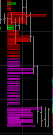
Note how the majority of the selling (in red) is near the highs of the day, and it tapers off through out the rest of the day (seen in magenta). Yet the day finishes near the lows. Here is another clue...not a hint of active buying...the selling comes in waves but its all net (delta) selling.
Selling runs into a wall of liquidity - Absorption:
Let us contrast the above condition (exhaustion) with the second of our scenarios. The "wall of liquidity" or "deep liquidity pools" or as it is often rightly termed "absorption". In this condition. The passive orders (buying liquidity) is "dense" meaning there is a lot of it in a certain area. Many of these orders are NOT on the books because they are activated by OSO orders. So they are called "iceberg orders" . Meaning they will only be revealed when price reaches the area and then the volume of this liquidity is so great it "absorbs" all the market orders coming into it. Now to be fair, as we already noted, the active selling was already waning prior to hitting this area. So what ever selling is left, is going to push up against this wall, but just doesn't have the volume to use it all up...so you will see a wave of selling - ACTIVE, Aggressive selling - but price will not drop like it did before, and price will stall and perhaps move sideways. Again it will look something like this:
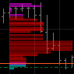
As you can see the majority of selling is now occurring near the lows of the day yet has very little effect on price. Price does close near the lows - but is running sideways a the close and all the aggressive selling through out this day didn't really advance price all that far.
Is this becoming clear to you? What we term "exhaustion" actually occurs in phases depending on the strength of the current order flow. It isn't just a price phenomenon it is really the structural components of the market seeking to balance a dominant (and by definition) over exuberantly out of balance order flow.
With price action charts I have characterized it this way. The first condition, "sellers all in" usually manifest in what I call a "climax" bar. In VSA theory, this is a bar with High Volume and a Large distance (in pips) between the open and close. It means that anyone who was long...is no longer. They have most likely been stopped out, and almost ALL orders coming across the order flow are active sell orders. They are using up liquidity FAST and this is what cases the large price move.
The second condition I have labeled "exhaustion", because now anyone who is actively selling is doing so very late in the game. They generally don't have much volume and therefore the effect they have on price (while still falling) is much smaller than the other wave of selling. It is this phase where the retail crowd is active...this is where all the "technical indicators" are lighting up and telling you to sell...however late they are to the game...and it is these participants that will eventually run into the WALL of liquidity.
OK...that's enough for right now. I have to rest my brain and drink more coffee...
------------------------------------------------------------------------------------------------------------------------------------------

Good Day All...
Currently "stalking" the USDCAD (Daily) looking for a potential short trade based solely on order flow and volume. I am not fond of this indicator for volume, however (so far) it is the best one I can find for MT4, and because it is based on ticks, will wait till NY close to evaluate entry/SL/Targets. Based on the attached chart, comments as to whether I have evaluated this correctly would be appreciated.
Many Thanks and Best Regards...
~Deanoracer~

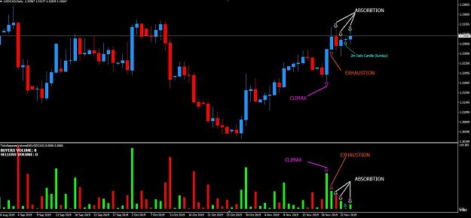

Quoting deanoracer
l... Currently "stalking" the USDCAD (Daily) looking for a potential short trade based solely on order flow and volume...

You have brought up a good area for us to look at. This is a great way to help us understand things and help us transition our thinking to order flow/volume and away from technical analysis. First let me say you have apparently absorbed all the material in my thread "Hey...what about volume" like a sponge. WELL DONE!! You have made a great first attempt and I see how you have come to your conclusions. I have some critiques but I first want to start with what you've done right.
You have correctly assessed this last run up as a climax move typical of the end of a run. You appear to be looking at top of these last 3-4 days and seeing price stall there and this is often what absorption (the final exhaustion phase) looks like. However I don't think that's what we have here. (Also keep in mind I am never right 100% of the time)
One small critique I have is that on your price chart you would do well to also have the tick volume data running on the bottom of your chart. I think in MT4 it simply a check box in the setting tab. Let me show you why:

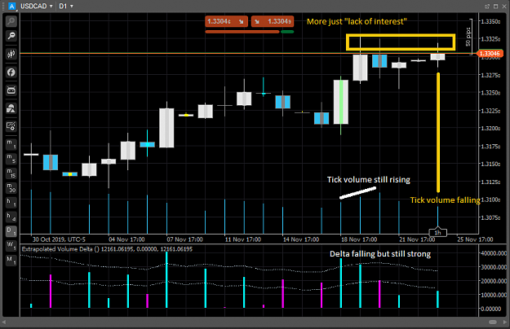

I have the same market shown here with the extrapolated delta on the bottom but also have the tick volume showing on the main chart. While you have correctly seen a drop off in delta volume (your indicator shows its a little more extreme than mine), I am still showing fairly strong buying delta, and the tick volume is still rising at the last high. I also note that after these two very bullish candles complete, price moves sideways indicating a change in the order flow from dominant buying to balanced. I think that if you were looking at this market in this light you might be a little less confident on the buying exhaustion here...as am I.
Finally look at how the tick volume drops off, into the week end, and today and while, yes price rose, it just really pooped out, meaning there is very little interest in on the buy side to continue moving price higher...at least at this point.
Finally lets take a look at the order flow charts (and yes I know you don't have these yet, but I've found they help me tremendously).
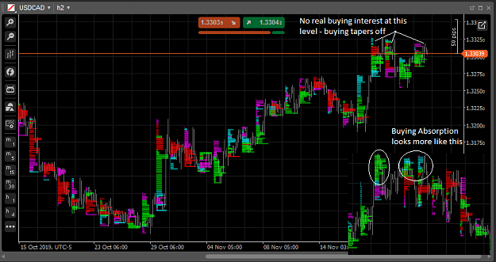

In this chart I show the actual market we are looking at and have inserted at the bottom left a smaller picture that is more typical of buying absorption. I hope you can see the difference...on a price chart they often look very similar, but one signals absorption, while the other is just lack of interest. You can see that in both cases, price moves higher, and then sideways for a period of several days. Both had the same result (lower prices) but different reasons. And those reasons make a difference in your expectation for the trade you wish to engage in.
Finally lets just look at a larger chart to see if we can better understand why there might be a lack of interest:
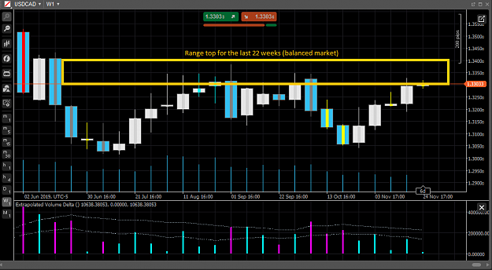

The week chart shows that price is once again testing a range top that has held all quarter. And as with most range tops, what usually keeps prices ranging is lack of interest...in other words buyers are not interested in aggressively buying this level (for now) which is what is needed to cause prices to move higher. Note also on this chart that ever time price is near these levels volume fall off, as does the delta volume.
So I've said all these things and I hope you are not discouraged. Because your trade premise (and this is what makes money) is correct in my view. I have a personal rule of "only engage at the edges" when prices are ranging. And so as we are at the top (or very near to it), short position is the most logical choice in my view. Just keep in mind that range "edges" like to be tested, and that sometimes participants with more volume will use the stops that are certainly near this area to "fund" his/her trade. Don't be surprised to see volatile prices after all we are at the beginning of a short week (Thanksgiving) and volume is going to be usually low the farther along we go this week.
------------------------------------------------------------------------------------------------------------------------------------------

Quoting Scotty B
...Throwing all this information out there just destroys any edge that could possibly exist. Why? Because the participants adapt and change the game. But, at the end of the day, those with the information advantage will always win...

The information contained here is public information and there is nothing "secret" or hidden. It is simply how markets work. There is no "method" or "system" that I advocate or promote. Just simple informed decision making...nothing more.

------------------------------------------------------------------------------------------------------------------------------------------

Quoting Scotty B
... Assume the entire retail FX community becomes aware of certain chart patterns and layouts that might show a glimpse regarding market flow/momentum/whatever. Patterns would start to emerge (in your trading) based on the painting of chart patterns, then YOUR ORDERS can be predicted and you will be the patsy...

This is highly unlikely that the entire retail FX community would work in unison, and even if they did their combined volume wouldn't amount to much at all in the actual interbank market. I highly doubt that even 1/10th of the entire retail community would all act in unison enough for any pattern to emerge at all. In fact what I am advocating here is to use the "established" technical analysis patterns in the same way the people you speak of would use them...but to do so by becoming familiar with how that shows up in the order flow.

Hello again Friends...There is a subject in keeping with my earlier post regarding "Exhaustion" that I want to make you aware of. It is a concept that is extremely difficult to understand especially for those of you who are just beginning to open your eyes to the truth about how market structure works.
This concept is what explains what is commonly called a "grinding" market. So here is how I describe it, (again using a bullish scenario). It is that slow relentless price advance that continues to move despite its seeming lack of momentum. Price does not advance rapidly, but continues to defy all seeming attempts to retrace. It is recognized as a "trend" in most technical analysis, and it that part of the trend, where (if you use oscillators) the oscillator is pegged at the top and moves up and down in the extreme high end. It gives "divergence" signals that always fail, and anyone who is trying to enter counter trend, is eventually chewed up by the relentless and seemingly unstoppable advance. I KNOW many of you have seen this, and if you are anything like me...have fallen victim to it over and over again, because you are trading some "rules based system" that tells you to enter every time you have a signal and that the "probabilities" will eventually cover all your losses...sound familiar?
Now let me explain what is really happening. It is these traders...the counter trend traders...the ones who trade "divergence signals"...the ones trying to catch a retrace or even the start of a new trend...yes YOU! (and me when I couldn't understand this concept)...these people are the ones who are driving the market higher. Let me be clear...the sellers, are driving the market higher!! Now let that one sink in for a moment.
How is this possible? How can sellers create or drive higher prices? The answer is; sellers drive prices higher when their positions stop out. This will often occur in the areas where technical analysis, claims its strongest power. "support/resistance", "Supply/Demand", "oscillator divergence". So what happens? Price moves into an area where someone (or a large group of people) placed some lines on their chart. They call these lines, by different names; "support/resistance", or "supply/demand". It doesn't matter. they point to an area on a chart where most likely a swing point occurred and then say, that if/when price returns, it will turn. The theory being that if it turned sometime in the past it will do so again. While this theory has some basis in fact...those facts have nothing to do with that cute little line. And many technicians realize this.
So they will also look for a "signal", either a "price action signal" or a "divergence" signal. The latter coming from some oscillator that lags behind price and will produce what is supposedly a "predictive" lesser extreme than price makes, thereby causing the "divergence"...So lets take a look at this.
First with price:

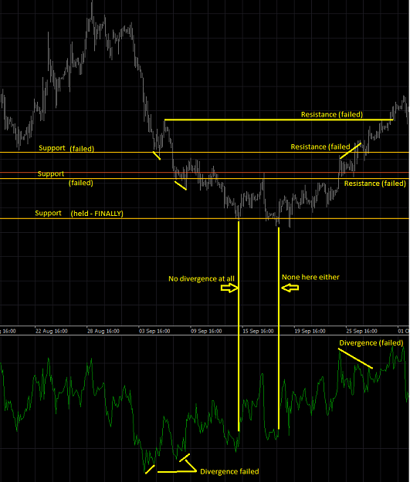

I have drawn some simple lines...where it is most common to see, and have an RSI running along the bottom and am using this to document how often you had failures of these analysis techniques simply because they don't work...but look at how OFTEN they don't work. What if I told you that just about every one of those failures was responsible for another move down? You can almost see it here on this chart, but lets now look at the order flow:

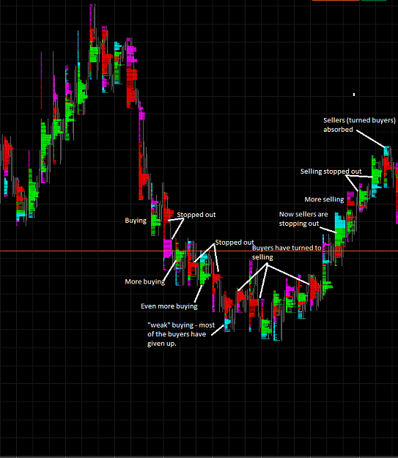

If you compare the two screen shots you will see that the buyers are driving price farther and farther down. These are the participants using the technical analysis you see above.
Of special note is that when the buyers give up...and turn to selling (as seen by the heavy selling that cannot seem to create a new low). These are the same participants that were buying and have now changed their minds to selling. And once again, they are responsible for driving the price higher. Using the same failing techniques that drove price lower...now they are doing it to drive price higher. In each instance, price stops its grinding relentless advance when this group of people GIVE UP...usually because their account balances require it.
I hope this will help you further recognize what happens every day in the markets...and if nothing else allows you to avoid this very costly mistake (or group of mistakes). The key here in your timing is to watch for the participants who are driving the market to GIVE UP! Once this happens the swing point is not far behind...if it hasn't formed already.

