Zoran:
Quoting auxesis
Zoran,
Howdy! Thanks for the help, i find myself now blocking out the lines and concentrating just on the price action/ push and pull when in the move, but there's still a few kinks in my mindset that need to be adjusted to fully incorporate fti's methodology, for me.
here's the key to FTI's comment imho.
This is because to flow on wards the point of reference is no longer the historical mindframe but the immediate past , and the present quickly becomes, immediate past, and the previous point of reference must be released that the new point of reference should be the point of contention. For strategic repositioning , the only point of reference , is the consolidated exposure and will always be in a singular directional play, so there is no consideration for the other perspective, unless this accumulated position find itself in trouble. If this was true then repositioning is required.
Thanks, you are then at the next level. Moving onto MM.
Remember, you are dancing in a single direction with a particular exposure and average. You would not want to be exposed highly for a prolonged period so winding out and back in quickly would be the way to do it.
Being nimble as fti would say otherwise your average is at higher risk. That is your point of reference and if you need to reposition strategically then you are in rescue and will need to spiral to the correct level based on your exposure and thrust of the market. You could lighten up a bit if over exposed and you could move to other time frames to find a potential rescue point.
It is similar to dancing with your scout except your exposure is increased. Look at your blotter and keep dancing as you would. Be present and wind in and out as necessary. Easier said than done.
I personally wouldn't advise on reversing unless in a position where one would bite the bullet. In general, these situations only come along a few times a year - generally when caught on the wrong side of a hurricane.
DutchAgnel:
Hi auxesis
Once you are in a trade all future decisions are based on managing the risk. To be a successful trader, you have to be a successful risk manager. This sounds easier than it actually is, but fti's methods are brilliant in helping traders consciously do this.
Another important aspect of trading, in my opinion is accepting loss. I don't trade with stoploss. I kill deals that make me uncomfortable and move on.You have to learn to become completely comfortable with losing. If you can achieve this, your mindset is no longer an issue because you understand its all part of the risk. This is just my opinion.
15 Mins: 26 Jun
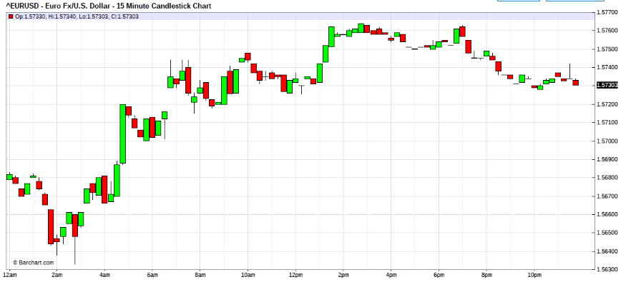
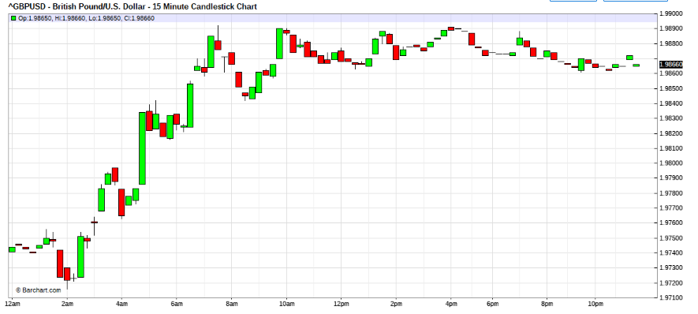
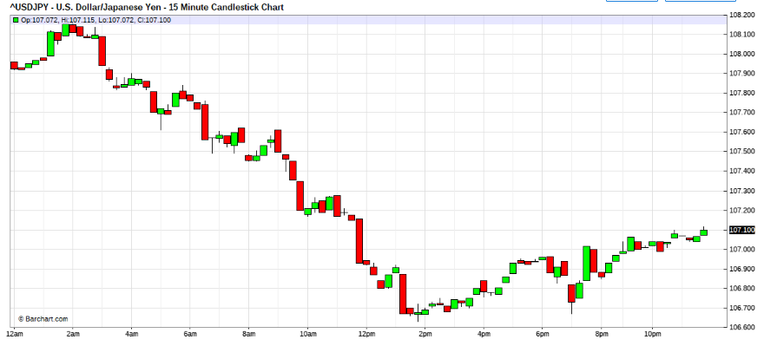
FTI:
Jun 26, 2008 7:44am
Quoting Green_David
This picture is good. Is it on the Guiness record?
BTW, all E/U short positions out @5655 on average. Some G/U short positions not closed out. Did some rescue operations. Still in trouble.
David
Hi David,
Long USD doesn't seem good fundamentally and chart wise.
be careful, bail out when you can.
Dance carefully, the USD devaluation doesn't seem the be over.
The EU may hike rates and the feds hands and legs are tied.
So feel that impulse carefully.
I tried the USD already before the fomc, there's no chart reason to try now.
For those trading the trend reversal.
Be careful of mines and snipers in the 1st wave.
Stay nimble. Attack but do not overstay.
Quoting DutchAngel
Hi fti
I am in, but with very low exposure. Keeping my eye on it though. Good trading to all.
Hi DutchAngel,
Good, you must have made good $$$ after the nfp.
beware of sniping action when the chet in Eur does his lip services tom.
Acertain that you have always, appropriate contingency response to your positions,
rescues must not overstay, attacks must be forceful and swift then normallise in stages.

July 90 Mins chart
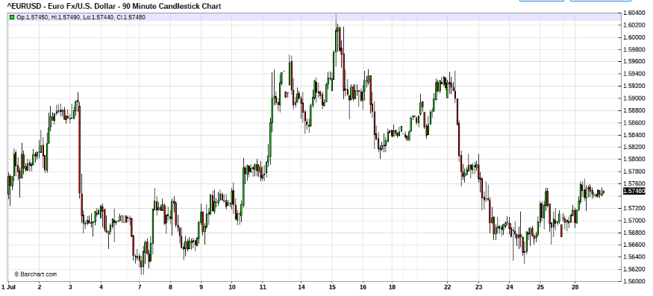
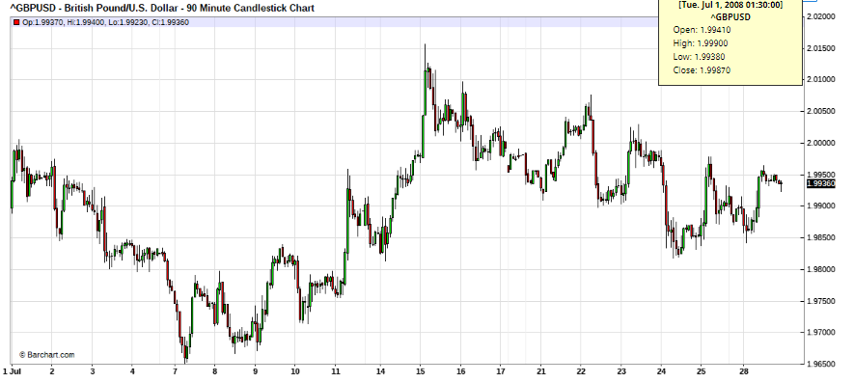
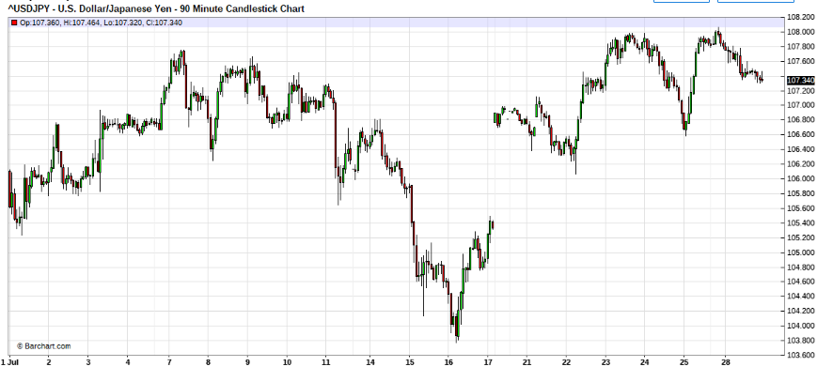

15- Min July 3
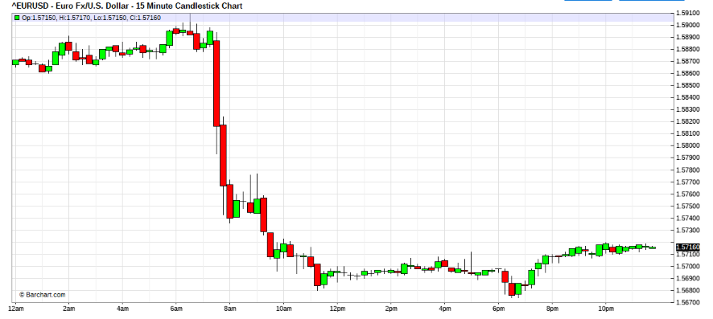
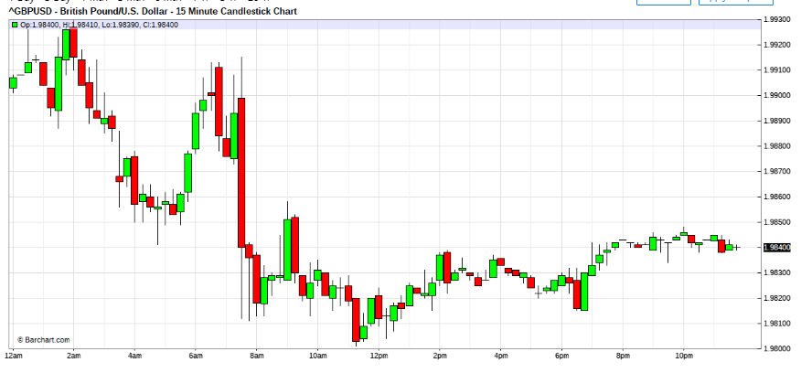
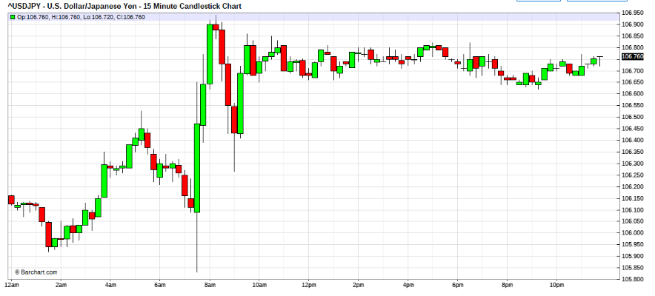
Jul 3, 2008 1:03pm
Quoting jest1081
Hi fti,
they're market orders...
efx...i should have run mfglobal's as well.
im not sure too but somehow you dont see the spook in the jpy tho. Is there something sneaking up in euro? I thought the ecb just jerked up the rates?
Do you see the Kingdoms lining up for a downtrend in the hourly?
Hey Jest,
You have a case with the broker. Market orders when received must be filled.
ask for time and sales , and document your orders and its time stamping or screen captures.Then speak with efx, top honcho, and document your conversations.
If they do not "make you good". Line off the broker, and contact CFTC and NFA for assistance.
ECB, up rates??? when?
anyway if ECB up rates, the market is reacting wrongly then.
HUH????
Oh, the Japs and cable had been at it all day , thats where the clues came from.
Euro had been a naughty all day, And now the splash.
"Hey jest, chet may like to give you a chance to get your so deserved position. "
That was me not Lusan.
I meant refix your orientation.
The 1st impulse may be over, you may get a retrace, if Trichet talks the Euro up, watch for opportunities, do not jump the gun. The chart is a key reversal, already.
Look for opportunities, and dance well, forget about levels, they mean nothing,
Focus on the pulse, and feel the tempo, I repeat , forget about LEVELS.
Look at the patterns, do not think about the price levels,
Pace the dance!!!!
1:39
Quoting jest1081
Hi fti,
thanks!
games over for today i guess. Im catching the early ride to dreamland! hehe.
Hey Jest,
rest well.
Tom will be interesting.
IFrom my read of the patterns formed thus far, there's much blood letting on the street,
so be watchful for opportunities.
LUSAN:
Quoting fti
ECB, up rates??? when?
anyway if ECB up rates, the market is reacting wrongly then.
HUH????
It does not make sense indeed...
ECB rate up and FED flat....then E/U ought to go up...but it does not...
E/U is falling...if ECB is up then...FED might increase rate!
The unemployment No came out bad...so FED might do it...Stocks bearish...etc.
Stop..I really do not know what I am talking about...
The truth...Traders are dumping Euro or gathering dollars...So I should sell Euro until they stop....

FTI:
Quoting Green_David
hi, FTI:
After several months experiment, I give up rescue operation.
OK noted, you were always free to choice how you traded.
1. It is too hard for me to rescue scout with more positions within 50 pips of pullback. And if rescue positions are trapped also, I am bitten more by the aligator(crockedile).
2. If my scout timing is too early, I just wait untill 100~200(GBP) pips against my scout to see if the price will resume the trend.
In a 200 pip impluse, the short trnd must have turned. Whether the hourly trend has changed may prompt you in your repositioning.
3. If it turned out the scout is against the daily trend, just take loss and start over. No point to rescue while trading against daily trend.
If that happened to me, I won't do as you suugested. If the market catches me, and force me to turn on wind to daily trend. I'll .........turn with full continuation snowballing. For undercapitalised , do not do this, It is very scary. I don't want anyone to get a stroke.
4. If the trend resumes, I try new price level and set up entry again.
When I tried to rescue bad positions, I found out that my added positions shall not overstay in the market so I have to take about 20 pips profits. And because of this I had a bad "habit", i.e. when my added positions are suppose to give me a 100-pip daily profit, I closed for 20 pips only.
I dont understand, ok so you make less, whats the problem? I never go riigid to count how much I make and should have made. I just make the $$, be thankful for the blessings (and $$) and move on. Gotta no time and mostly leave the ROI counts for those that cannot do.
David,
Iam not sure, but you seem to be moving further and further from the basics. Time to recap your MO esp mindset.
15 Min – 7 july
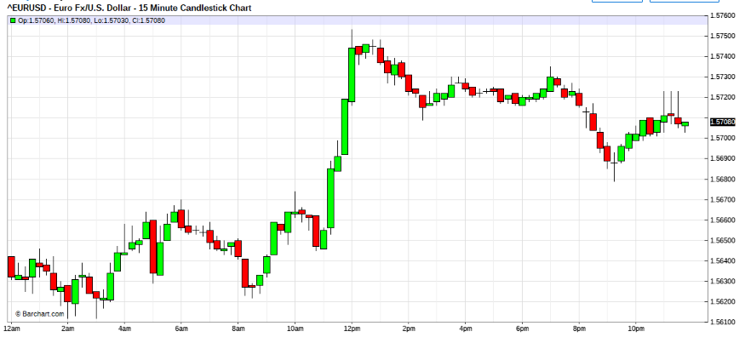
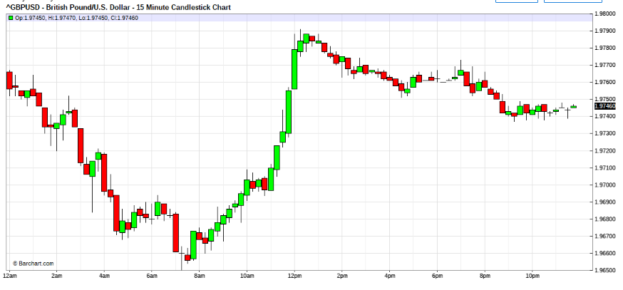
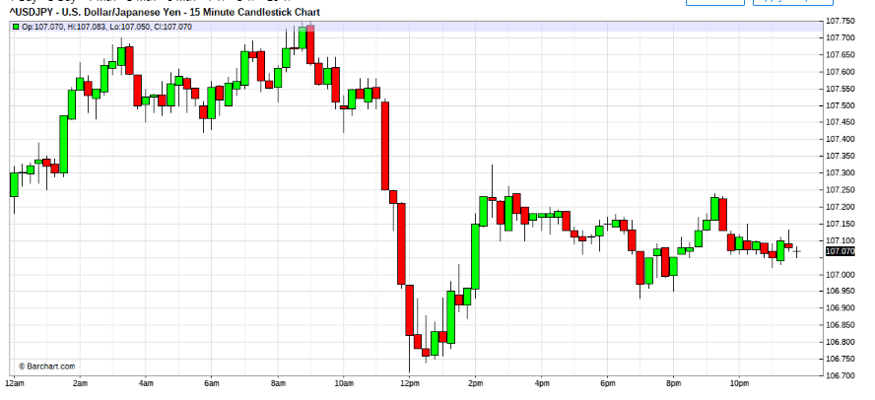

Jul 7, 2008 6:51am
Careful now, fireworks, fizzing out.
Look for signs. Try not to jump the gun, and be nimble and wise.
The question now, Is the weak USD now retrace or trend??
More signs along the way.

Quoting 2fx
Hello Fti and others.
I went short Eur/Jpy last friday towards close of day. This morning I couldnt babysit, right now am down 50% of my equity... not enough to rescue, do you think there could be a retrace or I should just take my hard loss and move on?
Pls help am stranded...
Hi 2fx,
I would suggest tht you cut the loses, stop trading for a while and read this thread carefully, to see where you went wrong.
I recomend you this course of action, as I believe that you may be very inexperienced trader. Moreover you have violated many principles that I deem prudent for traders.
Good Luck

Jul 7, 2008 2:07pm

Hi All,
Outside day reversal against outside day reversal in the USD/eur.
(manipulation at its greatest) and long long tails in the cable and USD/Yen.
This one's gonna confuse day chart traders and position traders. Do not try to Run, Beware, slippery, much blood on the street. Selling USD seems good stance now.
Devaluation isn't complete. Maybe tip of iceberg yet.
But please no running be nimble still. Dance gracefully.
Hi joypips,
I regret that I shall not be able to discuss "hips and lops" on a public forum , for respect and professional courtesy to Welles Wilders. But I can tell you that it is abrivation for high point and low point which is a basic technique in chart reading and methodology. In its basic , it is of no grave importance. However if you have working knowledge of it, it can enhance your timing, if you are out of step with market rhythm.
I hope that reading paper money may enhance your understanding of the market and its structure.
Hi All,
Its been trying times into the july celebrations , utimately it looks like the USD bears are on top, nevertheless many bears are bloodied too. In my opinion seems many dead pig carcuses all over the place. Stay to reading market dance closely, stay nimble always .
Be trendy, stay with whats current that is evolving, no one can say for sure. You have to dance , for now quick step is best.
Remember your training, efficiency of performance is dependent on the mix of ingredience of Analysis, MO, MM, and Captalisation. There is no magic bullet. This is scary terrain we are in now, dance well, stay alive.
Rule 1 Capital preservation.
Rule 2 Capital preservation.
Rule 3 Do not forget rule 1.

Quoting lilpip
thanks for the reminder to keep us in check.
Is support for long dance out of 5660 crumbling this morning ?
Just a retorical question.
Might be looking at a short dance south. No pun intended.

15 Min – 8 July
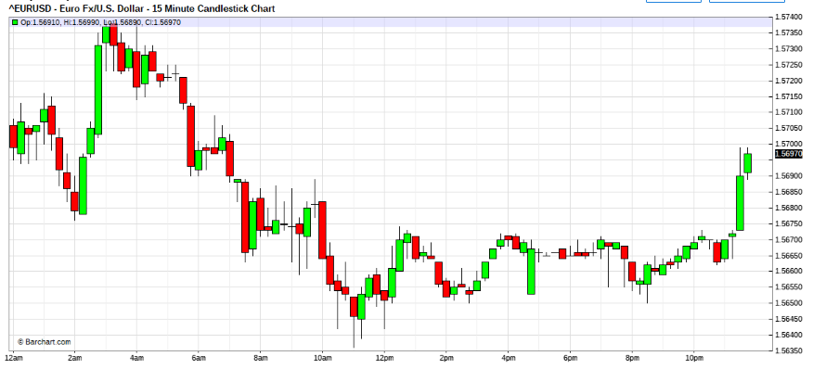

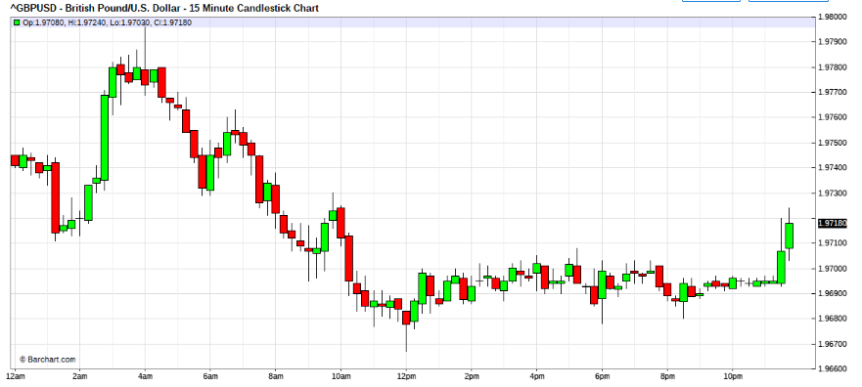
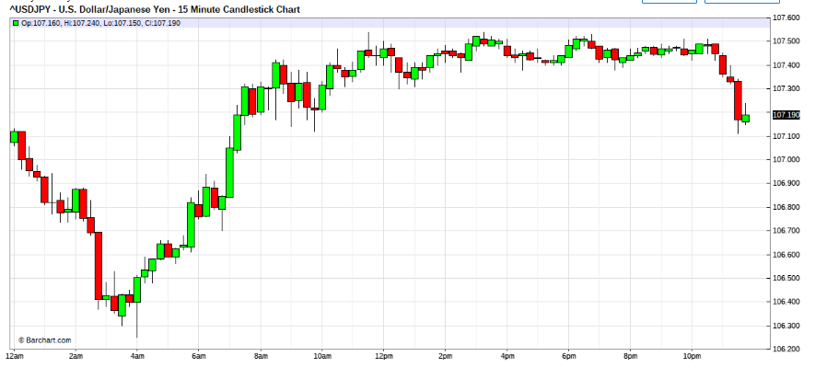

Jul 8, 2008 11:54 am

Hi lilpip,
Do you mean the USD bull?
well I got caught on entry long USD after the up sweep as well, just got out level 3 rescue.
Note daily charts, the distribution will either contract or expand out, but as the legs are swift and long, only can expect more of volitility play intraday.
Non ride opportunities detected yet. Like I said stay nimble, try not to overstay stance. There are much bleeding USD bears as well so be mindful of volitility sweeps.

Quoting lilpip
I was using e/u 5660 as a guide for support up to 5737 if it breaks I would feel comfortable leaving a portion of my babies unattended.
If 5736 area holds I'm looking for a short dance south to 5660.
I'm looken for short dance below 5660 with eyes and ears open around 5625.
Hi lilpip,
dangerous stance you have. Never leave baby unattended.
S/R can give way, it depends on it robustness, and for now with high voli Anything is possible, depends on the mass resolves. Stay nimble for change and sweeps possibilities.

Jul 8, 2008 02:17 pm

lets see if the USD bears can come out of the woods now. its trying vv hard huh. seems delayed action, looks like wating for the queens men to get into gear, LOL

Quoting auxesis
Fti,
Curious to your thoughts: at this time of day, do you think the USD bears are coming out or just distribution of todays USD Bull run?
Hi auxesis,
Really can't tell yet. Those USD bears had been bleeding lots.
Sure runring out of clock space though. Felt suspicious , that voli was high due to market thinness. Just suspicion as I cannot see much flow,
If this was true could get hairier into wellington zone.
Gotta see how the US boys playwhile they sq out for the day.
Seems the yen boys are out, there's a little life left yet for the queens boys.
Quoting lilpip
If I feel that the market is taking me short from a particular entry point.
For example a couple days back I felt that the market was wanting to go short at the 5747 area which I viewed as possible resistance so I entered and followed her steps .
Yesterday the same only the 5737 area possible resistance.
Today, even though I view 5728 and 5747 as possible resistance I wouldn't enter short dance if I felt the e/u was leaving that area heading towards 5660 because I feel its to risky today as the trend for the day seemed stronger coming out of todays lows 5660 area.
Hi lilpip,
I see, so when you say short dance, you mean that you were short EUR/USD.
Just that you may be aware, forex is quoted in pairs.
So, short USD/EUR=long EUR/USD
and long USD/EUR=short EUR/USD
do you see the confusion.
the dealing protocol is that we speak from the perspective of the Pair, as when placing orders.
But when we discuss markets, the protocol is to speak in USD terms.As in long or short USD.
The purpose to sync frame of thoughts, esp when you may be speaking about USD dominant pairs vis a vis common wealth pairs.
This protocol of discussion will standardise the basis of thoughts , esp allowing traders trading differening pairs as well as those who may be trading futures contracts (who trade reciprocal quotes) to speak to each other coherently.
In the interbank, it used to be that the only two non USD dominant pairs were the Cable and the Aus. Now we have the Eur as well.
I hope you may find this protocol for discussion acceptable and less confusing. 
Of course if you were speaking from position then inclusion of the pair intended, would provide better communications.
Quoting lilpip
I can't help myself
lets see if I can hekp you.
I'm in @ e/u 5745 looking for tonites lows,
so you are short EURUSD (size unknown probably 10,000usd)@1.5745
scaled attack down,
Why did you start with an attack, you scouted the range already?
anyways ,it seems that you took profits, yes? where?
scout left in at 5728. and scout is out @5724 for sleep.
so you squared with 4 pips profit?
Short EURUSD x1 @1.5728
Bot EURUSD x1 @1.5724
is that correct?
still long from 5660.
In @ g/u 1.9830 looking for tonites lows, scaled attack down, scout left in at 9805. and scout is out @ 5712 for sleep.
still long from 9777.
Hi lilpip,
You seem to have been a USD bull for the day.
Any specific reasons?
Althought you were bullish you are not wrong, as you did not leave overnights. OR DID YOU?
whats with the 1.5712 for GBPUSD though, ???? is it 1.9712?
Are you dancing the chart?

15 Min – 10 July

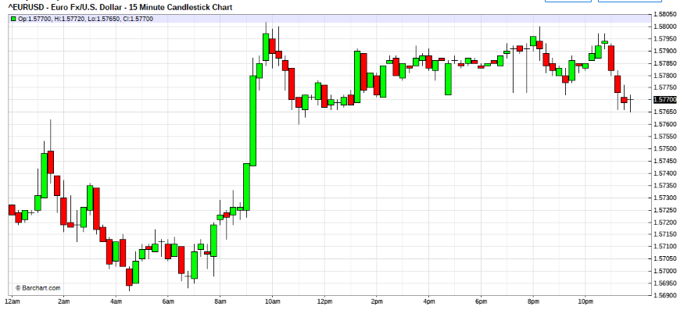
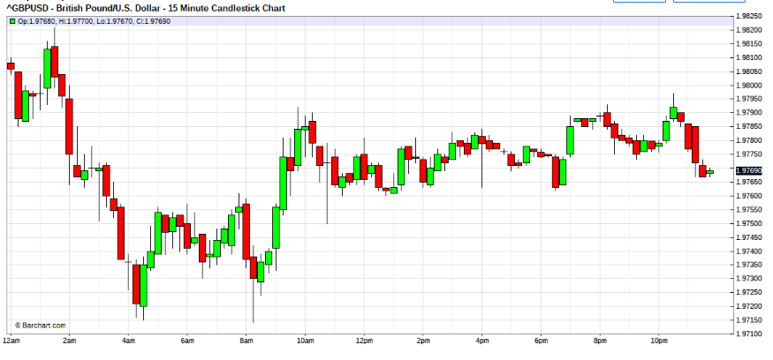
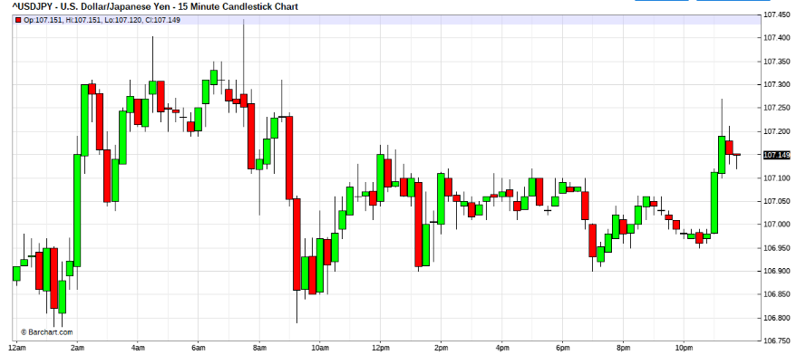
Jul 10, 2008 10:23am
OK army OUT , leave scout
scout out. now squared.

Jul 10, 2008 10:48am

scout in - buy eur/usd x 1 @ 1.5767 ob
scout in - buy eur/usd x 1 @ 1.5775 ob.

Quoting Zoran
Hi fti, do you use hip and lop actively?
yes, Zoran, otherwise how to determine leg's shape.
now mkt 65
Jul 10, 2008 12:18pm
Quoting auxesis
The market seems to be just bouncing between technical points/levels without conviction to direction.
Lunch time in NY,
bot x 1 x eurusd @mkt 1.5766
@auxesis,
dailychartwise,bias bear USD.
volitility legs vv high, therefore big battle on with the bull and bear.
difficult to ride, options premiums vv high, from fair value. gotta stay nimble.

Quoting auxesis
agreed range now 765 to 800, if trichet can rally the euro bulls for a new high?
no real consiquense, will be playing into highs and toppish mountain ranges.
However, that's the chart bias fro the day charts.
A nice usd bull sweep would be nice to reposition before chet comes on though.

Quoting Zoran
Isn't the "hip" around 60? So we can expect your position to be good shortly? Action looking good too.
No, zoran,
the lop was at 1.5700/20 region but unfortunately due to ben we couldn't capiytalise on that. No hips in sight, so the sky's the limit for the mom.
Now just trainee dealers playing screen, gotta wait for the big boys.
but of course if the trainees. like to take the market for a spin, we can spar.
Actually, later when chet comes on. the American interbank would be in snooze mode(their normal protocol). Direction can be gauged from the FX futures exchanges. if you please, the CME.

Jul 10, 2008 12:53pm
bot 1 eurusd x market filled 1.5773

Quoting jest1081
fti,
ive been playin yen on the short side since yesterday. The strength in usd worries me.
Don't see much USD strength on daily charts, bias bear USD
sre we looking at a return of the carry markets?
basically, USD, weaker rates, so negative carry, weaker FX unattractive, (plain ugly proposition)
seems like a good setup to long stocks... 
Sorry equity , not my cup of tea, although I am old uncle
Actually equity is bad proposition as well, with this galloping inflation the world is experiencing. unless you are a devalued dividents happy INVESTOR. If you are good holder, I am sure they'll be worth something by 2100.

Jul 10, 2008 1:29pm
sold x2 x eurusd x1.5771
only scout 75 is still in

Quoting Green_David
Hi, fti:
A question. You bought E/U around @57770 today? A little of chasing? Why you didn't send scout @5720(from 20:55 to 21:00)?
Because, ben was talking the market
I reduced most short E/U positions around 5720, leaving the scout still in the battlefield (openned @5873 one week ago).
Hi David,
Ok I guess you wanna know my postions.
Ok since the markets not moving, This is my blotter after ben's testi.
Eur/usd
B x 1 x 1.5735
B x 2 x 1.5741
B x 6 x 1.5752
S x 8 x 1.5781
S x 1 x 1.5779
B x 1 x 1.5775 ----scout still open
B x 1 x 1.5766
B x 1 x 1.5773
S x 2 x 1.5771
Any problems?
Like I was telling , who was it,? i forgot.
the markets technically in test zone. outside reversal, counter-outside reversal and coiling, overnights are dangerous, if you like scouts are riskable. Any thing more, then the gambles on.
Try not to follow this skew, it is tailored like this because it is in size. and the backup is large, goes up ot 7 levels.
Jul 10, 2008 2:22pm
bot 2 x eurusd x 1.5777
bot 3 x eurusd x 1.5782
bot 1 x eurusd x 1.5778
bot 1 x eurusd x 1.5779
bot 5 x eurusd x 1.5779

Jul 10, 2008 3:13pm
order sell 8 eurusd X 1.5785 ob
sold 5 x eurusd x 1.5786

Quoting lilpip
Although it comes across as a totally different mindset and method, its not intentionable, I'm trying to enter the dance with the market taking the lead.
You ask me what reason for the bull stance ? I just felt that the market was going that way so I wanted to followed to see how far.
As far as being pedictative and fortune telling I try not to. There are times I seem to have a bias though, when entering and exiting trades otherwise I try to keep it in check and I'm more than happy when others help me do so when needed.
I appreciate the reminder of not counting on levels at volitile times I needed to here that.
When I'm mentioning these price area levels I don't know the direction price will move but from trying to be familier with the pair with the best of my ability at this time. I view them as points of entry.
With extra attentiveness I try to feel the market on what its trying to do for safe entry.
So for example today for my entry to dance was to watch with extra attentiveness the e/u 5701 area to see which way I would enter.
The same for the g/u 9765 area would be an area to watch for an entry one way or another.
I have to say my bias was up for both pair, thats why I pulled the scout this morning as I just awoken 5 min. before and wasn't prepared for a fight. So as the g/u was going down from 9765, not doing what I thought and not prepared to follow I got out.
I'm just trying to understand how to get on the daily trend and avoid fighting with it.
Hey you walk the talk
I'm trying to learn the talk then learn how to walk and eventually be able to walk the talk to some degree.
Right now my speech is slurred and when left on my own to walk I wobble and fall down.
And I don't mind help from anyone if seen needed.
Hey, Its good to see your post on dancing with the market, it helps to see the steps and blows in a given situation. and a pattern to measure up to, I comprehend better now the hit them hard fast and get out.
I'll try to pick up on the appropriate timing for entries.
Let the fun and practice begin.
Hi lilpip,
its nice to know that you are begining to see and feel the dance.
like you saidyou may lack market experience, but we all started somewhere , unable to differentiate push from pull. But if you diligently try to hold to good basic mindsets, you will ultimate get there, time will be the divider.
For you lilpip, you I still detect rigidity in your perspective to market flow, so you will have to work at it to get that right.
Quoting luSan
I read your entries and suddenly I understood much better your dance!
Thanks for the message...Clearly it will take a long time for lusan to really learn how to dance...still I made a little pips but this was worthless week: to many uncertainties and I was too impatient.
Only you can deal with that you may not have mastered.
So your attack sequence was 1-2-6? How did you timed your entries? ...I know that there are no fixed rules, but how did you timed it?
For the attempt when the market reacted to ben only. We know that the fib sequence is the base. You have to build your own from that. That was a mild attack due to chart uncertainties. A true attack is much stronger, but only if there's good foriegn cap to back up the exercise.How to time?, well the dance "form" remember?
Quoting lilpip
fti,
trying to follow your steps, market felt like it wanted to drop a bit but I'm begining to wonder as its taking to much time as she worked her way back up and pushing above 5790 after I been in it for about 2 hrs. Im about ready to close it down for the night.
Well now your being to think, its a good step forward
Well, it dropped below 5790 and I slapped it with 5 lots.
e/u
s- 1x 5795 closed @ 5770
s- 2x 5790 closed @ 5774
s- 6x 5781 closed @ 5774
s- 2 x 5783 closed @5770
s- 5x 5788 closed @ 5770 I'll remember that 5790 -93 test
Funny that you did an attack sequence, when you didn;t get much feel.
Remember if you do that and you get caught, the rescue will be very painful.
Experiment this, assume that market kicked 100pip against you on your attack, calculate the damage. Scary isn't it? and this is only mild attack.imagine a full assault. Read my reaponse to Lusan.
July 11 2008
Hi ALL, remember, the USD bulls and bears had been at it for nearly a week.
Yesterday, the bears clawed back. But mkt is still in acoil note the cable and yen.So don't get caught with pants down. However the bias is on USD bears.
GREEN DAVID:
Confused and troubled: David
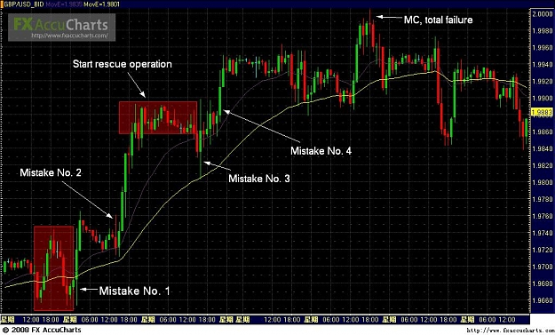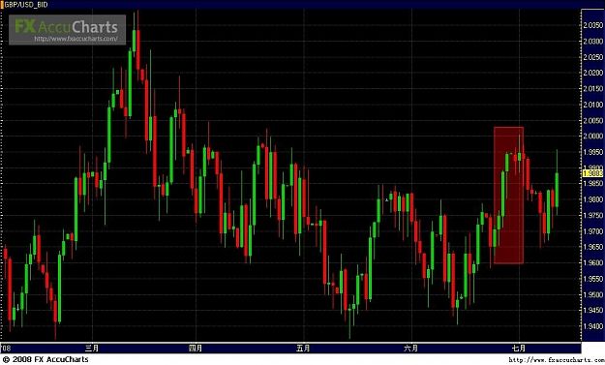
FTI:
Quoting Green_David
Dear fit, lilpip, Zenseven, Lusan, Zoran and other friends:
Since June 6 to June June 25(the day FED announce rate decision), I was doing OK with my FXsol account, got about 250% profit.
On June 25, I longed G/U around @9680, out around 9710. Squared, with no positions before FED decision.
Mistake No.1: After FED decision, the price resumed up-trend, while I was testing a trading platform and missed the opportunity to set up long positions.
Mistake No. 2: Since I missed the best oppotunity to long, You decided to kill yourself self by trading against the trend on day 26, I started to short, assuming ( making an ass of you and me ) G/U will have at least a pullback and bearing mind of avoiding chasing the market. Look at hourly chart, it is a shooting star(GMT +6), isn't it? I made a mistake from the beginning, chosing the wrong trading direction.
When the price turned against me, I reduced my positions. The problem is the reduction is not enough. so you decided to rescue against the trend The price moved too fast when passing 9760, and I didn't set stop loss order(I don't want to a sitting duck). This time, the patience is not a virtue but an enemy. Patience looked more like egor So I was stuck.
I started rescue operation by adding more positions around 9860~9880 averaged the price to 9820. The book loss is still with my threshhold. So you wondered that since you were invincible, you can do anything you like
Mistake No 3.: On June 27, the price went down to 9803 and gave me a chance to bail out. But the problem is: that was only a spike, I closed some positions around 9330~9340, but not all. Then what is worse, some rescue positions were also trapped. The position size is already in danger.and as you were the market , you can dance as you like, the market gotta follow you, it would not be otherwise , How would the market dare to get back into trend without giving your invivibility the chance to get all your positions out first, This is not possible, you are invincible and you are well capitalised.
Mistake No 4: I saw the price couldn't break out 9900, and in early NY session when price went up again to 9900, I started to short from 9880~ 9900. But this time, the price broke through 9900. And more rescue positions trapped. I found out the position size was too heavy, cound not make further rescues.What condesending behaviour , the market thinks that they can continue the trend without giving you profit first. You will show them, You got more money to back your positions then the market can trend against.
Finally, I got a MC on June 1, with a shame that the highest price was just 10 pips higher then the MC price, and 4 days later G/U went down to 9650. If my positions were still there, 150~200 pips profit if closed @9650!
What the...., now we will drown, why did you do that,. Well sorry, I couldn't help myself, It's my ......
There are some things I need to think about.
1. From 9720 to 2.000, when I was trying to rescue bad innitial positions, in effect, I was trading against the main trend of my trading time frame. If I just closed the bad positions and follow the trend, wouldn't that be better?
2. Why not closed my initial bad positions when G/U passed 9760? Maybe I don't want to be a sitting duck, but one hour later, when price broke up 9790, surely break-through of 9760 is not stop loss sweep. And then why not put a stop loss order this time? Maybe I could be a sitting duck, but so what? Capital preservation is more important than being a sitting duck for once or twice.
3. When price broke through 9760, why not gave back some profits to the market in change of capital preservation and risk control?
4. Actually, I did some successful rescue operation when the price reached 9880. However, the initial dead-in-the-water positions had -150 pips loss, and effective rescue range is only 60 pips(9890~9830, 9830~9310 is only a spike which last less than 5 minutes).
And I have be honest to me, for a range of 60 pips, I could make only 10~30 pips profts. Let's take 20 pips, so in order to save 150 pips loss, you need about more troops of 7 times of initial positions. Wouldn't that too harder than just take loss from the begining and traded while following trend with 7 times of troops?
Dear fti, sincerely, would you point out my mistakes and give me some advice. I am suffering and upset about serious drawback. You see, I am doing ants job and build up profits, but suddenly, several days drawback sent me back to the initial status.
Confused and troubled: David
Hi David,
If you allow egor to think for you while you count your profits, then you will earn this lesson again and again until you learn to recognise egor.
I wonder what I can teach you. Maybe I should let some here teach you instead.
This trader here has good mindset, you may recognise him.
Quoting Green_David
Thank you fti. I will always remember your saying dancing with the market. I think it is great thought beyond mechanical technical analysis.
So, for trend determination, we must see the chart not think/assume by ourselves. If the sign of trend is not clear, be patient and wait standby with no positions.
So, when you carry the positions over night. You will reduce the size to a safe level as no need to place a stop loss. I see.
Thank you very much. Looking forward to your Chinese story, I wonder if I ever heard of .
Cheers.

Any ways
Analysis = who needs that.
Trade in line with trend = failed ,
mindset: Trade counter trend
Patience = failed , so market didn't wait for you, teach it a lesson, trade against it.
Rescue in line with trend = failed, nevermine the trend , you can rescue any dead in water positions. You are king of market.
Flowing into the trend = against, You will teach the market not to respect you.
Humility to market's lead = failed, but you are king , right?
Dance : You are dance master, so market must follow you. No other way. There's no terrain that you cannot handle, you got MM, and thats all thats needed. No need to babysit this chaps , you gotta the $$, huh
MM : You got the $$, you can attack , even when in adversity, Super skilled.
Capitalisation : You got the big $$, no sequense can take you out. Can it?
Well wonder what happened, maybe its a fluke.
ORRR
A possibility, Once upon a time.....,
Quoting Green_David
Dear fit, lilpip, Zenseven, Lusan, Zoran and other friends:
Since June 6 to June 25(the day FED announce rate decision), I was doing OK with my FXsol account, got about 250% profit.
On June 25, I longed G/U around @9680, out around 9710. Squared, with no positions before FED decision.
Mistake No.1: After FED decision, the price resumed up-trend, while I was testing a trading platform and missed the opportunity to set up long positions. oops, the trend has resumed, I'm not in.
Mistake No. 2: Since I missed the best oppotunity to long, on day 26, I started to short, assuming G/U will have at least a pullback and bearing mind of avoiding chasing the market. Look at hourly chart, it is a shooting star(GMT +6), isn't it? I made a mistake from the beginning, chosing the wrong trading direction.
Where can I get in on this party. Should I send out the scout?, Whats, the volitility sequense? Lets see where the market allow a time window for me? Will this trend RUN?
When the price turned against me, I reduced my positions. The problem is the reduction is not enough. The price moved too fast when passing 9760, and I didn't set stop loss order(I don't want to a sitting duck). This time, the patience is not a virtue but an enemy. So I was stuck.
I started rescue operation by adding more positions around 9860~9880 averaged the price to 9820. The book loss is still with my threshhold.
Ah the scouts good, some quick attack will put the scout out of range to be endangered.
Mistake No 3.: On June 27, the price went down to 9803 and gave me a chance to bail out. But the problem is: that was only a spike, I closed some positions around 9330~9340, but not all. Then what is worse, some rescue positions were also trapped. The position size is already in danger.
Well is this 1st wave, or second wave? How aggressive can I attack safely?
Mistake No 4: I saw the price couldn't break out 9900, and in early NY session when price went up again to 9900, I started to short from 9880~ 9900. But this time, the price broke through 9900. And more rescue positions trapped. I found out the position size was too heavy, cound not make further rescues.
Oh good, another impulse, great, I got good profits, on attack as well as scout.
So how can I protect the profits , while staying on the trend,
Finally, I got a MC on June 1, with a shame that the highest price was just 10 pips higher then the MC price, and 4 days later G/U went down to 9650. If my positions were still there, 150~200 pips profit if closed @9650!
the trend seems deep in, must be nimble now.
DAVID,
MINDSET !
The ART OF WAR, SUN ZI
DON'T BUCK THE TREND, IT IS YOUR ONLY FRIEND
RESPECT THE MARKET, be humble
even, when you were caught on the first rescue, didi you reference your hourly chart for trend bias? did you reference , the volitility of the impulse?
you rescued against trend, this is the hardest, were you nimble?or were you fearless?
What is the standard and technical defination of "trend"?
Green David:
Hi, Fti:
Very glad to hear your comments. Thank you very much.
The attached chart is 1 hour chart. I entered scout and added first attack positions as in yellow circle. I was according 5 min chart(5 min chart can't show as early as June 26) to enter. Looking at the 1h chart, it is a shooting star, a bearing sign. I draw 2 imaginative red candles, well, if that happened, my entry would be perfect. In this sense, I didn't short blindly.
Of course, the price didn't go as I expected: the second candle didn't go down and the price bounced back, so I reduced my size with profits even though the profits are very small. But as I said, offloading is not enough, since I closed the only profitable positions.
I remember you shorted E/U on 23 June and made good profits. I did the same. It is also sort of against daily trend, isn't it?
And for mistake No. 4. Yes, I was trading completely based on guess. The reason is simple: to get a better price instead of waiting for 5min confirmation! Because when trading counter-trend, the space is narrow, and very difficult to make a larger profit.
Over 14 days, the daily maximum drawback is -1%, so, I am not gambling before that day.
My problem, I think is I just don't have guts to face the fact of loss and over-position, and due to lack of that guts, failed to act immediatle and allow the positions out of control(more than scout)
How can I say? I am still a newbie trader.
Of course, if reduced the size enough, -300 pips would not hurt me at all when G/U touched 2.0, and if I started to short again, that would be much better. Of course I shall miss the bulk of price move from 1.9720 to 2.0.
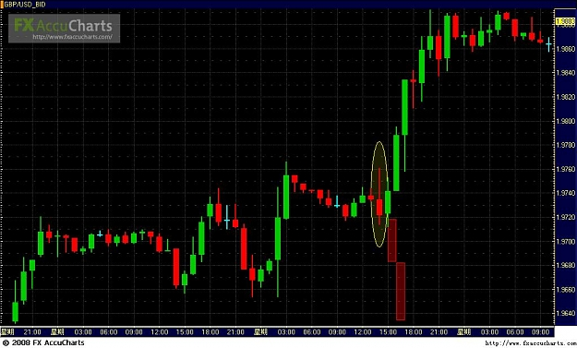
FTI:
Quoting rapaduski1
Hi all,
David, I just read your last post and would say that the actual candle after your circled candle is an engulfing candle that would scare me to death( correct,trusting analysis on one candle and pridictive mindset dangerous, must see continuity and compounded patterns. you may trade position but adjustment to upcoming patterns critical due to candle traps. This is weakness of many rigid analysts) especially given that the trade is against the 4H trend. Perhaps in the future, when the imaginary candles do not develop, you are just better off killing the counter-trend trade and riding the trend up, which seems clear as the day developed. In know, paper trading is always 20/20.
In addition, you seem to use the shooting star candle as the main reason for assuming a move down. I am pretty conservative in my trading, so call me carzy for saying this, but you may want to establish a trading rule that says you must have at least 5 reasons to enter a trade (that would be five facts/observations rather that assumptions) before entering a trade.(this may become rigidity perspective, careful there,)
Hi Rap.
dangerous Mo as well due to rigidity.
Quoting luSan
David, I have been there and I know your agony.
You fought the trend and that is not good.
The basic problem is that we get use of fighting the trend with the believe that it will always revert and that is not true at all; there will be case in which we find so far away that MC could happens or we cannot take the bleeding anymore. In my case I lost 1.5% only and that was enough to put into an extensive review of my approach. What is the value of a high success rate when all our ant work could be destroyed by an careless fight against the trend? None.
Do you remember when I was saying that we need to decide when to pull the plug, when to say 'Ok, I am wrong." That limit is different for each of us. I think that we need to set that limit BEFORE we begin the dance, because the dance itself will blind us. The dance will not blind you, it is you that is blinded from the dance. By our own ego. As clearly is the case for David.He was so focused on that he knew her moves watch her ams and didin't see her legs kicking to his groins.And even when they did He didn't felt that it had hit critically and still focus at the arms because he felt that he couldn't be wrong. That's egor.Yes, we will not win as often as before, but we will preserve our capital to fight some other day.
Because of my previous problems similar to you I put together my '10 commandments". Your trade violated 3 of them: never trade against 5M trend, never stay on a broken trend, never trade without a relaxed and clear mind."
I looked to your chart and marked the trend and my 'drop dead line.'
What to do? That is easy: (1) Review your basics: you were rescuing against the trend, rescue is done only for timing, He knows this one, he even wrote a posting about it some time ago, I am too lazy to try to find the posting though.(2) Review your size and dance, (3) Rebuilt your confidence.
Let us not forget that we are learning his strategy. fti told us that it would take about 2 years to get some competence, and he also said that large size and aggresive trading are premature, that we need to go slow and easy. I believe him very much and I do microsizes...I see myself I am NOT a trader but a student of his strategy.
I hope this help.
Hi Lusan,
thanks for highlighing.
Not babysitting exposure carrying loss over night and attacking when adverse, thats too dnagerous, no excuses valid.

FTI:
Quoting rapaduski1
I am not sure what you mean. Late for what? Entering trade? I am just saying you need some guideposts before you make a trade. For example (and the examples are endless):
1. Am I entering with the 4H/Day trend?
2. Am I entering with the 60M or 30M trend?
3. Am I entering after a new support or resistance has developed in direction of trends?
4. Do I "sense" momentum entering the market?
5 If this goes against me, can I live with a pain threshold as indicated on an upper compression chart?
My only point is, if I am going to enter a trade, it act of entering the trade is based on facts and observations of the market and the dance, not wishful thinking. Hoping before a trade is worse than hoping after entering, I think.
Hi Rap,
I understand your comments ,they are clear.
But 4 hrs trend, half hr trend, I never had consideration, in that aspects.
With rigid patterns analysis, you shall utilmate be impaired by them , likely that you will be late or disadvantaged in your positioning.
Quoting rapaduski1
Hi fti,
Agree about being late sometimes and it is a disadvantage (a frustration, too). I tend to look for the center cut of the melon and sometimes the whole darn thing passes me by, but I find that there are many opportunities each week. You are absolutely right, as per my own experience (I need to switch to decaf coffee, too).
One thought about this discussion that is going on now. We are jumping between MM and trade execution in our conversations. It seems, however, that a discussion about MM in the context of, what all agree on, was a bad trade may not be in our best interest. I think that a trade against the trend is a mistake, and probably should be killed right away. An attempt to save a bad trade against the trend is a MC waiting to happen, as in this case. Fti, is it appropriate to say that when you discover a trading mistake (e.g., not a timing issue but against a major trend) that you need to head for the door and protect your margin? Again, perhaps too ridgid?
Hi Rap,
Killing scouts is not a good way to "dance". Its function is to keep focus on market activity, as a conduit for market form, if you like.
Its positioning is of no consiquense to trade but to lead.
If scout is dead in waters, it is allowed to bleed.
The followup action when bleeding stops is subjected to its position and the voli of the markets,
the higher the voli, and the sigma, the more likely it is that the scout would be replaced by a new party.
On low voli intrutions, the scout is benchmark for attack.
Like youmentioned, indiscriminate killing of scouts is rigid mindset, in so far as my MO is concerned.
Quoting lilpip
g/u 1xb 9835 scout in
lilpip
the standard protocol for position reporting on blotter is, in your case
G/U BOT x 1 x 1.9835
please pay attention !
Your scout seems good you bot near the low of the day,
So whats your MO now?
what mode should you be in?
whats the safest skew based on market volitility?
Whats safe attack look like?
Whats safe rescue look like?
Estimate your rescue threshold.
Quoting Green_David
@zenseven, Lusan, Jest
You advices are taken. Thanks.
However, please read carefully. I didn't open positions after that shooting star. The shooting star was formed after I fininished scout and first attack. In this sense, I was right at least temperarily.
I realized the following 5min and 15min candles indicated me some doubts, that's why I closed some positions. The problem is either I did not close all, or the reducing the size is not enough.
Making mistakes occationally are unavoidable. What is more important is how to deal with mistakes and what learned from the mistakes. In the battele field, in the real-time fight, it is not that easy.
David, you are wrong, trading is the most natural business, esp markets as it is freely traded.
There is no conflicts at all, its all your MO, thats confusing you.
You are confusing yourself. Crisis is opportunity in adversity, you are chinese, you must know this, should you?
Steadfast in riding and manouvers.esp to MO.
Nimble to change.
Prompt actions when the time window opportunities opens.
Patience when the terrain is unclear.
Confidence in your analitical ability and contingency capacity.
Ability to subdue ego, and follow the markets lead and hints.
Guts - Ability to risk without panic and disorientation.
Conservative when in doubt or when position is adverse.
Where is the conflict?,
You have conflict because your skills may be unpolished.
Enough of hammering, reason with the man in the mirror.
15 Min – 14 July
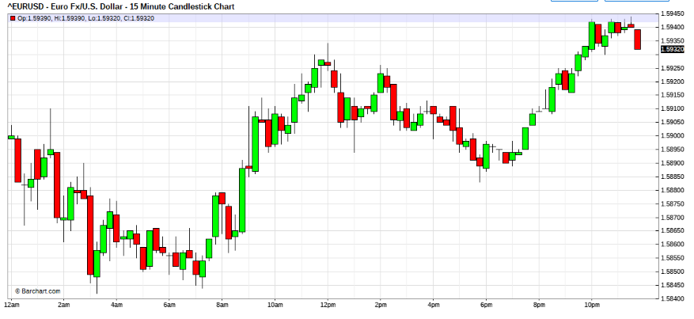
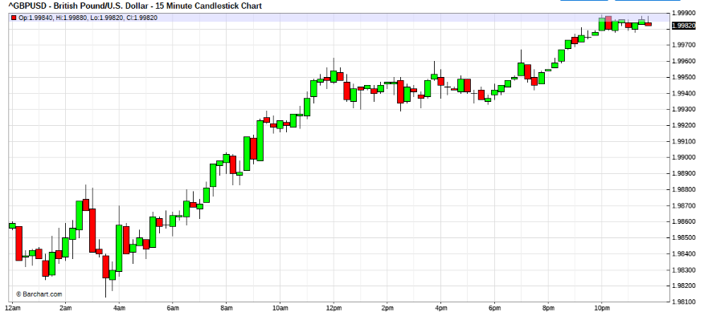
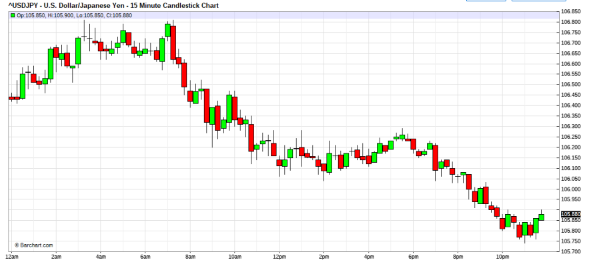
Jul 14, 2008 2:43am
Quoting lilpip
g/u bot x 1 x 1.9835
mo if trade goes the way I plan which so far it is, when the 9825-35 area tested again eyes are open to the action.
If heads up past 9865, starting to eye for attack.
dont know what mode r skew means yet- skew of attack? 1x3x6
Most trades closed by fridays highs.
1st resque attempt would be in 9815 area,9787,9759
attack I guess depends on the movement of 7 5min.bars and how they unfold.
hey lilpip,
what have you been doing, sitting on your scout?
Just that you know , eagle eyes now, London boys are coming in soon. watch for action.
Notice cable yen crosses in progress. Entry on stealth mode.
watch it, USD bears in action now. 1st wave
do not chase in size, watch that USD/YEN. may be usd bear trap, be nimble.
remember we are still in USD daily chart coil.
USD/Yen buckling. pressure from cable

Greenbag bear loosing steam, within coil, lickly insideday range play.
watch your position sizing.
3 kdm out of line, no trend.
If mkt sweeps, I shall be off line, watch you own behind, pls
Hi,
What a balls breaking day, nothings moving.
Freddie and fannie Mae seems to be the talk of town, For the time being , the USD bulls seems to have much ammo. Whether they will behave is to be recon from the charts.
Bewary that the ground may be shifting to bull USD for a little time.
Oil prices stabilises,?? funny. The equity market like to take the bull by its horns.
Wonder whether this is true bull or just BS.
The coil continues.
Oh,,,, patience, and its virtues, not even enough range to scalp.
Thank God, I had to run some errands, would have overload on the coffee, otherwise.
Jul 14, 2008 9:08am
Ah, no USD bull, bear USD bias was correct.
No Bull USD in sight still.
Cable , she was telling the truth.
oh my God, I am eur/usd
Bot x1 x 1.5875
Bot x1 x 70
Bot x1 x 67
Bot x2 x 63
this is my base x5 aka scout
strategy impulse range, no attacks expected, nevertheless we will see, as we go along

bot x5 xeurusd x1.5867

Quoting maheswara
im out with profits was scalpin a little to buffer out , in the end all out with small profits , will watch n see if bear trend resumes in usd ...
Hi
Seems Usd bears abound. with all the bullishness in USD fundamentals, sure is a disappointment. Stay nimble still, not out of coil yet.
Jul 14, 2008 10:01am
hearing one bank gone chapt 11, Who?? Indymac
eurusd
s x 2 x 1.5906
s x 5 x 1.5900
s x 1x 1.5897
s x 1 x 1.5895
s x 1 x 1.5891
now squared

10:36am

I am missing 2nd wave.
unable to reestablish Eur, due to comp system.
not chasing

Jul 14, 2008 11:53am

Quoting auxesis
Indymack was taken over by the FDIC, losses expected to 9Bil. Insureds wup to 100k will have their deposits insured, those holding over that are looking at 50% on the dollar.
FDIC has something like +50Bil to back up deposits, before Indymack, there are some 90 other banks in trouble with a reported total of 28Bil deposits.
Hi auxesis,
looks like the fed's gonna have their hands full again. 50cts on the dollar is ok, was guessing like 20cts to 1
seems there may be another wave in the eur/usd after lunch, patterns clinging to top, wondering how far they wanna sweep before it happens.
Any feel, ppl?
sharks, spoke too fast, patience, wait for the time window.
mkt pre ejected, USD selling orders may be aggressive.
Yeah its showing up in all kingdoms, so gotta be orders.
Battle stations ppl , the baby's moving
12:23pm
Quoting MaMood
Anyone dancing with U/J?
I'm waiting for a new short entry, after I have squared my short position @ 106.17 (incl.scout) ...
Nope, not there.
But I can tell you, your windows already open.
And she's lagging behind the others.
That cable, she gona along way, lloks like she's gonna blow thru tops, but she's missing one leg though.
Is this the start of something, dunno, gotta watch carefully.

12:29pm
eur$
b x1 x1.5915
order b x2 eurusd x 1.5925stp
order rejected
b x2 x1.5927

12:50 pm
Quoting MaMood
What's the meaning of stp abbreviation?
was it a buy stop order?
yes it was.
Sold x 4 x eurusd x1.5922
now squared
order buy X2 x eurusd x 1.5915 OB
unable and CXL
bot x7 eurusd x1.5934
01:13pm
bot x3 x eur usd x 1.5927

01:44pm

position bleeds now. anyone feeling the pain?
Bot x 5 x 1.5914
mild rescue delay due to system hung.
My God, horendous timing. Here comes, out timed.

Quoting MaMood
Hi fti,
How are you doing? are you still in rescue mode?
03:03pm
Hi MaMood,
The weakest point in the access chain is the strongest robustness.
This is the reason why , contigencies and capital buffers must always be in position for wierd eventualities. This access risk is inevitable for retail forex trading.
sold x 5 x eurusd x 1.5920
yes mahmood,
I am still engaged in my position rescue.
Could have done better, but was unwilling to expose the normal skew, due to coiling of the patterns.
Dealers and traders we have out work cut for us, there is nosuch liberty as time restricts and availability restricts. Further mindset robustness and coherant risk management is integral part of the prerequisites of the business.People think tsis business is easy money, that , is the archelles heel of many uninitiated.
As you may have noticed, sometimes, we burnt our candle both ends for noughts, but if we didn't then we fail.
sold x3 eur/usd x 1.5921
sold x4 eur/usd x 1.5923
03:22pm
sold x3 eurusd x 1.5923
now squared. looking to reestablish scout for carry trade.
OK, these has been a couple of follow the dancer sessions.
I hope that many who do not understand, will after having seen it live, will have a better understanding and feel as how to dance, with the correct mindset, MM and capitalisation.
A pot of roses was never promised. However if you are dedicated, and progress diligently, with a level mind on your shoulders, you may just make it to the pinnacle.
You have seen how I do it, you may be a little unsure why you cannot find a rigid regiment to follow. This , non rigidity coupled with the necessary ingredients , which I have always emphasised will stand you good , if you can put it into practise.
As you have seen it done, now, do it for yourself.
Do you have what it takes??
Only you can answer that question.
Its the deep end , if you take the plunge, either swim or sink. Its all you.
Trade well.
Good Fortune.
Quoting MaMood
Just a question to your yesterday session:
Could have done better, but was unwilling to expose the normal skew, due to coiling of the patterns.
Your blue marked statement above. Is this not a kind of predicting the furture?
I always have problems to determine between having "some expectations" for the market due to candle formations and so on and predicting the future (You know, the often cited fortune teller...).
How do you draw the line between legitim "market expectations" and "fortune telling"?
No MaMood, that was not meant to be predictive. That was my undertone.
based on what i saw in the charts, it was coiling and kingdoms were in conflict. My undertone was that there would be USD bear bias, so I decided to tone off the normal skew of attack and that attck should never go deep unless backed by good foreign capital for ability to risk. Thats why, the attack was mildest as possible. Of course the profitability recipocrates.
If you noticed after the attack, the skew went into level down. That faclitated reacue possibility, otherwise the rescue would be sized up. And even that inward spiral, took risking most of initial profits, to recover.
All trading , insist on traders to have a bias from pattern analysis. This bias , must never be used as "absolute", sometimes the bias is on the ball, sometimes it is off course. This bias should only impact the basic strategising of MO and MM, and must never dominate "dance"(ryhthem) nor "form" nor trader emotions. It is a function of strategy.
The latter must come from the price gyrations and the point of reference for that is in the "NOW". Now , does not mean only price,althought it is of grave importance. It incooperates the price and mode of gyration (movement). It is hard to describe, you have to be in to feel it.
You have to be on live to understand, reading will do little for understanding. If you were following the trades, try recontructing the trade mindset and sequenses of events again, it would be meaningless.
Courtesy of Karen, my wife.
For your reading pleasure....here it goes....
The first day of school our professor introduced himself and challenged us to get to know someone we didn't already know. I stood up to look around when a gentle hand touched my shoulder.
I turned around to find a wrinkled, little old lady beaming up at me with a
smile that lit up her entire being.
She said,
'Hi handsome. My name is Rose. I'm eighty-seven years old.
Can I give you a hug?'
I laughed and enthusiastically responded,
'Of course you may!' and she gave me a giant squeeze.
'Why are you in college at such a young, innocent age?' I asked.
She jokingly replied, 'I'm here to meet a rich husband, get married, and have a couple of kids...'
'No seriously,' I asked. I was curious what may have motivated her to be taking on this challenge at her age.
'I always dreamed of having a college education and now I'm getting one!' she told me.
After class we walked to the student union building and shared a chocolate milkshake.
We became instant friends. Every day for the next three months we would leave class together and talk nonstop. I was always mesmerized listening to this 'time machine' as she shared her wisdom and experience with me.
Over the course of the year, Rose became a campus icon and she easily made friends wherever she went. She loved to dress up and she revelled in the attention bestowed upon her from the other students. She was living it up.
At the end of the semester we invited Rose to speak at our football banquet.
I'll never forget what she taught us. She was introduced and stepped up to the podium. As she began to deliver her prepared speech, she dropped her three by five cards on the floor.
Frustrated and a little embarrassed she leaned into the microphone and simply said, 'I'm sorry I'm so jittery. I gave up beer for Lent and this whiskey is killing me! I'll never get my speech back in order so let me just tell you what I know.'
As we laughed she cleared her throat and began, 'We do not stop playing because we are old; we grow old because we stop playing.
There are only four secrets to staying young, being happy and achieving success. You have to laugh and find humour every day. You've got to have a dream. When you lose your dreams, you die.
We have so many people walking around who are dead and don't even know it!
There is a huge difference between growing older and growing up.
If you are nineteen years old and lie in bed for one full year and don't do one productive thing, you will turn twenty years old. If I am eighty-seven years old and stay in bed for a year and never do anything I will turn eighty-eight.
Anybody can grow older. That doesn't take any talent or ability. The idea is to grow up by always finding opportunity in change.. Have no regrets.
The elderly usually don't have regrets for what we did, but rather for things we did not do. The only people who fear death are those with regrets.'
She concluded her speech by courageously singing 'The Rose.'
She challenged each of us to study the lyrics and live them out in our daily lives. At the year's end Rose finished the college degree she had begun all those years ago.
One week after graduation Rose died peacefully in her sleep.
Over two thousand college students attended her funeral in tribute to the wonderful woman who taught by example that it's never too late to be all you can possibly be.
When you finish reading this, please send this peaceful word of advice to your friends and family, they'll really enjoy it!

These words have been passed along in loving memory of ROSE.
REMEMBER, GROWING OLDER IS MANDATORY. GROWING UP IS OPTIONAL.

We make a Living by what we get; we make a Life by what we give.
God promises a safe landing, not a calm passage. If God brings you to it, He will bring you through it.
Pass this message to 7 people except you and me. You will receive a miracle tomorrow (if you don't think so...look out your window when you wake in the morning and think about it )
If you choose not, then you refuse to bless someone else.
'Good friends are like stars..........You don't always see them, but you know they are always there.
Quoting Zoran
Very wise indeed.
When we achieve all that we want and stop creating, we become "The ALL" and enter a phase of self-destruction. In other words, the living dead.
It's through change and creation that brings life. Now that I have read "Tunnel Thru the Air Or Looking Back from 1940" by W.D.Gann, I realise that love is life!
fti, I think you have passed the message onto more than 7 people. Will you still get your miracle tomorrow?
Hi Zoran,
I got my miracle, a long time ago.And have lived it.
Now the almighty , had created a medium for me to pass it down to others that they too may find it in their life.
The human kind is full of love, mostly things are not shared, because they cannot afford to. We have to be able to afford it, to share. Many don't have enough, therefore it is difficult to share that which they have need for.
If you master what I tried to pass down, you will have abundance to share. Then sharing becomes afforadable to you.
However when you share, you must look after your own scurity concerns.
As when you have much to share, so shall you attract the devil whom seeks to rob you of it. Skill is something that cannot be robbed.

15 Min – 15 July
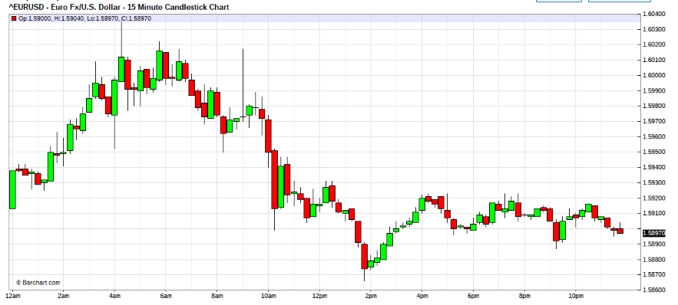
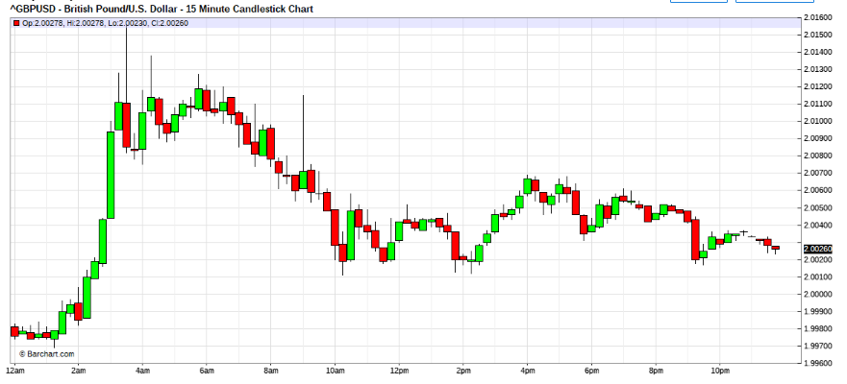
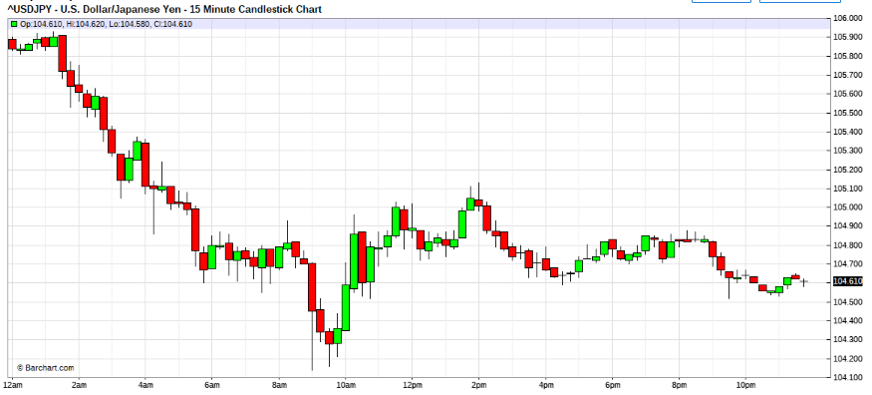

Jul 15, 2008 11:02am
see those tails, its heavy arsenals, to counter heavy equiptment, ----mobility.
stay light weighted , move quickly.
flow with it, then take potshots.
don't send in the army, you are outnumbered.

Pace her, don't fall in love with bias,
Its no time to get sentimental.
Regroup for lunch then eagle eyes her.

Quoting luSan
Chief, thanks for giving us your wife gift. I will pass it along.
Yes, I am done again...Enter long...then so the lady changing on me...and quick reversal with 2 waves...I capture the first large wave...over all: 111 pips...Enough for the day.
Although I cannot figure out why the dollar is getting stronger...Ben said that economy is going to hell this year and next one...only if the European drop their rates...but their inflation is getting worse...who knows...I just collect pips and laugh..
Hi Lusan.
he's signalling that his hold the rates stance may change. and he may change his stance to favour rate hikes to undo the damage his last action did. and markets vv short USD, all scambling to bail out aided by owners.So more snooking of weak holders should come.
Don't think now, anything is possible stay with flow instead. All bias will now be speculative thinking only.
For me today, had been a vv good day. Just buried a dead scout. However the damaged was easily rectified, now flowing with the river, and looking for possible exits later.
The feds is very insistance that the 1.6000 range be not taken out. Note their timing. and the false sweep over it to trap.
For now they have the podium.
Chartwise EUR/USD 's 1.6000 is very resisted . is it gonna be the interim top, who knows?
Quoting luSan
Thanks...I did bury that man too...Gosh! the day and hour trends were long...but we ended up going short...that says a lot about not falling in love with the wrong woman..I was feeling sorry for the scout...I killed him!
by they way...oil is falling rapidly on expectation of lower demand from weak economics...I think that they are accepting stagflation
not really too bad, Daily chart reversing very deep, Hourly charts have long tails sticking out. means that evey attempt to rally was snuffed out.
Count your blessings, that it was only one dead scout.
Picture those trading indicators, haven't got wind to it yet.
I guess mostly becomes sitting duck stops somewhere below the market.
if we end today witha reversal bar ., there will be much down side probing in the EurUsd for this wek at the least. If we manage an outside bar reveral (key reversal) the bottom s gonna fall of the Currencies. There's not enough info just yet, but the momentum seems reversed by the lip service.
I would suspect that some technical incicators are turning ,good luck to them.
Hope they not too late!if it does turn.

Quoting MaMood
Hi fti or other "market whisperers",
may be a silly question, but how do you know that the FED has done something in the market?
Do you know it from your deep experience? Is it the way the market moves?
Or is it just your assumption?
Hi,
At the bank levels, when they come into the market, their access is thru tier 1 banks, for the feds its the US teir 1s. It depends ,
if they are just checking for info, then friends and interbank brokers of those would know by means of encrypted conversations that big brother was asking.
if it was market ops (intervention) , then the teir1s would be under china wall shutdown and would be operatiing for the CB's behalf. About half a hr later these teir 1s would inform the media, reuters,AP, IP that the CB was in the market and what they did. And thru the news services , the info would be broadcasted.
There are several patterns formed when these happens ,on short charts, that signify big hands overshadowing the market, by its gaping behaviour and scattering markets, while the load is distributed thru the market structure, that prompts.

Quoting CHFJunkie
Dear fti,
Fundamentally I can't see any justification of the up move started last week, except the takeover of fannie and freddie. Commercials and large speculators are not supporting this move , they have been unloading and adding to the support of the shorts.
in addition to the record low zew economic sentiment, the eur's main support.
Technically , All I have been seeing was bearish signals then a failure of the signals during the past two weeks.
Now I think this move as an upthrust in a distrubtion range which will be confirmed by the close of today's bar to see how much the market rejects the 1.60 level.
Hi,
Well fundamentally, there is little factors to point to any strength in the greenbag, if any thing the last fed actions had created spill over effects to a devaluating dollar scenario, prompting weakness for a longer term perspective stand point.
However ben's actions today in coming clean about the impact of the fomc actions, and the hinting that monetary policy may change does have a spook effect on the market place.
Just speculating, I would be inclined to wonder , of a fomc that wants to behave reactive to the ground. What if they decide this time that they may have eased the immediate subprime problem and felt that they could test the grounds with a 75basis rate hikein respose to the EU's last actions. What do you think would be the markets reactions.
If you are a USD bear riding, your possitions, wouldn't it be prudent that some profitaking and position realignment would suit. At this level of a major big figure test zone. Coupled with ben's broadcast, many would be prompted to resize, notwithstanding squaring out.
Technically, the chart actions today are indicative of key reversal. On whether this reversal is a major Top, or a precursor to USD strength. well, thats left for us to speculate on.

Quoting CHFJunkie
I agree.
but my count here is the EU economy is much more fragile than that of the u.s.
that it can not handle a crisis like that of the u.s. with the least signal we will see euro dropping like rocket not a stone!
Hi,
your opinion is noted.
As for me I am only market player, so I prefer to follow the market as she dances, sorry my crystal ball is broken.
In my opinion, robustness of economies, is a very subjective topic to discuss. Its myrid facets excompass perspectives that are too wide to allow anyone to come to a conclusive judgement. Only thing I can say is that the US now, have the deadliest armed forces.
15 Min – 16 July
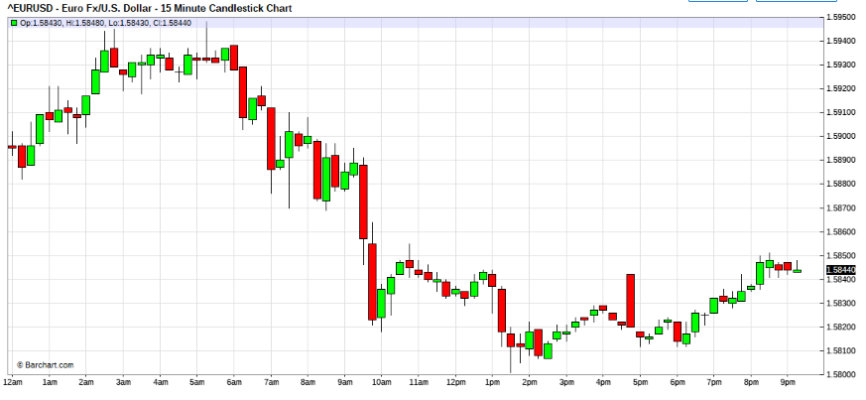

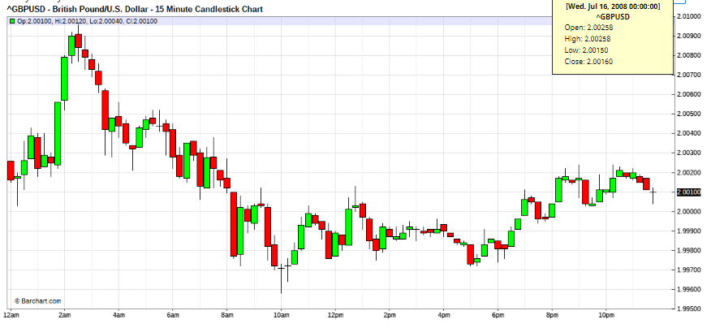
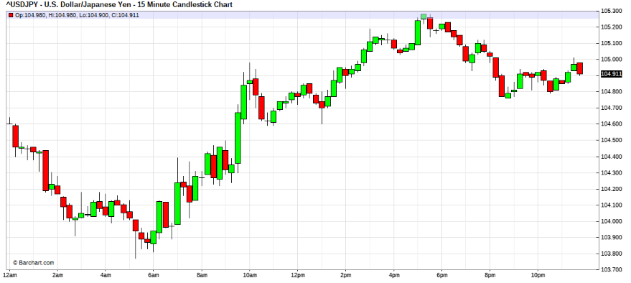

Jul 16, 2008 3:05am
Hi ALL,
What a long long day?The pips makes it worhwhile.
Looks like we may be getting into the eye of the storm.
The coils too tight already, london boys stalled.
Wonder whats coming our way?
Cable & yen says sell the greenbag. trying, but be cautious, Kamikaze scout deployed.
This will not be hand held session . If you do depend on your abilities, pls.

05:16AM
Hi,
slow dance, feels like wellington zone doesn't it?
the scout he's confortable and very . the action seems to be at the queen's court.
Scout came home. Wrote a long report about the traquility of the Eur countryside. LOL

July 16 2008
Quoting piccolo
from BBC World: US regulator curbs short-selling
Bear Stearns is the biggest casualty of the credit crunch
The US regulator has passed an order to prevent some forms of "short-selling".
The rule will prevent traders from taking certain "short" positions in major financial companies, which some blame for the slump in share prices.
It will apply to US mortgage finance firms Fannie Mae and Freddie Mac, which have seen about half the value of their shares wiped out in the past week.
Crack down
The rule, which will come into effect on 21 July, is part of efforts by the Securities and Exchange Commission to crack down on suspected manipulation of market prices.
----
so they might not "nationalize" the big mortgage companies in the end. just stop the bleeding and give room to recover.
Hi picolo,
Wow, has it gotten that bad. Looks like the systemic core may be damaged.
Its bad when they put the ball in th park for everyone to play . and when things gets hairy,
Change the rules of the game.
Esp stopping the game and taking back the ball.
Dangerous move , IMHO.
The cure may become worst than the disease. There must be better ways.

Hi All,
Eur/usd 1.5865 support is very hard to crack. and still attempting, outlook now very uncertain.
Best to be aside.
Stop order attempts may help, suspect if crack may be "fast markets"
other kingdom patterns do not support crack possibilities, for now.
stay vigilant.

Quoting joypips
hello fti and everyone
fti thankyou for music, it is appreciated please don't stop
today i see the cross pairs having all the action eg. gbp/jpy
i remember earlier in thread you talking about cross pairs tearing beware, but with so much learning i have forgotten exactly. please could you remind me.
Hi ,
Sorry Joy, missed this question earlier.
when major spots do not move in sync , it is normally due to crosses driven by underlying fundamntals.
When this happens, NORMALLY the greenbag is not in trend mode. you have to get some experience in watching , the kingdom characteristics to know how to indentify , which is which.
When there are influencial fundementals, as in now they move by their own momentum. (tear from sync activities)
Eg this week, the USD/Yen is tearing from mainstream sync , due to that the swift drop in oil prices is prompting hedgers in Japan who bought USD for oil stockpiles unwinding their hedge.
The underlying dangers on the Japan industry is relief , therefore some unwinding, and the tear happens.

Jul 16, 2008 11:47am

Hi All
was a good USD bull ride, huh.
Very orderly USD buying. maybe more to come , stay peeled for CME shock, if it comes.
That 's after lunch and i think the luch will be short,
otherwise indigestion, LOL.

one more thingy, if eurusd below 1.5865 by cme closing range. be watchful for swarm of moc orders to buy usd.

Quoting lilpip
I've been having a hard time getting a feel for the e/u since ny afternoon session yesterday.
My scout is out @ 5826 as I try to find a rythem.
Hi lilpip,
the direction of the USD is known.
What we cannot tell is , how they wanna pan out.
feels like the game is at the end day sessions.
The market is stabising for USD bear bailout it seems, mild nudge and slowly building up usd seems good strategy for now, and no chasing for USd in the market please.
Let them do it at the end of day.
thats my general feel, its going to try to make usd holders tired and to give them away. I think rap is collecting USD from non patient holders on the thread.
Hi,
anyone notice how orderly the usd rise is?
some big big boys are buying the greenbag and holding down the dollar to buy.
Sorry, he can get my USD at 3:30 NY afternoon, no sooner, LOL
and at much higher levels, I hope.
I may give them some EURUSD @ 1.5800, ok?
Yeah and maybe push it pass1.5870 that would snook me to give him my USD.

Quoting CHFJunkie
by the way fti, how do you evaluate the value of the usd in the market?
how do you know if it's overvalued or undervalued?
Hi,
I never do , and never will.
I was a pro, and pros do not make intelligent guesses.
I only know price.
You may like to check up with some economist, otherwise you could check it out with the fishmongers, they roughly know the value.
15 Min – 17 july

Jul 17, 2008 2:59am
Long USD
Eurusd 1.5862 ave level 2 attck
Checking your music out

Quoting MaMood
Wow - seems to be a tough dance so far ...
Hope you'll bring/you brought your troops home.
Hi,
After the USD sell off after NY close, seems market has been a collector of the greenbag.
Seems the market is being held for the collection.
So I think big boys may be doing the USD collecting,
USD may be in this mode until they finish , the collecting.
Generally, not chasing the market, but can feel underpined usd strength.
Completed level 2 mild attack sequense.
Waiting for time window for level 3 attack to initiate.
USD/yen already in 2nd impulse, gotta eyeball that on the Eur before sequense comenceses
Oh, another thingy is that since lunch have been experiencing much sweep swings, mostly false breaks.Evidence of the greenbag collecting.
Notice how the usd buying seems to be sustained in the USD/Yen, I suspect major collectors may be from the rising sun.
15800 is nice figure isn't it?
maybe 15775 looks sexier?
Sure would be nice to have some cooperation from the queen's knights. Why so , quite ?
Jul 17, 2008 9:17am |
Now we should be singing , 9 euro bottles sitting on the wall. and...

Hi All,
Does anyone understand what I am babling about? ie am I coherent to anyone?

Quoting ksl
eur has resistance where as gbp is clibing jpy hardly moving. does't make sense......
Jul 17, 2008 9:37am
that's cos' our friends ,from the land of the rising sun had been at it the whole day
(refer hourly charts)
while the Eur and cable slept.
Its about time for them to get into gear, don't you think?
were you sleeping too,? What have you been smoking? LOL
update: now we have 11 bottles sitting on that wall.
sorry , you re on your own, battlestations.

DutchAngel:
Quoting MaMood
to be honest: No - sorry.
It's somewhat difficult for me as non native english speaker.
The other prob: I'm not used to all this pictures and shortcuts like:
- queen's knights
- 9 euro bottles sitting on the wall and...
- land of the rising sun
queen's knights - gbp
land of rising sun - japan
bottles on wall - song that bottles fall of one at a time so if there were 9 now there are 8
Correct me if i am wrong fti, cos i am smoking something, no worries tho everything is legal here in Holland
FTI:
Hi All,
Ok a little time, so let me try...
Look at the hourly charts for the 3 kingdoms.
Some yoyo's been buying USD whole day ,
when the eur reacts. buys euros as well,
then GBP.
So Usd/yen keeps going north.
but whats happening to Eur and cable.
If my guess is correct there's gonna be a lot of yen floating in the market.
Question is , what's happening?
We know that the feds is handling some credit/ money problemie freddire&fannie.
So they came out at critical level for USD, may be bottom of the float range.
Then some yoyo is doing this yen stuff, and seems big enough to impact the whole market esp in crosses and inparting spot majors.
In the background oil is doing the snake and ladders. So you guess?
Take a close look at the Eurusd hour charts, any tech person would see something big in the horrizon. NO?

We can guess whats the big event brewing, the possibilities? high.
million $ questions when? how?
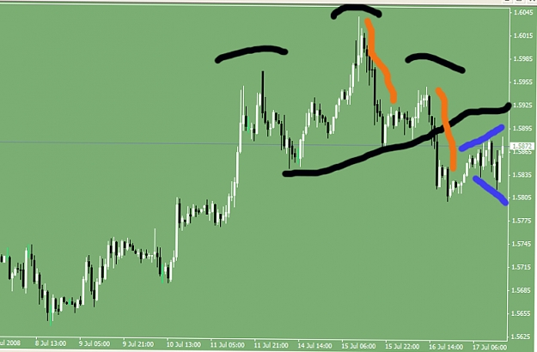

Quoting DutchAngel
Maybe its not about the song i was referring to, thats why i asked to be corrected. It its not I think its the 9 small hourly bars before the last couple hrs of choppiness. They signify a continuation of the downtrend.
Also I see a complex head and shoulder formation on hourly, and downtrend line that gonna be hit. Will it bounce off and dollar strengthen or breakthrough?
You were right dutchangel,
but the whole day the markets been weird.
the bottle were lining up like for firing squad, then some yoyo comes mess it , its intentional,
only thingy is the puzzle is still in pieces. for now.
And I thought I was the one needing sleep????
The quwstion is why is the yen dumped enmass. for USD, EUR Cable.
Didn;t check the swiss.yet.
The question is why, and WHO?
Corp or CB.?????
All eyes are on US, there seems invisible parties?
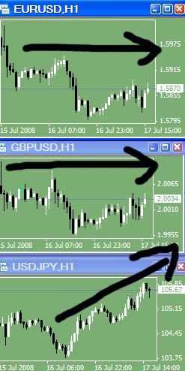

Quoting DutchAngel
Hi fti
The yen dropped against the dollar and the euro as better-than-expected earnings at JPMorgan Chase & Co. encouraged investors to sell the currency to buy higher- yielding assets outside Japan.
You can read full article here http://www.bloomberg.com/apps/news?p...currency_rates
Hi,
And they are so huge that they are impacting the whole Forex market for such long tenure?
A bit hard to swallow for now. lets see.
They must be moving trillions, or has the forex market shrink to become so small??  Probably Japan may shift to US???LOL
Thanks DutchAngel, at least something. to explain.
regards
Mnnnn, Just And after thought, sure would be a nice way to use surplus investments to fund Freddie and fannie. Is that what they are up to to save them.???? So watch that couple carefully. OR could be they wanna buy London Bridge. LOL or mat be autobahn,
Or maybe they buy USD stealth mode, make announcement of USD purchases, sudden USD rally , profits, no need to buy ANYTHING, Just perception will do , LOL
Oh my wished I had something jap to sell, and buy Eur, Wait a minute, some ppl I know , they have Jap cars, lets see.....
Jul 17, 2008 1:05pm
By the way looks like gotta wait for CME closing again, and let these stop orders do their magic.LOL

Quoting CHFJunkie
The question is ,"How do you evaluate the usd strenght in the market?"
from a fundamental point of view, and here I'm not talking about economic releases?
Du you use intermarket relationships?
How do u know it's safe to enter a trade in an up or a down trend?
I analyse the markets charts for signs of what's happening in the markets, ie your mention of intermarket relationsships, looking for stories that it wants to tell me , in its behaviour"form" and patterns. including the sigma and volitility sequenses. I time trades by market flow and volitility.
And staying tuned to breaking news and happenings in the market place . as best I can now, that I am no longer at thebank. I used to see large paper flow from customers and watched orders.
There is no safe place in the markets, you come in then you have to manouver to stay alife. There are no safe levels, any level is as good as the next. If your money management is good then you should survive. If you are egoistical then the markets will teach you humility. If you are sturborn it will teach you respect. If you think you have it all analysed, she will outwit you and show you the meaning of variance. There are many lessons in her that an average man will not be familiar with. The market it has wisdom and equilibrium, little intelligence. Oh and she is also very unforgiving to those who are impatience.
Quoting CHFJunkie
Back to my Qs, I always look at Gold and T-bonds to know the likely direction of the USD.
Also of all the things I know, the most important thing is money managment.
I use a formule based on risk factor of 10% and expectancy of 70%.
what about the one you use?
Hi,
Important component as it may be "Money and deposits" ie capital markets is only a small component of all factors that moves the forex markets. It is impossible to figure all of them from the demand or supply side of the equation mix.
Also money management and risk management are different issues. What you mentioned is risk management. That has to do with ruin management skills, nothing to do with trading skills.
Oh another important issue is inteligence , not unlike water is flexible . checklist type robotic methodology is rigidity, it kills dur to its inability to adapt to environment.
A little knowledge is a dangerous thing.
Quoting CHFJunkie
No, it's not double tops or bottoms.
it's a three bars pattern.
Hi,
oh, compound patterns, there's a few thousand, just for candlestick charting alone. Which was taught to me by my japanese under-study when I was heading a Jap bank treasury, eons ago.
I normally stick to my own school, and I do have funny names for them, myself.
Yeah, those are powerful tools. Only wished we had some stadadisation in naming convensions. Then it would be easier to discuss about it.
I do not use themm conciously , as my education was stalled when he was recalled to tokyo. However, I have seen its capabilities.
Quoting CHFJunkie
what books you like to read?
Generally , may not related to trading.
Books, that can help in forming the philosophy u recommend.
something other than sun tzu's art of war.
Have you read the way of warrior trader by Richard McCall?
I read about much anything, that can hold my attention span.
Read a lot more when i was younger. You would be aurprised at some of the stuff I read. These days , being old are tire easily, I read a lot less. Use more of the medias now.
Other than Sun Zi, the Bible's good. most everything about anything is in there. If you take the trouble to seek, you shall find.
No sorry didn't read about McCall's warrior traders. He'll have to make it to top trader circles to catch my attention. Too much of the same stuff being published and its hard to keep up , with people rehashing old ideas.
Normally good traders do not write books. They don't need to and probably don't want to.
Moreover time and rest is of essence. Of course there may have some with good ideas, but if it doesn't filter to bottom line, its just good ideas.Nice to have but difficult to live with. There are some "secret" mentoring manuals around. These are normally research manuals and mostly non performanced documented ideas.
It is close to impossible to aquire trading skills from reading This can help in foundational ideas, concepts and basic tenets. Trading is a skill that have to be learned thru the mentorship of hard knocks school. I know no successful trader who aquired their skills from reading, mostly from thinking and experience.
Trading is a life style, gotta match the personalities to the skills.
Successful traders all have difering styles, they all work. No one is better than the other, bottom line rules. We are as good as our last trade.
Learn how to trade well, and you will never again be without anything that you want in life.
Hi ,
yes, anybody using any style can make money sometimes. that is true.
But to be consistently and steadily profitable in all conditions, requires more................................ anyways, to each its own.
I don't agree to that statement , at all.
I have maintained about near 100% scince I was senior at the banks. Since The start of this thread, I have maintained 100% profitability in demo. Since trading live again, I have maintained 100% profitability, every trade. Some were scary, but all came home.
And I know many veterans that are in this league. So be fooled that 100% profitability is a dream, it is being achieved.
Cold losing streaks...
Quoting monies
I just want to reply to that last comment,because it seems that you have misunderstood me? All i am just saying is why take 10 trades when you can only take 3 and get the same return the market is not going any where look for the best of opportunities?
Hi,
No err, I thought that was what you said.
like picolo, he understands that, she (the market) is not at her best for you always.

Sometimes she's at odds with herself. but if you are not paying attention , when she is at her best, you shall not be there .......
Sure why take 10 trades when you will do well with just the 3 best.
But honestly , could you tell me which of the 10 are her best 3?
careful there ! thin ice.
Try to be there with her , as much as you can, for better or worst, till...oops overrun
but be there as much as you can, at every stage, some 'bad hair days' can turn out to be very interesting.

Jul 18, 2008 8:32am

Hi all,
Squared. enough, don't wanna squeeze blood out of stone, esp on friday.
The blood I see could be my own.
hemal011,
NO, and stop guessing.
When you trade and market tell you something , respect it and maybe you may be ok, challenge it and you will be dead before the cows come home.
Similarly when I tell you I dont want to reveal my identity, then take it as that. Maybe you would like to tell us who you are, thats your choice.
Who I am is of no consiquense to you, but what I try to show you about in trading. That you should ponder about.

Hi hemal011,
Had a nice dinner and night out. Sorry that you feel that way, what made you feel that I was angry at you.
No problem , friend.
It was just that I was disappointed that you may have a problem with imposing yourself on others, that, I guess is the problems faced by a large population of traders.
Nevertheless I was a little agitated that you would want to guess who I am. Something must have prompted you to guess Freddie. No matter. I am not he.
Its water under the bridge. No apologies necessary, but however remember your lesson, don't do that in markets, and chart patterns, call it as you see it, don't guess..
15 Min 21-July
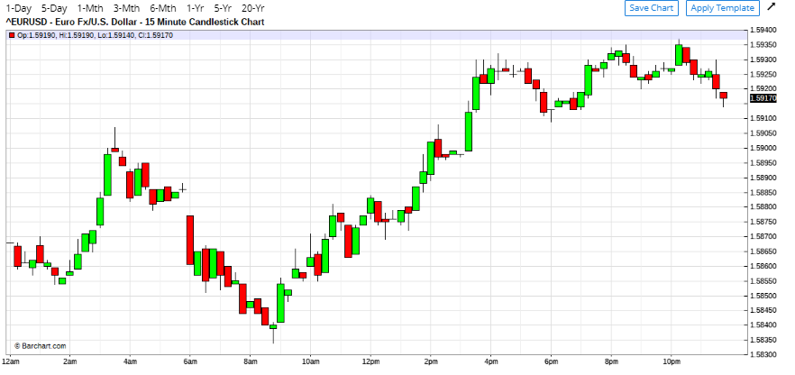

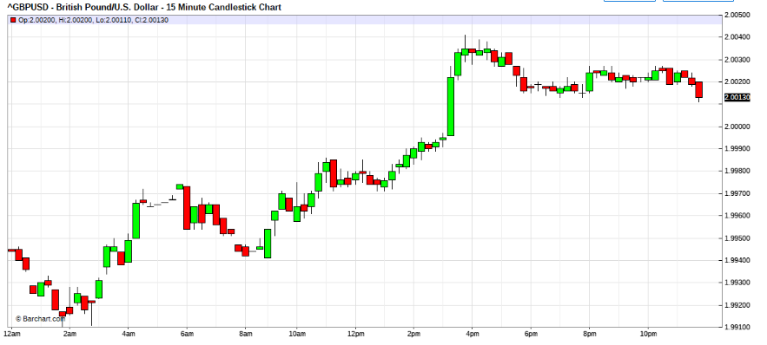

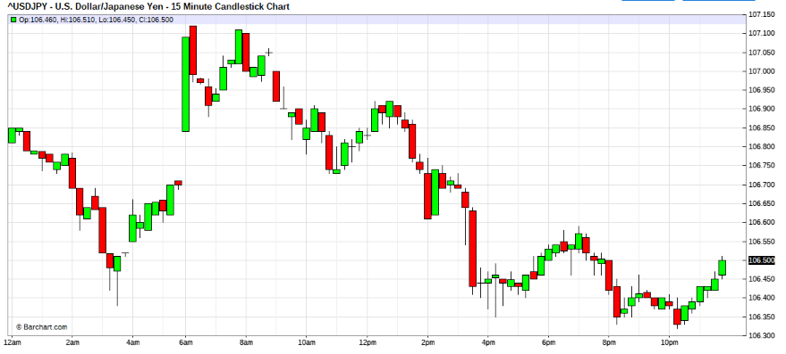
Jul 21, 2008 2:44am
the usd bulls wanna play. Will London boys play?
Usd bulls leader is cable.
USD/Yen found a bottom and is in ambush mode.
Now watching London boys
London seems USD bears or are they sweeping?
waiting for coil to explode now.
London boys are USD bear !

05:05am
What a short show, anyone noticed the bear has a long tail ( 1 hr charts)?
Wonder if theres any tickets left for the NY boys?
for now lets see if the bear parents are around.
The cable is in trench territories,(1 hr cable)
The Big Question is, is that a bear trap?
If Cable hits a trap, watch out for panic the Eur and Yen,
So be nimble, watch carefully, no armys dould be out there now, only scouts.
little bear , mind your steps in England.
Parental guidance necessary to clear this trench hurdle. Caution advised.
Mama bear are you around.
Can't see you ???

Jul 21, 2008 7:23am
Quoting hemal011
What was that ? NY guys just decided to push dollar up...or any reason for this strength ?
Should we start preparing attack ?
Hi,
Don't know yet. Just books squaring out, I guess.
Chartwise, the trench in cable is snooking the smaller market players.
Note that today is thinner markets due to Far East , off.
So be nimble yet.
I cannot see any signs of a USD bull yet.
It is likely sweeping range.
The undertone bias is a stronger USD, but the time vortex is not inline.
So time window is out of line.
Look for direction from the NY boys, have patience and be nimble.
Remember daily charts are still in coils, You could be trading bulls or bears, doesn't matter. But manage prudently, until clearer signs surfaces.
For term players , these are trying times.
Quoting DutchAngel
I think you would enjoy the book "Confessions of an economic hitman" written by John Perkins
Economic hit men (EHMs) are highly paid professionals
who cheat countries around the globe out of trillions of
dollars. They funnel money from the World Bank, the
U.S. Agency for International Development ( USAID) ,
and other foreign "aid" organizations into the coffers of
huge corporations and the pockets of a few wealthy families
who control the planet's natural resources. Their tools
include fraudulent financial reports, rigged elections ,
pay() s, extortion, sex, and murder. They play a game as
old as empire, but one that has taken on new and terrifying
dimensions during this time of globalization.
I should know; I was an EHM.
John Perkins
regards
DutchAngel
I have the pdf if you want it.
Thanks, Wouldn't mind reading it at all. Send me when suits.
But always remember , to ponder, why these people are blowing whistles.
There may be hidden agendas , sometimes.
Its ok to read, but people must have a good head to think.
A little knowledge is a dangerous thing.
Quoting hemal011
"USD Futures gain after BoA results" --> Seems to be the trigger of sudden jump after 7:00 AM EST.
Hi hemal011,
well this is the probelms of illiquid markets.
Now that the interbank is not liquid (on sectorial holiday)the CME becomes the market.
The disfference is that CME locals are not market makers, therefore does not provide liquidity, they will only lean on orders, and the papers there are not large , so you may experience , what leighsww calls, the funky chicken dance.
This is why I sometimes wonder , when prople have the most liquid markets to trade, why they trade illiquid cross pairs. Then diversification across these pairs creates for them liquidity risk. notwithstanding wider spreads ...etc
When I was at bank, whenever I get hit in illiquid crosses by customers, I had to resort to crossing the positions out to liquid markets to manage. However, seems that traders perspectives tend to be different.
by the way “squared” is to describe position.
“Flat” is to describe P&L.
Jul 21, 2008 10:52am
OK, for those of you paying attention to markets.
I will be initiating a MILD 1st attack skew, soon.Bear USD
Hey you are on your own , so unless you know what you are doing, don't follow blindly.
Oh by the way the time windows extends to after Lunch.

attack now in progress
Quoting Zoran
How do you work out your time windows fti?
Hi Zoran,
I told you before.Wave counts, and the dance sequense.
Quoting MichaelSA
I am truely gateful to you and to the other members of this thread. The insights gained on this thread have allowed me to not have a lossing session in the past 2 months! Thanks to the teachings on rescue.
The biggest insight for me was that both bulls and bears make MONEY (I originally thought that only one or the other made money!) And that when you are a bull/bear stay that way or you will become a pig (and pigs get slaughtered!!!)
Once again thank you to everyone who contributed to this thread.
Hi MichaelSA,
Thank you for your kind words.
I hope you will stay motivated and polish your skills as you develop market experience. With proper mindset foundation and experience, who may become invincible trader. When you become rich then you must afford to help those in need. Remember Be kind and generous, these are the qualities required to hold to right mindset. Most of all be forgiving, like your creator.
otherwise much torment wrecks you from the market place. When you forgive markets and yourself from errs, it releases the hold on you.
Develop well.
Quoting leighsww
I'm still in it, lol.
Hey, didn't you read my email and journal? I'm dancing slightly differently now, so my profit on Swissy will come when it hits my T/P (or if/when I have to rescue it, lol)
Okay, have a good rest of day, my friend
Hi leighsww,
Let me give you a little insight.
You are pioneering a very difficult field.
Many before you had taken that challenge and that is inclusive of myself.
Here's a little background and info that many help you , since you have undertaken the task.
In the late 80s, while my book was very profitable, and technology was developing very rapidly. I created a small group of reserchers in the strategic section. It comprised me, couple of senior dealers, a computer wiz and some programmers. We put most of my methodology into flow charts , with many subroutines controlling diffreent aspects. The subroutines were added as we needed. The core stem of the program flow was controlled by a developing model of fussy logic algorithems. Back then it was called alternating logic process.
By the end of the year, the millions of USD set asside for the experiment was depleted by trading and hardware and programming costing.
Having failed in that attempt, I reverted to finish writing the training manual of which you are having a little journey into. I never doubt computing power ,I was the 2nd person in SE Asia to own an Apple 2E. Before that, I had my hand, in the radioshack sub computers, if you can call them that. A spin off from my audiophile craze.
From all that, I re-learned an important lesson.
Rigidity is dangerous and reckless, when the conteracting parties and terrain is of much variance. It seems we haven't invented the computer that can match that which God created, not yet.
15 Min – 22 July
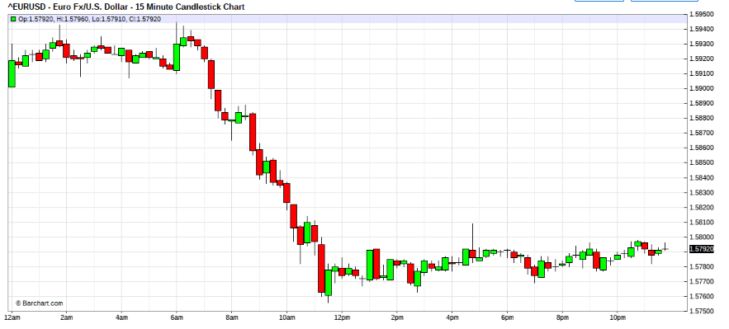
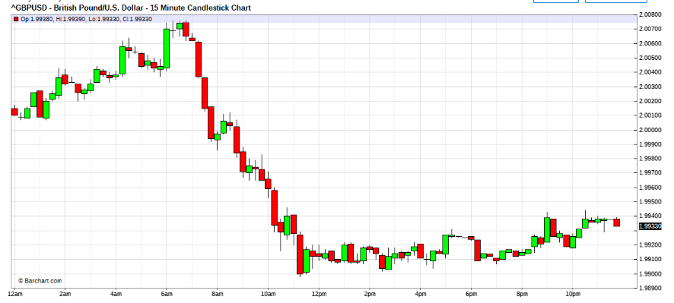
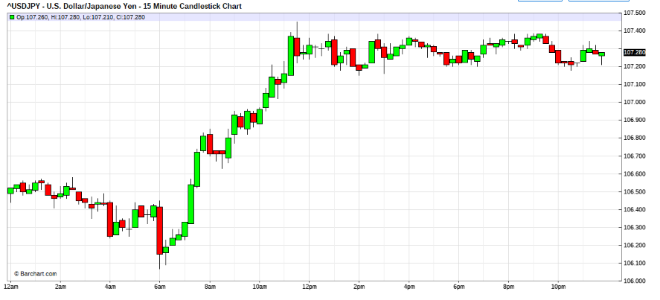
Jul 22, 2008 1:18am
OK the USD bulls returns.

Quoting leighsww
Bears went into hibernation already?! Sheesh, it's not even winter yet
So, fti ... you got a Scout in? We gotta get "Ward 13" active again
Hi Leighsww,
Yesterday we saw a little bear performing, then mama bear showed, but she's not aggressive.
So seems the bulls came in this morning, but its sweping both ways , goota see if the London boys are gonna ride bulls into the field. Got the scout in already profittaken and 2nd attempt in progress.
I think we may be a little busy for ward 13 today, lets see.
Liquidity is back.
Jul 22, 2008 2:48am | Edited at 3:11am
OMG, the USD bears were very strong.
Scout was killed.
Realigning.

Sorry this vvery USD bear terrain.
REALIGN NOW !
It would be interesting to see a test of EURusd 1.5950 seems above much USD bear stops.
Oops I wasted 9 pips to realign.
Standing by for attack level 1
Attck unable
standby to rescue sequense level 1
reacue deployed

Jul 22, 2008 3:28am | Edited at 3:51am
Rescue level 1 failed and removed with minor damage.
Standby level 2 rescue attempt.
rescue level 2 deployed

Jul 22, 2008 4:01am
Rescue successful and out
scout still in

Jul 22, 2008 4:14am
standby rescue/attack level 3

Quoting MaMood
Hi luSan,
difficult to say. Some signs from the data arround ...
- Dow future is going down -> $ weakness
- Oil is testing yesterday high -> $ weakness
- gold is up $9 -> $ weakness
- EUR and GBP near yesterday high -> $ weakness
But that are kinds of predictions - aren't they?
I just try get in tune with current PA on USDJPY ...
People, no opinions,
ONLY facts and figs please. + news
Try not to encourage bad habits and distractions.

Jul 22, 2008 4:37am | Edited at 5:11am
rescue 3 + scout = new scout base
ok, have some time.
note examples:
Tropical storm Dolly. If it hits the Gulf of Mexico oil rigs, oil price will be influenced = fact
It could build up to a Hurricane in the next 24 hours.= opinion
Gold is up $9 = fact
...so dollar weak? = opinion, err was bias question.
dollar weak= opinion

Jul 22, 2008 5:11am
Standby for new level 2 attack sequense.
notice yen crosses still at it.be aware.

Quoting MaMood
Do you see any anomalies in the 3 Kgd at the moment?
Anything that is worth to be noted or could help me by identifying times to be careful with my dancing??
notice yen crosses still at it. be aware.

Jul 22, 2008 5:18am
attack om Eur/USD deployed
Buying Eur for USD

Jul 22, 2008 5:39am
standby attack level 3
level 3 attack deployed

Jul 22, 2008 6:14am
Now you have some profits from attack level 2
near Eurusd 12 levels,
as market stabalises, try to get them out , slowly,
and toward 30 , do it slowly for level 3 positions until you are left with the scout out there.
Leave only the oldest scout,
new scout base should be slowly exited.
This is to conserve ammo for Ny zone.
This coil is very very tight now,
We shall reaccess analysis later, when NY comes in.

Jul 22, 2008 6:38am
30s not coming.
ease the positions to most comfortable,
remember the skew plays again at NY.
so have a comfortable base,
evaluate how a rsucue may look if it is required,
Also what an attack will be like.
Are you comfortable with the base?
then half that position.
Check the calander for any IMPORTANT fig releases , esp US figs,
Keep abreast the markets talk.Today seems nothing.
I am left scout, cu later.

Jul 22, 2008 8:44am

Quoting luSan
Gosh...PA dropped 50 pips on Paulsen announcement that US rate hike will come sooner than later...is this for real?....
I picked up 20 of these...have enough for the day...now we just watch this show.
Yes, Lusan ,
thats the precusor for things to come.
These people don't Joke !
start initiaing small usd buyings,
the whole terrain has changed.
This is no drill,
Battle stations.
Standby BullUSD scout( doublr strength)
Scouts deployed
Standby attack L2
Standby rescue L2 as well. rescue L2 sells EURUSD into 1.5895/00 range if able.
Standby rescue L3

Jul 22, 2008 9:00am
attack L2 deployed
standby rescue L3
standby attack L3
attack L3 deployed

Jul 22, 2008 9:04am | Edited at 9:20am
standby L4 rescue
stand L4 attack
for ref my levels
scout 90
L1 82
L2 75
R4 deployed 84

Jul 22, 2008 9:21am

standby R5
standby L5

L5 deployed =86
L6 deployed =81

Jul 22, 2008 9:32am | Edited at 9:48am
Quoting luSan
So this is a big war?
Greeks against the Persians!
Thermopylae and fit is Leonidas!
5 levels of attack!!!
already 6
ave below 90
How's you?
Total size 31
ave about 85-
wave 1.
not retraced yet, can't expect too much retrace. watch carefully.
Plosser up next, ifthey are all hawkish, sure not gonna see these levels again anytime soon.
blotter SX eurusd
2x90
3x82
5x75
8x84
13x86
preparing reverse skew selling now

Jul 22, 2008 9:48am | Edited at 10:08am
sx 8X 78
Initiating Buy back below 65
standby
Bx8x59
Bx13x60
Bx8x55
bx 5x47

Jul 22, 2008 10:13am
Bx4 x44
Hi I got 1 lonely scout left
How didi you do.?

hello, run may not be over yet.
Remember ! you are now USD bull
Position traders are mostly still in esp day chart traders + the stubborn+ the knowledgable +the anti fed +the .........
To many the charts haven't turned.
So look out !
Battle stations.
Round 2 comming up, watch your size into lunch please.

Jul 22, 2008 10:42am
S x 1 x 45
position recap
short Eurusd x2 x 90 + 45

Jul 22, 2008 10:55am | Edited at 11:10am
Sx1x39
Bx3 x27
now squared

Quoting MaMood
For me it is somewhat unbelievable, but are you really dancing without any kind of market information other than that, which you are reading in your charts?
Yes I have read the whole thread and I know your answer will be "yes".
But I still have to get used to this way of feeling the market. I'm feeling much more confortable, when I have some market news/rumors at my side.
For example when I get some hints, that the CBs will do some action, I'll play with reduced sizes ...
When I know the japan importers will have a strong demand on USD, than I can dance much better ...
And you are completely "naked", bare of this kind of info???
Hi MaMood,
While at the banks, I always had good info and paper sightings, keeping me much more informed. But now that I am on my own, sorry no such liberties.
Moreover , even while at the banks, I didn't dpended on too much. Once I could get the info to time and in the ride , I just watch her behaviour, more than anything. As my focus is very intense on price gyration, thoughts on other issues get in the way of the focus.
But of course when she behave AB normal, then I seek to see if there is any reasons why.
Others opinions and info, jus gets in my focus span when on rides.
If my style , is suits you, will will get to theis appreciation, as you go along.
regards
While trying to show my blotter live, I did missed 2 hits while trying to report to thread one of which was the last attack at 78, the hit was supposed to have been at 82 and another 5 at 78. Fortunately I pumped the 8 @78 and couldn't go further on the 5 as I was miss timed and out of sync for a little there. That was a little expensive.

AUXESIS:
Quoting maheswara
yes , but boy , did u see that skew ... to add so aggressively ... u ll be stretching ur profit like anything ... there is something in my head that keeps me from winning too large , kinda like satisfaction or contended from winning small ... i think after seeing fti attacks i wont be liking small wins anymore ...
maheswara,
Makes you take a step back and think, hummmmm...... as it's vastly different to most conventional herd thinking. keep your eye on your average position and where you are in the skew, and remember it's much easier (mentally) to attack aggressive when using profits.

LUSAN:
Quoting maheswara
yes , but boy , did u see that skew ... to add so aggressively ... u ll be stretching ur profit like anything ... there is something in my head that keeps me from winning too large , kinda like satisfaction or contended from winning small ... i think after seeing fti attacks i wont be liking small wins anymore ...
yet...you must dance small...you are not ready...I am not ready...do not forget...I felt into that trap and others too: green_david, jest...etc.
...remember his stories...the scorpions...etc...we dance/practice small until our learning curve slow down...I have been around since December...and I might be stupid, which is very unlikely... but it is now that I know how to deal with the news and other junk...
Of course, his performance is our target and he shows us what is possible...
...so stop that greed, Ok, my friend?

FTI:
Hi ALL,
I see you guys have been busy.
mom , will chat after cme close.
WARNING
don't be carrying too heavy Long USD overnight.
Light managable positions only.
remember when you pump water , once the pumping stops it will seek new equilibrium, Light manageable possition shold suface.
Quoting auxesis
FTI,
Once again thanks for taking the time to update, the info is very valuable and as all can see costly at times for the author.
We be sitting just above 83/90 level, interested to see if it will crack before lunch/today.
Thanks auxesis,
From the on set, I took up the task to see if I could impart some skills to the people open enough to learn esp to enhance Leighsww's learning capacity.. I guess in many ways mentoring required some sacrifices.
I thanks you , because you were sharp to have higlighted that paul was gonna lip us. And of course thanks to Lusan for excerpts of the event.
In alot of ways, what many witness here was bad performance on my part.
Any proficient market maker would have done much better than my performance. Unfortunately many are not privy to their access. They would be now out drinking their hearts away for the days market.
Let me explain,It was my bad that after a tight session, I left a scout open.
In all essence my biggest mistake was to have come back to the market late from dinner, having full knowledge that the market was in a coil and ready to pounch, moreover I underestimated the power of the fomc's capacity to pull a fast one. But really, I am a little rusty.
Some good lessons can be extracted from this handheld session .
One very glaring one was that after the doing away wit the dining scout. The position was on a doubled base, which would be the correctway to turn onwind. But unfortunately due to that my positions are not micro lots and the foreign captalisation was not too fantastic, which somehow held my hands back and I went on a minimum skew.
Notes how my position skewed 2,3,5,8,13,8 before the retraction. The corrct one would have been 2,6,8,14,... then the spiral within the spiral of 8,5,3,2, was abandoned due to my disorientation , as I had explained earlier. In many ways if you were to simulate a recap of the situation , you may realise that I had mised out on a big chunk of pips, this I hide behind my rusty skills as an excuse.
Further, My scrambling to winddown the risk, also dure to rustyness, had compressed the gain pips, otherwise from hindsight, could have been eased into much lower zones while I was chating on the thread. as you may have noticed I turned back to the market and I couldn't find (her). Lost of focus on my part.
In alittle way although I did make good $$ from the run, My performance was sloppy. as you may also noticed that a fortune teller surfaced to tell me how much better Icould have outdone myself.
Having said all this, I am to the realisation that, I must get myself back to shape, whip, whip, esp energy wise as I was tired to be unable to have performed and lead the thread in the utmost efficiency.
Quoting maheswara
yes , but boy , did u see that skew ... to add so aggressively ... u ll be stretching ur profit like anything ... there is something in my head that keeps me from winning too large , kinda like satisfaction or contended from winning small ... i think after seeing fti attacks i wont be liking small wins anymore ...
Hi maheswara,
Thank you for your aweness.
In fact , as I had explained (above posting), I had err and had stumbled in a few ways. I understand that you are not as experienced to have notices. But a pro would. In effects what you witness was me making sloppy decisions. and quite some glaring ones.
If you would analyse the sequense of events closely, My kill zone was only close to 40% of range. Based on Average daily true range basis, I had under performed. However I am happy with my pips, but I gotta get into shape, before the market whips me for my inefficiency.
And based on what you mentioned about your inability to add to win, then you must really review your MO and mindset. This is important if you are serious about this endeavour.
Quoting luSan
...you see why I awoke up at 3:30 am...fti is the best teacher around...all that is takes is to surrender to naked trading...which is not really easy...watch out!...he tell us that it takes 2 years to be proficient...a suggestion: keep your sizes small..
Thank you Lusan, you are a great help always, with your wisdom and prudence with money.
Did you made good $$ this run?
I noticed that you had to rest for an interview.
In regards to size, lets say manageable and affordable instead of small.
And for the training process, to be very correct I mentioned AT LEAST 2 years, and thats gauged from hands-on and face to face mentoring.So be wary , there are many lessons more that the market can teach.
I hope I have the strength, to carry this training for many here. It behoves , that I should be able to finish, that which I started.
You are a goodman and a worthy understudy.
Quoting Zoran
fti, did you have a similar experience?
Hi
I wished. Nothing near, my friend.
Although I have a personal relationship with the creator.
Mostly what my Dad taught me,and the creators invisible guidance throughout my life. How do you think I got to where I was. He made it happen, and I have a good life from it. It 's a wonder how "my way" the song I posted much earlier, relates to my feelings about my life. And I will not get into my adventures as a boy scout , later Scoutmaster......military flying ......
And how the creator , makes the challenges for me to conquer. Like for now I am experimenting with the retail side of forex training, unthinkable a few years back. I think he wants to keep me busy, because really I am one who cannot mellow away. See how things comes together. Have faith, we do have a creator.
Quoting MaMood
@Good morning fti:
To the suggestions of jest and auxesis.
Yes it's a little egoistical but if I had a wish for free and if it is doable for you, I prefer your live trading sessions. As you mentioned before it is very helpful for me to get to the rythm of the market.
Have a successful day!
Hi MaMood,
Doing fine, just fisned riding the USD Bull to testing the EURusd support, Lets see how London plays the game today.
So really today eveyone knows the USD bias, its a question how the game will pan out. I guess many can handle it from here fine. Test yourself out. This is good training ground. Be nimble !

JEST:
Quoting fti
I guess many can handle it from here fine. Test yourself out. This is good training ground. Be nimble !
Well it seems that you have alot of good students! One of the biggest lesson taught by you is identifying impulses, i usually take notice impulses on the 5mins and 1hr frames. If i caught it on the 5min, its almost a 100% homerun for the day, if the hourly impulse is strong, it usually becomes a knock out trade, high tea for me wife. lol. The rescues still makes my fingers cold.
FTI:
Quoting MaMood
MPC Meetig Minutes are out ...
Voting 7 -2 (expected 8 -1)
One against Rate cut
One for a Rate hike!
Thanks MaMood,
Its impact is seen in the cable now. The Eur crosses tears.
Looks like every one wants the Jap Eurodollars.
Just for clearification
"Eurodollars" are USD deposits outside the USA.
Eur/USD is called Eq pronounce as "E" "Q".
Quoting piccolo
fti, my only concern is that you don't exhaust yourself because you are too valuable. 
Hi picolo.
Thank you for your kind thoughts for me.
I will keep it in mind, as it is my scorpion that I do push myself too hard some times, esp when means justifies the ends.
However. let me tell you a short story.
My mum, she has an old antique table that my dad bought , loooong ago.
She loves it so much that , noones was allowed to use to.
It is keep in a "special corner of the house.
Not long after my dad, kicked the bucket.
we discovered that her prize was destroyed internally by termites.
It was very sad for her to have lost both her prized belongings.
The lesson there is, as if God's message was "Use it or loose it"
So it seems in life , whatever that doesn't kill you, only makes you stronger.
thats the motto in my life. " Be Prepared"
Quoting piccolo
since we are talking I want to share something to get your comments or criticism.
when I hold a big position in the market with some attack or rescue troops in and the she turns against me.. and I can feel it that the impulse in opposite direction will continue I offload the position to re-enter at a better time, thus booking a temporal loss..
here is an example:
if i am long eurusd from 1.5950 and it goes down to 1.5930 and I feel like its a free fall till 1.5900 at least (even tho I am still euro bull and would not want to take a short), I offload the position and re-enter when it turns back in right direction. Thus this missed out exposure is same as if I would take a short from 1.5930 to 1.5900 and keep my original position open. Thus I actually short it by not being in the market.. hehe.
I don't know if I expressed myself in an understandable way. I hope you all got the idea.
Hi picolo,
yes, aside of the market is a position. Thats what many traders do not realise. It all depend on the timing and dance.
When a dancer is motionless it doesn't mean that she is not dancing. Only that she has hit a patch of the dance where that was the required motion. BUT if she stay motionless , when the tempo comes into play then she's considered disorientated. This is similar in the context to trading.
Quoting rapaduski1
Just a few questions. If you are long at .5950 and then believe at .5930 that its headed for .5900, why not reverse positions and go short? Also, when you entered the long at .5950, did you believe the reversal to .5900 was possible?
Hi,
Thats the mindset thingy.
I don't ever KNOW, for sure what to do.
But I KNOW, when a market behaves a certain way , that I should respond defensively or aggressively.
This is the reason why I have the scouts in, if I am still interested in the trade.
You never know no one actually knows. Like in yesterday's case , I came back after dinner, and he was floating dead in the waters. He was well and safe , when I left him.
You see, in trading correct mindset, will free you from inhbitive subjection thoughts. This in turn allows you to reactiveness to the issues at hand.
You must deal with the situation of NOW, not what ifs and how ifs .
You deal with the P&L of now, and whats within your capacity and whats not.
I think warrent Buffet summarised it very well, when he said
"Excellence, I can aspire to achieve, perfection, thats the God's work."

LUSAN:
Quoting jest1081
picollo,
1. You booked a 20point loss.
2. You did not choose to attempt a rescue procedure, if you went a few lots more long at 900, so you re-averaged your position instead and could prly have conducted a clean rescue.
From my point of view, when you went long at 950, you were already wrong about the market direction when it went to 930, instead of rescuing you decided to drop out at 930, essentially, you are merely booking a loss and now awaiting for 900 to go long, if price reaches 920 after you went long again, you merely broke even. Its two different trades alltogether.
regards
jest
just a short comment since I have to leave
1. I would kill the scout and revert: I mean close @ 940-935 and enter in the opposite direction...why? because this is not a 5M mis-timing...(only rescue are allowed on 5M mis-timing) so I do not rescue but if I see that scout is crazy and going the wrong way..."the war is north and his going south"...he is a deserter and deserve to die...
2. For me a trade is a complete campaign. It is divided in 3 parts that I call waves..scout is 1st wave, then 2nd, and 3rd...very rarely I have a 4th...maybe when I have more experience...so killing the scout is not killing the trade but bleeding my book.
3. When I kill the scout and do not revert is only because the general is totally confused...he does not know what to do...He must wait until he recover his mindset...I believe that is what fti says.
so I would kill the man, reenter against the dead scout with the 2nd and 3rd waves and collect my profit at 900 and if I have time reenter in the opposite direction with a new scout...Collect booty in both directions. Overall it would be 35 pips one way and 35 pips the other wait. That is better than waiting, right?
This is my 2 cent...have fun

FTI:
Quoting MaMood
First of all I wish you good success for your job Interview!!!.
@fti and others ...
What luSan describes above. Isn't it the typical behavior of the "pig"?
Changing the directions from long to short and back?
If not, what then means the often cited pig in difference to the bears and bulls??
Hi MaMood,
Absolutely, on the money.
I was just about to point it out to him, when he left for his errants.
Hope he can learn , without having to pay too much for it.
Quoting Zoran
I sometimes lose my typing also - by pressing the wrong keys - but perhaps some other force is doing it? It usually tends to be something important.
Yes, I watched Z on the federal reserve and thought it was well made so I decided to watch all of them, including the one on religion. Now that one looked convincing also but seems to go against the bible - therefore my thoughts of the plot to destroy religion.
Here is the link - http://www.youtube.com/watch?v=BNf-P_5u_Hw
With your great knowledge on this subject, I was wondering what you thought of it.
Hi Zoran,
Sorry , alittle late, mkt was a little scary.
Build the skew like lorry load, at last got out fine.
The creator, he works in myterious ways,
So to understand may be beyond us.
Its alright to speculate, but as in trading.
We must never be too cock sure about that we have the answers.
It may slowly be reveiled to us over time.
And we must have an open mind to accept.
Just like now we know that the earth is not flat.
Creation is not our business,
If we want to poke at it , to learn and use the knowledge to dominate.
Then we had better have an open and unjudging mind.
Truth has many dimensions.
When Christ came , I wasn't around.
By my instincts and feel and the pureness of his teachings esp from the testimony in the book of Matthews, I believe.
Neither can I see air.I do use it.
More important , do I harm, anyone practising God.s will.
No,
Do I harm myself and my family ?
No,
God forbide there may be those who would like to twist things about to confuse, (divide and conquer) but thats for them.
If you try to understand Christ's life, you will see the pureness. Is this real ? I can't say for sure. But all I can say is that knowing him, brings joy in my life. For me thats God's gift.
For me Christ's commandments.
So easy and pure.
1.Love your creator with all your heart and soul.
2. Do onto others as you want them to do onto you.
this encompasses all of God's Will for mankind.
Comlpication only arises, when man trys to impose mans will on all , man and God. Thats rebellion.
15 Min – 23 July
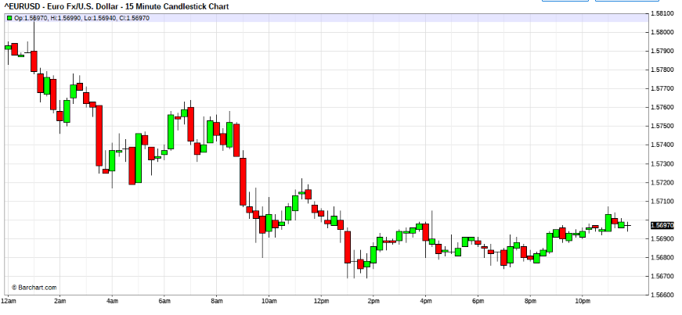
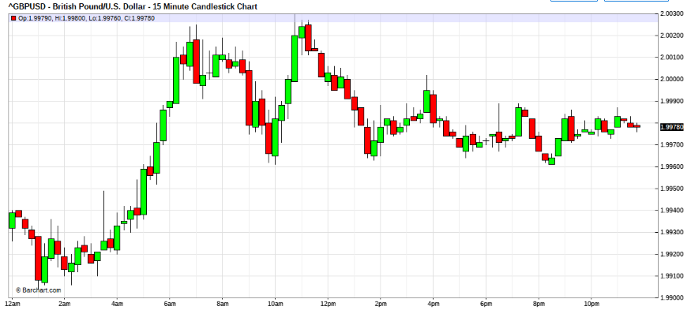
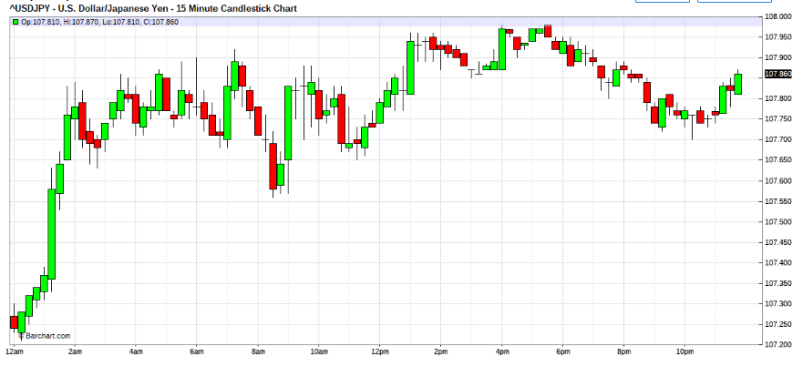

Jul 23, 2008 12:32pm | Edited at 12:43pm
Today's market is abit hard, got out with the skin of my teeth.
The fed's spoken, they are changing monetart policy.
so now everyone's wondering.
Is this for real or just lip service?
Then the EU is in hawkish monetart stance.
Even if the feds hike 25 basis.
Would the EU reciprocrate?
First we must see some goodwill from the feds, huh.
And the markets get more and more confused.
Divide and conquer. thats the strategy.
So now its any one's guess.
For us , we must feel the market and see how it feels,
it will be different in different times, so be very nimble.
If greed plays, then it pays.
Battlestations.
for now I think the jap are still buying the USD, quietlly,
and USA and Eur are suitors for the Yen injection. Lets see if this is the case.
Flow like the river, my friends
Oh forgot, Chart wise , the USD bulls still dominates.
So bias is Bull USD until the dance sentiments changes.
Quoting textor
Hi,
It looks that today is the 1.57 a walled city....
PS: Here comes another attempt ...
yeah, textor , very walled.
look at the cable charts. Thats like waiting to turn. strong STG.
probably nothing happening today,
just wanted to if if we may hit USD stop buy orders .
Yesterday on strong bull run on the USD they didn't show.
If they don't show again, then gotta review charts for direction.
I am squared now , watching for opportunities. Too quiet.
Jul 23, 2008 1:45pm
Quoting fti
Hi ALL,
Today's market is abit hard, got out with the skin of my teeth.
CHFJUNKIE:
This is the start of usd bull move.
it's the FED's typical action to step in during major bank bankruptcys.
the overshooting and the good days has ended for the eur.
the cycle has turned down, We have seen some indicators of a slowdown in the eur economy the last two months.
I believe the pair is going south .
JEST:
very bullish the dollar. daily may be a key reversal already.
whats wrong with the Queen?
It does seems to me that the YEN is leading the trend right now.
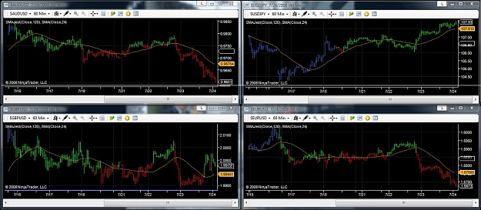

FTI:
Hi ALL, OMG, this looks like a cemetery to me.
Talk about manipulation.
Something's fishy.
Don't you think?
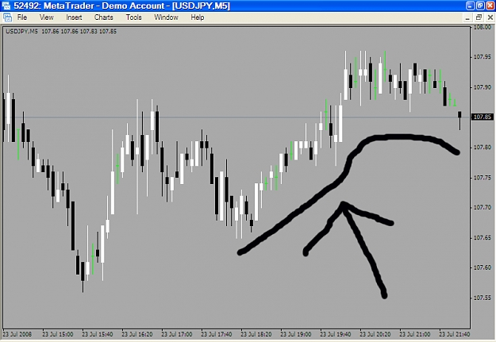
15 Min – 24 july
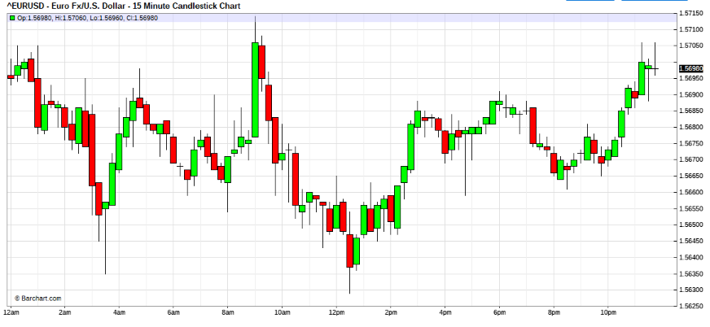
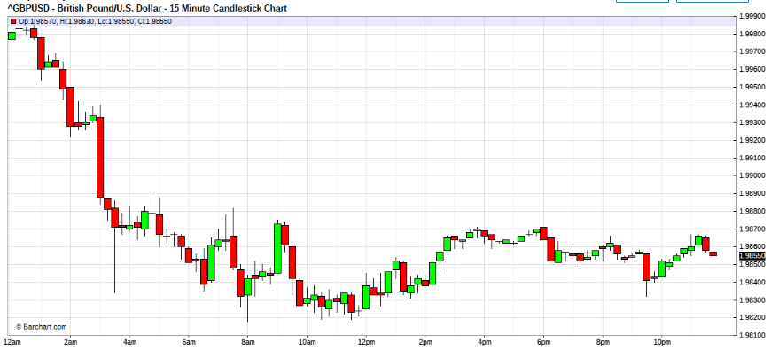
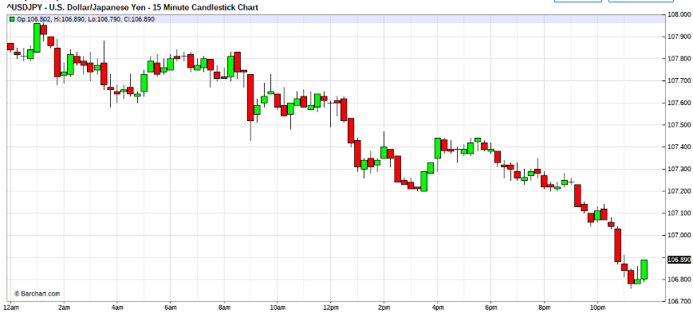

Jul 24, 2008 7:53am | Edited at 8:06am
Speedy years , huh.
I will get to the issues raised by some, when I can find some time.
I made good pips , the early sessions Long USD.
Got half the profits out and lost a half load back when they sprung a fast one on me.
Then afterthat I had been building my Short USD positions, on the 5m charts.
Now I have super spiralled Eurs ozzing out of my ears. What a PIG !
Anyone? Eurs?
This market now very tricky, Eur seems like found support ,may do a little retrace.
I'm on hourly charts now, wish me guidance.... otherwise may be sleepless for a few days babysitting.
Quoting Green_David
Hi, FTI:
I agreed with you that EUR got some support around 5640. I read a news that there is a large option @5610~25 expiring at GMT14:00. Anyway, E/U lost almost 2% just in 3 days from 1.5940 to 5640.
So what would be your strategy, capitalise on possible rebound, or let the rebound go, and short again when pullback lost momentum?
BTW, I made a killing shorting G/U. How many pips, I forgot, got about 10% return. Maybe on saturday I will post the chart and share how I did it.
Hi David,
I donno , my chart keeps turning weak USD , while I was very Long USD in before London.
The London Boys have no clues whatsoever of what to do.
Seems like theres profittaking ahead of Unemployment figs, Housing Starts, and the te fomc people talks,
Thisis little unusual , maybe fig bad, so they have to kiss usd again.
Be careful, you gotta be very nimble to try capture retraces like this , they could test the Eur to 1.5610 before anything happens, so if you take the challenge, you have to be fast. Not fast in position manouvers, but thinking and feel as well.
Otherwise stay out until fomc frog kisses us then see what happens.
They already nearly talk the USD to rise from the dead too many times, will the voodoo work again? we shall see.
Pardon me, I gotta wind down the positions to managable sizes before all these happens.
So If I didn'e say much, you guys can brainstorm amongst yourself for alittle, ok.
Quoting DutchAngel
"Damage is part of the battle, recovery is essential , victory is the objective"
This has become my mantra. I also like this from Theodore Roosevelt
"It is not the critic who counts, not the man who points out how the strong man stumbled, or where the doer of deeds could have done better. The credit belongs to the man who is actually in the arena; whose face is marred by the dust and sweat and blood; who strives valiantly; who errs and comes short again and again; who knows the great enthusiasms, the great devotions and spends himself in a worthy cause; who at the best, knows in the end the triumph of high achievement, and who, at worst, if he fails, at least fails while daring greatly; so that this place shall never be with those cold and timid souls who know neither victory or defeat."
Happy trading
Hi Dutchangel,
Wow, have to quickly say,
Teddy's saying, its powerful and very real.
Jul 24, 2008 11:03am
Hi ALL,
Looks like the BULLs are not letting go.
Got My Short USD out with good pip.
Have some Long USD positions now, will be formulating attack and rescue strategies after the NY lunch.

Hi ALL,
just thinking out loud. Feel free to chip in.
We know that some Jap investors are buying into USD thru their funds manager. Seem large as it is impacting the yen crosses.
I speculated that maybe some of it would go into the freddie & fannie bailout and US assets.
If these were true, depending on the size of the thingy, it may still be unfinished business.
Another thought is that after the USD purchases which help the fed contain the 1.6 ceiling against the Eur. They are in profits already and it would be in their interest to support the USD when they can/ or if it is cheaper, whichever the case.
The figs released today only supports the fact that the US economy is not in shape, notwithstanding the speculation that she may already be in recession.
What is ticlkles me is the fact that my positions keep reverting to buying USD in a US recession scenerio. And the positions are promped by the charts.
Is this prudent?
But of course the charts don't lie.
Quoting jest1081
one thing i remembered someone mentioned, trichet raised inflation in the EU zone one year after the US. So if they are running the same scenario, a year after the US, it wouldn't be a surprise that everyone is racing back to cheaper USD for value hunting.
Hi jest,
That is true, but it seem that the japs have beat many to this advantage, based on what's been seen.
I have no problem at all following the charts lead.
Just that tere is is naggy feeling at the back of my mind, About the Long USD in their recession.
Feels little like catching a falling knife.
Only that from charts, it may be near the end.
Not so unlike A, I did feel kinda ceiling at the 1.6 Eur test, so we may have seen the uper band tolerance of the feds, but they are not God, if things do gets worse, it become hard to be supportive of USD.
like I said just thinking aloud, due to funny feeling and undertone.
Also i guess because of the big USD bull couple days back, I find the follow thru , very mild and controlled. Somethings amidst.
Based on the failure swing after bad figure releases, which is very telling, I would tend to expect a sell off in the Eur, NY afternoon. but of course this is just speculation. Best to follow the pulse.

Quoting DutchAngel
You are wrong, in fact I have just finished re-reading it for 3rd time today. Have also just compiled an 83 page document of the thread which I am editing to remove typos etc. Curious about what gave you the idea tho.
I actually wanted you to confirm an assumption of mine. In the beginning of the thread you said you were going to give us lesson 3, the Blitzkrieg. Zoran questioned you about this a couple of weeks later, as it seemed that you still hadn't given it to us yet. My assumption is that the blitzkrieg lesson is actually the attack and rescue mission. Am I correct?
kind regards
Hi DutchAngel,
Yes, Lesson 3 is the last Chapter in my Forexangels, it is about how to put the rescue and attack thingy together in market making. and the way to incorporate the fundamental perspectives into the skew and sliding between the skews of the spiral within a spiral.
After posting it, I felt that it was more suited for dealing room purposes, so I didn't go there.
The relevant stuff, I had just given ad hoc , in the general discussions following.
Moreover to be able to do Blitzkrieg MO it requires massive capitalisation , quite OT for non corporation traders. More suited for big boys market makers.
Even myself is unable to use that MO due to capitalisation restrains, even now.
There's actually noting worthwhile to compile,
The Mindset aspects are covered in AOW,
The Money management aspect is a derivative from the fibo or arithematic spiral sequense.
And the rest is all your trader sense and market experience, esp in Chart Patterns Analysis.
Its only that the uninitiated will find the MM aspects very disorientating. esp the P&L snowballing. Without actual exposure practise it is difficult to accept/understand.
Jul 24, 2008 1:08pm
Quoting auxesis
Hummmm....... will the NY boys push it for the 5610 level or is this little double bottom it for the day.....decisions decisions......
Hi auxesis,
In fact, I don't like today's market behaviour at all, although I am making the pips,
It likes to do jerking motions then goes into hybernation and jerk again.
This prompts me that market is extremely manipulated. Super manipulated and thin.
Unfortunately I cannot see paper flow, but I think the suspicion is very valid.
This doesn't feel like the forex market at all. The 1.5610 level will probably come if stops are triggered late CME. Otherwise the markets will probably be put to rest here.

Quoting luSan
A pig goes left and right...a pig does not know left from right...what do you call one that fight the trend? ...I would call him a cow...
I mean: if you realize that you got your scout on the wrong bus, then would you stay on that bus? Would you rescue? What about if you fail on your rescue? Then you go with a second level rescue, right? but if you fail your second level rescue, you move into a third level...then what do you do?...you stay on that bus until that bus stop at the next price level ...that is a good idea if you have a full day for trading...and that it a luxury that I do not have...it is totally illogical...bleed the book and move on... [by that time if you fail then 0.16 % bad trade would be 200-300% of a bad trade and your heart would be pumping like hell, right?]
it does not make sense at all: the scout is for me 1/6 of a trade...16% of a trade...it does not make sense to defend it...kill the guy and accept the fact that I was wrong...I have done so many times, that it is second nature...the only time that this is wrong is when the market is totally chaotic, without structure, on a narrow range, then it does not work and I do not do wave attacks but range attack...but that is another topic....what I do works very well for me...I am happy with it....Also be aware that I do a fast dance...I do not hang around for hours and hour waiting for 5M to get in line with 1H and 1D...I do not want to trade for longer than 2 hours...
So if I am on the wrong bus, I get off...fast...and I move into the right bus..if I find that I got off on the wrong bus again...then I am confused and I stay out...this only happens with the scout...after all for me that soldier is testing the battle field..just a test...I never do this with the rest of my trades...So am I a pig? If so, then I am not a cow....let us laugh
Hey..remember my commandments: "never trade against 5M trend", "never have more than 1 rescue", "rescue only for timing"...so if I stay with a loser scout, then I violate my own laws, I am a sinner...and that is not allowed.
Hey Lusan,
Admit it, a pig by any other name is still a pig.
It happens sometimes, and sometimes the charts lead you to there.
In the markets we trade in.
There are BULLs , there are BEARs and there are PIGs.
There are no COWs.
If you don't look closely, But of course sometimes we may mistaken a BULL for a COW.
So don't go justifying yourself into a corner.
Quoting hcong168
fti:
Thanks for the handheld session on 2008-07-22 night; that is really priceless.
I was late to this thread and when I started to read, it is already >100 pages and >2000 postings. What's more is there are a lot of information to be absorbed, so reading from the start of the thread is really very slow.
And this thread keep appending, increasing my back log is small issue, there are times that the discussion of current market situation become very difficult by the time I read.
So I "attack" this thread at 2 locations: 1 from the latest posting and 1 from the start: burning the candle from both ends, err, burning the candle from one end and from the middle. (Right now I am still on page 180).
That is how I chanced upon your handheld session on 2008-07-22.
Beside expressing my appreciation of your effort in my first posting here, I would like to post the charts of your 2008-07-22 handheld session with entries marked, so that fellow forumer who come late (later then me) to the thread can understand your action better.
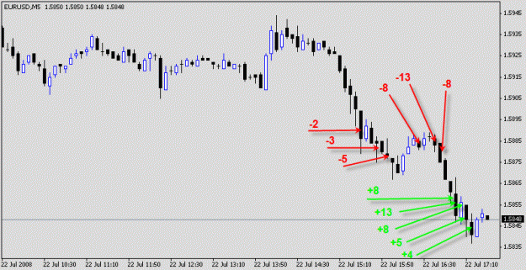 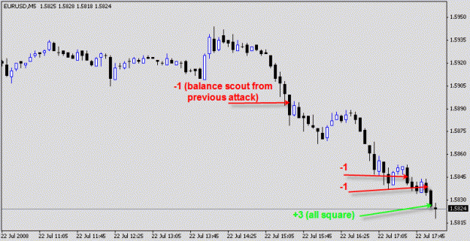
Hi hcong168,
The charts are about correct. Some of the timings are off By 1 or 2 bars.
Don't ask me to correct it. I never revisit nor remember my trades since 20 years back. I am old and my memory is bad, I go by feel these days. So I never remember levels, prices and telephonr numbers anymore.
Actually you can learn little from the chart, although you can see some of the methodology used. If you charted another session with me, it will look totally different. This is because there are other factors involved that are not on the chart, eg dance sequence, pip pulse....frame of mindset, influence of fundamentals. Moreover the trade skew are dependant on strategies imposed, state of book. All these are not on the charts. If you tried to mimic the attack,you will become rigid and thats dangerous.
Thats why you have to babysit trades, and I take sometimes for walk abouts. You nee to feel the situations to understand.
You may be shocked that if you followed me for some walk abouts, i may liquidate the position early due to that I may have a stomach ache and had to go to the wash closet. So it is better to ride along than studying the historical performance.
From the chart, can you pick out where, I came back from dinner. Or when I was chatting on the thread and misses the markets entry.
In perspective , being new to the methodology, you may like to reference it for understand of the principles involved.
It is important not to be robotic or mechanical about the the use of it.
Read the thread carefully and understand it,
then demo its use to familarise the skills required.(orientation)
There are much lessons the markets will teach you, if you pay attention and learn.
Then if you have become confident enough in yout skills, Test it on smallest positions that is available to you, That is necessary for development of the "greed $& fear" emotions that you will not gauge from demo.
You have worked hard to present the charts ,
Myself and many here (I believe) will thank you for your effort.
Quoting maheswara
Sir not sure about this one ...
I recognized that GBP was getting stronger in effect making dollar supposedly weaker , but with other pairs USD just resisted getting weaker , is this why its fishy ?
Hi maheswara,
What you said is in many ways correct.
What was detected was that there was alot of crossing going on.
Take alook at the cemetery chart I posted.
Can you see those many green bars, that was stationary sweeping.
What it means was that in any instances, the market makers were sweeping, from a pivot point. The market went nowhere, except that range ws created.
This can happen when the Mmakers are booking orders to their benefit or when they are acting on behalf of someone to hold markets.
Quoting jest1081
ooohhh wow, im feeling the heat here...hehehe.
lets take a chill pill guys. I understand that many of us here have made good for themselves, after a few months of trading, you guys have turned pro, thats impressive.
Lets take a look at ourselves in the mirror first, how did we first get here? What made us better, just a word or two from the teacher, and we get a long well written resignation letter and a pig and cow story.
I must say we have alot of egor running in here. It really doesnt matter if you have to kill 10 scouts so that the army may survive/win the war or be rigid to keep your psychological setup in check, but sometimes we should ponder a thing or two, here, what are the posisbilities if i kill less scouts, run some reecsue sequence and then turn it into an attack sequence?
Lets try to continually learn and improve instead, take the snippets by the teacher as a form of good advice. Of course many things will come into mind, many scenarios will take place, its a learning process... Remember, AOW is the backbone of the method.
Im glad you guys have found your niche. Good day and good trading you pros.
Okay, now you guys can take the guns and fire away, im open.
regards
Thanks, jest that was direct and should wake some up about egor.LOL
Quoting MaMood
Why should I start a rescue, when I found me on the wrong side of the trend or (to make it a little more difficult) a major move?
Why shouldn't I ride for example at first a short campaign and when the market tells me, the second one on the long side?
For me it is still difficult to define behavior of a pig/changing busses on the one hand and to be nimble on the other hand.
I'm still learning. But I cant trade someone else rules/style if I didn't get the reasoning behind. So I allways have a lot of questions ...
That has been the reason for my question above ....
So once again a stong "sorry" from my side.
Remember Whenever you trade both the long and short side of markets, for pips , in reality you are pigging. And thats the same for anyone doing it.Whether justified in doing so, thats in the eye of the beholder. However, a rose by any name is still a rose.
Quoting DutchAngel
@Leigh
This won't win me any brownie points, but to quote my father "If you want to walk, walk. If you want to sit, sit. Do whatever you want but do not wobble." Your numerous departures and comebacks seem like a lot of wobbling to me. I enjoy your postings, but could do without all the drama involved..
Hi DutchAngel,
With knowledge that the posting was not addressed to me. But i need to make a comparative comment. You Dad , he's wise.
If I was to relate what he said to trading, it would read:
If you are Bull, Buy,
If you are Bear , sell,
But don't go chasing the bulls and bears swings, and turn out to be a ...pig.
Quoting DutchAngel
"damage is part of the battle, recovery is essential , victory is the objective"
This has become my mantra. I also like this from Theodore Roosevelt
"It is not the critic who counts,
not the man who points out how the strong man stumbled,
or where the doer of deeds could have done better.
The credit belongs to the man who is actually in the arena;
whose face is marred by the dust and sweat and blood;
who strives valiantly; who errs and comes short again and again;
who knows the great enthusiasms, the great devotions
and spends himself in a worthy cause;
who at the best, knows in the end the triumph of high achievement,
and who, at worst, if he fails,
at least fails while daring greatly;
so that this place shall never be with those cold and timid souls
who know neither victory or defeat."
Happy trading
Hi DutchAngel,
Like I said before, very enpowering and inspirational.
If I had to give it a title, it will probably read " For those who do"
I guess Actions speaks louder than talk.
If only ben read it.
15 Min – 25 July
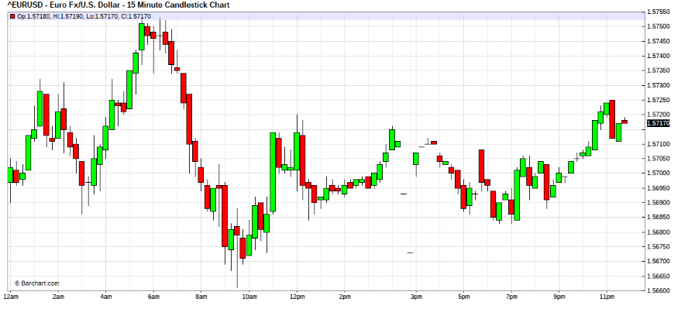

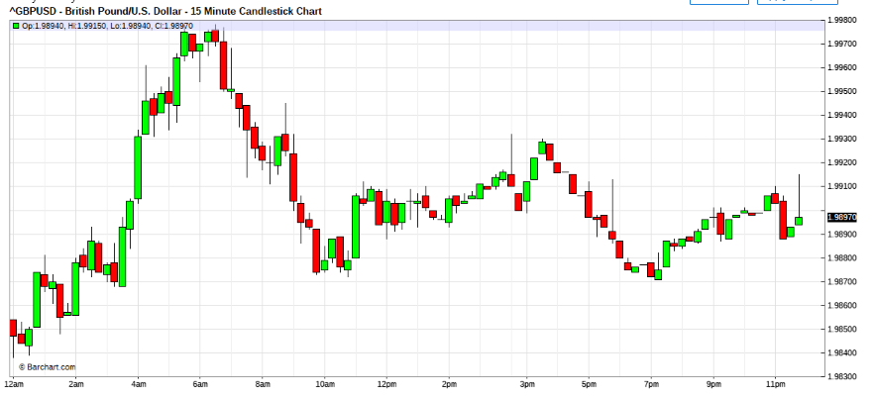
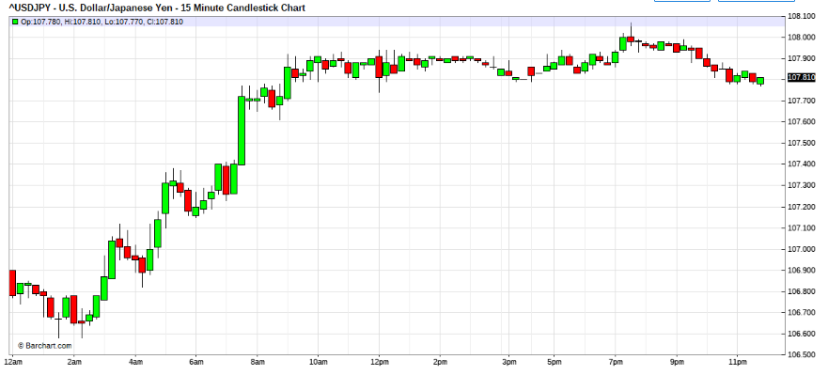
Jul 25, 2008 3:33am
Looks like USD Bulls are lurking in the markets, Seeing any?
Quoting maheswara
is rumor one of the extra tool that dealer uses to move markets ? , just curious ...
Hi maheswara,
It most certainly is, look at what all the fomc speakers are doing.
Do you see any actual rate movement. By the time it comes, it would be so discounted.Not by dealers but really everyone else.

Jul 25, 2008 6:55am
Hi ALL,
after run 1 round with the bulls,
I'm still waiting for the return of the bulls.
getting very bored
Missed the bear run so still
Very agile bear, in my opinion.
Wrong horse.
Hi ALL
They are still at it, buying USD, Eur, cable selling yen.
Seems got lot of the stuff to dispose of.
Every time the USD weaken , they come a bargain hunting

Jul 25, 2008 2:00pm | Edited Jul 26, 2008 12:41am
Hi ALL,
I am back ,and I caught another leg of pips, now finished for the week.
And this was a good week. I made 25%+ of my cap.

Hi ALL,
I took the liberty of using my sabbath, to do this posting.
It may not be everyone's sabbath, I just saying that it is for me..
I feel that I should get something off my chest , before I started trading again on monday.

What I have to say is long and asking of research, so I hope that most will bear with me, with an open heart and with empathy.
I detect that some of you are upset with my recent religious postings. I don't know if this may be the case for Leighsww. Some may be thinking that I may have gone OT and had wondered.
What is this guy, nuts?
What has God gotta do with trading?
Next he's gonna say that he has been making money because God favours him.
Before anyone stones me.Think !
I Hope that I can present the case clearly.
My methodology in trading involves non rigidity, and my many years survival was dependent on this non rigidity.
Let me begin by saying that , my great grandfather was a methodist missionary from Fuzhou. My grandfather was more focused on opium smoking than church work (it was then legal), My father was Catholic. And for me I don't fit in either, you may call me "The Book of Matthew" christian as I try to emulate Christ's ways from that testimony.(have always wondered why churches , do not follow christ's teachings.) It is not my intent to preach religion to traders.
I posted earlier, a little jestfully an excerpt that, "if people found difficulty understanding me that they should try to understand a clip of a venerable teacher, who was try to explain CHANGE. "
I hope it was of no offense to anyone that althouht the clip showed the teacher trying to explain reincarnation, the message was clear for traders. You should re-peruse the clip again , if this perspective may become clear to you.
In markets, the principle he mentioned is very important.

That change is the only constant in the plane or dimension or world ,that we live in.

Examine your dwelling , clothings, diets, life, surroundings and almost every thing thats around you, relative to: lets say 100 years ago. Most are the same , but they are different, isn't it. Nothing stays the same, nevertheless they are the same and they have changed.
This is also true in markets.
The clip's teaches that our soul lives in a body and when necesary it changes body. This is the case in markets. When the market is done in one mode of trend , it changes to another mode. It is the same market, but in different modes, always changing.
In markets as in life, no two trends are alike, as it trys to vibrate into that which is most equilibrium for itself on the basis of the NOW. So if your methodlogy is rigid, then sometime, you will be out of bounds.
One of the most important lessons I learned from Buddha from my race heritage, is his teachings of "The danger of I" and reincarnation. (rebirth)
You should try to get a copy of the scripture "The dangers of I" it is most enlightening. Try any Buddhist society, they should have free copies for a donation.
In this scripture, the issue is about rebirth. Many have interpreted his teaching to mean to be born again , in another life time.(reincarnated birth) If you research it carefully , it actually refers to the rebirth of the man's mind, in the same instance ie this life , but into another mode, through the 5 human senses. ie sight, hearing, taste, sensory feel and thoughts.
Buddha taught that mans minds are reborn again and again with every breath and to guard that we must seek the middle path that we may not change mode into the left or right extremes that the senses would lead towards. Therefore never to crave. (the hell fires of desire), And that this leading astray would originate from the man sense of thought, "I". He taught that if man can withhold the inclination to the inward realisation , that "I" should never be the center of focus, then it would surfice for the man not to stray into any extremes.
On this the foundation whereby his followers lived life.
In the market's perspective, this is very important. Because the tendency for traders to be focus on the "my position" will lead traders to ruin. Whereas if the trader can hold to a balance of the opinion on the market charted against its behaviour then the trader may avoid calamities , when the opinion is in err.The middle path of the analysis and the actual behaviour of the said.
This was the reason for the link to that clip. It was not for amusement.
The intent of the clip was to highlight "CHANGE".
All things in the universe, changes and in motion, nothing stays the same, or at rest. The only constant is change. Change behest Change and no two are ever the same even if they are the same. This the foundation of the Tao( Tao De Jing). Yin Yang. "Within the light is the darkness and within darkness, the light."
All thing remains the same but they are never the same.
This is true in all things. Even in religion.
Notice that All Christians are reading God's Holy Bible, but there are dividing differences between Peter's Church( Catholic) and the reformed churches.Even amongst the reformed churches the same that divides them.
For the muslims, similarly. The strongest pillar of Islam is the Holy Koran , which has remained in the original language as compiled by Abu Bakar after The prophet Mohamed,peace be with him. But take a look at the divided fractions of the practise and you will see that although the scriptures remains the same , the interpretations divides them.
Similarly the Buddhist...................
I say again, ""All are the same , they are different"
Can you understand this?
Why is this so ?
It is because the difference is dynamic. It is mind.
And all minds are different althought they are the same.
Therefore all may read the same , but perceptions must differ.
I hope that no one here, thinks I am nuts or gone OT.
My intent is not religion motivated. Let this be clear.
The other Issue is TOLERANCE.(strength of boundaries)
It may have a religious connotation to it as well, but really, it the foundation to the Money management that I practise.
I may not have explained clearly, so if anyone may help crystalise the point I am trying to make. Please.
PS: lest anyone ,should be tempted to stone me for not quoting cheist. In fact he repeatedly taught us the same. I will quote which is most close to my heart.
In the Lords prayer, Christ taught us how we should pray to the heavenly creator,
"Forgive us of our sins",as sinners we know not where we err
as we forgive those who had sinned us."that we must forgive where others may have harmed us, as they too know not what they do,
The marked in red is my interpretations.
In effects, we are all in err. as we deal with the unknown daily, and we really know not the consequenses of our action on others. Again the variance our actions creates,. Can you feel it?

Quoting Jairo
Hi fti,
Though it's sure there are many scams all around the forex world, I think the rise of the machines has already begun. Trading is becoming harder and harder for us poor mortals. Have you ever played chess with Fritz 10? This software is able to defeat the world champion. A few decades ago, people used to think computers would never reach GM level chess play. Now I have it in my PC (to lose every day if I want). Market is a fascinating environment. Millions of people get in and out all the time. Master human traders will always make their way to profits. But I believe machine trading level will increase dramatically in the next few years. Hope this doesn't turn into a man x machine contest. Otherwise, we would be hopeless (unless we could afford to buy - or write - a master trading software by ourselves). A software can be so flexible (or rigid) as its programmer(s). Each one has his own kind of limitations. A partnership is a good point to start with. The machine can save us screen time. It points out and we decide to pull the trigger or not. Even a rookie trader like me is having some good moments doing this.
Still pending that hypnosis session . I am an old dog with a mental malfunction that could be called "eternal childishness". A childish old dog finds it not too hard to change its mind (maybe I change it in excess and that may not be good). Anyway, I think I am not so "rebellious" about the trend anymore. But since Leighsww stopped whipping us, I will not ban that possibility forever . Hmm... something tells me she still lurks this thread secretly... .
Hi Jairo,
Yes machines have improved in peformance, over the years.
It is unlikely that machines can take over profitable trading.
Ponder this.
The computer's logic process flow is comprise of 3 switches , and, or, if, , Fundamentally it is not intelligent.In the logic process if it gets stuck in any of this flow, the logic goes into a nested loop, ie hung. So to avoid the crash, some form of fuzzy bypass logical process are added that kicks it out of the process by means of subroutine modules, to reset and bypass, known as jump routines. Although the procesor had gone thru generations of speed enhancement, its foundation remains the same. The case is that the machine has no intelligence power only good for repeatative dynamics and arrays.
In contrast the human mind is a very complex network of neurons and does not funtion on 3 switch logics.Although the process is unknown, it can be identified for its dynamics.
There is no case for substitution of dynamic logic for limited logic capacity. however fast they may improve the speed, the computer cannot think.
If you compare markets to chess, chess has limited vectors and possibilities. The variance in markets are close to infinite.
I hope you may think about this in depth.
regards
PS: decades ago, the search for an aircraft landing autopilot was researched. Until today, the best we could do is beacon landing guidance, And that is only used when it became visually impossible to land due to zero visibility. However most land strips prefers to close the strips than have guided landings. Says heaps about the ability to handle variance.
The first sign of any possibility I GUESS, is the possibility of self driven cars on limited managed road, even that seem an impossibility.
Trade the market? I'll think again.
Green David:
Dear FTI, and all:
On July 23, and July 24 I mainly traded G/U and make a success.
It is illustrated in the attached chart.
On July 23, I started trading short E/U and G/U, closed E/U around 25 pips, but G/U positions were stuck. There was a power failure in my area, so I stopped trading untill night.
After G/U reached to 2.0020, I saw G/U momentum lost, and price was softening, so I started recue operations. Fast in and fast out, two rounds, and the loss recovered.
About 2:30am( 2:30 pm NY time), I went to sleep with scout and first attack without babysitting, because:
1st, volitily would become small, extremely difficult to make profits,
2nd, the loss was covered already, even 100 pips more against my scout and first attack, it is no problem, still under loss control;
3rd, I need a rest to restore energy, alert to fight next day.
On July 24, my time was coming, everything went well, except attack level 3. I didn't make much from attack L3 due to worries of strong pullback--- most positions close around 9860.
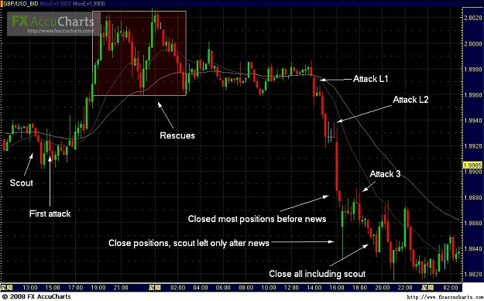
FTI:
Hi David,
Form your trades posted, I see that you may have the basic concept correct.
However , that I am alittle worried that you may have been too aggressive.
I bring your attention to the 3 attack, ie last attack on your charts. That is verny not prudent. as a matter a fact that is the last and concluding was by all count, That should never be a attack. Tradable but you must be aware that since that is last wave by any count methdology, that it should be a re scouted attempted with downsized skews.You seem very aggressive, the agression seems a little out in that when where the 3 nd attack was deployed, there were multiple abilities for strong attack.
What am trying to say is that from a hindsight perspective that I would howerver had been very aggressive at attck level 2 and 3 would have been up there near level 2, And that your level 3 attck would for me had been a scout and reki zone.
However, if you keep to thos mindset, with a watch out on the aggresion, esp when the run hasd done more than 2 wave, It would stand you good.
Quoting Green_David
Acutually both.
@FTI,
I forgot to ask you a question. On Friday, before E/U touched 1.5750, you said USD bulls were buying USD. What a wonderful observation. How did you see that?
E/U was actually going up even though the impuls was not strong.
David
Hi David, I believe you are referencing the top of the retrace turn. There I detected 2 failure sweeps as well as deep candle tails, moreover the pulse than I believe I felt that the sweeps hit something , as it paused for a little before sharp down shades of the Eur/USD, prompting heavy selling activity.
Can't remember in great detail, generally that was the tempo then. Moreover we had the USD bull overhang fundamentally.
Hi now that you have an outlook forward,
What is the chart bias,?
How is the dance?
How agressive ar not you should be, And where the dangers may come from.
Feel the dance rythym.
15 Min – 28 July
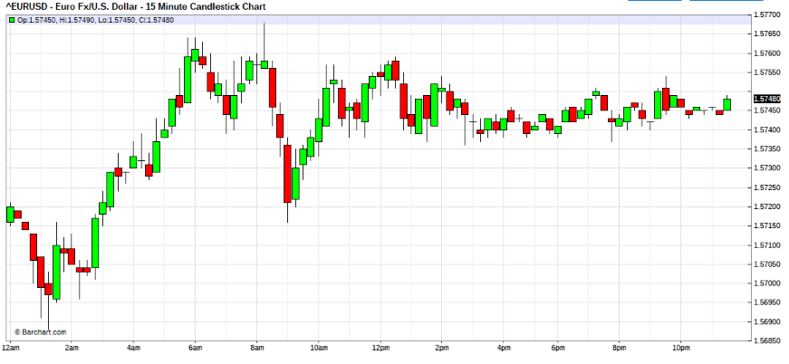

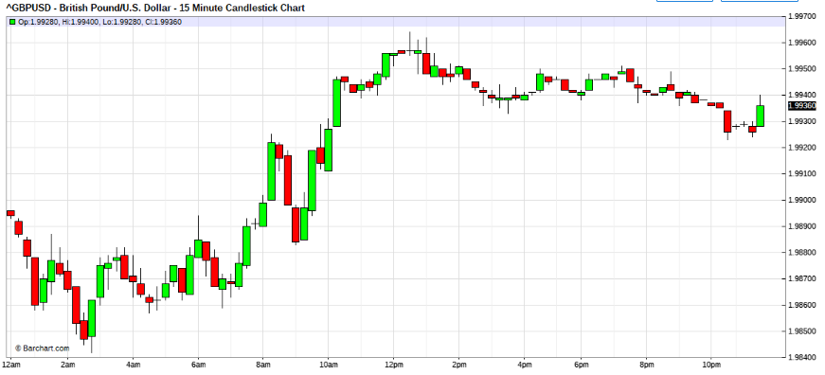

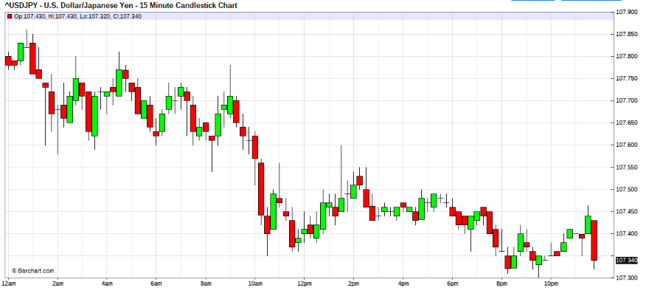

Jul 28, 2008 6:48am | Edited at 6:59am

Quoting Green_David
I am also bias on USD bull. G/U maybe the leader. The E/U increase by now is not impressive. Don't know at 12m what a FED official would say.
Take your words that "be nimble always and prepare for change".
Hi David.
if this bull scout falls into the water , be careful not to rescue to eagerly,
the hr chartd sre not there yet. Rescue cautioudly, best not at all until bleeding stalls.
Ops , he's in the waters, not dead yet, wait.
I/m letting him bleed.

Jul 28, 2008 7:17am
Quoting lilpip
Hi all, watching the e/u 5760 area to decide on which way to enter scout at the start of this next session.
Hi lilpip,
Don't be too eager, everyones on the edge, being there the whole day,
easy, reki missions ok, don't be too into it yet, anyways, feel her.
She's probably sweeping, London has no clue for a few days already. Watch for fatigue.

7:40am
Hi ALL,
becareful, when they line up like that, they are likely to try.
So don't be too in yet. watch for fatigue first.
Here goes again
Anyone missed mild rescue?
08:19am
Quoting maheswara
buffered , but scout still in
Good form, + correct startegy.
my rescue asking for a little more.
keep scout in for feel.
should be coming soon, don't be too eager, seems minefield .
don't be too eager, yet
remember you are still on your own, feel !
rescue out,
scout out,
repositioning scout later.
No fatigue detected.
8:28am
eei scout out again
preparing attack level 1, MILD one ok,
go go go
check your MM,
now try and find your own way , please.

Hi ALL,
Ah ya not so smart , hit mines.
Now bleed for a while still.
don't wanna watch grass groe , paying for it. LOL

09:08am
Quoting jest1081
the hourly still looks a bit flimsy. missed the first bear impulse...
sending the first scout in, short the eur.
Hi jest,
What impulse, its still ranging.
But this greenbag bull is watching grass grow, LOL
Look for fatigue, still trying not in sight yet, scouts merged and waiting, good average though.

Hemal:
Quoting fti
Hi fxa.
this , bloomberg's opinion.
Wrietr dare not identify .
Probably have no exposure.
regards
I just took some $
from rescue that was too fast to post.LOL
Hello fti,
Sorry, I might have missed something but as I understand that your bias was USD bull then why rescue and not level2 ,3 attacks ? EUR/USD is going down.
Regards,
FTI:
now every body shout break, no shout no cheese cake !
OMG, all scouts out, crocs detected in the waters.
a profiy is a profit.
retry scout again later at 50/55 zone. market tight.
We may be doing this funky chicken until fmoc out of the way,
Trade well, bears must be careful , bees around. just jesting

10:00am
Quoting MaMood
Ok' you'll get the cake for now!
I was a little hesitating.
May be now we should shout: False break ????
Hi
you mean back to CP , its just a jerk?\
Don't be too bull yet, funky chicken playing. after grass growing.
be careful, fomc still coming . playing range only.
probably sweeps on both ends.
Quoting MaMood
Just for Info:
USD/JPY: Flow Data Reveals Sentiment Switch
Montag, 28. Juli 2008 16:04:00
New York, July 28th. Proprietary data from one of the global European banks reveals a sentiment shift underway, There was an influx of equity investment into the US last week, mainly out of the Eurozone, although there were light inflows from Japan, having had modest outflows the week before. According to their data, the heaviest Japanese outflow went into NOK, and then Asia ex- Japan.
Last night the MoF released weekly data for the week ended July 19th; Japanese investors were net buyers of Y172.3bn foreign bonds, vs selling net Y58.4bn the week before. The data reveals that once again it was the retail investors that drove the data (the so called Mr. & Mrs. Watanabe). Japanese investors also bought a net Y71.1bn foreign equities during the week, after buying Y12.9bn the previous week. Foreign investors bought net Y333.5bn Japanese bonds and sold net Y297.2bn in Japanese equities, continuing last week's activity when they bought Y528.2bn bonds and sold Y242.4bn stocks.
US equities are opening soft, off 0.3% so far, which is holding USD/JPY back, last at 107.72. Oversold hourly Bollingers 107.50/60; overbought 108.00/10. Peter.Wadkins@ThomsonReuters.com
Hi MaMood,
Alamak, why these news always comes late.
Haaya,
regards
Again. no chasing ! start feeling her.
OMG, David, your horse flies, out of the gates, are u still in?

Quoting luSan
Indeed...that is why I am looking for a job...this will take a while...so easy but so hard at the same time...so many different possibilities...
Gosh...we are so darn lucky to have fti showing us his dance...I do not know how to acknowledge his guidance...thanks...
Now...let see if this bull hold at 5720...if it does not I will eat 2 cakes...!
Thanks for the songs.
Please be careful, you have little clock space left.
Don't b suckered.
Start winding ddown for fomc.
I am squared.
11:15 to 11:40 they will slow down for lunch,
again dont' be suckered into positions, no gambling please.

FTI:
------------
I not know what you may need.
but you know when a side is hit, it slides sometimes very fast.
as long as you are pacing , you should just follow the pump rhythm.
Do you remember when room was hit. Traders continue to pump off positions.
so never never stand in way of rushing force. no matter what your bias, when out of court never hesitate chop.
if you late to chop, then do not loose your balls.
you had been overrunned.
look at the charts
after run is consolidation distribution.
thats where you must pace again to square out.
When run is in your favour never rush to square out.
Bargain.
have you ever gone fishing?
yes, you must let it nibble.
place small baits.
let it nibble , until you feel strong bite. then yank.
i no need to tell you too much you should understand you seen treasury work.
Never be aggressive on positions unless you have good foreign cap back the punt.
so work hard make the small pips until you feel a run.
and after a run don't be a pig.
scalp on stream always. never against.
let the smart kids do the contrarian, They will be yur sugar daddy, on next wave run.
and let the analyst, rigid on their outlooks.
Thats not the business of a trader to be right.
learn be profitable.
Never be foolish for bargains on a run terrain.
bargain only in distribution.
if a run begins while you bargaining do not hesitate, on flow.
chacha properly if you value your toes.
REMEMBER, some days you will be very off form.
when off form walk away.
never force a bad day.
REMEMBER. ASIDE is a position.
about give edge.
never give the spread edge, unless is run against you.
in out edge will be 2x spread
you cannot get in and out on same price, always only on a shade.
extra thoughts, for the benefit of those who couldn't see it.
To help "the mind" from wondering wandering too far off.
Ponder this.
1. limits. esp daylight/credit stance. ie book capital vs cap at risk.Some peeps not have enogh cash last even 1 wave.i seen before.
2. Never ever expect to be right in any position. Its not right positions that kills, Its wrong positions, without an exit route/plans.
Note movie,300 mio loss turned out to be -1.4+ bio in 1 moment.
Markets loves injured egos. toss and fights but Easy kills.
3.Never think you have enough capital out last the negetive(trend) swings, ie no allow the ego write the cheques. Every one thinks they can out last the other, esp when have exposed stops.
MINDSET & management.
regards
If i ever decide do the BB Bourse game here. Eveyone wll be able see how a dealer can corner in the "right" moments, easily and NATURALLY.
Any way , I love peeps who buy my offers and sell my bid in the same hour. was very profitable when happened. For ME.
stop orders?
margin call buy-ins?
pattern break outs?

-----
END OF FIRST 204 PAGES.

