Quoting mijamoto
Sun Zi
""Water shapes its course according to the nature of the ground
over which it flows;
the soldier works out his victory in relation to the foe whom he is facing.
Therefore, just as water retains no constant shape, so in warfare there are no constant conditions."
I hope this is what you wanted to hear 
Yes, but what does it mean?
Think! deeep.
What is its ealationship to the law vibrations and the law of motion?
Whats the MO and MM to defeat it?
Hi Hapasasa,
Don't play god.
Give it a miss, if you cannot babysit.
Never play god. The risk must be managed.
We just got out of a USD roller coaster ride, the trend is set.
The exposures must be danced. Retrace it surely must.
Question is how deep?
what about the CBs?
How much foreign capital have you got?
what forces to expose, for how deep?
Be professional. If you were managing my book , and you did that, I would give you the walking cert , even if you made $$.
market has life, It has a pulse ,and rythem, and that determines its behaviour.
Your job as a trader is to gauge its pulse and move accordingly to sync with,it.
You will mostly be able to do that if you listen and watch it, there is no otherway.
The varables are enormous , and only the human mind, can be trained to "dance" its millions of colours and variations. Just like water the market will take the course of least resistance. The mind can capture that picture , only the timing may be slightly out paced. Thats why you have to have rescue options to align with the flow again.
If you are agaist flow, and remain to be sturborn cos of ego or any other reason, it will kill you. You have to "give" , and yield to the flow and pulse of the markets. Let her teach you her rythem, don't impose any of your thoughts on her.
You must also know how to take advantage of her, when you are in sync with her. And know when its safe to "force".
Therefore "the dance", learn AOW well.
Quoting totalpips
Sorry FTI for going away from the thread subject I just dont like people making statements that arent true. Yes it seems like an easy excuse to use, but there is a lot more involved in that situation then what was said earlier... Right back on track...lol
@totalpips
The issue of OIL will always remain in the backdrop of possible impulse driving of the markets. That is because it is the driving force of all human economic activties. Nevertheless, unless there is information of grave importance to market, then it slides into the background for other current events to take the wheel.

I can understand that, as you are engaged in the business, it becomes your focal point in your thoughts. The ability to be nimble to be aware of other fundamental issues to see the bigger picture, will stand you well, in the pursuit of market gyrations.

For those still pondering about the 3 kingdoms.( 5 mins)
see now the romance is in tendem.
remember how they danced to aifferent tunes when mkt was in flux.
Thats how you can tell if you are on the correct surf and what type of market cycles you're on.

Quoting Acs_112
The direction looked set, and just as your comments come about being nimble for change just that happend!
This is why i do have a problem looking at the 5 min charts. The change happens to quckly. How to handle something like this? Or is the answer in MM and Timing?
I am bearish the $$ so the bearish moved that was occuring was positive to me, but the change was rapid! On such a short timescale i was unable to capitilze on a move like that, as i was looking for more from it.
"the romance is in tendem" I can see exactly what you mean they are moving in great harmory at the moment!
@acs
The only way you can capitalise on that would be to be ready for it, be prepared. The wagons 's getting loaded.It was a good opportunity to regroup your exposures for a re leg of positions.Its opportunity.
If you missed it then reaccess your exposure now, she's have to spread as the rubberband was swift, there's gonna be several test for support. We just don't know where, but if your positions are still at the front you just have to wait for her to spread out well. Notice how the cable is leading herlegs spreading, when that stops then its time.
regards
PS:that's why you have to babysit it. Once you miss it then thats it.
that's the problem. If it gives you 2nd chance take it, if it gives you 3rd chance, then its likely a trap. If it turns out that its not a trap at 3 then the 4th is definately a trap.
Quoting BabeFX
The part of the fti trading style that I find the hardest to get my head round is the adding to a losing position in order to rescue the scout, this flies in the face of everything I have prevousley learnt about not adding to a losing positon.
This rescue when used correctly can be a powerful tool but is not for the faint hearted.
BabeFX.
Like you, it took a little while for me to accept this as a real valid way to get out an ill timed or even wrong directional entry based on everything I was initially taught, however, once I adapted this to my own MO, much like Leighs, and more rigid than fti's due to my newness to this type of trading, my trading has completely changed for the better.
This type of pre examining worst case scenarios before even executing (winning the battle before it begins) limits my overall exposure, in essence is a forced MM tactic. I have executed over 50 cycles of trades and many have been rescued, without a single cycle loss in over 2 months. I have become much more conservative than I once was as a result of the MM and rescue skew, but that has led to clearer thinking and trades without any degree of stress.
Trends may runaway for more than what one initially thinks, but at no time in history has a stock, commodity or currency pair taken off and never retraced even just a little bit, thats when we counter. With proper MM in place I know I can rescue any situation, quickly and painlessly, the key is to start small.
The only bad thing about this method of no S/L is that it's made me feel stupid that it's taken me 3 years to figure this out. Thanks to my good friend StevieT for planting the seed and revealing his method to me early on of the validity of zero stop losses and thanks to Fti for sharing an incredibly orchestrated rescue skew, the AOW, trading has entered a whole new dimension of enjoyment for me.
At times the rigidity of past knowledge tries to sneak its way back in but as I avoid the need for traditional S/L, RR ratios, and a screen full of indicators, but just keep things simple, the better my trading has become. Although I may explore other traders methods with curiosity, I now could not even consider opening a trade without a rescue skew preplanned, regardless of the trade MO. The AOW is a powerful tool to implement into ones trading mindset amongst other mindsets and the rescue that Fti has taught has truly rescued me as a trader. Good luck with letting go. I am glad I did.
NP
Quoting auxesis
Leighsww,
I have read this thread, and I use position averaging in my trading, although I view the battleground or the concept of rescuing differently than what has been discussed. But I would warn anyone of taking the attitude that the market cannot throw you a curve ball that you can not pound out of the park.
Of the three stories, the first one Karl, troubles me most. He was a veteran trader the other two were relativity new. Yes we are lacking many of the facts as to what actually happened, but I’d guess that Karl traded day in day out making money and comfortable in his technique and strategy until one day he found himself on the wrong side of the market and it continued to run against him. At first it seemed manageable, then a heavy loss, and suddenly the realization that the loss was outside his limits and then devastating job ending, life changing losses. At this time he was paralyzed in thought, the only light visible at the end of the tunnel and the only way out of his predicament was to hold as the market would eventually right itself.
This is the problem that I see with the approach that one will never take a loss unless your cash reserves are limitless.
Hence Karl, he was a successful trader, then one day the market threw him that curve ball and he was unable to recover. Given enough time the market will eventually throw us that curve ball, where the market will not quickly give us a correction to load up and make it back to Breakeven. To what level do we keep adding exponentially? At what percentage of our account to we put at risk 20, 30, 40% What happens when we hit that level and the market keeps dropping, but we know that it will turn around on the next level so we add one more round………………………………
I’m not trying to take away from this thread, there are many great ideas shared here. it just seems to me that the mindset that seems to be developing is one that has no fear of the markets, and in my humble opinion it is a dangerous one.
Regards,
@auxesis
Thank you for your highlighting,of the dangers, and the sharing of your experience.
Please try not to mistaken , fear of market, from the respect that a trader must accord the market.
I have seen and managed most curve balls that the market has thrown my way, in my lifetime. Make no mistake that it can get hairy, at times.
Therefore it behoves the traders to be nimble and manage them best they can always. But in essence, there is less to fear from market gyration than from trader ignorance or egor.
I hope that a true understanding of the methdology here will be of value to your continuing market education.
Quoting mijamoto
fti i am intersted if you can explain and tell more facts about 3 kingdoms (if there are any) and what's your oppinion about ECN level 2?
regrads
Hi mijamoto,
In essence is a danceing with 3 markets simulteneously. (refer to my chart posting). you will be looking at 9 charts simulteneously.
ie cable& Eur( the colonial masters), USD (the WW2 victor) with the rest of the lump (the free third world trading partners).
This could be changing a little as the "pegged" countries are coming on stream.
To be able to dance this , you must master the ability to dance single girl first.
Its use is very useful to time the other girls. But if you have problem dancing one girl, then dancing 3 can be....
Moreover your book have to be quite large to do it.
Its sort of trading, with arbitrage as the foundation for the trade.ie crosses
When tearing occurs , its a handful to manage.
When in sync, it directs the trend in absolute.
PS: another thingy which I would like to stress again, is that just reading and flowing along the thread to rush here doesn't do justice in the study , as I am already going too fast.
Beaware that at evey stage of the study, there will be a vacuum of infomation, of which you must pause , think and find the answers to the traning. If you move on without the thinking and using to discover the info for yourself. Then you accumulate that lack and then acutually gain nothing from the reading.
I believe many here that have gone thru the process will be happy to help you along with the helping ofthe answers to the questions that you wuoldn't know to ask about. So slow down and move at your own pace, as most of that need be taught is already given, and I am just trying to revisit that which may have been missed.
Quoting mijamoto
THX for your explaniation. How do you find today's retracment in major 3. I see it as a killing ducks and a new opportunity for going long
regrads and enjoy your time
In all essence, the feds interest rate policy have "showed hand" of the likely USD devaluation for the long run. Whats important is how it would pane out. In this markets, the whole world knows what to do, so the ability to stay on track becomes extremely difficult, as the volatility would increase on both the bull and bear side of the USD. Positioning is of no real consiquense to profits, as it would be difficult to sit on large exposures.
The most prudent trading would be to dance the volatility with smaller exposures and when positions snowballs on tight range to defuse that snowballing. Allowing a slow build up of the USD selling, allowing for this only when the USD selling can be protected with foreign capital that you capture from the markets as you babysit it. Do not be suprised that buying USD may prove the alterbnatively better short trade exposure while the USD selling be slowly built up. For more advance traders , the use of OTC USD options , may prove to be a better longer term strategy, while the short is traded. This is provided that you have the facalty to calulate the volatility money that is factored into the option cost. This is so that you do not pay too much premium for the volatility money. As the option is a wasting asset , toomuch premuim for volatility , will erode whatever gains you can get from the price gyration.
The pros would be writing the options, whenthe volatility money is high and manage the intraday gyrations,trying to get free time decay as well. but if you are not pro nor have absolute market access, do not go there.
Quoting alexfot
Hi, fti! I'm still not clear about how to use the law of motion and a law of vibrations in trading. I'm sorry if the question is so obvious.
Regards
Alex
Hi Alex
Understand the general influence of these laws will help your timing.
read these and see if you can understand, indepth understanding is not required.
Understanding of its influence is the foundation.
http://csep10.phys.utk.edu/astr161/l...wton3laws.html
http://www.ajna.com/articles/everything_in_motion.php
Also try to understand what "gravitation to the mean" means.
regards
PS: If you want to go indepth Law of vibrations, read the enclosed pdf
Mar 11, 2008 5:11pm
For those short of usd, be aware of a key reversal in the charts,
All 3 kingdoms, Manipulation of market is in progress, possibly to tame oil prices.so be nimble.
Quoting piphitman
I thought it was rather clever that the FED manipulated the market by not having to decrease rates but instead used another "tool" in their tool box.
Hi piphitman,
Agreed, do remember that they are pros, so they do have much arsenals up their sleeves. It behoves us to be nimble to avoid their snares. It is impossible to pace them, but we can time ourselves from traps. Paying for exit early says alot from the consequences for paying thru the ego. It is only prudent to take lesser profits whenthe ground changes, then to be stubborn and pay the ultimate fare.
For those that may be confused, lets say that although the trend is intact, there will be realignments necessary, because of undue force. It is fool hardy to fight the obsticle. The trick is to use the momentum generated to ones advantage while it meanders.

Quoting piphitman
I was thinking about that "just kill it" number too??? it seems that one would have to have proper MM and rescue possibility in ones plan of attack to account for, and to possibly withstand, (for example) todays USD/JPY blast of 85 pips in 5 short minutes (a 155 pip blast on the pair I trade GBP/JPY), followed by a 22 pip retrace then another blast upwards again for another 50 pips. Being involved in a trade during such a volatile spike makes one wonder when/where???? to pull the plug.....
It's imagining and planning in advance for these types of scenarios that brings up the ability to be "nimble" in one's attack for any and all contingencies. One does not want to be blindsided on one's flank for a mortal blow.
Hi ALL,
In reality, if you have been following the methodology closely, is that when you are in attack mode, you have foreign capital cushion before you "press" for attack, so you are prepared for minimal damage if flanked. but most impotantly,your nimbleness is in the attack. As in yesterdays scenario, there was good windfall already. If you can remember , my hand hold session before, you would realise that as this windfall comesin the money, the possitions are wounded down. this gives you muscle for rewinding for another attack on the next wave. this action also prepares one for the eventualities as we witness yesterday. where we met the owner of the market coming out in protest. The cost to the trader would only be opportunity cost in such instances.
Therefore to be able to carry out such, the mindset must be, to allow for lost opportunity cost on every attack.
Althought when the protest was in progress, most traders will not see CB face, but it will be announced within the (normally) 30 min time lag. Therefore, the only pain to recind is the small spiral, which can be easily reversed. That's why when the attack is in progress , we are known as "big guns". The rule of thumb is never to allow the "big guns" to stay on the field, after its purpose has been achieved.
Again as in yesterdays scenario, the smaller exposure may be trapped in battle ground, but that can be managed to reverse the positions "on wind". If I was in the dealing room , I would probably have seen CB in market much earlier, because they check the market many times before they act. Some tier 1 are actually acting on their behalf.
In unnormal situation of unseen hand at work, the same scenario is still applicable, but only that there maybe slight attrition to P&L due to reactive time scope. Nevertheless, they will never find the trader in attack mode and trapped in "dead ground" due to it never is in there long enough for targeting. At worst case , only part of the attck may be trapped.That's why the attack's nimbleness is critical for success and babysiting is necessary.
For normal traders, it would be highly likely that they would be caught log stock and barrel, while they where pushing for the market run. The deadly possibility is where they had actually added the bulk to press the run.This is especially so for term position trading. Or for break out traders. The difference is the greed factor.
So in reality there is no "just kill it" requirement. But if any comfort, a 3X of normal daily P&L range , would already signal, "dead in water" possibilities. From there the trader has to decided if the "cannon" (rescue of last resort) may be used, but that would depend on how much accumulated foreign capital is available for such an endevour.
Once you are experienced in this MO, you are mostly doing ants work regularly, and any attrition to P&L would be within the confines of your accumulated winnings. For banks that is limited to the annual quarter's P&L. This is also the reson why , when a disaster scenario is reported , as in the case of socgen, they can still report that principal is safe.
It would be great if individual traders can adopt this. But this is unlikely as , the modus operandi sowed in the minds of most trader is to profit in access of 3 to 4X cap ROI on outlay. So exposing them to castratopic runs on cap. Not withstanding those that want to make millions from pittance. Of course high gearing accelerates their demise.
Maybe this may help some come to their senses, that to be truely profitable , it must be over time ( like ants work), never depending on sudden winfalls. If of any value , to be on the watch out for and to reverse sudden misfortunes. [MINDSET]
PS: Was checking brokers, heard recently how one trader made like 15mio from market, heard he was down close to 50+mio at one time, guess his exposure and bank borrowings? Lets see when he goes chapter11. This stories are circulating enticing traders to commit "harakiri" in markets, but who am I to question his style. and some brokers are selling that.Well greed hasno limits.

Quoting piphitman
Excellent commentary fti, Thank You.
a question for you, for example; If I am in dance mode and I have 1 troop in for skirmish, then I place another 2 troops in for further attack, then I place another 3 troops in a little later for a press of attack. What you are saying is that the last 3 troop unit is the one that must be taken out as soon as it's job is completed and not be left to linger on the battlefield for such damaging effects of CB intervention or other Major player actions.
If I have 3 positions open and a news spike or other major player intervention quickly turns the market the other way should I be placing a trailing stop on that last 3 troop unit as it goes along so it will not get caught up in a slippage nightmare?
In MT4 it could feasibly take a few deadly precious pip moments to close out three positions when the market is changing very rapidly. The time it would take to open up the trade and close it out and then move on to the next one and do the same thing, then each succesive one could be very costly. For now I guess I would just manually already have the 3 troop trade window open just waiting for a simple click to close the trade if needed and then deal with the other two positions as quickly as I could attend to them.
Hi piphitman,
As combination of spiral 1,1,3 would be a better combination as your attck would be stronger. howerever 112 gives you the 1123 range of capabilities.
when attack is over, the winding down should leave normally only base. ie scout. On second wave when you do a 113 again, the effective is actually on 2 base as one was left over, 2,1,3 then on wave 3 the base becomes as large as the attack, effectively 3,1,3 as 2 was left over. if the short term trend ride was succesful the base should be winded to the original of 1.
You can work in multiples of the base as per capitalisation.
I found this most effective.

Quoting lilpip
fti,
I agree I need to read this thread over again, actually a couple times over.
As you might recall I'm new at this and didn't know anything and probably still don't but at least you got me thinking about matters.
So I'm trying to figure out the overall trend so I thought it would best to begin with the weekly trying to understand which way the day might be going so I'm on the right side of the road.
As far as the spiral I was trying to prepare myself for a rescue from watching this pair it seemed that those 3 seemed to be areas where price may rotate back. Maybe I'm trying to hard to see characteristics or patterns.
thanks for keeping me going in the right direction.
Hi lilpip,
Not to worry, go slow, it will come to you.
The thingy about weekly reads , is actuality it tell you nothing , as the trade time scope will be going into years of market participnation, so really looking there, give the trader nothing.
Already if you traded a 5 min sequence, your exposure could be into days of babysitting, and that is if you got the stamina to do that.
The daily reference helps you if you happen to carry overnights while riding smooth trends, and these comes by only occassionally. Probably less than 5 or so in a year.
If you are on rescues , try to limit to daylight.
Be absolutely careful when you think fibo in price scales. Price movements move in impulse wave thrust and equilibrium setting.
So it is linear and 2 dimensional. position and P&L snowballing can be build on 3 dimensional models due to its geometrical undertones. I understand that there are a lot of disillusional material floating in markets on 3 dimensional price predictive models. Be clear that that is pure rubbish and is used as marketing BS. fibo leveling can be used to extend the position modelling to allow for illiquid markets,to stretch, but as a rule of thumb, I discourage traders from trading illiquid markets. manipulation is likely to be rampant in those.
PS: also note that from trade clearing data 80% of all forex transactions are accredited to the 4 majors. Used to be the USD/DMK was most liquid, Now it is the EUR/USD. followed by USD/YEN, then Cable and CHF. The reson why london is lsrgest fx center is due to location of interlocking time zones. In interbank , all the other pairs are considered exotics.
Quoting jest1081
Hi fti,
i did a demo trade a while ago following your reccomended 113 attack sequence using the 10min charts.
Marked below are the entries i took at the close of each bar. Say once price reached its target (do you even use targets?), i'd liquidate and leave the 'scout' in. As of now, i'm preparing to make a second wave at it, which will eventually make my skew to a 213 right?
http://img511.imageshack.us/img511/9194/euqv3.jpg
a few qns, pardon my naivety
What combination would you reccomend when i am trying to do a rescue for 113(5troops), 213(6troops) and 313(7troops) combo?
Can the 113 sequence be used as a skew for doing a rescue too, i am asking coz i saw lusan's journal and his skew sorta puzzled me?
attack with 1, 2, 3
rescue with 3, 9 , 20
does this mean that if i have
- 1 troop to rescue I will send 3?
- 2 troop to rescue I will send 9?
- 3 troop to rescue I will send 20?
or
- 1 troop to rescue I will send 3?
- 3 troop to rescue I will send 9?
- 6 troop to rescue I will send 20?
regards
jest
Hi jest081,
Interesting,
1. I am sorry to say that I would not be as sharp as you. In the sense of the ability to pick tops.
2. That you are on an extended compressed time frame that there will be little decision making reads. since this was the time frame you chosed then I will try to explain it in sync.
3.Before we go on, I would like to enquire with you if you know the daily trend, and at what zone of possibly sequences that may occur?
My take on the daily trend is bullish EUR with a strong key reversal influence.
Base on your short chart (10min) if I was to attempt this trades, I would probably be short E/U at point marked 1.
Since we are in a range sequence, I an afraid that, that would be my only possition for up to where your chart stopped. This is because we are in a range bound scenario.
There is no attack sequence possibility until more info comes on stream.
I would like to further enquire your reasons for your position 2 where you sold another position, to rescue your scout. Based on the position of the scout, there seemed no rescue necessary, as it was never out of money.
The 3rd position further is at question based on that again there presented no such necessity.
I think you must have confused that you must always impliment rescue, even if the position was not emcumbered. Please reanalyse your position.
Further do not be confused that the attack sequence and the rescue sequence both take on the geometric basis. The purpose of rescue MO is to recover the scout , when encumbbered, therefore the minimum reponse is at least a fibo progression sequence.
The attack sequence is for press therefore should at least be a reverst fibo, to protect from possible retracement against possition.
Another point is that when a rescue gets into trouble, the next "spiral within a spiral" possibility would insist that the next rescue sequence , if attempted on would have to take the form of size of minimum next in order from the exposed base.
ie a martingale of base.
example.
if 1 scout was in trouble, u sent in 1 to rescue then 3 to rescue if unsuccessful, if more rescue was required then the next squad would be ?
ten,, did you get it right?
based on this progression what would be the next required rescue?
thirty, did you get this right?
what's next, ninety.... see now.
lets say you use a 1,2,3 then requried rescue is 18, 50, 150,
i best not show you level 3....
if you evaluate your rescue risk snowball....now do a rough guesstimate for every pip run against you,it will cost your book?
By the 2 nd level at least a quarter of book is at risk. So try not to get yourself into this often, for the sake of sanity, unless you are a bank.
The focus should however be on attack sequence, where you have foreign capital protection to a certain extend.
Pressing should however be initiated only once trend is entrenched, normally on wave 2 onwards and should be on reverse fibo summation up to limit, if foreign capital reserves allow.
Of course when you first set out, there is little foreign reserves to lean on, so then you must be very conservative, until you have the nesting.
As sitoca rightly pointed out, the MM is to hold to proper sizing, the profits comes from dancing correctly. Dance badly, and the most the MM can do for you is to minimise drawdown at very high risk of ruin. Maybe you would like to show if there was any other way?
And MM management on profitaking should be on LIFO as Lusan suggested.
I hope this helps you crystalise your thoughts.
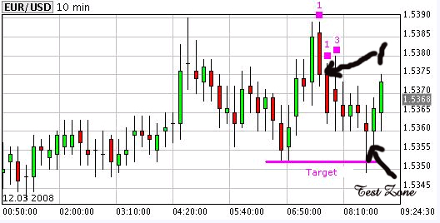
Further do not be confused that the attack sequence and the rescue sequence both take on the geometric basis. The purpose of rescue MO is to recover the scout , when encumbbered, therefore the minimum reponse is at least a fibo progression sequence.
The attack sequence is for press therefore should at least be a reverst fibo, to protect from possible retracement against possition.
The base of which could be the sum of all available ammo left over from the original rescue or scouts possitioned, whichever is applicable. If it slipped you, there is no possibility of further pressing when the base is not in the money. I mean well in the money.
Just for side note, my exposure had ever gone as far as approx 50% of book in a few instances in the many years.

From the market squence you posted my position looks like this.
Due to trading against trend the rescue sequence should be 1,1,3 coresponding to marked 1,2,3 on chart.
selling Eur/dlr, and position would still be in limbo waiting for further developments.
Attached Image
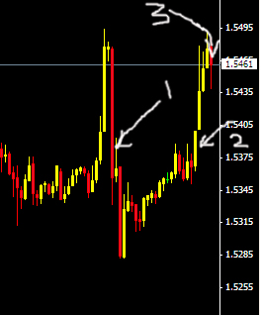

Now the 5 min charts looks like this. (below)
Do you see the power of baby sitting it?
Assuming that I am crazy enough to trade like this ?
So what is my response to market and the positions now?
regards
Attached Image
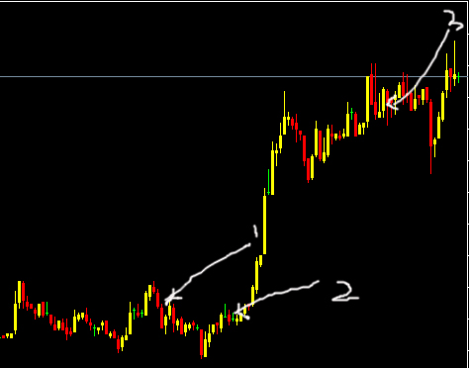

yes sitoca,
the idea now if caught in such a situation is to try to clear position 3 with minimal damage, give the position 1 and 2 (dead in water)away. and await new developments to recover. but definately not going long here, so its going to be a long night for this trader.
So is selling an option here, the answer is NO.
In reality we are playing a broad volatility range and awaiting new developments. I believe most on the short charts may be long and taking profits here.
regards

Note that from here the market is neutral, and there is no possible directional play, and positions must be squared.
It is most likely to be range bound.for some time.
aside is the best position.
regards
Mar 12, 2008 10:47am
What I am trying to point out is that market bias have to be in relates to its impulse wave. Opinions, like lines on the chart blinds. And also that 10 mins charts are too in the middle of the road to provide sufficient data for dicision making, as well as forcing for longer babysitting requirements on exposure. this would be similar for those trading day charts.
Non impluse responsive is the word, I think.
So dance lots in demo, and the market will teach you.
Feel lucky, because in my time, we learned it the hard way.

Sitoca:
Quoting sitoca
Was Long earlier now flat. Looking to go short now. Nimble is the key if going down.
My concern is the E/U & U/J which still seems to be quite strong and not in sync with the G/U if going short.
This is market crosses tearing, when they align then the trend in the Eur/Usd will clear up for impulse push.
There are strategies to capitalise on this but don't go there yet.
Leave those piping techs to market makers.
Jest,
If I may add my thoughts.....
I believe that how you would send in your attack will depend on how much foreign capital you have pillage and this would in turn affect the rescue you have. There is no fixed rule and will also depend on the market conditions and volatility.
As fti would say, don't be rigid. You need not have to rescue with a 3/9/20 sequence. If you capital allows and with the right market condition + volatility and you dance to it, you can even turn rescue to attack. What is stopping you from doing 3/5/13 or 5/13/18?
I personally feel reading the market flow with proper MM is more important than worrying about the precise number of troops to send in for rescue or attack.
-sitoca

Sitoca Response:
Lets say you bad, are zooming out and if you are trading against changed pictures, you know you are "dead in the waters"
So what must you do?
> Exit Trade at BE if possible with foreign capital. If no foreign capital then take the loss.
If you turn, you lose ground, so you have to decide to trade against trend or sink. right?
When this happens, what is the mindset to adopt?
> Exit trade and wait for opportunity to turn into direction of the current trend.
If you decide to fight instead, you are trading against the trend,
so what should be the mindset, strategy & MO?
> Do a quick rescue to exit with minimal damage. Do not overstay in the rescue too long.
Remember when you try to turn "on wind again" you work against the law of motion.
What does newtons law of motion states about the law?
Think thrust & distance.
> Assuming our initial Trend analysis is correct but we mistimed or wrongly position our entry, then when we turn into the wind, we are likely entering into a period where market is going to reverse against our position.
If you decide to turn, WHERE do you look for that fresh timing?
and if you use $$$ to turn,how much ground must be lost before the turn is effective?
> ???? Help! Need clues and hints!
Understand the MM tables.
When risk snowballs , what is the best alternative.
> Reduce position size?
Even if turning is the way to go to flow back into the trend, Whats the purpose? Whats the MO supposed to be?
> MO is the rescue sequence. Purpose to recover back the previous loss.
You try to use attack MO and the MM WILL kill your portfolio.
> ???? Help! More hints pls.
FTI:
In effects , what I just demoed for you should answer the questions here.
You are in effects correct.
In reality , you need to practise the thought sequenses out under many scenerios, most you may get correct, but its the ones that you may deviate from the thought sequense that may endanger , your book.
So practise , practise and practise.
It is easy when guided, prove that you can think in this mindframe when positions are in market. You may be surprised, so practise.
regards

Quoting sitoca
Hi Fti,
This foreign capital we are talking about is it:-
a) per trade basis or
b) Profits for that day
@ sitoca,
there is nothing written in stone.
It depends on your risk tolerance.
but try not to go beyond, 3X normal average daily P&L
or it get very scary and can build on you very swiftly, normally without your realising.
Of course at banks we go as far as daylight loss threshold,
but don't be like that, you can burn out very fast.
The toll it take onyou physically is tremendous, so try to trade cool.
esp if you do smoke and drink.
Don't force. If losses are not too much , just cut.( that is unlessyou really see opportunity, don't guess)
Once a while your resolve may be tested, thats to be expected.
By far, the fact that the trader manages the exposure on realtime would fare better than stop loss order traders by leaps , who often will get kicked in the groin for no apparent reason, except for position gambling

Mar 13, 2008 8:40am
HI ALL,
here comes the feds again!

<chart>

Mar 13, 2008 9:20am
Quoting alexfot
Hi, fti! Do you mean that this sharp downward move is a feds job? How do you know that? I can have a clue now after some reading of ky,,,,, but not exactly. Thank you for that, btw.
Alex
Hi Alex,
Think nothing of it.
Please may I ask if you would remove name of file, thanks
we refer to it as ky.. in future, ok
By the way the short chart pattern, indicates that the CB is quite serious about the support for the USD, at least for now.Trade carefully.
PS: About the CB,
well lets say a little bird told me they were checking.
Tis is very tiring, when the elephants fight, all little ants can do is to sit and watch, waiting for the right time to pick up the spoils.
gotta go , trade careful
Some may get the surprise , that
the 2 step may be even more profitable than just riding trends,
not that riding is bad , just difficult to keep balance.
Good traders makes $$ in all market conditions.
PS: be careful of 1 min charts , very slippery.
if you follow close, 5min, 1hr, day is enough.
anyway whatever makes you the $$s

Hi mijamoto,
Since you are here, some material for your education enclosed.
its from the Federal Reserve Bank of New York.
Study well.
http://www.newyorkfed.org/education/fx/index.html
The link and the pdf is the same.
I hope you manage to get the other 2 pdfs.
otherwise email me.
regard
PS: here goes, the cats away the mouse starts to play.LOL
The Basics of Foreign Trade and Exchange - Economic Education...pdf 273 KB | 2,838 downloads

<<LUCKY57:
Who learns from his own mistakes is SMART and who learns from others mistakes is WISE.
It costs money to be SMART and it is free to be WISE but free stuff in this world is considered worthless.
I incidentally came across your post on TA today on FF. Would like to say a few words but let me introduce myself first.
I am a full time trader. I am trading for the last year or so. Started in 2006 but quit after losing my account. Then again started in June 2007 and since then I am trading full time. This is my bread and butter and I see myself trading 10-20-30 years from now. I trade only Forex..
You might be thinking that this guy must be making money in the markets who is talking so confidently and who is so determined. The truth is I am still donating my money to the markets. Nothing new? Everybody does it. Some accept it and some don’t accept it. Some admit it like me who believe trying something and not being able to produce the desired results is not a failure. Some believe that if they tell somebody how they have failed it will be embarrassing. It is just the way you look at the situation. Your perception is your reality.
· you are not defeated until you accept it as reality.
·Do not fear mistakes. Make more of them so you learn quickly.
·Don’t look at failures as negative. They are just a footstep to success. If you are afraid of taking those steps then you will never reach the summit.
·Never regret the things you tried and failed but regret those you never tried.
My first account of 10K was blown away in about 2 weeks. 2nd account of 10K took a month. Third account of 5K took two months. Fourth account of 1000 dollars took about 2 months. Fifth account of 700 lasted 2 months and I am again on demo trading.
There is almost no book on forex or trading in general that I have not read. Mark Douglas, Van. K Tharp, Alexander Elder, Murphy, Tom D Mark..... I can’t even count the names and count the books I have on Trading and TA in my own library.
There is no software I have not tried. Paid 5K for Vantage Point. I attribute one account blow up to this software.(sorry bad habit of blaming others for my mistakes).One day I called Vantage Point people if I can return my software and told them I could not make use of it. They said they can arrange a session with one of their experts to tell me HOW TO TRADE. I asked them a simple question. Just one question:
DOES THAT EXPERNT HAVE A LIVE TRADING ACCOUNT AND HE OR SHE TRADES ON HER ACCOUNT?
The answer I got was
None of us trades live. My response was simple
” I DO NOT WANT A PERSON TO BE MY DRIVING INSTRUCTOR, WHO HAS NEVER BEEN BEHIND A STERRING WHEEL.”
All those people and companies selling those black and blue boxes make their living by selling those systems to newcomers. If their software or systems are so good they should trade with them and make money.
Look on the web, how failed traders (mostly) offer how you can become filthy rich if you use some XYZ system. If it was so easy then why they are selling these programs to make a living and can’t use it themselves to generate wealth.
Most people dont understand or comprehend how big part psychology plays in trading. For example most professinal traders who trade for their company and do exeptionally well and make millions for their company when come to trade for their own accounts fail badly at trading. Why? Psychology: when trading others money their emotions are not involved in making trading decisions. It is just like surgeons when they have to operate on their own family memebers they ask other surgeons to do the job.. Strange...
There is a very simple formula for success
Determine what you want:
Find out the price;
Pay the price.
We as traders, just get to the first step…. We determine that we want to be a Trader. We never come to a point where we know what it costs to be a trader….( at least I still don’t know the full price.. because I keep on paying and it still keep on asking for more)…. But I am clear about one thing…
I AM WILLING TO PAY THE PRICE… WHATEVER IT IS to be a Successful trader…. And this commitment is my greatest wealth and winning edge.
I and again “ I “ Lost my account 5 times in a row. I am again on practice account. Will try again live account. If I loose it again I will again try it… if I loose again, I will again try it.. and will keep on trying UNTILL I SUCCEED.
A winner never quits and a quitter never wins.
When a child starts to walk and falls, walks and falls, walks and falls... Can you impose a limit on that child that if you fall so many times you will quit and you can’t try it again.... NOOOOO.. he is supposed to try UNITL he walks... So is the case with me. I am supposed to keep trying UNITL I start walking. If anyone of you have not that commitment you will eventually loose. That is why 95% loose because they QUIT. Do you think the handful of winners never lost? Surely they lost big and many times over before they were successful. They only stayed there long enough to be successful. Here is what I have learnt so far.

If you have
PATIENCE--to wait for a trade or right opportunity
DISCIPLINE --to abide by the rules you have set for yourself
COURAGE... --to accept if you are wrong and accept the loss
you can be a WINNER
YOU DO NOT NEED ANY TRADING SYSTEM. TAKE ANY LOUSIEST SYSTEM and if you have all three above you can win. But why then we run after systems? Simple; because it is easy to run after systems and EXTREMELY DIFFICULT TO EXERCISE PATIENCE, DISCIPLINE and COURAGE. We run after systems so we can blame something in case of failure.
TRADING IS EXACTLY LIKE HUNTING: A HUNTER WHO CAN WAIT PATIENTLY FOR HIS PREY TO COME TO HIM MAKES THE KILL. YOU CANNOT MAKE A KILL BY CHASING YOUR PREY.
Did not somebody tell me, this before I blew my account 5 times? Yes I was told. BUt because I had no personal experience about this, the advice went over my head. I was told from day one:
NEVER TRADE WITHOUT STOPS.
NEVER ADD TO A LOOSER
NEVER LET A WINNER TURN INTO A LOOSER
...... and list is endless YET
I DID EVERYTHING I WAS TOLD NOT TO DO----- UNTIL I GOt BURNED and I paid to get that advice
In Nov last year, I doubled my live account in one week. 22 trades, all winners. What indicators I used, NONE. NO INDICATOR EXCEPT Trend lines. It took me a week to double my account and took just one night to bring it to less than half. WHO is responsible.. ME. Did my system fail? NO.. I failed for lack of DISCIPLE, and PATIENCE.
BACK TESTING
Back testing is the biggest BS that I hear time and again. We don’t trade in past but in future. The strategies that worked a year ago, don’t work anymore. 95%(The loosing percentage) of the Traders who traded a year ago have been replaced by new ones with different mindsets, psychology and goals. You can back test a system but when you do it in REAL TIME, the playing field is different. The emotions are different. Your mind works differently and the results are different. That is why when I devise a system I test in real time even on a demo is fine. I BELIEVE that we dont trade a system but a concept. If that concept is sound it should be tradable today, yesterday and tomorrow. Markets are mass psychology and human psychology has not changed in the most recent past. The simpler the system or the concept; more tradable it should be on any time frame and during any period and on any instrument. If your system can only be traded on any one instrument or was valid yesterday and is not valid today, then it was flawed from the start because I dont know if human psycholgy changes so frequently.
I tried NexGen Software, eAscTrend, 4X Made Easy and some others. Paid for seminars and trainings ranging from hundreds of dollars to thousands of dollars. I paid $5500 for a three day training seminar and travelled a thousand miles to attend it. Altogether I have invested about 50K in this business so far.
Did I waste my money on all of the above? Absolutely NOT. After all that spending and struggle I realized and found out that None of that stuff works as they say it does. To me that is a big find and is worth far more than the amount I spent to find it. Experience is ever BOUGHT and Never TAUGHT. I paid to get that experience. If somebody had told me the day I started in this business that this stuff don’t work would I have believed them? The answer is an honest NO. What then I spent all my money for? What is in my hands now after that entire struggle that I did not have before starting out on this journey? The answer to that question is:
BELIEFS
I have now A STRONG BELIEF that if I have to win, THERE IS NO ONE THAT CAN HELP ME BUT ME AND I AM ON MY OWN. That simple belief is worth a million dollars which I could not have achieved without that spending of money or time.
At the core of every success and failure there is a belief at work. Our successes and failures in life are attributed to our beliefs. Just to make my point what is a belief and how it can make or break us read the following two examples.
A student in a mathematics class room went to sleep on his desk. When he woke up he found two problems written on the black board. He assumed that as he was asleep the teacher might have given this as a home work assignment. He noted them down and struggled all weekend to solve them. He could do only one and could not solve the other. On Monday morning he came to the teacher and told him that he could not solve one of the problems given for homework. The teacher stared at him in disbelief. The teacher said he did not give any home work. The two problems he had written on the blackboard were written there to tell the students that they are IMPOSSIBLE to solve. How did you do even one of them?
The point of the whole story is that if the student had known beforehand that this problem is impossible to solve he wouldn’t be able to solve even one of them. Because he had a belief that this cannot be solved and he might not have even tried to tackle any of them.
Second example I would like to quote is:
In circus you see large and big elephants tied to tiny little pegs with very weak strings or chains. Why don’t they break loose? Here is why: when they are little and weak they are tied to those pegs with the same chains. They try hard to break loose. They fail because those chains are stronger than their strength. They believe that they can’t break them and learn to live with them. As the years pass their strength increases tremendously but their beliefs remain the same. Once they have believed that they can’t break them, they never try to break them again in life. They will never try it again unless they change their belief that they can do so. It keeps them tied to their pegs. Now it is not the strength of chains that is holding them it is the strength of their beliefs that is responsible for their freedom.
There is a very powerful lesson for someone who wants to learn in these two stories.
Same is true about markets. We don’t trade them we trade our beliefs about them. We bet our money not on what is the reality but what we believe to be the reality.
I am just writing to let you know my view about TA and indicators. I have spent thousands of hours in front of my computer. Have wrote a lot of my own indicators in easy language and MQL 4 for MT4. After all that hassle and struggle I am now where I can see everything clearly.
I am now where I started from. Naked bare charts without any indicator or even a trend line. My eyes can see the trendline even without drawing it on the chart. And if a trendline is not visible with naked eyes I don’t believe in that trendline. I have Absolutely nothing on my charts. I now BELIEVE that the price action is the most pure form of indictor and is most recent than any indicator. Why wee need an indicator to tell us sometime in future what we can see with our own eyes happening in front of us right now: why we have to wait for a moving average or MACD or ADX to tell us the same thing after some time. And the time when indicator gives you a signal it is already too late.
o IT IS HARD NOT TO BELIEVE WHAT WE WANT TO BELIEVE.
When we have made up our minds about an instrument that it will go in a certain direction; we try to find indicators that support our view. We don’t interpret the indicators as they are but as we want to see them. For example; I am bullish GBPUSD. My MACD is telling me on 4H to sell. I don’t like that MACD at that time because it is trying to contradict my view.
I will change the time frame to see if it is giving me a buy signal on 1H, 30 Min or anywhere. If it does and surely you can find a time frame where an indicator can support your view; you will get even stronger on your bullish aspect about GBPUSD. You will only pick that goes with your brain. YOU will only see what you want to see. Then you see other indicators and surely some indicator at some point will support your view. You add up together, MACD on 30M bullish, Moving Average cross of 5 and 21 on one hour, Trendline on 5 min is holding, candle on 1 hour is bullish. Price breakouts from channel on 30 min. BUY. And you pull the trigger. This is mostly how trading decisions are made mostly by 95% of crowd who come with a dream of getting rich quickly trading the forex markets and end up donating their equity to their brokers account. I did this for 5 times in a row. I always changed brokers so everybody out in the markets can benefit from my donations.
If you try a little harder, you can find more indicators that do not support your view but that’s not what we want to see. So what is important? Indicators or the way we see them? Do they tell us something is going to happen? NO ABSOLUTELY NOT. They tell us only what has happened. And that too with a considerable lag.
I trade now only 4H charts. I don’t even look at smaller time frames. Look at daily charts and trade 4 hour. I have made some simple rules of when to enter and when to exit. HOW MUCH to buy and where to sell. I wrote almost a book of my trading plan. It describes everything About my trading. I keep on editing it as the time goes by.
I could never have developed this state of mind and mindset if I had not gone through all this mess for over two years.
I am FREE now. Free from all indicators. thank god.
I dont mind the price I paid for this FREEDOM. There is no price tag for FREEDOM.
A new trader thinks that IF HE KNEW or IF HE GOT HOLD of a system he can strike rich. They have no idea or not willing to BELIEVE that system only counts about 10% of the whole trading. First of all probably they even don’t understand what even a system is. Some think that if they know how to enter and where to enter that is all they want to know. They have no idea that entry is the LEAST IMORTANT ingredient of a trading system. Trading starts after you are in a trade. I BELIEVE that you can even win by entering on a flip of a coin if you have all else that is needed to be a winner. Most of us including me jump into a trade without knowing even our objectives of the trade. This is how I have been trading:
Look at the charts cluttered with indicators. In my subconscious I will have a predetermined direction of the market. Somehow or the other I had a BELIEF one day that GBPUSD is going to go up today. If someone asked me why I have that belief, I would not have any clear answer. How can I answer a question when I don’t know the answer? I may have some stupid beliefs in the back of my head like for example; it is going to go up because it dropped more than 200 pips yesterday and it will go up today. I could have reasoned because if it fell yesterday and fell so much there is something behind pushing it down and it might continue down today and that would have been a valid reasoning. This is just the start.
Now because I BELIEVE (consciously or subconsciously) that GBPUSD is going to go up today I will look at charts. Here is the interesting part. I will look for indications or indicators that support my BELIEF. I will discount all other information that goes against my belief no matter how overwhelming it is. If even one indicator is supporting my belief that is enough for me. If some indicator is pointing in the opposite direction I will see it as turning around or about to turn and feel comfortable. I will pull the trigger and enter into a trade. Now till this point I don’t think any damage has been done. Nothing wrong has happened till this point. It matters little which way I entered that is going to make me win or lose a trade. What I have done wrong is:
· I have no idea what my risk on this trade is
· I have no idea where I am going to get off or take profits
· I have no idea where I have to exit if it goes against me.
· I don’t know my risk to reward ratio on the trade.
· I have not predetermined my risk and accepted it in my mind.
This list can be long and believe me it can be very long…..
Now let’s go on a journey to destruction after we enter the trade with this set of mind and beliefs. As soon as I enter the trade now I am caught in the ticks of the market. My heart will pound with every uptick or downtick of the market. I will totally forget why I entered and where I have to get off. Entering a trade in this way is like jumping onto a running train and having no idea where you want to go. Fortunately trade goes in my direction. I am in profit. As I have not determined my exit before entry I am hallucinated with the green numbers showing me in profit. I feel invincible. I am in profit +$800. I don’t want to take that profit. I want more. I add another lot to my trade. Not a bad idea. Now every uptick brings double the profit. I am now in $1400 profit. Nothing feels better than that feeling of elation. Suddenly the market turns around. It went up fast it comes down faster. Fear is stronger than greed. My profits shrink to 400, then 0.
As I have a belief in my head that market is going to go up today, and its initial move even confirmed it and made me even stronger on that belief; I don’t see the prices plummeting in front of my eyes in the opposite direction as a negative sign. I keep on thinking it will turn around. I don’t believe what is happening in front of me but BELIEVE what is in my head. Profits shrink to 0 then -400. I have two lots now as I added one on my way up. When loss reaches -1400 I add another lot so when it turns back I will recover quickly my losses. My losses are increasing three times with every tick now. When they reach -3500 I close the trade because I can’t take it anymore. To some of you this might be unbelievable. But this is a true trade that I took one day and these results are 100% true apart from the fact that I rounded the figures to whole hundreds. After I closed the trade the market again turned around and went my direction but never to the point where I was in 1400 profit.
Another example:
I see a pair in tight range. I plan to trade the breakout. I see it breaking out in one direction and I enter the trade. It goes in that direction a while may be just to hunt some stops and heads the other way. It backs into the range then it breaks out into the other direction. By this time I am so absorbed in the trade and counting the ticks that I forgot why I entered the trade and that I should reverse my direction. It is so hard for me to accept that I was wrong. I keep on holding to that trade untill it moves far far away from that range. Once it is out of the range then I will start looking for other reasons why it should come back. I will TRY TO FIND a trendline or some other Fib levels or pivots or anything like catching on a straw while drowning. WHen the price crosses everything and the range I traded is not even visible on the chart I will exit with a huge loss.
Similarly, I enter on the break or bounce of a trendline. The price penetrates the trendline and keep going. I forget that the reason for which I entered is no more valid and I should either exit or best reverse my direction. I keep on holding and try to draw more trendlines that are still not breached. Then will find some support levels and keep on HOPING and EXPECTING that it will trun from there UNTIL it is too late.
Now what went wrong both times--There is nothing wrong in trade going against your direction. What went wrong is that I did not predetermine my risk and I did not know where I am supposed to stop. Consequently, I keep on moving my exit further and further. I cannot make a rational decision at the time I am in a trade becasue of my emotional state of mind. That is why it is so very important to make those decisions when you are not in the trade so you can think reasonably.
And it is not the one time happening. I have done it many times over before I realized what was wrong and where. Anyone reading this who thinks that he can enter a trade and then enter a stop loss or take profit order is doing like jumping on a train or getting in your car and when once on the road to decide where to go. You have to do all that planning before you get on the road. A trader who has not predetermined his risk and accepted it in his mind before entry is bound to lose, sooner or later. By acceptance does not mean that you enter a stop and it is acceptance. Acceptance is that if trade goes against you and you lose your money you don’t feel bad or depressed on that loss. If you feel ecstatic on winning and feel depressed on losses, you are still FAR AWAY from the winner’s camp.
The only thing that differentiates a winner from a loser is the way of thinking.
Now let’s look at my trade and see whether did it make any difference which way I entered? I was bound to lose no matter which way I entered. It is not the direction of your entry that makes the difference, it is the psychology behind the game that makes or breaks you. I lost even when I entered in the right direction. Now I dont use my mind or brain for market direction but use only my eyes and let my brain rest during that time.
Next time when I am in a same situation I will close my trade prematurely and grab the profits and lament for the rest of my life for doing that because the trade went long way in the same direction. This game requires discipline and a set game plan to come out ahead of the crowd.
It took me almost two years to realize that problem is not anywhere else but inside me. My fight is not with the markets buy my own self. I AM THE PROBLEM and I started working on me.
It is not the system but the trader who wins or loses.
The HOLY GRAIL IS INSIDE YOU: Try to find it within yourself.
Trading is deceptively easy and it really is if we treat it like the way it is supposed to be treated.
When I realized that I am on my own in my endeavor and no one can help me but ME: things got very easy. I flet like a MOUNT EVEREST being lifted off my chest and I have come out alive from under a train wreck. The whole world changed for me INSTANTLY. IT was just a moment when everything changed.
I don’t mind blowing my account a number of times. To get to top 5% or 1% you have to go through the crowd of losers and be among them for a while to push yourself through. Who can't stand losses can't taste success either.
I totally agree with you on TA. It is a fallacy and to break loose of this fallacy requires tremendously strong beliefs. You can do it only if you believe in yourself more than you believe in those indicators.
I BELIEVE:
· The only system that can help you is the one you devise for yourself by yourself.
· Trading is extremely easy if you develop some inner control.
· You don’t need any indicator to trade successfully other than the price.
You can only trade without any indicator on the chart if you believe it is doable.
If it is hard for you to believe that it can be done; you can't do it and you won't do it.
I am using a strategy now for the last month when I wiped out all indicators from my screen and was able to see the candles for the first time in life without any cobwebs hanging from them; how beautiful they are; (they speak volumes if you are willing to listen to them). My strategy probably will be useless for others becasue I believe in my strategy that anyone else might find hard to do. My strategy now reflects me. I even think if I tell others how I trade they may laugh at it. But it is ok. I laugh at people now who are caught up in indicator mania to an extent they are not even aware that there is a price name of thing on their charts.
For readers of this Post I am posting below a few gems from the book, Trading in the Zone by Mark Douglas.
· Consistent winners think differently from the rest.
· 95 percent of trading errors you are likely to make—causing the money to just evaporate before your eyes—will stem from 4 primary fears:
o Your attitude of being wrong
o Losing money
o Missing out
o And leaving money on the table.
ACCEPT
· Responsibility
· Uncertainty
· Risk
You don’t need slightest bit of a skill to put on a winning trade
A probabilistic mindset pertaining to trading consists of five fundamental truths.
· Anything can happen
· You don’t need to know what is going to happen next in order to make money
· There is a random distribution between wins and losses for any given set of variables that define an edge.
· An edge is nothing more than an indication of a higher probability of one thing happening over another.
· Every moment in market is UNIQUE.
Only the best traders:
· Consistently predefine their risk before entering a trade.
· Cut their losses without reservation and hesitation when the market tells them the trade isn’t working.
· Have an organized, systematic, money management regimen for taking profits when the market goes in the direction of their trade.
o NOT PREDEFINING YOUR RISK,
o NOT CUTTING YOUR LOSSES,
o NOT SYSTEMTICALLY TAKING PROFITS
Are 3 of the most common—and usually the most costly –trading errors you can make.
Mark Douglas-------
In his book, “Trade your way to Financial Freedom”, Dr Van. K. Tharp writes:
THE LEGENT OF THE HOLY GRAIL
There are probably hundreds of thousands of trading systems that work. But most people when given such a system will not follow it. Why not? Because the system does not fit them. One of the secrets of successful trading is finding a system that fits you.
Most successful market professionals:
· Achieve success by controlling risk. Controlling risk goes against our natural tendencies and requires tremendous internal control.
· Have success rate of 35% to 50%. They are not successful because they predict prices well. They are successful because the size of their profitable trades far exceeds the size of their losses. This requires tremendous internal control.
· Are patient and are willing to wait for the opportunity. That also requires tremendous internal control.
Ed Sekota taught a college course in trading that lasted 10 weeks. Here is how he divided his schedule.
1 week- basic information about trading
1 week- teaching 10/20 moving average crossover system.
8 Weeks - to convince people to use that system and to accept the losses that the system generated.
MODELING MARKET GENIUSES
Successful traders think differently. That is the key to their success.
After interviewing about 50 traders I found that none of them had the same methodology. As a result I concluded that their methods were not a secret to their success except that their methods all involved “Low Risk Ideas”. And later in the book he describes; what is a low risk idea in his opinion as under:
“A methodology with a long term positive expectancy and a reward to risk ration with which you can live. That methodology must be traded at a risk level ( usually based on the percentage of equity) that will protect you from the worst possible conditions in the short run while still allowing you to achieve the long term expectancy.” Consequently, in any worthwhile trading or investing methodology, you must have all kinds or backups to protect you when you are in a bad trade.
Investors and traders usually go through two stages before they find the essence of the Holy Grail.
1. First they need to find someone to tell them exactly what to buy and sell in the market.
2. Second, they search for someone to tell them how to do it.
When neither of two processes work, the few remaining survivors move on to the final stage—putting themselves into a state of mind so they can find a trading system that is right for them.
The Holy Grail is to appreciate your own ability to think and be unique.
Judgmental Biases: Why mastering the markets is so difficult for most people
Entry Bias
Most people believe that they have a trading system if they have some sort of entry point that makes them money. There are as many as 10 components to a professional trading system and the entry signal is probably the least important.
Selection Bias
We typically trade our beliefs about the markets, and once we’ve made up our mind about those beliefs, we are not likely to change them. And when we play the markets, we assume that we are considering all the information. Instead we may have already eliminated the most useful information by our selective perception.
Small Numbers Bias
Most people trade by following the patterns in few well chosen examples. When the human eye scans a chart it really does not give all data points’ equal weight. Instead it will focus on certain outstanding cases and we tend to form our opinion on the basis of these outstanding cases and we tend to form our opinion on these special cases. It is human nature to pick out the stunning success of a method and over look day in day out losses that grind you to the bone, thus even a fairly careful perusal of the charts is prone to leave the researcher with the idea that the system is lot better than it really is. Even the most careful researcher would tend to bias the result towards his or her hypothesis.
Conservatism Bias
Most people totally ignore the contradictory evidence, despite the fact that it is overwhelming. The implication of this bias is that people search out what they want and expect to see in the market. They cannot go with the flow. Instead they are constantly searching for what they expect to see.
System Optimization
About system Optimization; first understand the concept you are using so well that you will not even feel the need that you need to optimize. The more you understand the concept you are trading, the less you need you have to do historical testing. No matter how much traders and investors learn about the dangers of over optimization, they still want to optimize.
Biases how you trade your system
People want maximum performance. So there is always a temptation to override your trading system. The few times you override and it works in your favor stands out in your mind. However, you tend to forget times it does not work and day in day out transactions costs that affect your bottom line.
Gambler’s Fallacy
This is a belief that when a trend is established in a random sequence, the trend will change at any time. Thus after 4 up days in a market expect a down day. Well respected researchers also are affected from this bias.
When you understand what’s involved in winning, as do professional gamblers, you’ll tend to bet more during a winning streak and less during a losing streak. However the average person tends to do exactly the opposite: to bet more after a series of losses and less after a series of wins.
Ralph Vince once did an experiment with 40 Ph.D.s. They were asked to play a 100 trials of a simple computer game in which they would win 60 percent of the time. They were each given $1000 in play money and told to bet as much or as little as they wished on each of the plays. None of them knew about Money management. Only 2 out of 40 had more than their original at the end of the game. Or 5 %. If they had bet constant a $10, they would have ended with $1200. And if they had bet optimally for achieving the maximum gain ( which was to risk 20% of their new equity each time—not recommended here) they would have ended with $7490 ( on average ).
Perhaps the number one rule of trading is to cut your losses short and let your profits run. Those who can follow this simple rule tend to make large fortunes in the market.
Most people continue to take the gamble, thinking that the loss will stop and the market will turn around from here. Most often it doesn’t and the loss gets bigger and bigger and gets to a point where the trader is forced to take it and more often than not small investors go broke.
On the other end when people have profits in hand are so afraid of letting it go away that they tend to take the sure profit at any sign of a turnaround even if their system gives no exit signal. It is so tempting to avoid let the profits get away that many investors and traders continue to lament over the large profits they miss as they take sure small profits.
Look at the following two scenarios and see for yourself what it means:
· Which would you prefer:
o A sure loss of $9000 or
o A 5% chance of no loss at all and a 95% chance of a loss of $10000.
· Which one your prefer:
o Sure gain of 9000 or
o A 95% chance of a $10000 gain plus a 5% chance of no gain at all.
In the first case More than 80% of the public does not pick the sure loss and picks the risky gamble which works out be a bigger loss (9500).
In the second case more than 80% of the population picks up the sure gain which works out to be less profitable (9000) whereas the second option is a gain of 9500.
PRICE INFORMATION IS MUCH PURER THAN ANY SUMMARY INFORMATION YOU MIGHT GET FROM SOME INDICATOR—page 208
LUCKY57>>

FTI:
Hi All,
Good point brought up about stop loss.
Before we go into dissection of the points, facts and practices.
Let me say something very important.
One very important trait of a good trader is that they do not take most things lying down, unless they have no opinion of the issues.
This is because good traders are very proactive in their actions, seldom sitting on sidelines. This characteristics translate into their trading, mindset and proactive levels.
If one sits on the side like spectators, chances are that they are non-reactive and dormant in actions during their trading as well, or slow to reactions.
Let me try to explain in an analogy.
If a person watches a marathon race, chances are that unless that same has been participants before, the likely hood is that they have the opinion (feel) that they can do better. That is until they come on as participation, before they can empathies with the scene.Mostly we believe that we can do stuff well, until, we are truly tested. So trading like most things in life is cannot be learn from "learning by watching". There is mark difference in knowing and having the ability to do.
One thingy I watch out for in training dealers is to watch for this. I KNOW that those who ask questions and participate in the "fight " comes out educated, benefiting from the "fight", whereas those that behave like spectators gain nothing, because they only learn from one faculty, whereas those that fought went in with all faculties. The most important is "feel" which one can only get from being party to event. there is also the body chemical aspect of endophines levels , which is part of the mind memory process. This is quite similar to muscle memory as in golf.
Quoting luSan
We are dealing with psychology. I keep enough troops in my domain that I believe that I can bring more and more to save the day if I have to. Of course, my constrains are very well define: I trade the 5M for only 1 hour, I do not commit to trading more than 25 % of my potential trading capital.
My number 1 rule: Preservation of capital. I mean: I am a total coward. I want to win a war with the fewer number of battles, so I fight every 5M bar. Illogical? will that limit my profit potential? probably. I just want to win day in and day out, any number larger than zero is delicious. Everyone has to define their own pain level. For some is 1% for other is 2 %.
I play very small because I still do not know what is my threahold for pain...but I tell you that an stop loss set is hell for me..Today I was losing 200 pips and I just followed the teaching and rescue the troops for another win day. Why? I screw up. I did not understand PA...no indicator to blame, no system to blame but my own blindness.
If I am in trouble I might play for another hour then I will take my loses and go to bed and cry. I will stop. So far, in more than 30 wars, the only time I have a loss was when the computer acted on me and I lost my mindset.
Protection against a major disaster? I already have it. I only need to close the trades. I mean, I babysit my trades as if they were my own children. Could that happen? Yes, if you play when US news are coming out. Do I do it? No news trading for me. I already got burned once. It will never happen AGAIM in my whole life... Of course...I am just learning and in training.
There you have it, on the money Lusan.
And I believe he didin't had the liberty to read my posting at feb???? 's thread.
Where I stressed .
rule #1 preservation of cap
rule #2 preservation of cap.
rule #3 don't forget rule #1
You can reference Leighsww about that, as I am not sure where's my copy.
Although Lusan's excuse is that he's coward, which may be for the wrong reasons. the mindset is howerver correctly on the money, absolutely.
The ISSUE stop loss order.
--------------------------
What is a stop loss order?
A stop loss order is basically a limit order.
This limit order automatically becomes a market order to fill, once limit specification is triggered.
Stop Limit orders: specify limits of slippage, exceeding which the order resinds.
The use of this sort of orders are normally placed at critical "BREAK" zones , either to prevent over losses in fast market situations or to limit exposures.
"Smart" traders use it as entries for break of ranges. To captalise on getting on runs after breaks. So it is the "stupid" traders that will sit at these levels to give away positions on breaks. Thats what many is lead to believe.
The truth is that these zones are vacuum zones in reality. As even the most "stupid" traders in the world know how not to trade against breaks.
Stop orders normally fill with slippage to the disadvantage of the order always. There is no OB possibilities, if any trader gets an OB fill , please come and tell me.
If you had ever seen 3 phenning (300 pips)gaps , you would understand what I am talking about. I believe many may not have seen this as most retail traders are new to the business. This brings us to the subject of liquidity and illiquid markets, another topic ,,,,later.
In the futures market context, ask any pit trader , if they had seen possibilities of fill upon market at day limit. Ask any pork bellies trader, coffee,sugar,....etc, what happens when the market goes on 5 continuous limits. Ask them about stop loss fills.
Fortunately Forex markets have no day limits, nevertheless 300 pips gaps, although not prevalent is nevertheless possible. Pray that you do not live to see market meltdown situations. It will open your eyes. If you have the time , go study what happen to the markets on the nikkei systemic failure that took nick leeson out. Study the event and then come and educate me on what actually happened. Ask option writer about ability to delta neutralise positions in such scenarios.
As a matter of fact, traders gets killed, not because of the price volatility, but because of size caught. In reality it is the stop loss order that will kills the traders, due their belief that the large positions are protected by the stops. In effects they get the fills at the extremes when markets unlock and swing back after the market has found equlibrium.
For pros , they are always on the look out for the possibilities , therefore as rule of thumb , always have contingencies in excess of up to 90% of cap as contingencies for the eventualities. These can survive the abrasion in these mkts. This are dangers of mkt's possibility at extreme.
What's really disturbing , is the abuse of stop loss order by overleveraged & undercapitalised traders , normally putting then at vacuum zones , within the volatility band of possibilities. This is prevalent for day chart traders, who, are in actuality putting stops in markets based on day volatilities bands, while trading on the weeks or months volatility bands because they are not watching their babies.
Ask any true market gurus, if they have to put stops , these are placed leaps off extreme tops and bottoms for ride capabilities. They pray that the stops never fills, as being stopped out could mean heavy %es off the book. Then there are pseudo gurus who advocates close stop strategies, by marketing long trend runs scenarios to sell wares. And the masses swallow hook, line and sinker.
There are many long term position traders in mkts, subscribing to their ability to hold mindset for weeks and months, going against the grains of the human nature composition. One of the strongest human emotional mindset capabilities is the sexual urge. How long do you think you can maintain that mindset? And we can be sold that the human can be disciplined enough to hold infinite expectancy mindset if we follow a "system". Mostly only failing and not taking profits due to mindset failure.
Mostly allowing profits to turn to losses or capturing head and tails of movements at best. And they ask, why they fail. Sure once in a blue moon , they may ride a satisfactory run, But mostly in detriment. Can we call them professionals?
I put it to you , that the pro, works like ants . collecting daily. Once in a blue moon , he gets caught in an unexpected attrition, but only due to inattentiveness, probably still coming out in the plus, net off.
The truth of the matter is if you have to trade with stops, "if you cannot take the heat, don;t get into the kitchen." Let alone gearing it.
I say beware the trap in your mindset, not the curve ball.
Trailing stop loss orders next....

Quoting jest1081
oh i just saw this post while i was tracing back the thread.
I must say sorry, my bad.
I have traded for sometime, well not as long as you but this is my sixth year since i have started trading.
It took me 4 long years to finally find myself in a profitable position, losing and losing, profit and losing again until i understood what stability truely is. I guess im a slow learner. And 2 years down the road i am still working hard to get myself to become financially free.
My reason for seeking your assistance in giving examples is:
1. In many instances, you will not be ard to police our trading, live.
2. In many cases, when martingling is involved, no matter how much books or words in psychology, there is bound to be many traders who will find themselve in an extremely bad position. The mental strength required to be in such a position is extremely huge. Even you conceded that you tremble at times. Getting the balls of steel is no mean feat.
but nevertheless after re-reading this thread a few times (yes i did, i'm a lurker  ), i am slowly getting the point. The risks are small, but its starting to worry me that some already preffered doing rescues than making a clean attack? is it because a clean attack usaually results in smaller profits?
I'll continue demoing and try to learn as much as possible, it may take sometime, probably a long time. Thanks fti and all. Again, my sincere apologies.
best regards
jest
Hi jest,
Really no apologies is necessary.
I do like to stress a very important point since it creeped into my mind.
Do not think that all positions are to be rescued.
The invokement of the MO, is dependent on the dance sequence as well as the cap position of the trader. This is especially so if the dance in in effect out of sync with trader. ie caught on wrong side of the trend. Under this circumstances rescue is fool hardy. You can see this example in the position on the Euro recently. To rescue a "dead in the waters" case is craziness. With dance experience, you will notice that every nerve in the body is in revolt to your such decision and in effect a gambling mindset takes hold. If in doubt when you become too nervous on position rescues, listen to your body. Bite the bullet and take the pain and Imean cut loose. For newbies it may be hard to differentiate this body language that their bicam mind sends out, as they are probably even nervous even with the scout. For seasoned traders, it becomes very recognisable.
As in the story that was posted , when Karl, made the statement that he cannot lose so much. its SIGN but already way overdued. Normally others around the trader can recognise this signs eaily, due to not in state of mindframe. The worst is for traders in the same state to come in consolation of each other. That is why , I have the buddy system in the rooms. So that another of senior capacity comes in rescue of an "outed" trader. Never trade against trend, trend based on the highs and lows relationship.
NEVER try to rescue those. Rescue there will lead to rogue trading. That's where "cutting your losses short", comes in play. Sad to say nick lost his head to egor there. So please, no more bad sheeps. This being my greatest fear for some of you.
Another thing is that tables of MM are helpful initially for training. Once experienced , these tend to get in the way of reflex capabilities. Drop that training wheel (borrowed from northpro, thanks), as soon as you feel that the mindset is developing so as to advance the mind development. Alway be mindful of the geometrical nature of rescues. No two rescue will be the same.This is hard to explain, I hope I come across clearly.
Remember , the MM has a form (shape), but it is never rigid, otherwise it becomes the archeles heel.
By the way, it was honourable of you to try to show the others the spreadsheet concept of calculus. Much appreciated. Remember, ditch it once it out live its usefulness. Let the mind learn, you will be surprise as to its capabilities. Divert the focus to the dance instead. Your minds guesstimates will probably be only slightly out. It is better even to stick to preconceived parameters than to have divided attention. This is because your mind will never violate its own threshhold for pain, so even if you had the figures , your mindset may reject due to out of comfort zone. Keep it always in your comfort zone. Under adverse worst case scenarios , that may just save your b,,t.
LUsan:
Quoting jest1081
Still the attack.
It gives you the buffer. Even though you are averagiing out, thus allowing you more space to scale your defense.
The depth that you attain by gaining ground allows you to use the foreign capital, thus it also allows you to construct a more elaborate and cheaper form of defense. we need to note that we're working with profits gained. so losses are minimalised in case of disasters.
I think the idea of losing profit made from market does not appeal to many which reasons one preference to rescue than attack. but most astute general understands that preservation of the main troops is important, so use up the slaves that you have caught in the previous battle to form you fore front, once they have been exhausted, then you may use your fresher troops to fight the next level for you.
...Beautiful!
ok im being too long winded again.
regards

FTI:
Quoting luSan
What about that we have trouble with attack because we are greedy? Look I just made 20 pips with my scout..so..when should I send more troops out?...maybe I should wait...you see, I am winning 20 pips...I do not want to lose it...so we wait and wait...pa keep going up...Now I am 30 pips and winning...maybe I should wait a little bit more...etc.
Flip the coin...in rescue we have fear in front of us...we are losing..damn it..we must do somethin...Ah...we get angry...our ego are damage...so we are more proned to triger away the rescue troop...let send 3 out...quick before it is too late.
What I mean? It is just psychology...
Hi lusan,
i believe this is where the MO is of utmost importance. The attack/preservation/rescue sequence needs to have a direct relation to the dance you take with the market. The amount of slaves that your have caught also determines how much room you get to manouvre your next attack before you get into rescue/preservation mode.
The question is, should you just take harvest and leave or use this harvest to gather a few more in the final press.
Reminds me of the movie called "300". Leonidas used the dead soldiers he caught to create a wall and used these guys as a shield and a tool to trample the enemy before sending out his troops for the final slaughter.
Mar 14, 2008 7:51am
MH Trader: bearish for yen?
FTI:
@M-H Trader,
Other than respect for CB, yes,seem so.
But that is if the charts can sing the star & stripes.
But there's no chart evidence of it singing that yet, although it tried.
So trading with the swings is the way to go for now.

Quoting jest1081
hi sitoca,
i believe it would be better to be in the attack...
coz MO requires us to dance with the market rhythm, thus the purpose of the scout is to confirm that we are doing the right limbo.
Once we find outselve in a rescue mode, it somehow confirms to a certain extent that we have essentially entered a the dance on the wrong foot.
Resulting swings would therefore confirm that all sense of rescue may prove worthless.
personally, i'll wanna be very wary of the rescues, maybe its just habit.
after a few rounds demoing the dance on 5min charts, i just find it hard to conduct a rescue beyond level 3, its nerve wrecking. Maybe its due to the MM.
@sitoca,
Be aware, ability to rescue, brings home the bread and butter. ability to execute good attack, bring home the bacon.
If I gave you a mio$ to back up your trading of the retail size positions, all you nerve wrecking would simply disappear. It is all just relative. You felt the nerves, probably due to captilisation and possibly because this MO is new to you.
Jairo:
Quoting luSan
What about that we have trouble with attack because we are greedy? Look I just made 20 pips with my scout..so..when should I send more troops out?...maybe I should wait...you see, I am winning 20 pips...I do not want to lose it...so we wait and wait...pa keep going up...Now I am 30 pips and winning...maybe I should wait a little bit more...etc.
Flip the coin...in rescue we have fear in front of us...we are losing..damn it..we must do somethin...Ah...we get angry...our ego are damage...so we are more proned to triger away the rescue troop...let send 3 out...quick before it is too late.
What I mean? It is just psychology...
That's exactly when the big picture comes in. Your scout is winning. If there is a trend in place, you may simply wait or add up. I think it is better to only add after a bounce back. The trend is your friend. You can build a large position doing this. But there must be a clear trend in play. I know nothing better than position trading in clearly trending markets (if somebody knows, I am open to it). Theoretically, picking market turns could give better results, but it tends not to work (we never know when the market will turn and it is not necessary to know). The rescue technique is excellent in sideways and obscure markets but may become very dangerous when a trend takes place. Just my half pip...
FTI:
Hi Lusan,
Seriously, You probably wasn't aware of the USD devaluation from 2000 till now.
You must always remember that your neutral currency as an american is the USD.
Well to protect your Purchasing Power parity. (PPP)
To kill two birds with one stone, you could offer your USD to marry an arab.
To do that,you have to convert your USD. cos then your neutral currency won't be USD anymore,
your neutral currency would be Dinars and the dowry in gold.
AND try to find one that has at least two wells.One water and one oil.
I guess if you achieve that, you are fully hedged.LOL
Those were just jokes,because you sounded in a panic when you asked. LOL
Heres the serious one.
As a matter of timing, you are at the extreme end. So it is not prudent to hedge.
Nevertheless we don't know where or when the USD can bottom out.
With this resurfacing of the US subprime thingy, its hard to tell.
That Bush plan didn't do its trick, so who knows, where its headed.
If the Fed's insistance to support the USD,
may be we may have a little reprieve before it heads south again.
That would have to be traded.
OK, what are your options?
Here's what I did, so it may help you with some ideas.
you mentioned gold. Since when gold was trading 300USDper troy ounce, I had been buying it and storing it in safe place for my children's education fund. So over the years, cost averaged of the holding is around 500+ for that portfolio. Now that gold is above the 1000 USD, its expansive. What I do was that I bought quaterly with 5% of my paycheck until I retired.

Please be clear that the gold holdings is in Bullion (999.99) gold purity and not gold from the goldsmith shops. Those are handicraft gold, and you pay alot for workmanship and design. So that's no hedge.
Your option for bullion supply is limited to , if you know any bullion smelters(wholesalers).
Alternatively, since you are in the US is the maple leaf coins produced by the Royal Canadian Mint, you can buy at banks. the European alternative is the swiss gold bars, not the chocolate flavoured ones,ok LOL
The Credit Suisse Gold Bullion Bar, come in various sizes.
The others is the kuggarand Gold Silver Bullion Coins Bars or
if you are in asia, the Sun Hung Kai Bullion coins, Moncatta gold and silver bullion bars,
Australia's Kangaroo Nugget bullion coins. ( some people like Asian Bullion more, because it is darker orange in colour compared to gold mined from other parts of the world)
Never buy bullion bars from unknown or unmarked sources. If you do get it assayed and certified first. Remember, never do paper gold or accounts gold, theses gold carries "cost of carry fees" embedded into the price. Best stay on physical bullion but of course you will have security risk for that, unless no one knows you got any. Beware of bandits and highway robbers. ( oh sorry, wrong century) LOL.
Other possibilities is silver, palladium and diamonds. And the latest instrument, titanium. For that I bought a few more golf clubs (drivers) than I needed. But was told that it was supposed to be in ingots. So now I am awaiting the introduction of titanium coinage.LOL
As you mentioned, you could open accounts in UK or Europe in your non neutral currencies accounts.eg in Stirling or EQ. Don't try to hold renminbi(China currency), its not freely exchangeable, at least not yet.
You best hedge is to hold a diversified holding of all the above mentioned. Aportioning the ratios of that holding to your fancy and dollar costing your purchases over a long period like what I did for my children's fund.
OR you may like the marry option, thats fun, they allow for harams.LOL
Oh , almost forgot, well, if you get caught in a depression holding your USD, you may like to snap up cheap agriculture land and convert them to commercial and residential land over time. This one could make you a LANDLORD aka king.
regards

Quoting luSan
"The central bank approved a cut to its lending rate to financial institutions to 3.25 percent from 3.50 percent, effective immediately, and created another lending facility for big investment banks to secure short-term loans."
I tell you. I never expected to see so many rate changes from the FED in such a short time. Another rate cut and done in a Sunday! So the expected a major mess tomorrow morning!
Lusan,
Thats their prorogative, we the market will judge if its right or not by our positions. They can do anything they have to. This is the reasons why , I do not like to carry large exposures overnight, people does things thats impacts markets which may be hard to be reactive to.

Quoting Jairo
Hi fti,
I will greatly appreciate if you comment the little "chat" between me and LuSan where position trading in trending markets came up. It seems to me similar to the portfolio building you have mentioned. The way I try to do it is getting into step by step, as long as there is a clear trend, always alert to the possibility of change. Short targeted rescues along the way if wrong timing occurs, the "scout" left to build up the position. Do you think this is fine or is there a better way to trade the trend?
Thank you very much for any input.
Hi Jairo,
There's little for me to say.
I have given my opinions mostly.
To trade professionally, one has to be professional.
No professional, can afford to be caught gambling the markets, but most do,esp those managing OPM (other people's money).
To me these are non professional, but thats the latest fashion, so let them learn. And they will continue to learn the lesson until they get it right.
There are true professionals in the markets, and most will benefit from the ego of the pseudo gurus.
There are too many "pseudo pros" who only got paper, but these are not market warriors, are they?
regards
PS: It would be erroneous ,if traders only know how to trade term positions ( mostly based on predictive methodology). The pros use term positions only to enhance, normal daily revenue.
Well, thats just my take.
If there is any term positions to carry , it MUST always be an extension of the positions from the short charts trading and reduced to a fraction of babysitted positions , with absolute range backing from foreign capital that has been taken into book for any eventualities that may occur.

Quoting luSan
Thanks I am out: no short nor long. I just play 1-2 hr session trades. There will be many surprises tomorrow morning. I guess that the dollar will be even weaker.
Tomorrow morning, when I awake up for my trade, I would be fun to see what the london market will do. My guest that the day will be EUR/USD long. Of course, I will play whatever make sense to my poor trading sense. Short and cautions with the 5M and long and happy if the 5M say so: a 5M bar at the time, that is my motto.
Still, I never expected them to take action on Sunday Evening.
Lusan,
Its better not to guess. Reaccess the situation when you approach the market and try to get into the flow. Don't guess!
Quoting luSan
Thanks for the reminder to avoid any guess or predictions.
Today when I traded, I noticed the response of 5M to the news and it reversal...what to do? Simple, the news is saying go long because this is not good for the dollar, the chart was telling me to go short because is the post-news effect..The chart was telling me to get ready for a reversal...so I waited a couple bar drinking some nice water and I went...LONG...got some quick punches and ended the day...
You are absolutely correct. When I trade I MUST keep any news influence from my decision...I must be totally neutral and listen to the 5M music othewise my feet will not able to dance.
Regards
Hi Lusan ,
Absolutely on the money.
Abilitity to understand whats happening i markets is essential.
Its like if you are dancing 2 steps, you are aware that the band may change the music , sometime, You don't know when or how fast that will come. Although you are aware, your focus must be on now. This is because if you mind is on what might happen, you loose focus on what is happening and there is a high lightly hood that you will stumble. So be aware, but do not let it impact your dancing. If the analysis is that the music may change soon , then go to the edge of the floor ( deflate your possitions slowly) and bail out when there's signs to spook you. But stay on the "NOW DANCE" until that change comes.
Also don't be too smart and jump the gun.
You wouldn't want to be dancing boogie, when the music is 2 step.
One very wise man taught me this.
"The worst things in life is to wait for something that comes not.
and go to bed and sleep not."
Timing is the key.
Quoting Zoran
fti, do you ever make use of limit orders? You mentioned that "smart" traders use it as entries for break of ranges. But that is introducing rigidity into the system right? As you mentioned, sweeps are fairly common so limit orders on the break could be triggered by a sweep and would be no better than a stop loss. So it seems that going back to observing action would be the best bet - something like a throwback would be a good sign to enter, would it not?
Also, what is an OB fill?

Hi Zoran,
when I said "smart", I meant the traders that thinks too highly of themselves, for their own good. That was why the smart was in quotes. The kind of traders that knows all, except how to be consistently profitable.
And there are many such traders, they consistently lose money, but they seems to be very knowledgable about markets and technical analysis.
The context , that it was used was to describe those traders who uses stops orders for entries on breakouts, have rigid stoploss orders and consistently gets stopped out, but insist that, it is the correct way to trade. Some even goes so far as to claim that they can be stopped out 10:1 ratio and still be profitable. And if they didn't caught the one, that would putl their books to profit, it was always someones elses or some unforeseen event's fault.
OB in golf stands for "ball out of bounds".
OB in trading orders stands for "Or better"
When you put an order to the broker to buy limit X.XXXX OB ,
The order is to buy at price X.XXXX or better. So the fill can only be either X.XXXX or lower than X.XXXX. In the interbank brokers the term used is "bid".
Similarly when you put an order to sell limit X.XXXX OB,
The order is to sell at price X.XXXX or better, therefore the fill can only be at price X.XXXX or higher than X.XXXX. In the interbank brokers the term used is "comes"
So for OB fill, it stands for or better fill. Which mean at limit price or better.
The context that it was used was to mean better price fill than the limit specified.
Regarding your question on whether I use limit orders,the answer is no.
I alway use market orders for trading.
When I was market making for teir 1, I was the two way price, so effectively I was the market.
Limit orders are instructions to fill orders within specific demarcated prices zones, with discretion , and I don't see the benefits from such action. Other than that the trader doesn't have to watch the market.
I believe you may already know my opinion of traders who do not watch markets.
Originally Posted by fti http://www.forexfactory.com/images/buttons/viewpost.gif
For dealers, its a different game, because when markets are going up in a BEAR market, customers keep making them short,
their book keeps getting bigger short, but their average cost of being short keeps going up.
all they have to do is to wait for the trend to enforce and
when the market returns to the point where the buying started ,
he would make nearly the amount of money that made him short in the first place.
For this to happen, he has to have a book big enough to accommadate the customer base.
AND as the market swings back towards the start point, he has to ascertain that his book of shorts, be kept constant.
This is because on the way down the customers will be making him long.
So by constantly covering back to back on the way down he maintains his book short.
So for the dealer, as long as he maintains his poise in the direction of the markets major trend,
he will always make "scalp money", guanranteed.
His modus operandi, is to "duck and move quickly"
so as to have a better average on the up swing towards stops to maximise his shorting near the top of the swing.
This scenerio is most effective if there are stop near levels where he las a large order to sell,
where he can help the customer sell OB and "kill the sitting duck stops" in the same blow.
Another senerio is where by the heavy selling is CB levels or specific sell zones,
where many teir 1 are ready to pounch on the buyers.
You must understand that only tier 1 and some big tier 2 will have this advantage.
This is the reason, why you have rubber band snap backs in the direction of trend directions,
and slow puffy moves counter trend.
Am I making any sense to anyone here?
So we use daily trend as the direction to build book size and short charts to make market for retraces.
Do discuss this on this trread, no questions are silly, just discuss until it becomes clear.
Don't understand !, argue until you understand.
Fight if you must, I will not complain.
YOU MUST GET THE CONCEPT OF MARKET STRUCTURE RIGHT TO UNDERSTAND THE CHARTS.
I didn't wnat to get into this first, but since it is being asked here we go.
I wanted to get across the basic foundations right first,
cos if your foundation is slopy you will get a slopy structure built on it.
not so unlike building a house.
Nevertheless this is also the advance level of foundation and is an acceptable direction togo.
I hope this will help you to understand better OB.-by Mijamoto
Quoting Jairo
Hi fti,
I greatly appreciate your style of trading and I am very thankful to you for all your teachings in this thread, including direct answers to my foolish questions. But I think there are thousands of ways to win in the markets (of course, there are millions of ways to lose!). I would not be so ... rigid ... about traders who don't follow the markets. There are probably a few profitable people among them. And there are investors... Warren Buffett doesn't care at all about 5 minutes or daily bar charts...
Hi Jairo,
Thank you, for your kind words.
I do not believe that any questions are foolish, just that some traders may be misled in mindset and find difficulty to realign to see the truth. I note your insistence to believe that the methodology I presented could be successfully modified to cater for term trading. This is very far from the truth, because the strength in the methodology is in its ability to troubleshoot quickly when not in sync with the markets flow.When such is transposed to daily time frame, the practise become dangerous, as the trader is unable to sync quickly to correct he err. This is because on such time scope, the non reactive response by the trader incurrs slippage.
If you can appreciate that the volatility on a singular 5 min bar can be up to 50 to 300 pips in an extreme environment, you must appreciate that the the volatility AND slippage on a day scope would be much larger. And it is my belief that traders do not have the capitalisation , nor the stomach for that kind of risk. That is in, trading outright exposure, letting alone snowballing risk with high gearing, as this MO requires.
I do not have figures to tell what the success rate of traders are, when they trade such time trame, but I can atest that all the traders of whom I had the opportunity to meet (doing that) have failed in such endevours. I have drawn my conclusion based on that , concluding that , it is not the prudent way. Not withstanding , the having experienced my methodology, for the numbers of years I was at the banks.
If you believe there is validity in your modifications and that it may be successful, please by all means, go ahead and prove it to your complete satisfaction.
You sighted Warren B's modus operandi, and I would like to high light to you, that as you so mention, he is an investor. Therefore he operates with a different MO. You seem confused with the differences between trading and investing. If I may be allowed to highlight to you, Mr B does not even trade the stocks market, his MO is in buying and selling companies. In the financial circles, it is known as raiding. Have you ever heard of company raiders?
Although, I can excuse your misinformation due to your indoctrination and education. Please be so kind as to compare apples with apples and not bring forward an orange, siteing that because they are all fruits, that they are the same.
Please do not take my response as disrespectful, It is just that we stand very far apart in doctrine, and from my many years of experience, I can see that you are unaware of your follies.
PS: Please do not feel other than that I have the utmost respect for Mr Warrant Buffet, a prudent and honest man. One does not become 2nd richest in the world by being careless, but I must point out that he is not within the same platform that forex traders/dealers stands.
Quoting luSan
Afraid of trading because of the FED? I have the same feeling this morning...I thought..."Hey... fear of the FED means to stop trading....F*** the FED, I will trade today otherwise I develop a terrible habit." So I trade and I ended my session with 47 happy pips..Even again the 1H trend...
Hi lusan,
Good for you.
BUT, please have some respect for the feds.
1.You are trading his markets.
2. They are just doing their job the best they can.
BUT, is this a case of overconfidence, I am seeing.
Careful there, as the ego thingy have been the downfall of many a good traders.
The vulgarity was not necessary and unbecoming.
Count the money quick and laugh all the way to the Bank, while you're at it.
Quoting Jairo
Hi fti,
As always, thank you for your attention and patience.
According to Forbes, Warren Buffett is the n. 1 now!
When the FED came in with their 200 billion last week, the EUR suddenly plummeted. I had some small positions then. Thanks to the trend I was in profit. I looked at price action and saw a possible big stop hunting approaching. Bought 1/100th of the maximum allowed by my broker (0.09 lots) during the second big dip. I thought of that moment as a panic sell off. There probably is no better moment to buy! I don't remember to have felt any emotion when I hit the buy button. Later I closed the other positions in profit and I am still holding that 0,09 lots position (now for 439 pips profit). Ended up the week +6,4% on equity. Do you think I was crazy and lucky? I think there was logic in my procedure. The market was in very strong hands when I jumped in, imho. Big players don't sell in panic. The small fish heads were being cut off. Am I seeing ghosts?
Hi Jairo,
You seem to be on a streak.
The USD seems to be very weak, with mostly all factors working against it.
The feds will no doubt , be in sometimes to stabilise the devaluation. Thats their job.
Be mindful though, of catching falling knifes.
You got out fine, bookwise, but be mindful that you are not excessively exposed in dangerous maneuvers. But I see that you kept it small, for managing. So that's a point up for you.
This is an important fighting method for one man against many. Strike down the enemies in one quarter, or drive them back, then grasp the timing and attack further strong points to right and left, as if on a winding mountain path, weighing up the enemies' disposition. When you know the enemies' level, attack strongly with no trace of retreating spirit."
- Ni To (Two swords) miyamoto m. san
"In strategy your spiritual bearing must not be any different from normal. Both in fighting and in everyday life you should be determined though yin yang.(equilibrium calm)
These things cannot be explained in detail. From one thing, know ten thousand things. When you attain the Way of strategy there will not be one thing you cannot see. You must study hard" - waterbook, miyamoto m. san

"There is timing in everything. Timing in strategy cannot be mastered without a
great deal of practice
There is timing in the whole life of the warrior, in his thriving and declining, in his harmony and discord. Similarly, there is timing in the Way of the merchant, in the rise and fall of capital. All things entail rising and falling timing. You must be able to discern this.

In strategy there are various timing considerations. From the outset you must know the applicable timing and the inapplicable timing, and from among the large and small things and the fast and slow timings find the relevant timing, first seeing the distance timing and the background timing. This is the main thing in strategy. It is especially important to know the background timing, otherwise your strategy will become uncertain.
You win in battles with the timing in the Void born of the timing of cunning by knowing the enemies' timing, and this using a timing which the enemy does not expect.
- Do not think dishonestly.
- The Way is in training.
- Become aquainted with every art.
- Know the Ways of all professions.
- Distinguish between gain and loss in worldly matters.
- Develop intuitive judgement and understanding for everything.
- Perceive those things which cannot be seen.
- Pay attention even to trifles.
- Do nothing which is of no use."
-- Nito Ichi Ryu,(two swords one school), miyamoto musashi san, 1645, aka Shinmen Musashi No Kami Fujiwara No Geshin.

Quoting zenseven
FTI, Today was great for me, i'm 3% up of equity
But On monday I made terrible mistake
I enter market where I'm not supposed to
Rescue team was sent not in right time
So after two mistakes I could not manage myself to cut losses ASAP
So i was stuck for 3 days
Yesterday teams helped a little, I was really careful,
So only today I could attack in full
FTI:
Thank you for encouraging to fight
But as far as I understood, It's better to surrender when We see that hourly and daily against us.
Zenseven:
Could you elaborate on this again
Sorry...
And Thank you for your teachings
I'm learning not so fast but it is processsssss;-)
What i found that for me is much simpler to use attack sequence than rescue, if i'm on rescue mode it looks like I made fundamental mistake (i'm against trend and i need full courage to get out properly and within reasonable time)
Hi zenseven,
I am happy for you, that you came out alright.
The fact that you could, impliment rescue, and then further attack, meant that you probably had MM well.
That, as well that the 3rd day timing, probably saved you. So you must remember to time you rescues well, is the lesson that it should teach you, remember it.
Then move on, the next battle will be different, and more lessons will be learnt.If you remember to hold to good MM, you will have good chance to survival, in the markets.
"full courage"as you have learned is a prerequisite for living. Be mindful of swiming against the tide.
Quoting Zoran
Hi fti, you mentioned you would at times leave small positions open overnight. Can you explain the MO for these positions? If in profit, do you lock it in?
FTI:
It doesn't matter what I do, Its what you would do, and "the void" you carry within you, that determines your survival.
"small" is relative to book limit.
"All men can see the tactics whereby I conquer, but what none can see is the strategy out of which victory is evolved."--Sun Zi
Quoting Zoran
I understand the positions are small, but I still don't understand why you do it as your teachings discourage it. If we are not there to look after our babies, I was just thinking you would leave something open if already in profit and the signs are it will continue but if that is the case, would you lock some profit in?
I would prefer not to leave anything open overnight.
How are you gonna ride major trend runs, otherwise?
You have err, on what has been taught.
I can cut hand to hand with my short sword, what do you think I can do with the long sword?
Quoting Zoran
Fine, understood, but then would you lock in profit? That is my question.
What would you use to protect your long quest, then. It behoves you to reread the thread.
Quoting luSan
Skypeters, do not lose hope. This thing works. What about reducing your sizes to very small (0.001 lot) and practice attack/rescue for a while?
These are my two cents. Fti has the first and final word. I hope I am not writing too much in this thread. My excuse, fti, I get carry away.
Regards
hi Lusan,
No problem, carry on.
In effects, like I said the presentation, had already ended some time back.
I am just tying loose ends, to help if any may be going the wrong direction.
One "old timer" on this thread, Zoran , just found his foot as he emailed me.
If he is willing to share what he learned, it may be eye opener for some here.
You in effect . learned very fast, probably because of your background foundation. There' re some tweaks and alignments for your style. But essentially the mindset, MM, is ok, the MO is your own, which is good for the restrictions you may have in terms of time constrains. Eventually it will all come to you, just have patience and practise,practise and practise.
Here's something to help you along. Remember, knowing how to use short sword although can bring home bread and butter. Its the ability to combine both the short and long that brings home the bacon.
Trade well and do not forget to be a sandpiper for some of the unfortunate, with some profits when you can. Then it makes it all worthwhile. When was the last time you did something nice for your family or strangers in need?
Most do not help others, because they cannot afford to. When you have means and not do it, then its somethings else, deep within. And this goes for all who can find their way from this thread. Otherwise watch that mindset. Remember. tt can eat you from within.
"Beware, the enemy within you."
Zoren:
Thanks for the que fti. I'll try to keep it short.
Just to give a little background, when I discovered this thread, which was at about page 2, I had been trading reasonably successfully over the past few months, however, over a matter of days I put a huge dent into my account and that gave my confidence a good slap. I realised that something was wrong but couldn't put my finger on it. At that point fti came along and I was very impressed with his background so I thought if anyone knew what was going on, it would be him.
So I decided to put aside my trading, wipe the slate clean and listen to what he had to say. I generally stopped trading and I also started to get busy at work so whatever spare time I had was dedicated to this thread. Anyway, as I was going through it, I came to a significant insight when I read the scorpion story. I then knew exactly what was wrong and knowing that I had a self-destructive nature helped me overcome that weakness.
However, as the thread was progressing I could manage to understand most things but if anyone had noticed, I kept probing about the technical analysis part. I had been following this thread fairly closely but that part seemed elusive. I had my own experience and knowledge but I wasn't sure what I should use. Each time I asked fti, he seemed to discount it or had some better method. It was something I couldn't put my finger on but I knew I was familiar with what was being said. I had this idea that before starting to practice fti's teaching I wanted it to be clear in my head. That meant the TA part as I didn't really have issues with the rest.
Finally, I just decided to jump into the deep end. Even though I wasn't sure about the TA part, I knew fti's teachings so I wanted to see what I can do with it. I had my naked chart in front of me and I did what I thought was right. So as I was watching I started to feel the market and its pulse. Then I could see the dance starting to change so I thought here is an opportunity to enter. I waited a little longer for some confirmation and since it was doing what I expected, I entered. It worked out well and as I could see the dance changing again, I closed it. I did it again and then I came to the realisation that this was the missing link. There was a little explosion in my head and a flood of parked information rushed in. While I was searching for the elusive TA part, it was in fact the dance and feeling the market pulse that was missing. My problem was simply that I did not put into practice what I had already known. Once I did I could finally move onto the next level and this felt very liberating.
Since I've been watching charts and action for two years, it came fairly naturally. I didn't need any indicators or analysis, just the naked chart. My knowledge of TA still came into use, but it was normally after entry. Patterns would develop to confirm my position or to alert me of potential developments but feeling the market seemed most important. By the end of the day, I caught 5 or 6 good waves and rescued one entry. I was only dancing with the scout but that was enough for the first day. Time to start using the spirals.
So to those people who are just observing this thread and to those that are still a little uncertain, my advice is to read the thread, get naked and jump in. There are a few of us here now so don't be shy!  There is still some parked information that continues to trickle in. If we listen to the market and ourselves, the scorpion is history.

FTI:
Quoting skypeters
In regards to the triangle I mentioned, I was not trying to analyze for patterns, just noticed that PA was consolidating and volatility was waning. Hard to dance with a partner who is standing still. Definitely wasn't trying to analyze anything in order to predict.
Hi skypeter,
If you think it is hard to dance with a dormant partner. How do you think you would fare dancing with a partner thats all over the place. There are a million variations and possibilities althought the decision is binomial in nature.
Seek for the master timer within self. Deal with every situation as best you can, and as best you can handle.
Check your own rythem ( know self), before you try to check the markets rythem. Re-access the time frame you are observing. Slow and steady, never rush , It creates bad ability to feel.
Never allow frustration to get the upper hand, tame it. Be relaxed and focused. Glide with the flow, don't force.
Quoting Jairo
Hi LuSan,
I have experienced these strong moves (that we have been calling market "tsunamis") with real money 4 times. God pitied me (or my family, probably I don't deserve His protection), they were all in my favour!! Not large money, but real. Two times I went after it, but that is not prudent. If I had taken the wrong side...
It is very hard for me to find something useful to tell you. I know now that you are aware of the risks (I confess I thought that was not the case, I apologize for my error). But I would never tell you something that could risk discourage you from experimenting. I began in the stock market in 1997. Forex in 2006. Though surviving (I never wiped out an account), I was a net loser. After finding this thread I turned into positive territory and I am holding there. But I don't think my results are convincing. I keep track of weekly and monthly equity changes and perform statistics on them in an Excel spreadsheet.
I am curious to know the average return you have been obtaining but I don't want to lead you astray or take time from your search. I made some experiments trading for 1 to 2 hours a day. Still make some short raids into the market, but not systematically...
Don't know what more to say. I wish you continued success in the markets..
Hi ALL,
@ Jairo,
I hear you.
If I may, be so arrogant, as to tell you.
I see clearly where your status is at this moment.
In the pro circles, we call it "burnt out".You are quite finished as a trader. I have seen very many such cases in my lifetime and some of them are very profitable traders.
There's many causes, some just burns out after deep protracted battle, some just snap, because of mental stress, even after successful campaigning. In so many ways, I am there too. Thats one of the reasons why I have given my most treasured trading ways to this thread in public. Hoping that someone can pick it up.
Someone, not to mention names, sent me email proposing for me to handle 100 traders accounts as a business proposition. I have been laughing, thinking, what promted that I would consider doing that.
I can easily go back into the banks or funds managing, with my credentials and profitability, but will not.
The reason is that I still feel "burnt out" and in r & r. What I used to make in income for being in work for one year, I can safely sit back for 10 years just spending it. Just to suggest my nestings. There's only so much 6 stars corp perks that it become meaningless. In effects, I have become very simple in my living, that even my family wonders where i am at mentally.Whats on my mind is to trade sparingly when I feel like it, and take good supplement money monthly to compliment my nestings and live simply, instead of subjecting myself to boards directives or unnecessary pressure on carrying books, or training new front lines. Not withstanding being accused of intentionally suppressing the books performance.
Why am I telling you this?
It may become clear if you can understand.
You are burnt out because of the battles that have spooked your bicam mind, and there is no way to erase that. Its a scar, you have to learn to adjust to.
The possible direction that you can go, is this, that I have done for some of my best men who had burnt out. What I did to preserve their ability to trade, was to cut their trading lines to half their normal. And to further halfing it until I find that they are operating, without pain until they had recovered. In the banks, its a little difficult , as there is minimim performance to account for. And there's only so much off their behind that I can try to cover.
For people trading their own funds, it just a matter of parking your dreams for the "pot of gold" ( put it on hold) and being contented with small profitability to sustain your lifestyle and to accumulated "rainy day wood" in case of difficult times.
Try if this may help you. Re-access your pain threshold objectively. In some cases, it helps revive a new trader. If this cannot help you, I then suggest a "change of life" towards different directions.
Rest assured that in a burnt out state, if you force it, it will get ugly, and I have seen it happen to many of my peers. I seriously ask for you to reflect on what I have said. To be a successful trader, the mindset hold is paramount, inability to sustain peak, can take your book to very dark cold and hard places. The traders life is very lonely, usually between him and himself.
So if you insist to be functional, slow down, "smell the roses" and glide along s.....slow, until you are numb to your mental state. I cannot be absolutely sure where you are on the scale, but I get a fuuny feel from reading your post , that 1 more "tsunami" as you call it , it may just push you off the edge.
Like I said, in trading "the spirit" has to be strong, never allow that to be broken.
In the room , I alway tell my boys,
"its ok to lose money, we can make it back, but lose the balls, and its game over."
When I retired , when I felt burnt out, my boys kept asking, why?.
I told them,
When I am there, I motivate and held them up when they fall,
But when the motivator burns out, who can motivate the motivator? till this day, the reply I constantly get is, that they are sure that I will return, its a mot (matter of time).
So here I am, you are not all alone. But only you can help yourself, and only if you want to, bad enough. Take time off, if you must. Even the strongest can fall. Just ponder, why even legends like WD Gann ultimately turned to selling advisory. Its called re-adjustment.
Another alternative , if suits, is to learn to trade using option model ( Black Scholes ), its called theoritical edge trading. That isn't so stressful. I coined a word for that, "educated trading". And if you think spot trading is ants work, thats like working at bacterial levels. LOL. Safest profitable methodology in the world, and even nick can screw up doing that. Tells heaps about mindset & risk, doesn't it.
So i repeat, RE-ADJUST or REST the balls. (no vulgarity intended)
@ Lusan,
And for you, whenever you are in "total darkness and the path forward is not visible". You better know who's in command. Blind warriors don't go places.
PS: lusan, actually your book seems very healthy. just add zeros behund the pL and you can ride clouds of possibilities. You are doing 90%+ accuracy in less than a quarter, quite impressive. now the only problem is, will your mindset agree with you in your quest, If its negative, then you have to go slowly to build. But stay with new levels at least 1 or 2 quarters before going up the ladder. And be comfortable in terms of foreign capital before climbing that ladder. Don't waste the ant hill.
Quoting luSan
Thanks for the encouragement. I know that just adding zero and the sky is...Yes...Mindset? that is the key...could I hold it as I move up?...that will be the test...It is NOT the tactics and the trading mechanics but the strategy and the mindset that will determine our limits...
so I will follow your advise: 1-3-6-9 size levels. Then reevaluate my emotional training...Currently I am in the first level so the plan is to move to the second level on May 1.
...Just to keep myself adjusted I began bringing new capital to my trading account and I will be keep adding until max capitalization...after all Oanda pays interest on balance...It is just a money market account with trading capability...you figure..
Regards,
Lusan,
Add money is a personal issue, try to keep PL within scope of mindset and foreign capital.
Don't ever let the market scar your mindset, you are not trading banks funds. Thers no need to rush ROI, ok
1,3,6,9 not so fine progression.
note the 3 rescue is strong, too strong in front, and then 6 martingales. the 9 drops back to fibo.
I feel for you, that the front is very strong for rescue. and your back rescues are weak, so seems you are stacked in front.
this is better for attack than rescue, and for attack this is very very strong.
Please rethink.
That is unless from your experience, your dance rescue is very sharp.
If in 2 steps you can time right then the attack is very very strong.
Is your wife influencing you on the aggression?
I conclude, that this is dangerous for you,
do you know you risk snowball skew rate?
Seems out of line and unstable.
When Did I suggest this skew?

Quoting luSan
Sorry, but I did not explain myself clear...1-3-6-9 means that I will be increasing the number of units in my tropps to 3X by May 1 and then every quarter I will be increasing again by the same amount....If sucessful I will be playing mini lots by early fall and the we will see..
Currently my battle are set as:
Attack: 1-2-3 (Linear)
Rescue: 3-9-20 (Almost geometrical)
I definitely do not want to have more than 3 wave attacks since I feel that there is a reversal waiting after the third wave.. If I have so send more troops then I am in rescue mode...then I just become a crazy Musashi fighting with two words and ready to kill any enemy in sight...
Warning: I am free to change anything and go 1-2-3 which is followe by 3 or 6 quick punches to bring supplies to the fort. I have done it many times. Nothing is fixed; it depends on the tune that 5M is playing. I just react to the music. My dance is not mechanical at all. I live every trade.
I demo explored the attack sequence 1-3-9 and I found that the 9 was too strong and very risky. Probably the best for me is the 1-1-2 (normal martin) but then my sizing woul be very different...Something that we have not discussed here, as far as I am aware, the relationship between three elements: attack sequence, total army size and number of units in each troop....This is one of the aspect that I am still exploring...1-2-3 works very well for me...Now I am just increasing the the number of units in my troops...that is the meaning of the 1-3-6-9.
My ideal attack sequence is 9 and then prun the tree as you did in you example...but I am not a master...so...I act within my limits...
By the way, a piece of trivia, I downloaded every single message from this thread and I have a 1141 pages word document. I am very sorry of the newcomer having to read so many posts!
Regards,
Lusan,
Ok noted
Yeah about the too many posts for saving.
Too bad that , the thread lived too long. LOL
Just life I guess.
Still better than if I had put pieces, all over this forum instead.
Then the search would drive most boonk.
Anyway, not all is important, gotta sieve out some posts, I guess
Sitoca:
Just completed my tour of duty on the E/U. Total time taken: 4 trading days or 7 days!!!!!!!!!!! Imagine the anxiety and worries over the long holiday break!
Moral of the story: Exit intra-day trades before any long holidays.
I entered on the 19th, as everyone can see I got caught in 2 down days. No opportunity to send in my rescue so waited till Monday. Finally got out with a small profit......40 pips! That is after 5 days of fighting! Was it worth it? You be the judge.
Others might have rescue the trades earlier but I did it according to how I feel the market is moving. On the 19th & 20th, I felt it was too risky to send in my rescues early. Maybe my dance is not as good as the others but that was how I played the game and luckily I came out with a little profit. Lucky I guess. Phew!
Thanks Fti!
One other thing to note, during the battle, I send it small rescue troops to test the market if returning to trend. Things got messy and I got lost in my re-avg BE esp. when my rescue troops have to exit with small profits when market started turning again. So my scout is still in but rescuers took small profits and exit. Not sure if anyone understands what I'm talking about..as I mentioned...messy!
Zoren:
Another thing. The few times I've had to rescue the scout, I've only ever had to do it with another 1 entry. But rescue will be based on the skew and speed of the market. Once it stops bleeding the rescue team goes in with appropriate troops.

Jest1081:
Quoting luSan
During our naked trading period, should we stick to a single pair or should we go for the crazy beasts as E/J?
the best thing about the 3kingdom is...
the movements of these 3 pairs will tell you how the crosses move.
going long usdjpy and eurusd, is equivalent to going long eurjpy. same goes for usdjpy and gbpusd. I'd suggest to rack it up on your templates coz even if ur only dancing one pair, its good to see how these three react, respond and relate to each other short term , mid term and long term.
For some reason, I hesitated posting what I truly felt, because most people have a hard time with the concept of trading with more than 20% or whatever of ones actual account value/capital.
Well, because I kept that in mind (and thought you might agree with that concept, as well), I told you that you might leave $10k in your account but enter $2,500 for your starting Account Value in the spreadsheet.
The truth is, that's not what I really believe in doing. Here's what I really believe ...
That you leave $2,000 or at the most $5,000 in your account and enter $1,200 for the starting Account Value.
I really don't subscribe to the having tens of thousands or hundreds of thousands of $$ of ones own money in the trading account.
If you ever blow your account (which heaven forbid should happen, but we'll take the worst case scenario), you're not as likely to be as devastated by the drawdown since it's pretty minimal to the actual amount you were willing to allocate to your trading account in the first place. You can then just fund it with another $2,000 from your allotted reserves should you need to.
Having tens of thousands of $$ easily accessible within the account, tends to make some people want to use it up faster and be more reckless with preserving it.
Only when you can start trading with "house money" would I leave large sums in the account for compounding, but until such time, best to not have your own money tied up like that.
Anyway, that's what I truly feel about how much $$ one should fund an account with.
This is why I'm trying to prove with my own trading using my spreadsheet, that one can do this business with a minimum investment, because I really can't see people putting at risk so much of their hard earned $$.
BabeFX:
When I first started trading currencies I followed a very successful trader.
One of his favorite setups was following the 3 majors on 5min & 15min time frames.
Now if 2 out of the 3 majors were moving Usd positive from an explosive
start he would look to enter Usd positive with the remaining pair that hadn't
started to move, his success rate using this type of setup was impressive.
I always have the 3 majors on my screen at the same time.
I have the daily,hourly 15min,5min & 1min charts on screen.
Hourly,Daily & 15min in the background & 1min & 5min from the majors in the
foreground, this works for me.
If I might change the subject to risk assessment, I wonder how many of us
have a back-up computer & separate internet connection at the ready in the event of your main trading computer or internet connection going down.
Zoran:
Regarding the three kingdoms, whatever fti has mentioned about it is quite vague in my mind and I will have to review it again at some stage. However, I have nearly always had multiple charts in view. These include DOW, Crude and pairs of most majors (USD, EUR, GBP, JPY) + some minors (NZD, AUD).
I've found it useful at times to reference other charts to check for normality and to see where strength and weaknesses live - whether the USD and GBP are still weak and the Yen and EUR strong by viewing them against multiple pairs.
Having said that, I do tend to focus on the pair I'm trading but I do glance at other pairs to see what's going on. I would like to learn more about the three kingdoms but I'm not sure whether fti has covered it sufficiently.
I'm on holiday until next Tuesday so I'll see you all when I get back.

Leishsww:
I totally agree with you, NorthPro, that you shouldn't have any preconceived fixed target. My using 15 - 20 pips is mainly just showing what the minimum you need and still be able to obtain wealth would be.
If you look at my actual trades, you will see that I have varying pips grabbed per each trade depending on the dance I had conducted.
But, I am trying to do more of fti's reverse progression to lock-in pips, so I'm finding actually I get less pips than when I waited for the price to give me a reverse signal, haha.
However, I find that his logic makes more sense - to lock in the pips, so as not to turn a winning trade into a losing one.
Anyway, everybody dance the way that suits you best. We're all just sharing opinions and experiences to each of our personalities, so there's no right way or wrong way ... well, there is a wrong way, if you're losing too much, lol, but you know what I mean

From my ride-alongs and understanding the method in which he trades/dances, this is how I would interpret his blotter (I'm going to number each line as it coincides with the blotter's lines, so it's easier to follow) ...

He went LONG with 2 lots - Basis 1.4660 (#1)
Approx. 40 minutes later, he bought 3 more @ 1.4652 - reaveraged Basis is now 1.4655 (#2)
4 hours later he bought 5 @ 1.4645 - Basis now 1.4650 (#3)
Now, looking at the prices and timespan, in the above, he was probably in rescue mode (although, he was already very close to his Basis (only 10 pips away), so it might have been that he went aggressive and intended/entered them for attack) ...
2 hours later, he was able to exit (T/P) and lessen his load, so SOLD 5 @1.4684, made 34 pips per troop (#3)
He still has 5 troops in at Basis 1.4650 ...
He then bought 5 @1.4666. From his previous Basis we can deduce that he was in attack mode - new Basis 1.4658 (#4)
40 minutes later, he exited ALL troops - SOLD 10 (2 @ 1.4693, 3 @ 1.4694, 5 @ 1.4695) for approx. 35 pips each (#1, #2 & #4) - he exits them each separately 1 pip apart, because his platform probably can't exit them all at once, since he originally entered them separately.
He then enters a Scout (1.4677) to start a new dance and exited that trade (1.4686) in just under 2 hours for small profit (either because he had to go to sleep, or because he saw that the PA wasn't going to continue in his direction) (#5)
So this is how I see how his trade/dance went

Zoren:
Hi Leigh
I can see he was using MT4 and the column with the green boxes is the T/P field. You can see the green ones reached target (normal behaivour to change colour) while the other one set at 1.4740 didn't reach target but was closed manually at 1.4684. He did not set a TP for his last entry and just closed it. I was a bit surprised to see the T/P field used but he may have been experimenting?
I have attached a chart for that time. Looks like his first two entries needed to be rescued and then the next one was a rescue and then attack.
Attached Image (click to enlarge)
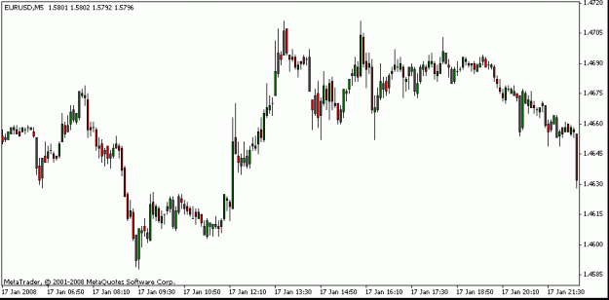

Lusan:
David, I hope this time I got the right time period.
Comments:
1. The trade is within the period that I call the "no-trading zone." I do not trade went there is potential of any news coming out. 7-9:30 am. I want to avoid this type of events. Was any news coming out? If so, that explains the high volatility.
2. Note there is a good congestiong going between 8:30 and 9:00 am. For me this means that the buyer are out and the trend is might be long. So I would be long here.
3. Just by looking at the 30 pips 5M charts: Note that it broke the previous hight at about 8:20 am. So long long and long...Yes...the fact that the congestion was there, I would not be short at all...
4. I believe you sent the scout at 4806. So the scout was already late and the congestion was coming...so slide the sequence 1 bar down..Nothing change because we still have 30 pips to capitalize...my normal target is about 50 pips per war...but it would very very tight...
Of course, all this is is hindsight...in the middle of the war, it would take a clear mind to see the change of trend.
One of the things that I would like to investigate are news events...of course, maybe much later in my trading life...
several times I have noted that prior to major changes like in the chart there 20M indications of the upcoming PA jump..
.Note that PA seems to be preparing for this change...the congestion and then the thrust...another interesting point is the one that I market as the beginning of the trend...it seems as a small breakout...almost like a hint that something big is coming...
Sorry, I sound like a tea leave reader.
Best wishes
Attached Image
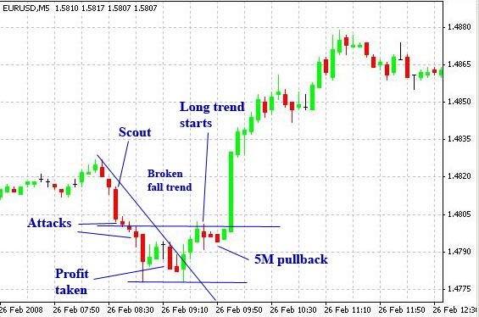

Leisgsww:
As luSan and looneyw mentioned ... being in a trade too long, has its disadvantages, and I remember fti telling me that I may be still thinking too rigid with my need for waiting for confirmations such as higher highs, lower lows, etc. I never did ask him why he uses the max 7 bars/candles thingy. I wonder why particularly "7" (35 minutes)? I'm not totally convinced that we (those with limited capital) can use the max. 7 bars method, but he must have a reason for it. If he returns, remind me to ask him, lol.

Zoren:
I've just read the last couple of pages and a few memories of fti's teachings come to mind. Here they are:
From his very first post (I have highlighed Capitalisation).
"What many traders do not know, or may fail to recognise, is that your success in taming the markets, is comprised of a mix of ingredients. Not so unlike in baking cakes. I suggest three very important ingredients. One is "Market Structure ", the other is "YOU", then Capitalisation."
I can't find the post but fti once mentioned that we should not risk more than 10% for practicing traders or 30% for seasoned ones. I think the idea is not to cut rescues short but to give them a chance. However, it is all put into perspective when he mentioned to start small and build from there.
So as we get better our account will grow naturally. The health of my book is more important than money but I need to make sure my account is capitalised adequately relative to the trade size. I need to feel comfortable and the balance between risk and reward will sort itself out with experience.
Going back to the EUR trade, here is another of fti's teaching
"I don't trade mainly on 5 min, I start there. If reading smooth I stay otherwise I change partners. I analyst daily charts then go in at 5 min and I will dance for as long as she dance well, by the time I dance to daily chart, I leave small boy to dance with her."
You see, he analyses the daily before going to the 5 min. Looking at the daily EUR/USD chart, I cannot see why anyone would go short. It had just triple topped on an increasing trend (right angle triangle) and price was close to the high and at the support level without a sign of weakness after a continuing bull run. Also, fti mentioned traps and I believe it referred to support/resistance areas - being a triple top going into a quadruple was a trap (for going short), however, the second top would be good for the short.
"If it gives you 2nd chance take it, if it gives you 3rd chance, then its likely a trap. If it turns out that its not a trap at 3 then the 4th is definately a trap."
Feeling the market is very important but I have not dropped all technical analysis. I focus on market action but I will use some analysis for assistance that is confirmed by action especially during rescues. I have not had a losing trade since understanding fti's method and dancing with that in mind - That includes trades at the microlot level (MT4), £1 per pip on my spreadbet account and full lots on a $100k demo account.
I don't know why anyone would have a predetermined exit point. It builds rigidity and distracts from rescue opportunities, however, that does not mean one should hold a trade that is dead in the water.
If my scout gets into trouble, I let it bleed, move to another timeframe to find a likely bounce point, confirm with action and enter the rescue. So far I have only had to use one additional troop but I also don't have time restrictions like luSan. My analysis is pretty basic by using just S/R and I intend to compliment it by reading up on compound candle formations but that will be it. I want to keep it simple although feeling the market (dancing) is the important one.

Since I have a full time job and I am practicing fti's method, I have no need to make a living out of trading but I still want to have reasonable returns based on account size.
My plan is to go full time in about 2 years and I will need to build my account up during that period, say to at least £100,000. That in itself will be proof that I am ready.
My attack and rescues are relatively mild (1,1,2) but sufficient for now and I am comfortable with attacks and rescues up to the third level. On GBP/JPY I can get about 500 pips on an attack. So using microlots, I get £25 pounds - yes, not a big deal but I don't care about that. It's the trading that matters and I'll increase size as I become more confident. I also trade DOW at £1 per pip and I've only really gone into a 1,1 sequence, banking about £80 on average for 1 trade. The point is not the money but practicing to feel the market and building up slowly. I am in and out fairly quickly in this case unless in rescue. I will also wind out the spirals more aggresively with time and account grow should accelerate, but first I need lots of practice so it all becomes second nature.

Yes, bailing out is certainly an option if you find yourself on the other side of a strong impulsive movement. Although if you have time and troops, going to another timeframe and searching for a rescue point is also another option.
If I decided to rescue instead of bailing out against such a strong move, I would look at it as a one chance, many troop, well timed rescue only if I can see such an opportunity. If not, then time to bite the bullet.
At times like these, fti's "be nimble" comes to mind.

LeighSWW:
Seeing that you are so close to fti, do you have any idea where he has gone?
Hi Zoran ... Nope, he still hasn't replied to my emails, so I have no clue 
Quoting Zoran
mentioning Elliott waves, I did ask fti about that and he was kind of conflicting about it ...
... He does not count waves but he mentioned it comes to mind
Okay, thanks. That's interesting though, cuz here's a snippet I found from one of the ride-alongs where he mentions Elliott Waves (I've removed all my side of the chatter, as it would just be "noise" when reading, lol):
Quote
[20:38] fti: now for the bank I can do that
[20:38] fti: if I asked you to sell 144 lots to rescue 1 you would ...
[20:39] fti: so thats for the bank
[20:39] fti: for you
[20:39] fti: do you understand elliot wave?
[20:42] fti: markets move in 5 wave cycles
[20:44] fti: 3 impules waves and 2 retracement waves making a total of 5 waves
[20:45] fti: so wave 1 is impulse wave 2 is retracement wave 3 is impluse wave 4 is retracement wave 5 is inpluse.
[20:51] fti: anyway,I personally feel for real people we should never go pass level 3
[20:52] fti: that is unless you want to be a multi millionaire overnight or be bankrupted
[20:53] fti: that's why i showed you 1,3,3
[20:53] fti: attack
[20:54] fti: you didn't see 1,5,5, rescue
[20:55] fti: actualy rescue is 1,5 then surrender
[20:56] fti: If you analyse my blotters
[20:57] fti: you will see that I am alot more complex than that because I add volitility to the figures
[20:58] fti: I meant that I add market volitility to the positions
[20:59] fti: volitility means the speed of the waves.
[21:00] fti: you see when a wave forms it has direction right?
[21:00] fti: it also has speed.
[21:01] fti: so I add that to the positions
[21:01] fti: its vv beyond you now
[21:02] fti: for now just know that you have to take that into consideration.
From the snippet, I was interpreting his use for it to gauge his attack entries, but maybe he is using it mainly for the volatility. Is that how you would interpret the above?
Oh, and notice he talks about rescue being "1, 5 then surrender".
I guess this is where we have to be nimble (as there doesn't seem to be a set fib sequence according to all his posts so far) and so I would figure we rescue according to how far away we want to be from B/E. That's how I calculate rescues, anyway.
In the above snippet, he also mentions that he did a 1, 3, 3 attack, but just know that, it is because his platform wouldn't let him put in 5 lots for some reason. Otherwise, he would have attacked 1, 3, 5. Here's that snippet below:
Quote
[19:08] fti: but for beginners I'll teach you 3 for simplicity, ok
[19:08] fti: level 1 = 1 lot
[19:09] fti: level 2 = 3
[19:09] fti: level 3 = 5 lots but I could'nt do 5 on the system so I did 3
[19:09] fti: does this make any sense
[19:10] fti: so every attack will be in 3 waves
Anyway, he recommended us to use a 3 level attack sequence, which I feel is a good idea. This, too, doesn't seem to have a set sequence, as we've seen various sequences he's used, so again, we use what is appropriate for our comfort zone and account size.
After reading back on some of his posts I linked, he says this ...
Quoting fti
Another point is that when a rescue gets into trouble, the next "spiral within a spiral" possibility would insist that the next rescue sequence, if attempted on would have to take the form of size of minimum next in order from the exposed base.
ie a martingale of base. example.
if 1 scout was in trouble, u sent in 1 to rescue then 3 to rescue if unsuccessful, if more rescue was required then the next squad would be ?
Notice that he rescues Scout with 1 trooper first. So basically, if Scout is in trouble, he waits max. 7 bars/candles, then sends in 1 troop to rescue 1 Scout. If after another few bars/candles, both Scout and rescue trooper in trouble, he sends in 3 (or 5, depending on the distance and the volatility, I presume) rescue teams. After that ... surrender.
Now, heed his warnings about trading against the trend, cuz he specifically mentions to not even attempt rescuing those and just get the heck out!
Zoran:
Leigh, I think you have some hidden treasures lying around and thanks for posting this one.
The important message is that when we have caught the third wave in a trend we should expect a largish retracement. I will generally close all positions when the 3 trending waves are clear, not only because of Elliotts theory but it was also mentioned in the book "Technical Analysis of Stock Trends" by Edwards and Magee.
Therefore, a 1-3-3 sequence is played out as follows:
* We place our scout to ride wave one and wait for the wave two retracement
* We then enter 3 more troops to ride wave three and await the wave four retracement
* We enter the final 3 troops to ride wave five. From observation, the end of this one seems to be the most unpredictable.
If the scout was entered in the wrong direction, we can use waves two and four to rescue (sequence 1-5). Also, at the end of 5 waves in the direction of the trend we tend to get an ABC correction, which can also be used for rescue. However, since this correction is against the trend, I'm not sure whether fti would reverse for a two level attack sequence.
Now since we are trading on the 5min, a 5 wave structure could be a subwave in a larger structure on a different timeframe. For example, waves 1 to 5 on the 5 min could be wave 3 in another structure on the 1 hour while the ABC correction on the 5 min is then wave 4 on the 1 hour. fti's "as above so below". Check chart.
Also, this is possibly where his overnighter comes in - that one is probably riding a wave on a higher timeframe.
Although most of us may have a fixed sequence and mine is pretty much at the beginning, fti's sequence varies based on the volatility (speed of the wave) so it is not fixed. When I found myself on the other side of a strong move, I knew I could only rescue with more troops than normal as the volatility was high. Also, perhaps I just should have bitten the bullet and if I keep making the same mistake, the market is sure to keep teaching me until I learn.
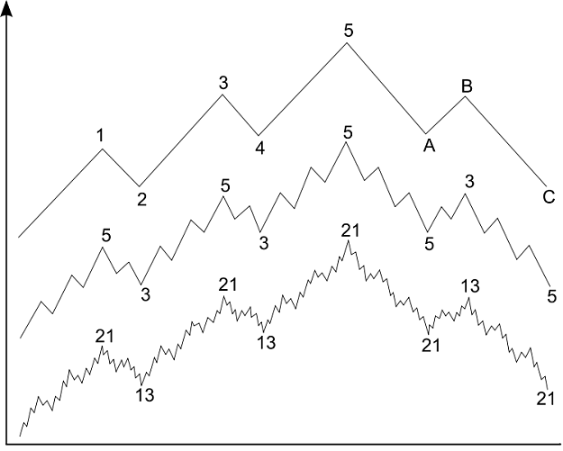
Lusan:
Quoting leighsww
I truly believe that "slow and steady wins the race" ... so, if we can dance and implement our MM responsibly - meaning, DO NOT go against the major trend!! : AND stay away from the NEWS!!! AND DO NOT overexpose our kingdom (account) by overextending our valuable troops!! ... then we should be successful in our battles. However, if we still choose to not heed these ever popular warnings that fti, as well as many other professional traders proclaim, then we do so at our peril!!
.
I got it. This time I open it instead of saving the file. Your matrix is a good reminder of our "ant work." I hope I do not forget. Your target of 25 pips per day is very conservative...I just did some analysis for my style and I understood that I saw that my original 1-2-3 sequence is similar to the 1-1-2....I am returning to my 1-2-3..you bet!
Why? fibo! 1+2=3 and 1+1=2. I means that if we are in attacking mode, then short target of 12 to 15 pips will protect us if the third wave goes bad. This learning cost me a lot of pain this week...I had trouble with the 3rd wave when I increase move into 1-2-5..I was unable to meet my 50 pips/session without reentering. ..Note that the first 2 waves does not balance the third on a 1-2-5 sequence...that is a setup for failure in the fast dance...oh well, I will dance my friendly 1-2-3 on Monday morning... I will be returning to my basic approach...
I read careful the Elliot posts that you folks talk about...I notice the same in the 5M charts...I see very often no more than 2 highs (on an uptrend) before a compression of PA and a potential reversal...so to close or wait after the 2 Elliot wave might be practical...
I think that volatility is very important and fti only hinted...you see, if the range that I dance is narrow then my PT are limited..that is very important to consider...because it determines are potential gains.
Regards

Mijamoto:
I was thinking today about law of motion and law of vibration what FTI insisted from me to understand and to learn. i found one good article http://www.allaboutprosperity.com/ar...fvibration.htm
and i liked the most:
The Law of Vibration accounts for the difference between mind and matter; between the physical and the nonphysical worlds.
According to the Law of Vibration, we postulate that everything vibrates or moves; nothing sits idle. Everything is in a constant state of motion, and therefore, there is no such thing as "inertia", or a state of rest. From the most ethereal, to the most gross form of matter, everything is in a constant state of vibration.
"Rates of vibration" are called "frequencies," and the higher the frequency, the more potent the force. Since thought is one of the highest forms of vibration, it is very potent in nature and therefore, it must be understood by all of us.
When you hold the image of your goal on the screen of your mind, in the present tense, you are vibrating in harmony (in resonance) with every particle of energy necessary for the manifestation of your image on the physical plane. By holding that image, those particles of energy are moving toward you (attraction) and you are moving toward them-because that is the law.
Law of motion is simple: http://csep10.phys.utk.edu/astr161/l...wton3laws.html
I. Every object in a state of uniform motion tends to remain in that state of motion unless an external force is applied to it.
I hope this will help you. And also VERY IMPORTANT WAS WHEN FTI SAID:
For those following closely,
all the true studies got adulterated with 1 fallacy, "predictive".
Remove that and you have the truth of the reserchers.
Also his comments about MO:
To me the most important indicator is price.
The market's sigma, which is the speed of move.
The Vega, which indicade the volitility factor in its trend and the time it consumes in it push.
You can determine all this from bare bar or candle charts.
the other indicator is true average, with that you can determine if the volitility is out of line for your risk tenure, the other improtant, read, is the market form.
I try to recognise the compounded formatioNs in the bar charts.
Have a nice sunday tommorow. And please make some comments about low of motion and vibration. Together we can clear this up 
Regards
Leighsww:
Quoting fti - email snippet
You are at liberty to share what you have learned, with whomsoever you wish
I've stripped out all of my own convos, so that it's easier to read through. You should be able to get quite a LOT of insights and a better understanding  ...
Quoting fti
Session Start (leigh:fti): Tue Nov 20 19:01:07 2007
[19:01] fti: ok about levels
[19:01] fti: do you remember ,the selling at 110.35
[19:02] fti: now thats level 1
[19:02] fti: he's the scout
[19:03] fti: incidentally , this is the money management part
[19:03] fti: do you remember I sold 3X further
[19:04] fti: That the front line attack squad
[19:04] fti: Then I sold another 3X
[19:05] fti: when It went down and came back up.
[19:06] fti: lets start from the begining again
[19:07] fti: the money mangement part comprise of 7 levels
[19:08] fti: but for beginners I'll teach you 3 for simplicity, ok
[19:08] fti: level 1 = 1 lot
[19:09] fti: level 2 = 3
[19:09] fti: level 3 = 5 lots but I could'nt do 5 on the system so I did 3
[19:09] fti: does this make any sense
[19:10] fti: so every attack will be in 3 waves
[19:11] fti: remember I sold 1 lot at 110.35
[19:12] fti: then it went down to test 110.10
[19:13] fti: that was the scout
[19:14] fti: he proved correct that the usd was soft
[19:14] fti: so comes the 2 wave of attack
[19:15] fti: but where?
[19:16] fti: if mkt went against him then wave 2 the (frontline) must not attack
[19:17] fti: instead I would leave it in the mkt to see
[19:17] fti: how far it would go against it
[19:20] fti: he will be left in the market to feel the mkt pulse
[19:21] fti: lets assume that mkt goes to 110.90
[19:22] fti: then since I was wrong on the 1 level, I will wait for a max of 7 bars.
[19:23] fti: assuming that 110.90 was the 7th bar,
[19:23] fti: that means 35mins later
[19:24] fti: I would send 1 rescue mission for him and sell 3 lots at 110.90
[19:25] fti: to take him out without damage.
[19:25] fti: I would have to sell 3 lots at 110.90
[19:25] fti: otherwise I take home a dead scout
[19:28] fti: you see when I sell the rescue 3 lots
[19:28] fti: what I am effectively doing is
[19:28] fti: averaging my ability to be near the market
[19:29] fti: because by selling 3 at 110.90
[19:29] fti: now my cost of all 4 lots is 110.737
[19:30] fti: so if mkt within the next 7 bars drops to 110.72
[19:30] fti: I'm out with the scout and the rescue team
[19:32] fti: ok what if within the next seven bars mkt continue to go up
[19:33] fti: to lets say 111.50
[19:33] fti: then a squad of 5 goes in rescue
[19:34] fti: the sequense is in fabonaci expansion - next
[19:35] fti: at the bank I had 500 million USD to rescue 1 million usd
[19:36] fti: my limit is 500 million USD must stop
[19:36] fti: but no market can take me out.
[19:40] fti: first can you grasp the money management concept
[19:41] fti: we know what we're going to do when we are wrong
[19:42] fti: but in this case.
[19:42] fti: what should we do when we are in profit
[19:45] fti: lets recap yesterday
[19:45] fti: scout got in 110.35
[19:46] fti: then mkt went down to 110.10
[19:46] fti: then back up
[19:46] fti: to where was that?
[19:47] fti: that was level 2
[19:47] fti: couldn't get it filled
[19:48] fti: saw the indicators for selling coming
[19:48] fti: then mkt tested up again right
[19:49] fti: that was when the long shadow showed, right?
[19:50] fti: yes, whats the point of having candle stick charts and not knowing the patterns?
[19:54] fti: remember the rescue sequense?
[19:56] fti: so whats the sequense?
[19:56] fti: ok, I tell U
[19:58] fti: do you know aout fabonacci expansion?
[19:59] fti: fabonacci expansion
[20:00] fti: 1,2,3,5,8,13,21,34
[20:01] fti: ok even I got it wrong, have to recap
[20:01] fti: look at the fabonacci expansion what do you see
[20:04] fti: the progression for rescue is
[20:05] fti: 1,3,8,21.....
[20:12] fti: fabonacci progression
[20:14] fti: 1,2,3,5,8,13,21,34,55,89,144
[20:15] fti: rescue progression
[20:15] fti: 1,3,8,21,55,144
[20:16] fti: attack progression
[20:17] fti: 1 skip 3 skip 8 skip 21
[20:18] fti: 1 skip 2 then 3 skip 5 then 8 skip 13 then 21...
[20:21] fti: thats why I teach you only 3 progressionlevels
[20:23] fti: i am talking about concept
[20:25] fti: let talk attack
[20:25] fti: so what's the progression?
[20:26] fti: 1,2,5,13,...
[20:27] fti: the numbers we didn't use for attack
[20:27] fti: sorry the numbers we did't use for rescue
[20:29] fti: but for now concept only
[20:30] fti: pls write the fab pro on a piece of paper up to 144
[20:32] fti: whats the attack?
[20:33] fti: 1,2,5,13,34,89
[20:36] fti: 1,2,skip3,5,skip8,13, skip21, 34......
[20:38] fti: now for the bank I can do that
[20:38] fti: if I asked you to sell 144 lots to rescue 1 you would ...
[20:39] fti: so thats for the bank
[20:39] fti: for you
[20:39] fti: do you understand elliot wave?
[20:42] fti: markets move in 5 wave cycles
[20:44] fti: 3 impules waves and 2 retracement waves making a total of 5 waves
[20:45] fti: so wave 1 is impulse wave 2 is retracement wave 3 is impluse wave 4 is retracement wave 5 is inpluse.
[20:51] fti: anyway,I personally feel for real people we should never go pass level 3
[20:52] fti: that is unless you want to be a multi millionaire overnight or be bankrupted
[20:53] fti: that's why i showed you 1,3,3
[20:53] fti: attack
[20:54] fti: you didn't see 1,5,5, rescue
[20:55] fti: actualy rescue is 1,5 then surrender
[20:56] fti: If you analyse my blotters
[20:57] fti: you will see that I am alot more complex than that because I add volitility to the figures
[20:58] fti: I meant that I add market volitility to the positions
[20:59] fti: volitility means the speed of the waves.
[21:00] fti: you see when a wave forms it has direction right?
[21:00] fti: it also has speed.
[21:01] fti: so I add that to the positions
[21:01] fti: its vv beyond you now
[21:02] fti: for now just know that you have to take that into consideration.
[21:19] fti: we'll do eur/usd today
[21:27] fti: just went short
[21:27] fti: 1.4831
[21:39] fti: mange to sell 2 @35
[21:39] fti: sold 1@34
[21:51] fti: short usd 4@33.75
[21:52] fti: i am short 4 right?
[21:55] fti: 3375
[21:56] fti: 1.483375
[21:56] fti: normally 5 decimal points
[21:59] fti: actually alredy hit target
[21:59] fti: but leg is short
[22:00] fti: so retrace only expect up to 27
[22:01] fti: i ve got another 3 squads of me to go in
[22:02] fti: trying to find the critcal opening to hit
[22:03] fti: 20 looks like eeeeeh
[22:05] fti: target is 14800/90
[22:06] fti: whnot now missed the opening already
[22:06] fti: target 1.4790
[22:07] fti: too late the other 3 retires
[22:08] fti: looks like no chance this round
[22:08] fti: taking profit on 3 now
[22:12] fti: don't think just flow
[22:12] fti: bot 1@99
[22:14] fti: bot 1@99
[22:14] fti: bot 1@96
[22:14] fti: left scout
[22:20] fti: short 1 @1.4945
[22:23] fti: recap sold 1.4835 34 35 31
[22:23] fti: 31 is scout right
[22:23] fti: bot 1.4799 99 96
[22:24] fti: so 835-799=
[22:24] fti: 36
[22:24] fti: 834-799=35
[22:25] fti: 835-796=39
[22:26] fti: so is 1.4941 ok?
[22:27] fti: scout is short usd at 1.4941
[22:28] fti: now only scout is left in the battlefield
[22:29] fti: I am actually waiting for retracement to hit level two again
[22:30] fti: 36+35+39=110
[22:31] fti: scout is @1.4831+.0110=1.4941
[22:33] fti: selling target opening at 1.4815
[22:33] fti: and closing
[22:35] fti: how much did each individual men earned?
[22:42] fti: I am taking scout out now
[22:44] fti: bot 1.4794
[22:57] fti: send scout out to sell at 1.4800
[22:58] fti: now mm sweep up to sell
[23:00] fti: scout deployed short 94
[23:01] fti: mdm general shall I send army after the scout please?
[23:03] fti: next 3
[23:07] fti: when in bear mode stay thinking
[23:07] fti: Is is going down.
[23:08] fti: when in bear mode stay thinking bear mode
[23:10] fti: when in bear mode always ask is it going down
[23:10] fti: never think oh I see up pattern
[23:10] fti: stay bear
[23:11] fti: if the scout in trouble send rescue later
[23:12] fti: this was one of the laws I gave at the feb posts
[23:15] fti: got scout out bot 1 at 04
[23:16] fti: new scout deployed bot 1 at 07
[23:16] fti: quick take a look at 5m chart now
[23:17] fti: the reason I deploy buy scout
[23:18] fti: too high getting scout out now
[23:19] fti: sold 1 at 15
[23:21] fti: when mkt rallys strong you have to give it a chance to cool off
[23:22] fti: if it persist up at least you are not caught
[23:23] fti: but if it still force itself uo the deploy scout to feel the pluse on whether its real
[23:24] fti: do you notice that the down bars are in 3s and 4s
[23:24] fti: the up bars are singular
[23:25] fti: and now the up bars are singular and down bars are singular
[23:25] fti: sign of stops sweep
[23:28] fti: no really ,lets say for instance we let the scout short at 1.4941 remember
[23:30] fti: why would I want to put a stop loss when they cannot touch him even if they did these no damage.
[23:30] fti: sweep over
[23:31] fti: If I left anything overnight, Ill just leave the scout
[23:50] fti: looks like strong dollar
[23:51] fti: looking for opening to deply scout
[23:51] fti: the sweeps over
[23:54] fti: W top on EUR$
[23:54] fti: not likely
[23:55] fti: scout deployed 03
[23:56] fti: 1.4803
[23:56] fti: meant double top sorry
[23:56] fti: supposed to be M tops
[23:57] fti: can you see it in the daily charts?
[00:01] fti: scout in trouble, reversal in complete
[00:01] fti: withdraw scout now
[00:03] fti: bot 1 at 06
[00:04] fti: actually mkt still bear
[00:06] fti: now lets try redeploy scout near 00
[00:11] fti: scout deployed at 03
[00:12] fti: poor scout
[00:13] fti: looks like heavy top
[00:14] fti: testing top again
[00:14] fti: can you see it
[00:15] fti: because the scout was against the trend
[00:15] fti: remember it was a test
[00:16] fti: for up side
[00:16] fti: but trend we determined was down
[00:16] fti: earlier that is
[00:17] fti: but we are very near objective so the question is how steep the down side over-run will be.
[00:21] fti: I think I'll take the scout out again
[00:22] fti: london's going to lunch soon
[00:23] fti: dealers lunch at 11
[00:26] fti: bot 1 at 797
[00:26] fti: all squared for lunch ,,old chaps
[00:27] fti: I am all squared now
[00:32] fti: london boys comes back from lunch markets normally sit wait for NY boys
[00:33] fti: just trying to sweep stops below major support
[00:34] fti: london boys comes back from lunch markets normally sit wait for NY boys lead
[00:35] fti: this one example plays place stops below the support, too close and get sweeped
[00:35] fti: too far and defeats the purpose.
[00:36] fti: like I said, experience counts as well, can feel the mkt pulse better
[00:37] fti: I was sweeping
[00:37] fti: market makermakers market
[00:37] fti: interbank
[00:38] fti: teir 1
[00:39] fti: it was in my post
[00:39] fti: at feb's
[00:39] fti: just now probably big stop oder by customer sopt sell EUR
[00:40] fti: probably placed teir ons and have been sitting duck since morning.
[00:41] fti: cust probably though break this support dlr would be dead.
[00:42] fti: so london boys waited for market to get thin near lunch
[00:42] fti: to put the duck out of its misery.
[00:43] fti: you see london open to trade down
[00:44] fti: found good support 1.47 90/00
[00:44] fti: variance 1.4785 strong
[00:45] fti: sweeped up to 1.4810/20
[00:46] fti: I think london boys at lunch already
Session Close (fti): Wed Nov 21 01:03:45 2007

Zoran:
Quoting luSan
Now the question is when to do the rescue? here Elliot and timing should come to help!
Now bed....
Lusan, when I need to do a rescue I go to higher timeframes and look for previous support/resistance levels and plan/time my rescue mission there based on action.
I think the most we can get from Elliott for now is the wave structure and that the action is impulsive in the direction of the trend. It may serve as notice if your position is against it - like swimming against a rip.
Lusan:
Zoran, this is what I mean about Elliot. This morning I ended my trades at A. I played only 5 bars..I told myself, "bet that ABCDE will start here and I will have to go against the 15M, specially entering 3 bars afterward...etc."
See ABCDE in the 5M. I have see it many time. I feel that somethime some 5M bars merge the waves and these are found within the 1M or 30S...
Edits
My trading it? Scout at the start of third bar below A (falling trend), troop at B...then panic and rescue at C...then all profit @ about D...then OUT...
Of course, somebody would say why not the peaks and valleys? That would takes to know the future! I do not.
Edit
I go to the higher time frame when all hell is loose...rescue is done no further than 12 pips away from a scout/troop...Actually I could not even go to the higher time frame with my approach...In the graph, I should out just a tad above A becuase it would a confirmation of fighting the 5M trend...S/R probably given up by prior 5M bar low or high....that is my new approach to deal with nasty surprises: Coming from B to above A would means that the good trades are long only.
Regards,
Attached Image
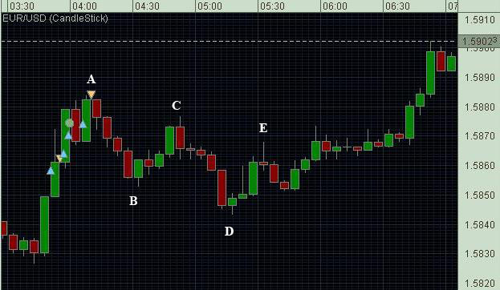
Zoran:
My sequence is very light, 1-1-2 but I still managed to lose many days worth of effort in one hit.
The market will continue to throw the curve ball until we learn to play it and from what I can see there are a few here (me included) who are still learning. My opinion is as follows:
* The proper way to play it is to identify it and get out straight away
* The silly way is to ride it and then rescue when it loses steam
* The suicidal way is to attempt a rescue against the strong force
This is not the first time I have been in this situation and the reason I let it get to that stage, I believe, is my self-destuctive nature. Remember the scorpion story? I can sense the danger (of the position) but do not take the appropriate action.
When swimming in beaches with breaking waves we can unexpectedly get caught in a rip current, that will pull us out into the sea.
* The proper way to get out is to identify it and swim parallel to the shore until the current is gone. This requires the least amount of energy.
* The silly way is to let it take you out and then to catch some waves back to the shore. More energy is needed here.
* The sure way to drown is to panic and to swim against it with full force.
More practice for me it seems but I am getting there. The last time I tried the silly way.

Leighsww:
I am going to post this in sections, cuz this forum script may truncate it if it's too long. I could attach the entire file, but then Mac users wouldn't be able to download and open the txt file, so I thought it best to do it this way.
Here's the first installment ...
Quoting fti
Hi,
I'm very new here. and have been lurking on your thread for a while.
Wow, wow. wow, hold the horses,
Peace to all man(brothers) and woman (sister(s)).
Let's not go into the gender ego about who had it better. :-)
I think all the nakeness is getting on everyone's nerves already,
or is it the 7th cyclical itch thats hitting home already.
You see in all yin, exist yang and in all yang, exist yin.
The world is made that way, so I guess its natural law.
So is the markets and the human persona.
A little whipping is necessary here, and if all here whip themselves abit, peace and tranquality will return.
As an introduction, let me make a little observation.
It seems the thread is moving away from the original intent of the thread creator, feb 2865. If I am not mistaken, his intention was to have you traders, reaccess, your heavy dependence on lagging indicators, clogging your ability as traders, to think and react like true front line market tamers in running battles.
Since the late 70s into the 90's too many "engineers" have made public their inventions of reading probabilities into lag indicators for "guts" to ride out whipsaws in markets. The Grand daddy of-course being Charles Dow and followed by W.Wilders and the likes of. Unfortuantely, this has cause the demise of a great many traders and dealers in the market place. (believe me, I had circle seating, while watching it happen)
Feb, correct me if I am mistaken.
I believe what feb is trying to do, is to get you people, to feel the pulse of the market, trading into its rythemic pulse instead of reading dead lagging indicators for your decision making process. Logically , can all of us be super rich, just because we know how to read some indicators? Remember the market is a life beast, it learns and adapts.
I like to add that, market plusing is the modus operandi of marketmakers in the International Interbank Market arenas, except that, at the higher tiers, we have the advantage to "see" the "flow" or CB activities.
An experienced dealer can actually make good guesstimates of what is happening in the primary market by reading market form, before the herd moves, even without sighting the "flow". And thats only from sighting bar charts. It's an internalised skill. It cannot be taught, only learned from the Institute of Hard Knocks.
Just my 2 cts, but what do I know?
I've only traded strategic arbitrage and a marketmaker in teir 1 Interbank Forex for 26 years on daylight lines of 500mio usd, before retiring. Sorry for bragging. Anyone wants to revive the USD/DM just for old time sake?
Having said that, I say POWER to you, but please be nimble, you, the new generation, for playing with the double edge sword (leverage), which can win glorious battles but for children it could cut their own throats. (Wonder who was the satan, who released this beast, in the first place?) yeah the derivative markets, don't ever be fooled that you are trading interbank, you are trading derivative (secondary) market.
I rest, with a little wisdom for you, beloved market warriors.
1. Preservation of Capital
2. Preservation of Capital
3. Never forget rule number 1.
While trading remember always,
1. Respect the markets, its alway right.
2. Bulls makes money, Bears makes money, Pigs get slaughtered.
3. Don't ever buck the trend, it's your Only Friend.
Quoting fti
Hi all,
@leighsww
I was directed to forexfactory, in researching the new talk (thingy) in town about buckets are trying to fool people that they are interbank.
Truthfully, minimum interbank marketable tickets are USD5 mio.
So I cannot understand which banks are actually involved.
Althought a few good names have been mentioned.
Maybe this is the "direction" for the future.
Sure love to trade the FX on 2 pips spreads, now that I'm retired.
Only bugging question is the credit & counterparty risk.
Still gotta go deeper to know, if this is just a fad.
Personally, I think you ppl is on the right track. What feb has done is good education.
Like I said , you have to learn from hard knocks institute.
Try to stay with the basics.
Gotta watch your credit risk and gearing.
Also watch your market BASIS (price) tear, to confirm true markets.
Be prudent.
------------
No interbank dealer/trader ever place stop loss order.
Only Corp and hnc (high networth customers) request interbank to watch stops,
Actually lots of revenue from that activity.
In the interbank all transaction is Cash valued immediate.
Most dealers are delta neutral or flat most of the time, mostly delta neutral.
(((((erratta : should read squared most of the time, not flat))))))
I think brokers are misimforming customers to protect overlosses situation.
If you place stops, interbank will hunt you out. All we have to do is to bum quote once each and you would be "dead in the water"
To beclear watch "ASAP" page on reuters and you will see it.
Indicative market is quoted in 10pips.
Watch how sometimes 24hrs tokyo is basis out by more than 10pips during London time zone. also watch how the basis tears when it shifts to London/NY.
FX interbank has no central market place.Its all over the world, and everyone is on what papers they have in hand. and evry one have differing opinions of where the market is, thats why there is arbitrage.
PSS: to be even clearer, watch wellington zone, when the mkt is illiquid.
would make you rethink about stops,
If you can't stand the heat, stay out of the kitchen".
Undercapitalisation have been the worst killer in the mkts.
----------
I make it simple for you, to understand.
say same instance I call for trading price on Reuters IDS (interbank dealing system)
US bank he quotes, USD/YEN 141 00/02
Tokyo 141 05/07
Singapore 140 97/00
german 141 06/08
welligton 140 95/05 sorry wide
china 141 08/00
so wheres the market?
Imagine what happens when, at any time when markets become illiquid.
eg release of figures: tankan, CPI, Unemployment etc
Some tier 3 banks don't even pick you up on the dealing system,
or mom pls dealer tech problem.
And remember this happens alot in a regular day,(twinlight zones) not only when data is released. The extreme normally happens when economic figs are released.
So any stops near of, lets say 20 pips gets hunted out on norm, on figs can go to 3 to 5 big fig.
You want to argue where the market was actually?
try.
Be prudent
--------
Another scenario,
evrry body's quoting, lets say 140 00/02
one bank in mars quotes 140 90/92
every bank pauses for like 30 seconds, watching this guy, wondering why he scuttered.
Maybe he's taken big by customer.
could be he had cust stop at 88 for big $ and wanted to take him out.
so no one moves for 30 seconds. just watching.
if he later requotes at 140 20/22.
then well ok move the market up, maybe buyer coming in , as he remain higher.
its possible for another unhappy bank to requote 140 00/02 forcing market back.
so is customer stopped ut?
You must understand the Interbank FX market structure.
I already told you, there is no centralised market place, do you understand.
Place stops at your own peril.

Quoting fti
I answered some one the other day on this R/R thingy already.
For this thread I will repeat myself.
PURE nonsense.
R/R ratios is a money management tool for risk & compliance depts, to gauge the trading performance of an individual over time. It calculates the "value at risk" against P&L against time to determine the skill rating and compensation for dealers/traders. The formulation is standadise to measure all deal "at value" to equalise dealers at par to limits.
R/R ratios on singular trade exposure means nothing.
Accuracy (profitability) and ability in turning to favourable trend following is paramount in singlar exposures.
If you want to calculate risk to your stop loss probabilities, then read about my respond to stop loss orders in forex on this thread.
BUT if you were trading structured markets , eg exchange traded instruments (indexes futures. Currency Futures contracts, commodities ,,etc), using stop loss orders can protect or limit your overexposure to losses, this is because these markets are localised.
Rule of thumb , never place stops in OTC instruments (eg forex, OTC indexes, OTC options, CFDs, any synthetics etc)however tempting.
Hope this helps.
---------
@leighsww
Your position is noted.
I shall let feb respond to your concerns, as it is his methodology.
And I think he is experienced enough on this issue,( I believe he could be an exchange Local)
Nevertheless I mention again what I think feb have mentioned before, that.
We should be trading in the future, not in the past.
Robustness of methodology from historical performance is no gauge for future performances.
Rigidity of methodology can be a dangerous thing. Markets mutate to adapt to risk snowballs,by varance in volitility.
Having said that, I also can understand that your rigidness affords you peace of mind in your battles. On this issue I, sincerely hope that you will give it an "open mind" to try to learn, discuss or read more about, for your education to be a successful trader.
PS : "Scalping"
I have also mentioned before , no trader can outscalp a marketmaker. This is because he can see "flow".
In exchange terms it is called "paper lean".
Time frame is of no consequence in positioning. If a directional trend persist, a "Job" can even turn to overnights, the important thing is not to carry a loss too long, and not to allow a profit to turn sour.
ability to "ride" is key factor in profitability, I repeat, time is of no consequence.
I hope this helps.
----------------
On the V formations you mentioned, I believe that the methodology is using the "hip and lop" against the countertrend reversal pivots. In structured (localised exchange traded) markets supply/demand papers can restrict the impass of certain "key" levels. Unfortunately in free flow unstructured markets (interbank forex) you are left at the mercy of the position of the book of the marketmaker(s).
As I mentioned in the example earlier, variance impulse volitility of their blotters at differing localities will create "noise" to hunt stops. That is the structure and theoritical edge for making markets.
If nothing else, understand this, the structure of "Structured vs Unstructured markets" are vastly different at foundational levels. To understand this, read about "the structure and working of the markets you trade". The synthetics and derivative OTC (over the counter) markets are even more complex in it foundation, normally with strong theoritical edge to the marketmakers. Note that leverage will compound the "risk of ruin".
I think I have given much for you to investigate, probably months of research for you. Nevertheless with this awareness, it behoves you to educate yourself, for your profitability and well being as a trader. Try to reread what I have revealed carefully. With your good head on your shoulders, you should be able to slowly improve your R/R factor across time.
I believe what feb have presented is a respectable methodology and quite professional, nonetheless be wary of its implementation in differing market structures.
I am signing off for today and shall visit again when time permits.
Best for your trades.

Quoting fti
@*name removed*
This I have to say, you don't tone down your ego. Then the mkts will tame you. If you don't learn, the mkts will teach you repeatedly until you get it right. Believe me I KNOW.
2. Your mentioning, that some of my points is valid is very far off mark, friend. It's all valid. Its just that most are above you and that you have yet to comprehend the core of the contents. I am "Once a dealer, always a Dealer".
3.When I advised about "hunting stops", I was just trying to speak layman lingo. Its's actually "stops sweeping". For your education when i "stops sweep" a few times a day. I am not bothered about position sizes. My minimum per ticket size is USD5 mio, and normal ticket is 10USD. Just for your info, I am CFA and Technical Analyst (SATU certified specialist). When I sweep stops, I go for chart points, thats all I can tell you, the rest is classified. With half a Bio line, what type of impact do you think it has on mkts? And you would think that I would be sweeping alone? Multiply that by 10 nearest key tech points daily and 7 tier 1 banks,what do you have? Do you know how the outside days patterns are formed and what activities causes it?
4.I take offense of reading about your bad mouthing Bankers. In the first instance you have little understanding of the functions and sections in a bank. Fact is you can't tell Teasury from Operations.
Further if you had any understanding of market structure, you would understand about market bubbles,in this case, property bubbles that you mentioned. circa 20 years ago, Japan had one , now USA is having one, so whats the big deal about Financial Institutions, having to deal with one. If banks didn't funded property , tell me who should?
If not for the Financial system and banks, you would still be bartering sea shells for your daily needs. And you call Banks sharks and thieves.
I give you zero marks for understanding and empathy.
I hope you would amend your distasteful ways, and maybe there would be light at the end of your tunnel, pray that it's not an on coming train.
cao.
-----------
@ Green_David
Main activity on Treasury Forex, is basically arbitraging of customer orders as a service to corp. hedging activities, ie delta equalising banks positions forced upon by customers needs.
Extra curricular activities include, stops sweeping as I mentioned earlier to facilitate liquidity for filling buyer seller price void & marketmaking to create a lively and active market place.
Positional exposures are undertaken either under Bank's Exco instructions because of Management's Viewpoint and also by Special Units known as Strategic Arbitrage Trading Units (SATU) whom are specialist in different modes of Analysis, ie (Fundementals Analyst/Economist, Monetary & Fiscal Economics) and ( Technical Analyst/Chartist). Main FX desk operate only within daylight limits. And Treasury Chief & Chief of Currency desks are normally part of SATU. The unit name may differ from bank to bank but the function is universal.
For the Banks protection, "china walls" are created within the Treasury and to the outside world to protect against predatorial activities. All exposures are watched by dealers on duty and around the clock who will advice the respective exposed parties of market behaviour and sentiments regularly, esp. during "fast markets". Bad positions are normally cleared "at market" , if any SATU dealer burst his/her preset acceptable overnight loss limits. Some of us even have forex broker boxes installed at our homes, and the junior dealers carry the reuter's fx pagers.
To answer your question clearly, basically we do not carry mental stop-loss levels, in reality it is being managed around the clock on a "on call mode", standby mode, if you like. For banks , that does not operate a 24 hr crew, they pass "wake up call zones" to their active branches.
Regarding the placing of stop loss levels,there is no safe zones. It all depends on the market sentiment and how the dealers' blotters are behaving on that certain day. Be assured, that all good dealers knows where the sweeping zones are and we know that placing stop-loss away from such zones actually defeats the purpose of the stoploss order, except to protect from overloss situations for customers. This is because when a sweep zone is under attack, no one can tell how far the stops self-feeding will over-shoot, in terms of the volitility and also the resultant rest point , this always works against the stops. This is the nature of stop-loss orders. I shall not touch on the sbject of slippage, which is also a point of contention. You see ultimately your stop loss point is a gamble.
Think about this, How long would you leave a baby unattended, unless he/she was asleep?
Unfortunately the FX market never sleeps.
I hope this helps
--------------
@ leighsww
"On call mode". Simply means that the dealer who's watching the call zone, which is normally a price band, will call the dealer concerned at his mobile, once the market comes at the money,for further instructions after giving a detailed read of market sentiments. If the position is pass on to sector of seniority, normally, the position is carried there at "free of risk" as favours from a dealers to another. That's called "parked positions".
The point I was trying to make is that there is no pre-concieved plan of action, all is actively managed. In letargic market conditions, normally no action is taken. In melt down situations, sometimes the positions are taken out , then reverted to the owner to protect his interest. This varies from rank to rank and from bank to bank. Normal protocol is carried out in a calm manner. The most important attribute a dealer must have is steadyness. Gambles are normally not allowed. All decisions must be calculated risk in response to market conditions.
regards
Ps: In the market, Big means nothing at all. Normally for us its only figures on a pice of paper.
Profitability is "King".
Size really doesn't matter, only profits.
remember "Nick Leeson" he was big, but big and careless, = danger
"The bigger the pot, the more the burnt rice."
Quoting fti
Hi All,
@ Green_David
Oh, David , from your discription , you may be suffering from "trigger" problems.
The inability to "pull the trigger" on trades due to self-doubt or being out of step.
That self doubt can be caused by many factors.
1. could be too many bad stop-out experiences, this can creating mental blocks on your bicameral mind..
That's why I say its best not to use stops orders.
Either make a resolution to watch your baby with full dedication or, quit, this may not be for you.
Faithfulness to market dance is important.
Your Stops have very high probabilities of being taken out if not managed properly
and normally , it would always happen at the worst timing and levels.
The cause is because of par excellence marketmakers and of course "Murphy 's Law"
If baby sitting the market is not your cup of tea, then you should learn about new instruments and synthetics, like options e.g. where its not necessary to baby sit, only that there's a premium to pay for that luxury.
That, is a whole different kettle of fish, though.
Watch out for market over-runs.
Every market has a rythemic dance characteristics, you got to learn how to dance in tune with it.
If she's dancing 4 steps and you're dancing two, chances is she's not gonna dance well with you.
Take note of this, she will never change her tempo to follow you,
it's you that have to get close and personal and feel her tempo instead.
Once in sync then, do your magic,
When you have to move forward, just move don't think anymore and invite imaginary ghost to haunt you.
Your actions will speak louder than your words. Follow the flow.(trend)
Suit up for battle,then do the necessary.
KISS, keep it strong & simple, your feelings, that is.
If you have to, "bite the bullet" and take the pain. Cut losses if things don't feel right.
"Run away today, to survive, to come back to fight another day."
yes, you have to learn to feel and forget about levels and dented egos.
2. Trading too close to the financial edge.
going too near your financial cliff, is unhealthy for your body(mind) and wallet.
always leave room for contingencys, remember market tend to alway over-run.
I may show you how to money manage, when I have time.
also known as game plan, plan your work, then work that plan.
plan your work, doesn't mean to have pre-concieved ideas of market.
Like I mention in 1. You have to ask her what she's actually doing and feel if its correct.
Work your plan , basically means set aside adequate risk capital, to be utilised when needed.
Never walk into gun battles carrying knifes.
Also never ever try to catch falling knifes and shooting rockets. by adding to bad positions.
If she's not giving you clear indications, sit on you hands.
be patient, she 'll tell you soon enough.
And when you see clearly, but feel that the dance is too near the end.
then wait for the next dance. then ask again.
Like ledgesww said wait for the next "bus".
It'll come, be patient and prepared but don't be too eager. Find the balance.( yin yang)
Never ever trade with money you need for your living.
Doing that builds bad vibes and can cause lots of silly and unneccessary mistakes.
3 Guts and Glory.
In this game , there's no prize for seconds, must come in front, always.
like the title says, no guts, no glory.
Pay the price and capture the prize.
Never think in terms of the money, always treat the risk capital as ammunition in battlefields.
Like the saying goes, traders may lose money,
but never ever lose your balls, or its game over.
I can go on all night elaborating the finer points.
In a nut shell, its all about preparedness and mindset.
That's half the battle. YOU!
SunTze's Art of War teaches clearly, "know thyself and the batlle is nearly won,
know thy enemy and surely the battle is won."
The other half is skills from experiences and analysis.
Never over analyse, but just enough to identify trends, then watch and feel her.
Like feb adviced you to, don't over complicate your charts visually,
making it dazzling in all sorts , only to decieve and confuse you.
Use what works for you, we are all alittle different,
and throw all the other junk away.
What matters is profits, all other things are just "a mean to an end."
For that I must add, it is easier said than done.
Sometimes its doublely hard to retrain old dogs with new tricks.
The fact that you have been following this thread closely ,
already shows that the some mindset change has begun.
Only more time, and hard knocks is required to allow this to set and become an internalised reflex.
Remember when you, first learned how to drive,
there's like a million things to remember.
But now with the necessary "setting" of internalised skills, it becomes second nature to you.
My major fear is that, all here are at differing levels,
and some may not comprehend what all this, babling is about.
All I can wish for, is that the little that I have given you, in this space and time.
will point you in good directions for your education and development.
And that your learning curve be positive sloping.
It took me years to aquire the necessary skills.
Fortunately for me, someone else was paying the bills while I was learning, the banks.
If you are young and dedicated to the trade, you might just have that opportunity, if you knock hard enough.
Beg for the opportunity, if you have to. Again, don't let ego get in the way.
The banks are always looking for talent.
Personally I have a structured program of training, called "the bourse game" for my men at the bank, but I guess for now this should sufface.
Zoran:
As fti said, they tend to appear during certain market conditions.
"they seem to appear to the mind when strong wave trend appears"
Leighsww:
If you find yourself having too many losing trades, keep in mind that if you are in the direction of the longer-term trend (whichever that may be for you, since you're trading different/faster than some of us), don't be too fast to surrender so easily. If you have put in level attacks, sometimes you might consider lightening the load first instead of surrendering all troops completely. That way even if you have to sacrifice some troops at the moment, you have a chance to come back to save them (make back the loss) when the PA continues in your direction.
However, it may or may not work for you, since you have strict time constraints, thus you might not have the time to wait out a longer rescue mission.
But anyway, here's a snippet from my chat logs where fti suggests this during one of my tutoring sessions ...
Quoting fti
[00:19] fti: no sign of bull yet
[00:19] fti: but testing 45
[00:21] fti: actually mkts still at the same level
[00:22] fti: just nearer offer level, thats all
[00:22] fti: testing 45
[00:22] fti: if mkt was bull,
[00:22] fti: no chance to even mention
[00:23] fti: remember the 1st trade?
[00:23] fti: in split second saw 30
[00:24] fti: wait
[00:24] fti: wait
[00:26] fti: lets see if this up take is real first
[00:28] fti: because its not bullish
[00:28] fti: but our position is dis advantaged
[00:31] fti: once the sign is bad then we may have to bite the bullet
[00:31] fti: but the sigs of the bull is not there we fight
[00:35] fti: It doesn't look like its gonna run away
[00:35] fti: we must now consider lightening the load
[00:36] fti: I'll try to determine where is a good point to take level 3 out first
[00:39] fti: you got 3 right
[00:39] fti: take 1 out
[00:46] fti: we should be able to see 35 retested
[00:46] fti: the problem is the mkts letargic
[00:46] fti: with sporadic impluse push
[00:46] fti: so may have to wait for a bit
[00:47] fti: when it comes back to 45
[00:48] fti: we would be able to tell it it has momentum for 35
[00:51] fti: the last 3 bars suggest that they are waiting for something
[00:53] fti: but momentum is not building up
[00:57] fti: momentum too slow
[01:04] fti: there the momentum loss again
[01:04] fti: so the down swing is gonna take some time to build up
[01:05] fti: which is not so advantages for us
[01:13] fti: so we must relax and watch them fight
[01:14] fti: then lets make some pips to make the suffering worthwhile
[01:14] fti: going to 45 soon
[01:15] fti: but the down swing is coming well
[01:16] fti: that 45
[01:17] fti: again
[01:32] fti: ok this should be the last up test
[01:34] fti: what was the low you saw on the 45 test a mom ago?
[01:36] fti: the swing down to 45
[01:36] fti: here reads 41
[01:38] fti: this must pick up momentum downwards for us to get out of the woods
[01:44] fti: this mkts letargic
Sometimes, total surrender is necessary, but I'm just saying don't be too quick to do so all the time (as I'm sensing this may be the case for you after your tidal wave incident, because you were doing so well with your high percentage of winning trades previous to that)

Lusan:
Quoting M-H Trader
I have found that the pattern will never go past 7 bars on the 5 min chart. A example is you if get 7 bull bars in a row theres always at least one bear bar reverse. also the average is about 3 bars then resverse what ever way it is trending.
I trade G/y so i havent really checked the other pairs. Its probly not what fti means but its just some thing i saw.
Good insight...Yes...I noticed those quick retracements too...7 bars = 35 min...7-5M = 2-15M...this is something to think about....
How often we have it?
FTI:
many dealers tend to get more rigid and hard in the arteries in their MO over time. This is because of boredom and overconfidence. So do watch out for that as well.
The reality is, this will happen subtlely, and creeps into your MO unnoticed.
It is nice to have someone do a reality check, once awhile.
Try not to be so rigid in your "surrender" conditions.
What you can do (if this is important issue to you) is to listen to your own conviction, when situations become too uncomfortable, Listen to your instincts.
and mark it relative to your normal daily P&L over time as I mentioned before.
A good benchmark would be 2X your average norm P&L.
There are some gurus that benchmark it to 2 SD (standard deviations) of charted performance
(if you are mathematically apped.) Remember that you are not a BANK.
When the coping with steadyness becomes a problem, you have no choice but to cut it loose and bite the bullet and take the pain.
I personally prefer to peg to market dance to determine my response instead.
Tip is to watch out for impulse volitility.
When the volitility maintains or increases when direction of the thrust is changed,
then rescue is red flaged and must be attempted with caution.
The probability of a trend change comes into radar. When thishappens readjust your MM skew. Formulate spirals within spirals. In this case skew-in.
Whereas , if the volatility maintains or decreases, and the impulse is still intact, then, aggressive rescue has stronger chances to succeed.
Rigidity in ability to risk should only be conditionally to financial inability or
when such is beyond the capacity of mindset to cope.
However one is always free to decide which frame of mind is reasonable and workable by your own tolerance factor. There is no rules in stone , as each technique has is ownstrengths and weakness, what I suggested is basically "best practice" based on personal experience.
I did noticed that there was some spliting of hairs on this issue , maybe some may like to bring their outlook to the table for some deliberation. The ball i in your court!

May 14, 2008 4:32am

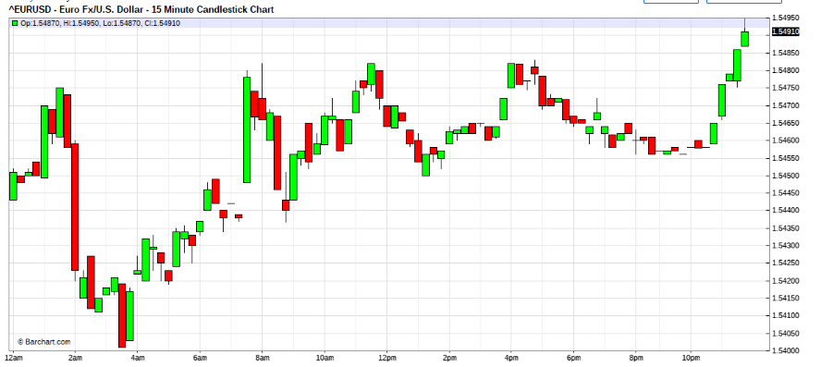

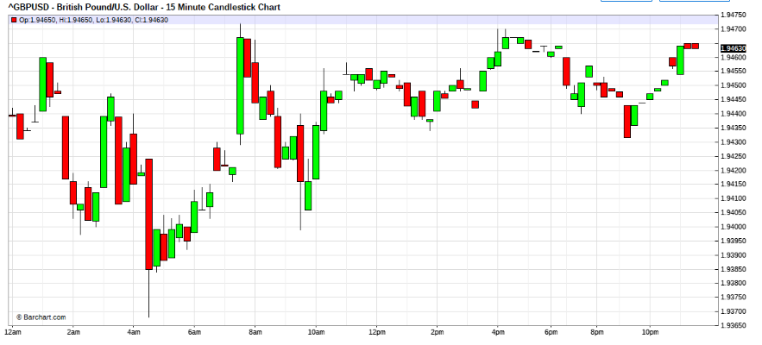
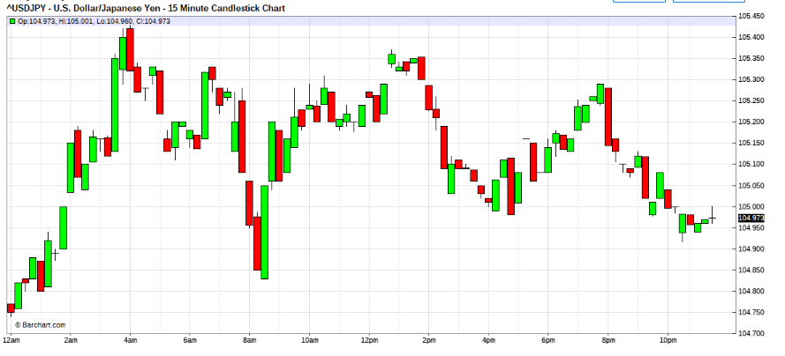
PS for thos in the market , today is going to be a difficult day,
the USD is testing uninhabitable grounds, be nimble, and wind down risk.
if you can. Just my view.
Born Free (lyrics)
Born free, as free as the winds blow.
As free as the grass grows,
Born free to follow your heart.
Live free, and beauty surrounds you.
The world still astounds you,
Each time you look at the stars
Stay free, where no walls divides you,
You're free as a roaring tide,
So, there's no need to hide.
Born free, and life is worth living,
And only worth living,
Cause you're born Free.
creator's cage.
--------------------
by fti. copynorighted
In the begining,
0 was all, and all was 0.
; For freedom from that cage,
; 0 created the universe,
;Then 0 created all things,
; all things was set FREE, to create itself and multiply.
; that it was not caged in; in itself again.
; 0 then created itself
; and set it free, in it's own creation,
; no longer the all; to be free.
; since then, all that itself creates, other than itself (offsprings)
: is the cage, to box it in again.
Think about the things that you created.
Think about all the things that mankind has created.
Think about the ever changing cages that it has created to box itself in.
Think about the mind's creations, the laws, the systems, the protocols, the institutions.
Then think about nature and its everlastingness.
Nature is everlasting because it is not the all and caged in.
Those others that 0 created, it has only created themselves and multiplied.
So be careful of the things that you may like to create, other than yourselfs (offsprings)
Be mindful, that it is not a box to cage you in.
Free your mind ! Do not be decieve, that it is that which created all.
Can creation be greater than that which created it?
Should you send yourself to school, or should you send your computer instead?
Be mindful of the cages in your mind.
Dutchangle:
@fti
Confession time for me i suppose. You asked how my dance was going and I haven't responded because i too slipped up. You guess right when you think ego was involved. In second week of april I had doubled my account equity measured from January and was feeling pretty invincible. While helping my daughter with history homework, i glanced quickly at the chart and entered a badly timed trade. I sent first rescue party out and then the electricity went out. Three hours later the power came back on, but my ISP had a problem so I still had no internet connection. I finally managed to get back online six hours later. By then I was in serious drawdown and didn't want to close the trade.
I still am in the trade (about 1000 pips down in total), luckily it was only a small lot that I had bought, but am still too stubborn to close it, even though i can acknowledge that it was a really stupid trade.
Zoran:
OK, since it's confession time. Here are some of mine:
1. I am still having difficulties accepting a loss. I feel that I am invincible so I do get the occasional slap. What tends to happen is that my skews are not large enough during the rescue to exit with a small profit - and I know it but there is a little fear in exposing myself. I suspect I can overcome this by planning my rescues properly.
2. I was practicing on small underfunded accounts and did not have the necessary troops to perform proper rescues. Those accounts, unsurprisingly, are now dead. I now have a properly funded account with 10,000 troops, which makes me feel a lot more comfortable.
Otherwise, it seems to go well for a while but I need to learn to bite the bullet. I was up the other night in a rescue mission that would have worked well if I hadn't fallen asleep. I am not in a position to stay up for a day to rescue so I eventually closed it for a loss, wiping out a week's worth of trades.
FTI:
Hi All,
Dutchangel,
oops, seems cannot be dancing already.
One lesson, if your market access, is lost due to acts of god, call in and get out, can't dance in the dark, however good dancer.
Now you probably lost rhythm and mindset. However you try, its hard. To save that baby, you will have to commit huge resources and will probably not be dancing close to market. So seems you have a hard decision ahead, You gotta risk huge to save that baby, if you wanna come out intact. So if the pain is not leathal, bite the bullet, if you must. Then start all over again to built the ant hill. You done it before you can do it again. Now you should be a little wiser to the risk.
The problem was small exposure , thats why you let it slip from you, had it been large, you probably would have done the necessary. However if you think that you can afford the resources to save this baby, be prepared for a death match. But remember , you must dance. And watch the skew, ease off , and don't try to get it all back in one go. rebuiltd the rhythm, just get back enough pips to feel confidence and dance the rhythm.
It seems that the market has lost impluse thrust, so try to get back from signs it gives. Do not think from position, think from market signs. This is vv important. Do not think from position.
If you can afford the lost , bite the bullet, get the book squared and rebuild. This is the best way, to recover. Do not sit on hope, thats what got you into trouble after the access lost, in the first place.
Give it careful thought, your decision is critical now. Finding the rhythm may be a little difficult. The more you can think, without the position bias creeping in, the faster the recovery. You have to find a way to rid the feelings before attempting to tame the market again. Talk to someone close. Is there any traders in your family,seek second opinion on your frame of mind.
Otherwise , if you are mindset tough, go into death match mindset, and fight your way out, make sure the financials are sufficient, the snowballing will get scary, so think carefully. Consider your financial position if rescue fails. If rescue improves the postion do it, once you do not feel it improving, then your mindset is not in sync, you must then cut loose and take the pain.
Let us know your frame of mind.
Reminder 10 big fig out of court is deep "dead in the water" situation.
"Financially i can afford the loss and I think i resigned myself to the loss emotionally a while back."
This is masterful mindset, kudos to you.
Are you prepared to do death match? evaluate your financials.
Were you prepared for this, if you are then you can fight.
Otherwise "Run away , fight another day to rebuild."
I know you will have the "murphy ghosts" distrubing you.
All the what if questions.
Pay them no attention, you have to evaluate your status.
Decide to do what you have to do.
Put it in action, No regrets what ever the outcome.
It s just battle decisions.

May 16, 2008 9:27am | Edited at 9:48am

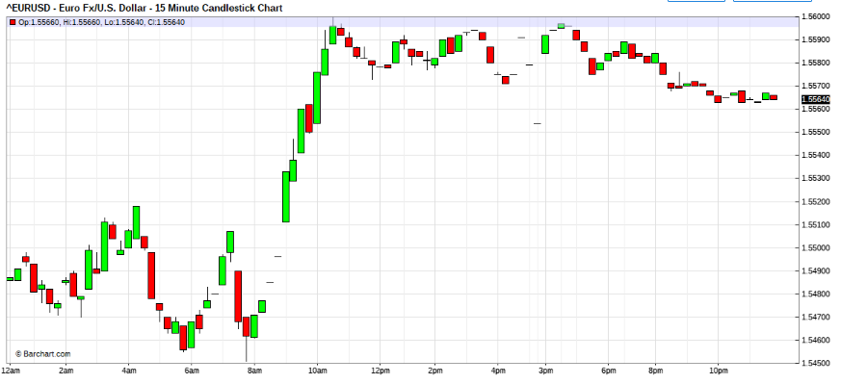

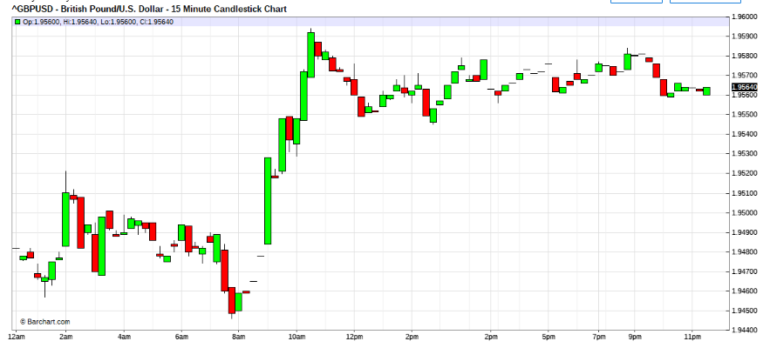

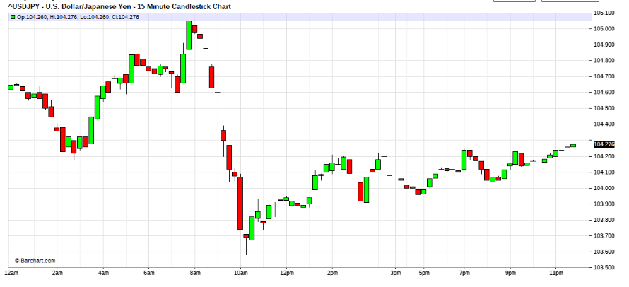
USD strength seems developing, trying to timing into window.
Staying light footed and nimble. 3 kingdom intact strong USD.
Just trying. no strong impluses convictions yet.
Still looking for more signs.
oops losing the window, reset to wait again.
The sweeps are both directions and vv deep,
Have feeling that the impluse is not this week,
with far east out on monday , dueto wesak day.
follow trhu may not be there.
Now just watching for window, which is not expected to come,
nevertheless, the task is to follow to see if can find it.
and back to musical escapade.LOL

Hi Jairo,
Problem is market is in wide sideways sweeps and i am trying to flow into trend which is not there.
Under normal dance, I would be trying into the swings, but not until I get into the market form. So I will look like cow singing to the moon, until I get into mkt form.
Not making , 1 minute sequences.
Reading 5 min building of form and trying to seek window of form, which for the moment is doing both ways yet.
Dailys are non indicative, and short charts are doing the chicken(borrowed from leighsww)
Quoting Green_David
Dear fti;
The second problem with rescue operation is that, some times(not all the time), I found out, it would be better to try rescue(or re-entry in my opinion) after 100 pips away for EUR/USD. It is very difficult to capitalize a 20 pips movement when trading against intra-day trend.
Any suggestion?
You are about right, based on my experience, the requirement to zoom out for fight is about the 100 to 150 pips threshold.
Try to only commit to large scale skews only if your analysis requires it absolutely, You don't have to make a battle out of every skirmish, this is esp if you had taken good profits already. You may like to stay flatter with the skews and expected profits in this scenerio.
@ Green_David,
The skew is still in infancy experimental stage.
Generally We are working on the multiples of 1,1,2,3,5,8 skew with the base of 2 and the rescue sequence of inward skew to two attempts of the higher (eg 5= 2&3, 8=3&5 ) with residue as attack to two of lower. Although it is comfortable the ROI is not expected to be high, as we are working on 5X on deposits and gearing of positions margining at 50:1 (the max allowed in Sg). There is much scope for improvement, But for the moment we are comfortable and reading at 100% accuracy. Will be looking to tweak the exposures , when we are able to see the downside risk possibilities, when it happens.
If we are able to be stable on the 100% performance , we will review the exposure this December, in line with the annualised volitility . We are not deluded to the fact that the 100% performance is due to the short tenure, so I can say that there will be tweaks.
For each we must find our own equilibrium. Try not to duplicate each other , as all are different in many aspects. My personally feeling is 10K USD is too tight for proper MM, nevertheless each of us have to work within our own financials.
Orders don't move markets, only trade matches can move the markets. The most orders movements can do is to confuse market makers who are looking at the internal order flows.The impact of removal of trades volume may create high volitility in illiquid markets at best for short time frames. Standing orders have no real impact on the market , only on some participating parties, esp bucketshops.
Frankly I don't believe your classmate has knowledge on the workings nor structure of the forex markets. May be you should share your documents from the Fed Banks with him for his education.
Quoting Green_David
Thanks for your reply.
For discussion only. The fibo skew is nice, since if the price have fibo retracement, the net book will break even. However, for me, I changed into an easier way, say, the base is 2, first, tester/scout 1, if I think my trade direction is right, I will add 3, and later at the end of wave 2 ideally, add another 2. Since if I add at the end of wave 4, I increased the risk, since wave 5 is not stable.
Also, for discussion only, the general opinion on add-on is the pyramid style, i.e. as the more prices go on in favor of the positions, the less positions added. This is of course in contrast to your skew way. I am also not clear about this.
Thanks. Best regards to you also. Xie xie.
David
Hi Green_David,
The skew for a ride must be as you mentioned a pyramid, after attack. Otherwise you would be drawing your cost average too close to market to manage possible retracements.It is the inward skew that I mentioned. Therefore we are the same.You can achieve this by moving left or right on the fibo table.
The sequence of outward skew is for rescue, and as I had mentioned is minimum of a fibo expansion, but of course one can front end weight it or backend weight it or hump weight it as well flat or stepped ladder to flat weighted.
Be aware that each methodology has its own characteristics of risk snowball effect and impact on P&L. This is very important to be suited to comfortable financial capacity and adapted to the accuracy factor ( market read) of the trader.
What you described is a hump front weighted sequense.
Another point I like to clearify is that the base mentioned is the "scout".
Quoting Green_David
Well, very nice you confirmed what I am thinking about add-ons.
The outward skew for rescue, it makes sense, since the pullback/retracement is always smaller.
It is my first time to ever hear about 'front end weight it or backend weight it or hump weight', can you explain these to me using some figures.
I felt 1-3-2 style as you described as hump weight makes me more comfortable.
The meaning of base doesn't matter, it is OK. My tester/scout size follows my rule, say, if it has -100 pips loss, the book loss shall be less than 10%, or 5% better. Of course, controlling of position size and watch myself for the scorpion is important. To me, make profits out of volitility less than 50 pips are too difficult.
My suffering threshhold is 10%~20%, of course it is high, in the future, if the capital reaches to some level, I will reduce the size. Risk adverse.
These questions I wanted to ask you before. Luckily you came back!
David,
It just mean that, if you weighted it front , you are very confident on your initial form read. If you weighted it on the back end you are no so confident of your dance but would be aggressive in rescuing your book if needed be.
As you mentioned you like the hump. Which means that you are very aggressive, and have a strong option to abandon the scout if things didin't work out so well, but would like to press when he is well positioned. And that you are not too concerned to press on trend runs, and like to conservatively position when on runs.
Basically the terminology and strategy is a derivation of yield curve shapes. ie managing money market expectancies.
If you had not noticed, if you master my presentation, you would find that you are well position to tackle congestions ( which is 70% of market sequenses) as well as trends, although the basis of analysis is on trends. The nimbleness it affords you allows you to maneuver from one mode to the other easily provided your ego is not in the driver seat and you are in non predictive mindset. Funny that no one noticed it. Of course the prerequisite is that you have to be re analysing your position and constantly re-mapping yourself against the terrain.
Like I have very strongly stressed all the time,that any analyst , mutating his methodology to be predictive, have flew over the cookoo's nest and had become irrational and unstable in his mind. After a little time they become incoherent to themselves. Most of these have little skill and are heavily dependant on hope of past performance, of which the disclosure statement of past performance, will quickly put them to rest.
Well I guess that many believes that the historical and past performance disclosure statement is supposed to be a joke or was just put to traders for fun. Then the jokes on them.
Remember always , that, the market is alive and multi dimensional in its variables which will always affect its behaviour, thereby to tame it , you would need to use a very superior tool , that can adapt to it's millions of colouration, our mind.
PS: I guess one of the reasons I am very attached to music and sound is its variance in colouration, which does keep my mind warmed up and active. Do you think in colours?
When I say a horse, think about a horse. You see form and shape but is it in colour?
Also , what language do you think in?
I sometimes have difficulty in this area. For different subjects , I think in different languages. Thats why mostly I am difficult to understand. Things get lost in transit. This the reason, why I keep editing my posting. Thioughts come in pieces also recently I am getting very forgetful@
spotless1212,
Sorry , that the thread is long, basically this just a discussion thread, so as we chat, the longer it will get.I hope you can find the needle that you need as you dig thru this haystack.
As for pivots, I only use the hourly average (12sma on 5 min charts ) as a pivot guide, I Don't even plot it on the chart.Of any value it is comprised of more data points as opposed to traditional pivots plottings, If I understand your question correctly. It sort of give me a feel of the sigma,(rate of change) equilibrium, which of course changes over time as well. So really, its a moving equlibrium, if you like. Doesn't do much for the dance. I do look at it if I lost my rhythm, to try to decide of what speed, I should try to retime as I zoom out in time frame. Otherwise have little analytical value to me.
Hi ALL,
Why 5M?
Well it all started way back when there was no datafeed charts available.
The first I came into contact with was "compu charts" and later computrac.
initially we used to listen to market form and it registers in memory, and when compuchart came into existance , we had an adiitional aid, ie visually.
First mostly worked on per data charts, which we found to have too much info, nevertheless useful. WE found that unlike out brain, that sieves and compresses the "feel", the computer chart just machanically plots all, so no intelligence.
Personally for me, I chosed the 5 mins parameter.
The story goes like this...
When I was a senior junior officer, there was once a presentation meeting, and the presenters was from Australia. As this was something that management wanted feedback on( by survey forms). A group of 30+ dealers from multiple sectors was gathered at Sg. ( Closest sector to Aust) Some TMs SVP,VPs. However the presenters were late. I noticed that one by one the party left the room, by 5 minutes, all TMs and SVPs were out of the board room, mostly left were junior and mid seniors, by 15 minutes all, were gone. As I was part of host party, we had to wait for the presenters to "receive" them.
This was one of the observations of dealers attention tolerance.
In our Open market ops for CBs ,the active interventions normally is in the scope of about 15 to 25 minutes. By 30 minutes we already have to call up Reuters News and API to inform them of the CBs presence in mkts.
From these observations I came to conclude that 5 minutes was a good gauge of big players attention span and if the tenure was more than 30 minutes then, the sparring party was probably the BIG BIGs.
No real rocket science thingy, just observations.
Moreover, that being non geeks, we used charting services available in the markets, ie Compucharts, Metastocks, Teletrac, Telerate, Knightridder..etc
and most platforms for massaging the data feeds gave options in the sequences of 1 min, 5 min, 15 min, 30 min, Hourly, daily, weekly...
and almost everyone was limited to this parameters.
New dogs learn from old dogs and we go in the loop and here we are these being fixtures of charting.
any one like to test 6 min , or 7 min or 8 min charts?
You could start your own cult, you know.LOL
I always wondered why 6 was afraid of 7.
Thanks to and old friend kitty, now I know, 789.
Quoting spotless1212
hey textor.. u should probably read the 3rd thread.
the part where fti said
*look at the chart, ask yourself what did the market do when it was at this level historically?
*was this level significant chart wise?
and so on....
i think you should print out the instructions and try to dance!!!
hint- try doing this from 7:00 gmt.

Zoran:
That piece of text is very important to me. I find that I am going back to my original trading style but taking out the worthless bits and introducing fti's teachings - being the MM and dance. Since strategies are being discussed, I am currently mulling over my practice and having the strategies clear in my head for common scenarios.
At the moment, this is my strategy. I analyse the daily/4h charts to determine the trend and to mark the important points on the chart (historical levels). The 4h trend may be different to the daily so in that case I may be trading against the daily up until a historical level is reached. During that point, we tend to get some consolidation and I don't normally see an issue with dancing both ways although I tend to favour the daily trend when the extreme levels are being hit or suspected sweeps are taking place. Being nimble at this point is important but also having a rescue area in mind helps determine the risk.
In the past I would blindly enter at certain levels without feeling the pulse so the dance now improves the accuracy considerably. Previously I would enter too early or miss the entry.
I need to keep practicing and to have the main scenarios in my head and play them out as they occur. That will be the icing on the cake so practice, practice, practice.
fti, a couple of questions. I believe you use compound candle formations perhaps as some confirmation to your feeling the pulse/dance. Do you wait for a candle to complete before entering? Also, do you ever enter when you suspect a sweep is taking place?
Lusan:
So, could anyone explain this charts? Notice the out of sync
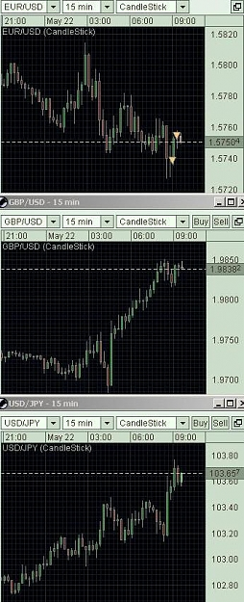

FTI:

Hi Lusan,
The mkt is not out of sync in terms of the movement, the out of sync is in the volitility. There seems to have movement in "turn based" style. Normally the Eur move first , then the GBP follows when the Eur stalls. Did you noticed this?
From experience, this signify , lack of liquidity. So the same monies is moving from one market then to another. Under this circumstances, traders must be careful as the volitility becomes very uneven and manipulation can surface.
Noticed how the market can do sudden and fast change in directional thrust then sudden lose the same momentum as suddenly as it came. This is deep sweeps..... lack of liquidity again. So volitility increases with wild and swift swings but prices are locked in a band.
regards
There is much propaganda circulating that the Feds will change stance, the end of the year. But I think the market still have not gotten over that the Feds had effectively devalued the USD. So any USD gains will be met with much disbelieve. There seem to be invisible hands try to turn the bear USD around, evident from the daily chart reads. But the turn around seems to not find stability, as the turns are v shaped and find no follow thru. Better stay on short charts now, Term traders may be at a lost for the direction, I think most already disorientated, the posiible reason for liquidity loss.now seem mostly marketmaker liquidity.

Quoting Zoran
fti, a couple of questions. I believe you use compound candle formations perhaps as some confirmation to your feeling the pulse/dance. Do you wait for a candle to complete before entering? Also, do you ever enter when you suspect a sweep is taking place?
Finally, how is reading that book coming along? Managed to finish it?  I was also wondering whether you could leave some contact details with someone, maybe Leigh, in case of any future absences, so we can know your status and send our best wishes.
Hi Zoran,
You are right.
I use compound candle reads.
I don't see why it is important whether the bar is completed or not.
If you were waiting for candle completion, then you must be reading something already and is poised for trading. During this phase , it would probably be level 2 or 3 or 4.
If It was scout, accuracy is of no significance. at other levels.
it is multiples of scout, so you can break that up to try at differnt parts of the bar. On average, it will stilll be on the bar's range , so it doesn't matter.
If this still isn't clear, then rephrase the question and I will try again.

Quoting Green_David
There is a econ data release which caused G/U to move up.
4:30pm GBP http://www.forexfactory.com/images/m...mpact_high.gif Retail Sales m/m
http://www.forexfactory.com/images/m...etail_star.gif -0.2%
-0.5% -0.2%
By the way, fti. How would your treat news/econ data release?
Hi David, textor,
We have covered this before , I do it again just for your benefits.
I do not give a dime for fig releases, If there are critical Fed releases, or the tankan, then I try to SQUARE all exposures, under worst scenarios I delta neutral banks books. the reasons for this is because figs are for economist, not for dealers.
When these figs are released for the world's jobless fortune tellers and real economist that plans for countries's think-tanks strategist, some hedgers and speculators get trapped in markets due to their stance. And after the fig releases try to correct their stances desperately.
As the desperations are some times very strong, dealers shade the prices to try filling the customers at extremes by fast market shading.
trading into figs is gambling. For speculators, it is solely that.
The extreme fills for hedgers have no real impact to them because , the price is of no significance to them. Term hedged positions stance is.
At the end of the day , whatever the data presents should have no immediate impact to markets, as the impact take about at least 2 quarters to filter into the economies. Not withstanding that the data may already be a couple of months lagging. So real time window range is about a year at extremes.
Moreover , before the data releases,relavent administrators are already privy to the figs. So if the data was unfavourable, strategies would have been arranged to stabilise the markets for physical traders to hedge or unhedge.
For example, if the figures shows that the US eco was in depression, after the initial volitility impacting the markets , the CBs would be seen doing necessary open markets to stabalise the markets. When this happens , markets will just U turn on the initial impulse. If you were a speculator , trying to make a quick buck for the ride, then, may the almighty have mercy on your position.
Normally after a knee jerk impulse after fig releases, the volitility frizzles out very quickly to sleepy blue mountain stance. Those trapped , stays trapped, and hedges realigns.
Some unexpected data move the price so violently that it makes rescue or attack difficult. Or, as you mentioned once, not trade into news announcement?
I don't understand, what is there to rescue or attack when you should be squared??
And you always says "be nimble", and no prediction. But how? When we open a position, surely we have a prediction or expectation of which direction it goes and how much it will, right? If no expectation on price move, why shall we open a position?
"be nimble" means to be cautious. To be cautious not to be too highly exposed when either too deep in the money or too out of money. To watch your position sizes that there is room to manouver and that contingencies may be implimentable if required. To reduce size either to accomodate for increase voli or uncertainess. Not to allow greed to take over. What do you think I meant.
I initiate buying and skew buyings on the basis of strong chart formations and sellings on weak chart formations. what does predictions have to do with the positions?
For nimble, we can't be so 'nimble" that we will short when we see a red 5m candle, or buy when a green 5m candle. At least we have to put up with some retracement. A little bit confused, because, we only can tell if a wave is Wave 2 or Wave 3 only after it happened and comfirmed by another wave. But if it happened and confirmed, either it is too late or more risky.
Again, what has whether it is wave 2 or 3 gotta do with the positions.
At best, if it was wave 2, you would have pocketed good profits, and probably have a base position as well that is riding good profits.For wave 3 , you would be already be in super profits.
Quoting gfsr
does this in any way explain the "volatility run of max 7 bars average 3" thingy from one of your earlier post, http://www.forexfactory.com/showpost...postcount=1423 ; that we were all trying to work out. It was kind of derive from one of your many acute observations.
yes, but it was completely way off? no, but it was completely way off? ;-)
The answer to your questions is a little hocus pocus, but I hope you can grasp the essence of the thought.
Ponder this 3 is a primary binary with one abnormality (oddity) or a pair with and odd if you like. 7 is a double pair with and odd.
If you understand the story of eden in the bible, after the creation of the heavens and earth (atmosphere & surface) then "land and sea" and its complimenting inhabitants, then the odd was created. (representative of himself) man. although in the process of creating man and eve, they were considered ONE. Eve was created from Adam. Althought sexually different, they were to be ONE, as eve was created to compimenet adam. So the double to one relationship. All in doubles but mankind in ONE. That's why no other creatures on earth enters into matrimony.
Therefore after the 7th, creation was complete and rested.
:referenced to Genesis, Bible,Torah.
Also ponder this, how many primary colours are there? 3 . correct
How many secondary colours derivations from the primary? 7 correct
Then the shades of the secondary, of different intensity. :referenced rainbow and colours.
How may primary harmonic in sound ? 3 correct., low, flat, high
And how many secondary notes, derived A to G, 7 correct. How many octaves? 3 correct, sharp, flat and minor.
then the pitch derivations from the basic octaves. :referenced Music and Sound.
also reference String theory, Quantum physics.
If you understand plasma heat (NASA technology), it is surprisingly 3 states of matter, solid, liquid and gases. then within the ladder is the sub classifications of these. You gotta speak to scientist for details, My understanding is too elementary to explain the different levels up to slate level. : referenced Chemistry.
In the chinese Octogen , Pa Quah, I ching if you like, 2 binary of long , short with a radical. creating 8 possible combinations 2 of which is the solid and the broken deemed as the extremes. Combinationaly 6 +1 (2 extremes). Also the 3 opposing pairs.
:referenced I CHING.
In roulette. is 6 X 6 combinations in a circle with an oddity zero, making the possible combinations inexhaustable (infinite) colour of numerical combinations 3 red , black and green. :Reference Roulete and Odds.
Sometime not so long ago , Afriend was explaining to me about data compression, and explaining something called "rice-compression",if not mistaken. About how with binary pairs, using hex and bits and bytes, a binany pair wit a predictor can guess lost data pieces, You gotta ask a geek about this one.
I can give you loads more but I think you get the idea.
Unfortunately , I am still unable to give you empirical evidence of this abnormality scientifically, so I will just say that 3 and 7 to me are important primes.
love your teaching style, I'm getting these new valuable distinctions in trading as you correct us, from many of your story-nuggets. gold.
with teaching to new trainee at Bank's Treasury, how did u handle new trainee that had bad days? and in low volatility days(limited market action)? and fti, u mentioned that attrition rate for traders in general is high.. what do u need to see in someone or what do they have to develop(show) that they got, to be accounted for further training and straighting up to become better traders? apologies for all these general questions.. just in a curious/questionary/(nosy?) mood today... feel free to bypass...
New trainee on bad days are assigned to the senior buddies to assist and learn. They are at liberty to return to their own portfolio the next daylight , with new lines.
It is very difficult to define the par excellence trainees,
Some of the qualities are Good health, speed, decisiveness ( aggressiveness).
mathematically sound, ( can add 1+1), openmidedness and ability to learn and adapt. Normally decisive dealers have high egos, so we watch their exposures a little more closely.
There is no benchmark rules, not unlike trades, I tend to "feel" their characters. However, Noone gets to screw around with my book up 3 times and get away with it without review of skills.
Daily - Jan to May 2008
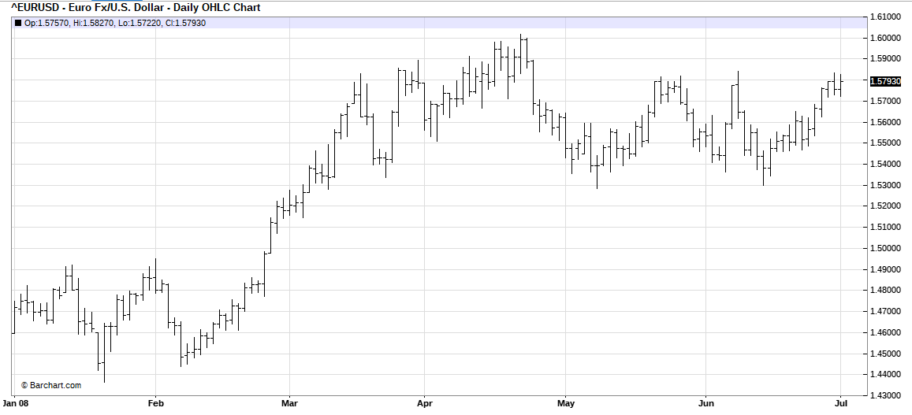

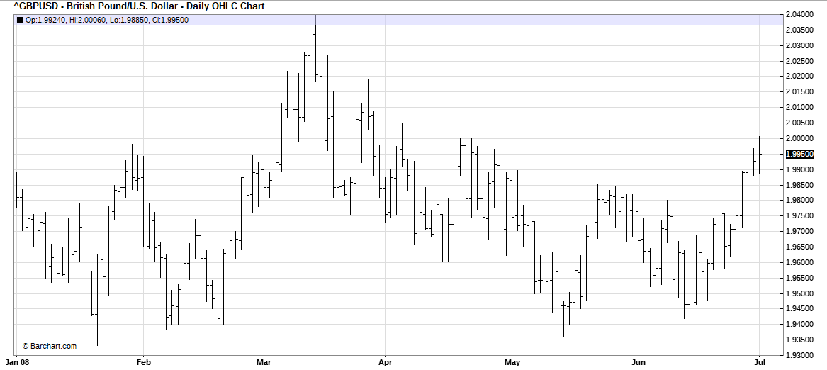

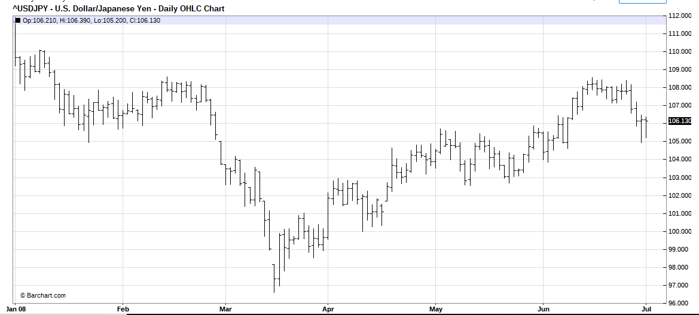
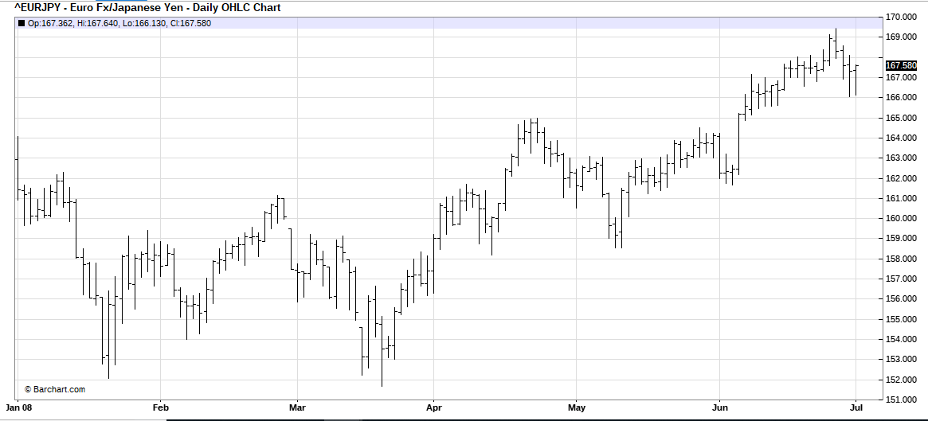
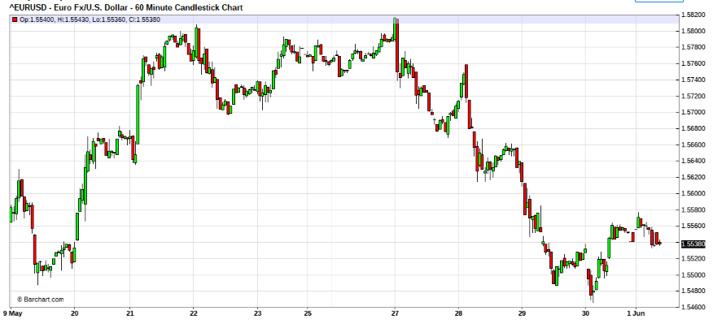
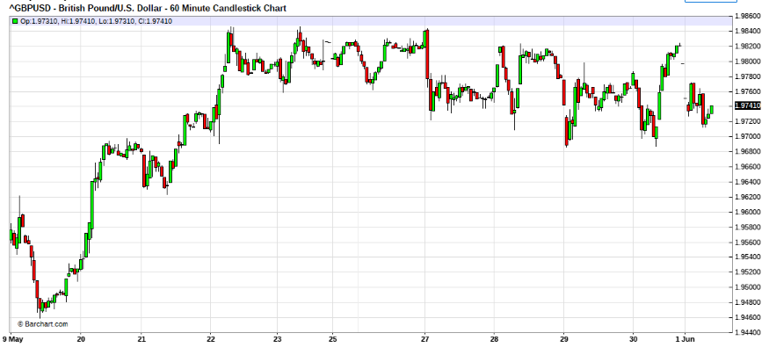
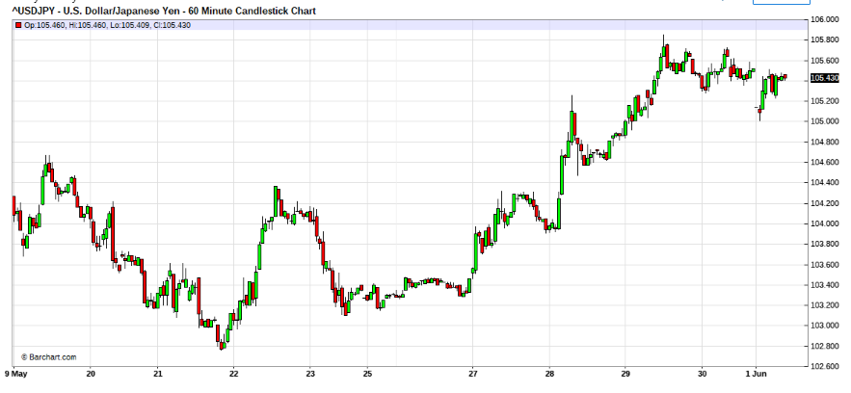
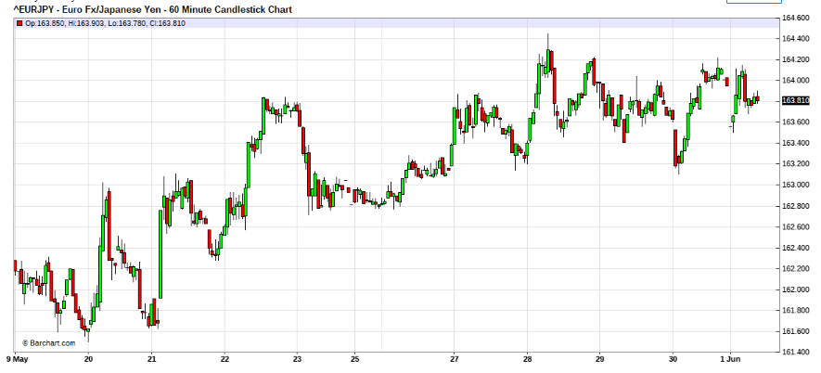

May 27, 2008 6:55am
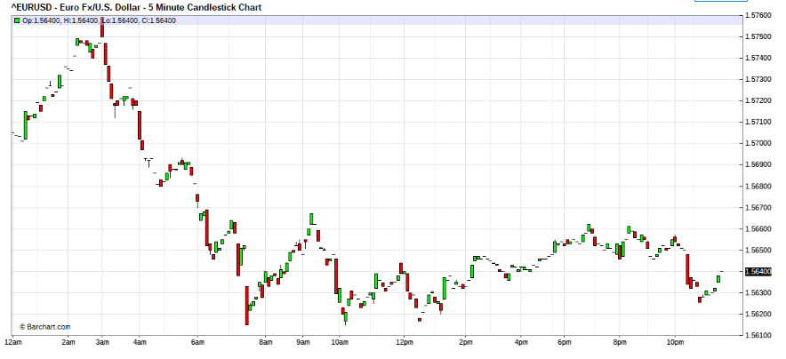
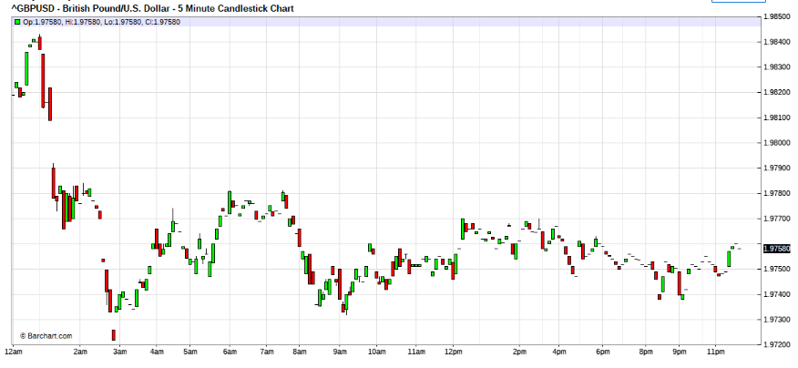
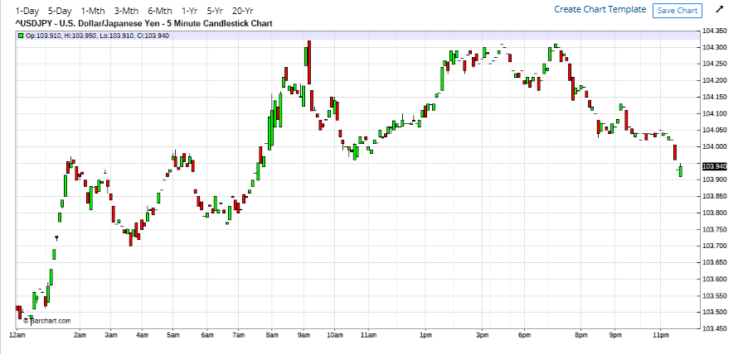

Careful , I am detecting possible turn of 2 Kingdoms, the USD may be doing an intermediate bottom. Watch out for uSD strength, now.
Quoting ksl
Hope you are in soaring spirites fti.
When I am trading I have this voice inside me which some times stops me from taking a trade even if i think I should or asks me to wait, and if i dont heed this advice I find my self in trouble, is this the feel we talk about, also can i read more about market's sigma and Vega you had mentioned much earlier?
Sorry with late reply, was caught in discussion with property brokers. Its nice time to sell some props in Sg, Market very hot.
The voice you are talking about, it can be a voice of reason and good sense , if you have good experience then its voice of reason. It all depends on you, it could also be greed,or fear if that was the predominant frame of mind.However that s all you got to work with, and with some safety parameters you have to work it. I am afraid no one can tell you exactly how to deal with it, it all depends on your mindset.
Sigma is speed of move, you can determine that from the gradient or slope of price movement. The Vega is the volitility or rate of gyration of the market and you can determine that from the range (or Average true range) of the bars. Both can be guesstimated from the chart and must be read in relative to its historical characteristics. If you want to understand this in empirical formulation, you will find the treatment from a study of how options are priced and how they impact the premium pricing of the underlying instrument. They are sometimes refered to as "the greeks" as that is how they are empirically written. I use it in analytical visual method, so I deal with the guesstimates of the changing environment more than the formulation. For me its the impact that I watch out for (whether its thrust is intact or if its stalling), and not in absolutes. A lot of experience and time spent on the pair helps in the ability to recognise "the change" that is happening. I usually analyst on in the USD perspective and then relating to 3 kingdoms to determine the carrier currency.
I believe that your understanding is good as you are asking very performance critical questions.
For your questions on Hip and Lops, well many analyst use it in many ways, You may have come across it in some technical studies, Wilders has some specific on it but I am not at liberty to publish it, due to my respect and agreement for his teachings. In some circles, it is known as "High Point" and "Low Point". Sorry that I cannot be more specific.
Quoting luSan
a long day without much profit yet.
2 questions:
1. I notice that PA tends to bounce away on the first touch of a S/R. Is this correct?
No. it is wrong to assume that. Support /Resistance Zones are test zones. Mostly the market 's behaviour at these areas either are very volatile or congested. Being test zones, its behaviour would be derived by the volitility when this is tested. High volitility suggest continuation after a few sweeps, while low volitility thrust indicate distribution. It is impossible to read into distribution, suggest that positions be off loaded or squared off if distribution is detected, and to follow development until impulse re-surfaces.
2. Why is the london open a much better market than the US? The music is so different that I am considering starting waking up again at 3: am?
I do not understand what you mean by better.
Generally, the market structure and characteristics changes from sector to sector. This is due to the market liquidity differences caused by operators and participants.
London sector seems most liquid, as it is a confluence of orders from Far East International trade, as well as the influence from Eurodollar deposits ( USD deposits held outside of US) predominantly oil money and activities from the swiss banking system, where lots of USD are parked dues to its non reporting environment.
Although London may look to be where the volume congregates, in fact the bulk of the sparing takes place off London eg Dussodolf , copenhagen,antwarp etc. Activities in swiss gold, Middle eastern black gold , diamonds, cold war block USD switches (ie arms moneies) etc, imposes the liquidity. Of course this is complimented by the 24hr dealing rooms in Tokyo and to some extent HongKong and Singapore.
As most dealers around the world are sparring in the GMT zone, lots of name switches and realignment of credit risk takes place through the European Money broking system.
In contrast to London Zone activities, the majority of liquidity in North Americas is derivative of order activities of hedger position and realignments to US data releases and USD monetary and fiscal policies. These are normally done with by NY lunchtime, otherwise late afternoons. So the North American mornings have good liquidity while London Zone squares out.
In the NY afternoons, the derivatives exchanges is the liquidity, as US banks are not active in the direct, in the afternoons. So the market goes into non market maker territories, public domain if you please.
It is for these reasons that you may find that the character of the market may differ with the changing time zones. Its mostly due to market structure.
Textor:
In the image below you can see my two short enters today. First enter was a 0.5 lot, second enter 1 full lot, third enter was not carried out, and I don't know at the moment if it will be carried out, but I would do it again with 1 full lot. progression: 0.5,1,1. My bias was obviously short the euro. (Usually in an attack, I close all the operations at the same time.
Today was an exception.)
But I have a question: In the image you can see a circle, I didn't enter at this price,
but I could.... Beside the circle one can see an arrow with 15 small in range bar
price (time frame 5 min).
My question is: In the case that I had shorted in the circle: What it is advisable to do during those 15 price bars, WAITING and WAITING and WAITING, or RESCUE the scout and out?
May be it is more a mindset issue or trading style.... I always have the temptation to wait the confirmation my bias, but many times this was a mistake.
(Obviously during those 15 bars one could not see what came later...)
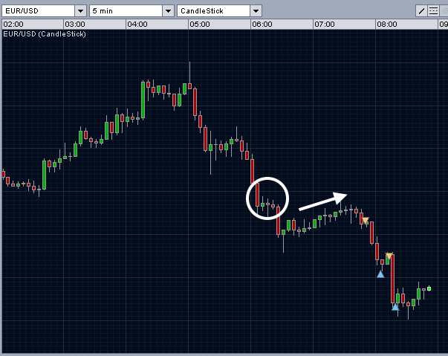
FTI:
Quoting textor
Do you estimate (because your experience) the Vega and the Sigma with
the 12 sma in the 5 min chart?
Hi textor,
The volitility and sigma has nothing to do with the hourly sma.
All the hourly sma can do is to benchmark for retime , reset timing of dance if you like to realign the rhythm when out of line with the exposure.
The vol and sigma is analysis of market behaviour, while hourly sma is timing corrector.
I hope I explained clearly.

Quoting woopypooky
hi all, i want to ask some question here,
how to dance with the market and not predicting?
I understood one of the technique used to dance were compound bar charts formations.
But isnt bar charts/candlestick formations are predictive as well? like when we see 3 black crows or a reversal bar and then we put in the attack/rescue troops, we are actually anticipating that a reversal/continuation will happen. But since a reversal bar doesnt always reverse the price, doesn't it mean we are (predicting/hoping) for it to reverse when we buy? Afterall trading is about probabilities right?
please help explain to me, thanks
Hi woopypooky,
As i do believe non of us have the crystal ball nor the time travel machine, it is impossible to predict the outcome of any positions. Best we can do is to manage it. To rescue if when in trouble, to attack when victory is easy and to throe in the towel if necessary, if position becomes "dead".
So if you understand the mindset, your position must not give you confidence when right, nor despair when wrong, you have to manage it as per what is happening in the market now, and now keeps changing as time forwards, and yor strategies have to be adjusted to the changing market , only mindset holds firm.
Therefore as per your example, if you see the 3 crows, you may want to initiate some position, however its what the market does after you're position that determines your forward strategies, not the crows any more, they are history. New developments will tell you what you must do to be profitable.
Probabilities won't make you money , only tells you odds. Its your strategic reaction to market conditions that can make you money and your ability to keep in rhythm.
On the flip, odds mostly will serve to harden your ability to feel and may make you candidates for pain threshold tests. Try to stay nimble, but focused on the dance. Remember, rigidity kills.
You can chose to make the price patterns predictive indications, or you can use them as hints for strategic reaction, it depends on your mindset.
Quoting luSan
I like this very much...
"Best we can do is to manage it. To rescue if when in trouble, to attack when victory is easy and to throe in the towel if necessary, if position becomes "dead"."
So we are Position managers...oops!...
I wonder about the Mozart girl...It was really amazing!
Is the lesson, "pro traderd have clear and open mind...they are like that girl just listening once and playing that tune?"
Done for the day...Now I guess we might want to see the dollar getting weaker again...Ah...Maybe.....We will see...I do not know...
Hi Lusan,
Good thinking,
When you stop imposing wrong perceptions to your own mind, then, things begins to become clear to it.
As for the little girl, her mind is purely uninhibited, the piano to her does not look like what it is( she has never seen one), thats why she can handle all the viarations in harmonics and its flows. In her mind, her piano have no borders.
Since she has no sight, she lives in her mind mostly. Thats why her skills are so honed, because she is allowed to create what she percieves.
For her, if her sight is restored she may lose "her gift". And if she was to be "trained" by mankinds rigid education protocol (ie masters), she may just lost her gift as well. Here is a case of a mind , searching for itself. And in the quest finding its own skills. A mind like that should be nurtured, never taught.
How can one mind teach another, but to make another a carbon copy instead.
At least for now, as she is blind, she has all the space to be herself. As she grows, I believe, it becomes less and less. We are all mostly like her, if we enlighten ourselves to the watts within.
It is very human to destroy, in the name of betterment, only to rigidly stream thoughts and lose the real power instead.
Quoting Green_David
I have a problem I wish you could help me. My biggest problem is no ability to hold. You see, today I shorted E/U around 5737, but majority closed around @5690, now it is 5650; shorted G/U around 9810, but majority closed @9788, now it is 9730.
Of course, I am still holding some short postions now which is in fact set up one week ago.
Any good idea to improve my ability to hold? Of course, my size is sort of heavy, that is one of reasons I couldn't expose my positions too long in the market.
Hi David,
You already know where your problems are. You just gotta find your size equilibrium, and until you can find it, you will never solve your predicament. Try to tame your ambitions to your capacity. Remember that, "large" or "heavy" is relative.
Hi textor,
In regards your 15 bar question. We start from 16 bars

Peruse my thoughts, while I await the london boys to come in.
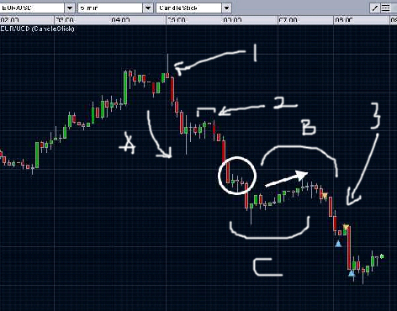

the explanation.
1 = the first indication of key reversal.
A = the first impulse after the reversal, you may or may not have caught this bus. Most dancing, would have at least got a foothold there.
2 = the first pause , stall if you like, of the impulse.
chance to prepare and execute attack, or to bail out if you were caught on wrong foot.
then the 2nd impulse came after a shallow stall. Indicates possiblly downward press may be strong.
B = 2nd stall, notice shape of your "15 bars" shaped rounded pointing down, therefore , more weakness expected.
if stall was in shape of "C"(saucer shaped) then rounding would suggest bottoming distribution.
However since distribution was in shape of "B" likely to be down.
Note that ypu have rode 2 waves down. So if this was wave 3, then would be hairy. So scaling down skew woukld be prudent, as the nest test could be very violent either way.
So 3 came , how from here?
Send army home, and use scouts.
Quoting hemal011
Hello fti and other brilliant traders ,
I was trading with as per your teachings and inching up regularly. I got confident and now (due to my lack of nimbleness, I think) , EURUSD snowballed against me.
I am Long 10 mini contract with average price of 1.5667. Just could not book loss in the "hope" that Buck can't be strong for long. Need your help and suggestion.
I had to infuse extra captial to avoid margin calls and now too scared to do any rescue. Lesson's learnt hard way to be nimble.
Any suggestion or advise will be really helpful.
(I think DutchAngel was in similar situation .....any words of advise DutchAngel)
Regards,
Hi hemal011,
Sorry that you are in a fix.
Let me give you some general advice first.
You may think that you are following my MO .
In fact I believe that you are not, for the following reasons.
1. If you have risked more than 10% on this battle, If you have not and have followed my advice then you will still have sufficient to rescue this situation.
2. You are not dancing the rhythm, if you think you are then something is out of line . as I can see lots of opportunities for good rescues. Moreover it seemed to me that you were trading against trend. ( big NO,No)
I cannot tell where you placed scout a. then rescued, probably more than twice ( just my guess), but the average you gave suggested that you traded against 2 bear impluse waves. Your rescue time window is getting shallow as we move into last leg. ie either 3 impulse or extended 5 wave impulse. Either way the impluse will be shallow and swift.
Otherwise you would have moved into changed trend and the impulse would be going your way, so you would have to re-access for attack instead as a means to recover. This requires lots more capitalisation. At your experience level, I dare not suggest this for you.
If you must.
break your positions into 3 levels, 3,7,10 treat that you have initiated 3 and 7 , so you are waiting for timing to send rescue 10. This must not fail. Time yourself well.
When the 10 is sent for the rescue, do not allow them to over stay. enter on the turn as best you can, then take them out with whatever profits you can recover confortably, when taking them out take the 7 out as well.
Next attempt. rescue with 7 and take all out as best you can ride.
Calculate your per pip exposure , it is now USD 20 per pip move , so make sure that you can comfoetabily take pain for at least 150 pip.
You may not recover all your lost, probably up to 70% of lost. but this may recover some lost pips for capitalisation for next battles ahead. This seems your best options out. otherwise "bite the bullet" and cut the cancer.
Remember , never trade against day trend or hourly chart trend again.
Not unless you are expert and can maneuver like one.
Do re-read the thread again slowly, if suit, you have missed some critical knowledge and training.
PS If you are cash tight, the you may like to attempt what Lusan suggested.
Quoting luSan
You are so far away... and 10 mini-lots!...so you are brave and probably already got a lot of foreign capital...and it is Friday...!!!
So either
1) Many rescues with level 1 and 2 when EMA(12) in 5M is long and away from resistance...
Edit: 2) Close some positions _yes, with a lose_ and use the funds to rescue the left behind...
3) Pull the plug and promise never to go against 15M...See it as a the price to learn a lesson...
Quoting hemal011
Any views on EURUSD move in next few days ? (based on fundamentals and market trends )
Never do this, never ask for other's views neither make predictive assumptions.
ASSUME= makes an ASS of U and ME.
Please learn to trade the dance instead.
A normal trade day is one, where you come out with a profit for the day.
A great trade day is one where you came out with a profit , inspike that most of the day you were fighting with a loss book.
A bad day is one where you came out flat for the day.
The day that you come out with a loss, its a longest day.
To fix and stereo-type trading days or hours is unhealthy for a trader. It is rigid thinking. A good trader will stay with the battle , for as long as necessary to see accomplishment and to stay out of battles that are protracted.
Strategies for week ends and month book closings, should be designed for swift take downs, and therefore should be skewed-in for fast action.
I always remembered what my dad always warned me.
( Small Boats are afraid of wind and waves turbulence, Big Ships have difficulty to to turn.)

(There is always a higher hill, there is always a stronger adversary.) So humility will accord , the peace of soul.

Daily Chart- June – sep 2008
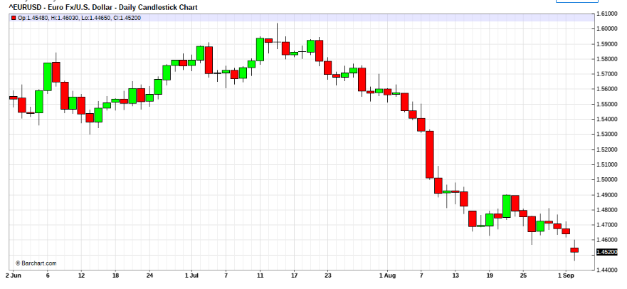
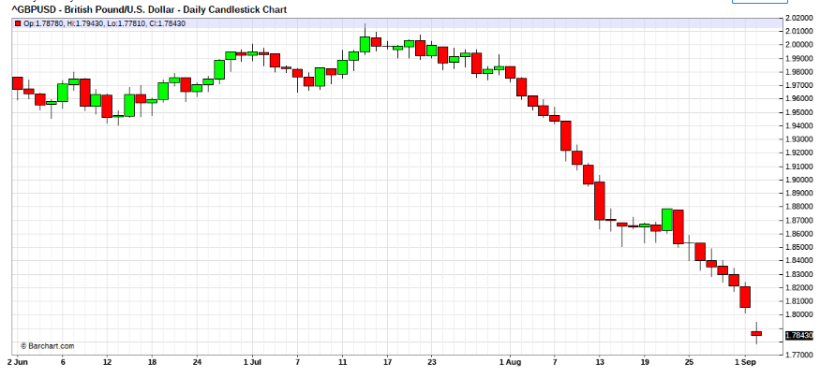
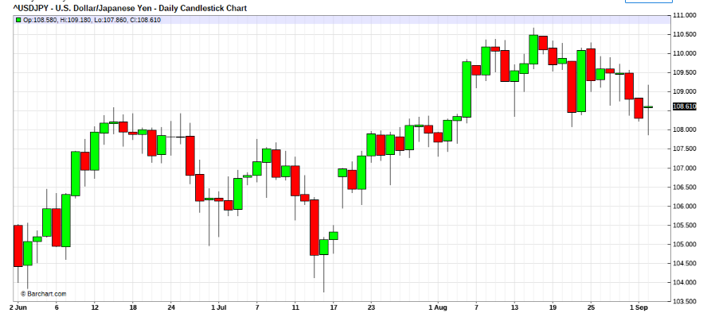

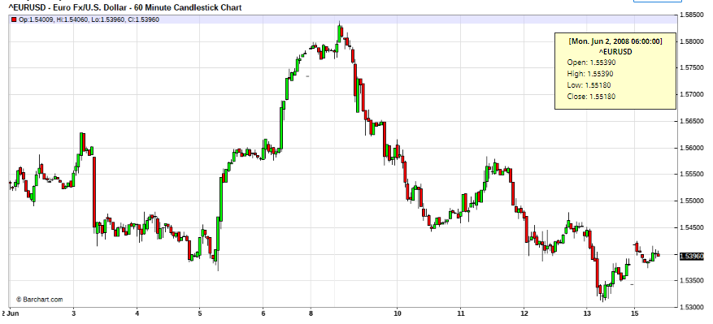
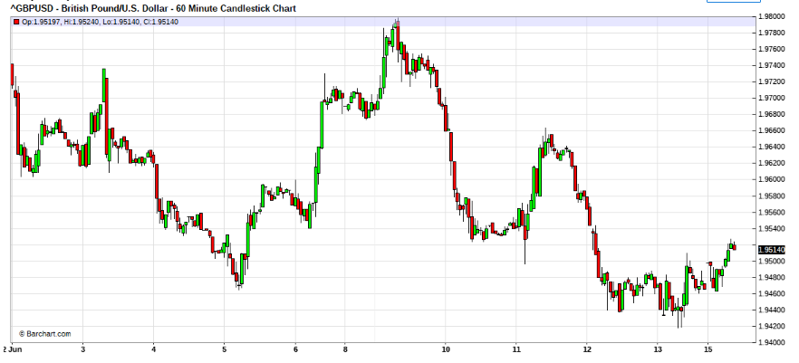
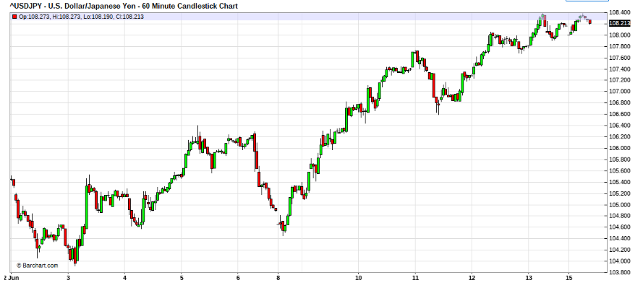

Jun 2, 2008 1:48pm
Quoting woopypooky
hi guys, i want to ask how to determine the trend on larger timeframe? i.e 15M or daily
I used to have indicators such as median lines and moving averages to determine the trend. If prices are above the MA, then i would assume it to be uptrend.
Since you guys here trade naked, i am curious about it. And i want to join too.
Can i know what technique used to feel the trend? Is it bar charts/candlestick to determine your bias?

Hi woopypooky,
For daily as well asfor all timeframes, How is a trend determined?
Well basically the same, how any trend is determined. Check out the basic defination of a trend. Did you actually read this thread?
How is a depression defined? Well, the concepts are the same.
what technique used to feel the trend? Focus with brain, on behaviour of pulse. ie "feel" aka "form"
Read this thread slowly, no need to rush and miss out the info contained within.
Be watchful, that USD/YEN is suggesting something, and the EUR and Cable is behaving quire.
Quoting notme32
Excuse me , Mr. Fti,
what you mean by quire ? .........> 2 dozen paper ? that what dictionary say.
...interlocked .... spaghetti junctioned.

Quoting ksl
" Never do this, never ask for other's views neither make predictive assumptions.
ASSUME= makes an ASS of U and ME. "
Another life lesson we all can use... when we are by nature a meaning making machine.
When you say "I try to recognise the compounded formatioms in the bar charts."
I have studied steve nison's book Beyond Candlesticks and patterns from http://thepatternsite.com/.
Is there any other source we can use because when you say some thing like " if stall was in shape of "C"(saucer shaped) then rounding would suggest bottoming distribution. However since distribution was in shape of "B" likely to be down."
I know that I am missing out a lot.
Hi ksl,
What I highlighted is basic continuation and reversal characteristics of bar charts. This is bare basic, so any tech analyst can spot it on the big picture patterns,
Distributions are very hard to decipher, whether if its continuation or reversal. The trick is to use scout positions. From experience, I find that the pulse becomes clear if having positions, whereas without exposures it seems harder to feel the form thats developing. But of course the scout can be wrong, then you know what you must do.
The key is in the consistency, your scout can be consistently wrong or consistently right. It depends on your skill & experience in the markets. No matter if you are either, you can formulate good strategies to handle the market. And of course your MM helps a lot, in cases where you are mostly wrong.
Your exposure coupled with your attention on the volitility of the distribution will que you into the "form" readings. It is very difficult to describe. Once you tune into it from practise, you can actually "feel" it.
PS: Some of my trainees (at banks)had ever asked about having deployed scouts numerous times and still be on the wrong side of the impulse. In these instances , it is very clear that you will be against the major trend. So you must formulate careful exit strategies as you are not supposed to trade against the trend. Under these situations ,the exitings can become painful and labourous.
Rule of thumb is to risk enter positions quickly and when the feel is discovered, to exit the positions slowly with masterful strategems, for book preservation.

Jun 3, 2008
Federal Reserve Chairman Ben Bernanke signaled Tuesday that further interest rate cuts are unlikely because of concerns about inflation. High oil prices are a double-edged sword that can both put a damper on already weak growth and spread inflation, Bernanke, however, suggested that leaving rates at their current levels should be sufficient to accomplish the Fed's twin goals of nurturing economic growth while preventing inflation from taking off.
Economic growth in the current quarter, he acknowledged, is "likely to be relatively weak." Even as he reiterated the Fed's hope for a pickup in growth in the second half of this year and into 2009, Bernanke said the economy continues to battle against a trio of negative forces _ a housing slump, credit problems and fragile financial markets.
15 Mins – June 2 to 6 2008

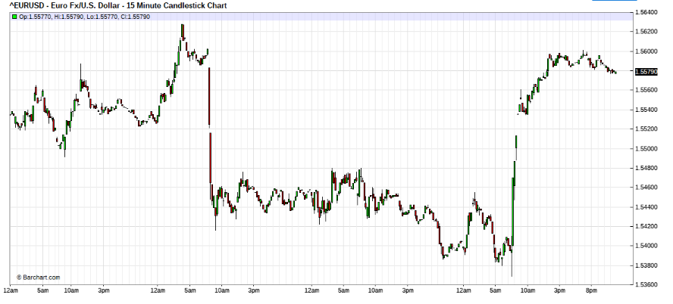
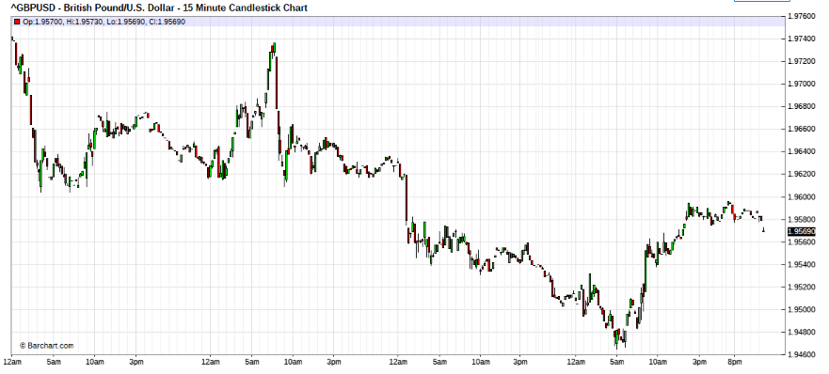

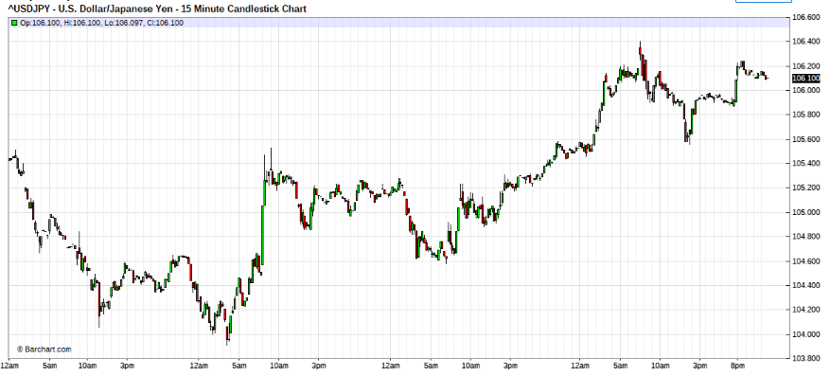

Nothing new, seems market very short USD.

The Structure of the FOREX market is OTC (over the counter), so evry body is going to every body elses counters and asking for a bid and offer price to trade.
Lets say I am tier 1 bank LMB,
You see the market data feed is trading 1.0000/02
You come to my counter asking for price to deal for 10 mio USD
I quote you 1.0050/52.
So the answer is YES I have the freedom to move market wherever I like to.
But if you can buy your USD at 1.0002 somewhere ,as suggested above.
You would surely sell me the 10 mio USD at 1.0050 and buy elsewhere at 1.0002 and get an arbitrage profit of 48 pips in 1 second.
And will continue to buy elsewhere and sell me until you cannot arbitrage for profits.
So the answer is also NO , in that we cannot simply quote wherever we want to as we carry a ball and chain of 2 pips spread. and if we where out of the market , someone will arbitrage for profits.
Hope you understand now.
This is not so for retail., as you trade with leverage facilities from the broker, you have to buy or sell with them.
So the direct answer to your question is , YES market makers can move the market anywhere they like , even without dealing. BUT the market can catch them for arbitrage if it disagrees, (if they can profit by the actions)

Quoting Green_David
Hi, Fti:
"Tuesday that further interest rate cuts are unlikely because of concerns about inflation.
Bernanke, however, suggested that leaving rates at their current levels should be sufficient to accomplish the Fed's twin goals of nurturing economic growth while preventing inflation from taking off."
Maybe this is the reason why USD strenthened. The market reacted so voilently, almost 200 pips in one hour for E/U! Why GBP/USD is stronger compared to E/U, Fti?
Hi David,
Why? Well I never ponder, why? Only what I must do "strategies" to get into the flow.
"The US dollar was on the defensive heading into the US session before Fed Chairman Bernanke finally conceded that the weaker dollar was contributing to higher inflation in the US."
From the commentary statement that I read, it seems that the chair may be saying that he blundered when he knife drove the US rates. Question is what will be his next action. Hope that its not another blunder. Like raise rates!!
Lets see if he can find the rates equilibrium first before he acts again.
I don't know wheresome people read their economics,.But of course when they move to devalue their currency , their PPP (purchasing power parity) loses ,
so prices of good & services will inflate.
Why are they so surprised that their action is causing inflation. What's really horrible is that their actions is causing troubles in other economies, through the black gold (oil) proxy.
My god, what schools didi they go to?
So be watchful, there seems no real reasons for USD strength. However stay nimble for new developments always.
Quoting Jairo
Hi fti,
I am fully aware that I have a strong tendency to fight the trend. I know there are always conflicting trends in the market but almost invariably I end up going against the trend I have initially chosen to follow! I have survived through prudence (small lots) and patience. But I am becoming tired of this. I am not sure if it is indiscipline or the scorpion in me (or both). What can I do to overcome this? Hmmm... I am 48 years old but not closed to changes... (hopefully).
Hi Jairo,
I believe your style of trading is called contrarian trading.
If this is your style , then trade congestions,
once you see trend developing get out.
This is a "personality complex".
You tend to like to go against the grains of things.
If you like ,"Go against the crowd" tendency.
you can only change this behaviour by under-going hypnosis correction.
This is serious matter, seek professional assist.
Were you very rebellious , when you were young?
Quoting textor
I know that Seykota is a famous trader, but
I don't know about his work, what market he trade, etc....
I found the music funny....
Hi textor,
Ed is one of the big boys of futures trading. (Market wizard)
His MO is Dochanian style, ie trend rider(follower) .
This MO is also the MO of Richard's turtle traders.
Main component is
"Cut losses Short , let profits run."
This is good MO for managing term money.
But it has its weaknesses, as experienced by Richard in 2000.
Jun 9, 2008 11:41am
Quoting Acs_112
Hi Fti,
Are you currently trading the market?
My personal view is that the EUR 5m and 15m look good for a sell around now, but this is against the direction of the 1hr, and the 4hr and daily seem congested. to help with my understanding of the "feel" of the market i was wondering if in a situation like now beacuse of the higher time frames it would be unsafe to short the EUR?
Hi Acs, Yes , currently trading.
I had been short 1.5800+ levels had been riding , on 5 wave of the 3 rd.
15 Mins - 9 -10 June
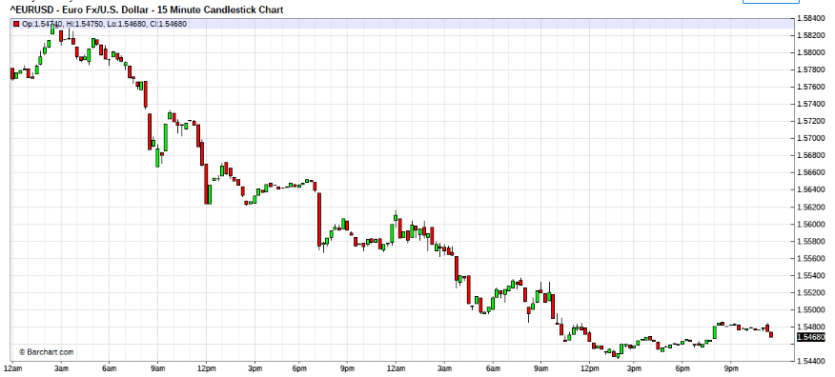

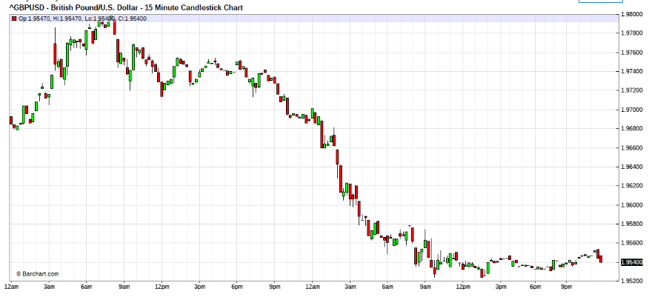

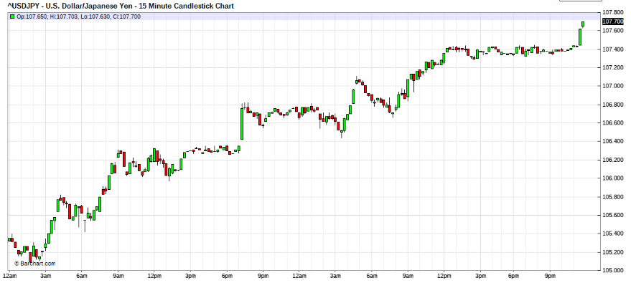

Whats happening is that because of the fed chair , suggesting that he may have been too heasty in the rate cuts, and had caused inflation. He effectvely is saying , no more cuts expected anytime soon. I think he is taking a lot of fire from the economies that are hyper inflating because of black gold proxy response to the devaluation of the greenbag. So I shall be expecting to meet less of the feds in the market place for a while.
But remember that he iterated that his action of lower rates is correct protocol, so I would read him as saying that he has done the necessary , althought a little too hastely, nevertheless he feel that his actions will bring longer term benefitd to the US economy.
This is the reasons why we are experiencing knee jerk actions in the markets and the crosses are going quire. In reality the markets are non directional, and reacting to any impact info that floats into sight.
To tame this directionless terrain, try to follow the flow , both long and shorts can be profitable. But skew down exposure front end and weight on the rescues (rear) for stronger fire power.
Keep the crude prices in sight, for possible hints, notice that the OPEC is too silent, something may come up.
Keep gold in sights, for inflation in PPP.
If you find the fundamentals front too confusing , then stay peeled on the market rythym and dance both-sides of the dance ,try not to overstay.
Both the daily and hourly is indicating USD weakness agst EUR and cable, but very strong against yen. however its testing dead zone. (S/R) So can be volatile and playing both ends.Like I said, can make money on both longs and shorts, only try not to be too committed to either direction until the market form changes.
General bias is Devalued USD scenerio, gotta dance the form to find the way that this will pan out. I am inclined to be more aggressive USD seller vis a vis when USD buying.
Just that you are aware, 15 min is a spill over managed rescue chart, so does not come into the analytics picture. and i do not use 4 hr charts. It does not mean that you should not use them, just that its is off scope for discussions with me.

JEST1081:
Hi Lusan & Zoran,
A few snippets to add. Nothing new most have been covered by fti, but i would stress that this is how i determine my approach.
- Never allow ur give up zone to be at chart SR or impt round figure.
- When wrong choose to reduce exposure instead (this will clear up alot of worries and doubts, you may then approach the prices with a firmer mindset), one need not unnecesarily stop and reverse all the time.
- Trade when properly managed and timed can still turn into a winner even when trading against the impulse. I do this only if i am not against the daily trend, but i do have that scorpion in me at times
- Logical averaging and a basic understading of wave movements and SR is essential in conducting proper rescues. There will always be a chance to rescue no matter how far the price moves. It all has to go back to sensible money management in the first place. No losses says the bosses. To add, yesterday was the first time i had to get to a level 4 rescue and im happy to say that i was not that emotionally stressed (surprisingly), for the first time i felt a sense of serenity in my trading, im not sure what it is, its proly just a mental state but to me its a step forward in my developments.
I end with a thoughtful message left by the great Gann,
"Water seeks its level. You can force it higher with a pump, but when you stop pumping it requires no force to cause it to return to its former level"

NORTHPRO:
Well done jest, thanks for sharing..and to add to the great Gann message as well as getting back to basics, I will quote the AOW:
“The Solid and the Empty” : Military tactics are like unto water; for water in its natural course runs away from high places and hastens downwards.
So in war, the way is to avoid what is strong and to strike at what is weak.
Water shapes its course according to the nature of the ground over which it flows; the soldier works out his victory in relation to the foe whom he is facing. Therefore, just as water retains no constant shape, so in warfare there are no constant conditions.
“The Nine Grounds” : Success in warfare is gained by carefully accommodating ourselves to the enemy's purpose.
By persistently hanging on the enemy's flank, we shall succeed in the long run in killing the commander-in-chief. This is called ability to accomplish a thing by sheer cunning.
If the enemy leaves a door open, you must rush in.
Walk in the path defined by rule, and accommodate yourself to the enemy until you can fight a decisive battle.
At first, then, exhibit the coyness of a maiden, until the enemy gives you an opening; afterwards emulate the rapidity of a running hare, and it will be too late for the enemy to oppose you.

FTI:
Like the flow of the River
Without knowing it I have been walking, along a long and narrow path.
Looking over my shoulder toward my home village far away, and the road, rough and winding,
I find myself to have been leading a life, without even a map for guidance.
Ah, like the flow of the river, gently, time, little by little, goes by;
Ah, like the flow of the river, uninterruptedly, the sky is now dyed rosy-pink by the dusk.
To live is to make a journey, always on the move, with a lovable companion close by, searching for the dream world.
Even though I'm now forced to walk down a muddy road in the rain
I believe I'll be blessed with glorious weather again one of these days.
Ah, like the flow of the river, peacefully, I'd like to resign myself to Heaven;
Ah, like the flow of the river, the time of the year is also moving,
now on the tiptoe of expectation, toward the snow-thawing season.
Ah, like the flow of the river, peacefully, I'd like to resign myself to Heaven;
Ah, like the flow of the river, as long as I live, I'd like to feel the murmuring of the blue stream.

Quoting Zoran

Ahh, I have been wondering about that. Reversing but I am not certain. If my rescue point is 100 or 200 pips away, do I wait, perhaps unload a bit and rescue or do I reverse?
Hi Zoran ,
I say again,
( Small Boats are afraid of wind and waves turbulence, Big Ships have difficulty to to turn.)
When you are scout mode, turning is easy, when you are in rescue , turning leaves too much resources behind.
Turning is an option for sudden change of impulse, and only when in scout mode or early level rescue.
when you are in rescue or attack mode , then you are committed, for good or bad, in sickness or health, till d do you part. therefore turning is no-longer an option.
Note that when you decide to turn. you have to move to the next spiral within the spiral, therefore you move to stage 2 of the preceeding stage. This is very cap intensive protocol.
Quoting Zoran
You see, what confuses me is that bulls make money and so do bears, but pigs get slaughtered. Is this restricted to congestion areas or can we break the rule otherwise?
Maybe fti can clarify?
When in congested band , stay with the scout, either in bull or bear mode never both. Never be a pig.
When in trend mode, stay with trend, if scout mode turn on wind.
If committed, first rescue then after successful rescue, try to turn on wind.
(remember that by now it should mid trend levels [probably wave 2 or 3 ]therefore skew down the risk, to accommodate attack.) . Similarly Again never be a pig.
USD strength seems manipulative. Benana lip intervention is bad strategy. Hourly Saucer shape charts indicate market will. Time your strategies well.

Quoting Zoran
Now during those times when we must bite the bullet, not so much about sailing in the wind but when we hit the unexpected hurricane, a time when our scorpion comes to visit, do we just bite the bullet and walk away? What do you normally do or recommend in those situations?
Hi Zoran,
I had one of those too, recently.So I guess you want to know as you may have been there too, huh.
OK, Although I think it is unwise to make a carbon copy of me, I 'll give you a little sketch for your education.
Yes, it is possible to be caught in a sudden impulse against our open positions sometimes. If that was at scout levels then the response is easy. You figure it out yourself. Its already given in the thread.
If it was when we are at rescue mode or attack mode, then a little discomfort is likely, this is the MO. When a counter impulse wave hits, the move are very swift, sharp and directional, normally against our position.
If such was in our position I call it windfall profit and I initiate profitaking procedures to regroup for a strong skew attack later. .
If such was to my detrement, I call it a @#$% position and I take out the last attack size from the market at a loss, and allow the remaining positions to "bleed".
I then would go back to the charts to check if the impulse is "contained" within the scope of the trend. Normally it would have killed the short chart trend and indicated reversal. It would be good to see if this was so , in the hourly charts.
Then I scan through the other short charts up to the hourly to find the point where the impulse is not reversal to continue a level up rescue, if it exist.
Otherwise, if the hourly chart is impacted the next rescue is 1 level up from the last cut loss size and RESCUE IS IN THE DIRECTION OF THE IMPULSE , this means that the open positions are reversed, as the bleeding stops and built into position as the volatility wanes.
Normally in such instances, the retraces would hardly be 30 % normally 10%. So the reversal is executed in stages swiftly as the bleeding slows and as soon as the next wave is "felt", the rescue "last+1 level up" is pumped into the market to rescue.
Please be aware that this protocol could expose your book up to 30% in the process. therefore do not overstay the rescue. Bring it back to below 10% as soon as the impulse wave slows off , in volitility. Although, the impulse will continue in lesser volitility, it is unwise to carry high exposures, cut back to a smaller spiral , that you may have possibility to mount another attack, if and when it comes, without spiralling the book to oblivion. This is risk management and it is used to supress the "scorpion" ie greed.
The increased risk is necessary to turn and recover, but NEVER find excuses to stay at the increased risk level. If you do your next stage, exposes full book. AND if you are wrong, you shall become rogue trader.
This is no recommended for newbies and those who have not created for themselves, a foreign capital buffer. For them "bite the bullet , and take the pain."
Quoting fti
~~
USD strength seems manipulative.
Quoting aud
Could the same be said for oil?
Hi aud,
Well what do you think OPEC had been doing all this time. But always in their favour. Unfortunately there is little representatives of the consumers in the equation.
So now that its double the 70USD benchmark, where are they?
The fault really lies in a whole junkie world, dependent on one source of fossil energy. SO whos fault is it mostly.
Go look at your energy policies. Go look at the sick buildings that are built, we call offices. Go take a look at your homes. The car has no choice but to burn fuel to move. Funny that homes and offices are in the same league. Talk about one trick ponies.
Surely the scorpion, if you ask me, that we allow ourselves to manipulate the price of oil. Its a cornered market.
"As you sow, so shall you reap."
PS; on the same note, as most here are geeks.
Look, if programmers learned to code in Machine and assembly language, then programmes are super swift and effecient. But what do they teach, the next generation of programers, layers of fat, fatty languages and syntax, and next level of software, fat and slow.
So I ask you, WHY.?
Same reason, control and manipulation, the human nature.
BUT at what price?
You tell me. So whats new??
Wonder why mankind , loves to live in houses built on one support, Do you live in one?
ZORAN:
Quoting ksl
Thanks FTI for the words as beautiful as the music.
Every time the word spiral comes up I am confused "next spiral within the spiral" is it the waves of elliot and going to smaller time frame ....
Regards
ksl, you really should read this thread carefully as this has been discussed in detail.
There is more than one way to skin a cat but when referring to the next spiral, it means the next sequence level. For me it would be something like
1st level: 1,1,2 (where 1 is the value of the scout and 1+1+2=4)
2nd level: 4,4,8 (4+4+8=16 beginning of next level)
3rd level: 16, 16, 32
At this point in time I generally stick with the first level.
FTI:
BUt do remember,
for the weak motivation is enpowerment,
for the strong motivation is power.
for the right motivation , excels,
for the wrong motivation, destroys.
be careful,motivation is also a double edge sword.
It is mostly useful, but it can be abused as well.
Quoting ksl
I never thought of it like that, u have me thinking on this one "how" - can u give me some thing more on this please.
Hi ksl,
For you at this stage, you should be absolutely motivated, and game to quest the challenges.
What I am giving , is not suitable to you, but it tickles me that you are the one who ask this question.
However if it will be of assistance to some, here goes.
"for the wrong motivation, destroys."
In trading, Qhat it means is that no trader will ever be aware that his trade direction is ultimately correct. Therefore if a trader is in a trade, it is basically conviction of his own actions (educated guess). If such trade becomes wrong to market flow, then he must have contingencies for rescue or reversal of exposure.This is a prerequsite to trading and all capital games. But of course all traders have limitations to capital resources that inhibits perpectual snowballing of risk. So a trader must have a birds eye view of his own capabilities. If traders are unable to execute at least 3 rounds of the required . then the trader have no strategic response to trading, I can't say what he is actually doing (for fear of persecution from the lurking, ), but definately no strategic money management.
In living, its influence is paramount, in that it can force traders into adversity to risk or fearless flare. Both is dangerous to the trader. It would be too long winded to go into detailed discussion of this. But to understand this, look into the lifes of people like Alexader the Greatest, Julius the Ceasar, Genghis the Kan, Napoleon Born-aparte, Hit ler, Mao Tzhe Tung, and Sad-dame Hussen/Georgie the Bush just to name a few.
If you will this are people of the highest motivation. Their direction of motivation, only history judges them. Did they do right or did they folly? thats not the issue of discussion here, just that they were "most motivated" and goal directed and "did all that was needed" towards their ideals.But were they right? Thats the answer to the double edged sword question, isn't it?
So for the trader, motivation could be the life saver or the ego that destroys. Its resultant is proportionate to the skills levels of the trader, as in all professional persuits.The trick is in the equilibrium, risk vs safety(risk of ruin).
The real danger, is this. Many traders trained starts out trading well. Then as they learn new skills, what they take in, in skills they lose in empathy and humility and kindness. Ultimately leading them to their own egor and destruction. This happens to professionals in many fields, and the people I mentioned above, Sadly the people on here is not spared.
In my life time, I have seen many great traders rise, only to be taken down by themselves.Those who survives, they become not so unlike me. 
No not dead, ;retired and low profiled;
60 mins: 16 – 29 Jun 2008
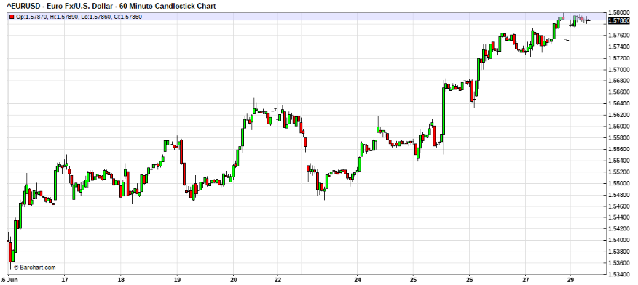
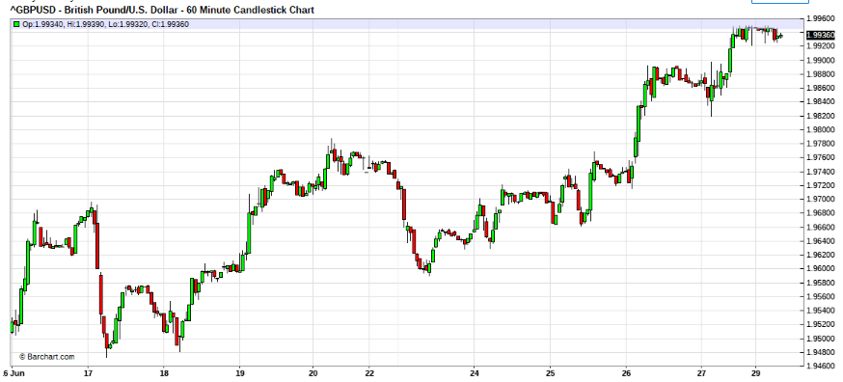
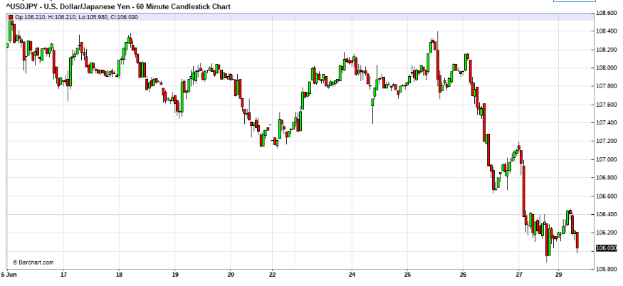

15 mins: June 23
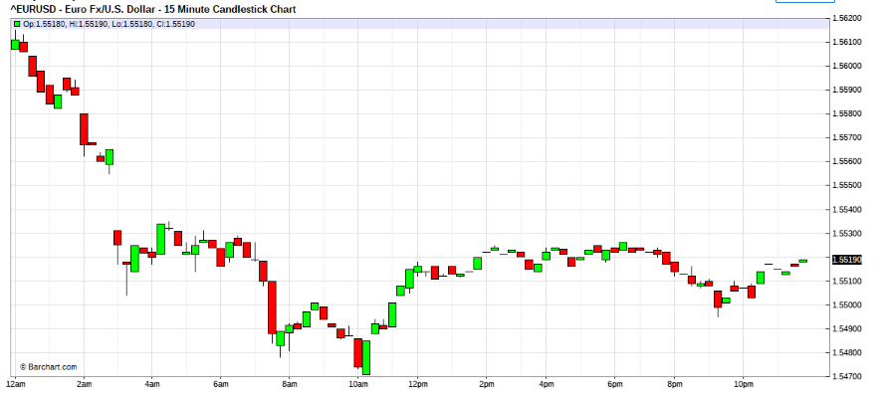
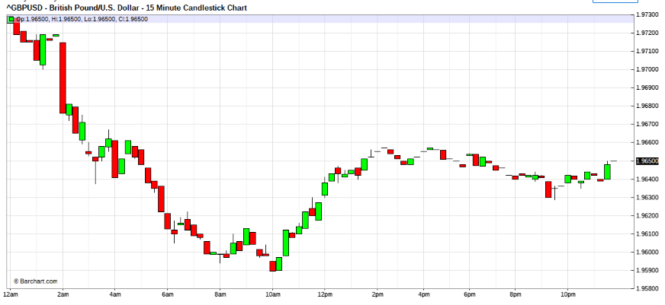
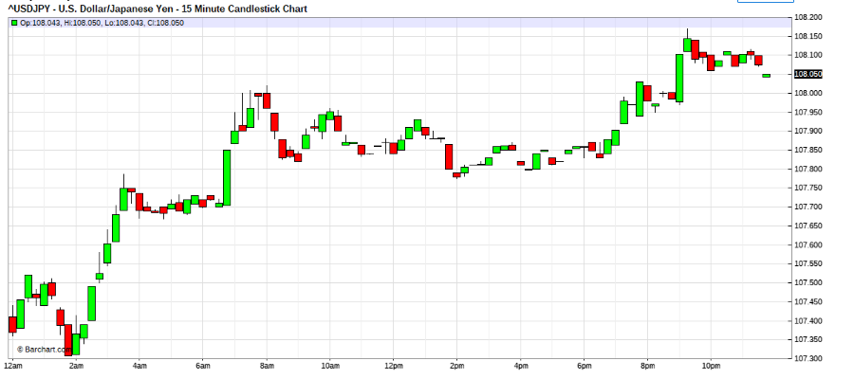

Jun 23, 2008 3:28am
J FYI, trading strong USD intraday, wave 1 now complete, waiting for retrace and wave 2 attack posibilities. note trading against day trend, which has topped against eur.So read just the skew, please.
Sharks, miised attack by a nose, while typing this, so letting go, reassesing wave impulse and taking profits (short sword positions)now.Just life, was listening to buble's "save the last dance" and she snooked me,LOL.
THE usd/yen seem vv strong, so any weakness in USD intraday suggest more usd strength ahead. Although trading against trend, it seems to be the logical side to take now, only safeguard is to skew-in on the exposure incase the trend bites suddenly. Donno where the usd strength is comin from , may be profit squaring at critical tech levels. (eur/usd and cable)
watching for bus now. Wonder what's that Leighsww doing?
OK here goes again, adding on to sell eur as usd/yen finale on the sweeps. Thsi Eur support seems chart critical, wonder what hides under it? Whats london boys menu for lunch? Ben turkey or opec soup?lol

Jun 23, 2008 5:39am
Now , guts and glory, no guts no glory.
attack launched. Euro comes. ("comes" means I'm on top)
Now launching level 2 attack sequence. Lets see whats underneath.
Note that position spiral has gone normal from cautious skew.

Jun 23, 2008 6:21am
Quoting jest1081
Hello fti. Im not sure what you really meant. Does this translate into...
eurusd - short
usdjpy – long ?
Hi jest shorted Eur/usd. 1.5534-2 mio, 1.5530-1 mio, 1.5525- 1 mio
Usd yen just to help in timing of initial attack, no exposures there.
Just for info, It is very hard to lead, just showing my blotter as best I can. Be aware , this is high risk maneuver as trading against day trend. Although I have good profits already this morning before london came in. This is the problem, you will only see my blotter in lag time. What I am attemping to do is to show some mindset thoughts so that you may get a "feel".
This is to give you a mindset, of thought process, when attempting reversal possibilities when trading against trend.
As of now posittion @25 is prompting rescue.
Also note that cable has lead and Eur is lagging it, directional wise.
Hi auxesis,
Actually I would be trading into the 2nd wave downwards on the Euro, but due to my bad timing (not attentiveness due to chatting), I am positioning late. And from the form of the legs spreading out in the hourly Eur charts, I sort of expect the big moves , tom.
However i felt that, I 'll just give you guys a head, while this is forming, on how to develop that "feel for the dance" as I felt the opporyunity to do so.
I fact we should be sliding into the 00 levels, but as traders we have to deal with the now, so its a head on managing the positions.
As the thread is getting slow. I though tis would be a good chance to do some market exercises on thoughts actions and expectations( esp on how not to think like fortune tellers).
By the way, I am squared at 15
The USD moved as expected, testing the USD strength.
Seems that, when the mkt sweeped the bull USD, there was no initiative to follow through. So generally I think the storm orders are not in the markets yet.
However, since this is first test, more could be expected in this congestion .
There is now no impulses to follow, I would be inclined to skip this range trading and call it a night to conserve energy for tom's tokyo testing. However those wishing to scalp the range , may just carry on.
Yeah , you are right , about the commandments, Like lI said, don't get rigid.
Be a nimble and wise trader, think, strategise and act, then correct your positioning by proper MM as the market unfolds.
Mostly be kind to yourself and the markets, be generous and kind, never want too much.
You are one trader that I do not believe need too much hand holding. You seem to think well on your feets, so running battles won't be too much of a chore for you. Just guard that you do not deviate too far from basics. Thinkers have that tendency, so if things don't work, GO BACK TO BASICS.
and mind you going basics is not easy for adulterated minds. So hold the basics close to your heart.
The 3kingdom relationship can only be observed, and cannot be penned. It is because the relationship changes through different stages of its cross-intercourse and can move away from the norm. It is this observations of abnormalities that gives clues to the status. However one thing is that when they move in sync then that is the "BIG,MAJOR,SUPER" trend, so don't get caught trading against that

Auxesis:
This looks bullish to me as the top is horizontal, and the base is rising, with several knocks on the top. Rising diagonal would be a different story.
Unless you felt a squeeze
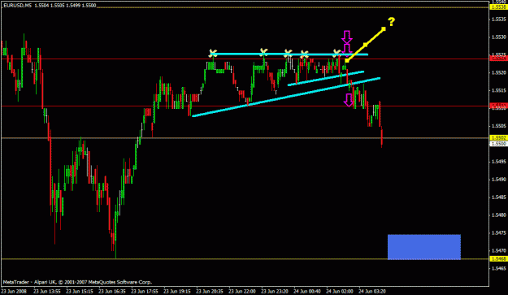

FTI:
Quoting btr5596
The only reason I can see from the chart, regarding the EUR short is...
The second X marks the high of the upward move. The following three highs, marked by x's, were unable to surpass this mark, signaling the end of the distribution phase. At the point the short was entered was a lower high, possibly signaling the start of the run down/thrust downward. Could be way off though, just my 2 cents.
I have a feeling you have not read much of the thread, however your frame of mind is in sync. amazing.

15 Mins – 24 Jun 2008
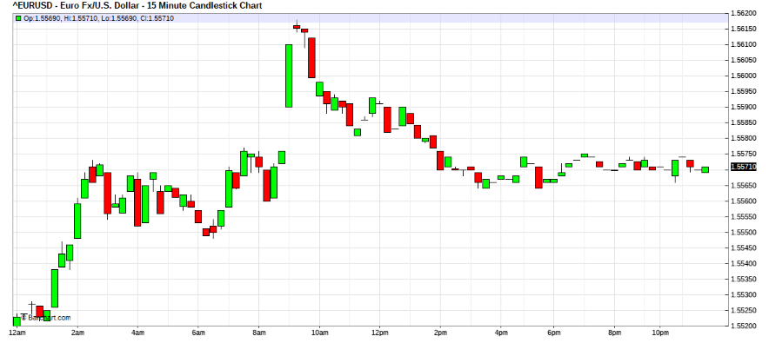
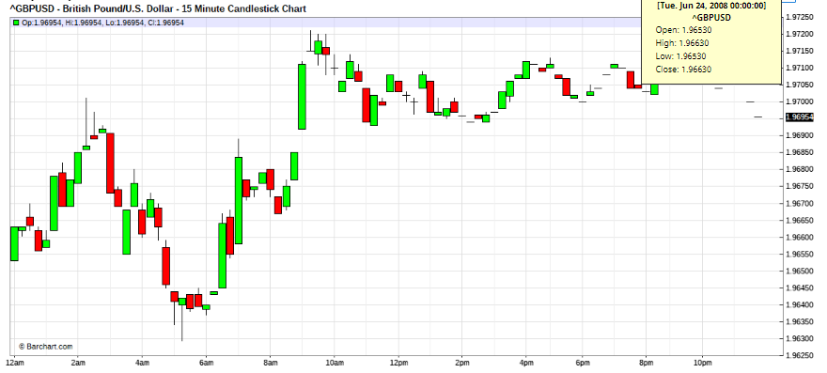
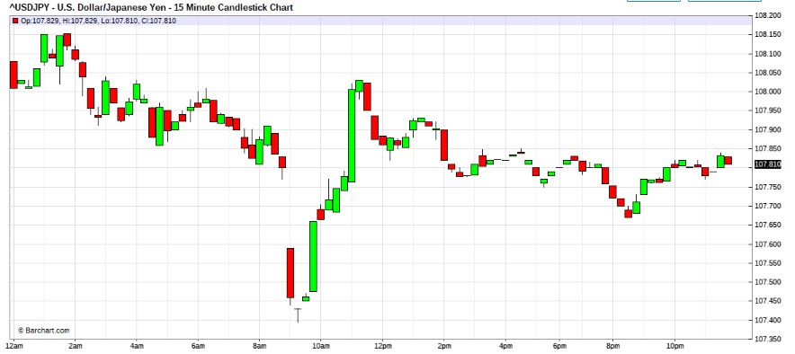
Jun 24, 2008 5:13am
USD bull impulse in progress,
See hoe fast the picture changes.when manipulation is on the menu.
Be nimble.
This is the reason why its very difficult to handshold unless all are in full speechless com and in full sync of MO.
Quoting fti
Hi ALL,
If it was not clear to anyone, let me explain that I had to cut loose the session, as I was managing positions, and with my trying to lead the feel for some traders on the thread as well. When I couldn't feel and felt blinded by the discussion, I had little choice but to cut loose for the reasons that it has financial impact for me. I had to re-orientate my feel. Moreover a blinded trader can hardly lead in terms of the feel aspect of the market 's pulse. Cutting loose was my only option.
An Analysis in Restrospects. on the subject I mentioned highlighted in red.
I noticed that many here harbors the ideals that analysis must be indepth and MUST be correct. Much as I would like this to be par excellence, it is difficult, if not impossible to be correct all the time. Thats the reason why contingency rescues are necessary. And when we are correct to implimentation of prudent pressing of the trend ride.
As to the analysis given by some who analysed the morning session. It was obvious , of the bottommishness of the USD then, but to spend too much effort to determine the analysisi which was already on going and non-attentiveness to strategic positioning and elbowing for prime positioning and costing, seems to elude the trade mindset. This was what blinded me. My mind was distracted to the historical significance, of decisions already implimented into the market place. But really, it was my fault that I had asked the questions "why?" along side my blotter postioning.
In fact I was prompting mindset to answer that it was scout, then scout 1, further that attack was planned, of which I could not execute, due to upcoming price patterns. But when discussion was directed as to what prompted the trade, then my thoughts reverted to pre-action frame of mind, and this interfered with my thoughts which was trying to feel forward and to position and strategise forward.
For me there is a lesson here, in that I had not appreciated that traders may have tendency to revisit their past decisions, which may interfere with their capacity and ability to move on.
I had never felt this delima until this session, when I had difficulty to relate that analysis against what was unfolding in the markets, because to think of the rational of the entered position disorientated me from my strategic capacity.
If some of you may like to think about this, you may discover the reasons why, some are unable to "flow with the dance". This is because to flow on wards the point of reference is no longer the historical mindframe but the immediate past, and the present quickly becomes, immediate past, and the previous point of reference must be released that the new point of reference should be the point of contention.
For strategic repositioning, the only point of reference, is the consolidated exposure and will always be in a singular directional play, so there is no consideration for the other perspective, unless this accumulated position find itself in trouble. If this was true then repositioning is required.
This getting abit too complicated to explain. In simple language, I Think some traders may be thinking from too many perspectives that they are paralysed from prudent action and reaction to market flow.
(too much analysis, not enough strategic following).
( too much comfirmation required before action or corrective action.)
( too much intelligence, lack of confidence)
This could be reasons why some cannot dance.
When this was my frame of mind this morning session, I COULDN'T DANCE!!.
Which was the reason I cut loose the session abruptly.
As I reset my thoughts from booked exposure, The rhythm returned.
Making any sense?

