My Day Trading System (MDTS) is a Trend Following

I) Identify the trend
A) Up Trend: 5/10 crosses up and confirmed by RSI > 50 (BLUE) and Stochastic cross up (BLUE)
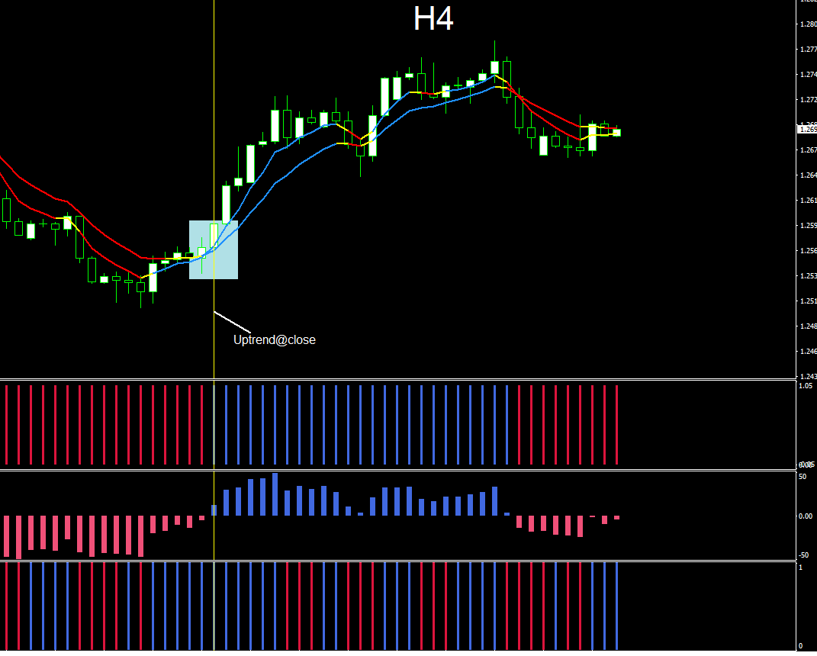

II_UT) Waiting for a pullback
M30:
For an uptrend:
1) Price must touch the 5 EMA (H1) of the low and confirmed by;
2) CCI (M30) closes below -100;
Then go to M5

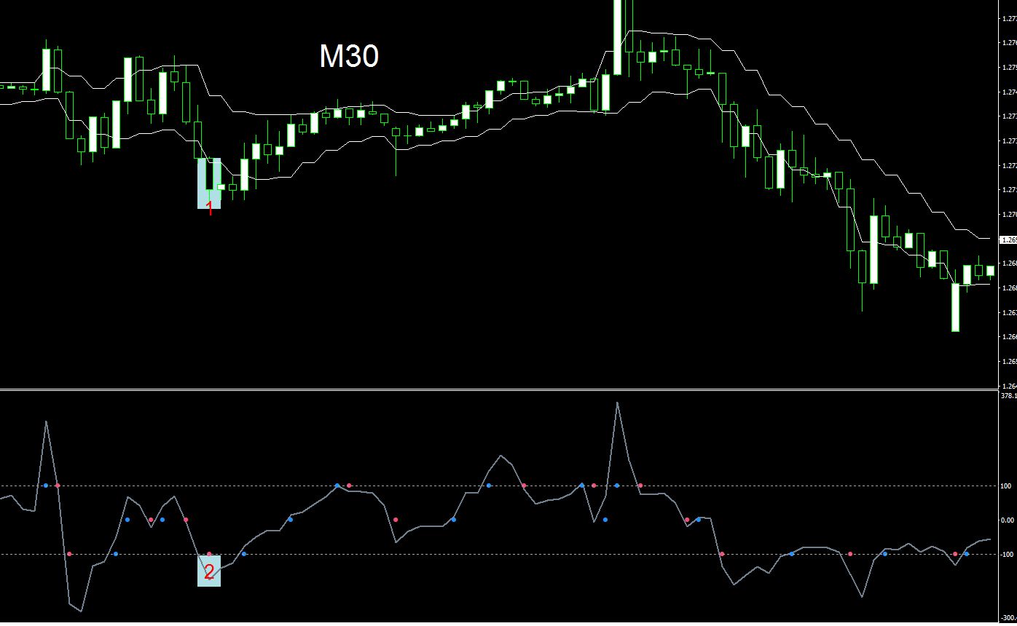

III_UT) Enter a trade
M5:
1) 5/10 crosses up and confirmed by
2) RSI (H4) is above 50;
3) RSI (Blue) is above 50;
4) Stochastic (Blue) crosses up;
5) Awesome is below the zero then paints Blue (Very important, if we want to enter a trade when the momentum starts to increase)
Buy = 1) + 2) + 3) +4) + 5)

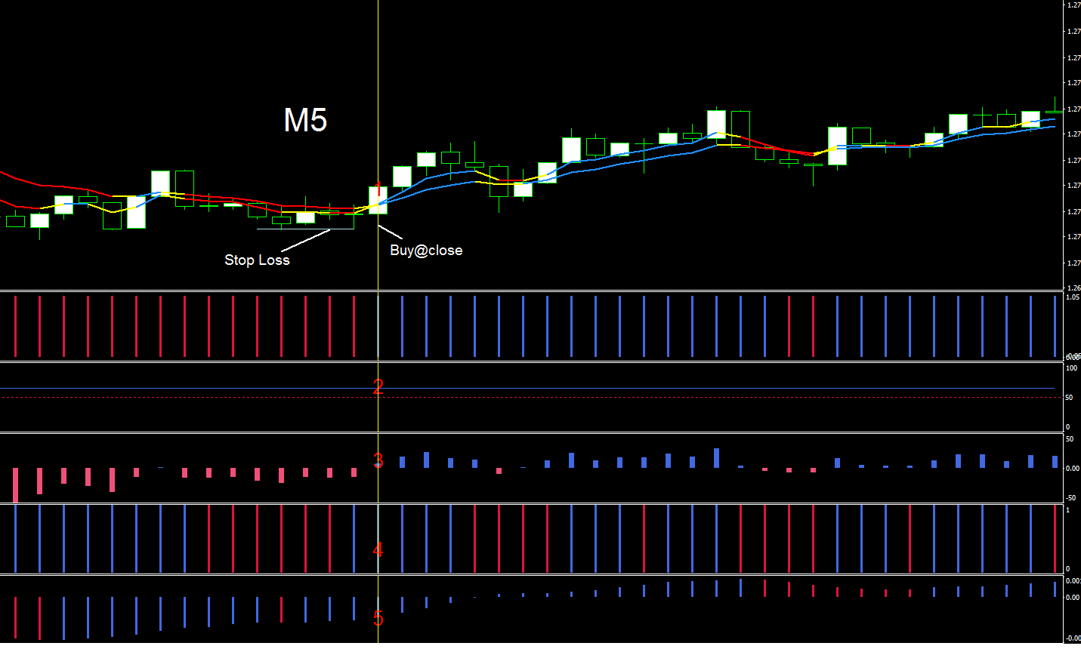
a) Stop Loss is placed at the most recent low.
b) Take Profit is the same amount of stop loss or up to you.

B) Down Trend: 5/10 crosses down and confirmed by RSI < 50 (RED) and Stochastic cross down (RED)
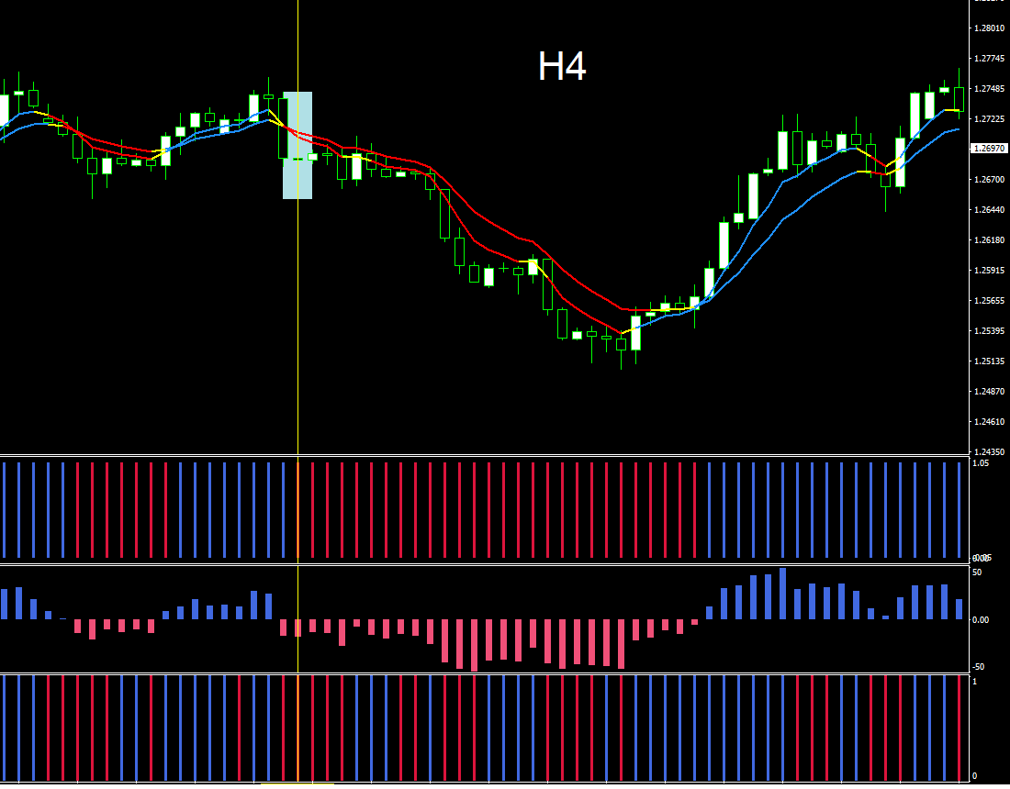

II_DT) Waiting for a pullback
M30:
For a downtrend:
1) Price must touch the 5 EMA (H1) of the high and confirmed by;
2) CCI (M30) closes above 100;
Then go to M5
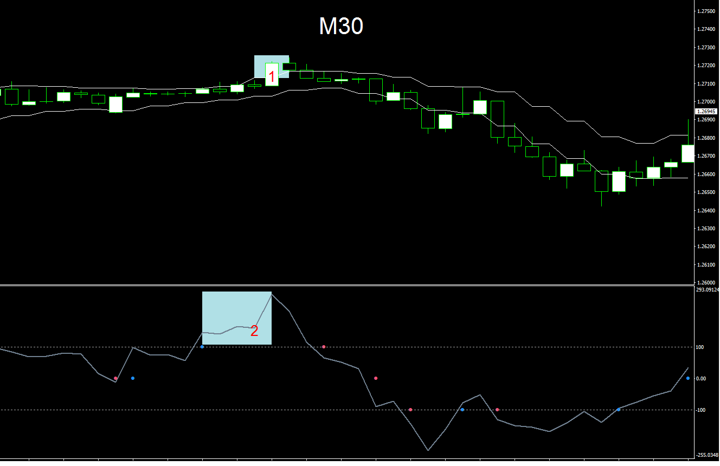

III_DT) Enter a trade
M5:
1) 5/10 crosses down and confirmed by
2) RSI (H4) is below 50;
3) RSI (Red) is below 50;
4) Stochastic (Red) crosses down;
5) Awesome is above the zero then paints Red (Very important, if we want to enter a trade when the momentum starts to decrease)
Buy = 1) + 2) + 3) +4) + 5)
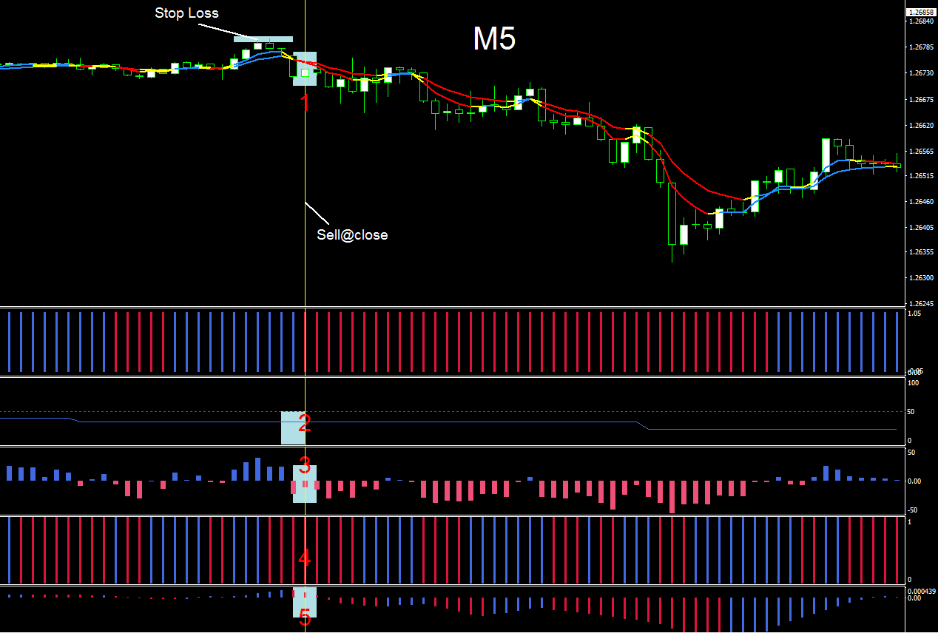
a) Stop Loss is placed at the most recent high.
b) Take Profit is the same amount of stop loss or up to you.

