My Day Trading System (MDTS) is a Trend Following
I) Determining the trend
Up Trend: 5/10 cross up and confirmed by RSI > 50 (BLUE) and Stochastic cross up (BLUE)
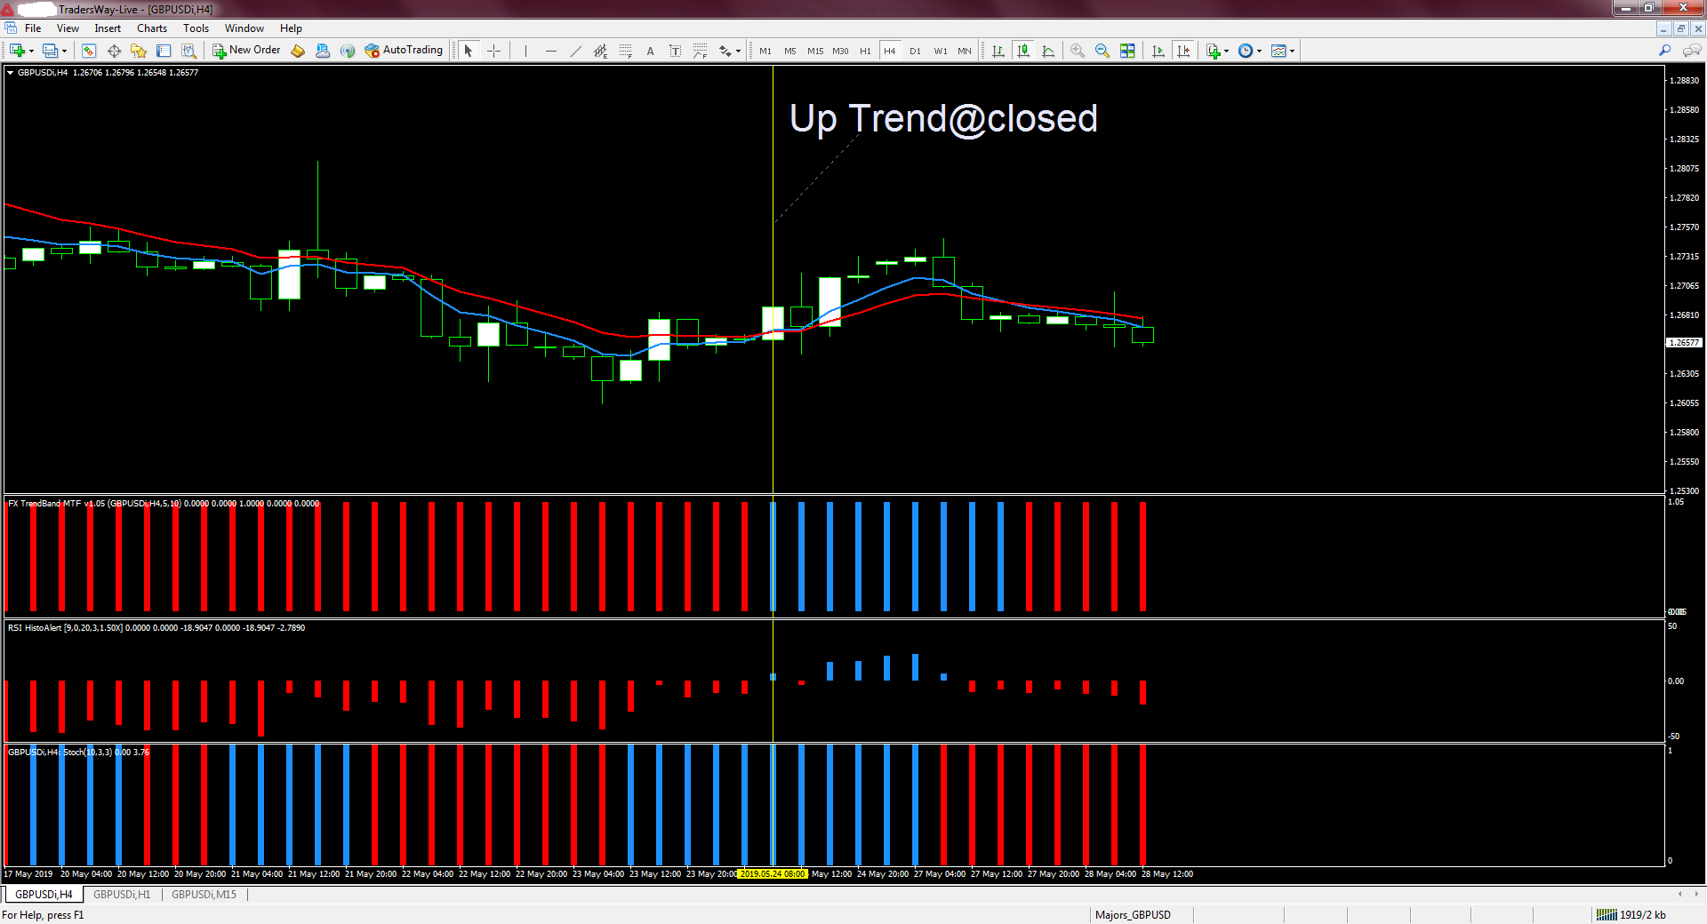

Down Trend: 5/10 cross down and confirmed by RSI < 50 (RED) and Stochastic cross down (RED)
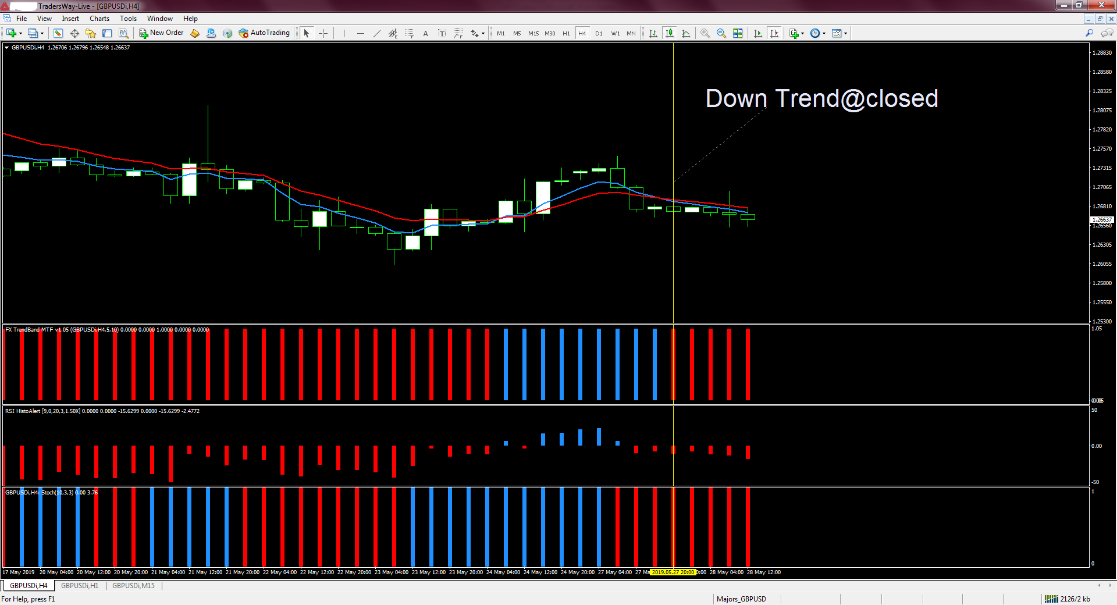
II_UT) Aligning (Trend H4 and H1)
For an uptrend:
H4 (5/10 cross up) and H1 (QQE>50)
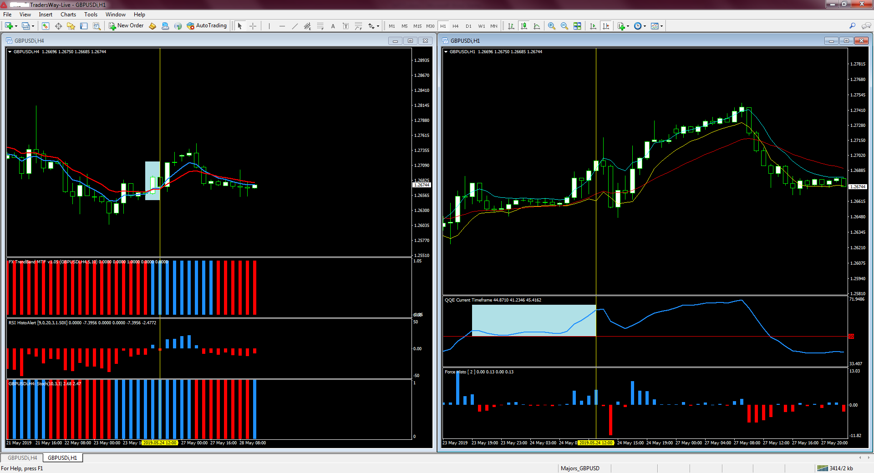

III_UT) Waiting for a pull back and Macd histogram goes below zero line entering a trade with conditions.
M15:
For an up trend:
1) Price must touching the 5 EMA (H1) of the low and Macd histogram (M15) goes below zero line; (Retracement) very important;
2) Force Index (H1) bar (Blue) is above zero;
3) Macd bar (M15,Blue) is above zero and stochastic cross up (BLUE).
Buy = 1) + 2) + 3)
Additional information:
If the entry signal occurs at a time when the price is above the 20 period ЕМА (H1) of the Closes, this indicates a much stronger trade.
a) Stop Loss is placed below the previous cycle low or 20 pips but 20 pip min.
b) Take Profit is your discretionary.
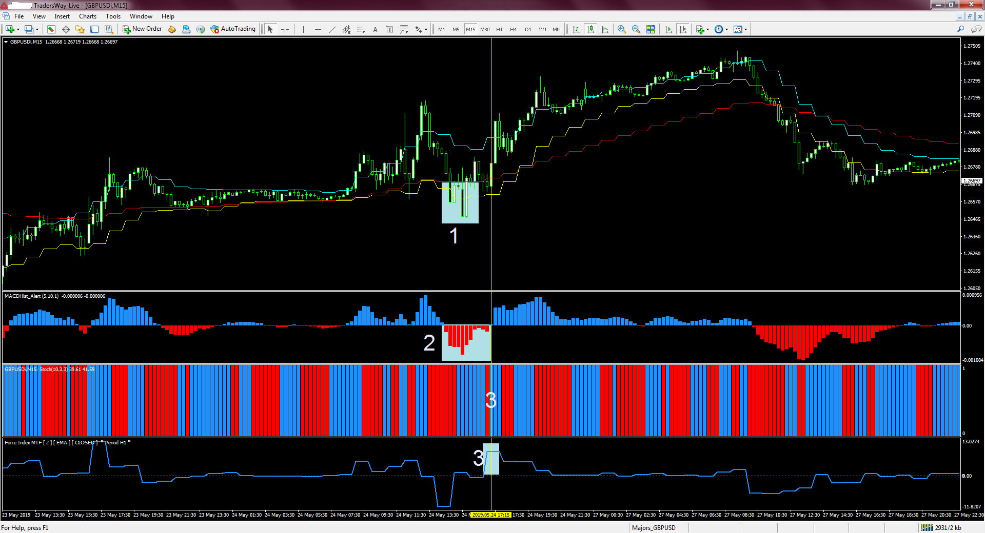
II_DT) Aligning (Trend H4 and H1)
For a down trend:
H4 (5/10 cross down) and H1 (QQE<50)
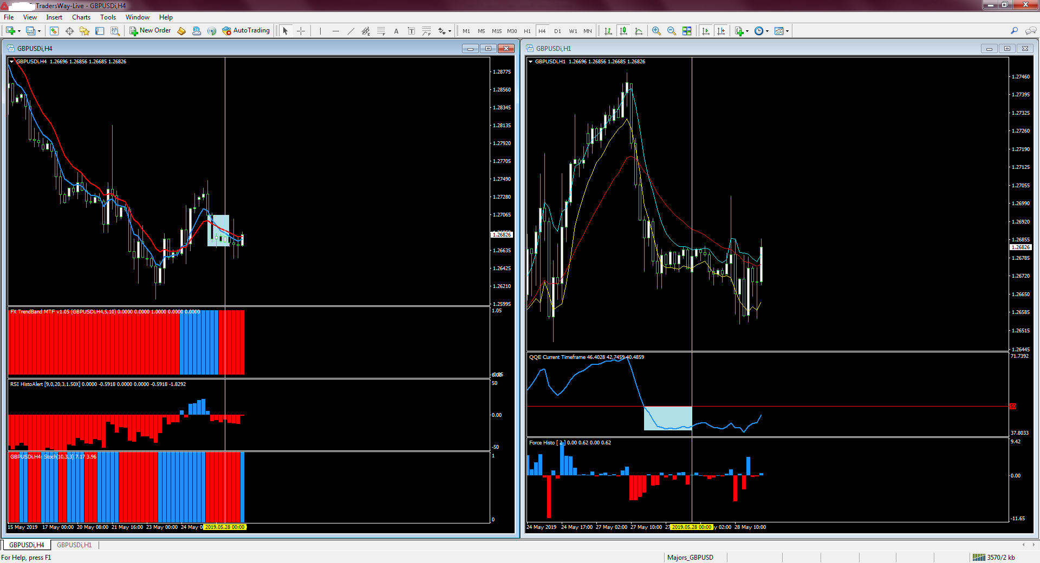

III_DT) Waiting for a pull back and Macd histogram goes above zero line entering a trade with conditions.
M15:
1) Price must touching the 5 EMA (H1) of the high and Macd histogram (M15) goes above zero line; (Retracement) very important;
2) Force Index (H1) bar (Red) is below zero;
3) Macd bar (M15,RED) is above zero and stochastic cross down (RED).
Sell = 1) + 2) + 3)

Additional information:
If the entry signal occurs at a time when the price is below the 20 period ЕМА (H1) of the Closes, this indicates a much stronger trade.

a) Stop Loss is placed above the previous cycle high or 20 pips but 20 pip min.
b) Take Profit is your discretionary.
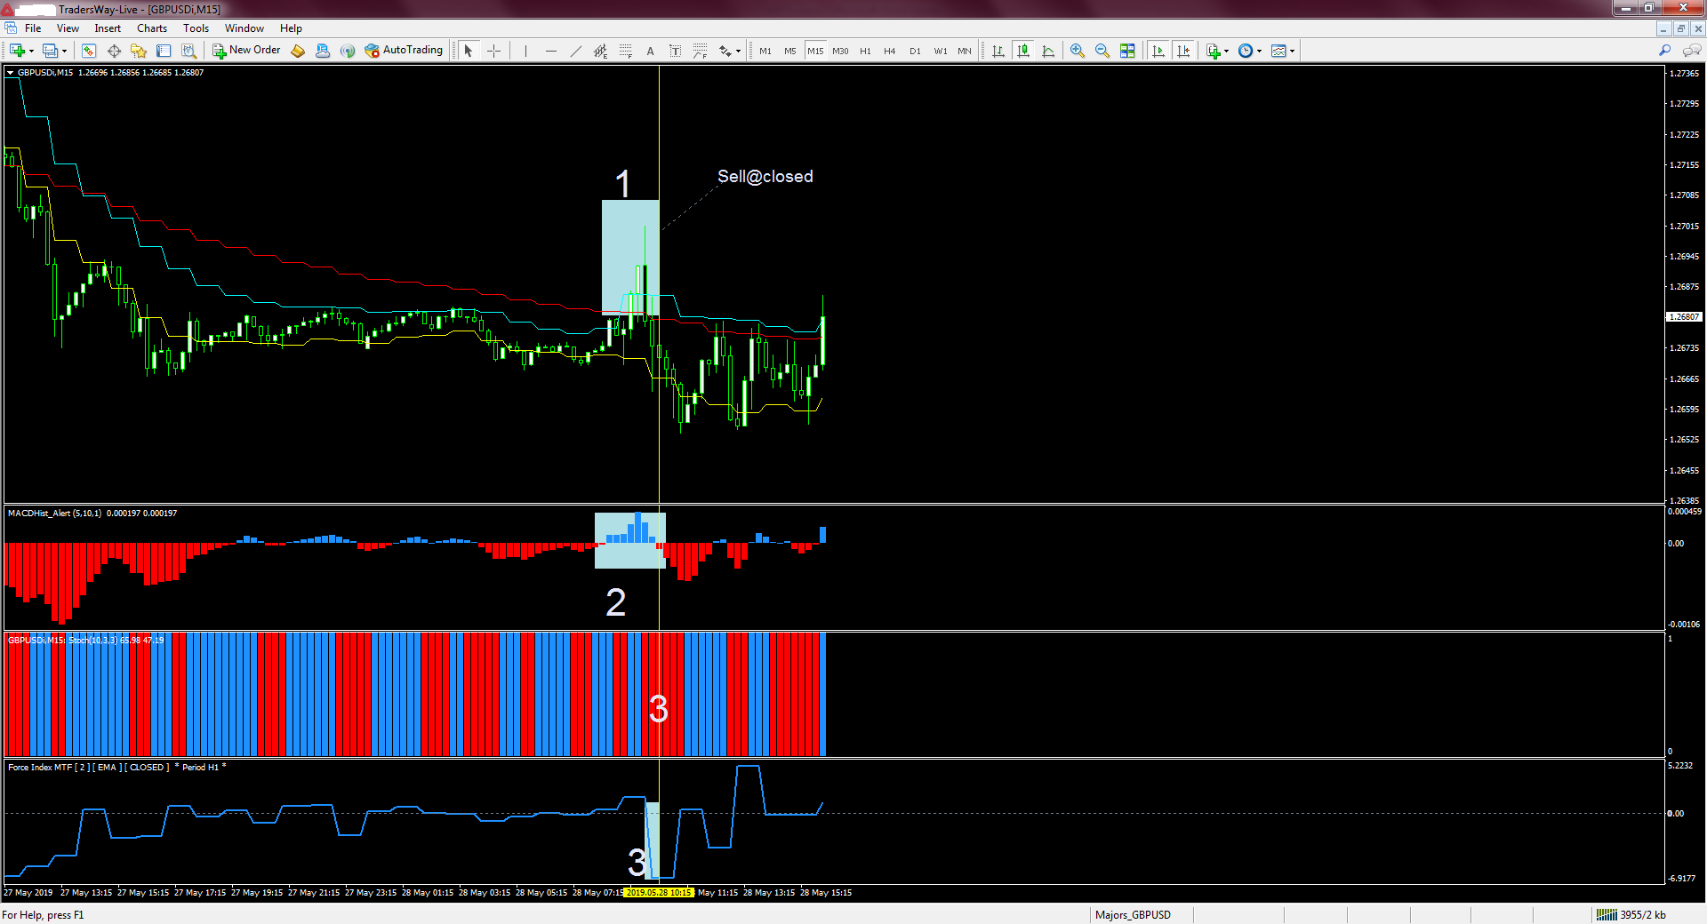

Good luck, guys

