My Day Trading System (MDTS) is a Trend Following
I) Determining the trend
H4: Set QQE (TF:1440 – Daily)
Up Trend: QQE cross up
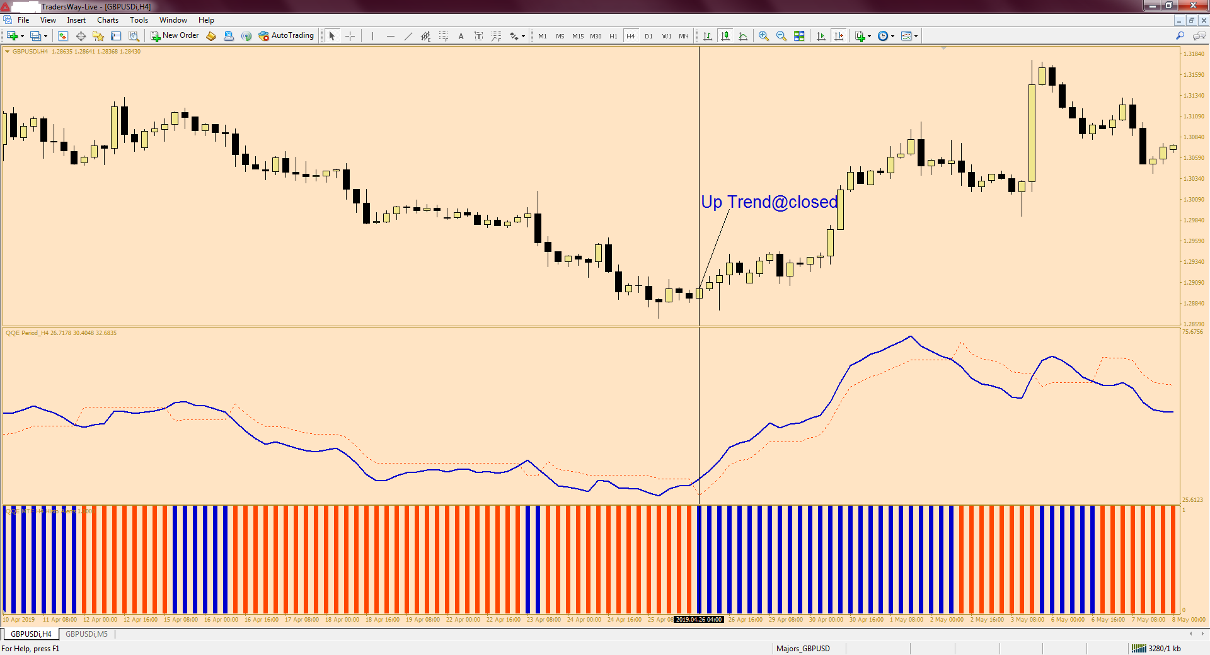
Down Trend: QQE cross down
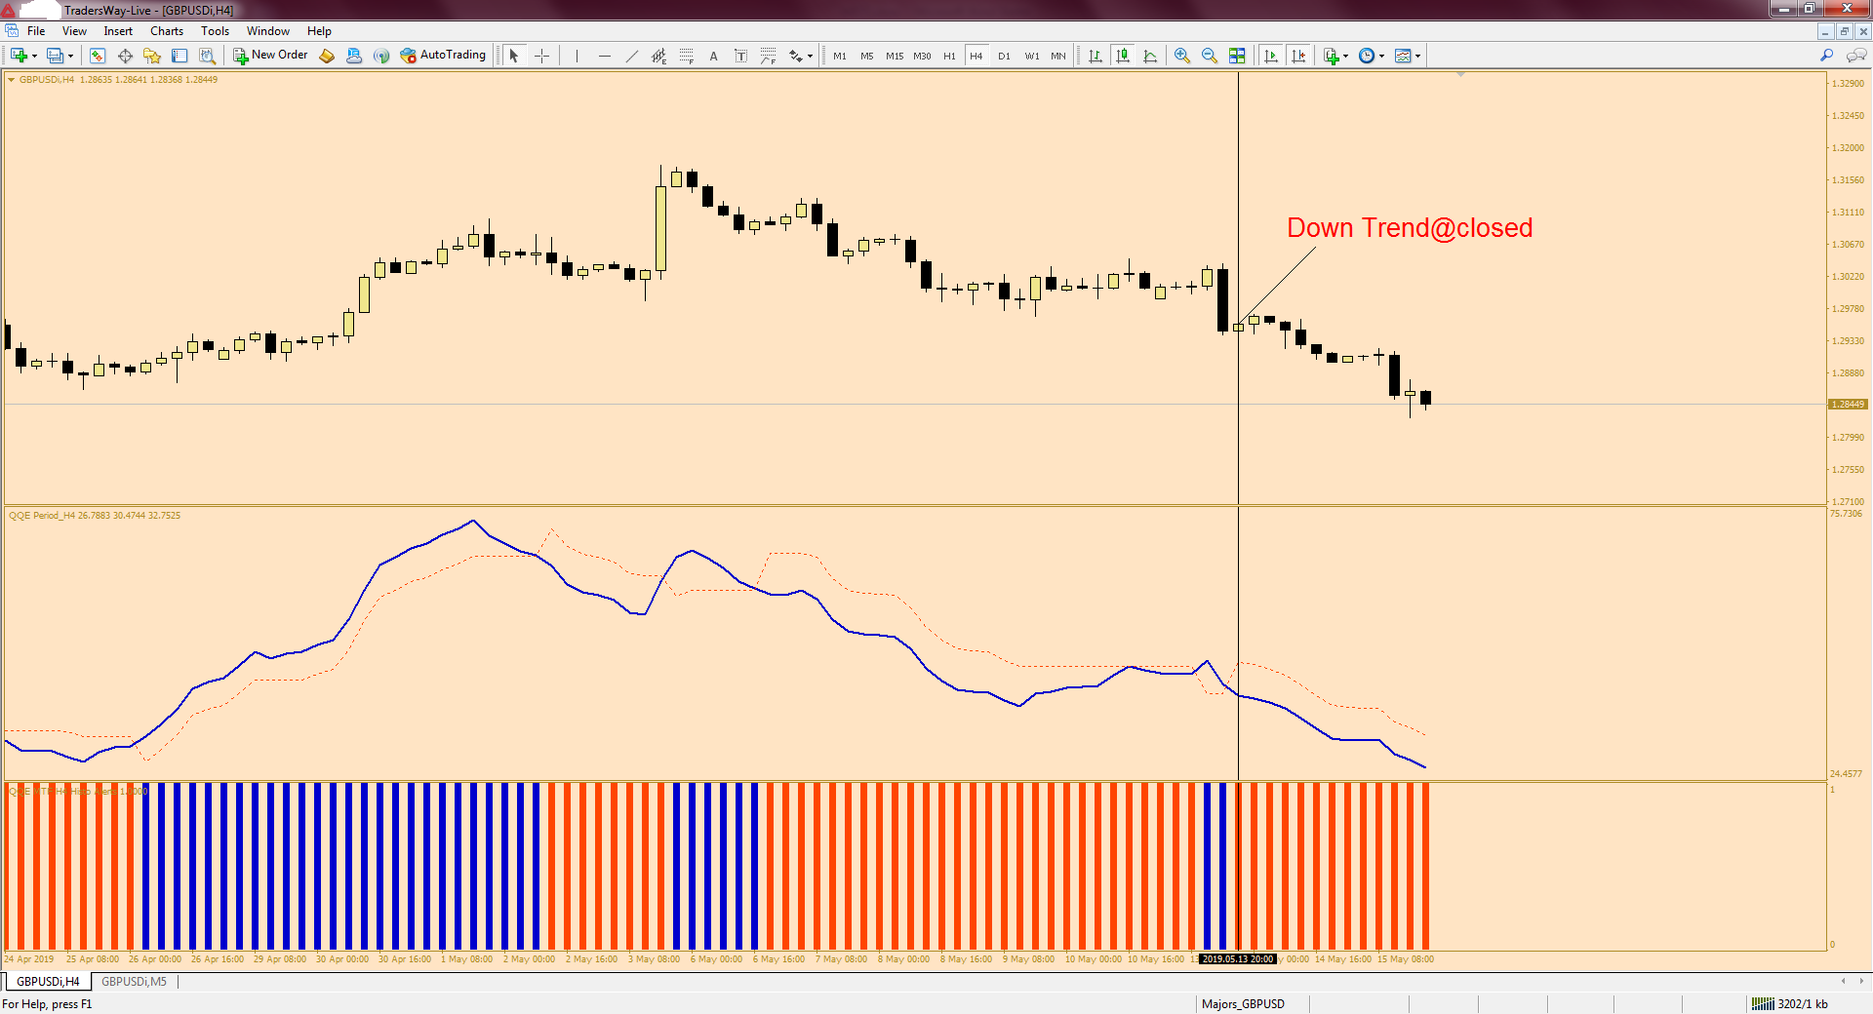
II_UT) Aligning QQEs (H4, TF=1440 and H1, TF=240 )
For an up trend:
QQE (H4) and QQE (H1) bar are Blue
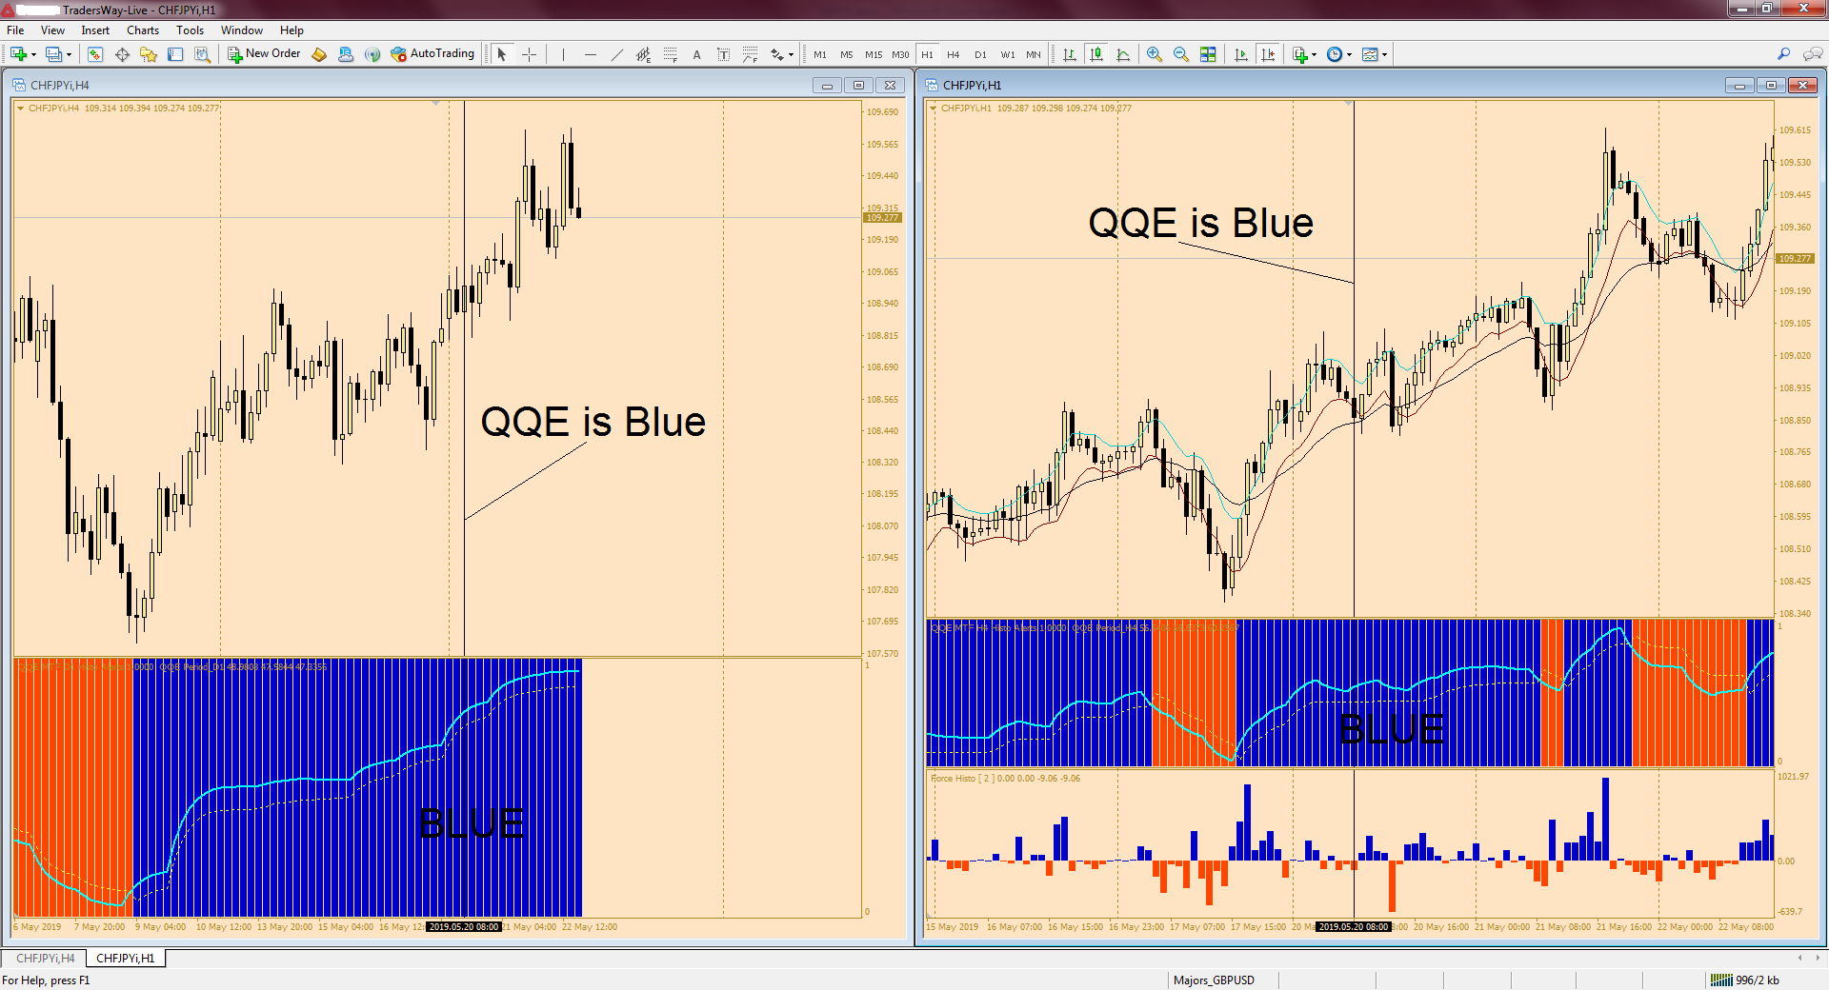

III_UT) Waiting for a pull back and entering a trade
M15 or M5:
For an up trend:
1) Price must touching the 5 EMA (H1) of the low;
2) Force Index (H1) bar (Blue) is above zero;
3) Macd bar (Blue) is above zero.
Buy = 1) + 2) + 3)

Additional information:
If the entry signal occurs at a time when the price is above the 20 period ЕМА (H1) of the Closes, this indicates a much stronger trade.
a) Stop Loss is placed below the previous cycle low or 20 pips but 20 pip min.
b) Take Profit is your discretionary.
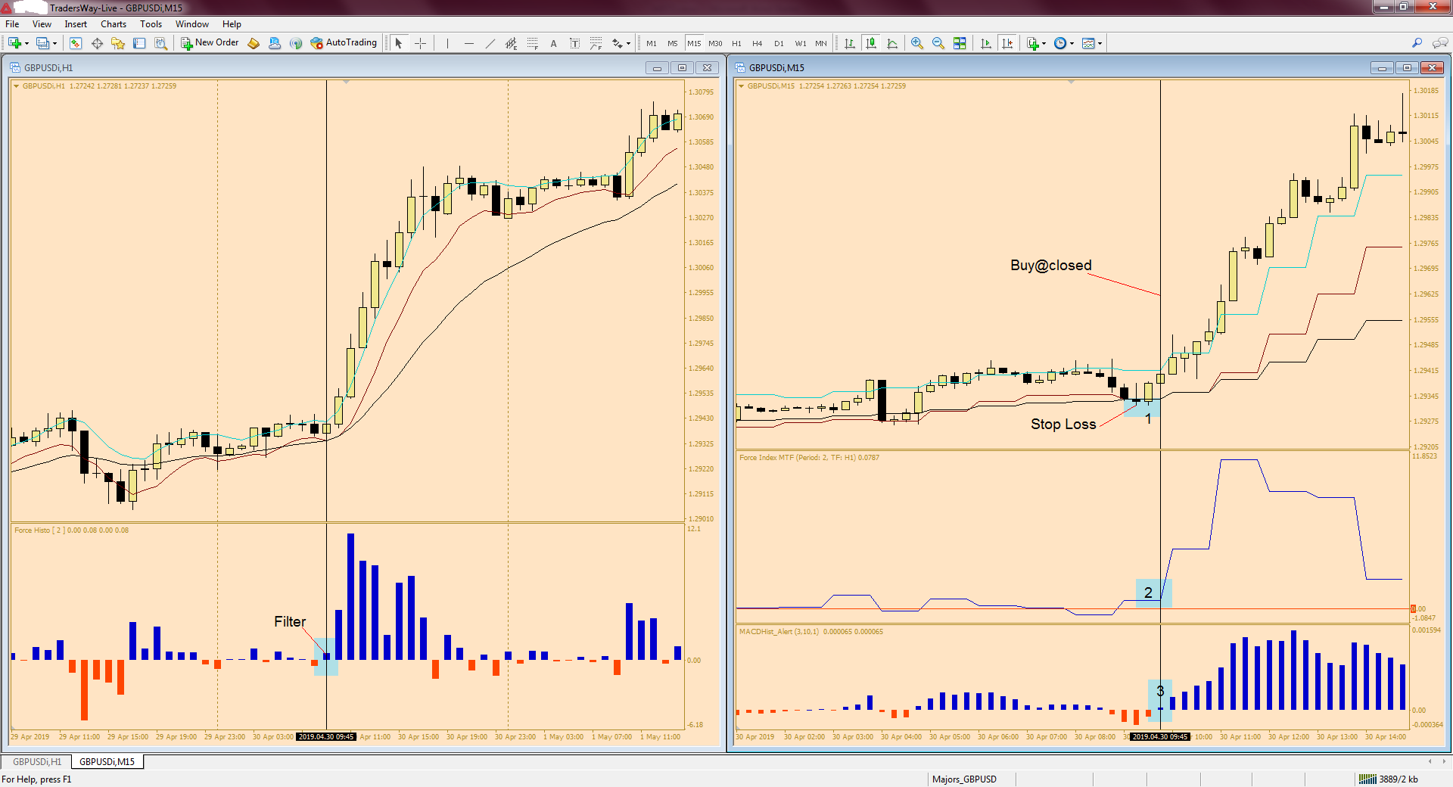

II_DT) Aligning QQEs (H4, TF=1440 and H1, TF=240 )
For a down trend:
QQE (H4) and QQE (H1) bar are Red
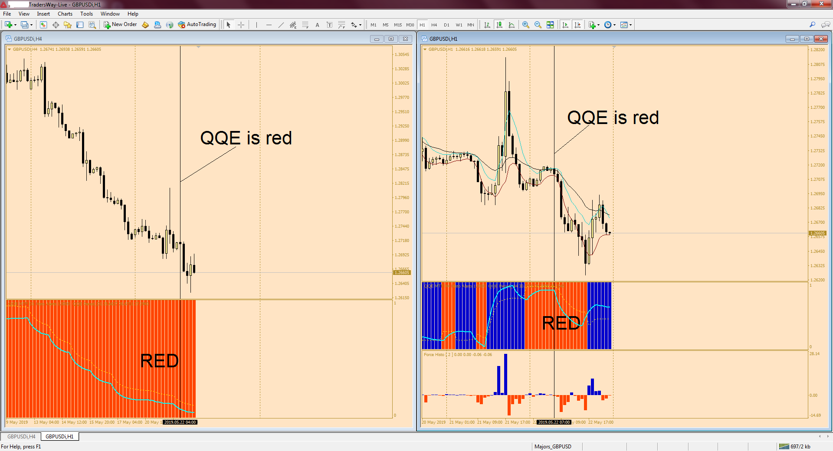

III_DT) Waiting for a pull back and entering a trade
M15 or M5:
1) Price must touching the 5 EMA (H1) of the high;
2) Force Index (H1) bar (Red) is below zero;
3) Macd bar (Red) is below zero.
Sell = 1) + 2) + 3)
Additional information:
If the entry signal occurs at a time when the price is below the 20 period ЕМА (H1) of the Closes, this indicates a much stronger trade.

a) Stop Loss is placed above the previous cycle high or 20 pips but 20 pip min.
b) Take Profit is your discretionary.
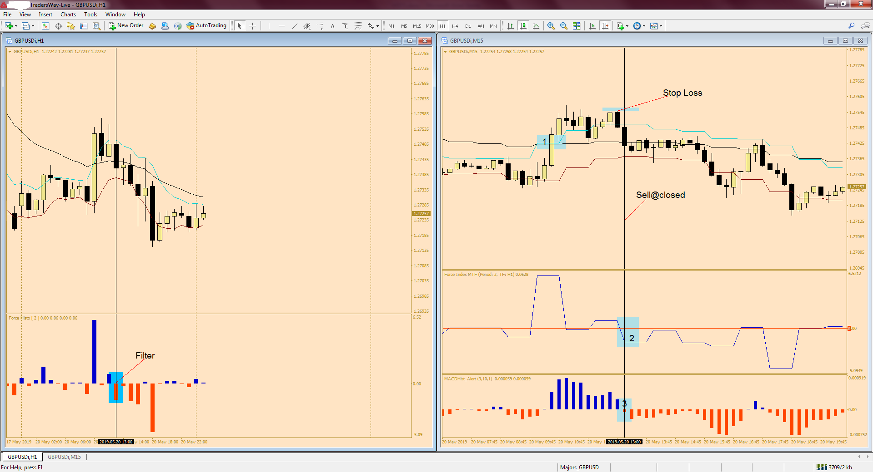

Note: Because we use QQE parameter of next higher time frame we will see, sometime, the QQE of the current time frame repaints. But this is not the issue. We have to be very patient.

Good luck, guys

