My Day Trading System (MDTS) is a Trend Following
I) Determining the trend
H4:
Up Trend: QQE cross up
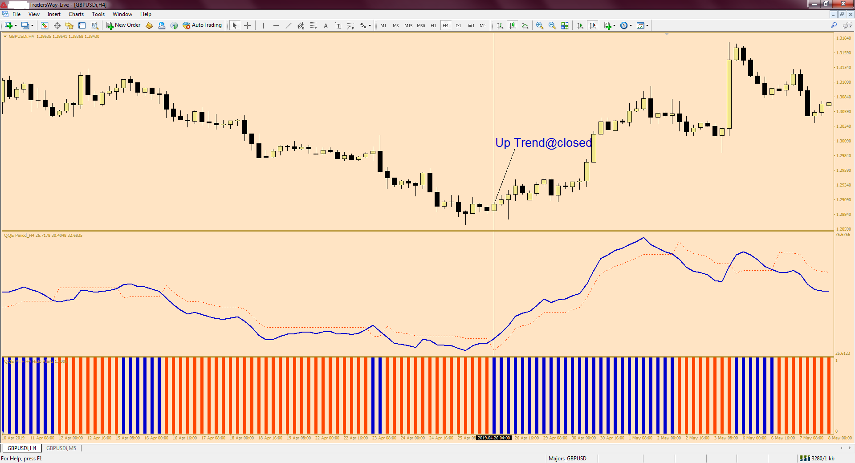
Down Trend: QQE cross down
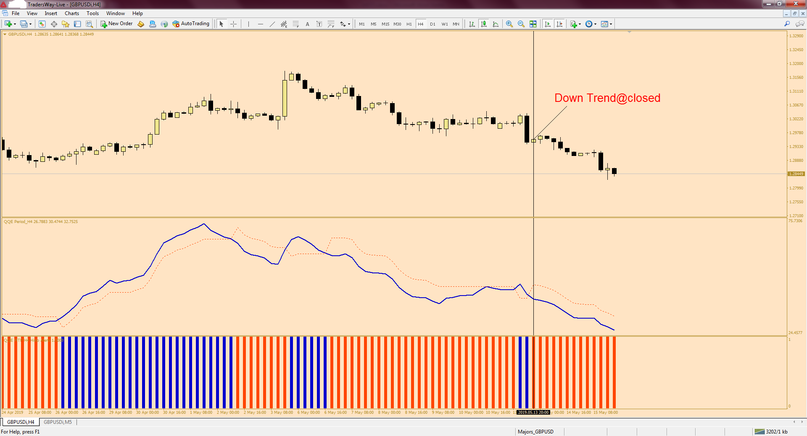

II) Waiting for a pull back and entering a trade
M5:
For an up trend:
1) Price must touching the 5 EMA (H1) of the low;
2) CCI is below -100 level;
3) 4 EMA (Close) cross above 5 EMA (Open);
4) Current bar of MACD must closing higher than the previous bar.
Buy = 1) + 2) + 3) + 4)
Additional information:
If the entry signal occurs at a time when the price is above the 20 period ЕМА (H1) of the Closes, this indicates a much stronger trade.
a) Stop Loss is placed below the previous cycle low or 20 pips but 20 pip min.
b) Take profit when CCI is above 100 level and the 4 EMA of the close cross below the 5 EMA of the open or your discretionary.
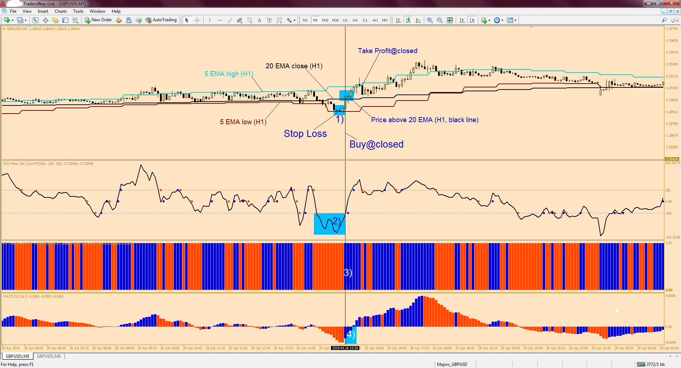

For a down trend:
1) Price must touching the 5 EMA (H1) of the high;
2) CCI is above 100 level;
3) 4 EMA (Close) cross below 5 EMA (Open);
4) Current bar of MACD must closing lower than the previous bar.
Sell = 1) + 2) + 3) + 4)
Additional information:
If the entry signal occurs at a time when the price is below the 20 period ЕМА (H1) of the Closes, this indicates a much stronger trade.

a) Stop Loss is placed above the previous cycle high or 20 pips but 20 pip min.
b) Take profit when CCI is below -100 level and the 4 EMA of the close cross above the 5 EMA of the open or your discretionary.


