Contrarian Bank Strength Testing
7-11 May 2018

Checking ScorpionFX recommendations against myFXbook as specified in “approach” doc, I checked pairs that qualified for a potential trade; 4 for this week.

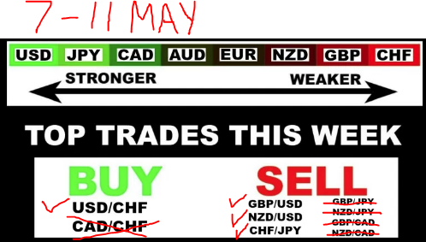

** If I had checked ScorpioFX on Sunday afternoon as prescribed, entered a trade on USD/CHF on the 30 minute chart late Sunday evening I would have netted ~ 60pips by 6AM Monday morning. 2nd image shows PA starting above WPP, passing thru R38 (R1) almost to R61 (R2); legitimate trade.
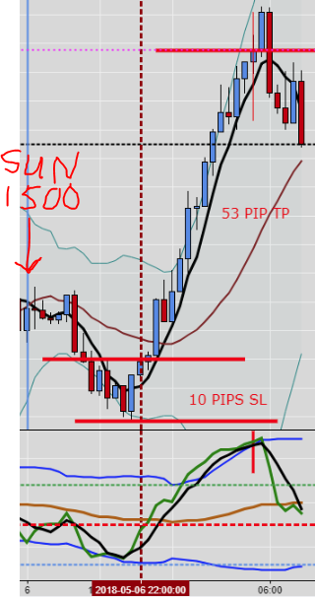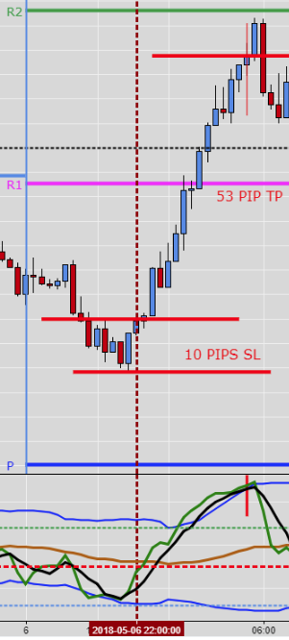
Checking GBP/USD using the same criteria, I find a trade @ ~ the same time Sunday evening & exit about the same time the next morning for a ~ 35 PIP gain. 2nd image shows PA between WPP & S38. Using Fib Pivot levels as entry/exit criteria in this case, I would probably NOT have taken this trade.

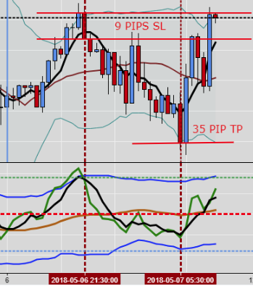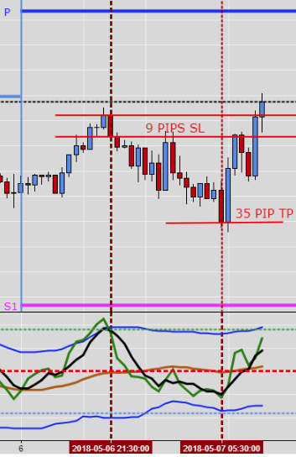

Let’s check the rest…NZD/USD for another 32 PIP gain. 2nd image shows PA Xing WPP but not to S38
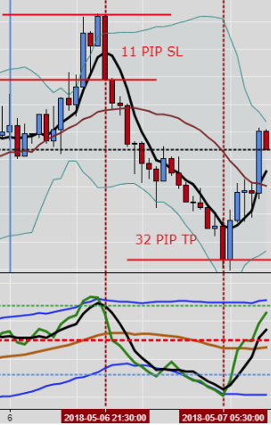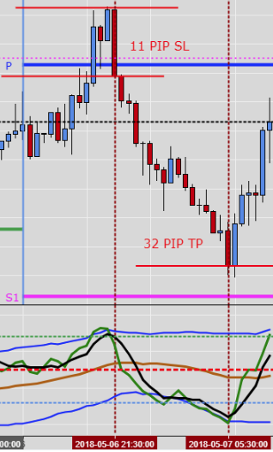
Last one for this week’s list is CHF/JPY….this one was a little more stressful as it had some drawdown and not quite as straightforward entry/exit. Blue colored lines are potentially where I might have been in a hurry to get in/out (aggressive). Red lines would’ve been the ideal (conservative). Maybe CHF is not such a good pair to trade. Still, a 30 PIP profit if I had placed the trade and gone to bed to leave it alone til morning. 2nd image you can see that PA has touched the S38 pivot level; another good confirmation.
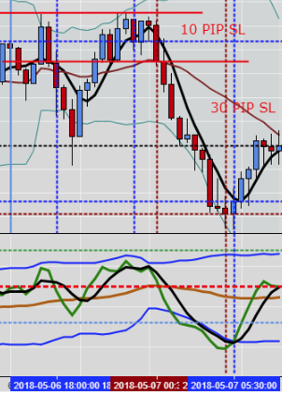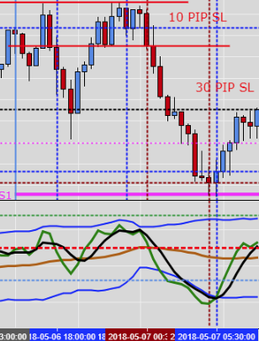

** I initially used BB’s + 5SMA + TDI to establish the timing for entry/exit on all of these trades.
** 2nd image is Fib Pivot levels.

