My Trend Following

H4: Determine the trend
Up trend:
5/10 EMAs cross up and confirmed by MACD is above the zero and Stochastic cross up.
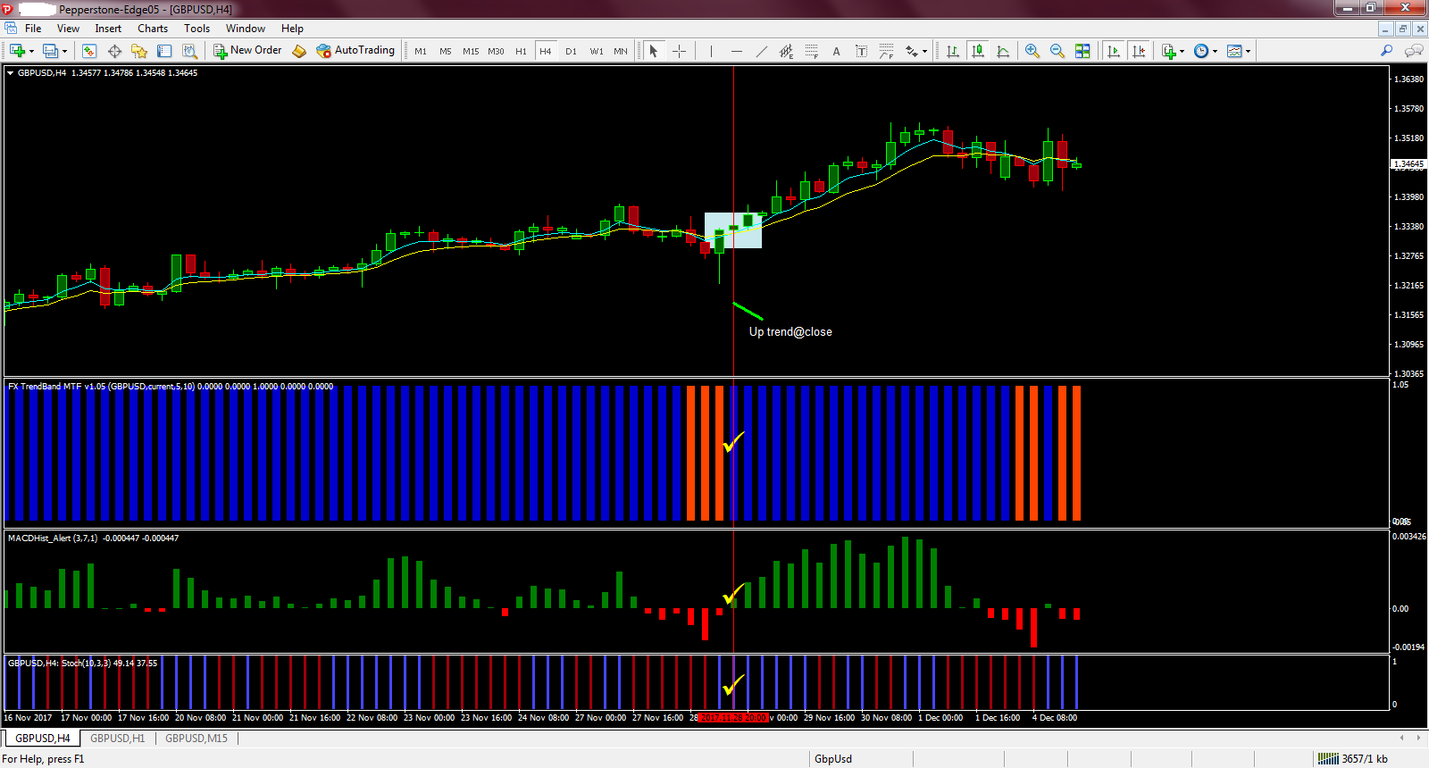

H1: Wait for the retracement
Up trend:
CCI must be below -100
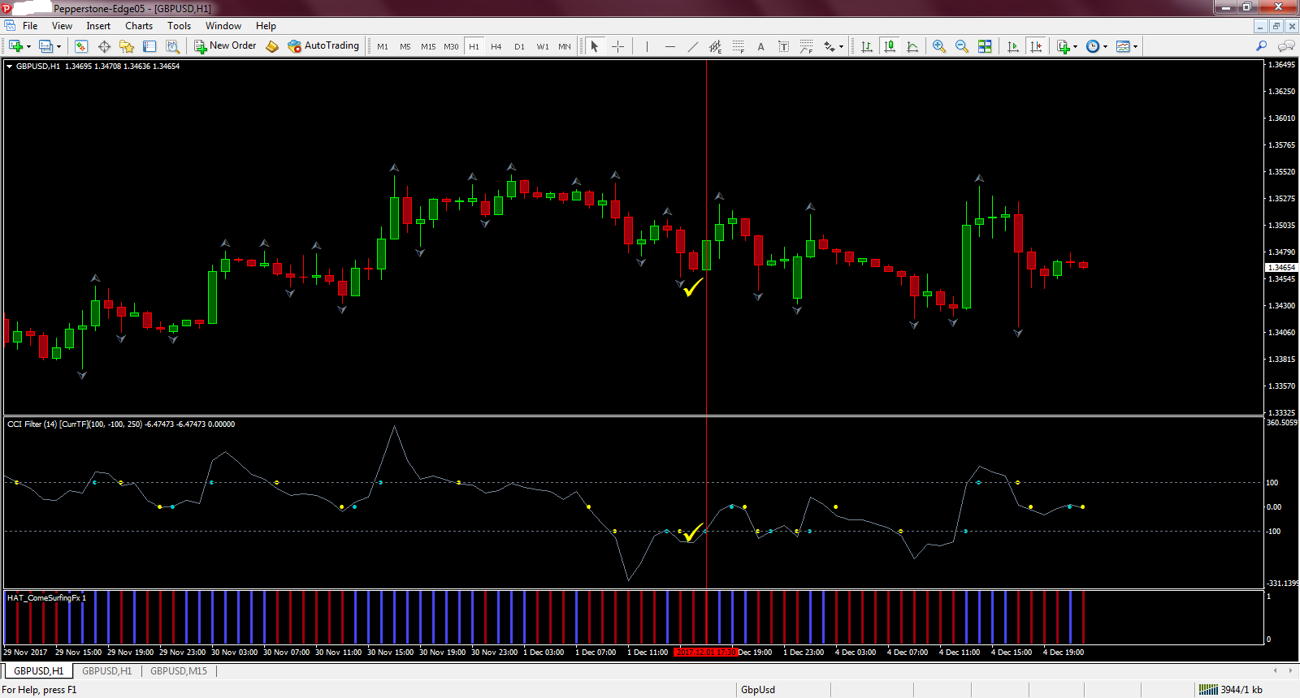

M15: Enter a trade
Up trend:
LONG when CCI is below -100, the slope changes to blue and is trending upward and confirmed by MACD histogram is above the zero + Stochastic cross up + Awesome is below the zero then increases its momentum.
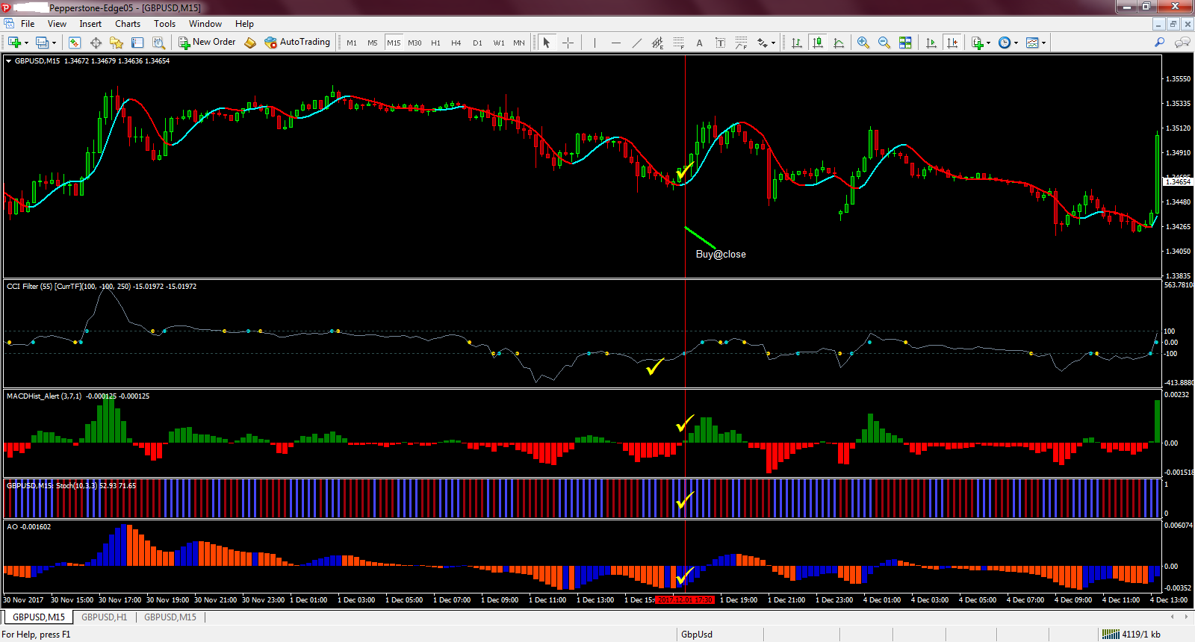

Stop Loss (SL) and Taking Profit (TP)
Up trend:
SL@ the most recent low and TP when the slope changes color.
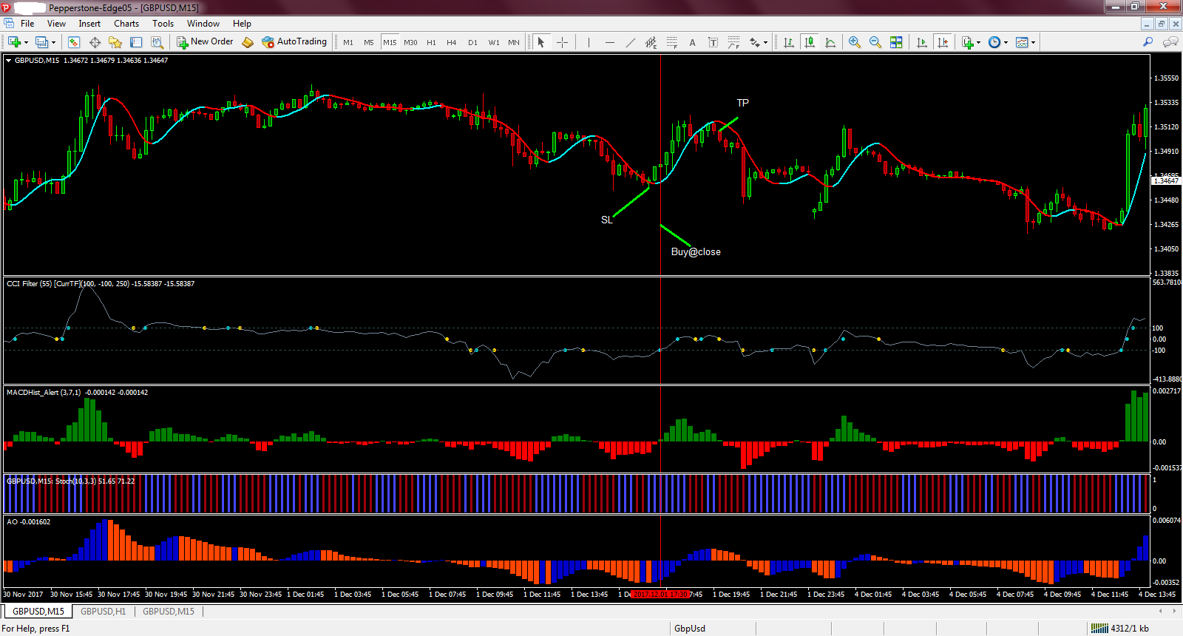

H4: Determine the trend
Down trend:
5/10 EMAs cross down and confirmed by MACD is below the zero and Stochastic cross down.
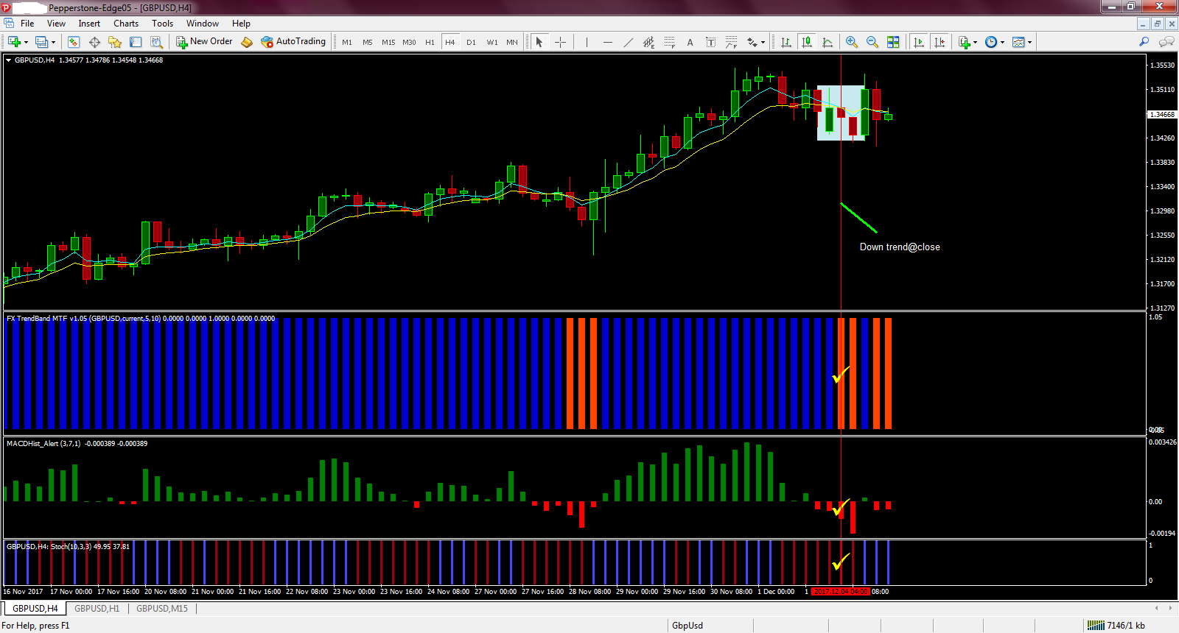

H1: Wait for the retracement
Down trend:
CCI must be above 100
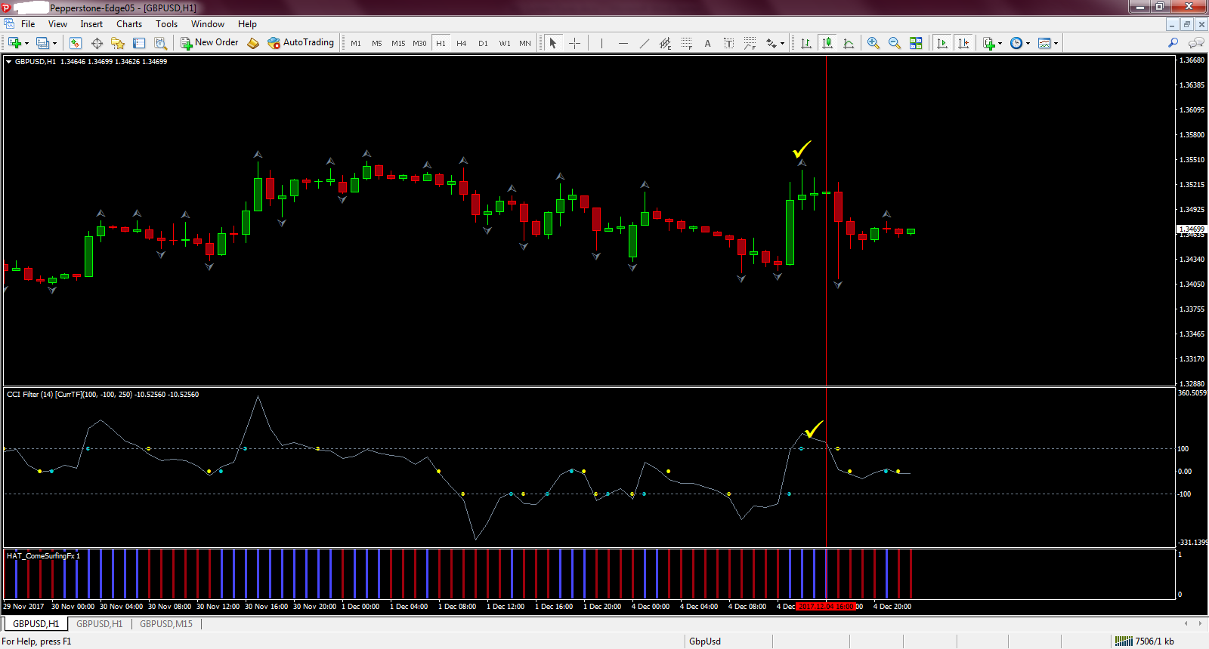

M15: Enter a trade
Down trend:
SHORT when CCI is above 100, the slope changes to red and is trending downward and confirmed by MACD histogram is below the zero + Stochastic cross down + Awesome is above the zero then decreases its momentum.
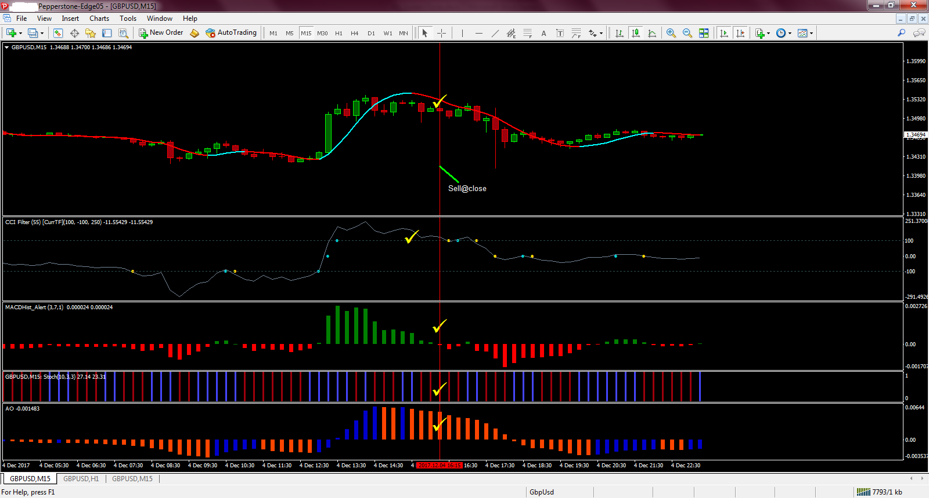

Stop Loss (SL) and Taking Profit (TP)
Down trend:
SL@ the most recent high and TP when the slope changes color.
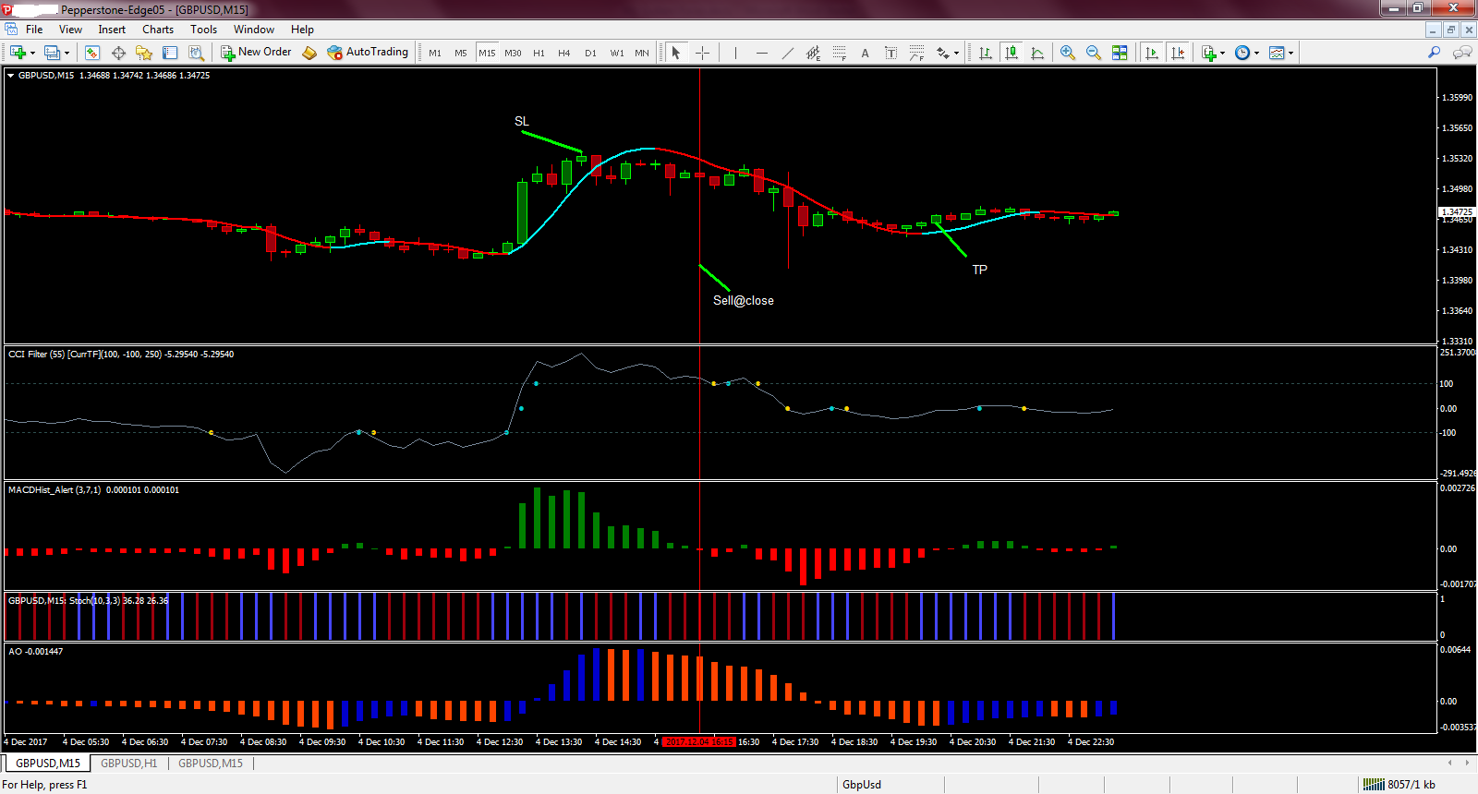

Up Trend:
Counter trend
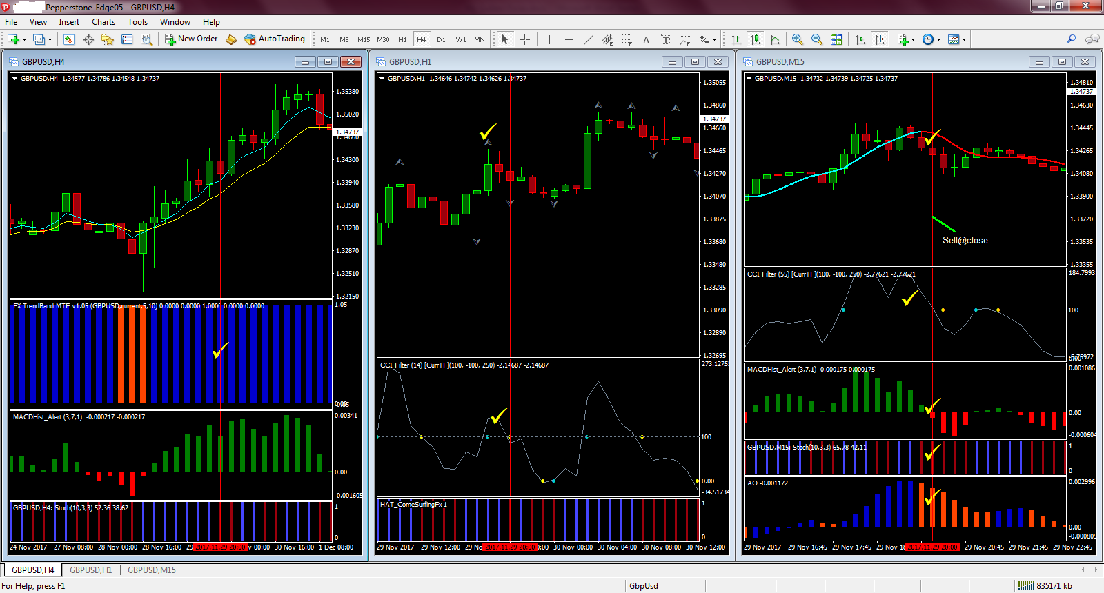

H4: The trend is up
H1: CCI is above 100. When fractal appears then switch to M15
M15: CCI is above 100. Going SHORT when the slope changes to red and trends downward and confirmed by MACD is below the zero, Stochastic is trending down and AO was above zero and decreases its momentum.

Down Trend:
Counter trend
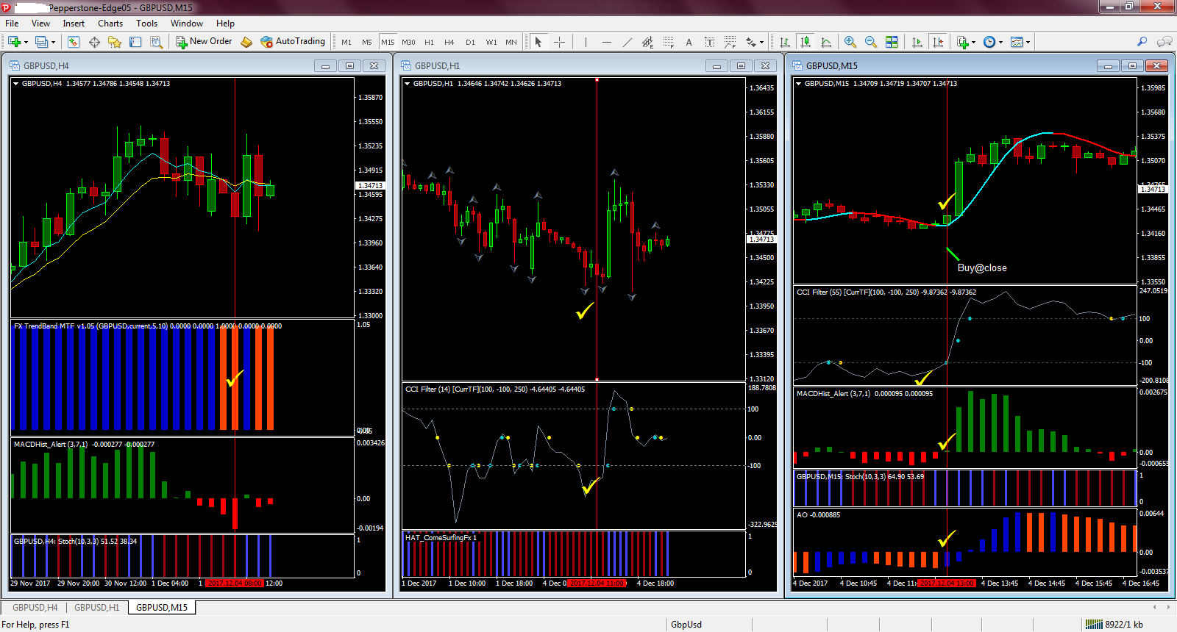

H4: The trend is down
H1: CCI is below -100. When fractal appears then switch to M15
M15: CCI is below -100. Going LONG when the slope changes to blue and trends upward and confirmed by MACD is above the zero, Stochastic is trending up and AO was below zero and increases its momentum.

R-values
R-values are a way of seeing how much you are risking compared to how many pips you are making. It is calculated by taking your final profit/loss and dividing it by the amount of pips you risked.
For example, if you were to risk 10 pips and you ended up making 30 pips, then your R-value would be 3 (30 divided by 10).
If you were to risk 10 pips and ended up losing 30 pips, then your R-value would be -3 (-30 divided by 10).
Sometimes we ended up making less pips then we risked and will find ourself getting an R-value less than 1.
For example, if we were to risk 10 pips and ended up making 5 pips then our R-value would be 0.50. (5 divided by 10).
The reason we measure this value is because over time, we can look at our trades and see if we winning more or less than what we are risking.
If we end up with an R-value less than 1 then it means we are not winning as many pips as we are risking.
If this is the case, then we have to make sure our system is winning over 50% of our trades or else our system will not be profitable in the long run.
If we end up with an R-value that is greater than 1, then it means we can afford to lose less than 50% of our trades and still be profitable in the long run, depending on what our actual R-value is.
For example, if our R-value is 3.00, then it means we only need to win over 30% of our trades to still be profitable. The higher our R-value the more we can afford to lose. The lower our R-value the more we need to win!

Green pips for all
OM SAI RAM

