My Trend Following

H4: Determine the trend
Up Trend:
5/10 EMAs cross up and confirmed by MACD is above the zero line and Stochastic cross up

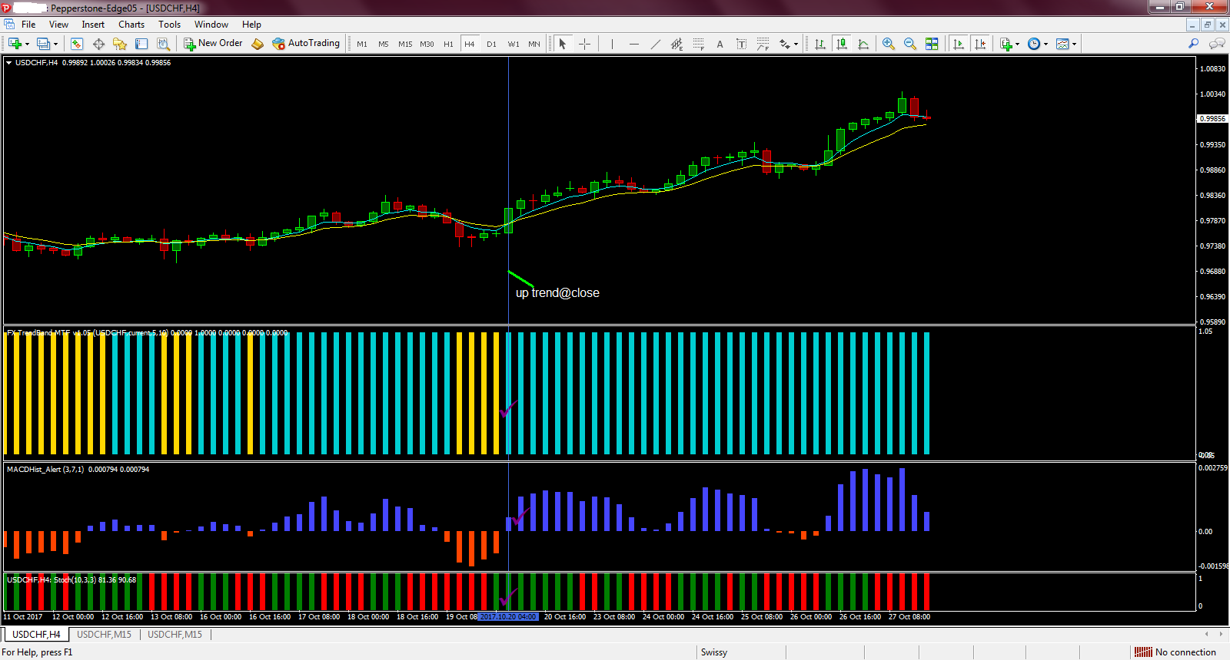

Down Trend:
5/10 EMAs cross down and confirmed by MACD is below the zero line and Stochastic cross down
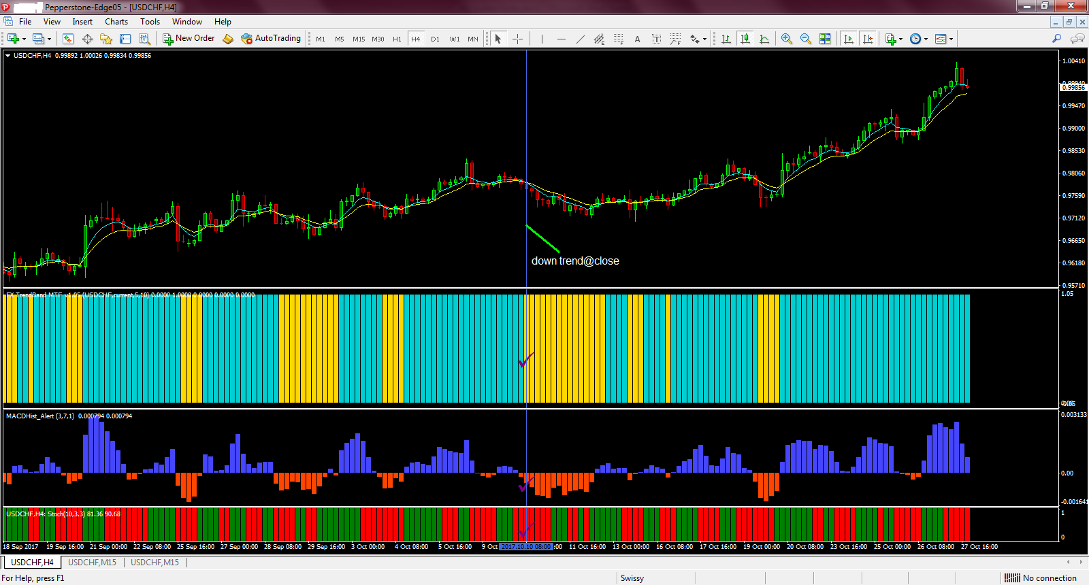

H1: Wait for the retracement
Up Trend : CCI must be below -100 level
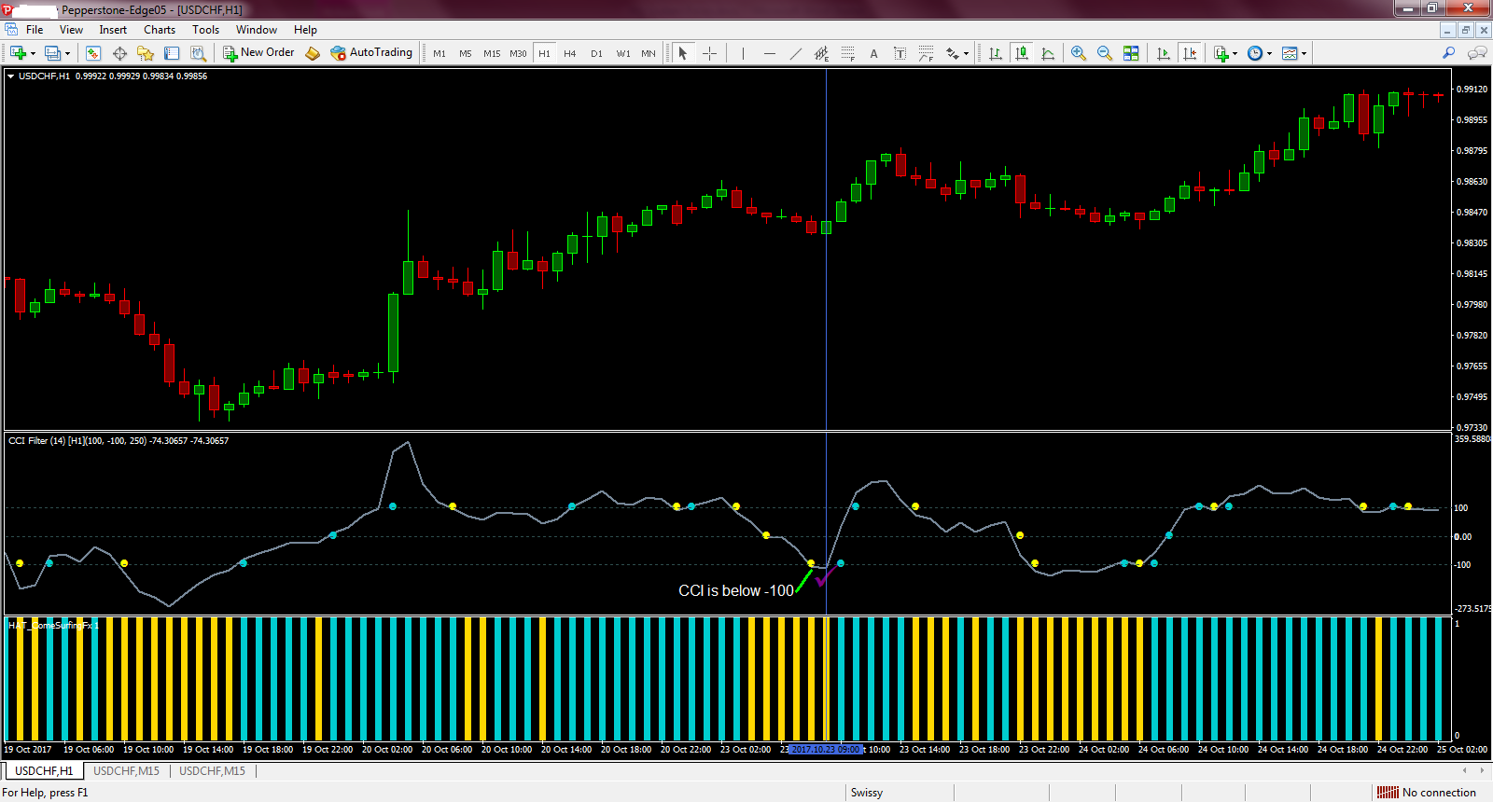

Down Trend : CCI must be above 100 level
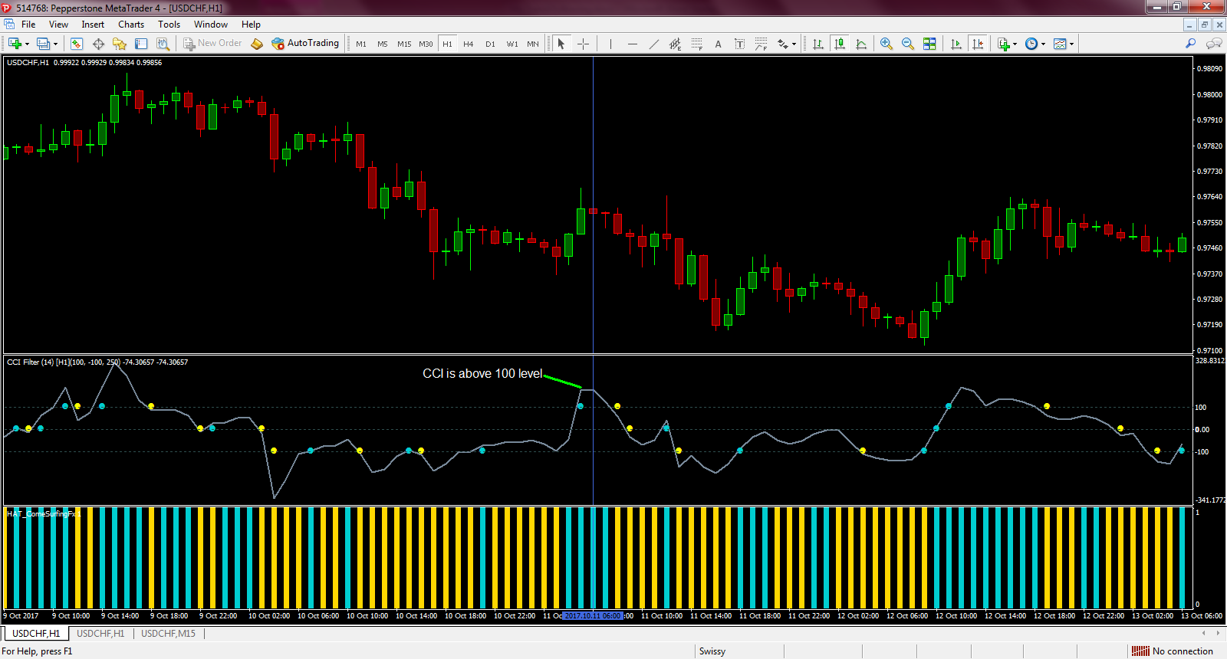
M15: Enter a trade
Up Trend:
MACD is above the zero line + Stochastic cross up + Macd OsMA is below the zero line then increases its value.
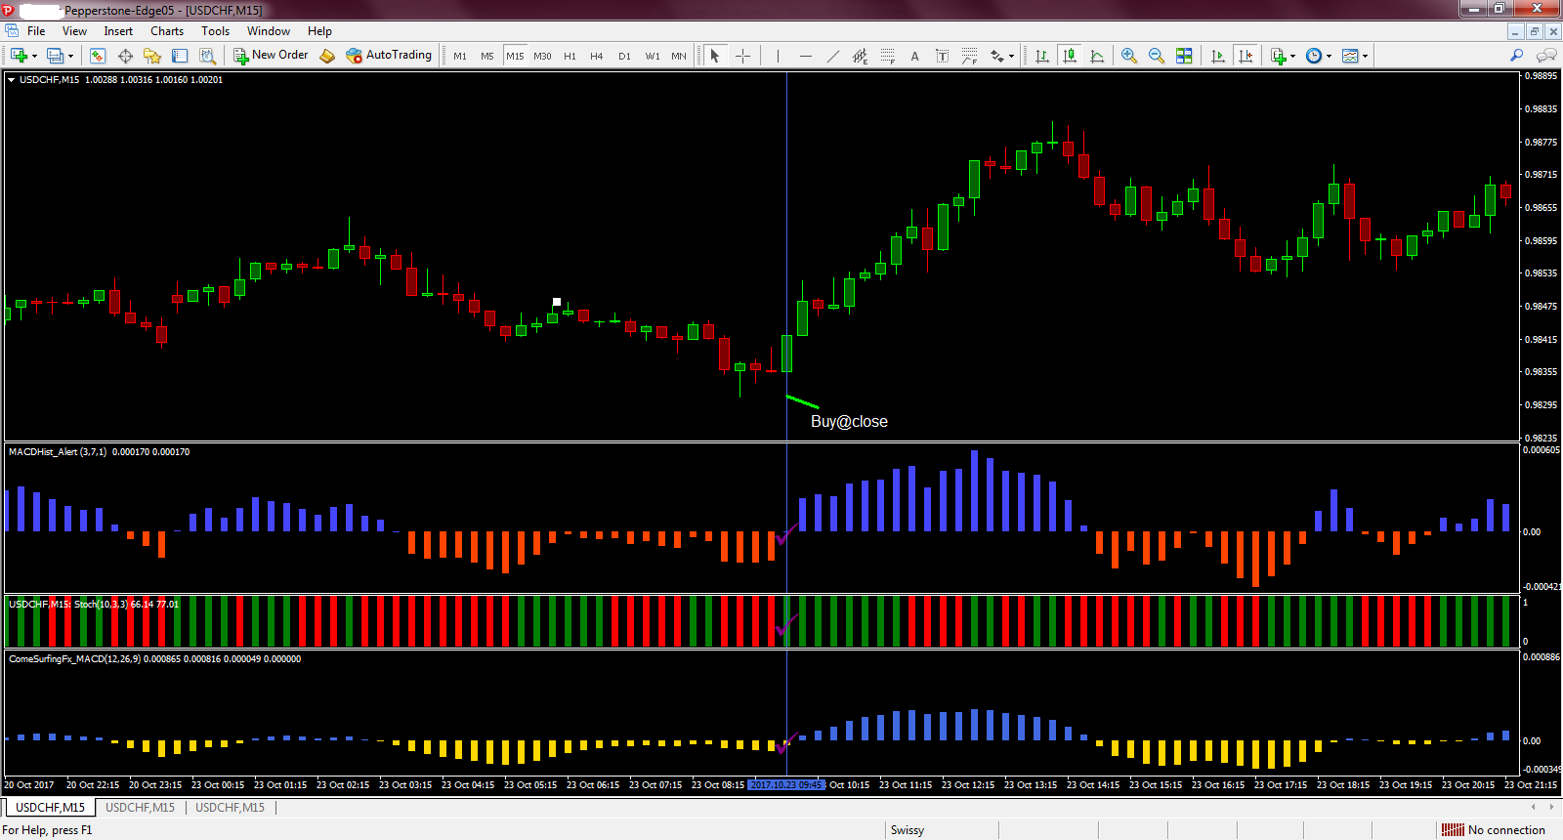

Down Trend:
MACD is below the zero line + Stochastic cross down + Macd histogram is above the zero line then decreases its value.
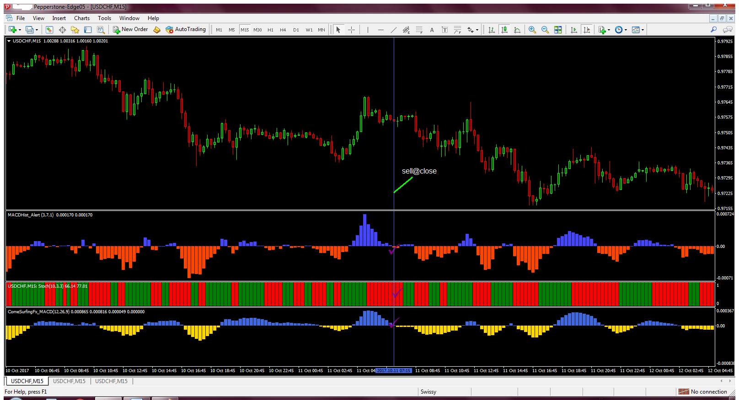

Taking Profit
Taking profit at 00 and 50 round numbers.
Up Trend:
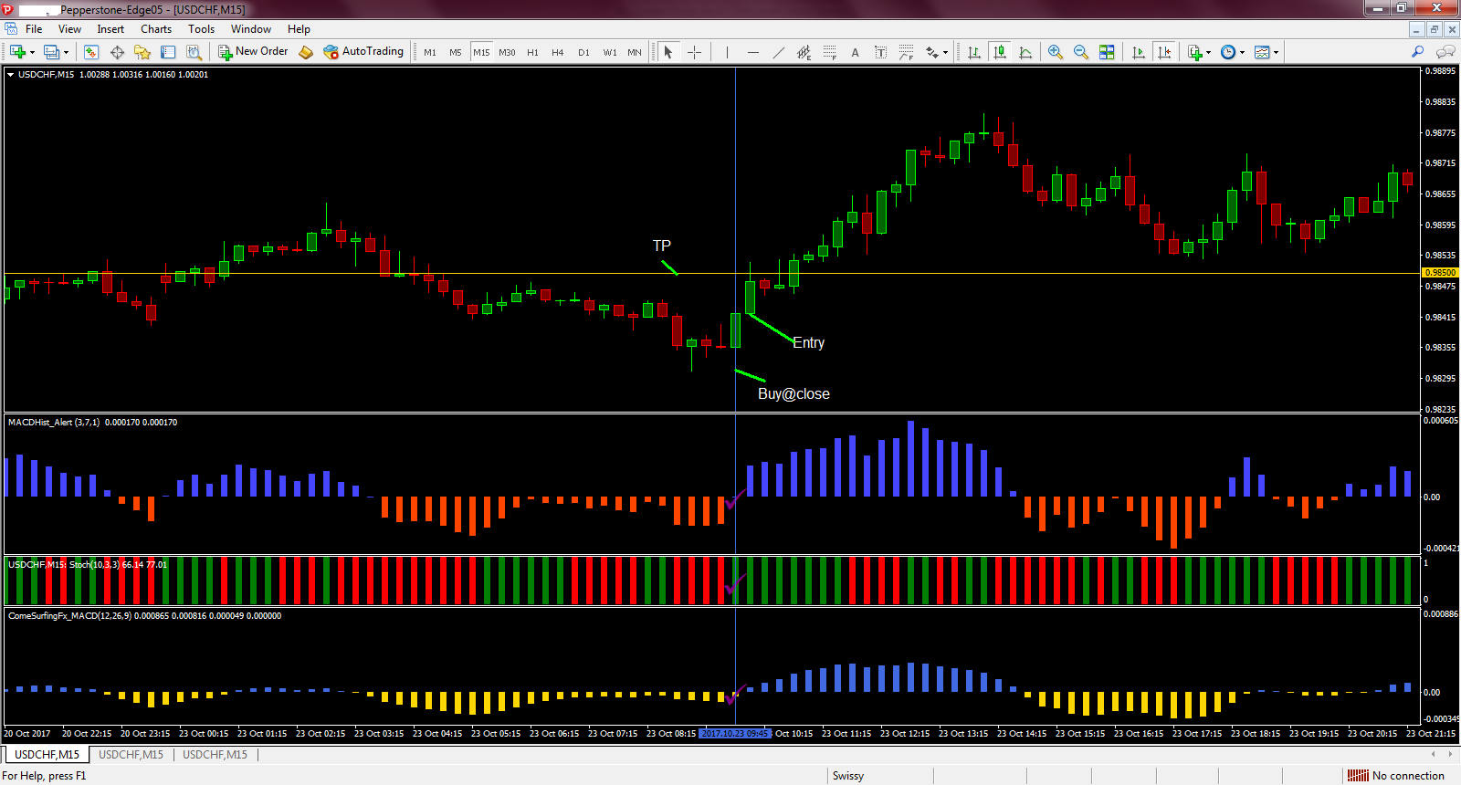

Down Trend:
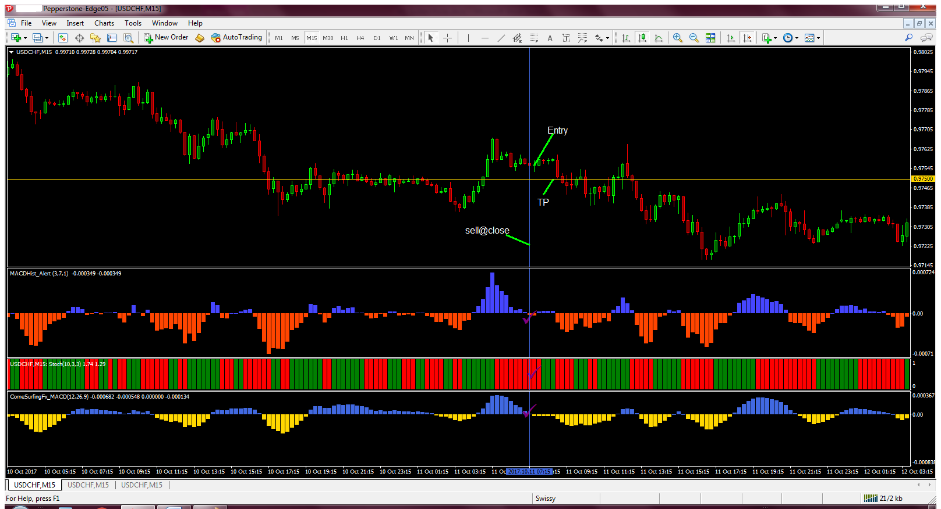

Stop Loss
Up trend : Put a stop loss at the most recent low
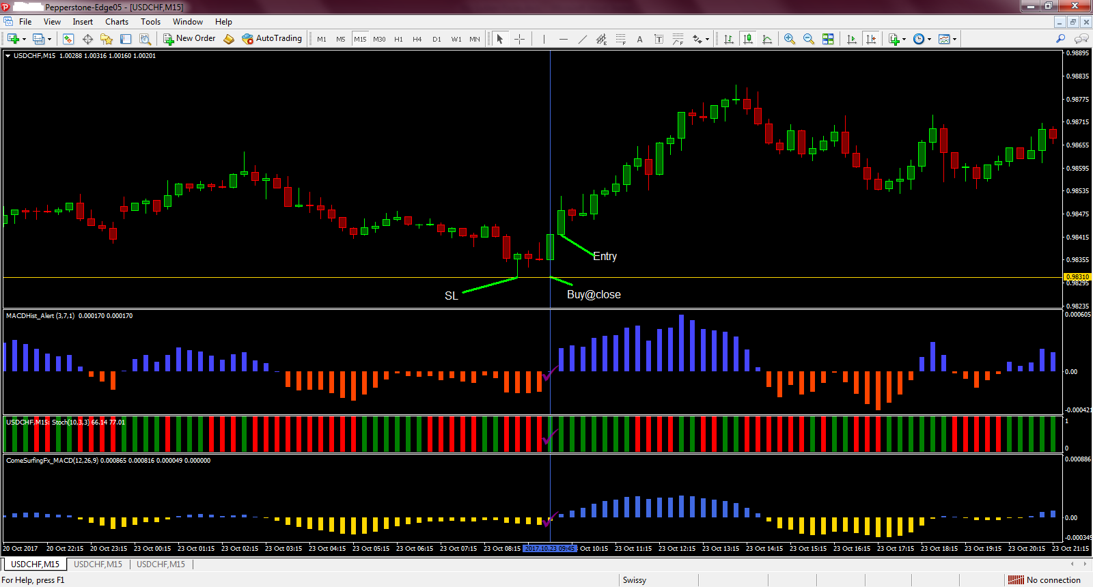

Down trend : Put a stop loss at the most recent high
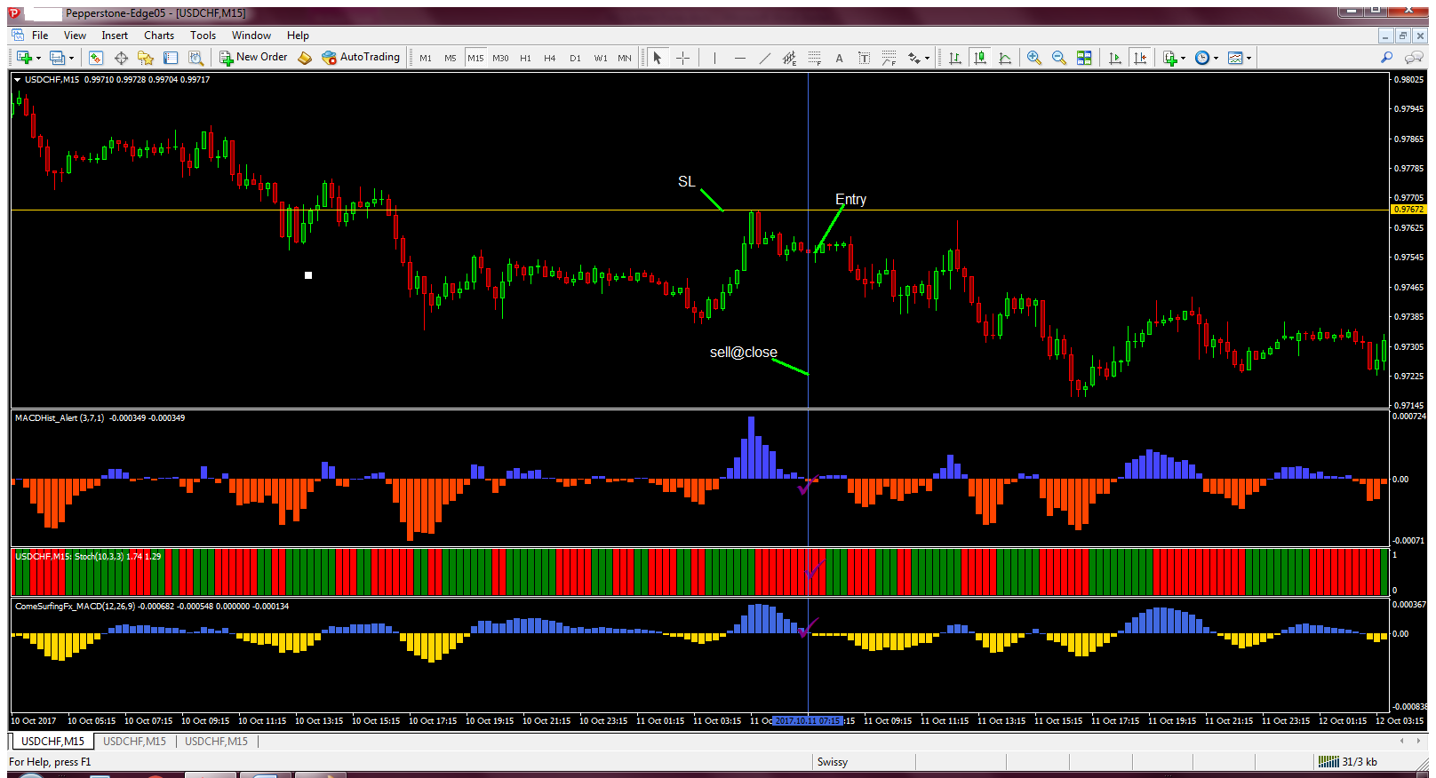

The 50 and 00 level target
The markets pay a lot of attention to these levels especially in the short term.
Since many traders always tend to put stops and take profit orders around these levels, it can often trigger a sharp continuation or a sharp bounce. This is why I pay close attention to my trades once they reach these levels.
If momentum continues in my favor, I ride the wave. If I start to see a bounce…I’m OUT!

R-values
R-values are a way of seeing how much you are risking compared to how many pips you are making. It is calculated by taking your final profit/loss and dividing it by the amount of pips you risked.
For example, if you were to risk 10 pips and you ended up making 30 pips, then your R-value would be 3 (30 divided by 10).
If you were to risk 10 pips and ended up losing 30 pips, then your R-value would be -3 (-30 divided by 10).
Sometimes we ended up making less pips then we risked and will find ourself getting an R-value less than 1.

For example, if we were to risk 10 pips and ended up making 5 pips then our R-value would be 0.50. (5 divided by 10).
The reason we measure this value is because over time, we can look at our trades and see if we winning more or less than what we are risking.
If we end up with an R-value less than 1 then it means we are not winning as many pips as we are risking.
If this is the case, then we have to make sure our system is winning over 50% of our trades or else our system will not be profitable in the long run.
If we end up with an R-value that is greater than 1, then it means we can afford to lose less than 50% of our trades and still be profitable in the long run, depending on what our actual R-value is.
For example, if our R-value is 3.00, then it means we only need to win over 30% of our trades to still be profitable. The higher our R-value the more we can afford to lose. The lower our R-value the more we need to win!

Green pips for all

OM SAI RAM

