Volli 5.555

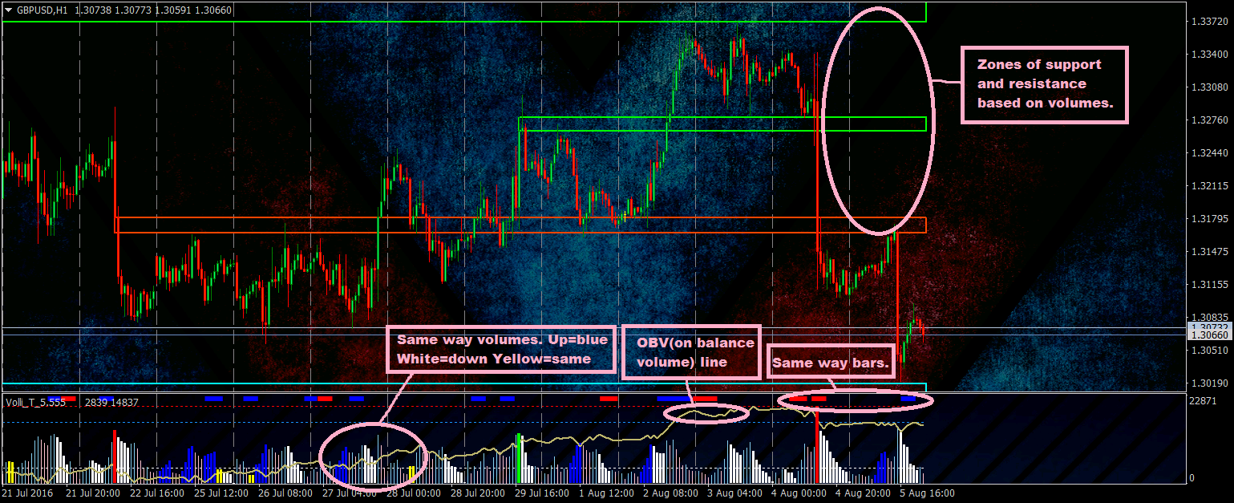
Volli is an indicator that bases on volumes. You need to set Volli to real ECN/STP account. Tick volumes at this types of account are almost similar with Futures volumes(CME). By default you can set Volli on M30,H1,H4 timeframe.
1
The main in Volli is zones of support and resistance. You can use only them. You need to look how price moves near(on) zones. Stops you can set in or out of zone.
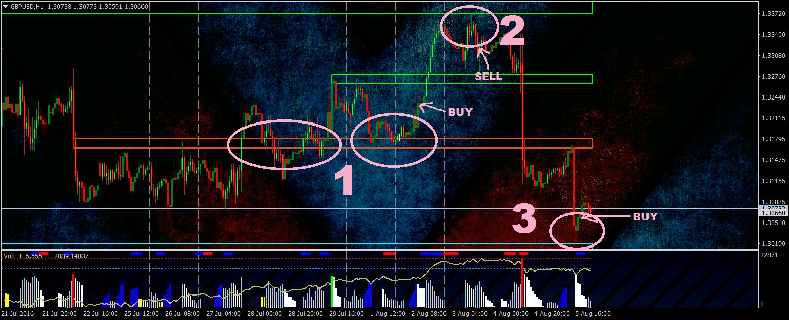
- Price didn’t make retouches(didn’t accept zone,didn’t respond). Then price touch zone, then retouch, signal to buy.
- 3) Price after touch of zone quickly goes to side opposite to zone.
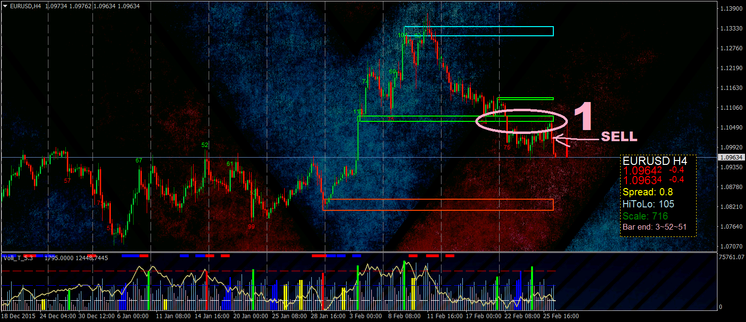
- Price goes under support zone and after touches it. Support became resistance and it is signal to sell.

2
Other things in Volli are useful too.
OBV line you can use like RSI(overbought and oversold zones).
When volumes go up or down in a raw it can be interpreted like time when big number of traders opens trades or closes trades.
Same way bars can be used like indicator of rollback of price. Usually when price goes in one way some time in a raw, than rollback of price occurs.

