The Hedger EA

Strategy: Range X and Y

Range X: If price touch up EA opens Sell, if price touch down EA opens Buy
Range Y: Next orders to open

Strategy Images
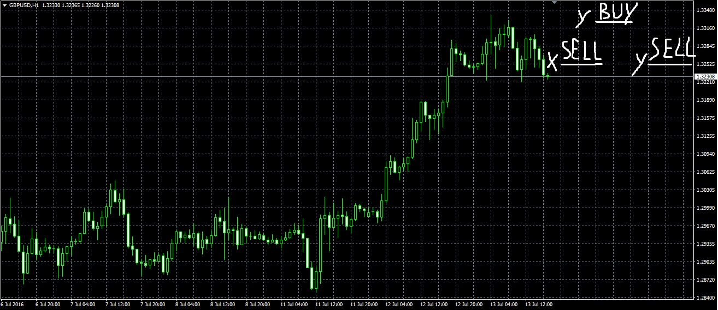
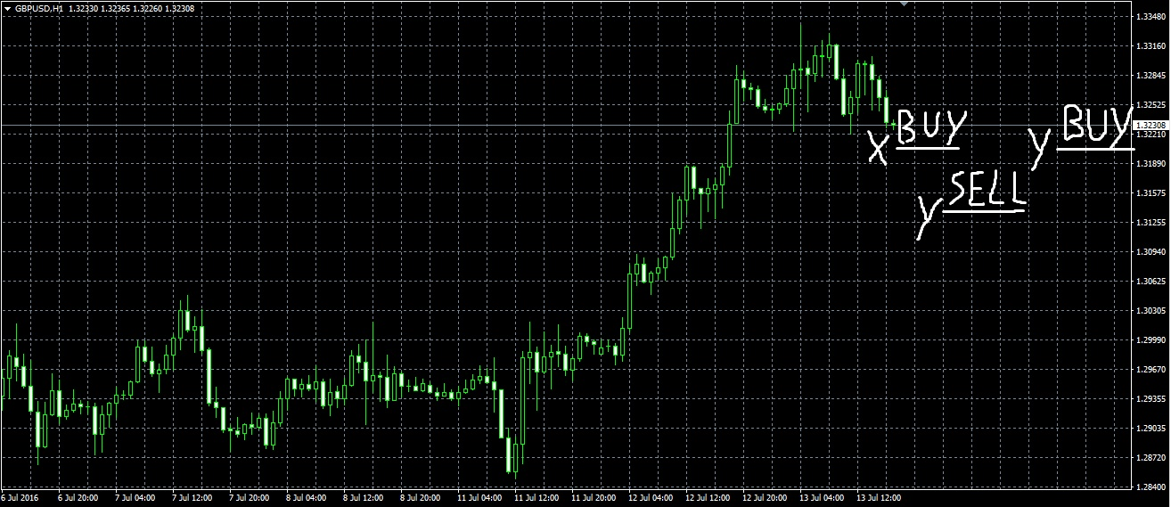

First order on Range X, if price goes down: Buy 0.01
Second order on Range Y: Sell 0.03
Third order on Range Y: Buy 0.04
4th order on Range Y: Sell 0.04
5th order on Range Y: Buy 0.04
6th order on Range Y: Sell 0.04
Then all next orders always Buy or Sell at 0.04 on Range Y until Take Profit

Parameters
Magic Number: 1
Max Orders: max number of orders, if 0=unlimited orders
Take Profit: in points (Profit calculated on all positions, not every single position), included Swap
Range X: in points
Range Y: in points
First Order Lot: 0.01 (in lots)
Second Order Lot: 0.03 (in lots)
Same Next Lots: true or false (if true here, it’s false to Lot Multiplier)
Next Lots: 0.04 (in lots)
Lot Multiplier: true or false (if true here, it’s false to Same Next Lots)
Multiplier: 2.0 (Multiplier Factor)
Commission: in points
Max Spread: in points, only for the first orders every time EA reach TP. If Max Spread: 15 and Commission: 5, the Max Spread on any pair allowed to open orders is 10, because EA consider commission as spread
EA Comment: The Hedger EA

Copyright Luigi De Falco

