COPY & PASTED RULES
Timeframe
M5 or M15
Buy Rules
1. Daily candle is Green
2. RSI Filter is Blue
3. MFI Meter is Green
4. Uptrend (7 EMA is above 20 EMA)
5. Price pullback inside 7 and 20 EMA
6. Draw TrendLine from highest swing
7. Wait for price to break above trendline and bar is closed
8. Set your targets
Sell Rules
1. Daily candle is Red
2. RSI Filter is Pink
3. MFI Meter is Red
4. Downtrend(7 EMA is below 20 EMA)
5. Price pullback inside 7 and 20 EMA
6. Draw TrendLine from lowest swing
7. Wait for price to break below trendline and bar is closed
8. Set your targets
Stoploss & Takeprofit
10-20Pips
I can set my SL = 10Pips and TP = 10Pips
I can set my SL = 10Pips and TP = 15Pips
I can set my SL = 10Pips and TP = 20Pips
I can set my SL = 7Pips and TP = 20Pips

Buy Example
Attached Image (click to enlarge)
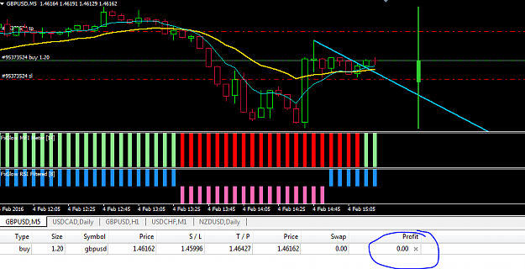

Attached Image (click to enlarge)
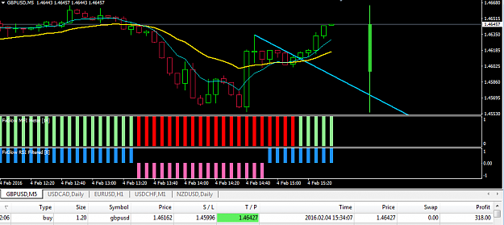
Sell Example
Attached Image (click to enlarge)
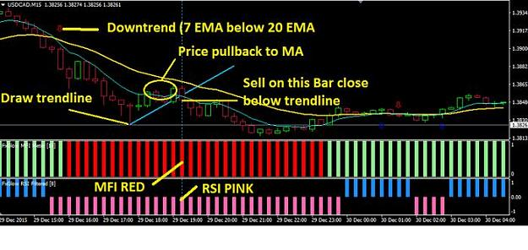
Sell Example
Attached Image (click to enlarge)


