01 Feb, 2016

You clean your trade up as soon as the SAR hits. Or else you will be losing your profit.

Quoting woww
dear dove, it' the firsth time that i look the chart (H2) with PSAR between EMA and Smooth.. is it a particular aspect?
No its not; once the parabolic gets in between EMA and Smooth the trade is coming to an ending. Either a turn or a slider.

Quoting dinkydau147
what are the 2 horizontal lines labelled b1 and s1 . what are they meant for ?
They are your MA signals: They operate closely to the nose level of an ADR indicator.

Quoting Timo7
Hi, Dove, this is a great system, May I ask, how did you come up with this system? What is the background to it creating this? I'm sure a lot of us here would love to know. Thanks.
The story is something many would not understand. But without trying to insult those who do not believe I will try:
Every human being has a spirit. And if one believes in Jesus with all their heart; then has conquered many obstacles that stands in their way. My faith and belief is rooted so deep that nothing can destroy it. My own spirit is connected with the Holy Spirit in which He is our teacher and guidance in life. It was through He that the Paradox was created; which goes back to 2003.

The SAR and Long Term swing indicators are your two resources for support and resistance in the Paradox. There are times the SAR will disappear after the Long term is connected. At least it seems so but the SAR is till there behind the Long Term Swing. It never disappears. Any time either one connects with a candle - the next objective is the opposite way. If the DB (Long Term Trend) is connected on Top of a candle then the next connection is on the Bottom of a candle somewhere down the line. And it is the very same for the SAR; and vice-versa. So, at this moment you had the DB on top of Fridays spike. Which means the next connection with the DB is on the bottom of a candle on the downside. This is also true with the SAR. It is connected on top of a candle and the next connection is with the bottom of a candle on the downside.
Quoting rcbarlow
Basically, when you are Position (Swing) trading you can ignore everything except the Dodger Blue and Magenta SAR on the H1 and H2 and Daily Charts, correct?
That is pretty much in saying it. But eliminate the 1 hour chart. Just the 2 hour and Daily.

Hesitation is a big stopper for traders. The fear factor. Because of fear you hesitate in pulling the trigger and there goes your trade and nothing you can do it about but letting emotions take control. And once emotions take over you on the path of destruction. Being patent is a virtue and once you see your trade - you hesitate. The fear just took over because your own is money on the line. That is something every trader has to conquer. And the only way to beat it is pulling the trigger.

Quoting Cherry
{quote} Hi Dave, sorry if I confused you. I am using MT4. I was only questioning that you basically agreed said this morning in reply to rcbarlow when he asked: Basically, when you are Position (Swing) trading you can ignore everything except the Dodger Blue and Magenta SAR on the H1 and H2 and Daily Charts, correct? Yesterday you said: The Position is taken on the flip of the Fibo. The best entry is when the Parabolic had flipped also or the Parabolic is already in place with the Fibo flip. So my question is: That would mean we still require the...
When I position trade I us the 2 hour. Sometimes the 1 hour will give a position and it is short lived. The flip of the Fibo is your primary source of information for the position. Now - if the 2 hour is still in trend for the flip the consolidation is very well expected. Not always - but more consistent for consolidation. And that is why I said the Fibo flip with parabolic is the entry.

To begin with traders - the 1 hour chart is a reference chart and the only reason it is included with the 2 hour is because the 1 hour was needed for the converter. originally I was not going to include the SAR_Swing or the SwingHighLow with the 1 hour because those two indicators do not belong with the 1 hour. But thinking about it I decided in cramming 6 week into a 2 week period may help those who have problems recognizing S/L. I can see I was wrong. The SAR_Swing and the SwingHighLow is to be deleted from your 1 hour chart. There is too much confusion with most of you. And they truly do not belong on the 1 hour.
To give an example of the SAR on the 2 hour chart; and by the way - the 2 hour is the only chart I trade - here is my entry and profit for my entry from the SAR.
At 2:20 PM (my time) this afternoon; I arrive back home and notice the SAR just being attached. I immediately pull the tiger for the short. and here the results with a 40/40 trade
Entry was at 131.969; and notice 1 trade for this date.
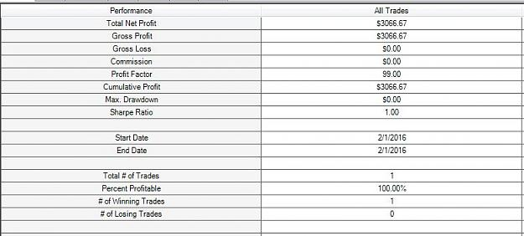
And here the Limit and Stop.
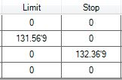

Quoting rcbarlow
I did the same thing but mine is named Alert, but it does not work.
The sound folder is in your program folder (C) MetaTrader4 and you cannot change the name. The music you choose also has to be in wave (.wav) not MP3 or any other format.

As you notice last night, early this morning, you had the Long Term (DB) attached without a label (rectangle price box); and then shot back up to the resistance Parabolic. And back down again for the DB and still without the label. The SAR is still holding for the down. If you go to page 40 and top of the page is a post for the reason.
Now - once the SAR attaches at the bottom WITH the DB it will go up as it will then have the label.

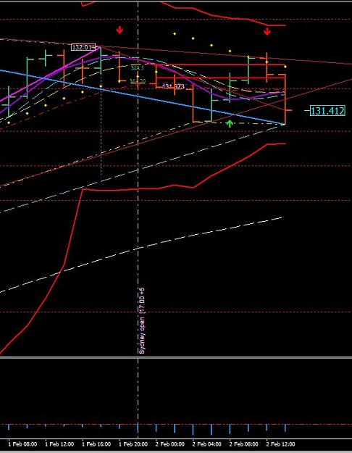
http://www.forexfactory.com/attachment.php?attachmentid=1845773&d=1454427669

Quoting venividivici
{quote} I think I have a problem, my chart is not showing the same sar as yours. {image}
The reason is because you are with a broker that compromises their platforms.

My platform is with FOREX.com which is a sister with Gain/Capitol. They do not compromise what-so-ever.

Quoting venividivici
{quote} Could it be that I shut my computer between sessions? I think the template may be repainting everytime i turn on again, instead of leaving it open.
That too could be a possibility. I already told you what would happen if you do not let your computer running. This system runs entirely on data.

The Dove - Forex Trainer

