Jan 30, 2016

Trading is a threshold of owning your own business. It is your life; your profession, and no-one is going to take care of your business accept for yourself. To be successful with your business you must have rules and a passion in seeing your business making profits.
Owning your business in a new profession you must first learn the structural components of that business in such a way; that profits can be accumulated to be successful. And trading is no different. You may have the passion but it too is useless if the desire in learning is lacking. Your own intellect can only accomplish with what knowledge you have gain with the structural components of trading. If you are lacking knowledge then your future with the business is a failure.
There are several components with the structure of trading. And today I will start with the first one.
A daily trading plan:
A daily trading plan is the most important element for the start of your day, as you sit down with your trading station. And the question I ask: How can you trade without knowing whats happening in the market? And the answer is you cant. You can sit there for hours on end and miss the entries without the knowledge of what is truly happening. Your own thinking and intellect is powerless without the knowledge first.
I will give several trading plans as scenarios so you may gain the knowledge in what you are looking for. To begin with; place your plan on word or note pad so you can print it and place it right there next to you on your trading station. This plan is your reference and you will need it until you reached your profit.
This is what my template looks like to create my plan.

DAILY CHART - DATE:
ROMAR:
EMA:
Parabolic:
NOTES:

2 HOUR CHART:
Opening:
ROMAR:
EMA:
Parabolic:
NOTES:

1 HOUR CHART:
ROMAR:
EMA:
Parabolic:
Notes:
Entry:

To be fair I will be using my actual trading charts for the MT4. My charts are with ROMAR, EMA, the 4 horsemen, and Fibo with only the MACD zero crossing for an alert. And the reason is; because I can read into the future. And you need to get to that point with your charts so you can also do the same. So until then; leave your charts as is.

We will start with the Daily. The Daily chart is only reference for support and resistance.
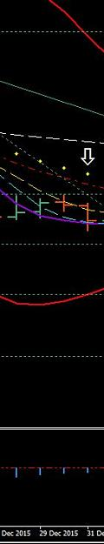
http://www.forexfactory.com/attachment.php?attachmentid=1843253&d=1454124364
DAILY CHART - DATE: 12-30-15
ROMAR: Resistance
EMA: Resistance
Parabolic: Resistance

NOTES: All three support/resistance are in compliance for a strong downtrend.

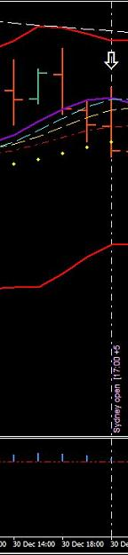
http://www.forexfactory.com/attachment.php?attachmentid=1843254&d=1454124435
2 HOUR CHART:
Opening: 120.499
ROMAR: Resistance
EMA: Support
Parabolic: Support
NOTES: The 2 hour is in a swing with White at the crossing of Purple and eliminates the Parabolic as support. Smooth and EMA are shallow for the crossing with Purple. The daily is showing a strong trend and the 2 hour is showing the crossing of purple with opening at EMA.
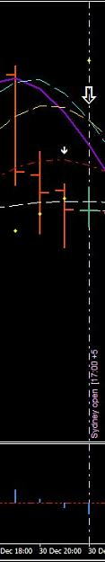
http://www.forexfactory.com/attachment.php?attachmentid=1843255&d=1454124472
1 HOUR CHART:

ROMAR: Support
EMA: Support
Parabolic: Resistance

Notes: The 1 hour had finished the upswing with Smooth in the daily downtrend. The signal for the zero crossing had shown with the previous candle. The Parabolic is already in the downtrend as resistance. Both ROMAR and EMA are at the crossing of the Purple that is already strong for the downtrend.
Entry: The 2 hour is showing the Parabolic as support but also eliminated with the White/Purple crossing. It will take the hidden LR to flip the parabolic and with the down being strong I will take entry with the next 2 hour open candle and/or, the retrace toward the parabolic.
++++++++++++++++++++++++
And on the next candle is where I made my entry for 40 pips.
Now my question is: Would I have seen that entry without my trading plan? The answer is no because I would not had seen it without my trading plan. I would have still been looking for an entry.

OK lets move on to an uptrend.
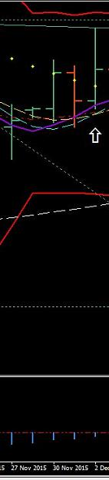
http://www.forexfactory.com/attachment.php?attachmentid=1843256&d=1454124794
DAILY CHART - DATE: 12-01-15
ROMAR: Support
EMA: Support
Parabolic: Resistance
NOTES: On this daily is showing an ending of a swing consolidation with ROMAR as support. White/Smooth had crossed Purple and is support with EMA at Purple for support on the uptrend. The Parabolic had been eliminated as resistance with the White crossing Purple. The upper Bollinger Band is within striking distance for a hit.
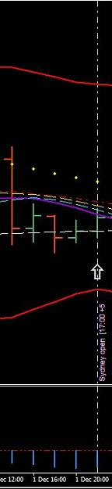
http://www.forexfactory.com/attachment.php?attachmentid=1843257&d=1454124832
2 HOUR CHART:
Opening: 122.848
ROMAR: Support
EMA: Support
Parabolic: Resistance
NOTES: The market opened on top of ROMAR support with EMA on top of Smooth/White in a consolidated shallow swing. The parabolic is also holding resistance.

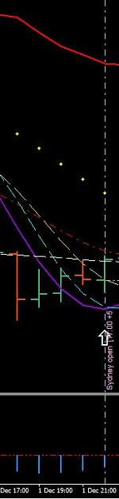
http://www.forexfactory.com/attachment.php?attachmentid=1843258&d=1454124860
1 HOUR CHART:
ROMAR: Support
EMA: Support
Parabolic: Resistance
Notes: ROMAR is sliding under EMA in holding EMA as support with the white crossing.

Entry: According with the Daily chart the swing had ended with White, Smooth, and EMA crossing purple for the ROMAR uptrend. The 2 hour is very shallow with EMA, Smooth, and White very tight. And the 1 hour is finishing up its swing. With ROMAR holding support just under the 4 horsemen and resistance being tight above ROMAR; the best entry would to wait for an open candle above either Smooth or EMA. Which ever come first? That places market above purple for the uptrend.

*******************

It was the 2nd 2 hour candle after my trading plan that opened above Smooth and took entry. And that was a 40 pip trade.

Lets move on with a consolidated trading plan.
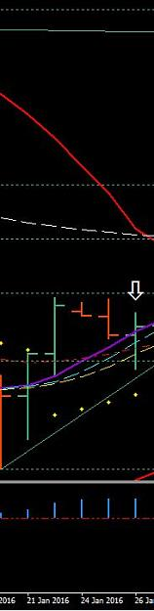
http://www.forexfactory.com/attachment.php?attachmentid=1843259&d=1454125024
DAILY CHART - DATE: 01-26-16
ROMAR: Resistance
EMA: Support
Parabolic: Support

NOTES: The Daily has ROMAR as resistance with EMA crossing purple as support which places the daily in consolidation. The 4 horsemen are in the uptrend in this consolidation.

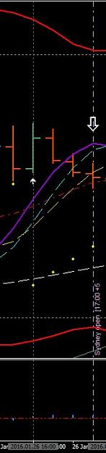
http://www.forexfactory.com/attachment.php?attachmentid=1843260&d=1454125052
2 HOUR CHART:
Opening: 118.398
ROMAR: Support
EMA: Support
Parabolic: Support
NOTES: The 2 hour is turning for a swing in consolidation with opening at Smooth. Open candle below purple.
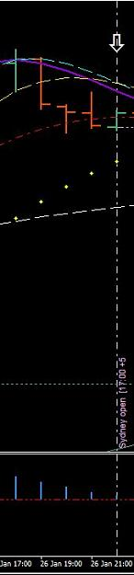
http://www.forexfactory.com/attachment.php?attachmentid=1843261&d=1454125079
1 HOUR CHART:
ROMAR: Support
EMA: Support
Parabolic: Support
Notes: The 1 hour has White/Smooth crossing for the down with open below EMA and in the swing.
Entry: This consolidation could very well go on for hours; especially with ROMAR holding support on both the 1 and 2 hour charts. The risk for a short is more then I desire to take because of the Daily 4 horsemen in the uptrend. The entry would be between the hit on the 2 hour ROMAR or; waiting for the reverse of the swing for an open candle above EMA in trend. Counter-trading ROMAR at this time with the Parabolics as support but eliminated still places the risk of not hitting ROMAR.
So - on this plan I will wait until after I have rested and see what tomorrow brings.
******************
The next day I was blessed with the entry on the 2 hour 07:00 EST candle with the open ABOVE the EMA support; 40 pips taken.
As you can see a trading plan is a weapon in beating the market. All you have to do is make your plans just as I had shown in what to look for. You get your supports and resistances in place with all three charts; on each chart - under notes - you write what is happening in the moment. And then put it all together in what the charts are saying to you.
Also notice the plans are made at the 17:00 EST with the new data. This does not mean you cant make a plan with either London or the USD opening. But be sure the data has been running since the 17:00 EST.
Last month I had switched from the EJ to the UJ in preparing for training with the UJ. So these trading plans were in real time.

Let me now try to bring it all together as a visual on the charts. You have to always remember That ROMAR is trend on all charts.
Long term trend is ROMAR on the DAILY. And what determines ROMAR as trend (on all charts) is when ROMAR crosses EMA. So lets say ROMAR is holding support for the UP and then crosses EMA; ROMAR then changes from Support to Resistance; such as on the Daily. If you look on your Daily you will see where ROMAR crossed over EMA from Support to Resistance.
In order for the Daily ROMAR in becoming support once again; it must cross over EMA for that to happen; this also true on all charts. And because the Daily ROMAR is Resistance and the 2 hour is Support we are in consolidation. Which means the market is in a continuance swings of ups and downs.
EMA is the secondary trend with the swings for the charts. And with a consolidated market EMA is always in and out of support and resistance. And what changes EMA from support to resistance and vise-versa; is crossing Purple. And it is a daily routine with EMA in consolidation with continuance swings.
The picture below is the 1 hour and gives a detail example of EMA. And the 4 horsemen will give you the opportunity for entries.
Starting from left of the chart you have "EMA Crossing Purple". And when you are trading keep in mind what the Daily is saying to you with your Trading Plan.
Coming out of the upswing you already had Smooth as a slider over purple with White crossing into the downswing. EMA is tight with an open candle below EMA changing from support to resistance in crossing purple. You also had the lower band with ROMAR as SUPPORT and ROMAR is out of the trading area. Trading area is between the bands. Which means it would be almost impossible for a hit on ROMAR being outside the trading area in consolidation. So it hit the band and retraced back to resistance.
Next: "White - Crossing - Purple".
You have the White crossing Purple for another swing. EMA is resistance and so is the Parabolic's. But the Parabolic is ELIMINATED.
Let's get a better understanding of what it means for the Parabolic to be eliminated. Once White crosses Purple with the parabolic opposite of the crossing; one of two things will happen in consolidation.
One: it will bounce off the Parabolic.
Two: The market will break the Parabolic with an open candle on the other side of the Parabolic.
If it bounces the Parabolic will stay in trend. If the market breaks the Parabolic the Parabolic will flip on the next 1 or 2 candles. That is what being eliminated means. You do not know what will happen with the Parabolic until it happens.

Next: "EMA - White - Smooth - Parabolic".
The Parabolic's held as resistance with the market bouncing off the Parabolic's and is now in the downtrend against ROMAR support with ROMAR coming back into the trading area. You have an open candle below both EMA/Smooth as resistance; and the 4 horsemen are set for the trend down.
This is the 1 hour chart and is not the same as the 2 hour. This means the 1 hour ROMAR will be hit first and then the 2 hour will be next. If the market bounces off the 1 hour ROMAR then that is it; if the trend is not strong enough for the continuance of the 2 hour ROMAR. In this situation the 4 horsemen are strong in the trend with White showing no crossing. So the market continues on for the 2 hour ROMAR. In this trade the market got below the 2 hour ROMAR as SUPPORT and closed as support. On the next 2 hour open candle the retrace back across the 2 hour ROMAR Support was automatic. And the reason is because the 2 hour ROMAR (IS) support until crossing its own EMA.
NEXT: "ROMAR - EMA - White".
You now have the White crossing Purple to end this swing. ROMAR is still Support and the market must get above ROMAR as support. EMA is resistance and sliding over ROMAR for the support. The Parabolic was eliminated with the open candle above the Parabolic and flipped on the next candle. The entry for this 1 hour was with the 2 hour open candle below the 2 hour ROMAR SUPPORT.
Next: : "White Crossing Purple".
The White crossing Purple had ENDED this swing up. The next open candle was at the crossing and was also entry for this swing down to ROMAR. And the reason is because White had automatically changed from support with the Purple crossing to resistance; and the Parabolics had then been eliminated as support.
Spend a lot of time with this post and structure what is happening with these indicators. This post is the only way you will beat the consolidation. And that is understanding what the Paradox is saying to you. Gain the knowledge and use it.
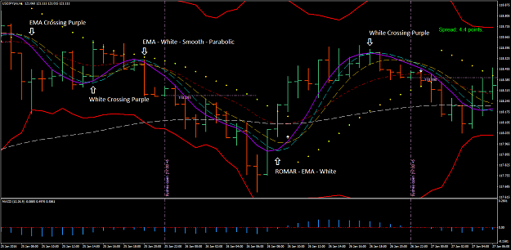
http://www.forexfactory.com/attachment.php?attachmentid=1843516&d=1454183124
Here are the three charts for EJ:
At this time I am giving away the secrets of positioning trading. Positioning trading is done on either the 2 hour; or the Daily; or even on both charts. The reasoning is because you have both alert and visual on the charts for entries and exits.
Positions trading are done from the high to the low and vice-versa. And there are a couple of ways to trade positions.
Position trading takes a lot of heart in watching your profit being taken on the retraces. And most traders will take their profit as they are watching it being taken; and have no idea what to do next. The example of positon trading is on both the 2 hour and the Daily of the charts below.
On the 2 hour you have a Low at 128.240 and a High at 132.276; for a total profit just over 400 pips; and taken in a 2 day period which is two weeks profit for trading 40 pips a day. And I admit; we had a 271 pip spike on the EJ; included between the high and low. But the fact is it did happen. So, it is included.
Also take note of the SAR on the 2 hour. When it showed 129.467 as a high; you could do one of two things. Take profit and reenter at the low of the SAR at 128.93; and youre back in for the long. Or; let it ride on the retrace to the low of the SAR and add more funds (provided you did not use up your margin) for another entry long. This way you regain the loss on the retrace.
If you want to be a real lazy trader with nothing but free time; then on the Daily you have a high of 132.787 and a low of 126.156 with a profit of 663 pips. I believe you now have the big picture. And you work the SAR with the Daily as the 2 hour.
This is known as Positioning trading. And it all begins with the flip of the Fibo. This is something I suggest beginner traders take a good look at; and even the old timers that are still struggling. This may be your answer for trading.
I have two trading accounts one for intraday and another for position trading. After the end of the week I will become strictly a position trader. I will become one of those lazy traders.
And by the way I do not watch the profit being taken I just let it ride with my charts close and check it daily with the 17:00 EST Daily candle.

Daily:
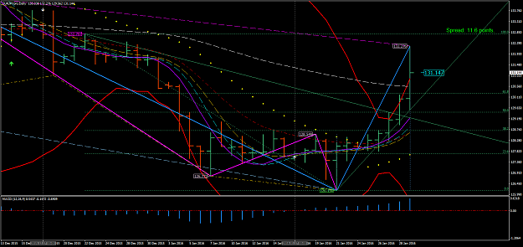
http://www.forexfactory.com/attachment.php?attachmentid=1843546&d=1454197405
2 hour:
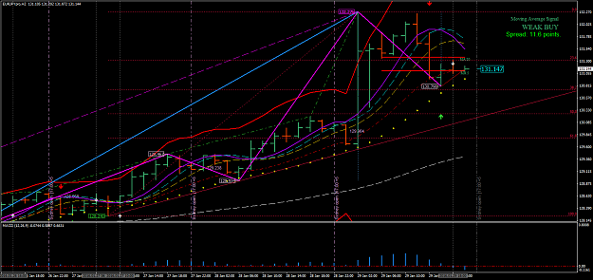
http://www.forexfactory.com/attachment.php?attachmentid=1843547&d=1454197435

1 hour:
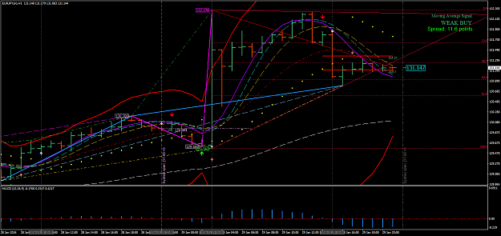
http://www.forexfactory.com/attachment.php?attachmentid=1843548&d=1454197520

Jan 31, 2016
Hello Traders. You are now trading a very volatile pair. The EJ is in consolidation because the Daily ROMAR is resistance and not support. And if you was paying attention you would know why. Last week there are traders that had made substantial profit without any losses. But I must admit - they are traders that has been around for awhile. But the main objective is they payed attention in was being taught. So, they were able to get it.
Quoting L1ndgren
{quote} Hi again Dove, I do have a question. How often do the SARs reattach to subsequent candles?
It all depends on the Data.

Quoting woww
{quote} i'm still leaning , I have very difficult with language...so Daily touch BB and seems to go down H2 has white cross smooth confirming direction but EMA resistence is very near (<20) H1 has purple cross withe in direction UP so I think I wait the confirme on down whit H1 in accordance whit H2. correct me if Im wrong. P.S. I dont also understend the SAR utility.
Creating a trading plan is on what you see in what is happening with the market. And you may see it differently than me. Everyone is different. So you have to practice at creating a plan for it to work for you and not someone else.

Quoting Timo7
Hi, yes I have a question. Do you set the stop loss at 40 pips and just leave it there, or do you bring it to break even at some time, if so, what is the criteria of bringing the stop to break even? And, what is the difference, if any, between Ninja 7 and MT4 system. Do they both give the same results with your Paradox System?
The B/E is set after 15+ pips of profit because if you are less then 15 pips the chances of being taken out with B/E is greater then above. And with the E/J I would go 20 profit before B/E because of the volatility.
As for my NT7 - there is no way the NT7 can be duplicated on the MT4 because of lacking programming with the MT4. But - the modify version of the MT4 is programed in a different way so the structure is in similarities with the NT7.

Quoting Cherry
Dear Dove, Thanks heaps for the Daily positioning post. I do hope you will expound some more on this and the 'flip of the fib', entries etc. Also how much of the previous rules we need to be using or not using. Many kind thanks. Cherry
The flip of the Fibo happens with either a new high or a new low and is automatic. Once the Fibo flips (in consolidation) may bump up on the top side an 8-10 pips; and on the down side 10-15 pips but not always. It can reverse right there at the Fibo flip. And the rules apply as for the trend once the the high or low is hit with the 2 hour chart This is the reasons for the bumps. It could consolidate at the flip and continue to bump until the beginning of the turn.
As for trends - the market will continue with the low or high from candle to candle until it does turns.
I hope this answers your questions? And sorry - I did miss your post.

Quoting L1ndgren
Hi Dove, I have a question about position trading. If the Fibo flips on the daily and a SAR attaches itself, then that is when you enter your position?
The Position is taken on the flip of the Fibo. The best entry is when the Parabolic had flipped also or the Parabolic is already in place with the Fibo flip. Last week I had my NT7 up with the 2 hour just waiting on the Fibo to flip and did so with the Parabolic already in trend for the up with the Fibo; and I made entry for the long term.

Quoting Cherry
{quote} Thank-you Dove. Currently we have a longer term downtrend with ROMAR as resistance and Parabolic as support. The next fib flip could be expected either here at 50% or above at 61.8%? The flip occurs at close of daily candle? For H1 trading consolodation is determined by H2 ROMAR being support while daily it is resistance. How do we determine if daily is also in consolidation... or is it the same? Sorry if I've missed this somewhere and thanks again.
Lets take the Daily. The Daily can very well consolidate sideways for the ROMAR/EMA crossing; especially after the spike we had Friday. But - we just don't know that yet - it is too early. On the other hand - if the market is waiting on the ROMAR/EMA crossing then be looking for a good trend going upstairs. With the 2 and 1 hour being support this could very well happen. And this is what caused the consolidation with the Daily ROMAR being resistance and the 1 and 2 hour ROMAR being support. All three charts must be sync for a trend. Otherwise you are in consolidation.

To answer the questions over the week-end about the SAR here is an example of the so call repainting. With Both the SAR and Long Term DB:
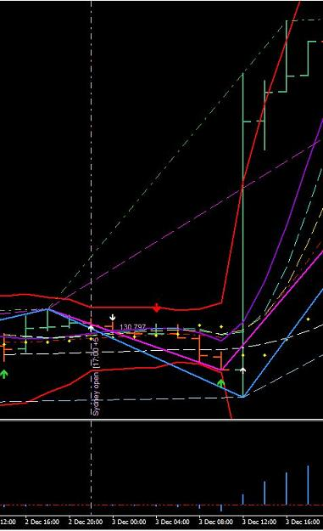
http://www.forexfactory.com/attachment.php?attachmentid=1844056&d=1454288607
If you noticed - the SAR did not repaint with the DB.
That's just it -- there is no repainting in consolidation.
Quoting cfudge
{quote} Now PSAR has flipped on 2hr I have shorted back to Daily ROMAR area for 20 pips. Hopefully quick in and out. Yes Dove I know it is against SAR but we have room Long term SAR at high on daily
You trading against a 2 hour candle that is still moving and that flip of the parabolic is not set until the ending of that 2 hour candle. Which means - it still can be up at the ending.

