27 Jan, 2016

Being a teacher I have always learned in order for knowledge, wisdom, and understanding to be applied it begins with basic. First I must give a complete revolution of how the system works; and this step is applied with a continuance of references. The next step is witnessing mistakes from the references and make corrections in the direction which the mistake should had not been made. And believe me; this is not easy because of the way people think. So a continuance of corrections or forth going.
This system was built to trade in the moment which is also looking into the future. And the question I always get is how do you trade looking into the future?
Believe it or not - this is not complicated at all. It is the same thing as ROMAR vs EMA I had recently posted. And it is also the same reference as Consolidation vs Trends. So take a look at this tight consolidation we just had after opening yesterday:
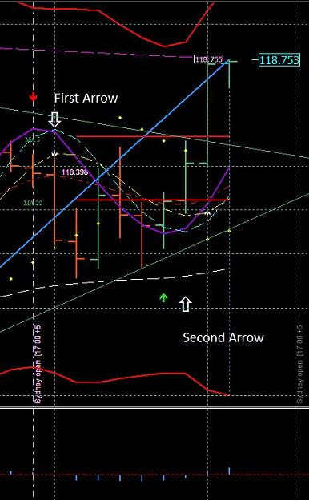
http://www.forexfactory.com/attachment.php?attachmentid=1840823&d=1453914616
The very first step for a consolidation and/or trend is the White crossing Purple. From that point you are looking into the future. The first thing you notice is if the crossing is with the ROMAR trend or is it a counter-trade. This also eliminates the Parabolic support/resistance because in consolidation with the White/Purple crossing; you then have a market up and down. On the picture with the first arrow you had the White/Purple crossing with an open candle below Smooth and just above EMA which was a counter-trade against ROMAR. On the second arrow you had the White/Purple crossing with an open candle above both EMA and Smooth and into the trend with ROMAR. The parabolic's had been eliminated with the White/Purple crossings and that was an entry going into the future.

Quoting dove_alliance
Traders - we have a new high resistance and the Fibo had flipped for the down.
Until consolidation that new high can be bumped up a few times.
Another reference I would like to bring to your attention. And that is the swing lines. During consolidation those attachment with the candles are a very good source for entries and exits for trading. They may bump a little lower on the next candle for the down and vice-versa. But in consolidation with a 40 stop you are safe.
BUT - in trends; those attachments can move from bar to bar and keep going. So you use those reference for consolidation ONLY.
This also reference the BB's. The hits on the BB's are only for consolidation with the 2 hour chart. Not the 1 hour. Once a trend takes off both upper and lower bands will spread open at a 45 degree for the trend as showing on both the 1 and the 2 hour charts. Just remember your 2 hour chart is the trend chart and you follow the 2 hour for the trend. Your 1 hour is the trading chart in consistent with the 2 hour trend.
So everyone knows: I got out of this trade at the new high from the breakout with the opening candle above EMA/Smooth on the 2 hour. Both charts were in consistent with one another at entry and I seen it before the market even knew about it.
The bottom line traders is recognizing the difference between consolidations and trends. And the basics of recognizing the difference is ROMAR with all three charts. Once you have one of the 3 ROMAR's out of sync with the other two; then you are in consolidation. And unfortunately - the Daily ROMAR is what keeping us in consolidation. So that means you have to use the 2 hour ROMAR trend for the consolidation until the 2 hour ROMAR is consistent with the Daily. Then - you are in trend.
The new high was bumped up a few pips and if you had taken the entry with the new high (in consolidation) you would had made your 40 pips for the day.
Great example of the variables in trading this system.
It is after 17:00 EST and time to reboot. And here is the new data for the next 24 hours. One thing I suggest is after you have rebooted your platform do not reboot until after the next 24 hour 17:00. If you are finished with your MT4 then minimize it to keep it open. If you reboot after 17:00 and then reboot again later - then the data is not correct.
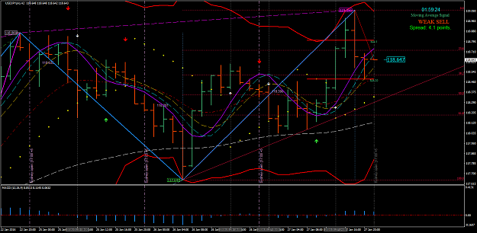
http://www.forexfactory.com/attachment.php?attachmentid=1841010&d=1453932316

OK traders - we have on the reboot with the market between the MA signals. You also have the SAR hit just above the 1 hour parabolic. The 2 hour is in consolidation below Purple with White at the crossing. Bottom line - there are no opportunities for a trade until one shows up.
Just remember you have a new high and the Fibo is set for the down on both charts. And following the Fibo settings for the High resistance and the Low support represents a new target for the low.

The Dove - Forex Trainer

