MOVING AVERAGES TRADING SYSTEM

I use 2 different MA. One for trend direction and the other for ENTRY and EXIT. The settings can vary according to user’s preference and the timeframe you are using. As for me, I use the linear weight MA on H1 for this system. The settings are as follows : -
- The trend MA.
MA PERIOD : 100 (CUSTOMISABLE)
MA TYPE : 0 = SIMPLE, 1 = EXPONENTIAL, 2 = SMOOTHED, 3 = LINEAR WEIGHT (I use Linear Weight)
MA SIGNAL TYPE : 1 = CANDLE CLOSE (ABOVE OR BELOW MA), 2 = COLOUR CHANGE AND CANDLE CLOSED. (I use candle close)

Once a candle has closed above or below the trend MA, I assume a change of trend from here and my trades will only be in this direction.

- The ENTRY and EXIT MA.
MA PERIOD : 10 (CUSTOMISABLE)
MA TYPE : 0 = SIMPLE, 1 = EXPONENTIAL, 2 = SMOOTHED, 3 = LINEAR WEIGHT (I use Linear Weight)
MA SIGNAL TYPE : 1 = CANDLE CLOSE (ABOVE OR BELOW MA), 2 = COLOUR CHANGE AND CANDLE CLOSED. (I use candle close)

ENTRY RULES : -
The system is not about the crossing of the MA’s because just like many other indicators, the MA also lags. When a candle closes below the 10 MA while the MA is below the 100 MA, that is our signal candle. I would set a pending order (PO) below the signal candle with a buffer in pips. If price goes back up, then the trade is not taken. If price goes through my PO then the trade is activated and my SL is placed at the top of the signal candle with buffer.
As in this example

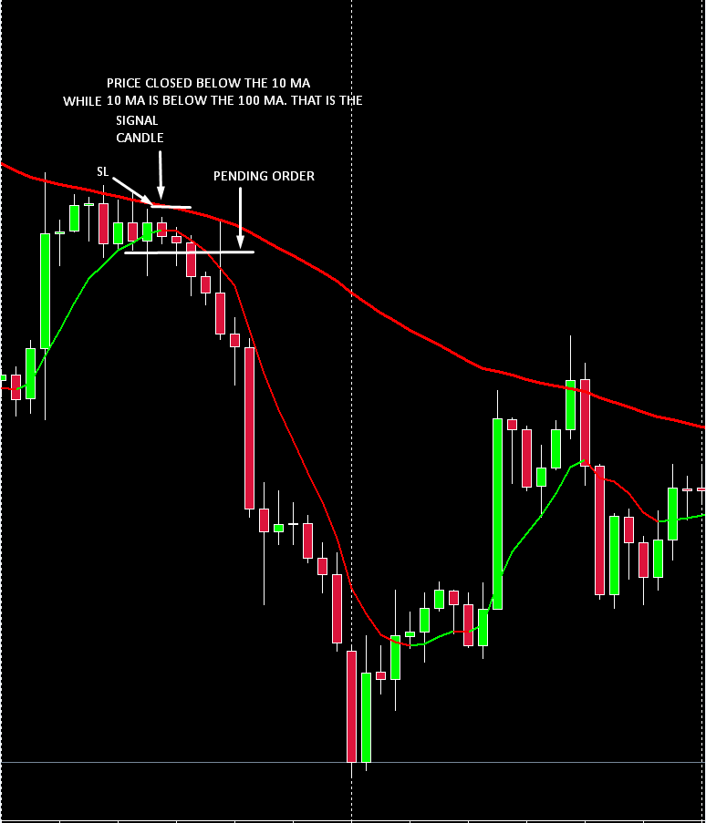

Same goes in a BUY setup.
In casino, I believe we would not need a PO. Instead we will use buffer for taking the trades, as it is in the trend break pin, if price moves ___ number of pips from the high or low of the signal candle, then open trade. If the P.O is not triggered and price goes back and close at the other side of the MA, the signal candle becomes invalid, then we wait for another entry signal candle.

Sometimes, when a trend is changing, price would first cross the 10 MA before crossing the 100 MA. In this case, anytime price crosses the 100 MA, even if the 10 MA has not crossed yet, it can be considered as a signal candle for P.O, as long as the colours of the MA’s are the same. If the 2 colours do not match, then we don’t have a signal candle.
As in the following example.

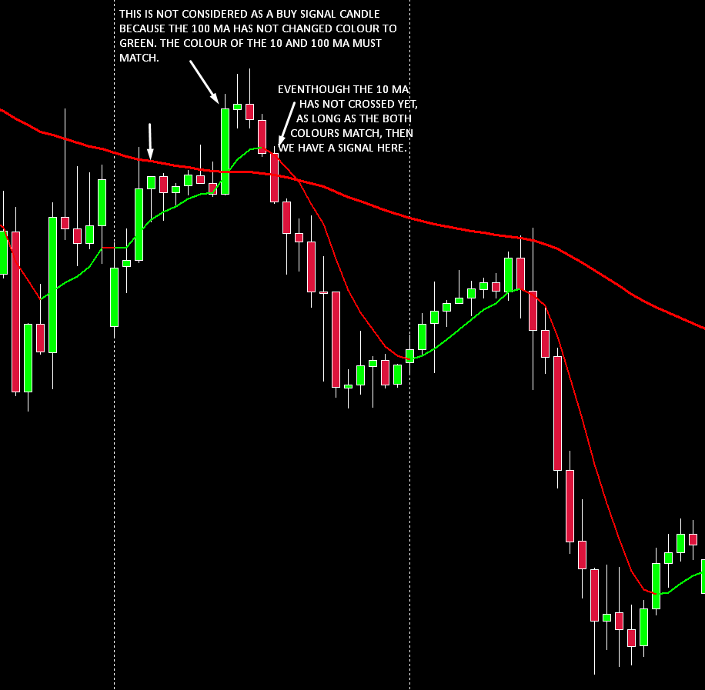

EXIT RULES : -

We exit a trade when there is an opposite signal. The opposite signal is when a candle closes in opposite direction of the 10 MA. We may need a buffer to close if price moves ___ number of pips from high or low of the exit signal candle. If the exit is not triggered and price goes back and close at the other side of the MA, the signal candle becomes invalid, then we wait for another exit signal candle.

THE FULL SYSTEM DIAGRAM

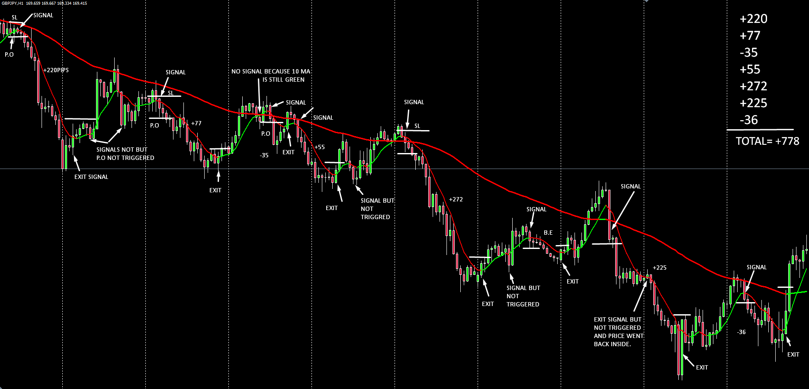

This is by trading it manually. Imagine if Casino is doing it for us and working on the 28 pairs at the same time. That would be close to a Holy Grail.
We may decide to trade both direction without using the trend MA for direction but it’ll cause a lot of losing trades. So to avoid this, it is recommended to only take trades in the direction of the 100 MA.

GOOD LUCK
MM.

