JibalaPasan
Quoting flx69
{quote} @Jibala, I was reading up on all posts since I left on holidays, when I came across this post. Most successful scalpers seem to agree that the key to success is studying price action on the charts (which is what I did during my holidays ;-) I was struck by the fact that - apparently - you don´t even study/watch the charts anymore. This, in combination with the relatively high "hit rate" you have, made me curious as to what "necessary information" is displayed on your dashboard ? I recall that in one of your posts a while ago, one of the...
Since we are using a scalping system, chart hopping might become very stressful to monitor many charts. The idea behind the development of a Dashboard was to display all necessary information for 15 pairs at present. At the end, if all criterias are matching, there is a buy / sell signal.
What are the informations / filters displayed on the dashboard?
- a relative strength meter incl. a RSI (small arrows inside the strength meter)
- an absolute strength meter which effectively shows the strength between the two currencies
- a time based strength filter (different values for different market openings / conditions)
- a spread filter (Oanda likes to play with the spread!)
- News indicator for the red news
- Trend direction (above or below DO incl. a 7 pip buffer)
- RmUp / RmDn incl. a 3 pip buffer
- a SMC - Filter (SMC = Smart Money Change)
- Market times / openings
- bid / ask price
- signal
Try to visualize how the matrix of the Dashboard looks like with all this information! Do we need anything more? Absolutely not, because all is at one hand! No stress, just waiting on signal and then open the chart. The Dashboard is an external application based on raw tick data from meta trader!
@all: This statement is with no argument! You asked about the secrets behind our (yes our, because its not only me) trading and I answered. If you ask google you'll find more about it. Thus, full stop here!
Tomorrow we start our trading office and the "Boss" will have one more student beside me. Therefore I might have time to continue reading beside my duties, but there will be more theory in teaching also.
I wish you all a good time and many green pips always!
Jibala
http://www.forexfactory.com/showthre...18#post7708018
I've corrected my trading hours and the time filter was modified such that signals currently only each of the first two hours of each session (Tokyo, London, New York) is output. On FF is completely omitted
after you started your session, just look for the first possible entry above / below DO in accordance to the rules and place orders. Don’t go for the 2nd, 3rd or 4th level above / below DO. Actually it is too risky!
Jibala
http://www.forexfactory.com/showthread.php?p=7691975#post7691975

You can believe in it or not, but it makes the difference! Many times I saw the guys here failing because the trade was against H4 and "we" didnt take it! Therefore for us it has been extended to D1-H4-H1-M15 and only if all shows the same direction it is a valid signal.
Jibala

Can you explain the filters? Thank you.
Its answered already!
http://www.forexfactory.com/showthre...18#post7708018
One more filter has been added to the WSD, makes the choice of trades more easy and safe. Since trades above or below 30 / -30 pip from DO have a higher rate to fail, a filter was implemented not to show signals above / below anymore.
We need just 2 trades / day out of 15 pairs, thus PDF & BCC is the only key to success!
Jibala
http://www.forexfactory.com/showthread.php?p=7731070#post7731070

Quoting flx69
{quote} Nice results JiPa ! But, according to "which rules" or which system are you trading ? The H1 system, the M15 system ? A mix of the two ? flx69
The automated trading is not based on any time frames. It is based on raw tick data coming from metatrader and it uses price action and strength (asm & rsm). SL 10 with TP 7.5
If I trade manually I use m30 chart and both entries 50 + 00(0) with TP of 7.5 pip. The crv is changing amazingly! 2 winner + 1 loser = still + 5 pip
Jibala
http://www.forexfactory.com/showthread.php?p=7913188#post7913188

Quoting moretti12
@ Jilbala I can see you are experimenting with a 7-8 pip target, how long have you been doing that and what is your success rate? btw.. are your stop loss still 10 pips?
We are not experimenting with a new set of TP it is a very simple formula if you analyze some hundreds of trades. We've analyze that in most of the trades the 1st move is good for 10 pip or a bit more even. Thus the formula for TP is 10 - (spread + comm.) = ~8.2 to 9.3. SL is still the same, therefore our RR has become much better. All depends on price action & strength!
Jibala
http://www.forexfactory.com/showthread.php?p=7970127#post7970127

Quoting Emmpoli
{quote} It is either i'm understanding you better @ jibala or my brain is swelling. correct me if i'm wrong, supposing GBPJPY is nicely trending up and price action gives you a good reason to take a trade(long), u will decline taking such trade if the JPY strength is not really weak or jpy is beginning to gain sudden strength. true or falls?
It's defined in the rules of the automated trading program (no EA) that strength must have certain level for buy / sell. If a pair doesn't hit that level, NO DEAL! For example strength of market is 2.33, thus the currency I'm going to buy must be >= 2.33 and PsyLevels must also be sync.
Jibala
http://www.forexfactory.com/showthread.php?p=7983749#post7983749

Quoting cigarguy
{quote} Hi Jibala, I think I missed your post answering; Do you still use the ForexProfit Supreme Dashboard or your proprietary indicator? Regards, Cigarguy
Hello cigarguy, we do not use this indicator anymore. It's not working accurate enough. Therefore a PsyLevels like this http://www.forexfactory.com/showthre...77#post7982477 has been implemented into the Dashboard.
Jibala
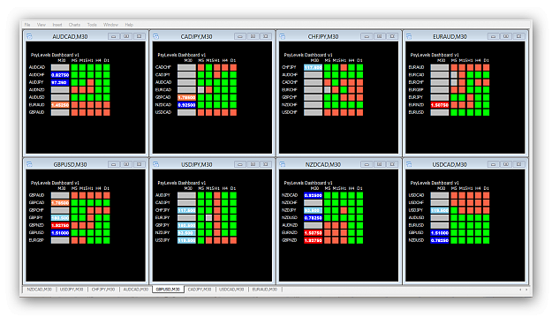
http://www.forexfactory.com/showthread.php?p=7982477#post798247
http://www.forexfactory.com/showthread.php?p=8009187#post8009187

