The Fx Sniper

When trading in lower time frame specially M1 then one must to opt the right decisions before trigger.
The strategy that I’m going to lay out use the modern weapons like THV TRIX MTF, RenkoStreet_Trend,
RenkoStreet_Channel and other channel to strengthen the analysis in the volatile situation.
I call the scalping method: FxSniper
FxSniper concentrates the duty in the volatile area, M1.
The trend M15 determines by the THV_TRIX_MTF’s Histogram indicator
The FxSniper uses 3 time frames to perform the analysis, M15-M5-M1
Indicators :
- Synergy or Heiken Ashi candle
- RenkoStreet_Trend
- TMA Line
- THV MTF TRIX
- Entry Signal Stop
-Renko channel
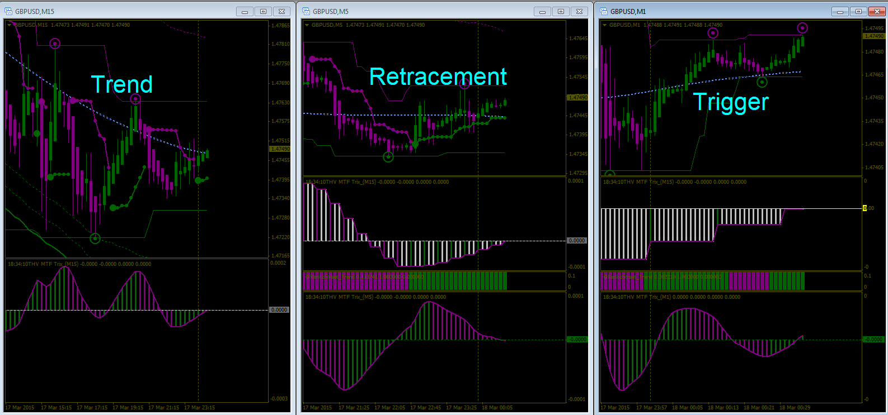

Determine the trend –M15--
To determine the trend we use THV_MTF_TRIX’s Histogram.
M15
Up Trend :
THV_TRIX_MTF’s HISTOGRAM > 0

Down Trend :
THV_TRIX_MTF’s Histogram < 0
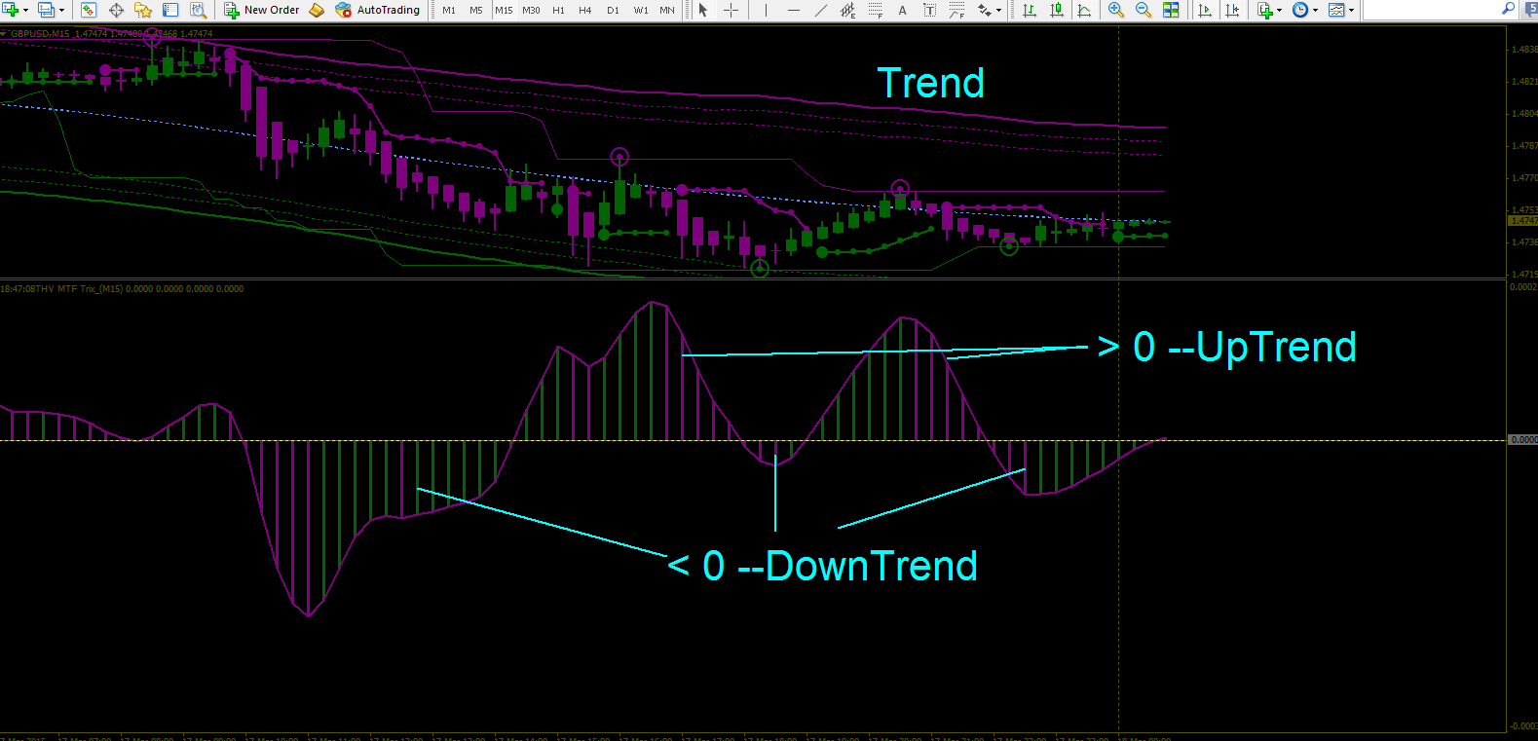

Retracement near the end --M5--
To identify the full retracement then two steps must be happened.
M5

Down Trend :
Step1 : Big dot (Signal Entry Stop) painted green
Step2 : Purple Circle touched the purple resistance line (Renko channel)
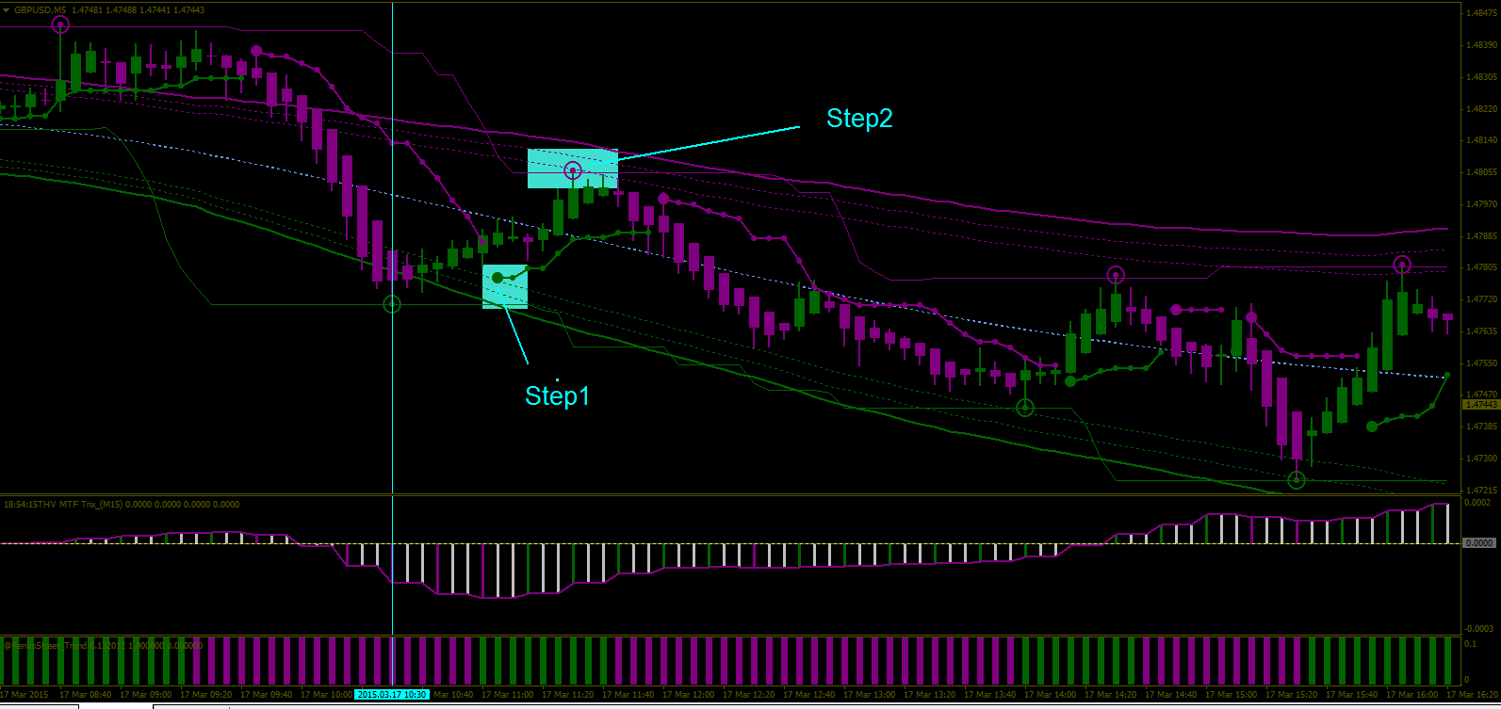

Up Trend :
Step1 : Big dot (Signal Entry Stop) painted purple
Step2 : Green Circle touched the green support line (Renko channel)
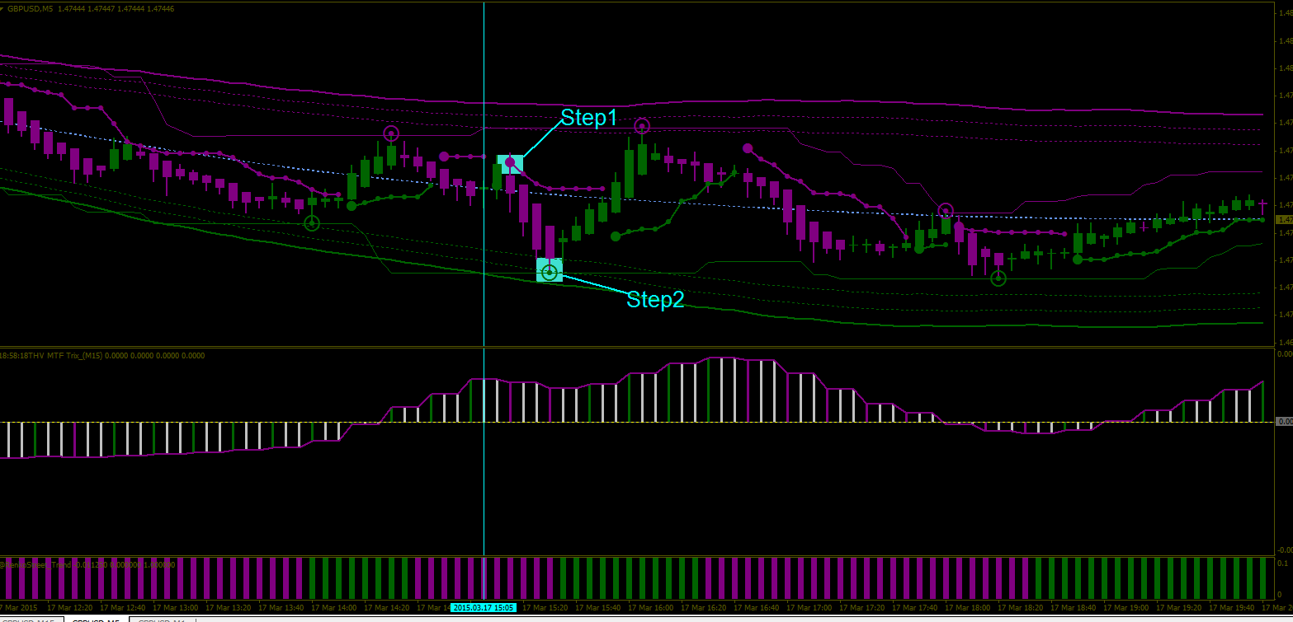

GO TO M1 FOR ENTRY POINT

Entering a trade –M1—
Very best signal entry when price trades above the middle or near the upper channel
M1

Short Trade
i) Purple Circle touched the purple resistance line (Renko channel)
ii) Candle painted purple
iii) THV Trix MTF(M15)’s Histogram is below the zero line
iv) THV Trix MTF(M1)’s Histogram painted purple > 0 (High Probability Signal)
vi) RenkoStreet_Trend painted purple


