The secret entry of the Hedges Funds System

The system is used the trend following to determine the direction of the market.
The Hedges Funds do their analysis in Monthly, Weekly and Daily charts and they enter their trades in 4 hour chart. If we, the Dumbs Money, can identify the trend in H4 then we can ride the wave along with the Big Boys.
The trend H4 determines by the RenkoStreet_Trend indicator
The secret entry of the Hedges Funds System uses 3 time frames to perform the analysis, H4-M15-M5
Indicators :
- Synergy or Heiken Ashi candle
- RenkoStreet_Trend and RSI(9)
- TMA Line
- THV MTF TRIX
- Supertrend
- Entry Signal Stop
-Renko channel
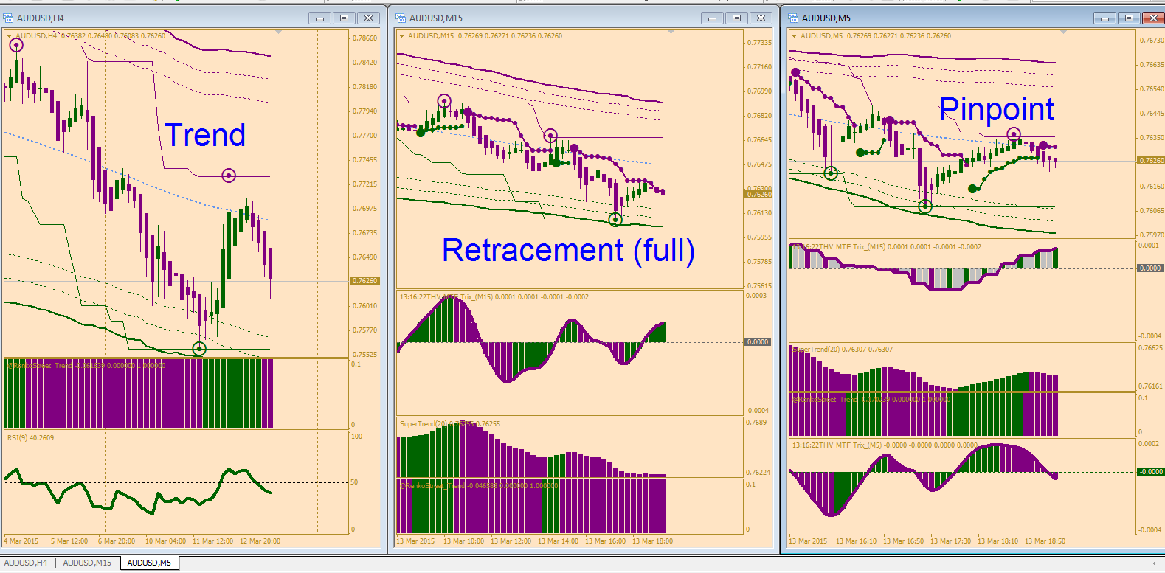

Determine the trend --H4--
To determine the trend for the first time we must use 2 indicators to confirm the prevailing trend.
H4
Up Trend :
Candle and RenkoStreet_Trend painted green + RSI(9) > 50
Once the prevailing trend is confirmed then we keep only the RenkoStreet_Trend indicator a long the road as the current trend. We can ignore the RSI indicator.

Down Trend :
Candle and RenkoStreet_Trend painted purple + RSI(9) < 50
Once the prevailing trend is confirmed then we keep only the RenkoStreet_Trend indicator a long the road as the current trend. We can ignore the RSI indicator.

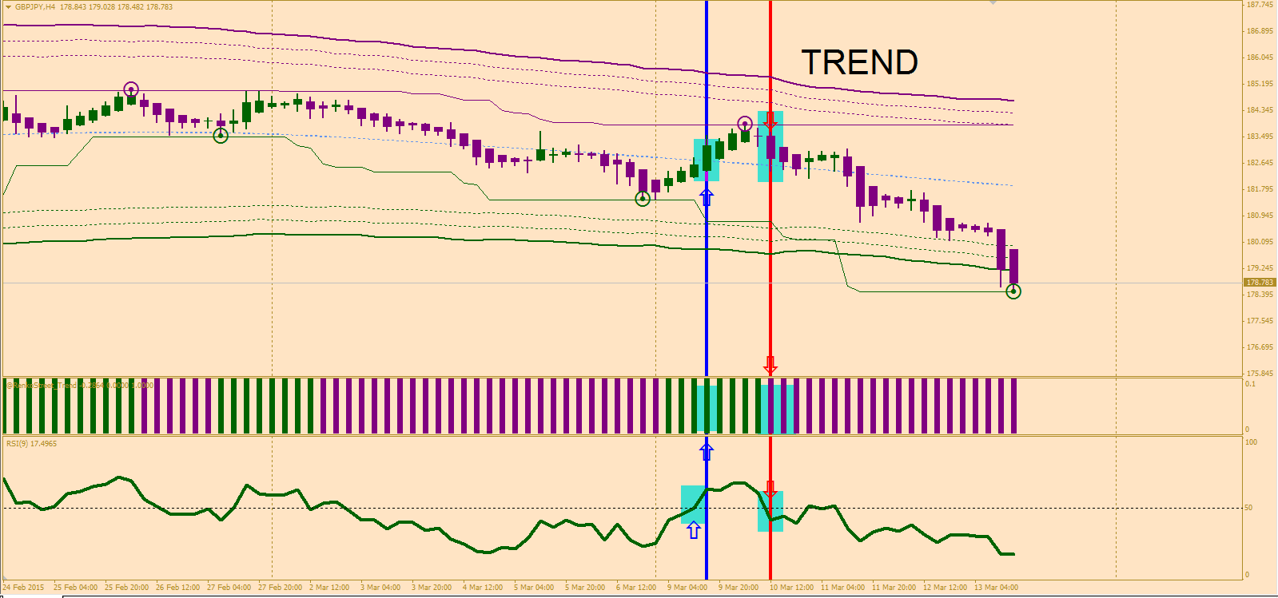

Retracement near the end --M15--
To identify the full retracement then two steps must be happened.
Down Trend :
Step1 : Big dot (Signal Entry Stop) painted green
Step2 : Purple Circle touched the purple resistance line (Renko channel)
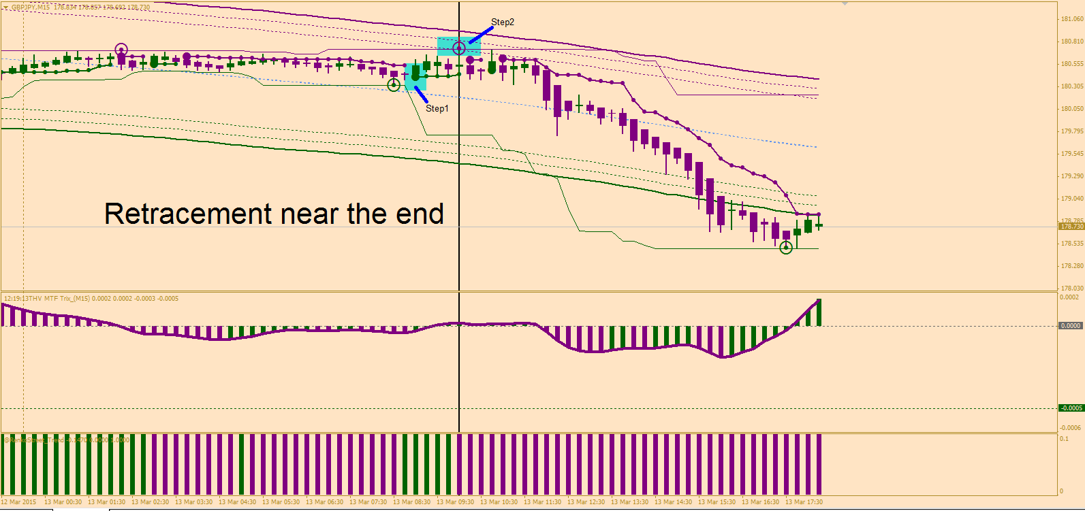

Up Trend :
Step1 : Big dot (Signal Entry Stop) painted purple
Step2 : Green Circle touched the green support line (Renko channel)
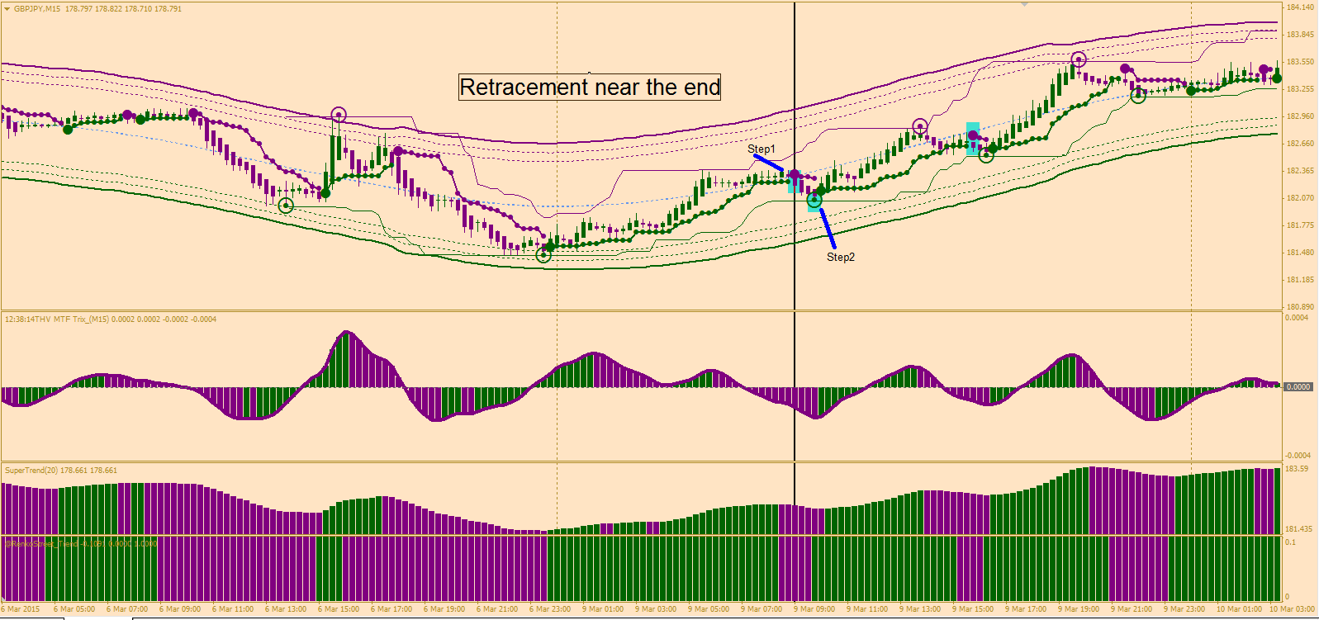

GO TO M5 FOR ENTRY POINT

Entering a trade --M5—
Very best signal entry when price trades above the middle or near the upper channel
SHORT TRADE

Aggressive
i) Purple Circle touched the purple resistance line (Renko channel)
ii) Candle painted purple
iii) THV Trix MTF(M15)’s Histogram painted purple above or below the zero line
iv) THV Trix MTF(M5)’s Histogram painted purple > 0 (Best) or below the zero line
v) Supertrend painted purple
vi) RenkoStreet_Trend painted purple
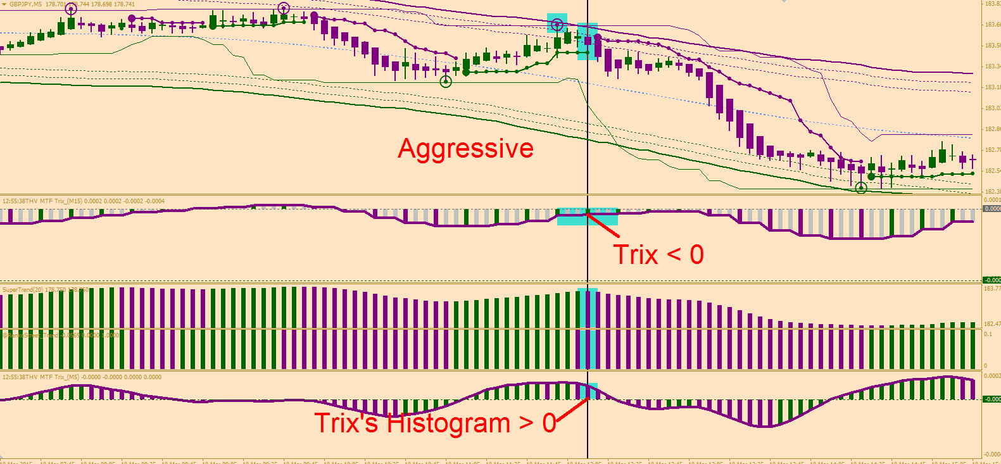

SHORT TRADE

Conservative
i) Purple Circle touched the purple resistance line (Renko channel)
ii) Big dot painted purple (Cynthia’s entry signal entry)
iii) THV Trix MTF(M15)’s Histogram painted purple above or below the zero line
iv) THV Trix MTF(M5)’s Histogram painted purple > 0 (Best) or below the zero line
v) Supertrend painted purple
vi) RenkoStreet_Trend painted purple


