The journey in the forex world
i) Trend following
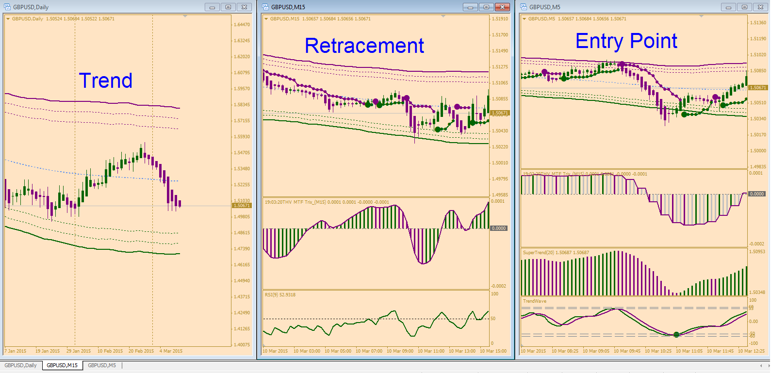

On the daily chart, we look the last HA candle :
1- If Synergy candle is purple ---- Downtrend
​2- If Synergy candle is green ---- Uptrend
NB.: Synergy or Heiken Ashi is not repaint
It is very simple !
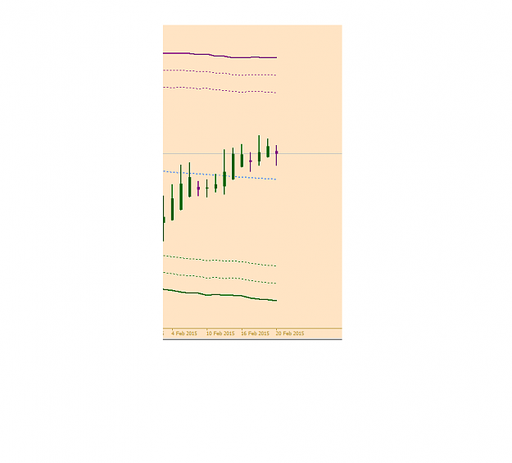

15 minute chart : Retracement
1- The daily trend is down then we wait the first signal entry stop to be painted green

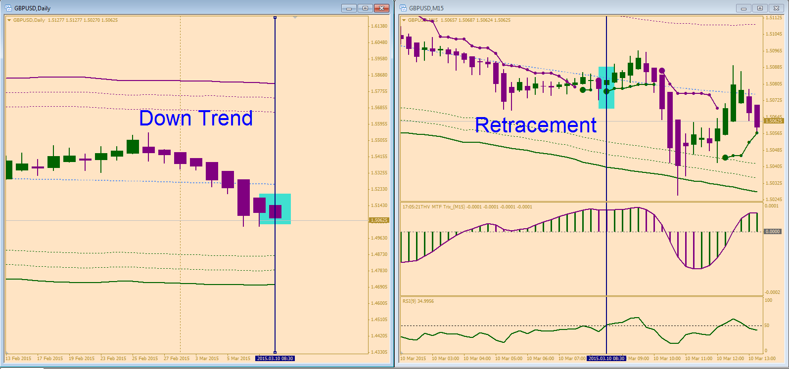

2- The daily trend is up then we wait the first signal entry stop to be painted purple

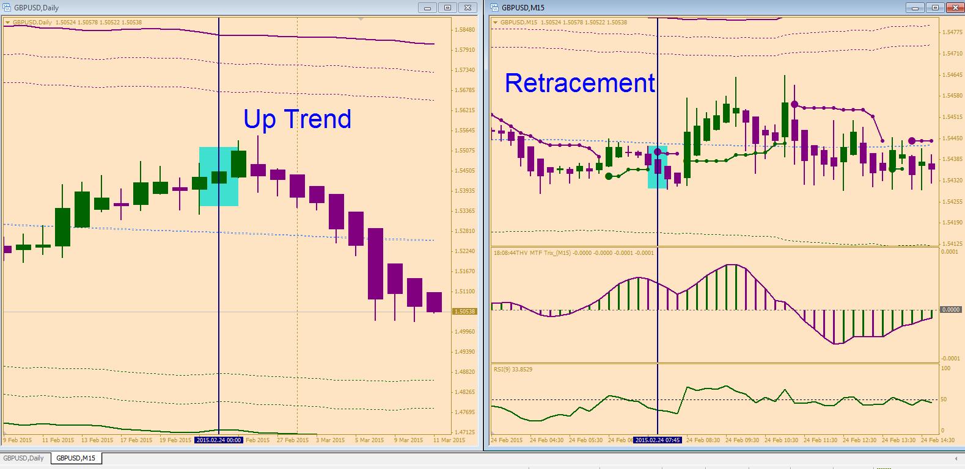
THEN GO TO 5 MINUTE CHART TO LOOK A PINPOINT ENTRY
5 minute chart : Pinpoint an entry
SHORT TRADE
1- Conservative :
a) Candle is painted purple and must trading above the middle channel. If price trades close to the upper channel the risk is small and the worry is less.
b) First big dot painted purple
c) THV TRIX MTF’s Histogram in M15 is painting purple

d) Supertrend painted purple

e) TrendWave crossed down

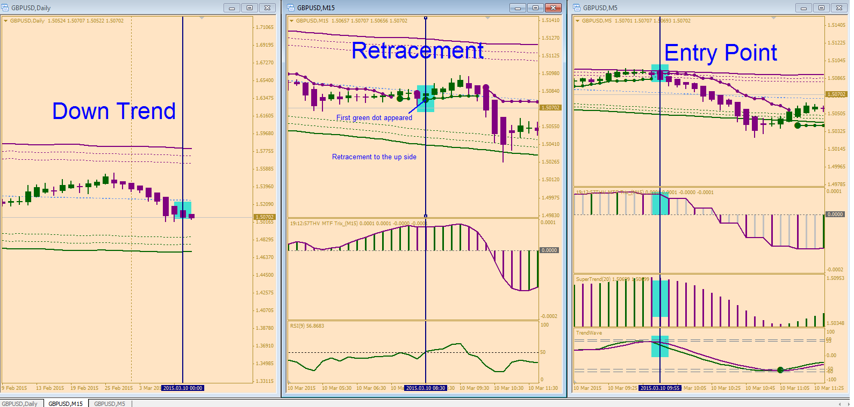

1- Aggressive :
a) As soon as candle is painted purple and must trading above the middle channel. If price trades close to the upper channel the risk is small and the worry is less.
c) THV TRIX MTF’s Histogram in M15 is painting purple

d) Supertrend painted purple

e) TrendWave crossed down

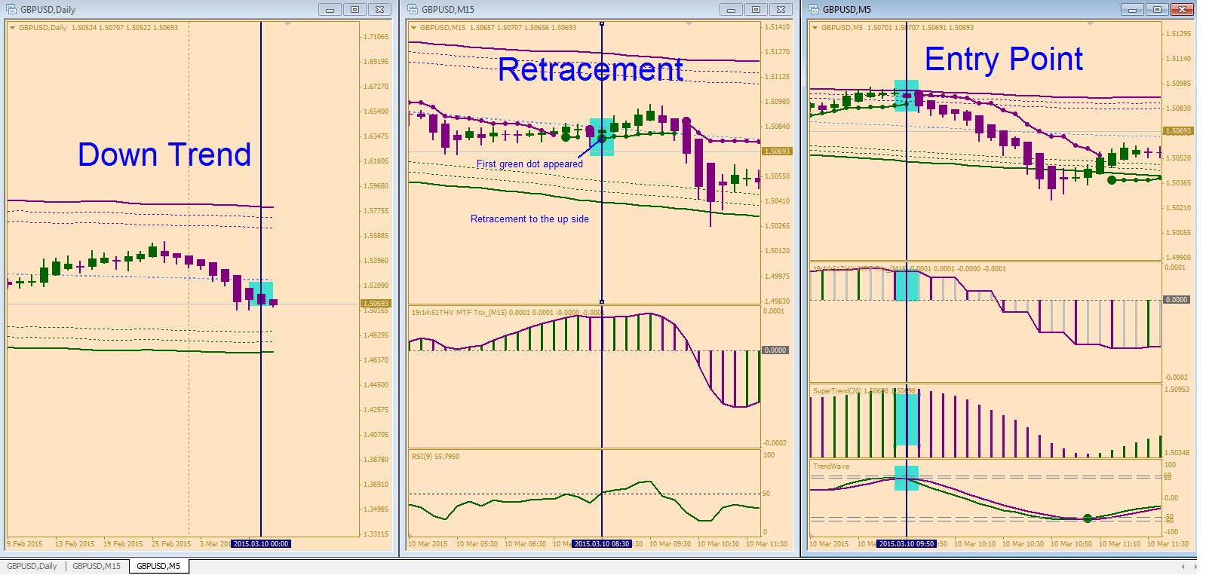

Stop Loss and Take Profit

See chart

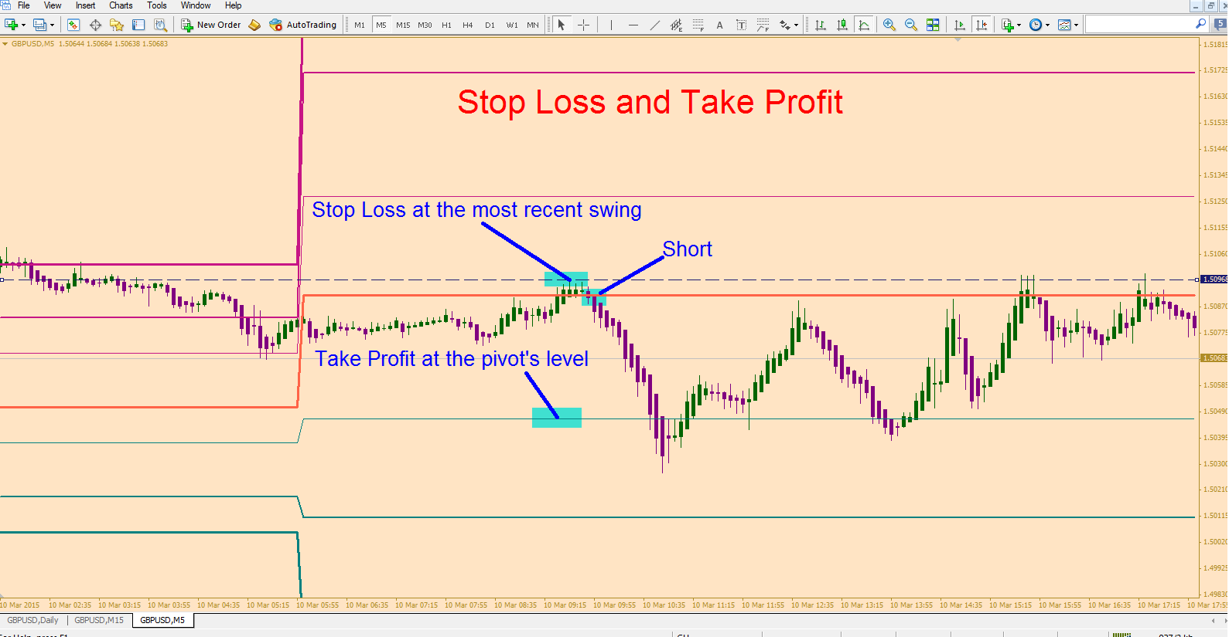

GOOD LUCK !

Sai Ram

