ATM MACHINE

The system is used the trend following to determine the direction of the market. There are 2 trends that provide the informations ready to trade:
1) The trend D1 determines by the fast THV MTF TRIX in D1 ( Prevailing trend)
2) The trend H4 determines by the fast THV MTF TRIX in H4 ( Counter trend)

For the best result, ATM machine uses 2 times frames, H1-M15.
Indicators :
- Synergy or Heiken Ashi candle
- TMA Line
- THV MTF TRIX
- Supertrend

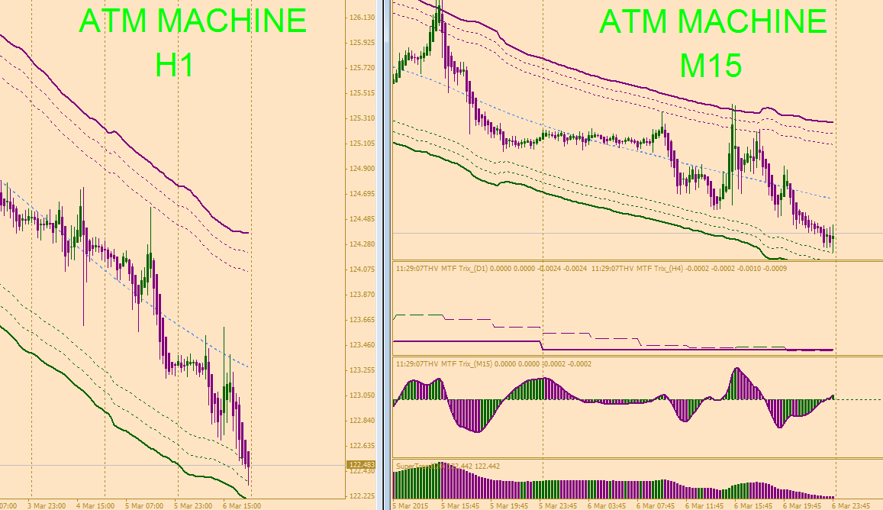

Enter a trade in M15
Short Trade : Above the middle channel or around the upper channel (Best)
a) THV MTF TRIX painted purple (Trend D1 or Trend H4 or both, or at least one of them)
b) Candle painted purple
c) THV MTF TRIX’s histogram painted purple and above the zero line (to validate the signal) important
d) Supertrend painted purple
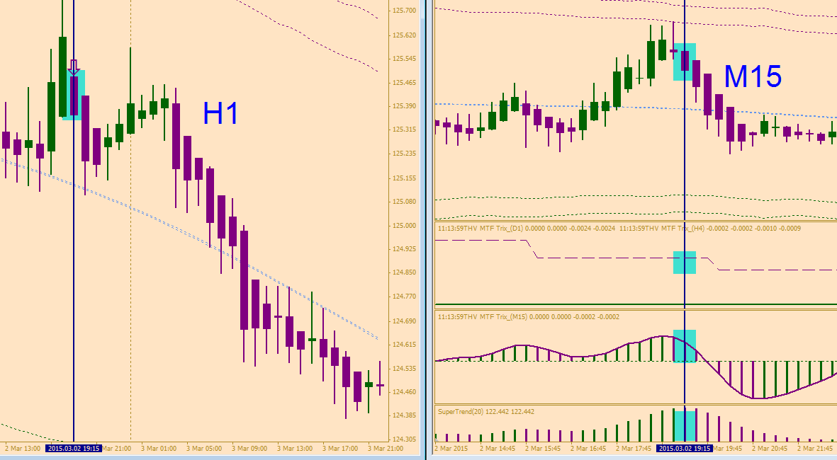
e) The signal in M15 must confirm the same candle in H1 is painting purple

Stop Loss and Take Profit
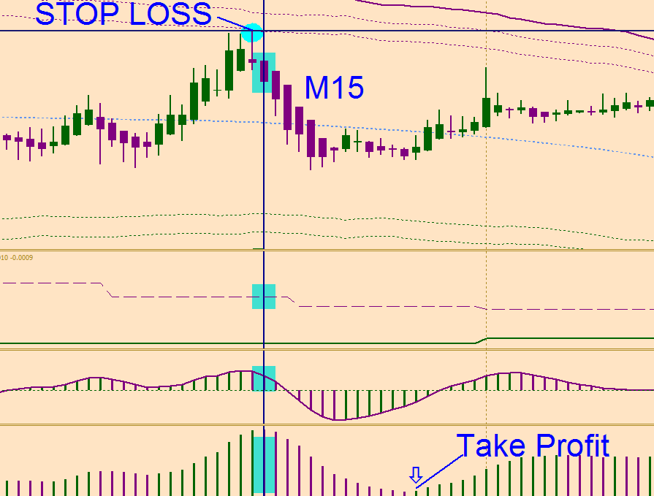
_Put SL at the most recent swing high
_TP when supertrend changes color

