INTRODUCTION :
This DashBoard is designed to provide quality information about the current market profile. With this indicator you will get chance to watch all 28 currency pairs ON 3 different time frames.

The DashBoard employs the use of 7 different indicators with special calculations to assist in predicting price movement.

The DashBoard provides the user market transparency, Calculating RANGE, Calculating POWER Ranking them and assessing points to the pairs to differentiate and help navigate the sea of uncertainty in the Forex Market.

The DashBoard compiles all of this information into a powerfully synergistic approach.

Any of the DashBoard users will able to see the strongest and weakest pairs. By movement average calculation you will be protected against buying high and selling lows.
Spread vs average will provide information about pairs and their fluctuating spreads. It aids in protection during news releases when brokers widen spreads to protect themselves. Even though you may normally experience a 2 - 3 pip spread on pairs around
NFP (The Bureau of Labor Statistics releases preliminary data on the third Friday after the conclusion of the reference week, i.e., the week which includes the 12th of the month, at 8:30 a.m. Eastern Time;[5] typically this date occurs on the first Friday of the month. Nonfarm payroll is included in the monthly Employment Situation or informally the jobs report and affects the US dollar, the Foreign exchange market, the bond market, and the stock market.) or
FOMC (The announcement of whether the Federal Reserve has increased, decreased or maintained the key interest rate. The FOMC meets eight times per year to decide on monetary policy. After each meeting policy decisions are announced. The main task of the FOMC is to set the monetary stance by fixing the overnight borrowing rate, which essentially sets short-term lending rates in the US. Through this mechanism, the FOMC attempts to affect price levels in order to keep inflation within the target range while maintaining stable economic growth and employment.) and many other HIGH ranked fundamental news releases the spread can increase to 2 - 3x the normal amount affecting the scalping opportunities of your trade. Some of the features mentioned are designed to protect the trader in essence the DashBoard is a tool to make your trading life easier.
How to Setup :
- Download all data.ex goes in to script folder (Files > Open Data Folder > MQL4 > Scripts)
- Rest of all files goes in to Indicators Folder (Files > Open Data Folder > MQL4 > Indicators)
- Open MT4 > Tools > Options > Graphics > Max bar’s on the chart above 10000
- Open M1 chart - Run Download All Data script as shown on the Picture
- (If any alerts or errors you have please contact with me from skype id: Rma.mt)
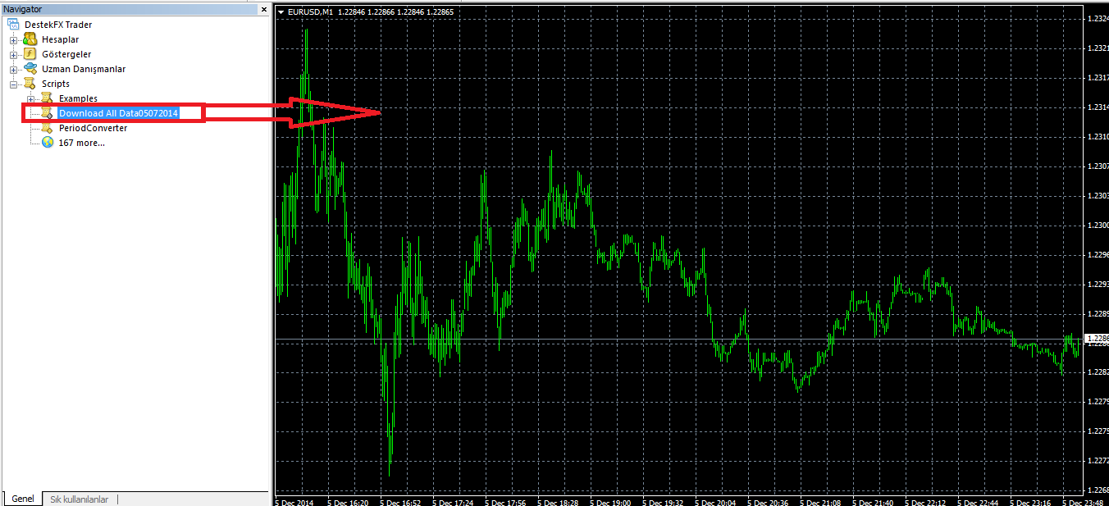

- After download complete open M1 Chart which is Not JPY pairs to run DashBoard Drag Breakout.ex in to the chart
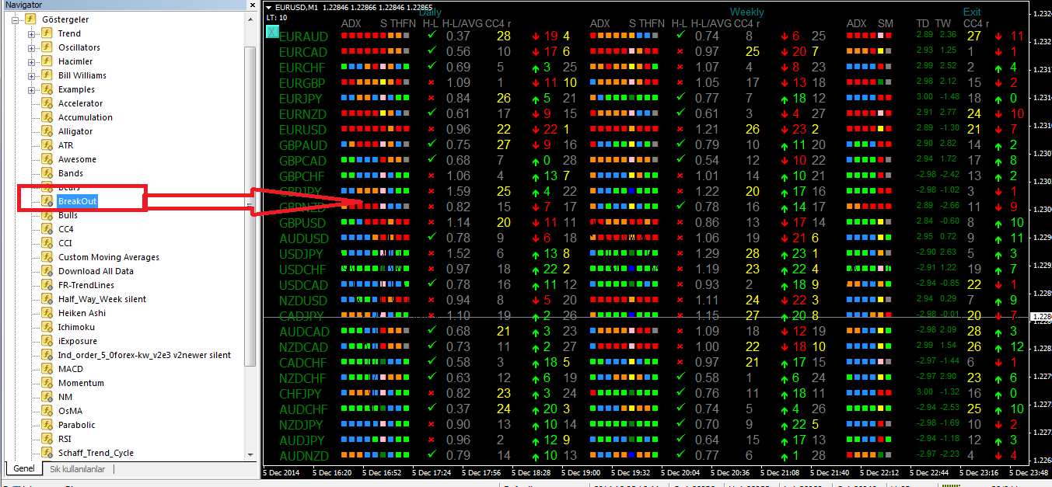

WEEKLY AVERAGE TAKE PROFIT AND ENTRY LINES
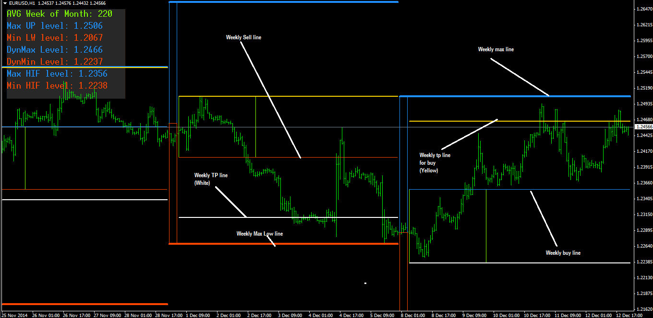

H-L PART EXPLANATION
-This is Half daily lines shown on the Picture. When price gets closer to White or yellow Line Example Daily : IF price movement avarage is 100 pips for day and EURUSD Moved 80 pips (%80 OF THE avarage ) H-L Part will turn in to X on DashBoard 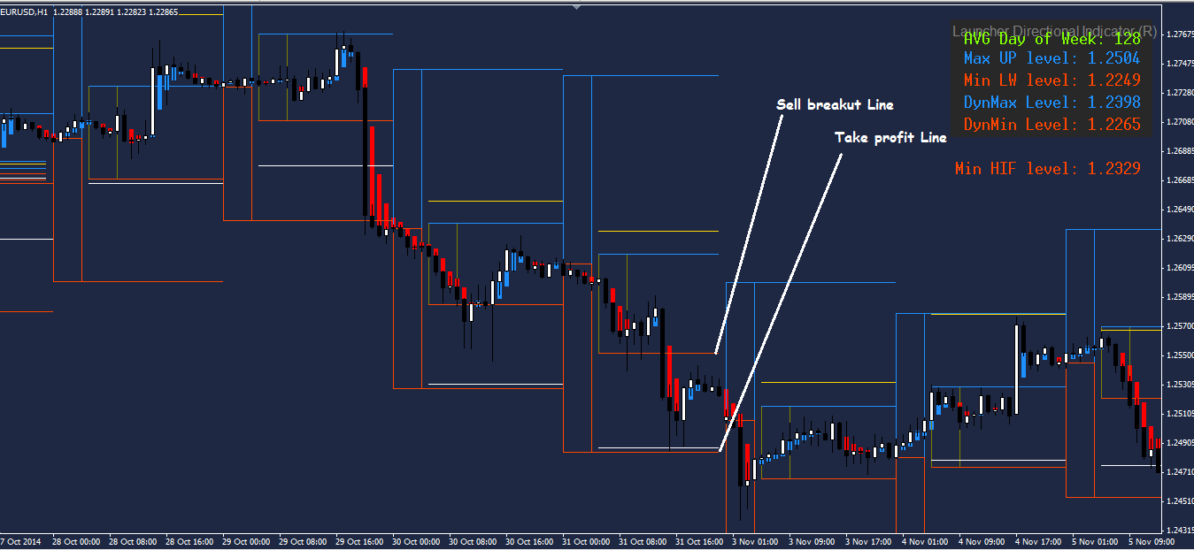

Example Weekly : IF price movement average is 300 pips for week and EURUSD Moved 240 pips (%80 OF THE avarage ) H-L Part will turn in to X on DashBoard
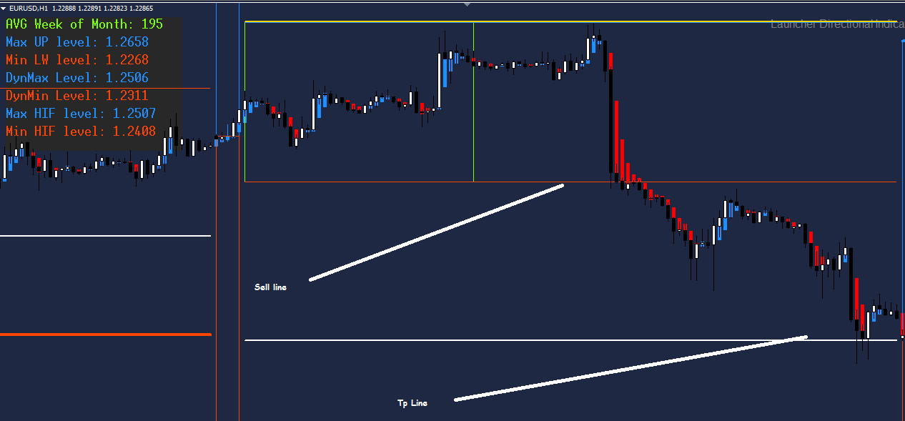

TOTAL POINTS AND RANKING
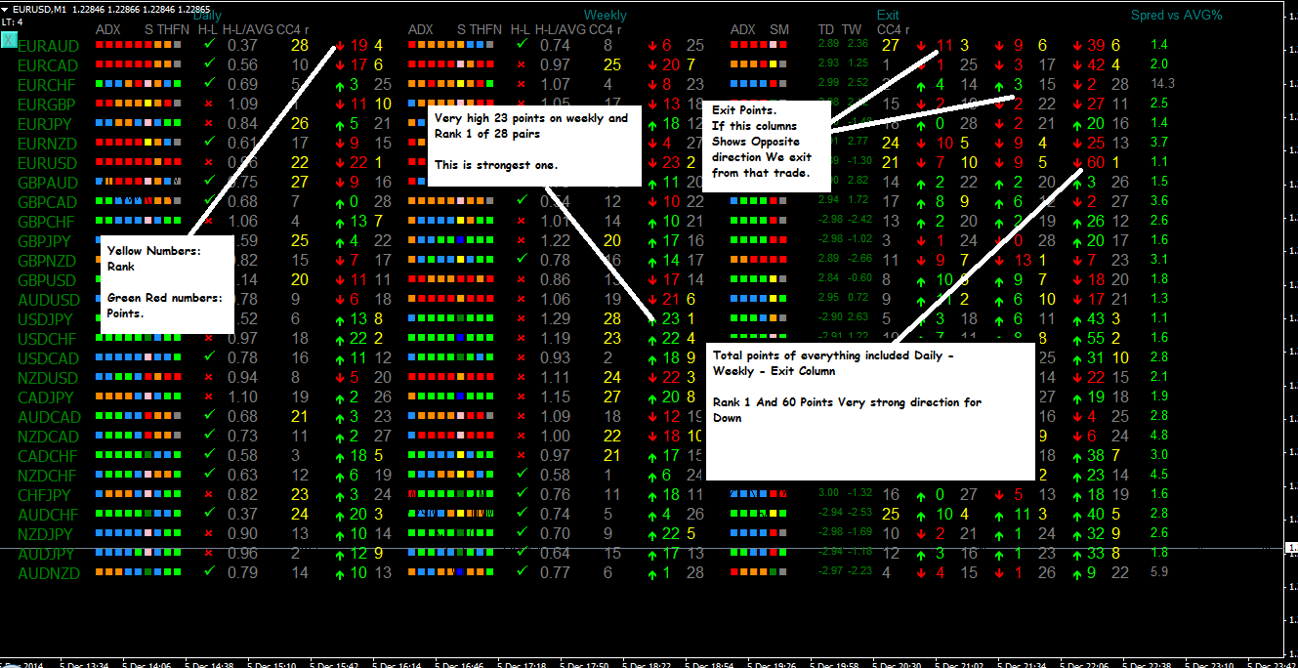

QUESTIONS –
-What is HL PART ?
-H-L Part on DashBoard turns in to RED X To tell you there is no more room left and you have to be careful.
-What is CC4 ?
-CC4 is another strength indicator , Yellow and closer numbers to 28 are stronger.
-How can I manage my stop loss ?
-We are suggesting to put your Stop loss according to Daily average , Example , If EURUSD have 100 pip daily movement average stop loss can be calculated as -25 pip.
-What is ADXSMN ?
- They are following indicators which is
Adx = 5 Box , S = Schaff TrendCycle , T= Trend Indicator, H= Half Daily Indicator , F= FR-Trend Lines, N= CYCLE they are feeding total points and ranking part.
-What is the difference between weekly, daily and exit parts ?
Daily part of DashBoard : -Based on M30 Time Frame (Adx periods) -Based on Half Daily (H-L Avarage
Weekly part of DashBoard : -Based on H1 Time Frame (Adx Periods) -Based on Half Weekly (H-L Avarage)
Exit part of DashBoard -Based on M15 Time Frame (Adx Periods)
-What is that colours what they mean ?
Adx = 5 Box. (5 Different Periods)
All Red = Strong down move ,
All Green = Strong up move
Orange = Direction Down No Power
Blue = Direction Up No Power
S = Schaff TrendCycle
Do not focus on colours here , Its feeding Total Points to get more predictive results.
T= Trend Indicator.
Red Box = Strong Sell ,
Green Box = Strong Buy
Orange = Direction Down No power
Blue = Direction Up No Power
H= Half Daily Indicator
Orange : Price Below Daily open and dont make breakout yet.
Blue : Price Above Daily open and dont make breakout yet.
Red : Price Below Daily open and made breakout
Green: Price Above Daily open and made Breakout
F= FR-Trend Lines
Red: Below Trend Lines short direction
Green : Above Trend lines Long direction
Example Entries : NO 1: Weekly Lines are Longer , Daily lines are shorter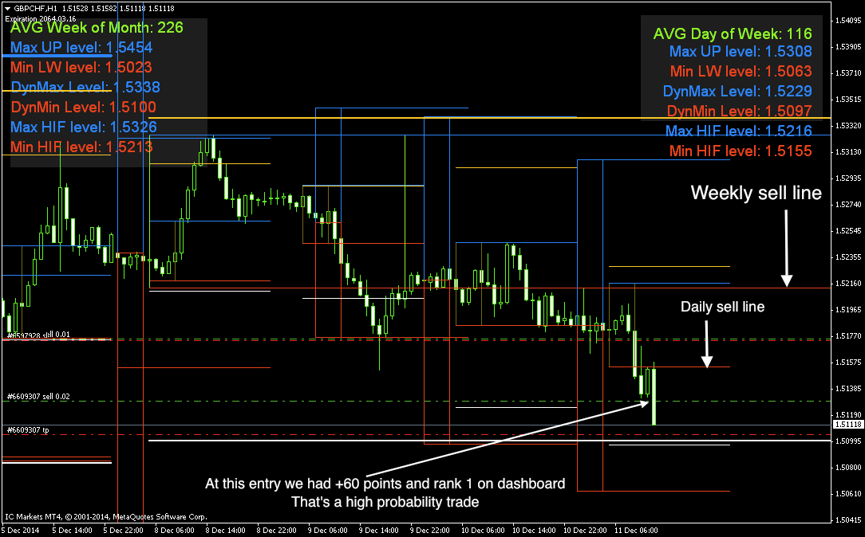
EXAMPLE ENTRY NO 2 :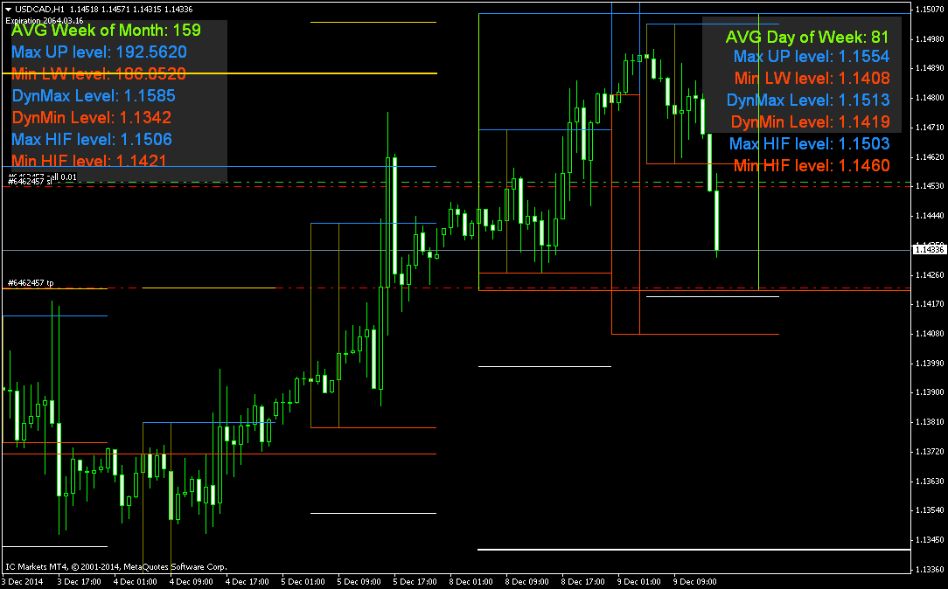

EXAMPLE ENTRY NO 3 :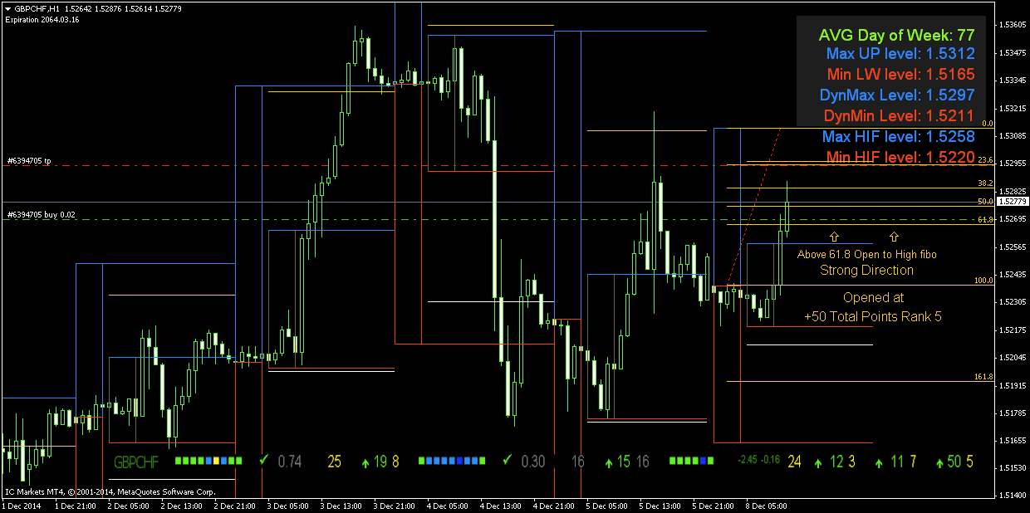

EXAMPLE ENTRY NO 4 :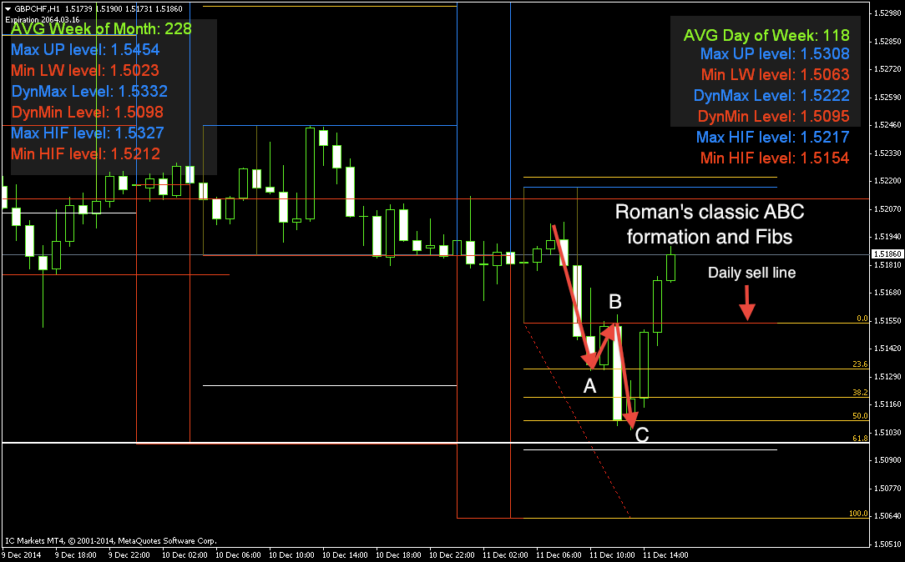
EXAMPLE ENTRY NO 5 : 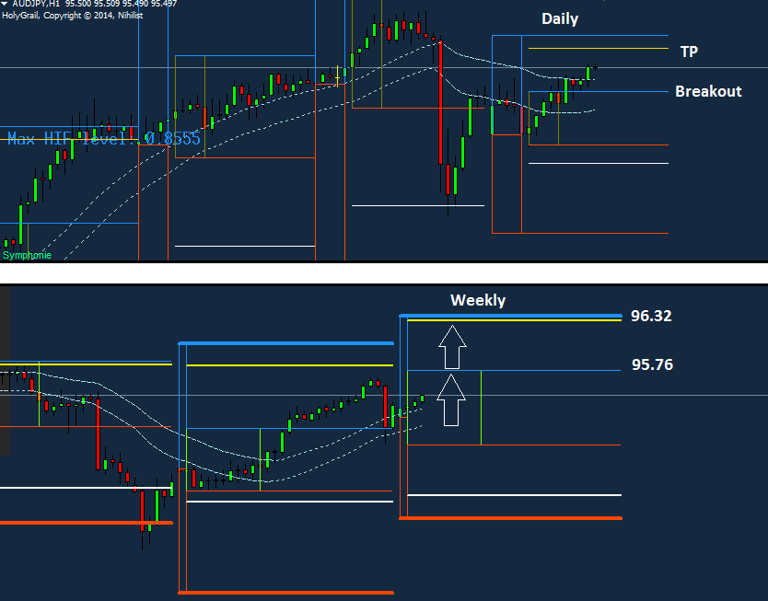

Roman Vigovski
Skype id: rma.mt

