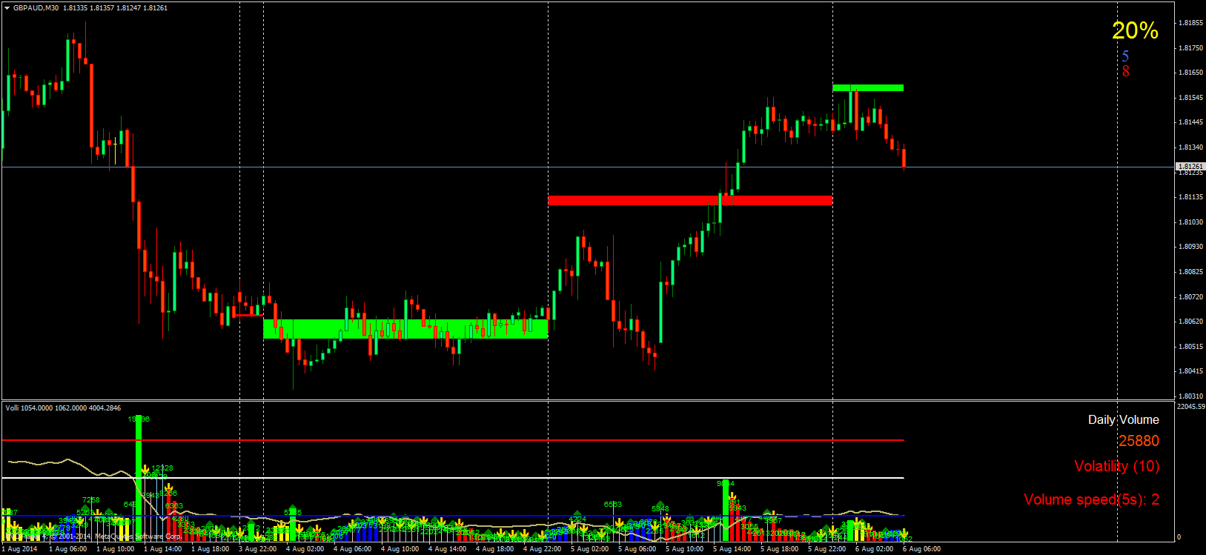

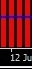
s_w = "Way";
use_show_same_way = true; / / Whether to use the allocation of volumes that goes up or fall.
count_same_way_bars = 3; / / Min. number of bars at which to start the selection.
middle_luft = 0; / /% Deviation in the value between the two volumes of readings for approximately even.

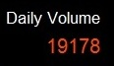
use_show_daily_way = true; / / Whether to show the daily volume.
D_label_volume_size = 12; / / Size of lettering.
Y_label_volume = 15; / / The distance from the top edge of the display.

H_vol = "Highest Volume settings";
use_highest_volume = true; / / Highlight the greatest volume.
Days_highest_vol = 9; / / Number of days of the selection.
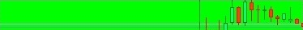
use_vol_zones = true; / / Whether to use DVZ.
days_vol_zones = 4; / / Number of days drawing DVZ.
use_lines_or_zones = false; / / Draw a line or zone.
lines_zones_width = 2; / / Thickness zones.
lines_zones_color_up = clrLime ;/ / color zone volume up
lines_zones_color_down = clrRed ;/ / color zone volume down
lines_zones_ray = false ;/ / whether to draw a ray zone or within a day.
lines_zones_back = true ;/ / paint any area.
show_opositeC_zones = false;// whether to draw zones on a new method.
use_sunday_shift = false ;/ / use temporal shift. Needed if the broker starts trading on Sunday.
sunday_minutes_shift = 120 ;/ / the number of minutes the time shift.

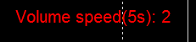
sv_set = "Volume speed settings";
show_vol_speed = true; / / show whether the speed of volume.
interval_seconds = 5; / / period of seconds for which the count speed of the volume.
label_IS_size = 12; / / size of label “speed volumes”.
label_IS_corner = 1; / / corner of label “speed volumes”.
label_IS_X = 20; / / distance along the X axis of label “speed volumes”.
label_IS_Y = 120; / / distance on the Y-axis of label “speed volumes”.
label_IS_high_col = clrLightBlue; / / color of label “speed volumes” if the value is greater than the specified.
label_IS_mid_col = clrWhite; / / color of label “speed volumes” if the value is in the range of the specified bounds.
label_IS_low_col = clrRed; / / color of label “speed volumes” if its value is less than specified.
label_high_level = 20; / / top speed level volumes.
label_low_level = 4; / / lower speed level volumes.

arr_ = "Arrows";
use_arrows = false; / / Whether to draw arrows when changing direction volumes.
otstup = 10 ;/ / indent arrows from the top of the volume.
arr_code_up = 233 ;/ / code for the up arrow.
arr_code_down = 234 ;/ / code for the down arrow.
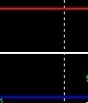
li_ = "Lines";
use_lines = true ;/ / whether to draw the line.
line_width = 2 ;/ / thickness of the center line.
line_color = clrWhite ;/ / color of the center line.
line_low_width = 2 ;/ / thickness of the bottom line.
line_low_color = clrBlue ;/ / color of the bottom line.
line_low_percents = 20 ;/ / location of the bottom line in% relative to the height of the volume.
line_high_width = 2 ;/ / thickness of the top line.
line_high_color = clrRed ;/ / color of the top line.
line_high_percents = 80; location of the bottom line in% relative to the height of the volume.

per_sh = "OBV label";
use_obv = true ;/ / whether to draw OBV (OnBalanceVolume).
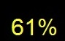
use_obv_label = true ;/ / whether to draw in OBV%.
obv_normal_size = 19 ;/ / size in OBV%.
obv_zones_size = 28 ;/ / size in OBV% if its value is greater than a predetermined upper level or below the lower predetermined level.
low_percents = 20 ;/ / lower level.
high_percents = 80 ;/ / upper level.
obv_color_centr = clrYellow ;/ / color OBV% in between levels.
obv_color_low = clrLightBlue ;/ / color in OBV% below the lower level.
obv_color_high = clrOrangeRed ;/ / color in OBV% above the upper level.
obv_X = 20 ;/ / distance OBV% in from the right edge.
obv_Y = 20 ;/ / distance OBV% of the top edge.
obv_corner = 1 ;/ / angle in OBV%.

p_s = "Points settings";
use_points = false ;/ / whether to draw the numerical value of the volume volume.
distance_point = 80 ;/ / distance digital value from the volume volume.
color_point = clrLime ;/ / color digital value volumes.
size_point = 6 ;/ / size of digital values ​​volumes.

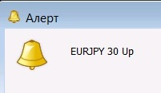
al = "Alerts";
use_sound = false ;/ / whether to use sound notification when the direction of rising or falling volumes.
up_sound = "news" ;/ / audio file name with volume growth.
down_sound = "ok" ;/ / audio file name from falling volumes.
use_alert = false ;/ / whether to use an alert when the direction of rising or falling volumes.
up_alert = "Up" ;/ / message when volume growth.
down_alert = "Down" ;/ / message from falling volumes.

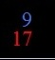
in_fo = "Count bars settings";
show_info = true ;/ / whether to draw count bullish and bearish candles from the beginning of the day.
cor_ok = 1 ;/ / angle readings counting bullish candles.
X_ok = 60 ;/ / distance readings counting bullish candle from the right edge of the chart.
Y_ok = 60 ;/ / distance readings counting bullish candle from the top graph.
ok_size = 14 ;/ / size indications counting bullish candles.
ok_col = clrRoyalBlue ;/ / color readings counting bullish candles.
cor_false = 1; / / Angle readings counting bearish candles.
X_false = 60; / / Distance readings counting bearish candle from the right edge of the chart.
Y_false = 80; / / Distance readings counting bearish candles on top of the chart.
false_size = 14 ;/ / size indications counting bearish candles.
false_col = clrRed; / / Color readings counting bearish candles.

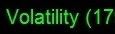
vol = "Volatility settings (ATR)";
use_show_volatility = true; / / Draw the volatility based on ATR (AverageTrueRange).
period_volatility = 14 ;/ / period ATR.
level_volatility = 13 ;/ / the level above which a volatile market, below is not volatile.
use_volatility_koef = true ;/ / whether to use the multiplication factor for ATR.
volatility_koef = 10000 ;/ / multiplier on ATR.
use_transform_JPY = true ;/ / consider ATR multiplier for currency pairs with currency JPY.
digits_volatility = 0 ;/ / rounding data volatility.
size_label_volatility = 12 ;/ / size volatility readings.
Y_label_volatility = 75 ;/ / distance from the top of the indicator readings for volatility.
low_volat_color = clrRed ;/ / color readings volatility.
high_volat_color = clrLime ;/ / color volatility readings above a predetermined level.

?
oth_se = "Other settings";
update_once_in_bar = false ;/ / update the data once the candle.
update_tf_bar = 1; / / Select TF candles for updates.

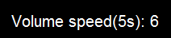
extern string sv_set = "Volume speed settings";
extern bool show_vol_speed = true; //whether to show volume speed
extern int interval_seconds = 5; //interval of count and update

