Ok, like what I said, here we go with explanation for the ForexProfitSupreme Meter. May Udine forgive me / us for this post, but since still many of you are without success in this great strategy / system, he hopefully will understand. If for any case not, he has the right do delete this post again since we promised not to start discussing about additional indicators.
As most of you may know, this indicator is part of a complete system, the Forex-Profit-Supreme-System. So then there are some other rules in how to handle with it.
The two parts of the indicator, relative strength panel on the right and the left we really dont know how its calculated and its much different from ours! But it really doesn't matters, since we just took a trade only by watching the rsm.
When the order was placed, we only looked at the panel on the left side. And this was a big mistake! We should have a look on the right panel first. Just compare for yourself.
Attached Image (click to enlarge)
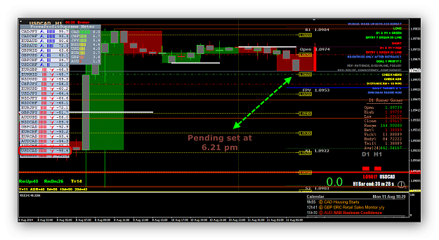
On the left side the USDCAD is in a very good position for a sell order. But what about the relative strength on the right? It doesnt look really promising! Although CAD is on the top, but what about the USD?
Attached Image (click to enlarge)
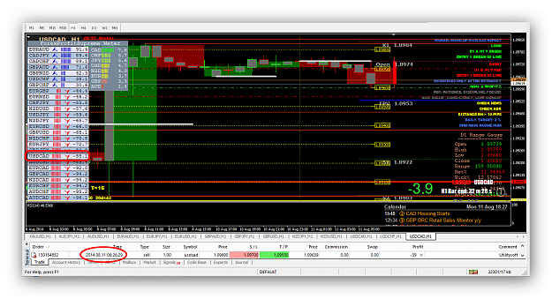
Therefore it happened what should happen. USD becomes stronger and price went opposite almost to SL!
Attached Image (click to enlarge)
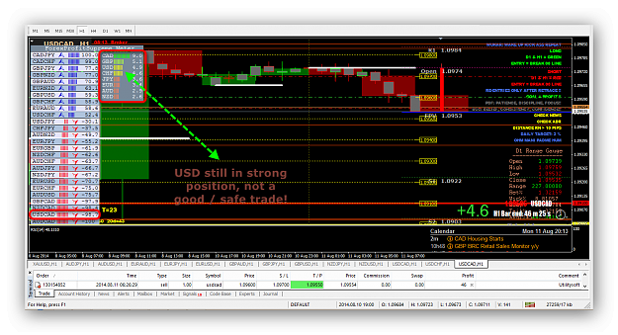
Have a look on M1 chart for yourself and compare how the price moved. Keep on mind to trade only the top against the bottom! You will have less trades but more safe. And - there is no warranty for a winning trade!
Attached Image (click to enlarge)
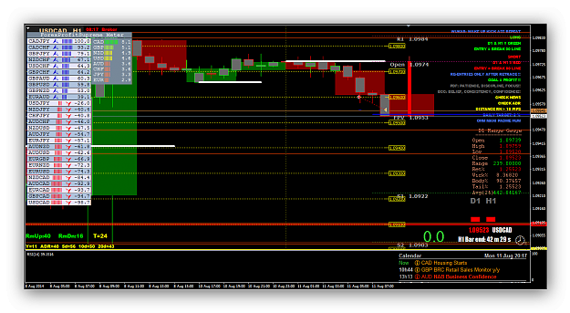
It's very easy once you understand how it works. Always remember it's better not to take a trade than to lose a trade. There are many opportunities all over the day / week / mth / year.

Gud morning everybody! Just another sample of our trading, to show that the FPS indicator is not the "holy grail" some of you may expect.
Trade #1 AU TP.
Attached Image (click to enlarge)
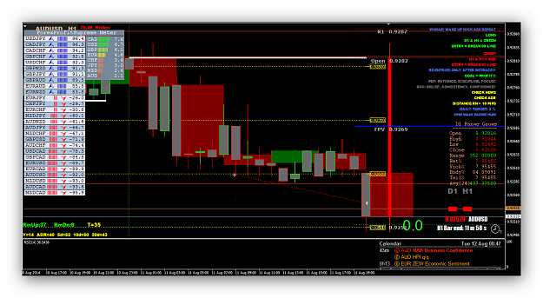
It was mentioned some posts ago that you have to understand, accept and adjust on current market conditions! Last evening we got a signal on AU. Therefore we checked the FPS and it looked good. Not pretty good but good.
Attached Image (click to enlarge)
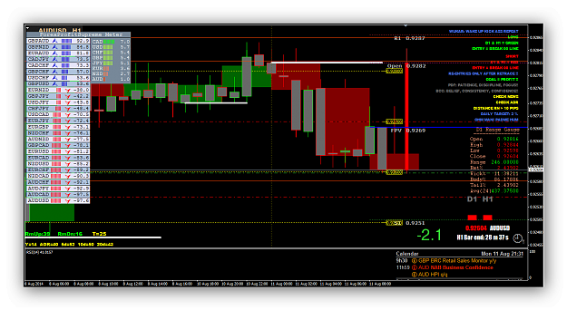
Finally it took 10,5h to trigger TP! What I wanna tell you, it's still holiday season, the market is weak! You have to be very careful by chosing the right battles.
Attached Image (click to enlarge)
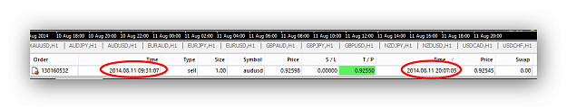
Wish you all gud luck and lots of green pips!
Jibala

Trade #2 NJ TP.
Attached Image (click to enlarge)
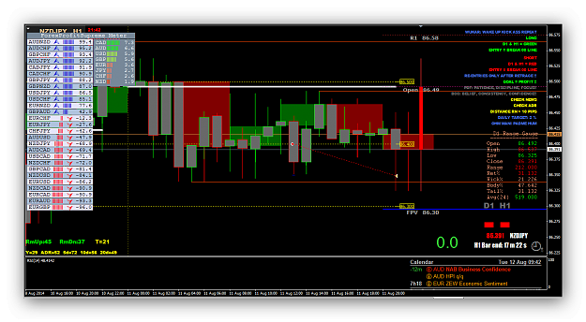
What a pitty! Strong sell signal but the spread kept it away from TP. Yet another long run. But it shows also, by using TS we got stopped out but later on it will move to TP.
Jibala

Trade #3 EA TP.
Attached Image (click to enlarge)
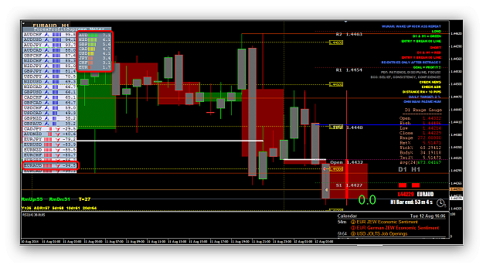
Just have a look on the FSP indicator! AUD on the top while EUR is sleeping on the bottom.
Jibala

Trade #4 EJ TP.
Attached Image (click to enlarge)
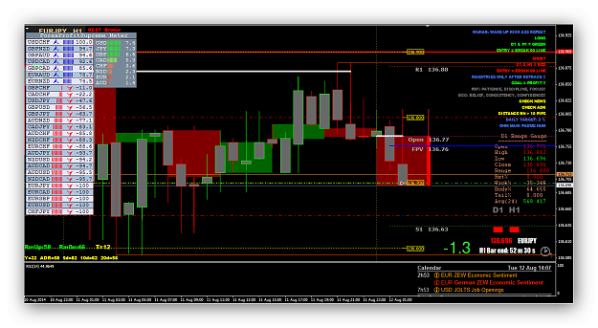

Attached Image (click to enlarge)
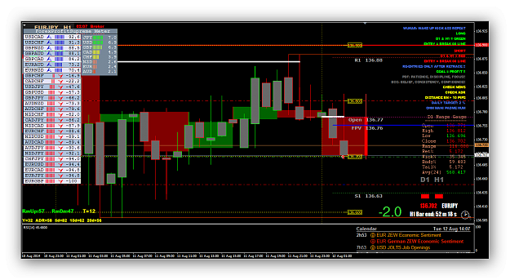

Attached Image (click to enlarge)
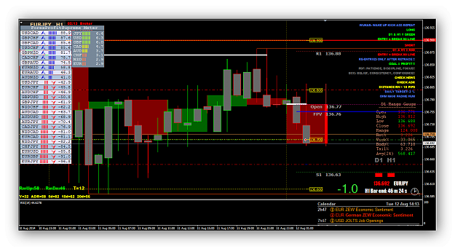

Attached Image (click to enlarge)
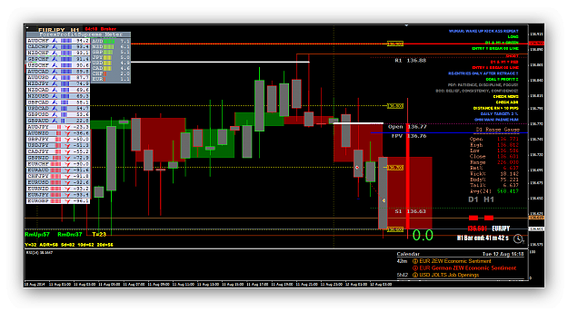
Kindly look at the FSP indicator how it was working during the session.
Jibala
Trade #5 EU TP.
Attached Image (click to enlarge)
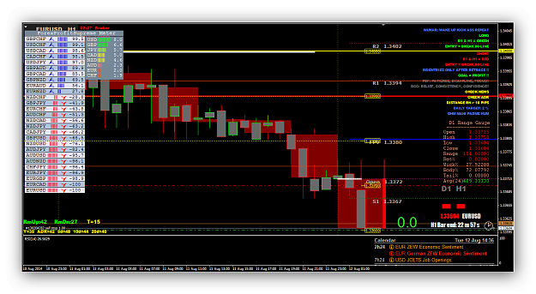
Pending order set. Although FPS indicator showed strong signal it took 1,5h to trigger entry!
Attached Image (click to enlarge)
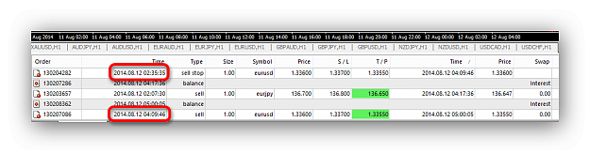
Fast TP right after the news.
Attached Image (click to enlarge)
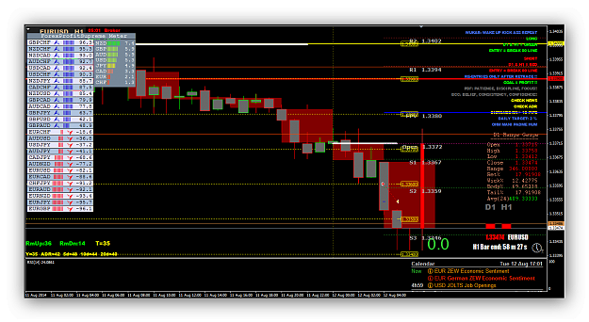

Attached Image
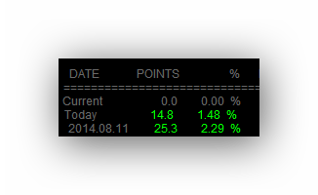
Above shows result how it works for us almost every day. Some days more some others less but average 5 / 6 trades per day. The system works well, but not for all of you. Thus do not talk bad if it doesn't for you. Just move on and look for something other.
I think above is a lot of materials to study the FSP indicator, therefore I will not post more charts with it. You have to do your homework. Watch it and try to understand.
Jibala

