Getting Started
BT_14_v9nb Basket EA

It is assumed that before you start here that you have placed all the files located in the zip folder into their respective folders.

This EA will run on any period offline chart.
You only need 2 charts open for it to work, a single pair M1 chart where you place your offline chart generator indy and the offline chart where you attach the EA.

You can create your own basket with other indicators found on different forums if you like, just make sure the pairs that are in the “Offline” basket chart are the same ones you are using in the EA, you can use from 2 to 14 pairs in the EA.

Quick Start for 14 pair Basket setup:
USDCHF,GBPCHF,EURJPY,GBPJPY,NZDUSD,EURGBP,GBPUSD,EURUSD,USDJPY,AUDUSD,NZDJPY,AUDJPY,CHFJPY,EURCHF

- Start up your MT4 platform
- Open a M1 chart of USDJPY
- Attach the uj_basket_h1_14p template to this chart.
- Go to the “File” tab of MT4 and pull it down and click on “Open Offline”

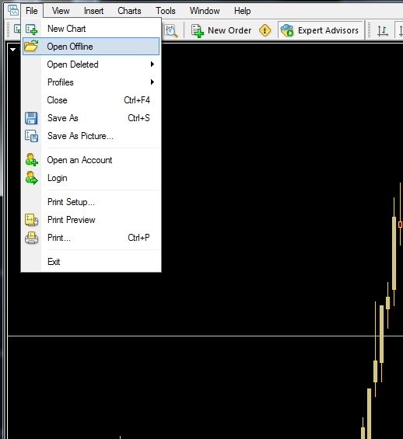

- From the window that then opens, double click the #BT14#14,H1 chart.

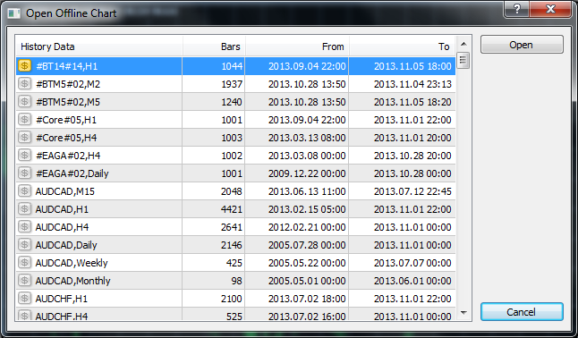

- A new “Offline Chart” should now open on your screen.
- Attach the BT_14_v9nb_14P template to this chart. Your offline chart should be similar to one of the following.

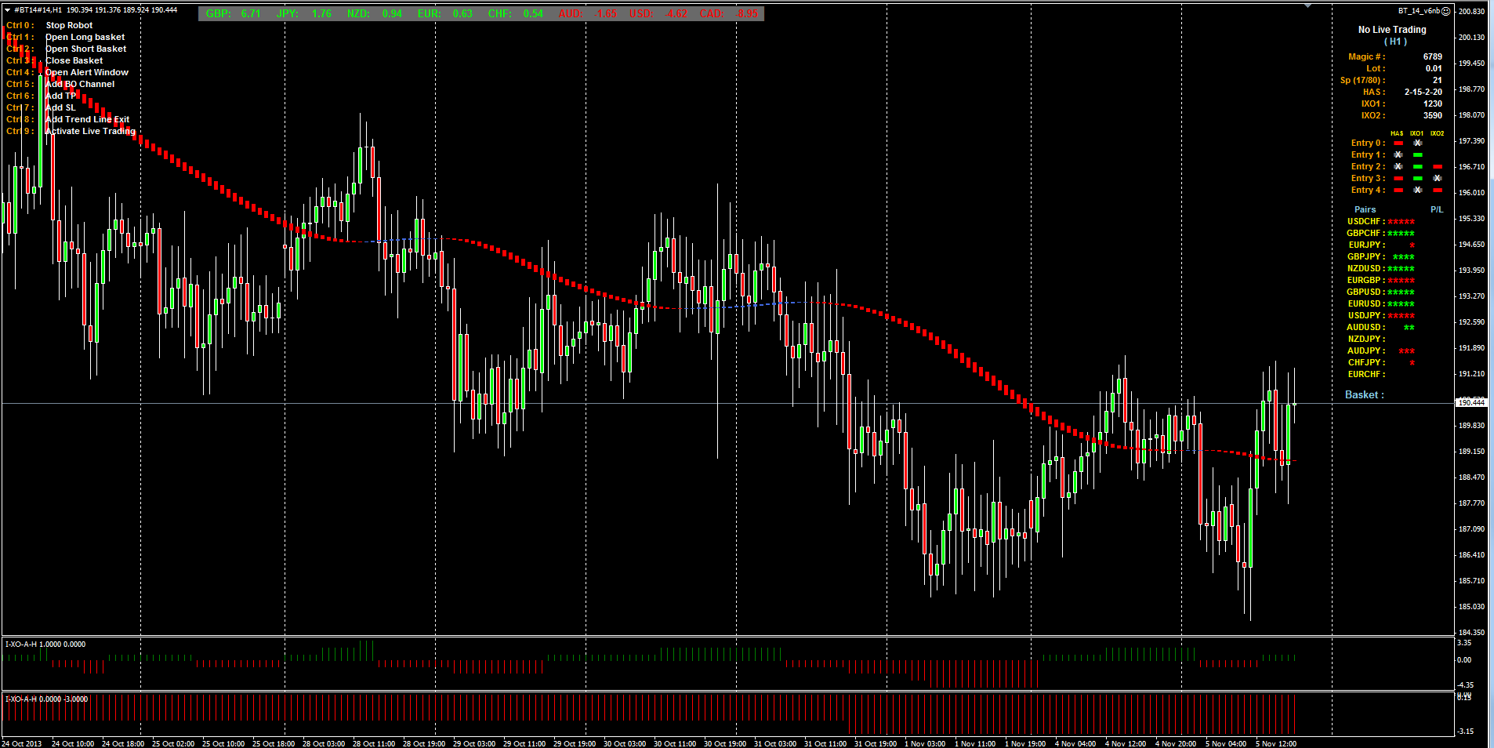

- Restart your MT4 software.
- To start trading live, use the Hot Key Ctrl+9 and click the YES button in the window that opens. If you want to stop trading live use the Hot Key Ctrl+9 and click the NO button in the window that opens.

Quick Start for different pairs Basket setups:

- Start up your MT4 platform
- Open a M1 chart of USDJPY
- Attach the Basket_Price_v2 indicator to this chart to this chart.
- Set up this indicator for the pairs and time frame you want to use.
- Go to the “File” tab of MT4 and pull it down and click on “Open Offline”

- From the window that then opens, double click the #offline chart# you just created.
- A new “Offline Chart” should now open on your screen.
- Attach your indicators and the EA to this chart and set it up the way you want, be sure to set the pairs and time frame in the EA to the same ones used to create the offline chart it is on. You can also save a template of this setup if you want to.
- Restart your MT4 software.
- To start trading live, use the Hot Key Ctrl+9 and click the YES button in the window that opens. If you want to stop trading live use the Hot Key Ctrl+9 and click the NO button in the window that opens.

This EA uses Hot Keys to access some of the functions while the EA is running. You will also notice that there is an information window on the right side of the chart to show you what the status of some of the EA functions are and also what some of the settings are, also the status of the Trade Entry Rules. There is also a help menu on the left side of the chart to remind you what the Hot Keys do, you can disable this in the EA properties if you don’t want to see it.

Hot Keys:
A Hot Keys Help Menu in the chart upper left corner can be turned on/off with “ShowCtrlHelp” in the EA properties or with the Hot Key “Ctrl+Alt+F10”.

Ctrl+0 = "Stop Robot";
Ctrl+1 = "Open Long Basket";
Ctrl+2 = "Open Short Basket";
Ctrl+3 = "Close All Trades";
Ctrl+4 = "Open Alert Window";
Ctrl+5 = "Use Break Out Channel";
Ctrl+6 = "Add TP line to active trade chart";
Ctrl+7 = "Add SL line to active trade chart";
Ctrl+8 = "Use Trend Line Exit";
Ctrl+9 = "Live Trading On/Off";
Ctrl+Alt+F10 = “Show Hot Keys Help Menu”

EA Properties settings: (The default settings are for a 14 pair basket)

The EA always looks for an Entry 2 first, if none exists it looks for one of the other entries.

The Entry name will change to either Green or Red if an entry has been made using that rule, and the corresponding signals will also be displayed, the entry will be Gray if it is not being used. Remember the signal for a color change (cross) will only be there for one confirmed candle, after the confirming candle has closed the signal will change back to gray.

You will also notice when using the Break Out Entry Lines that the display changes to show the two signals for the BO, the other Entry Types are not used when in BO Mode so they are not shown in the display area.
The BO lines can be either level or trending, you just double click them and move them around with your mouse to place them where ever you want them.

It is best when moving any lines on the chart to turn off live trading with the Hot Key (Ctrl+9) so you don’t accidently trigger a trade while moving the lines around.

- - - - Trade Settings - - - -
MagicNumber=0;
Lot=0.01;
TradeComment="";
TradePeriod = 60;
GoLong=true;
GoShort=true;
UseRobotForOpen = true;
UseRobotForClose = true;

- - Master TP / SL - -
The Master TP/SL settings, if used, over rules all other TP/SL settings.
UseMasterTakeProfit = false;
MasterTakeProfitPips = 0;
UseMasterStopLoss = false;
MasterStopLossPips = 0;
TrailAllStopLosses = false;

- - - - Channel Breakout - - - -
ChannelBOTP = 200; When BO Mode trade is opened by the EA this will be used as a TP, set to zero if you don’t want the EA to have a TP in the BO Mode.
ChannelBOSL = 200; When BO Mode trade is opened by the EA this will be used as a SL, set to zero if you want no SL in the BO Mode. It may be a good idea to leave some value here and then you can always move the SL line on the chart as the trade moves along. The IXO1 Exit does not work in the BO Mode.

If an Entry Type is set false it will be Gray in the display area, meaning it is not being used. If a trade is entered with one of the Entry Rules the display will change to either green or Red for that entry rule depending on the direction of the trade.

- - - - Entry 0 Settings - - - -
This is a User Adjustable Entry, all settings can be set by the user.
UseEntry0 = true;
UseHAScross = false;
UseHASdirection = true;
UseIXO1cross = true;
UseIXO1direction = false;
UseIXO2cross = false;
UseIXO2direction = false;
Entry0TPpips = 200;
Entry0SLpips = 200;

- - - - Entry 1 Settings - - - -
UseEntry1 = true;
ChangeToEntry2 = true;
Entry1TPpips = 200;
Entry1SLpips = 200;

- - - - Entry 2 Settings - - - -
UseEntry2 = true;
Entry2TPpips = 400;
Entry2SLpips = 200;

- - - - Entry 3 Settings - - - -
UseEntry3 = true;
Entry3TPpips = 200;
Entry3SLpips = 200;

- - - - Entry 4 Settings - - - -
UseEntry4 = true;
Entry4TPpips = 300;
Entry4SLpips = 300;

- - - - - Entry Filter Settings - - - - -
MaxSpread = 70; This is the total spread of all pairs in your basket, if the total spread reaches this number no trades can be taken. The display shows 3 numbers, the 1st is the min spread since the EA was started, the 2nd shows the max spread since the EA was started and the 3rd number shows the present spread. If this present spread is greater than the “MaxSpread” set, than no trade will be taken.
IXO1val = 1230;
IXO2val = 3590;
HASMaMethodE = 2;
HASMaPeriodE = 15;
HASMaMethod2E = 2;
HASMaPeriod2E = 20;

- - - - - - - - Exit Filter Settings - - - - - - - -
UseIXO1asExit = true; If set to true the IXO1 will be used as an exit for all trade entries.
UseHASExit = false; Set this to true if you want to use the HAS color change as an exit. See below for settings if you just want to trade the HAS change in direction only.

- Active Trade Restart Settings –
This is the default setting for the TP/SL when you restart the MT4 platform and there is a live trade present, you can then move these lines on the chart or delete them if you like.
FixedTakeProfitPipsRES = 200;
FixedStopLossPipsRES = 200;

- - - - Pairs to Trade - - - -
These are the pairs you want in your basket to trade, they must be the same ones that are in your offline chart. If your Broker uses a suffix put it in the “PairSuffix”, not with each pair. If you use less than 14 pair in your basket just leave the blank lines at the bottom of the list. If you want 1 or 2 pairs to trade in the opposite direction of the basket put them in “Pair1” or “Pair2” and set reverse to true.
PairSuffix = "";
Pair1 = "USDCHF";
ReversePair1 = false;
Pair2 = "GBPCHF";
ReversePair2 = false;
Pair3 = "EURJPY";
Pair4 = "GBPJPY";
Pair5 = "NZDUSD";
Pair6 = "EURGBP";
Pair7 = "GBPUSD";
Pair8 = "EURUSD";
Pair9 = "USDJPY";
Pair10 = "AUDUSD";
Pair11 = "NZDJPY";
Pair12 = "AUDJPY";
Pair13 = "CHFJPY";
Pair14 = "EURCHF";

- - - - - - email must be set up in MT4 - - - - - -
SendEmail = false;
AlarmSoundOn = false;

- - - - - - - - Screen Capture Settings - - - - - - - -
AlarmScrnCapOn = true; If set to true this will take a screen capture at the moment the trade is taken or the trade is closed and place it in the files folder. If it doesn’t work you may need to check your rights to write to that folder.
ScreenH = 1680;
ScreenV = 1050;

- - - - - - - - - - - Misc. - - - - - - - - - - -
DrawArrow = true;
DrawVertLine = true;
- - pipsmulti = 1, 10, 100, 1000 - -
int pipsmulti = 100;
ShowCtrlHelp = true;
ShowCurrencyStrength = true; This hides the currency strength display at the top of the chart.
OneTradePerCandle = true;
CurrencyType = "$";

- Trend Line Break: This can be turned on by using the Hot Key (Ctrl+8) during a live trade, this is used only as an exit, if the PA closes above(short trade)/below(long trade), the trade will be closed. Place this line where you want it on the chart by double clicking it and then moving it with your mouse, be careful when placing this on the chart not to trigger an exit accidently.

- The Currency Strength is something that is not used by the EA at this time but may be used in future versions depending on the usefulness of it, at this time there are no settings for it. It measures the strength of each individual currency on the time frame of the chart the EA is placed on. The stars next to each pair in the display give an idea of the strength and direction of the move of that pair. The larger stars at the bottom of the display give an estimate of the strength of the Basket Move and direction. There can be from 0 to 5 stars.

- If you want to trade just the HAS change of direction for entries and exits then make these settings in the EA properties.

- - - - Entry 0 Settings - - - -
UseEntry0 = true;
UseHAScross = true;
UseHASdirection = false;
UseIXO1cross = false;
UseIXO1direction = false;
UseIXO2cross = false;
UseIXO2direction = false;
Entry0TPpips = 0;
Entry0SLpips = 0;

UseEntry1 = false;
UseEntry2 = false;
UseEntry3 = false;
UseEntry4 = false;

FixedTakeProfitPips = 0;
FixedStopLossPips = 0;
TrailFixedStopLoss = false;

- - - - Exit Settings - - - -
UseIXOEasExit = false;
IXOEval = 2260;
UseHASExit = true;

Restarting EA with live trade present:

Remember when a live trade is open the EA is handling the trade and the computer must be left up and running with the MT4 platform active, don’t expect the EA to remember everything you were doing when the computer was shut down and the EA restarted.

The EA does not resume where it left off when it was closed down, it does not remember things like trend lines, BO lines or TP and SL lines you have placed on the chart.

*******************************************************************************************
Recording states and then restoring your states are not effective in my view.
Why? Because the time gap between recorded and restoration can vary and you may lose money...
That is why I prefer semi-auto trading; I believe human intervention is required and a must to make sure nothing goes wrong, like time gaps....
Imagine wanting to close all positions but no, only partial positions are closed. You lost connections and are stuck with open positions in the negatives....
Without that human element, you can lose money.
**********************************************************************************

