Date: 12/06/2013 Currency: EURO USD
Is it Right Time? | News? | HTF analysis? | Do u see the flow? | With Trend? | Right Signal? | How strong U felt about the trade? | Did U wait for the signal? | Was it a right decsion? | TP | SL | P/L
Yes | No | No | No | No | Yes | Medium | No | No | - | 21.10 | -21.10
+ Analysis | A retracement pin bar on the 10 EMA
-ve Analysis | CT  Not much pips difference from 200EMA to price. Not right for a CT  Should have watched three long wicks down.. on the candles that closed below 200EMA, indicating the price was not so willing to go down.
Review | Wrong trade. CT. Wrong decision.

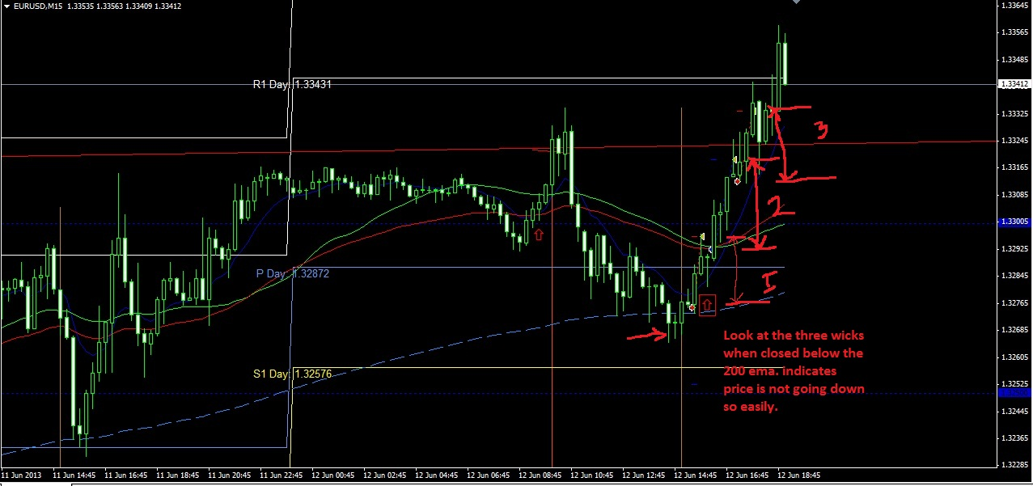
Currency: Euro USD
Is it Right Time? | News? | HTF analysis? | Do u see the flow? | With Trend? | Right Signal? | How strong U felt about the trade? | Did U wait for the signal? | Was it a right decsion? | TP | SL | P/L
Yes | No | No | Yes | Yes | Yes | Strong | Yes | Yes | 26.70 | - | 26.70
+ Analysis | With the trend. Previous price action confirming uptrend.  Entry away from 200 EMA, Pin bar with tail crossing pivot and bouncing off 10 EMA
-ve Analysis | Just below 50 EMA and 35 SMA
Review | Right Trade. Winner

Currency: Euro USD
Is it Right Time? | News? | HTF analysis? | Do u see the flow? | With Trend? | Right Signal? | How strong U felt about the trade? | Did U wait for the signal? | Was it a right decsion? | TP | SL | P/L
Yes | No | No | No | No | Medium | Medium | yes | No |  | 20.70 | -20.70
+ Analysis | Pin bar bouncing from PPA and also daily TF trendline. Price once retraced from that point.
-ve Analysis | CT  Only 35 pips from 200EMA
Review | Entry done in a hurry. CT with only 35 pips gap.  Stupid Trade
------------------------------------------------------------
Currency: USD JPY
Is it Right Time? | News? | HTF analysis? | Do u see the flow? | With Trend? | Right Signal? | How strong U felt about the trade? | Did U wait for the signal? | Was it a right decsion? | TP | SL | P/L
Yes | No | No | Yes | Yes | Yes | Strong | Yes | Yes | 31.56 | - | 31.56
+ Analysis | Confluence of 50,35 & 10 SMA, Price below 200 EMA and heading down.  Down trend. Price crossed below the range with a big candle.
-ve Analysis | Entry candle not a Pin bar.
Review | Right analysis. Right trade.

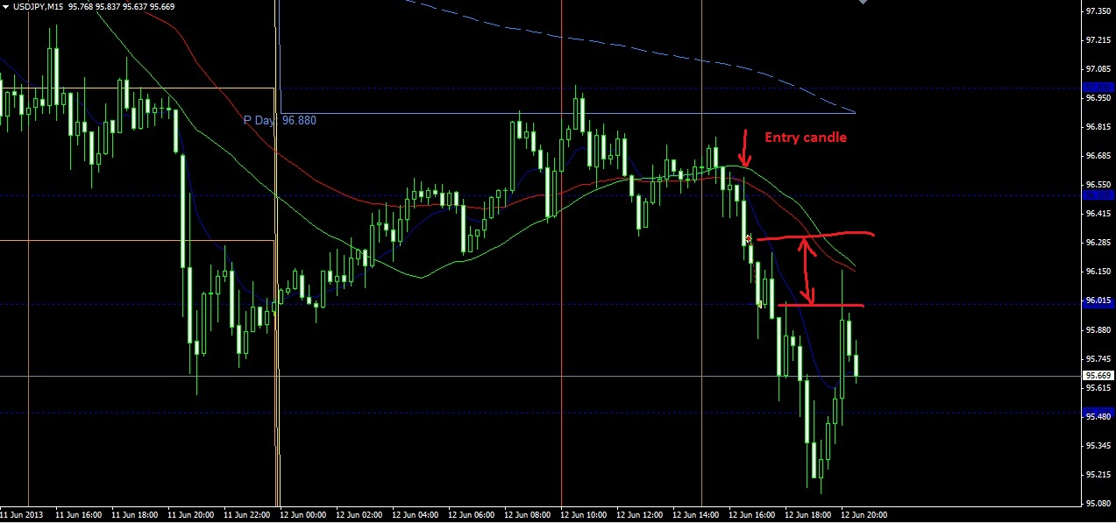
Currency: Aud USD
Is it Right Time? | News? | HTF analysis? | Do u see the flow? | With Trend? | Right Signal? | How strong U felt about the trade? | Did U wait for the signal? | Was it a right decsion? | TP | SL | P/L
Yes | No | No | Yes | Yes | Yes | Strong | No | Yes | 26 | - | 1.10
+ Analysis | With Trend. Above 200 EMA  Pin bar bouncing off 50ema and R1 and RN
-ve Analysis | Right below 800 EMA
Review | Good trade. Almost reached tp of 26 pips and then came back and hit the SL at BE+1  Good decision.

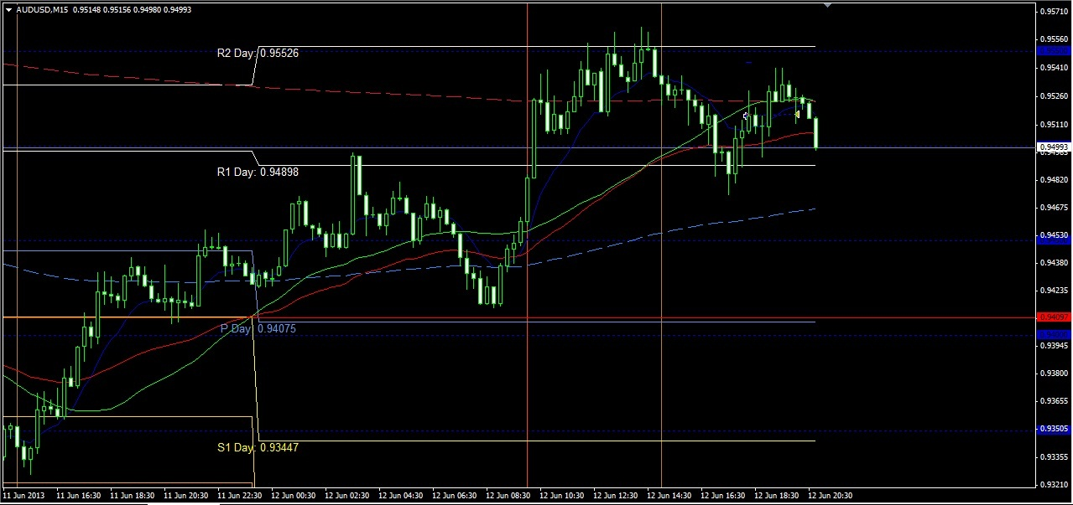

Currency | Pips | Date: 12/06/2013
EuroUSD | -21.10
EuroUSD | +26.70
USDJPY | +31.56
EuroUSD | -20.70
AudUSD | +1.10
 | Total: | +17.56

Date: 14/06/2013 Currency: EuroJPY
Is it Right Time? | News? | HTF analysis? | Do u see the flow? | With Trend? | Right Signal? | How strong U felt about the trade? | Did U wait for the signal? | Was it a right decsion? | TP | SL | P/L
Yes | No | Yes | Yes | Yes | Yes | Strong | Yes | Yes |  | BE+2.95 | +2.95
+ Analysis | Bouncing off down trendline. Entry candle- pin bar bouncing off RN and 10ema, in the direction of trend
-ve Analysis | Entry candle close just above pivot
Review | Good entry. Price moved in the direction of our entry and then came back and hit SL at BE+2.95 and then continued back in the direction of our entry.

Is it Right Time? | News? | HTF analysis? | Do u see the flow? | With Trend? | Right Signal? | How strong U felt about the trade? | Did U wait for the signal? | Was it a right decsion? | TP | SL | P/L
Yes | No | Yes | Yes | Yes | Yes | strong | yes | Yes |  | BE+ 7.79 | +7.79
+ Analysis | Good entry bouncing off 10ema, 50 ema, pin bar, below pivot in the direction of trend
-ve Analysis | Jus above RN
Review | Good trade went in the direction of trade for about 30 pips and the reversed and hit BE +7.79

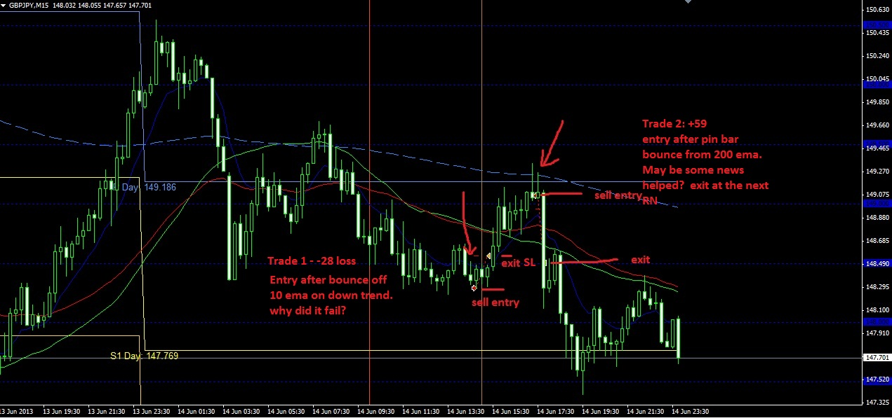

Currency: GBP JPY
Is it Right Time? | News? | HTF analysis? | Do u see the flow? | With Trend? | Right Signal? | How strong U felt about the trade? | Did U wait for the signal? | Was it a right decsion? | TP | SL | P/L
Yes | No | No | Yes | Yes | Yes | strong | yes | No |  | -28.34 | -28.34
+ Analysis | With the trend, pin bar bouncing off 10ema and RN
-ve Analysis | Was at a resistance from PPA
Review | Seemed like a good trade, but somehow went and hit SL.

Is it Right Time? | News? | HTF analysis? | Do u see the flow? | With Trend? | Right Signal? | How strong U felt about the trade? | Did U wait for the signal? | Was it a right decsion? | TP | SL | P/L
Yes | No | No | Yes | Yes | Yes | Strong | Yes | Yes | 59.72 |  | +59.72
+ Analysis | Bouncing off 200ema, with the trend. Two pin bars formed with tails crossing pivot and 200 ema.
-ve Analysis | Was just above RN.. though it didn’t seem to matter much, at that time.
Review | Very good trade. May be helped by some news or so, went on to hit 59 pips in the next candle. There was no news announced at that time, anyway.

Currency | Pips | Date: 14/06/2013
EuroJPY | +2.95
EuroJPY | +7.79
GBP JPY | -28.34
GBP JPY | +59.72
 | Total: | +42.12

Template:

Is it Right Time? | News? | HTF analysis? | Do u see the flow? | With Trend? | Right Signal? | How strong U felt about the trade? | Did U wait for the signal? | Was it a right decsion? | TP | SL | P/L
+ Analysis
-ve Analysis
Review

