We TRADE TO LIVE. We are NOT like others who LIVE TO TRADE.
We know that our Health is ALWAYS more important than our wealth.
We know trading is NOT a “Get Rich Quick Scheme”.
We know trading is a serious business and WE treat our trading as a SERIOUS BUSINESS
We understand we have, like any other profession, to put in the thousands of hours studying, learning and practicing our methods and techniques.
We understand there is NO SHORTCUT to becoming successful and profitable traders.
We understand that successful and profitable trading is 95% psychology and 5% technical skill. We know who and what we have to control.
We need PATIENCE to wait for and “SEE” opportunities
We need DISCIPLINE to act and trade on such opportunities
We are PLANNERS – We always PLAN each and every trade and then Trade the PLAN without exception.
We are BELIEVERS. We believe in ourselves and our PLAN.
We are happy, content and satisfied with where we are in our trading career.
We believe in the Holy Grail. We know what the Holy Grail is. We have found the Holy Grail and our search for trading enlightenment is over.
We can only take what the market gives us - we do “NOT” force the market.
We respect PRICE and the Market.
We understand that PRICE is Lord, King, Queen and Country.
We ACCEPT losses as the cost of doing business
We are PROFESSIONALS and PROFESSIONALS look for a reason NOT to take a trade
We are NOT Amateurs. Amateurs manage money by taking RISK. PROFESSIONALS manage RISK by taking money.

What is PASR
PASR is a total method. It revolves around PRICE ACTION at SUPPORT and RESISTANCE.
It is not just PRICE bouncing off SUPPORT and going to RESISTANCE or vice versa. It is about WATCHING what PRICE does at these important PRICE levels.
Understand why these levels exist and why they are there. They are levels where, at some point in history, BUYERS and SELLERS took control. They are levels where the BUYERS and SELLERS, in their own right, support or cannot support PRICE.
These PRICE levels are created by supply and demand during certain economic conditions. Supply and demand changes with each economic and political situation. What was once a PRICE level in a certain economic scenario may not be important or supported in a different economic situation.
Supply and demand will drive PRICE to those levels which are supported by the current economic and political conditions. Usually, these are levels identified in history but occasionally, each condition creates its own PRICE level.
Certain currency pairs, and GBPUSD is one of them, have PRICE levels where round numbers are important. We have to know what these round numbers are and what PRICE does at these levels.
PASR at its simplest is PRICE bouncing from SUPPORT to RESISTANCE and vice versa. Unfortunately, that’s not a rule, just a condition.
PASR is also watching what PRICE does, and how it does it, at these levels.
PRICE always respects PRICE levels previously defined as SUPPORT and RESISTANCE. Read that again with correct understanding.
Price ALWAYS respects price levels previously defined as support and resistance.
Just because PRICE slices through support and resistance doesn’t mean PRICE doesn’t respect that level. It DOES respect that PRICE – it just means that, at that point in time, it is not as important. The supply and demand conditions have changed such that the BUYERS and SELLERS are moving to different levels.
So, PRICE breaking through SUPPORT and RESISTANCE tells us as much as PRICE bouncing off SUPPORT and RESISTANCE.
However. it is not as simple as price breaking through a level and going to the next PRICE level. There are many factors to consider.
How did PRICE break through the level? The most important and significant question is, Where did PRICE close? Did it close above or below the level? Was it just a spike through the level?
What was the market sentiment when PRICE broke through the level? Was the bar just an average range bar or was it a bigger range bar? What were the bars before it – average or bigger?
Where is the next PRICE level?
PRICE breaking levels is not as easy to trade as basic PASR where we trade PRICE from SUPPORT to 1st RESISTANCE and RESISTANCE to 1st SUPPORT.
Students MUST learn basic PASR before moving on to other aspects of PASR. This will be and IS our basis for everything we do. This is instilling into our brain, mind and sub-conscious the equivalent of learning to ride a bike. Having learned to ride a bike we can move on to different types of bikes and maybe competitive bike racing.
So it is with trading. Learn basic PASR until you can do it upside down, inside out while hanging upside down from the Eiffel Tower with one hand while playing the whistle with the other hand.
The point is, basic PASR MUST be drilled home until it is embedded in your sub-conscious just like any other motor skill.
After learning basic PASR, understanding the next levels becomes easier. Try and do more and you will confuse yourselves probably resulting in losing trades.

Price Action Basics
Most Forex trading systems are made off technical indicators (a moving average (MA) crossover, overbought/oversold conditions in an oscillator, etc.) But what are technical indicators? They are just a series of data points plotted in a chart; these points are derived from a mathematical formula applied to the price of any given currency pair. In other words, it is a chart of price plotted in a different way that helps us see other aspects of price.
After a new trader finds out about all these indicators, they absolutely flood their charts with all these lagging tools. The sad thing is that it never dawns on traders that they should be learning about price action, when it comes to trading the forex market. It is believed this has to do with the fact, that many traders think its impossible to tell which direction the market is headed without having to use these generic indicators. They truly dont know which way the market is going.
The thing is when you are trading with indicators, its a lot like trading with other peoples signals. You are only hoping that the information they are giving you is right. The reason for this is because you dont actually understand the REAL reason why you are taking the trades that you are taking. All you hope is that the indicators formula is accurate.
But the real beauty of trading forex with price action is that once and for all, you are able to eliminate these useless tools, and you are able to see the market the way it was initially intended: without the need for indicators.
The forex price action trader will use no indicators but just a study of the price in his trading charts to decide on the next line of action. In that sense, the forex price action trading has been described as the no-frills, plain vanilla type of trading, as there are no technical indicators such as bollinger bands, Relative strength index, moving average convergence divergence (macd) and other related indicators on his price charts that he uses to trade.
Price action can be simply defined as trading from a naked price chart, with no other inputs. We display a bar or candle chart on time frames such as daily, weekly or hourly etc. The term price action signal will be given to any pre determined pattern/trigger which develops from a single price bar or series of price bars.
Most traders understand lifes core philosophy to KISS,’ keep it simple stupid’. Price action is trading from a first tier piece of information. Our decisions are based on 1 input i.e.: price. Conversely, when we trade from indicators and fancy patterns etc, there is subjectivity and multiple inputs. Trading price action is trading the here and now, with no lag or delay. Price action allows the trader to trade what he is seeing first hand, without subjectivity.

Price action makes a traders life easier
When a trader has to make fewer decisions in regards to every trade, his life becomes livable and stress free. Contrary to what most so called experts say, it is very possible to trade with fewer inputs. Inputs would be areas like financial, economic news, world news etc etc. Another input might also include the number of indicators and charting tools that are used for discovering and managing trades. Another input that could be avoided is listening to friends opinions about what or when to make a trade (except us of course).
Whenever you listen to the news and the opinions of others, you then have to filter that data through your thinking process. You actually have to make some kind of decision concerning all those bits of information you come across. Attempting to understand how all those various inputs will affect the markets is usually difficult to manage. Predicting how traders will react to the plethora of news items is often a haphazard and illogical process to go through. It is really a guessing game that most so called experts are unable to consistently figure out.

The best alternative is trading price action
In a nutshell, great forex traders, always go back to the very foundation of a price chart, (a raw blank candle or bar chart), and make decisions based on the truest information available.
Observe the price behavior. Without any indicators, a market can be seen as trending, hitting resistance or support, congesting sideways, etc etc. No computer or indicator, or news item will provide this information perfectly, except the human brain.
Shooting Stars
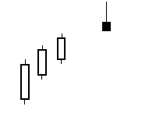
The Shooting Star Signal is a one candle pattern appearing in an uptrend.
The shadow (or tail) should be at least two times the length of the body.
The color of the body is not important, although a black body has slightly more Bearish indications.

Rules
- The real body is at the lower end of the trading range. The color of the body is not important although a black body should have slightly more bearish implications.
- The upper wick should be at least two times the length of the body.
- There should be very little or no lower shadow.
- Further confirmation is required to indicate a reversal signal. The following day needs to confirm the Shooting Star signal with a black candle or even better, a gap down with a lower close.

Signal Strengtheners
- The longer the upper shadow, the higher the potential of a reversal occurring.
- A gap up from the previous day's close sets up for a stronger reversal move provided the day after the Shooting Star signal opens lower.
- Larger volume on the Shooting Star day increases the probability that a sell-off day has occurred and a reversal is possible.

General Analysis
After a strong uptrend the Bulls appear to still be in control with price opening higher, but by the end of the day the Bears step in and take the price back down to the lower end of the trading range, creating a small body for the day. The long upper shadow represents that the Bears had started shorting at these levels. Even though the Bulls may have been able to keep the price positive by the end of the bar, the Bears made a good showing. Lower trading the next day reinforces the probability of a reversal.
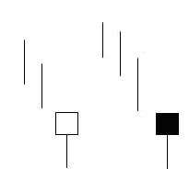
A very important signal is the Hammer signal. It is extremely easy to spot since it really does look like a hammer, the body is fairly square, there is little or no wick on top, and the lower shadow is generally at least twice the length of the body.
The Hammer is a single candle. At the bottom of a downtrend, the trade opens near or slightly below the previous days trade, drops down during the day to some value, and closes slightly above or below the open. This is an indication that the buyers are stepping in and may be the beginning of the reversal. If the close is higher than the open, this is a slightly stronger indication of a reversal than if the close is lower than the open. To be sure, it is wise to wait another day to make sure the trend has really reversed.
Rules
- The lower shadow should be at least two times the length of the body.
- The real body is at the top end of the trading range. While a white body is slightly stronger, it is not required to signal the reversal.
- There should be little or no upper wick.
- Watch the next day to ensure the reversal is not a “fake”.
Signal Strengtheners
- The longer the lower shadow, the higher probability of a reversal.
- A gap below the previous day’s close indicates a stronger reversal if the following day after the Hammer opens higher.
- Large volume trading on the Hammer day indicates that the reversal is occurring.
General Analysis
The market trend was on its way down. The price opens and starts moving down as investor sentiment is still in sell. The buyers step in and start pushing the price back up, thinking they have hit the low end and its time to buy. The price moves back up to the top of the trade range, closing either slightly below or slightly above the opening. This shows the sellers could not maintain control and the downtrend is slowing down. The upward rally of the price starts the sellers thinking that the decline is over. If the next day opens higher, this indicates the sellers have given control back to the buyers, and the reversal is likely to be continued.
Bullish and Bearish Outside Bars ( BEOB/BUOB)
For an outside bar the high and the low have to be higher and lower than the previous high and low but the open and close could be close together.
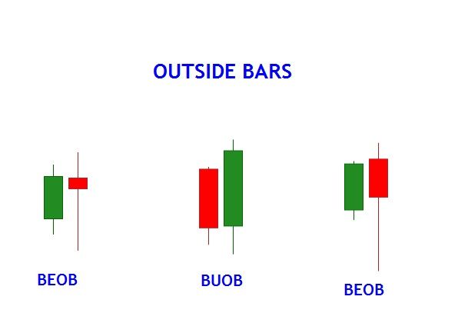
Bullish and Bearish Engulfing Bars ( BEEB/BUEB)
For an engulfing bar the open and close have to be higher and lower than the previous bars open and close.
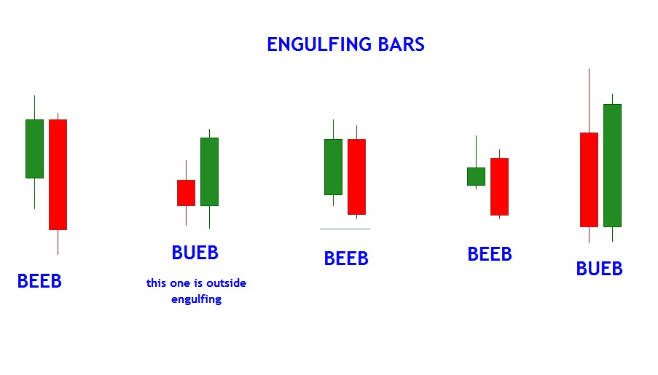
Power of Time Frames
1) We take our direction from the BIG BOSS (Monthly)
2) We take our direction (and sometimes trades) from the BOSS (Weekly)
3) We time and initiate our trades on the Worker (Daily)
So, when we do an analysis of a pair or any financial instrument for that matter:
We identify our SR levels
We find out where the BIG BOSS is relative to ITS trend AND where it is headed in the SHORT TERM relative to ITS SR levels
Knowing the direction of the BIG BOSS, we review the BOSS. If the BOSS is fighting the BIG BOSS, it will be very difficult to trade so we WAIT until the BOSS aligns herself with the BIG BOSS.
With the BIG BOSS and BOSS now in harmony (both moving together in the same direction) we drop down to the Worker.
We wait for the Worker to give us PASR in the direction of the BIG BOSS and BOSS. Rewarding and stress free trades come when we time the Worker JUST TURNING into the direction of the BIG BOSS and BOSS at PASR (as shown on the attached chart)
The MOST REWARDING and STRESS FREE trade comes when you can time the Worker turning into the direction of the BIG BOSS at THE SAME TIME as the BOSS turns into the direction of the BIG BOSS.
It sounds SIMPLE and it really is that SIMPLE but to make it stress free we MUST trade with PASR. Trying to guess trades is the best known way to blow an account.
WAIT until you SEE all the above happening.
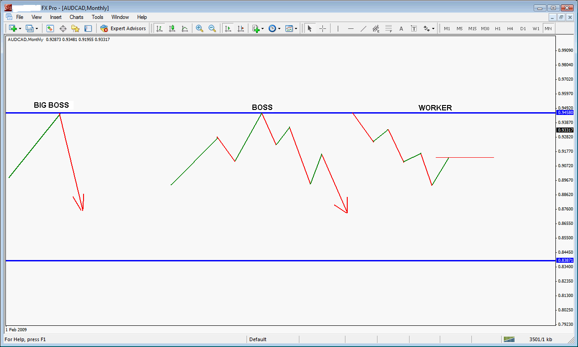
Time Frames
Time frames are probably more important than most people give them credit for. First, it is the time frame that determines our “comfort zone” in trading. Second, it is our “workspace” that we base all our trading decisions off.
Many new traders don’t understand the “higher order” of time frames and forever suffer frustration not knowing why. Each time frame is governed or “controlled” by the next higher time frame. Since we trade the Daily, which is our workspace, we will start there.
The Daily is governed or controlled by the Weekly, which we call the BOSS. As long as we only trade from the Daily, then these two are all we really need. We can look at the Monthly for a longer, further out view, but as regards our trading decisions on the Daily, since the Monthly is two time frames higher (and controls the Weekly), we can disregard this.
Each time frame consists of waves or cycles or whatever name you want to give them and WITHIN those waves or cycles are smaller waves or cycles – these are our smaller time frames. So when you look at a BOSS chart you can see the large, major swings. Within those large, major swings are smaller swings – these are our Daily swings. From this, you should now understand that the BOSS controls EVERYTHING the Daily does. (Within the Daily swings are smaller swings which are your H4 swings).
This means that a BOSS swing controls several Daily swings.
If you have understood everything so far, you should realize that the BOSS support and resistance levels are those which the Daily moves up and down against. These then are YOUR major support and resistance levels. We qualify it as “YOUR” because they may not be the same as another trader’s major levels.
A BOSS bar consists of 5 Daily bars if the penny has still not dropped.
Hopefully this will help you understand why you cannot use information from a lower time frame to trade the higher time frame. For example, you cannot use support and resistance levels from H4 to trade the Daily since there are 6 H4 bars in a Daily and as many swings meaning that eventually you will be stopped out mid – bar. It is OK to find an entry on a lower time frame AFTER first identifying the opportunity on the Daily, PROVIDING you go back to trading the Daily.
If you want to find really strong, powerful levels of resistance and support, then pull up a Monthly chart and where the Monthly levels coincide with the Weekly levels is where you will find super powerful major, major support and resistance. If you do this, do not draw other lines in as you will end up with more horizontal lines than price bars!
The higher order of time frames also tells us that the higher the time frame, the more reliable, accurate are price action and technical analysis. So, a hammer on a BOSS chart is very meaningful and if you look back on your charts, you will see that many huge moves have come off these bars.
The higher time frames are easier to trade because there is less “noise” and trends are longer BUT you need very large accounts to handle the Stop Loss levels.
The one area which is not black and white is during a trend change. We can struggle with inter – time frame trend changes as sometimes the Daily has to change before it’s BOSS does. However, when we look in detail, it can be seen that the BOSS has changed first. The trick is to know what the immediate trend is or the momentum of the last couple of bars.
There is much more to time frames than this but this should be sufficient to help you along your way.
Same Currency Different Timescale
Look closely and see how the Big Boss ( monthly ) controls the Boss ( weekly ) which then controls the Worker ( daily ).
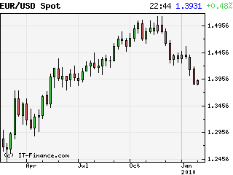
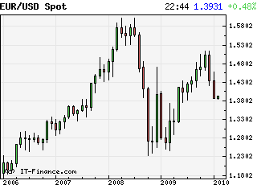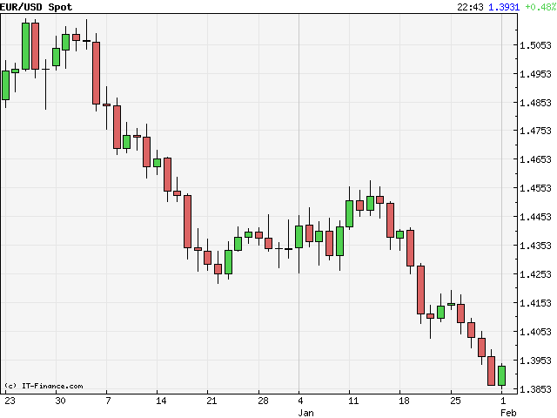
Time Frame Selection
I never cease to be amazed that the selection of time frame is never considered in trading discussions. After being told, and then finding out for myself, that brokers, system sellers, auto robot sellers etc., and other scammers target wishful thinking wannabe traders with their M1, M5 and M15 time frames, it is hardly surprising that the majority blow their accounts within weeks, sometimes days.
To just arbitrarily choose a time frame to trade is like choosing the first girl you date to be your wife. For many, that decision is made by the ads that suck you in with their $1200 per day M5 scalping system. There is far more to consider when choosing a time frame to trade.
Jacko’s trading partner, Mark, used to be a broker and has witnessed first hand, the longevity of traders trading short time frames. Their trading life is very short and painful as you would expect for someone sat in front of the one eyed monster all day long trying to wring out 10 pips on M1. Similarly for those on M5 and M15. Just like a revolving door, he has witnessed them come and go. Add into this that many short time frame traders have more than one monitor, sometimes up to five. Is it any wonder that these guys are highly stressed mental wrecks?
For me, the time frame controls your trading destiny. I rank it as high as trading psychology and in fact, that is probably where it belongs.
How many traders consider the impact that time frame has on their profits? I will bet there isn’t one. Consider a trader using a “successful” scalping system on M1 time frame. These guys are looking to make 5 pips or 10 pips at the most per trade. The effort, stress, mental anguish to reward ratio on this is horrendous. When you consider that they are “in the hole” for 2 to 3 pips (spread) the second they put on that trade, it puts tremendous emphasis on the accuracy of exits and entries to come out in profit. To be successful on M1, you have to be in the top 98% of everything – method, entries, exits, psyche, etc.
If you haven’t realized by now, then, the shorter the time frame, the more accurate your method has to be, meaning that there is little leeway in your entries and exits. Miss them by a couple of pips and you are in the red.
Conversely, the longer the time frame, the more leeway there is in both entries and exits. Entries and exits on weekly time frames do not have to be as accurate as those on the daily time frame which in turn, do not have to be as accurate as those on H4 and so on. When we are boarding our train on the daily express, it doesn’t really matter whether we are in the first carriage or the tenth carriage. We all arrive at the final destination with plenty of time (relatively speaking) to get off.
Another factor in time frame selection that I have never seen discussed, or I will bet, thought of, is our personal suitability and compatibility. We must never forget that the markets are energy. We traders are energy. Energy is governed by the Laws of Nature and, as such, can be broken down into different forms, states and matter. One of the properties of energy is it’s vibration and harmonics. The market, and each one of us as traders have vibration and harmonics which revolve around our personal natural frequencies. Yes, like it or not, we are just matter constantly vibrating in everything we do at our natural frequency. The markets are there, always vibrating at their natural frequency.
There is a state called resonance which occurs when two bodies of the same natural frequency come together. What happens then is that these natural frequencies excite each other causing large amplitudes and vibrations which continue to expand and vibrate until they both explode. I have witnessed this many times in my studies and experiments.
What has this to do with time frame selection you are asking? Everything. If you are familiar with the dating service e-harmony, it is the same thing. We are trying to find our partner (time frame) whose harmonics are compatible with ours. We need a partner (time frame) whose harmonics ideally have a sine wave 180 degrees opposed to ours so that their peak harmonic is at the same time as our valley harmonic.
Still lost? In simple terms, you may say that you are going to trade M15 because you know of a method/system on that time frame which is proven to be successful and profitable. Yet, when you trade that system, you cannot get it to work for you, no matter how hard you try. Usually, the harder you try, the more difficult it becomes. There is nothing wrong with the system, it works, it has been proven by others. What is wrong is YOU. YOU are not compatible with that time frame. YOU have to find a time frame which complements YOUR harmonics. Until you work on a time frame that compliments and is compatible with your harmonics, you will never be successful, comfortable or happy.
This has nothing to do with the longer the time frame being the more comfortable for you. It is about matching a time frame that you feel comfortable with, that allows you to trade easier and better with the lowest amount of stress and anguish.
In my case, I know my time frames are Weekly and Daily. I am so comfortable with them that I feel “as one” with them. I would love to trade H4, yet, as soon as I drop down to H4, I get an uneasy feeling, I just don’t feel as confident or as powerful as I do on the daily and weekly time frames. For me to trade H4 would put me at a disadvantage before I even put on a trade. This is exactly what happened when I tried to do M5 and M15.
Pay attention to time frames and find the one which is compatible with you.Blue Colored Text
The Importance of Support and Resistance
In the amazing world of foreign exchange currency trading, the forecasting of the future trends and price variations of the currencies are extremely important. Two of the important financial indicators used in the foreign exchange trading market are support and resistance levels.
Graphs, Charts and Indicators
There are many types of indicators giving the important signals of the future market behaviors. Technical analysis can absolutely help the investing community to expect the likely happenings in the market. The expected price ranges and variations of trading currencies can be accessed through the technical analysis with a high level of confidence. Technical analysis makes use of varieties of charts, data, lines and statistical tools to get the good predictions of the price ranges over time. Price charts are always used as the prime sources for the technical analysis. Even if you equip with highly advanced software codes and analysis technique, you will be going through the charts and pictorial information to get the basic trend of the market.
Support and Resistance
Two important terms used in the technical analysis of currency trading are support and resistance levels. These are the top and bottom lines in the charts. These are the temporary limiting lines for the currency prices. Support levels indicate the demand and the resistance levels indicate the supply. Support and resistance levels are characterized by the periods in which trading moves within a confined range indicating the deadlock of supply and demand. When a breakout comes either supply forces dictate the market or demand forces dictate the market. Here the currency prices will go out of the confined ranges of supply and demand. At the support level traders can expect the market to go up. This is the field of buyers. Resistance levels are just opposite to the support levels. It is the top most ceiling in the forex charts. This is the field of seller’s market. When the price ranges meander around the resistance levels traders start taking profits by selling their instruments.
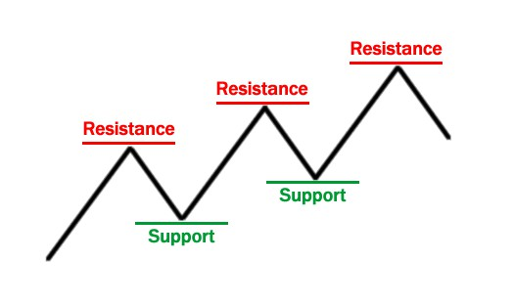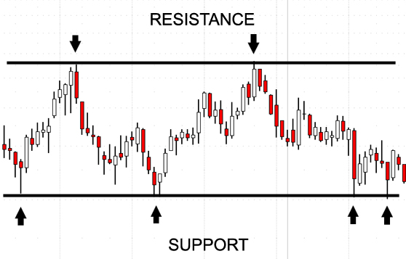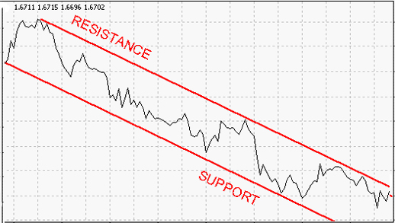
The Technique
Simple chart analysis can help identify support and resistance levels. Support levels and resistance levels provide the trading ranges in which you can go for currency trading very confidently. Technical analysis can help you in spotting these two levels together with any types of breakouts in the currency market. It is advised to wait for a breakout at resistance level to increase the returns. Similarly it is advised to buy currencies at the support level to get lucrative returns from the market.
Importance
Support and resistance is the one of the most popular and widely used methods of technical analysis in Forex. It’s simple, easy to understand and doesn’t even require any additional analytical tools except the bare chart of the currency pair. Support and resistance levels form when the price action creates the distinct peaks and plateaus on the chart. Support level acts as a barrier for the rate that falls, while the resistance is the level that prevents rate from growing farther. Buying when the resistance is broken and selling when the support level is broken is an easy Forex technique that made thousands of traders rich. If you plan to trade using support and resistance, don’t forget these important facts:
- When the support level is broken it becomes a resistance level, the vice versa is also correct.
- Breaking the support and resistance levels isn’t an exact math. False breakouts are possible.
- Real breakouts are usually marked with a bar closed below/above the support/resistance level.
- Check your charts on the different (larger) timeframes. Some important support and resistance levels can only be seen on the long-term charts.
- If the rate bounces off the support or resistance that level becomes stronger. The stronger support and resistance level is the more profit can be gained when it’s broken.
Concluding all that was said above I should also warn you that using support and resistance in your daily trading will become profitable over the time as this method requires a lot of real experience and becomes more powerful with each trading success or failure.
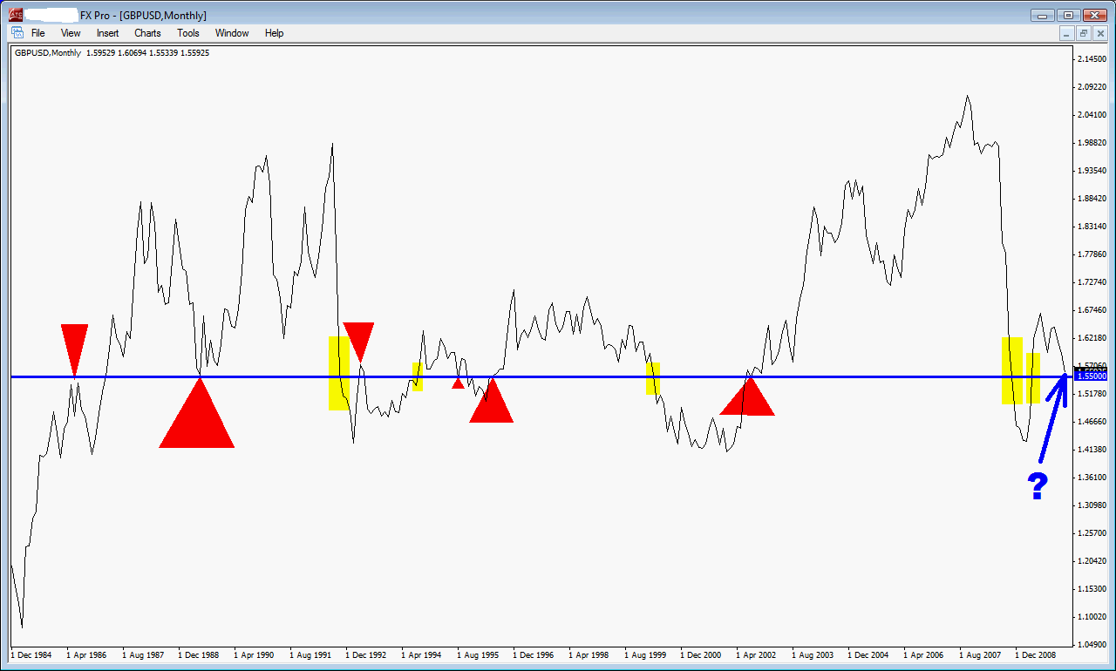
Drawing Support and Resistance Lines
A step-by-step guide to drawing good SR lines.
Note : This is a simple SR discovery instruction - Detailed SR identification is available within the forum.
The Big Boss
First of all, open a Big Boss line chart and put horizontal lines where you think the levels are important (preferably tested a few times). This is how your chart should looks like after completing this exercise. Then switch to candlesticks and compare both with respect to the lines you draw. Did you all see 0.71 SR level where it was drawn originally from line chart due to 1996, 2005 and 2007 swings/tests but more importantly look at Feb 2004 shooting star where price reversed from 0.7099. Isn't that beautiful?
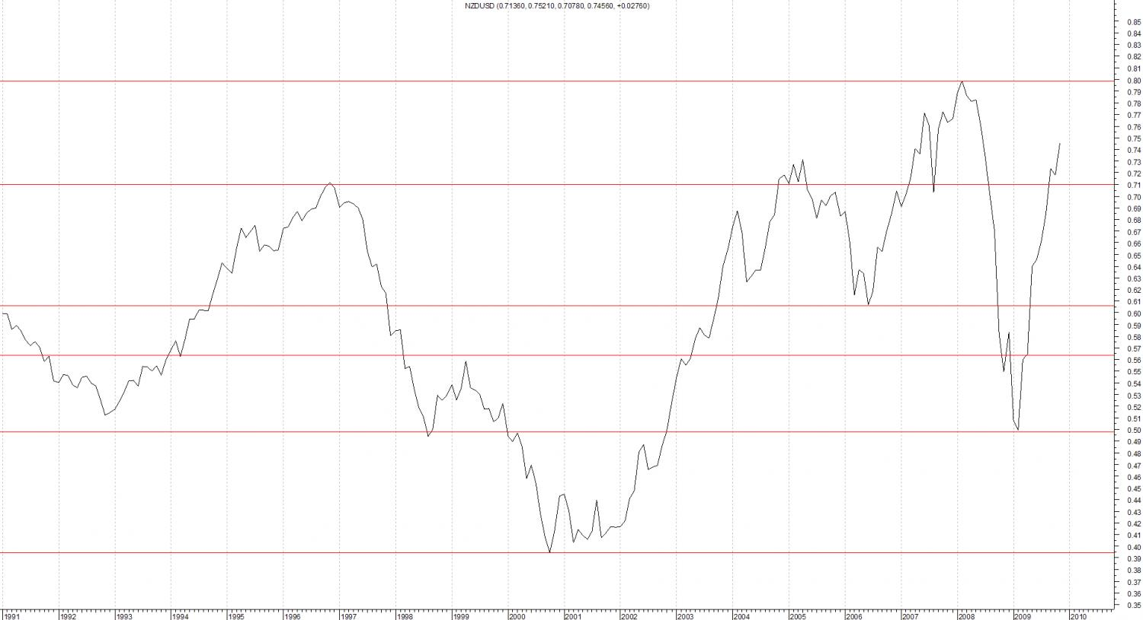
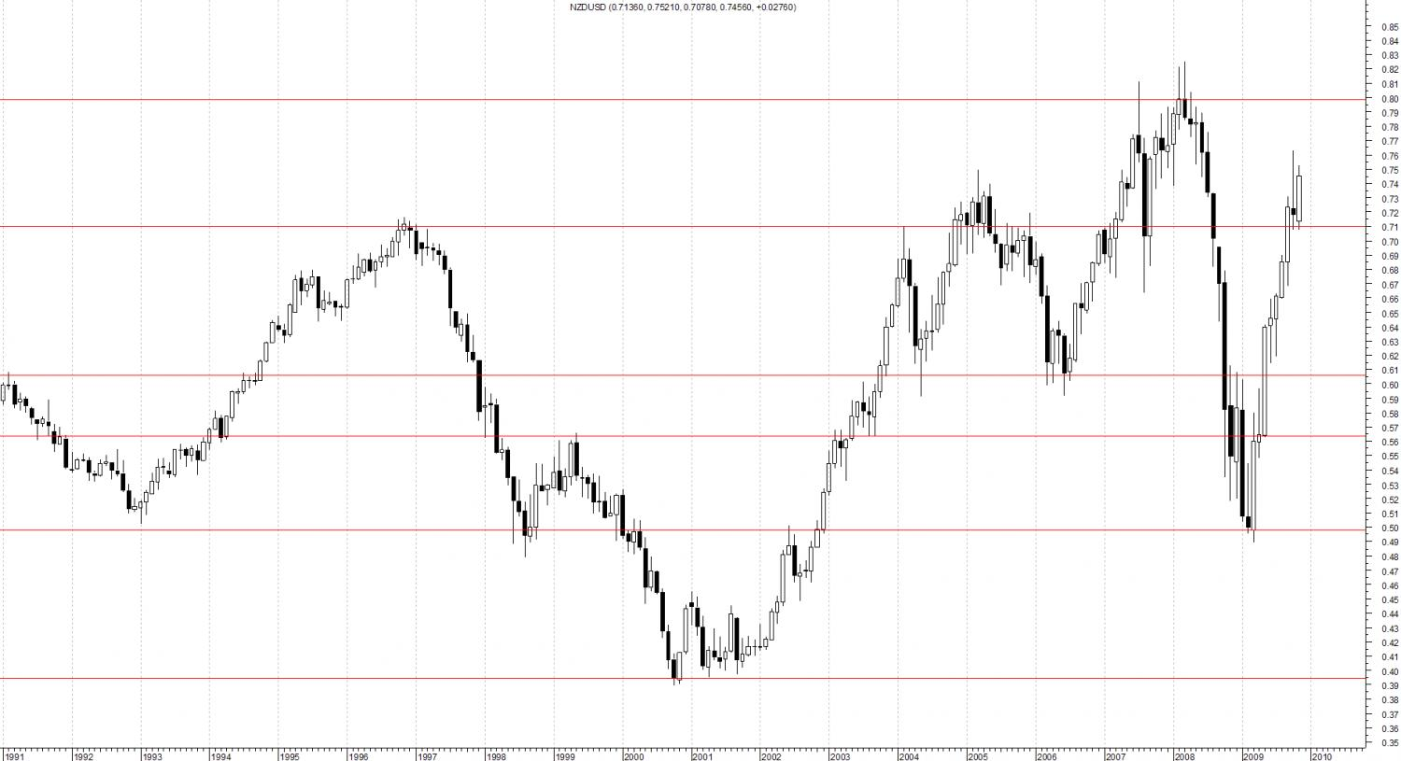
The Boss
We now have 9 major SR levels on the completed NZDUSD chart and we already drew 6 of them from Big Boss. Then all you have to do is to keep them on your chart and switch to Boss chart to draw additional major SR lines which may not be seen on Big Boss and to fine tune the ones already drawn from big Boss, if needed, based on Boss opens/closes and high/low of certain bars.
Attached are how both charts look like after switching to Boss chart. Everything looks OK except a fine tune may be needed at all time high and we also need to check 0.5650 SR due to 2008-2009 moves where we see too many violations (not respected). If it is so on Worker, too, then we may downgrade it.
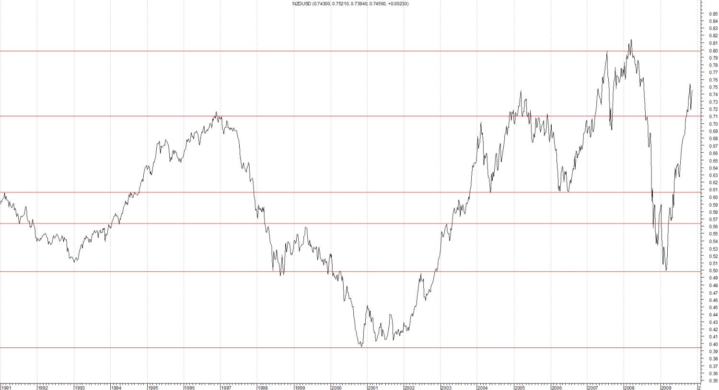
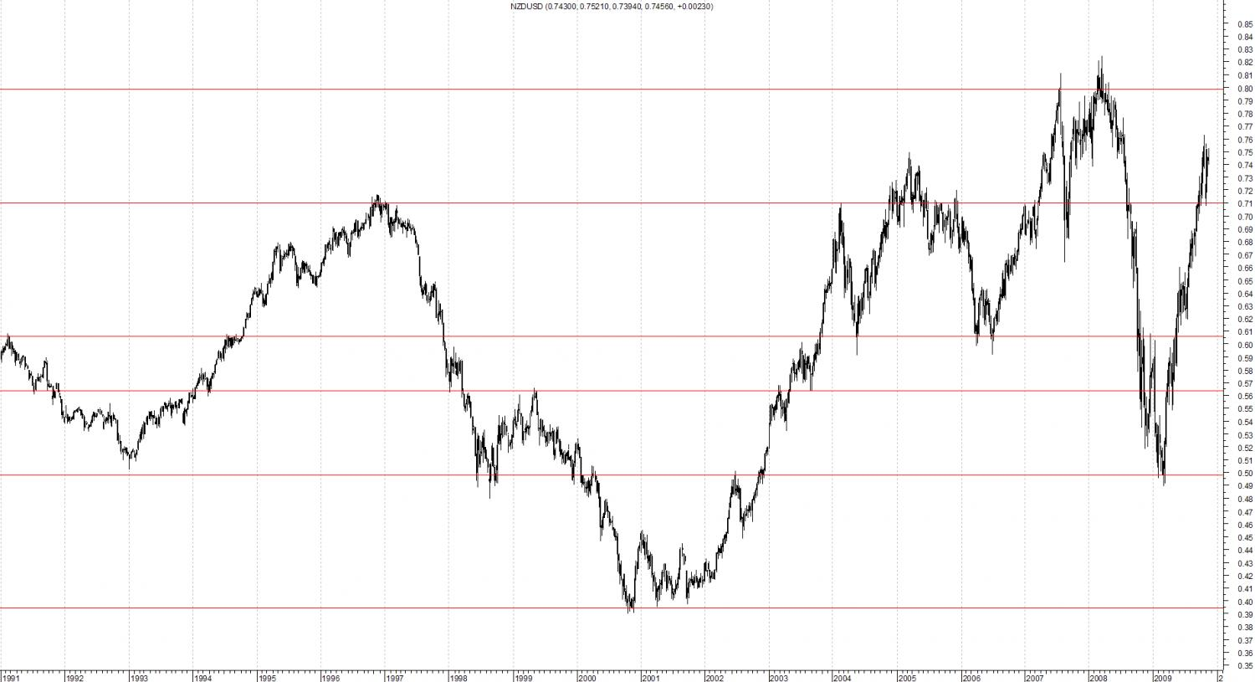
And this is how both charts look like after adding SR lines from Boss chart and fine tuning the ones from Big Boss chart.
Note that also added were the 0.6450, 0.6700 and 0.7500 SRs which were not that obvious on Big Boss chart and fine tuned 0.8000 SR to 0.8150. Blue SRs are the additions.
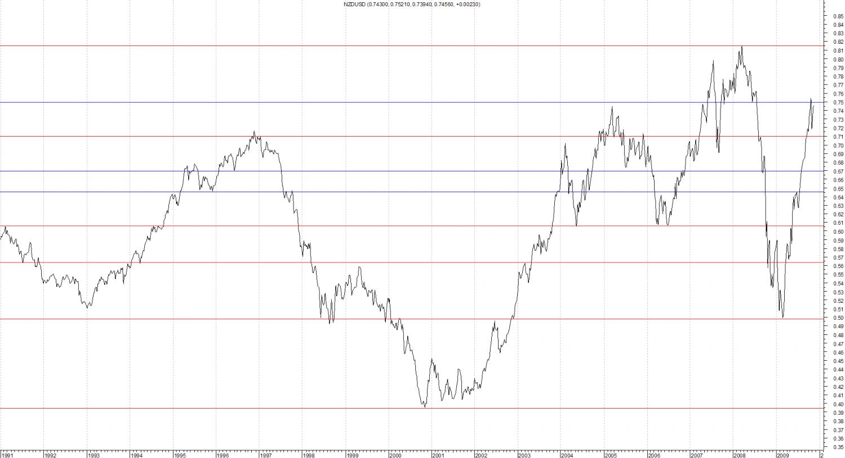
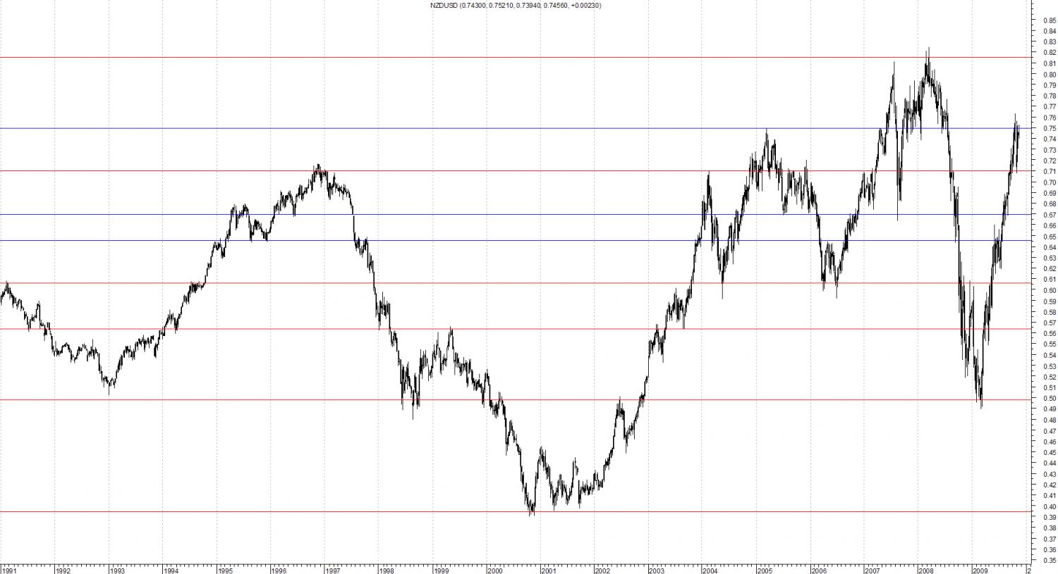
Grading
After checking Worker with all SRs drawn, we start grading them. For NZDUSD, all are accepted as major SRs except 0.5650 where this SR was not respected in 2008 and 2009 as much as we would like, therefore it is downgraded by changing line thickness.
Attached is a zoomed-in view of that area for 2008-2009 for you to understand what is mean by “not respected”.
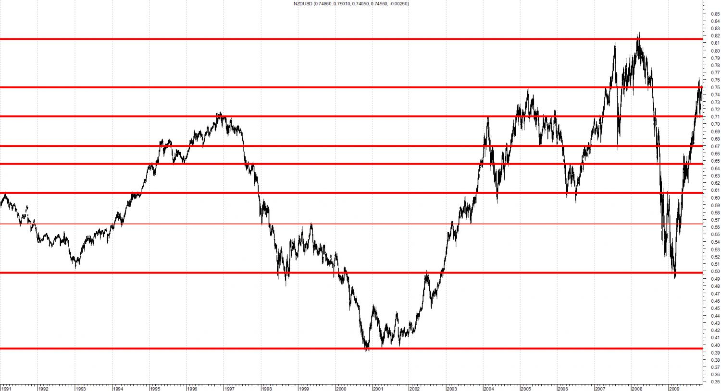
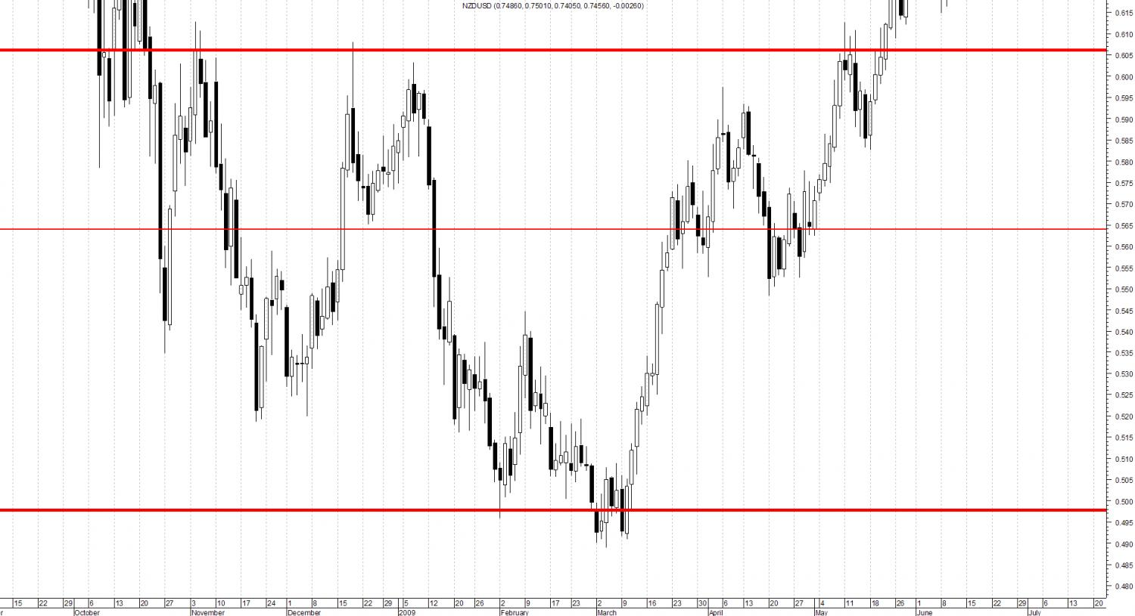
Use all-time high and low as major SR even though they are not tested too many times. In this case, all-time low and high tested several times.
Then one more thing to consider is if price moves into uncharted territory and remains there for a while. On NZDUSD, we can evaluate the area between 0.7500 - 0.8150 in this manner. Since they are newly formed, it is better to draw SR lines, if there are any, from Worker chart.
For NZDUSD, we have put an SR at 0.7750 and labelled it as Minor (medium grade) SR by drawing in a different colour.
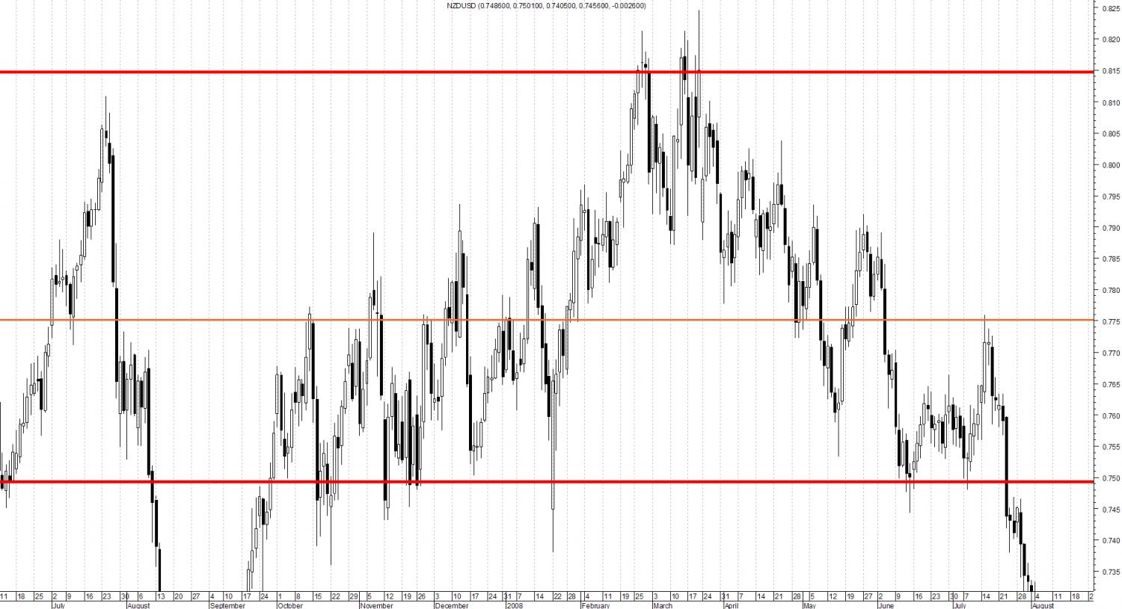
The Final View
As a result of this exercise, this is the final view of our SR lines on Boss chart.
All you need to do is to trade these SR lines “BASED ON STRAT'S TEACHINGS”
Hope this exercise helps you improve your trading. Do not forget to keep your charts clean and trade major ones only in trend direction at this stage.
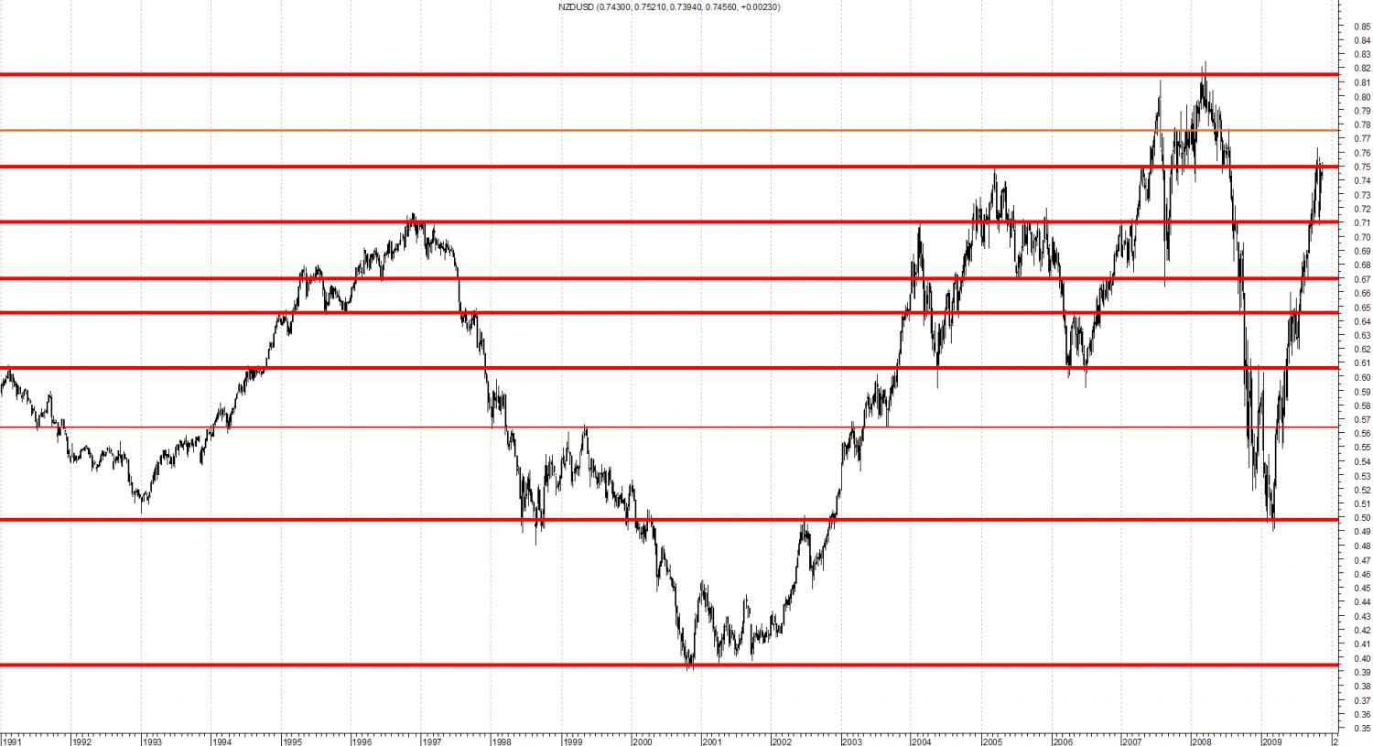

Round Numbers
We are constantly rounding off numbers in our day to day activities. It occurs when we go to the market, read the temperature, buy a piece of property or go to the gas station. We are immutably drawn to round numbers and numbers that end in zero. These round numbers play a major role in Forex trading.
Why The Interest In Round Numbers?
In 1999 the Dow Jones Industrial Average hit the 10,000 mark for the first time. Investors were testing this level for almost two weeks before it finally closed over the 10,000 mark. This even was cause for much celebration as it was considered a major milestone.
About seven years later the Dow was trading at only 11,000. The investors that were driven into a frenzy when it hit 10,000 had little to show for it some years later.
In 1999 the success of the Dow was one of the most publicized events of the year. Financial news channels were running four hour specials extolling the event as the second coming. The entire market was totally absorbed by this figure.
Theories abound that humans have developed a numeric systems called “base 10” because they have 10 fingers and toes. Humans also gravitate to numbers that are factors of 10.
The Round Number Effect
Investors and traders have a very strong tendency to enter orders that coincide with round numbers. For example a trader may place an order on a specific stock when and if it falls to a $40 level. If multiple traders also place buy orders at $40 because it appears that the stock is a good buy at that level, the stock will encounter a large pool of buy orders. This often causes a large amount of buying activity and because buyers are outnumbering the sellers the value of the stock will rise rapidly.
In essence, the traders have generated what is called a “support level” at the $40 mark because multiple buy orders have accumulated at that price. This is what is referred to psychological support because it is not based on any prior price activity.
This phenomenon is common to all trading markets but is especially prevalent in the currency market. The reasoning behind this round number phenomenon in commodity, stock and forex trading is that part of humans that is attracted to round numbers. As long as people are involved in trading this phenomenon will be present.
Round Numbers In Forex
The profound influence of round numbers in the Forex marketplace should not be underestimated. A good example of this occurred in early 2005 when the USD/CAD currency pair found support repeatedly at 1.2000. Another example occurred in the early part of 2006 when the EUR/USD found support at about 1.2700. Traders that specialized in round number entry points were able to gain some great rewards.
Banks enjoy substantial commissions when they implement customer orders around these round numbers as large pools of orders tend to accumulate. The fact that these orders do tend to congregate around numbers creates a major strategy for many traders and many traders lean on this as a major trading technique.
The First Bounce Is The Best
Round number support and resistance is extremely attractive to those utilizing a Day Trading strategy. The time frames involved in day trading are typically very short. This happens because of the fact that the first bounce off of the round number support or resistance is usually the one that is the best and most profitable bounce. Traders are constantly looking to make certain that they are seeing this first bounce. Longer trading time frames are ineffective because they can often hide multiple bounces within a single candle spike.
Every time the exchange rate achieves the round number support level orders are executed. As this occurs, the pool of orders that created the support or resistance level diminishes. Once the level of orders is insufficient to affect the support or resistance level that level will eventually break.
It is for this reason that it is vital for traders to take advantage of the first bounce off the round number since it is at this point that the number of orders is the greatest and produces the biggest value. An active trader can also trade the subsequent bounces although they tend to yield smaller profits.
The Power of the 20 EMA and 50 EMA in Forex Trading
The 20 ema is used by most institutions, banks, funds and big boys as part of their trading. Some use it with the cross of another MA or MAs as a system. Many of the little guys (us) use the 20 ema in some form or other in our trading. Some professional traders use the price and 20 ema as their method by buying a close above the 20 ema and selling a close below the 20 ema (don’t try this at home, as they say, as the Professionals also use filters to avoid whipsaws and “false” moves).
For consistency all charts posted on this website will display the 20 EMA in RED and the 50 EMA in BLUE
To a certain extent, the use of the 20 ema becomes, like Fibonacci retracements, a self fulfilling prophecy.
Our use of the 20 ema is not as a trigger in any shape of form, but as one of the tools to help us in our decision making process. It should never be used in isolation and never be taken as “the last word”.
Think of the 20 ema as equilibrium, or the balance line which is the point at which buyers and sellers AGREE on price. Remember we are dealing with energy both of the market and its traders. Energy ALWAYS seeks balance through the path of least resistance. If you haven’t done already, you should study thousands of charts (daily and up) with the 20 ema and 50 ema moving averages on and note several things:
The slope of the averages The cross of the averages Price relative to the averages
You should also take note:
- What the market is doing when the 20 ema is flat
- What the market is doing when the slope is up AND how STEEP that slope is
- What the market is doing when the slope is down AND how STEEP that slope is
- What happens to price when the 20 ema acts as resistance
- What happens to price when the 20 ema acts as support
- How price reacts around the 20 ema
- What happens when the 20 ema is broken
- What happens to price when it crosses the 50 ema
- What happens to price when, and after, it is trapped between the 20 ema and the 50 ema
- What happens to price when it is stretched away from the 20 ema
Think of the 20 ema as a magnet which attracts price (equilibrium). Outside forces greater than the power of the magnet ( buyers or sellers) pull prices away from the magnet. As price pulls away from the magnet, it takes the 20 ema with it but at a slower and lagging rate. The price reaches a certain point beyond the 20 ema where the 20 ema invokes its elastic limit and pulls prices back in line.
If you take the time to study each pair going back as far as your data allows, you will find that there is, for each pair, a certain number of pips that price moves away from the 20 ema before the 20 ema pulls price back into line (equilibrium)
The slope of the 20 ema gives you a “rough” approximation of momentum – use this with my TLs and you have a very good Momentum system.
The slope of the 20 ema and the cross of the 20 ema above the 50 ema tells you which direction you should be trading in.
The 50 ema is not as powerful as the 20 ema but when price “uses” the 50 ema, take note.
As per our style of no spoon feeding, we have given you the pointers, now you do the work and prove the value of the 20 ema for yourself. Nothing works better than something you have proved for yourself AND therefore BELIEVE in.
Add the knowledge of the power of the 20 ema to our PASR and we have an edge over most traders. In case of any conflict, PASR rules over EVERYTHING.
MA show the Forex Way
The first thing is that we use 2 MAs. A fast one and a slow one. The second thing is that MAs only show the past i.e. they are lagging indicators (as we all already know).
When a lagging indicator (a moving average) begins to react to price, it is able to show you a smoother picture of what might be coming down the pipe and to be watching for it.
The fast MA ( 20 ema ) is the first indication that a change might be on it's way. When price merges with and then crosses the fast MA, it tells me market momentum is slowing and the market is either catching it's breath or unsure of where it wants to go. Reason being, when an MA begins to hook, the visual result is that price bars begin to bunch up and grow tails and shadows.
The next indication is that price and then the fast MA crosses the slow MA ( 50 ema ). Rather than being an indication to trade, this tells me that momentum has begun to build in that direction and thus 'more prices in that direction are likely'. (note most now use the 63 EMa instead of the 50)
Once the slow MA begins to turn in the same direction, this shows that price has built up enough momentum to impact a larger average and that higher prices are even more likely. This is where the physics of once in motion it stays in motion comes into play.
As the faster MA now begins to pull away from the slower MA, this is simply a smoother way of visualizing steadily increasing prices and that higher prices are now even more likely to follow. Furthermore, momentum (now being a function of the distance between the 2 MAs) is increasing.
The rubber band effect is really just a retrace or wobble where the market is catching it's breath…the MA just helps you to see it as such.
When you see an MA acting as support or resistance you have a combination of self fulfilling prophecy, since traders use them, and a simple indication of momentum by the angle of the MA. But the beauty of it is that you can use them as such.
So to sum all of this up as it relates to the worker, boss and big boss and why the higher time frames rule the lower:
If price has been going in a direction so long that it is able to move the 50 EMA on the big boss, then it's momentum is the equivalent of a freight train. Don't try to stand in front of it then expect it to stop and suddenly go the other way…even if it's going slow. This is why the big boss tells the boss what to do.
The boss is more sensitive to movement than the big boss but is still a city bus. Don't fight it. Also note that a city bus doesn't argue with a train. We've all seen the videos of what happens to the ones that do.
The worker does what the bosses say because ( in relation to the MAs ): As price heads in the general trend direction, it retraces and changes…these oscillations have an overall impact in a direction on the big boss MAs. A very slow one. Monthly is is the ultimate price smoother and why you use it and it's MAs as the big boss.
So, if you see momentum decreasing in the big boss ( MAs getting closer together or the fast MA beginning to hook and price is crossing it ), this an indication that the overall trend, while still intact, might be at a pause because price is now between the MAs. Pay attention to SR close by.
What you will see on the boss as a result, is that weekly price is showing good headway in that direction already. Pay attention to SR close by.
STEPPING BACK on the worker will show that same picture but with all the wiggles, wobbles and retraces that are tradeable. Look at the HH/LL in relation to SR and interpret them accordingly. If they are at SR, do your PA analysis and trade accordingly in the direction of the trend.
Dr Joe and Trends
Thank you for the PMs on indicators and price action. Rather than answer individually, I will do it through this post, if I may.
I’m not here to fight with anyone over whether to use indicators or not for we have a larger fight with the market makers than amongst us little guys. I respect the traders who can make consistent profits with indicators as it is something I have tried and cannot do. If anyone has an indicator that produces CONSISTENT profits then, please, show us the way.
In the meantime, I will continue with what works for me: raw price action using price, volume, S&R, momentum, exhaustion, cycles, time, harmonic analysis, market sentiment with a splash of funny mentals thrown in.
With regard to my transition from having indicators up the ying yang on my charts to now with just volume and the 20ema and the 50ema, I need to share my experience with an old time trader, Dr. Joe, which will also show how stubborn I was.
Back in the early 90s when I was getting really serious with my trading, I was buying signals via fax. In those days there was no email and no computer trading and we had to either plot our own charts or buy them from a charting service. We then had to calculate our own indicators and then hand draw them on our charts. This really helped in understanding what indicators did (take the data from “n” days ago) and how they worked.
One time I faxed my questions back to the signal service and the reply I got back was that I had sent it to the wrong number. Also written on my fax was that I was wasting my money on signals and to contact Dr. Joe. After a few fax exchanges, he sent a handwritten fax saying something like “trading is easy, you don’t need nuthin fancy (he was a good old Texas boy) just buy when it’s going up and sell when it’s going down, that’s all there is to it”.
Dr. Joe used to work for NASA as a nuclear physicist on the Space Program and was a Professor, PhD with just about every physics and maths qualifications there are or you could think of. He got fed up of the bureaucracy and politics at NASA and as a part time investor in stocks , decided to go full time as, in his own words, “the price cycles are just some sort of fancy sine waves with decay and acceleration distorting them and should be real easy to plot and forecast.”
Well after over 5 years doing triple integrated, double differentiated Fourier transforms, harmonic frequency analysis, fractal filters and theorems and goodness knows what else that, although I have a PhD, just ran circles around me. He said he got so frustrated that although he could plan and predict space craft trajectories, orbits, landings etc, he could not forecast even one bar of prices into the future. Not one to quit, he decided that there was some external force that he was not taking into consideration and the only place it could be was on the trading floor where the action took place.
Through his connections, he eventually got an invitation to the Chicago Mercantile Exchange (CME) and was shown the futures or commodities pit (can’t remember which). His sole purpose of going there was as a spy or detective to find out exactly how things worked so that he could write it into his software. He told me he was “amazed and dumbfounded” at what he saw and heard which forever changed his life. (I had all this written up in my trading notes in my files but I can’t find them so I’m using this post to “replenish my notes”).
He arrived at the pit before opening time and saw all the floor traders congregated together in a meeting. He saw this as strange as he thought they were out and out competitors with each other.
What he saw in the first 15 to 30 minutes he would never have believed even if his best friend had told him. At the open, the overnight trades, which were long positions, were put through but he detected the traders entering them were giving signals to the other traders. After the orders were put through there was “nothing” – they just waited to see how the market reacted to those orders.
He then observed what he thought were illegal practices but later learned it to be what actually goes on each and every day. During this “dead” time, the floor traders were reviewing their orders in the pipeline and then on a given signal, a group started selling followed by another group. Then when a certain lower price had been reached, another signal was given and the same groups then bought back amongst themselves. He later learned this was called “Running the Stops” and what they had done was found out where all the orders were, which were below lows, swing lows and elsewhere, and just driven the price down to fill them and take them out so that they had a clean order sheet! Not satisfied with that, they then collectively took the price back to where it opened!
After this and now with the market moving, orders started to come in and when a large order came in from a bank, fund or other large institution, the trader with the order gave a signal before entering it. After entering it, the traders went quiet again. They were looking to see how the market reacted to that order. When they saw more buy orders coming in, they just bought more and more and kept on buying until a signal from a trader that he had a large sell order. Again the sell order was entered and the traders went quiet as they waited for a reaction from the market. He learned that the floor traders were waiting to see whether the sell order was going to be accepted as profit taking or full blown shorting. He said this went on all day long with the floor traders just “piggy-backing” on which ever way the market moved. He said he could see no skills or qualifications (other than being a whore – a very rich whore, he said) whatsoever in what the floor traders did.
On his way back to Houston, he thought about how to use what he witnessed to HIS advantage.
His first action was to throw out all his indicators, forecasts and technical analysis. He told me that there is no analysis, indicator or other program now or in the future, that can analyse or predict human behaviour and specifically, human emotions. He had seen for himself that there was nothing technical or logical in how the floor traders (now better known as Market Movers) traded and therefore any analysis or thinking from “off the floor” was an absolute waste of time.
His second action was how to beat “those whores” on the floor as he called them. He said he thought over just about every scenario imaginable and just as he was running out of ideas, it came to him. If you can’t beat, them join them although as a very devout and God fearing Christian, he didn’t think it was ethical. Unable to find another alternative, he decided he had no options left but to try and do, “off the floor” what they did on the floor.
From this came his very simple method:
Buy when it goes up and sell when it goes down.
He went on to make $millions doing this and I subsequently learned he passed away a very rich and contented man knowing that he had beaten the “whores” at their own game.
I learned all this in a few telephone conversations with him but he lost his patience with me when I still questioned his method. He wouldn’t answer my calls so I reverted back to faxes. Again, I can’t remember it word for word but I sent a simple fax saying:
“How do you know when to stop buying?”
On the same fax was his handwritten reply, “When it stops going up.”
So I wrote on it, “How do you know when it stops going up?”
His handwritten reply, “When it starts going down.”
So I wrote on it, “How do you know when it stops going up and starts going down?”
His handwritten reply, “When people start selling.”
After going round like this in riddles, I pleaded with him to “just give it to me straight”.
He sent a fax saying this would be his last communication with me and that if I didn’t understand how to buy when it goes up and sell when it goes down, I had no business trading.
His final paragraph was one which I ignored, like everything else he told me, until a couple of years ago when I realized what a dumb, stupid, arrogant, stubborn idiot I had been:
He said I would only be wrong twice using his simple method:
“Once when you buy at the top and once when you sell at the bottom.”
I just ignored this as a smart – ass answer but still tried to do what he said. Unfortunately, and as Sod’s law dictates, I tried to do it in a consolidation and lost on every trade which had me buying when I should have been selling etc.
I tried and lost again and then eventually lost my way in the quest for the Holy Grail in Indicator Land.
Now, with all my experience and thousands of lost $ behind me, the light came on!
My understanding of what he was telling me is this:
Buy when prices are moving up. Buy each retrace/dip. Keep buying until the last retrace becomes a trend change which is the one trade you lose on.
Sell when prices are moving down. Sell each retrace/rally. Keep selling until the last retrace becomes a trend change which is the second trade you lose on.
I have not traded like this as I have my own method/style now but on the look backs I have done it works very well. Obviously, the trendier the price, the better it works.
In my later communications with other floor traders, I told them about Dr. Joe and what he told me, and asked them if it was true. As you would expect, each and everyone vehemently rejected it as absolute rubbish.
Sometimes I wonder if old Dr. Joe was smoking something but then when I see those long legged neutral dojis before a significant move, I know he was right.
Trend within a trend within a trend within a trend within......
The style we are teaching on here is conservative, safe, low risk, stress free trading on the Daily time frame and up. One of the ways to do this is to ALWAYS trade in the direction of the trend. This then begs the question “Which trend”. The answer is and always will be, THE IMMEDIATE TREND. The next question MUST be “is the immediate trend in agreement with the next larger trend”. We need to know this to determine whether we are trading with the trend or against the trend. A trade with the overall trend has more chance of success (profitability) than a trade against the trend and is emotion free and far less nerve wrecking!
To determine where you are in a trend you must first zoom out to get the BIG PICTURE - see attached USDJPY Daily chart. Just eyeballing this chart you can tell straightaway it is in a downtrend - yes? We can then break this down into smaller separate legs ( Major Swings) identified by the thick red and green arrows - yes?
Now, look to the left of the chart in the May 2007 to Feb 2008 period. Using the red 20 MA line as a guide as a filter, we can identify the smaller and shorter trends shown by the short, thick yellow lines - yes?
You can keep repeating this to identify the trend by zooming in until you find the portion of the chart you are wanting to trade - yes?
Note that any trade taken in the direction of the red arrows is IN AGREEMENT with the OVERALL TREND and is “usually” longer and more profitable.
Trades in the direction of the thick green arrows (Major Swings) are COUNTER TREND (against the overall trend) but because they are “corrective” swings, will also “usually” be profitable but will be shorter.
Now note the thin green arrows marked “counter trend” in the May 2007 to Feb 2008 time period. These are counter trend trades against a “Swing”. Note how each successive trade gets shorter and shorter. These are the trades which, while they look good looking back, will blow your account and your mind WHEN you don't have the experience to trade these.
So, the point being made is ALWAYS know ALL the trends of the time frame you are trading AND know which part of the trend you are in. This allows you to determine the risk and “comfortability” in your PLAN.
For all those in the early steps on The Path of Learning, IGNORE all counter trend trades and only FOCUS on those trades which are in agreement with the overall trend.
If you think you are already smarter than you are, then consider your trend to be a huge concrete ball on a gentle slope. You can push the ball down the slope (requiring less effort, energy and attention) to gain momentum (trading with the trend) or you can push the ball UP the slope (requiring huge amounts of effort, energy and attention) (trading AGAINST the trend) and eventually running out of energy and the ball rolling back down and flattening you! (blown account!)
Trend recognition is fundamental and part of our total PASR trading method/style.
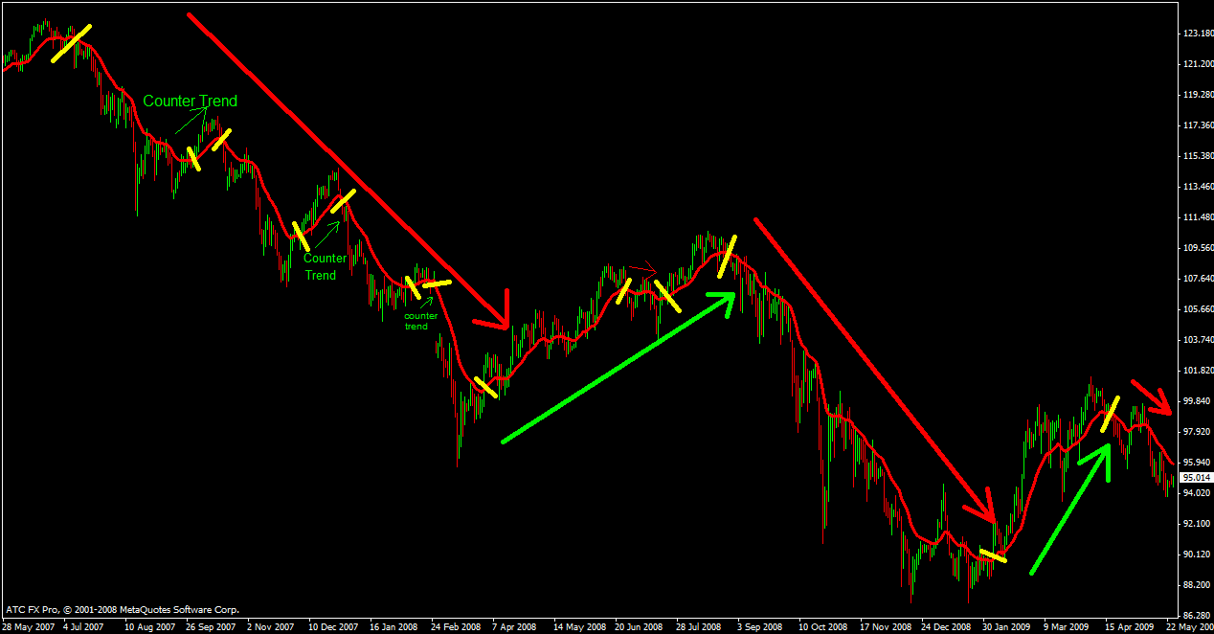
Which Trend
Let's first just make sure we understand that even within one time frame there are several trends. We must establish what the dominant trend is and to do that, zoom out as far as you can go and it should be obvious. I have done this on eurusd weekly and you can see the dominant trend is UP as shown by the deep sky blue channel line.
Then zoom in to find the intermediate trend as shown by the magenta line.
Then zoom into that trend to find the short term trend as shown by the gold line.
Then zoom into that trend to find the immediate trend as shown by the lime green line.
You need to be aware of all these trends when trading the Worker to know whether you are with or against the trend.
So, to trade the Worker, you need to know the IMMEDIATE BOSS trend since this governs the Worker direction.
Remember also that if you draw TLs as I do, you can use them as your Momentum indicators which tell you far more than a squiggly line.
So, where we are today on the BOSS, the IMMEDIATE trend is DOWN but it is at the cross - roads of it's short term trend meaning that something has to give. Whichever way this breaks IS the IMMEDIATE trend and will provide direction for the Worker.
Don't forget that even 3 bars on the BOSS is 15 bars on the Worker.
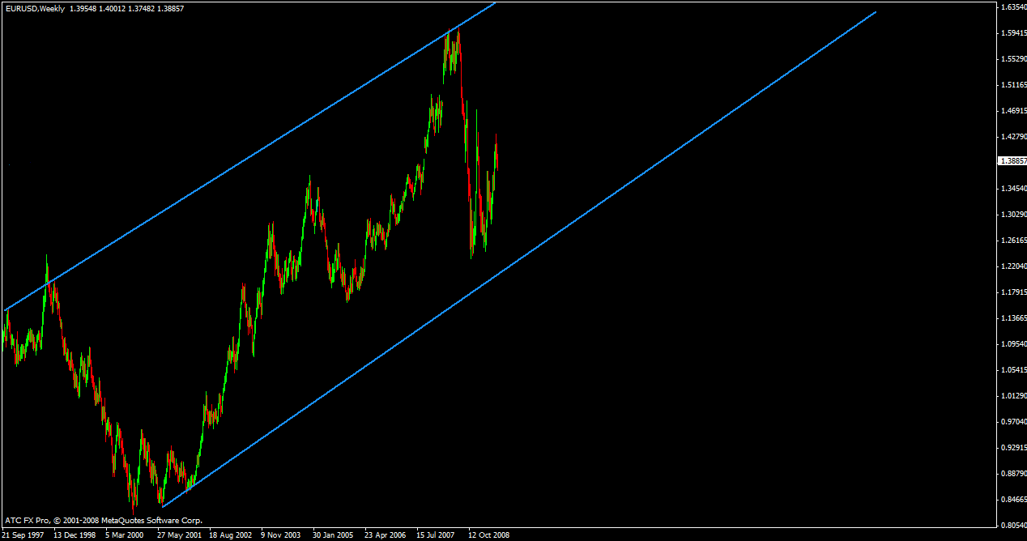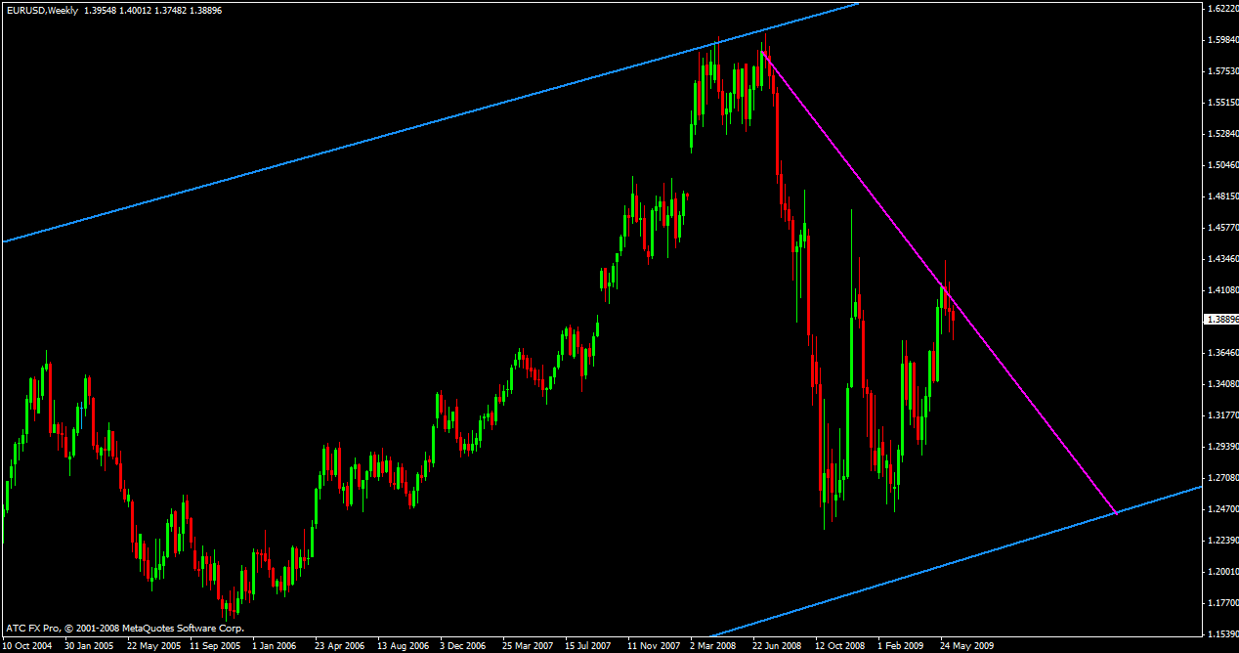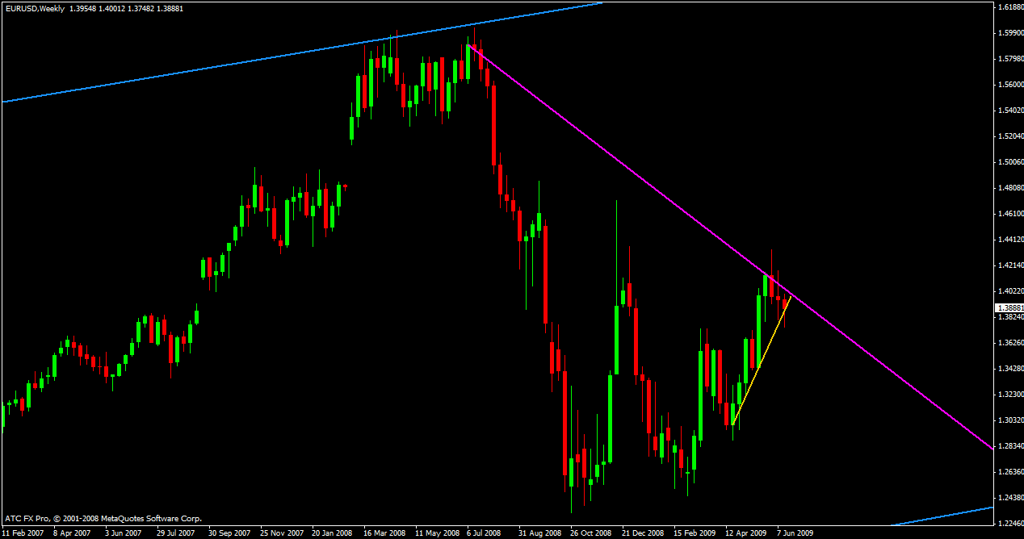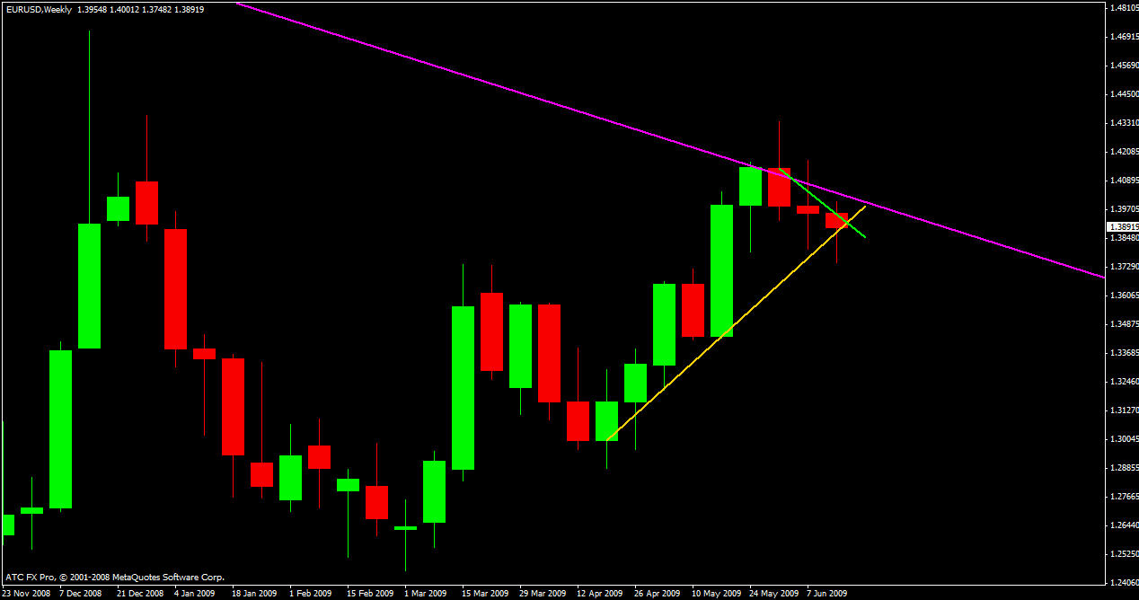
Trend Indicator
Take a glance at AUDUSD:
If PRICE continues to close higher, PRICE is trending up. The angle of PRICE making higher PRICES is MOMENTUM and, in itself, “THE” indication of trend strength (or weakness).
If you cannot see that at first glance, then just look at PRICE relative to our MAs. Is PRICE moving in parallel with them or getting nearer to them or moving away from them?
If you still cannot see Trend Strength then draw straight lines on the swings. Observe the angle of those lines.
Usually, but not always, the steeper the slope of PRICE (line) the nearer PRICE is to exhaustion.
Gann declared that a 45 degree PRICE slope was the ideal slope for steady, trending PRICES.
The slope of lines A & B are very steep, greater than 45 degrees and warn us that PRICE does not usually continue at this speed.
Line C is more gradual and basically changes into Line D where it again exhausts itself.
Line E is a short exhaustion trend.
Lines F & G, being down, will always be steeper than their “UP” counterparts due to the effect of gravity (PRICE falling).
We also know that at turning points and end of trends, PRICE usually, but not always, “peters out” (loses momentum – loses the energy driving/pushing it) which is shown by smaller bodied candles. This is not a hard and fast rule as PRICE sometimes PAUSES in a similar manner before continuing the original trend.
The RSI and this “Trend Strength” indicator is supposedly for trading trends BUT just applying this to our trendy AUDUSD would whipsaw you so badly that you would wish you had never heard of trading forex!
Again, the best indicator for ANYTHING is between your ears.
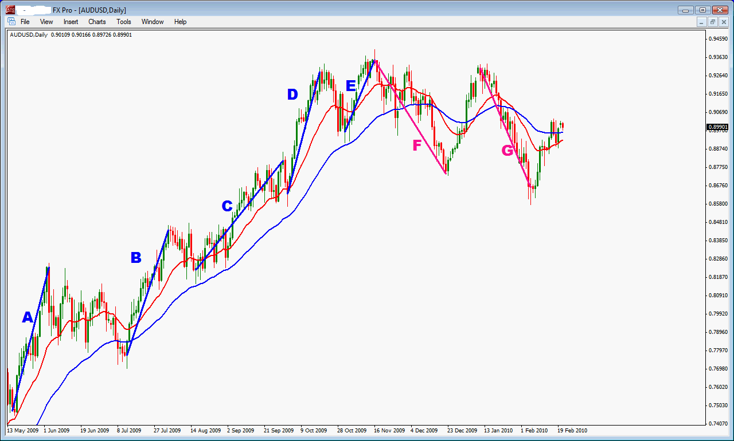
Confirmed Swings
Many people get swings wrong because they are not using CONFIRMED swings. Unless a swing is CONFIRMED it is not valid and is about as much use as a crack in a glass eye!
To answer your questions:
I see three possibilities for confirmation here;
- Marked candle has a higher high and has closed lower than the previous bullish bar
- Price breaks below the marked bar's low or,
- Price breaks below the last bullish bar's low since the swing high.
Unless my eyesight is failing me, Dave, your 1) statement is incorrect because (i) it is neither lower or (ii) closed lower than the prior bar.
At the end of that week that your marked candle closed, it was an UNCONFIRMED swing high.
For confirmation of a swing, the OPPOSITE end of the candle must be taken out (exceeded). So, for a CONFIRMED swing high, the highest candle must have its LOW taken out and Vicky Verka for a CONFIRMED swing low.
Therefore, your marked candle is CONFIRMED as a swing high the following week when it’s LOW is taken out.
See also attached examples
Should you wait until the swing high is confirmed on the weekly chart before you look for a shooting star or other entry candle on the daily chart?
Remember that although the higher time frames determine the direction of the lower time frames, they lag at turning points. This is because the lower time frames are faster and therefore respond faster.
If you do what you suggest above then you are trading the BOSS chart and not the Worker.
When you see a classic shooting star at resistance as you show in your EURAUD Worker chart with a bearish BOSS then, providing everything else is equal and you are not trading into an immediate area of strong support, you would place a sell order below the low of the Worker shooting star.
Would this SS be considered a bond candle because there had not been confirmation yet, therefore would have been a low probability trade? Or would this have appeared to be a likely winner at the time because it appeared near a resistance area and worth trying to get in before confirmation by the weekly?
Maybe you need to read again what happened to my mate Bond – he thought he had pulled a gorgeous chick but when he got down to the nitty gritty, he found the meat and two veg – in other words, a “she male”. So, a Bond candle is something it is not and is trying to “fool” you.
It can be a correctly proportioned candle but nowhere near S&R or, it can be an incorrectly proportioned candle at S&R or any combination of both.
In your example, the shooting star is correctly proportioned, the open of the candle was at resistance, the close was not only below the prior candle but also within the body of the candle before that. The wick of the shooting star is also rejected by resistance. As if that wasn’t enough, the shooting star was also a BEOB! This was a trade to die for!
Don’t get confused with how to use the BOSS to trade the Worker. The BOSS gives us our direction and sentiment – the Worker gives us our timing. When you see the BOSS signalling an opportunity, start looking at the Worker for PASR to trade in the direction of the BOSS.
Also, don’t waste your time looking at Worker pairs when their BOSS is not signalling an opportunity – this is a sure way to losing trades.
If you are still confused, ask more questions – we’ll get you there!
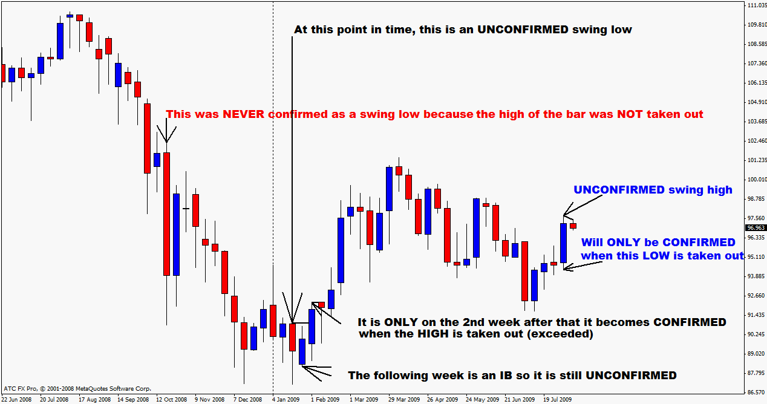
Forex Money Management Essentials
Money management is the process of analyzing trades for risk and potential profits, determining how much risk, if any, is acceptable and managing a trade position (if taken) to control risk and maximize profitability.
Many traders pay lip service to money management while spending the bulk of their time and energy trying to find what they think is the perfect trading system or entry method. But traders ignore money management at their own peril.
There is no lack of forex money management strategies online, yet the fact is that a majority of neophyte traders lose a lot of money because they ignore this important aspect of trading. Money management is such a basic fact of business, yet many people do not pay attention to it.
The results of neglecting this facet of forex trading are disastrous. Without appropriate monetary strategies, it will only take a few forex trading sessions to lose your entire account. While you may have a large deposit, do not waste it by ignoring correct money management.
Get Rich Quick - it will NOT happen to you.
First the following must be kept in mind: no matter what you may read online, or what anyone tells you, the forex market is not the place where you can get rich in an instant. Theoretically speaking, it is possible to earn $1 million dollars from a $100 dollar account, but the chances of that happening is as good as winning the jackpot lottery twice. In other words, it can happen, but the possibility is quite remote.
Part of a superior forex money management strategy is limiting the amount you risk from your initial capital. Contrary to popular belief, one does not get rich quicker by trading in huge amounts. The ideal setup is to trade 1 to 2% of your capital in a single session. While the return may be small, it ensures that the losses will be minimal should the trade go south. You will also be surprised at how these small gains add up to a large amount.
As with any business venture, patience and perseverance are required in forex trading. The importance of maintaining a healthy initial capital cannot be over emphasized; the simple fact is that the more money you lose from your deposit, the harder it will be to make a profit as part of your earnings will go towards recuperating your losses.
Another way to keep your money in check is to establish Stop/Loss and Limit Orders. While these orders are easy enough to setup, it is more vital that you stick to it. If the pip count reaches the Stop/Loss level, then have the order executed; do not pull it back, hoping things will reverse course.
Finally, an integral part of forex money management is keeping abreast of the news. Stories of investors who make millions and billions in currency speculation did not discover a way to “beat the system”; it came from months, even years, of studying pertinent data.
Having said all that, there is no suggestion whatsoever that you should not take risks in the forex. No risk, no reward, it is said and true enough, you cannot possibly profit without taking a chance. But what we are saying is by following the steps above, you will avoid taking unnecessary risks.
Trading Psychology - the Basics
From the day that you decide make the move from a demo account to a live account, things change in ways that you could never really be fully prepared for.
What is trading psychology?
Trading psychology is the perception change that you go through once you are actively in the markets trading your own money. When trading on a demo account, it seems like it would be easy to make money and there seems to be no reason why you wouldn’t be able to start making money with a live account. Then, you make that first live trade and you start to feel indecisive about when to take profit, or cut your losses. You have just discovered the effects of trading psychology.
How does trading psychology affect your trading?
Trading psychology can affect your judgment while you are trading. There are two emotions in particular have been the source of ruin for forex traders over the years. Those two emotions are fear and greed. Fear will cause you to either not make a trade when the opportunity arises, or to close a trade prematurely without giving it a chance to be profitable. Greed will cause you to make trades that are too large or too risky, while trying to make massive gains. Greed can also cause you to try to wait for the “last pip” of a move instead of being satisfied with a “good run”.
How to beat your emotions
The best way to combat trouble with trading psychology is by making a trading plan and sticking to it. Use well thought out risk management and don’t get in over your head. Remember that mastering your emotions will allow you to seize the real profit from the markets while emotions are high for others. If you can master your emotions and follow good risk management practices, you can be a successful forex trader.
Fear and Greed
Besides all of the fundamental and technical factors a trader must keep track of in order to be successful, there is another area which is often overlooked – themselves.
No matter how good your strategy is, the other factor which will always influence your outcomes are your own emotions. After all, it is emotions that move the markets. Emotions are what most of our indicators are designed to give us a measurement of. And in order to be able to profit on market movements created by the emotions of others, you must first learn how to read the mood behind the move, and also how recognize and control your own.
Greed
As prices rise, they naturally attract more attention. As more and more people jump onboard the rally, its climb accelerates. But in all the excitement, there is a tendency to confuse account balance (the amount actually on your account) with account equity (the total value including the sum of your open positions). People begin to treat their potential profits as if they were already realized. This expectation can sometimes cause basic reversal signals to be overlooked.
Additionally, those who missed out on the opportunity early on, when the trend was still young, are becoming hypnotized by the length and size of the rally. Jumping onboard late is a risky game, however, as those who got in early will eventually need to take their profits. There is also a bit of the “greater fool” factor, as anyone who is still buying is now buying at a higher price, and from a seller who has reason to believe the move may soon be over. The idea then is that hopefully someone will keep on buying after you, at an even higher price, when you eventually decide to become a seller yourself.
Fear
When prices start falling, they awaken fear and panic. Fear is one of our most primal emotions, which explains why prices often fall faster than they rise. People holding longs run for the door trying to sell as quickly as possible, and short sellers motivated by the falling prices add their own orders to the mix as well. When those short orders are eventually covered in order to realize profit, there are temporary rallies which can give false hopes.
This crowd mentality frequently creates moments of market imbalance which can be capitalized upon, once one can learn to recognize the signs and interpret them correctly. Above all else, the key to developing this skill is practice.
How Emotions Manifest on Charts
One of the key measurements of market sentiment is support and resistance. If resistance breaks, there are more bulls in the market at that time than bears. If it bounces, we know the bears have overpowered the bulls. Likewise, if a support level holds, we know that any drops in price were most likely caused by routine profit-taking. If it breaks, on the other hand, we know we have short sellers entering the market along with longs starting to close their positions.
Another indicator that mood and sentiment in the market may be beginning to change is momentum. Declines in follow-through on moves can often signal a drop in enthusiasm and increased likelihood of a pending reversal. Both trend-following and oscillating indicators can give us some clues and insights in this regard, especially as divergences begin to appear on the chart.
Lastly, there is volume. Often overlooked on forex charts due to the lack of a centralized exchange (though still worth paying attention to even if it is only the volume from your own broker), volume should typically increase as trends accelerate in either direction. If volume suddenly starts to drop off, it can signal an impending end to the trend in question, or at least some turbulent times ahead.
Learning to Control Your Own Emotions
The first step to becoming a more disciplined trader and having control over your emotions is becoming aware of them. If your results are not consistent, take a close look to see if you are indeed following the strategy you outlined for yourself. Are you entering and exiting positions due to a well-defined signal, or was there some other reason?
Here are some of the most common “symptoms” to watch out for, especially if you see the pattern occurring with some regularity:
- Getting out of positions too early, only to see them continue on in the direction you were hoping they would go is a sign of fear.
- Staying in positions too long and watching the markets take back some of your profits is often a sign of greed.
- Closing a position for a loss, only to see it reverse and go back above break-even moments later is a sign of fear.
- Not closing a losing position, and letting small losses become larger ones in the hope of a reversal that never comes can often be a sign of greed.
- Jumping into a trend late, after much of it has already happened without you, can stem from a fear of missing out on the move.
- And jumping in too early, before the market’s given clear evidence of a direction, can be driven by greed.
It is important to take a step back and really have a close look at what is driving us into and out of the markets. Is it really the strategy and signals we have outlined for ourselves (which should be easy to verify), or is it something else? Our progress in the markets can only be as good as the records we keep, and the time we spend reviewing them. And when we hear news in the markets, it is important to do a quick reality check to make certain we’re giving both positive and negative news the same weight in our evaluations, and not allowing our biases towards a position interfere.
By far the absolute best time to set both targets and stops is before you enter the position. Once the hopes and stresses of the market become your own, we can rely less and less on clear and sound judgement.
Forex Trading Plan
The market is not driven by money but by greed and fear. The two biggest emotions that move markets up and down at random; they seem to fluctuate without any logic behind them.
Why do we get these emotions when we trade? After all, it's stocks we're trading, not playing sports where our bodies are physically working to exert energy and sweat. So why then does it take to so much emotion just to click a buy button and a sell button and watch the screen with numbers moving back and forth?
When it comes to money, it's the master of us all. It doesn't matter what walk of life we hold, we are taught that money is the only way to reflect us as successful and accomplished people. But in the end, does it come down to money to become successful in trading?
The answer is no. Why? Success comes from loving what you do, not from doing what you're doing for the sake of money. There are people who work at jobs they don't like. Many do it just to get by but do not have the drive to excel. People who love their jobs have higher probability to excel in their work because they don't see it as work but something they love to do. Many of us enter the market to make money, not lured by the challenge of figuring out how the market works. It is the reason why new investors and traders start by placing a large position thinking the trade in monetary value, profit or loss. They think will be quick and easy, not really giving thought on how to figure out this complex but interesting market first before committing money in there. By committing money, its about the money, not the pleasure of learning about the markets.
This is where fear and greed comes in. This very first thought people make when entering is 'how much can I make?' and not 'I wonder how this market works?' There is a big difference in this mindset. When we don't worry about the money, we can view things in a more objective way. Believe it or not, there is a fine line from being in a trade and out of a trade, especially holding a big position. The emotions overtake judgment very quickly when a major loss is on the line with the prices fluctuating rapidly.
So how to deal with this? There are several things we can do to keep greed and fear out of the trading plan:
- Start trading smallest positions possible -The idea is to learn, improve and perfect trading while not thinking about the importance of gains or losses. This should subdue if not remove the fear and the greed.
- Use stop loss order - Believe it or not, stop loss orders bring comfort and peace of mind that would otherwise bring many traders sleepless nights. Why? Not knowing how much the loss is, which can be unlimited, carry a major concern. This method will get rid of the fear factor.
- Create a trading plan - Having a plan of attack, where to get in and where to get out in a certain market condition relieves the trader from having to think on his feet; without a plan will cause the trader to freeze and be indecisive and in turn cause more emotional stress.
Forex Trading Plan Elements
First write down your goals and objectives that you want to see happen in your trading business. Keep your trading plan as simple as possible. It should have enough details and a set of strict rules like for example include the golden rule “never invest more than 5% of your capital on any one particular trade”. Always question your trading activity, and look to your forex plan for guidance. If you are off track use your forex plan to get back on track. A forex trading plan should guide you at all times in your trading activity. If you ever want to achieve consistency in your trading pattern, having a forex trading plan is a must. In fact your own individual personalized forex trading plan would be the cornerstone of your entire trading activity.
When you have a forex trading plan, you have automatically programmed yourself to embark on a path of continuous growth and expansion in your trading business. By sticking to your plan, you would hopefully trade larger lots and make better profits over a period of time.
Perhaps at some point in your trading life you are likely to run into the adage “Plan your trade and trade your plan”. However this is easier said than done. But if you follow this advice, you would in effect be following very safe trading guidelines. The guidelines in your forex trading plan could very well be set up to watch out for both exit and entry rules in entering and exiting a trade, and the common pitfalls you got to avoid at every step.
A good currency trading plan will remove all the emotions from your trades. Some points that you should consider including in your currency trading plan are as follows:
Analysis Criteria: Specific conditions must be met to consider a currency pair to trade with and requires the use of technical indicators such as trend indicators, momentum indicators or hybrid indicators, how you read them, chart patterns that you trade and don't trade.
Entry Strategy: determines the price at which you will enter your trade. For example, an entry order can be an order to buy if the market trades above a certain level. Learn how to read technical indicators and learn what an entry signal looks like to you, know what you will use as entry signals.
Open Position Strategy: Is the most important and focuses on managing your emotions after you have entered the market. Too many open trades are harder to track and they put too much of your money at risk. When real money is involved your emotions change greatly which can effect your profitability as a trader. If your emotions are not in check they may cause you to stop following your currency trading plan because fear or greed got the better of you.
Stop Loss Strategy: A disciplined stop loss strategy is critical to the preservation of profits and trading capital. Your currency trading plan must include a stop loss strategy for use on all trades. The stop loss price that you set is up to you. It depends on your risk profile, trading capital and financial goals as of how much you should set for a stop loss. A stop loss between 1-2% of your trading capital is suggested. If your starting balance is small and you trade mini lots you may need to set your stop loss order far enough to make the trade workable. For this reason a higher percentage of risk may sometimes be acceptable.
Profit Taking Strategy: Before entering a trade you need to determine your profit taking level. Good traders remain flexible with the profits they take. When a trade moves in your favour you may have a strategy to lock in a profit that matches the amount of your trade at risk. You can then move the stop loss to the entry point while you continue to watch the profit run. A limit order can be placed at a price at which you will automatically sell if the trade goes your way. You will automatically collect your profits even if you are away from your account
Discipline: Without it a currency trading plan is useless. If you stick to your currency trading plan and you are not successful then your plan needs adjustment. If you don't there is no way to tell if your currency trading plan is at fault, or if it was the decisions that you made outside of your plan.
Exposure: You should always know what level of exposure you are comfortable with in the market. A general rule of thumb is to risk no more than 2-3% of your available trading capital for any one trade. This will ensure that regardless of what happens to you, you will still have money left to trade with even if you have made a number of consecutive losses. After making the necessary changes to your currency trading plan you can still go back to the market.
Money Management: Forex money management is very important as it focuses on how you protect and allocate your trading capital. You need a strategy of limiting risk while making the most out of favorable market moves. When you allow your profits to run it is necessary to trade with a risk/reward ratio of about 1:2 or greater. Risk is the amount of pips you are willing to lose in any one trade and reward is the amount of pips you intend to gain in any one trade. To maintain the risk/reward ratio it is wise to cut your losses short and let your winning trades run.
Method Summary, Points To Ponder and One Hit Wonders
To be tidied up - YOU do if you are reading this
- Learn basic PASR (price action support resistance). This involves learning and understanding exactly what PASR is.
- Identify ACCURATE SR levels. Support and Resistance is never calculated using random prices, SR is identified from PREVIOUS PRICE ACTION.
- Learn to identify basic price reversal candles – Hammer, Shooting Star, BUOB, BUEB, BEOB and BEEB, nothing else. Hunt these out and study them on thousands of charts. Once you have done this do the same on thousands more charts. At this point we have to learn the classical definitions of these candles and more importantly - where and how they must form to be considered significant. DO NOT think about or study other candles or patterns as they are NOT reliable and/or consistent for PASR trading.
- Learn how to calculate risk according to stop size and pair then combine the above together to do SIMPLE yet very profitable trading:
- Trade from support to 1st resistance and resistance to 1st support. Use fixed risk and no more than 1-2% risk in total. Place buy stops above hammers/BUOB/BUEB's and sell stops below shooting stars, BEOB/BEEB's so that trades only trigger on momentum. Do this over and over and build your confidence. As you do this you will learn more about how to PLAN YOUR TRADE and how to TRADE YOUR PLAN.
- Unless a swing is CONFIRMED it is not valid and is about as much use as a crack in a glass eye! Placing stop orders doesn't guarantee you won't get in on unconfirmed swings but it does better your chances.
- A “Bond” candle is a deceiving or misleading candle. It can be a correctly proportioned candle but nowhere near S&R OR it can be an incorrectly proportioned candle at S&R OR any combination of both. Learn how to recognise a bond candle, and better yet, a real, strong candle that seeks lower prices but finds buyers.
- As there are bond hammers there are bond shooting stars. Due to “gravity” bond shooting stars can be considered more favourably than bond hammers BUT learn to recognise the real thing.
- How to use the BOSS to trade the Worker:
The BOSS gives us our direction and sentiment, the Worker gives us our timing.
When you see the BOSS signaling an opportunity, start looking at the Worker for PASR to trade in the direction of the BOSS.
Don’t waste your time looking at Worker pairs when their BOSS is not signaling an opportunity – this is a sure way to losing trades.
- Reason for trading dailies: “I am more suited to doing a 20 minute analysis over 10 pairs after 2pm (PST, when NY closes) and placing limit/stop orders and letting them run”.
- My stops go either at swing highs or lows or major S&R and are NEVER by pip value. (i.e. structure high/lows).
- I use a combination of everything I know to forecast direction and only get it right about a third of the time.
- The triangle/coil is that formed on the Daily chart by the trend line across the lower highs and the trend line across the base.
- I use a Daily candle chart with a red 20ema, a blue 50ema, a dotted red 100ema, and a dotted Blue 250ema and a Volume indicator in a lower window. I then switch this to Weekly to look at the big picture. When I do my end of week analysis, I add a couple of cycle indicators but I'm not entirely convinced yet that they really tell me anything or are worth the effort. The most important parts for me are to be able to clearly see price bars or candles.
- My method is very basic and simple:
Price Action at Support & Resistance (PASR).
The key is to know what Price Action IS and what it DOES at Support and Resistance.
- What is important is not to use any one aspect of my method in isolation. For example, it would be foolish just to use Price Action without Support and Resistance. Next it would be foolish to use both of them without knowing where we are in the big picture etc.
- The trick is to limit your losses so that your wins are always far greater.
- The entry is to place a stop sell order BELOW the low of that outside engulfing bar so that when it goes lower, you are filled in and are therefore taking advantage of the downward selling pressure (momentum). If we are wrong and price takes off in the other direction, then no big deal, we don't get filled and live to fight another day.
- About how long to leave a pending order in place; there is no set rule, it all depends how price action is developing.
If I entered an order anticipating a sell and then next day the sentiment changed or price action started to hint at buys then I pull the order immediately. It also depends where the price closed relative to support and resistance.
- To trade the long term trends we have to BELIEVE that we got our plan right and be prepared to sit it out until it tells us we are wrong. Most of the time we will get it wrong and either get stopped out at break even or for minimum % risk. The few times that we get it right make up for those wrong times a thousand times over
- The “meat” is after the first confirmation of the trend. Finding the end of the “meat” is a little more difficult but still relatively easy depending on your greed for profit.
- Another point, a trade is put on as part of a plan (PLAN THE TRADE). Once the trade is entered, the trick is to TRADE THE PLAN. If you are trading the Daily chart, then TRADE THE DAILY chart - forget about how many pips you are up or down, your plan takes care of that. So many traders try to trade the Daily with a H4, H1, M15 or M5 mentality and then wonder why it doesn't work!
- We trade price action at support and resistance. This, along with the direction from the higher time frame(s), guides us in our trades. Also we manage our trades once in a position.
- I trade on momentum not on guesswork. I only want the market to fill my order if it moves in my direction.
- On a dip in an uptrend and IF price action was at support and everything else was lining up, I would place a buy order several pips ABOVE the high of the preceding bar - if price doesn't go up, I don't get filled.
- Jacko: In trading, you should park the “ego” at the door, be calm and patient, and trade ONLY when the risk/reward ratio is in your favour. It is not easy, but it is simple.
- My stop losses always go at swing highs or lows or support and resistance but NEVER by pip value. Yes, those levels are further away now but so are the profits. It's all relative.
- I don't normally interfere in mid session of a daily bar and when I do it goes pear shaped.
- On MAs; the Daily 20 and 50 give us i) trend direction, ii) support and resistance and iii) whether it is a bullish or bearish outlook. The BOSS 20 and 50 does the same but from a Weekly point of view.
MA's are very powerful and I use them both in isolation and in combination with all my other stuff.
They tell you the trend in two time frames, where prices are in relation to the trend, the strength of the trend, are invaluable as support and resistance AND especially when they are in confluence with support and resistance levels and can give us an idea when to expect the rubber band move to come into play.
The cross of MA's, although never used as a trading signal due to the lag, is also very informative. Their slopes provide valuable information as they do when they “trap” prices between them.
Since they are also used by banks, funds, hedge funds, trading houses and large institutions they become “self-fulfilling” much like Fib levels and retracements.
MAs are dynamic whereas our support and resistance is static.
Nicola: The moving averages are great indicators of trend. If the 50 is above the 20 and the price is below them both then the trend is definitely down, and vice versa. Strat: You have the logic spot on but the description is upside down. To make it more understandable, it would be better to say:
If the 20 is below the 50………..The 20 is the boss of the 50.
When the price is stuck between them it is in a box and direction is not always clear.
I see them as floating (Dynamic?) lines of support and resistance which can be just as powerful as the fixed lines of support and resistance I have drawn on my chart. Not sure if it is because a lot of traders use them but there is often price action off the moving averages……..if there is a moving average at a strong support/resistance level and that also coincides with a fib level then I am definitely looking to see what the price will do there.
Price is what we are concerned with and IT'S position relative to the 20 and 50 (not the other way around). The 20 is the BOSS over the 50 - it is far more powerful - many times it acts as resistance and support - go back and look at lots of charts. Always look at where price is relative to the 20. If price is above the 20 it is bullish - it does not necessarily mean you should buy at that point but that you should be looking for other signs to tell you to buy. The more often price goes above the 20 while it's direction is down, the greater the chance that it will eventually put in a low swing above it. Price is now boxed in between the 20 and 50 telling us to sit tight until it shows us it's future direction. Often times a substantial move evolves from the “Boxing in” of price. The 20 and 50 are also coming closer together and going horizontal - another sign that a big move can be expected from this.
Yes, they lag and yes they are indicators of price history BUT we are not using them in any way shape or form to generate signals as you are probably more familiar with. I have some pretty good MA systems which are very profitable UNTIL they hit the dreaded consolidation and just like everything else in consolidation, (in my opinion), are useless. We also never use them in isolation. They are used as part of our total package in our decision making process.
- The worst thing anyone can do is look back after an important announcement and especially, NFP, and to think what might have been if I had done this, stayed in, etc. Either trade it and suffer the loss or reward, but mostly, stress, or stay out. If you stay out then forget it, let it go, don't look what happened. What did happen is something over which we have no control so why waste energy worrying over it.
- Since I'm trading reactions to Support and Resistance, my stops have to go either above/below Support and Resistance or at swings. For me, they have to be away from the noise of all the time frames below the Daily. When I place my stop loss, I EXPECT the MMs to run the stops and clean everyone out BUT I believe in my plan and let it run accordingly.
- Support and Resistance are proven areas in history where buyers have bought and sellers have sold.
- If you try to take a piece of method A, and add a piece of method B plus a squirt of method C, it won't work. A method is an all embracing strategy.
- Patience and waiting for the trade to come to us is the difference between winning and losing (read amateurs and pros). The “dead area” (trapped between support and resistance) is where most traders lose their money.
- If I was an aggressive trader, I would have sold at the market but then that puts me in the hands of the MMs and takes away what little control I still have left.
- I am only interested in the CLOSE of a candle. I do not care where it started, where it's been, how far it's gone or why it went there, only where it ended up.
I do not use highs and lows for any of my analysis - not even for trend lines.
The close, in my opinion, is the most important level on a candle. I do not use tails or wicks for trend lines or any of my analysis. So, on a down trend line, I draw the line through the open.
Although the close is the most important, the other 3 levels also have their use in telling us what went on in that 24 hour bar.
- Where to draw your fibs, the general rule is from swing to swing. When that swing has produced it's retrace, rally or whatever the move, then move on to the next swing.
- What you have to remember is that trend lines, fibs, support and resistance are not exact. That is why you will see us say 1.3650ish. There is no rule that says price has to be “spot on” with any of these - just pretty close will do the trick.
- When something is not working for us after we have given it a good try, we need to stop and ask “WHY?” How many of us have traded with something that does not work and asked “WHY ISN'T IT WORKING”? We just keep plugging away and HOPE that our “LUCK” will change. Hope and luck are not included in the recipe for trading success
- Don’t be in a hurry to trade - let the market show it's hand and then jump on it's back. You do not have to get in at tops and bottoms on the Daily time frame.
- I struggle with getting SL to break even also. It's a toss up between hanging in for a longer move or getting out with some profit. I try to look at where the next roadblock (support/resistance) is and work back from there. It also depends where you are in the trend (or not in a trend).
From the trading psycho view, it is always best to grab some profits while you can and not let a profit turn into nothing, or worse, a loser. However if you do screw up and end up with nothing or a loser just take it on the chin and move on to the next trade.
Baba G: In regards the whole S/L break even take profit thing. Its never gonna be any different because market the is never the same twice. This is what I do. I look in my crystal ball and I say entry is……there it will pause there, there and there. At each of those “there’s” I do something. I decide what I’m gonna do before entry. If A,B or C happens at one of those “there’s” I’ll do X Y and Z and I’ll do that process till I feel I'll be at the free trade point then I don’t care. In a trending market ill give it more room. In a consolidation market I’ll take no prisoners.
The combinations are endless and the outcome is always different.
- You have to learn what each single price bar is telling you, then what a group of price bars are telling you, then what a swing is telling you, etc, etc ALL within the boundaries of support and resistance.
- For volume, I use the standard MT4 volume indicator………forex volume samples are just as accurate (as political polls which sample a small part of the population).
- A neutral doji - it is telling you there is indecision - the buyers and sellers have met and cannot agree on anything. It does NOT, absolutely NOT, tell you of a possible direction change. What it tells you is there are sellers closing their shorts (profit taking) and others coming in to sell and some to buy. It is doing nothing more than taking a rest - it is NOT a price reversal bar
- I'm using a line chart based on the close to draw my lines (trend and s/r) which I’m finding helpful in clearing the clutter.
- “HOPE” is not an ingredient in the traders' success recipe? If I am “hoping” for more that means GREED has raised it's ugly head again.
- Volume: Never use volume as something to base a trade on - only use it in conjunction with everything else. I use it to confirm price action at support and resistance and to gauge the strength of a move. I would never dream of trading on volume alone.
Volume is also not as simple as a price bar in the sense that increasing and decreasing volume indicates demand and supply so please be very careful using volume until we explain it in greater detail.
- There is absolutely no magic in the reaction of price to S & R levels; if you understand price action at support and resistance. There is a caveat though and that is, you have to find the CORRECT or ACTIVE S&R lines.
- I recommend everyone enter trades with at least 2 positions. This does not mean twice your MM allocation. It means divide your regular one trade into two trades thereby halving the size on each.
Place the 2 positions with the normal SL but set a TP (Take Profit) for the 1st position. This should be a very realistic TP not some “dream” figure. A good TP is just under the ATR1 (Average Trading Range) of the pair being traded.
When that PRICE is reached you have just taken profit. It is in your account. No-one can take it back.
Now, depending on where that PRICE is relative to SR and swings, you could move the SL of your second position to that PRICE meaning that it is now at break even and you have a “free” trade.
So with 2 positions, you get a profit and a free trade if you manage it correctly.
- We have a 20ema and a 50ema which tells us about the Daily and on the same chart we have a 100ema and a 250sma which tells us what the BOSS is doing.
The 100ema on the Daily chart is the same as a 20ema on the Weekly (20(daily) x 5 (days in a week) = 100) The 250ema on the Daily chart is the same as a 50ema on the Weekly (50(daily) x 5 (days in a week) = 250)
In each case, the 20 is more powerful than the 50
- IBs are “PAUSE” bars - the market is undecided - taking a rest - usually in a confirmed trend it will be a continuation bar meaning that you can trade in the direction of the trend.
- With regard to shooting stars at the end of an uptrend and hammers at the end of a downtrend, they will jump out at you if they are the real thing. What is happening now is that you are “searching” for them and trying to make every bar look like one. Pay special attention to position or location. These type of candles mean different things in different positions in a chart and sometimes mean nothing at all. Then, when you see what looks like a hammer or shooting star, remember Bond. Ask yourself if it meets ALL the criteria, “is it really a hammer/shooting star?”.
I want to encourage you to only trade “classic” price reversal bars as these are the safest ones with the lowest risk. There are also several ways to trade the price reversal bar but I’m only going to discuss the safest and lowest risk (for me). After you see the price reversal bar and thought of Bond, this then becomes your “set up” bar. If it really is a hammer (don’t get fooled like Bond did!), enter a buy stop order about 10 pips above the high of the hammer. The amount of pips above the high will depend not only on the pair but on the current volatility of price action (below the low on a shooting star).
- When you go looking for opportunities, ALWAYS start with the BOSS. Look at what it is telling you. Then knowing that, move over to it's slave - the Daily and look at what that is telling you.
- The North bound train can't go anywhere but North until it STOPS in the station, gets on the turntable and turns around to go South.
- If it means something it will jump out at you.
- If you want to find really strong, powerful levels of resistance and support, then pull up a Monthly chart and where the Monthly levels coincide with the Weekly levels is where you will find super powerful major, major support and resistance. If you do this, do not draw other lines in as you will end up with more horizontal lines than price bars!
- Nicola: I just do the ones ( SR Lines) where the price changed direction. PS - I make them pretty faint dotted lines so as not to be distracting too.
- I use specific price levels - sure there may be and are several levels around the same price but they mean more to me than a zone.
Have another go with your Weekly S&R but try to identify the swings and, when you have identified a line, scroll back to see how many times price reacted to it. If there are very few reactions to it, then it is a low incidence line and may never come into play again.
- The TIME factor has no bearing on S & R - the only thing that matters is PRICE.
- Despite what you may read that the markets are Random or Chaos they are actually quite organised and respond to the past. Always remember that with the markets, HISTORY repeats itself.
- Ignore the colours for bullish/bearish determination. It is only red because it closed below the open. Everything else other than colour is more important.
- I like to put fibs on the latest price action.
- The ideal 2 day pin has the same length noses. The greater the difference the weaker the bar. And the close wants to be in the body of the bar……g
- We must be very careful not to over-analyse and over-think - something for which I am also guilty. I love nothing more but to look at charts and think through every possible scenario, but for what? It doesn't get you anywhere. RWS- the K.I.S.S. principal rules.
- The absolute worst thing for anyone trading the Daily to do is watch what happens on a shorter time frame or watch the Daily candle DURING trading hours. We don't care what goes on within that Daily candle - all we are concerned with after 5pm NY time is where the candle closes and where it's been.
- “What is the market telling me”? If you have to ask this question then you have really answered it yourself - the market is not doing anything, it is waiting.
- Dr. Joe visited CME - all he saw was the floor traders just FOLLOWING the market - when it went up, they bought - when it went down, they sold. It really IS that simple despite all today's electronic widgetry and gadgetry.
- A common sense trader will always outperform a technical trader. Dr. Joe realised all his academic qualifications were worthless and ditched them in favour of common sense - doing what the market tells you.
- The formula of an EMA puts more weight on the most recent data whereas an SMA treats all data equally. The shorter EMA is thus reacting sooner (don't forget it is still lagging) to the latest data giving us a closer “watch” on immediate prices. The longer term SMA is ignoring the short term “noise” and providing us with a “smoother” picture of prices. Don't forget that all indicators, MAs etc are just mathematical derivations of price so that we can “see” price HISTORY differently. We do not use MAs to trigger signals - they are only there as one of the tools in our tool box to guide us in our analysis. Neither do we use them for predicting future prices - only PRICE ACTION can do that.
- I have found that my 30 second glance across the time frames of each pair is beginning to mean more than a structured detailed analysis.
- Trends demolish ALL and ANY cycles like a hot knife through butter.
- I cannot make head nor tail of fundamental economics therefore I ignore it and just trust what I see on my charts.
I do know that trading the Daily time frame keeps us relatively immune from the wild swings that are seen on the lower time frame from news announcements. At the most, a news announcement may cause a “wobble” but after the excitement and everyone calms down it's back to “business as usual”.
The only news I stay clear of is NFP on the first Friday of the month.
- There is also a Rule of 4 which says something like after 3 attempts at support or resistance, there is a high probability that the 4th attempt will break through.
- So much success with your trading that you will feel like “you can walk on water” - this is the MOST dangerous time.
- Trading is easy, trading psychology is hard
- I have gone to a style where I scale in my position and also scale out as I show a profit. I do not establish my entire position from the get go but I add to it once the market shows me my analysis was correct. I also establish multiple target levels and pull money out as they are reached, the first being relatively small. The psychological side of showing a winning trade is very powerful and having a winning trade turn into a loser, even a small loser, was very damaging to me. I like to be right and profit means I was right. When I looked back at my balance sheet at the end of each month, I would just see the negative number, I wouldn't remember I was right and gave back my profits, I would just see that damn number.
I know there are hundreds of methods to manage positions, this is just one that over time I have come comfortable with and seems to work for me.
- For me there is only 1 place for your stop loss - at the other end of the daily bar your playing……..that's it. Select a % risk and divide that by your stop loss in pips and there you have your volume size……..nice.
- Do not put your S & R lines in BOLD. By doing this, we are tricking our mind and subconscious that these are the BOUNDARIES of price action. These are NOT boundaries, only levels where we EXPECT price to do something.
- I just don't like long candles (unless I'm already in the trade). As I posted earlier, these long candles often throw out IBs and I would rather trade off those.
- An IB is a PAUSE BAR - both the buyers and sellers have lost interest.
An IB can be a reversal bar, bullish continuation bar, bearish continuation bar or mean nothing at all. It all depends where in the price, the IB falls.
An IB means nothing by itself - we have to look at everything around it to make our decision and that decision could be to do nothing.
- Inside bars for me are a sign of a narrower range on a pair with neither the buyers or sellers able to win or gain ground. The more inside bars, the tighter the range and the more volatility builds up (on a lower time frame you may have a wedge or a coil). You cannot trade them until you see which way they break out but they usually work well.
You get a lower risk entry because you would usually put your stop the other side of the bar you are trading so the smaller the bar, the tighter the stop.
The IB is a set up bar and you place your order either side of it DEPENDING WHERE it is in the price/trend/range and WHAT it is doing in price relative to the bars around it, OR, you may not do anything at all. With a decreasing number of IBs, if you know the direction, you just keep placing your order above/below them - this gives us our DISCOUNT PRICE.
- Be aware that long bars with tails usually provide a reaction on the next bar so we may end up seeing IBs again
- While you are reviewing the BIG BOSS in your End of Week analyses, don't forget the higher order of time frames:
The BIG BOSS watches over the BOSS and tells her what to do.
The BOSS watches over the Daily and tells her what to do.
So, when we are trading the Daily time frame, we must know what the BOSS is doing while at the same time BEING AWARE of what the BIG BOSS is doing.
Also, be aware that when the time frames conflict with each other, especially the BOSS and the Daily, this is when they start fighting each other and produce erratic price action.
However, when the BOSS and the Daily time frames are aligned, watch how easy price action is and the way price moves in the direction of the BOSS.
- You should only be drawing SR lines which have meant something in the past i.e., was there a lot of congestion? how many times was price supported/rejected? etc.
- Patience is ALWAYS better than being trigger happy. However, we have to find a happy balance between the two. If you put too many S&R lines on your chart, you will stop yourself from taking any trade.
- I am only interested in trends and the major swings. I want to trade the swing high down to the swing low and vice versa. Trading from support to the next resistance doesn’t thrill me anymore
- Support and resistance is part of price action
- You won't be successful mixing time frames. It is OK to use the Daily to get a better entry to trade the Weekly but you have to choose a time frame which will be your base. You will lose out on some really BIG Boss moves if you trade the Boss with daily signals.
If you are trading the Boss then only watch the Boss signals - nothing less - but make sure you are also watching the BIG BOSS.
Don't forget that within one Boss bar, there are 5 daily bars each with their own cycles etc. The daily will, most likely, stop you out WITHIN a Boss bar, while the next Boss bar will probably continue with it's (Boss) trend.
- You don't have to be trading every day! You still have that M15 mentality that you HAVE to trade. Let it go and LET THE MARKET COME TO YOU.
The trades that everyone searches for are LOSERS. The winners stand out.
- Anytime you have a moving average which is horizontal, it tells you that prices are going sideways. More important is that the market has reached equilibrium or balance. The market is constantly striving to achieve balance but rarely achieves it due to out of balance external forces (buyers and sellers). This means there are as many buyers as there are sellers which is really telling us nobody wants to do anything. Why? Because they are waiting for the outcome of this week. Nobody wants to get caught on the wrong side of whatever the outcome is.
When we get both averages horizontal it doubles the expectancy of the next move.
When you get them embracing themselves in mad passionate love in a horizontal position as GBPUSD is doing that raises a huge red flag the size of Alaska!
This all means it's quiet now, but WATCH OUT, something BIG is a foot!
Do NOT try to guess the outcome or direction. Instead, let price action show us the way. Patience and Discipline IS the key.
- SUPPORT:
Support is, simply put, a price at which point traders expect to see buying. Support can be a level that we have seen previous buying activity at (perhaps the price bounced off of it last month).
The most common place for support level is an obvious spot where traders have seen a major reversal in the past.
- RESISTANCE
As you might guess, resistance is the exact same as support except it is an area where we have seen traders selling the pair in the past.
First is always to identify the direction in which the pair is trending.
- I personally don't use R/R - if I did, I would probably never take a trade. I do start out with risk no more than 2% of my account.
Cutting your losses - it's part of my plan and is controlled by my SL - I have already accepted the loss BEFORE I enter the trade.
Running your profits - the only reason I trade - see my EURJPY trade
Nobody, I repeat NOBODY, can tell where a trade might go. Sure, we have a good idea, others have fib projections, others have S & R, others have trend lines, others have pattern projections, others have pitchforks, others have cycles, others have time projections etc., etc. History can ONLY guide us to where we think the trade might go but that is all it is, a guide. Ultimately, the Queen (the market) will take us wherever SHE wants to go. The only thing we can do is jump on her train and stay on as long as it goes in our direction.
As I've said before, for me, I'm only really interested in trading big moves, or what I think will be big moves, major swings and new trends which at least have decent profit potential.
- Don't worry too much about the 20 “pointing up or down” - be more aware of where price is relative to the 20.
- There IS a difference between an OUTSIDE BAR and an ENGULFING BAR.
To act on an Outside bar, the high and low must be completely outside the previous bar with the close being higher than the previous bar for a BUOB or the close being lower for a BEOB.
To act on an Engulfing bar, the engulfing BODY must be outside that of the previous bar's BODY with the close being higher than the previous bar for a BUEB or the close being lower for a BEEB. An engulfing bar does not require the high and low to be higher or lower.
As always, Outside and Engulfing bars are sensitive to where they are in price and can mean reversal, continuation or nothing so do a thorough analysis before acting on them.
- See the longish wick on that BEEB? That is price being rejected by the strong resistance which rejected prices in the past. You need to see a strong close above that resistance before going long
- Always follow PA IN THE DIRECTION OF THE TREND. The latest candle/bar supersedes the previous bar because it is THE LATEST price action.
IF IN DOUBT, STAY OUT
- The TL needs to be drawn from swing highs in downtrends and swing lows in uptrends.
- The problems with trading during holidays are lack of volume and “skeleton” staff in the big boys. Lack of volume causes prices to be stagnant and directionless but the real problem is “unsupervised skeleton” staff at the big boys. Without supervision of their “head” traders, these guys can put through orders which may otherwise have been held for normal working hours, which can cause erratic moves in the market. Often times they will run stops just out of sheer boredom. If you pull up charts during holiday periods, especially the big ones, you can see long legged dojis all over the place.
I will not initiate positions during holiday periods and will tighten stops if I am holding substantial profits.
I will hold existing positions through weekends but generally do not like initiating new positions on a Friday unless it's a 'no brainer”.

