Big Picture Planning EUR/USD [May 19 – 25]

Pré-trading

A lot of news for the Euro and the Dollar next week. Would only take trades on Monday and Tuesday. Risk of consolidation, indecision on Monday and Tuesday due to news later that week, will only trade if sufficient movement.

Big Picture planning

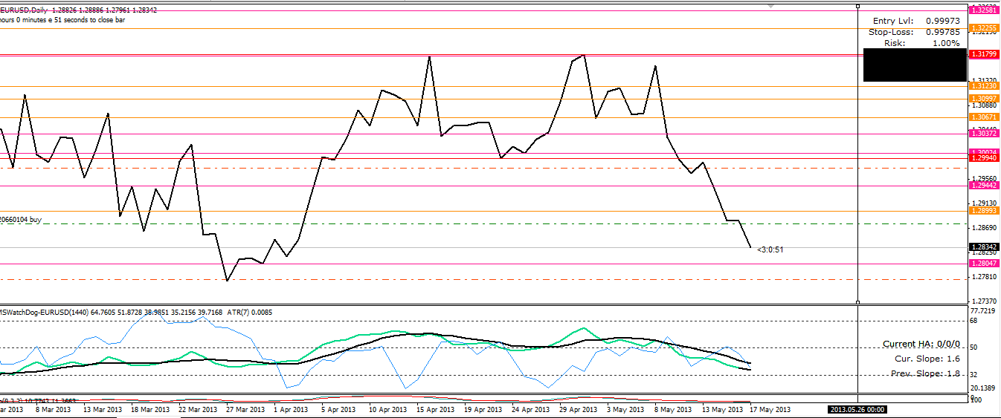
Monthly, weekly S&R drawn and two daily levels with a lot of wicks marked.
Candles on:
- Monthly show a ‘Dark Cloud’ Bearish reversal pattern. Outlook Bearish
- Weekly shows a strong bearish candle. Outlook Bearish
Trend on daily is down for the moment.
Closer look at 4H time frame:
We see a double inside bar, which means indecision. We can expect a break-out. But it’s Friday en of the week, lots of news coming out next week so my number 1 forecast is consolidation around that monthly 1.2800ish level (BRN too) and will break-out after a shock impulse from the news. If positive for EURO, north possible target around 1.3000ish (Monthly resistance, BRN, past days resistance). If negative for EURO, south possible target around 1.2670ish. My number 2 possibility is a break-out south due to Monthly and Weekly outlook, the daily trend and no reversal pattern showing. But needs to break through monthly resistance just underneath it.
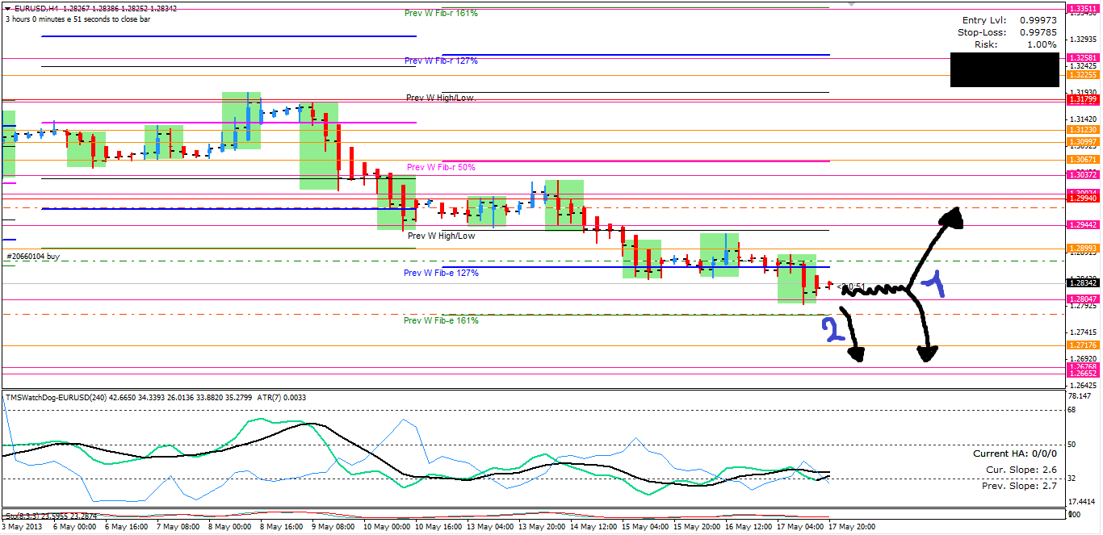

How will I trade this?

Don’t think I would take the risk of taking a trade, capital preservation is most important. If I had to say something I would enter at the break-out of the double inside bar (only down) with tighter stop. If resistance is too strong should be possible to exit around break-even. So I would only trade my scenario 2. Scenario 1 is dependent on news and I’m too inexperienced to trade that.

