In 1935 H. M. Gartley published the book, where mentioned about the graphical model “Butterfly”, and further this idea was developed by Scott Carney, and Larry Pesavento.

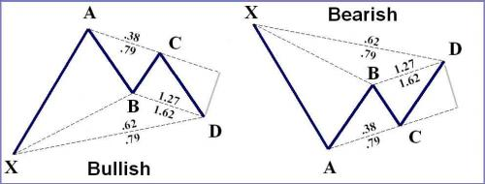
Gartley Patterns are based on Fibonacci numbers, and should fulfill the following regulations.
1. Wave AB should be 61.8% of XA and should equal CD in time length.
2. Wave BC should be 61.8 to 78.6% of AB.
3. Wave CD should be 127 to 161.8% of BC.
Indicator features
1) to construct patterns Pesavento and another different figures, for example, Gartley patterns.
2) to automatically derive fiby and to show the price value of fib.
3) to construct Fibo Fan.
4) to construct Fibo Time.
5) shows information about the current currency pair.
6) Possibility of constructing of price channel (confirmation levels) and levels of the previous peaks ZigZag.
7) to construct ZigZag Fibonacci.
In real trading ideal Gartley pattern is very rare.
How to use Gartley Pattern indicator
Bullish Gartley Reversal Pattern.
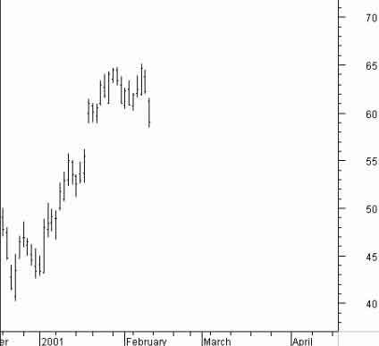
The first thing to find is an impulsive move up from a swing low. Gaps on the way up are great sings of impulse.
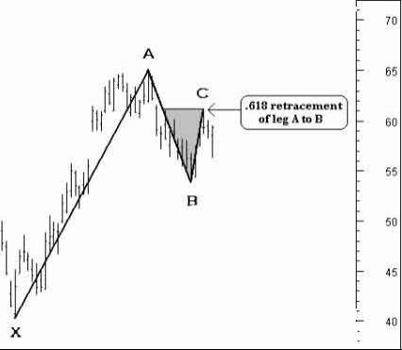
The first step is to identify a fairly one way move [X to A]. Followed by an initial reaction [A to B]. The next leg is where the math begins [B to C].
The B to C leg is the important let to check the math on. It should retrace the A to B leg to one of the key Fibonacci levels [.382 .500 .618 .786]. In this case it retraced to within a hair of the .618 retracement level.
At this point on the chart the assumption is that point C is the swing high and that prices will eventually trade below swing low B. We can now begin the two step process to try and find a target for swing low D to reverse from.
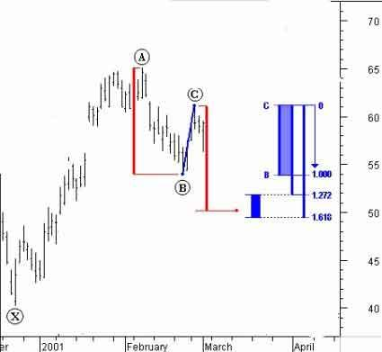
1. Calculate the length of the A to B leg [A minus B]. Now subtract that number from the top of the point C swing high. This process can be seen visually by looking at the redlines. As you can see this step targets a reversal low around 50.
2. Find the length of leg B to C. Take that length and multiply it by the two key Fibonacci extension numbers to find the range for a possible low to occur.
The chart shows the C to B leg as 1.000. The next step is to subtract from swing high point C the two extension numbers. Take the 1.272 and 1.618 of C to B and subtract those numbers from the C swing high. What you get is a target range for a swing low to print between 51.89 and 49.36. Two separate measuring techniques predict a low in a 2 ½ point range. Also AB=CD in the range.
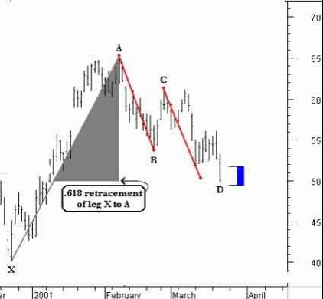
Here’s the final step to confirm a point D reversal buy point. Point D should print at a key Fibonacci retracement level of the X to A leg. After doing some quick math the closest level is found at the 0.618 retracement of X to A. That number is at 49.72 right at the ab=cd.
The chart shows that AB=CD at 50.01. The .618 retrace of X to A is at 49.72 and the CD “range” calculations target a reversal between 51.89 and 49.36. The preference is to favor the lower end of the “range” because AB=CD at the low and the chart is harmonic at the .618 retrace of X to A.
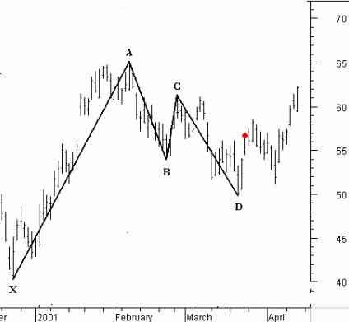
The trader tries to buy as close to the reversal “range” as possible. The first trading target is a 0.618 retracement of the C to D leg [56.82].
Stop loss placement is up to the trader. The next level of support below D in this example would be around 45.50 where the .786 retrace of X to A resides. Others prefer a stop at about where X originated [40.25]. Stops must be used with this pattern because 30% of the time it fails and extends below X by 1.272 or 1.618 of the X to A move.
Bearish Gartley Reversal Pattern
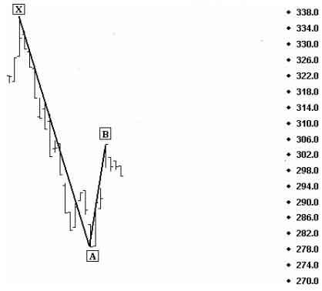
The bearish gartley reversal pattern begins with a fairly straight one way move off of a swing high [in many cases it is from an all-time high].
The drop is the X to A leg. This pattern is initially formed by finding what you see in the chart [an X to A decline and an A to B retracement].
The trader now waits for another swing low to print before we start the point “D” projection calculations.
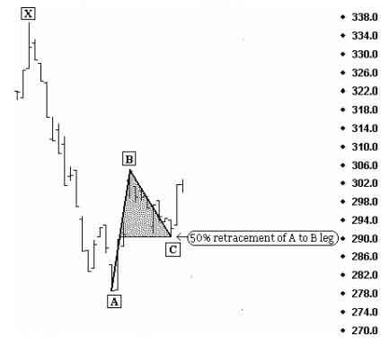
The next key to the pattern is to check the Fibonacci ration of the B to C leg. It must be within a sniff of one of the key retracement ratios of the A to B leg. Huh? Let’s take it step by step. First measure what price distance the A to B leg was in points and write that number down. Now do the same for the B to C leg. Divide the B to C leg number by the A to B number. [(length of B to C leg) / (length of A to B leg)]= ratio. That ratio should be about .382 .500 .618 or .786
We can now begin to calculate the most likely area that the point “D” reversal will occur. This is NOT a forecasing method predicting that prices WILL go to point “D” it predicts where it should reverse.
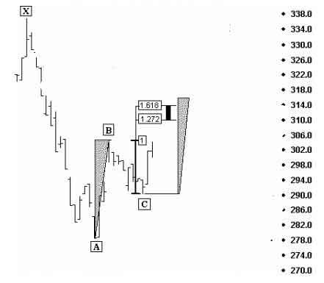
The following process is the key to the pattern. 1st calculate the price length of the A to B leg [B-A] and add that number to the swing low of C to project where AB=CD. I drew equal triangles on the chart to help visualize this process. Next calculate the length of the B to C leg [B-C] and then take that number and multiply it by 1.272 and 1.618; add those numbers separately to the swing low C to get a range.
Just to the left on the chart you can see the two methods are predicting a reversal point “D” could occur from as low as ~309 to as high as ~316. The ideal thing to happen is to have the triangle fall right in the projected “range”. The triangles simply help you visualize where point D should print if the A to B leg is equal to the C to D leg in length. Traders now have a defined range to expect prices to reverse from [309-316].
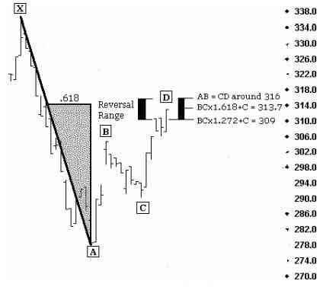
There is one last ingredient to the gartley reversal pattern that is crucial to it’s success. Point “D” or it should be said leg A to D should retrace to within a sniff of either .618 or .786 of the X to A leg. As you can see the .618 retrace of the X to A leg also falls within the projected “range” for a reversal to occur. This is the final factor that must exist.
Now that prices have risen into the projected “range” the trader looks to sell longs they own or initiates shorts. The pattern reverses from this setup ~70% of the time. The initial downside trading target is a .618 retrace of C-D which is around 299.
Protective stops will need to be placed for the 30% of the time this pattern will fail.
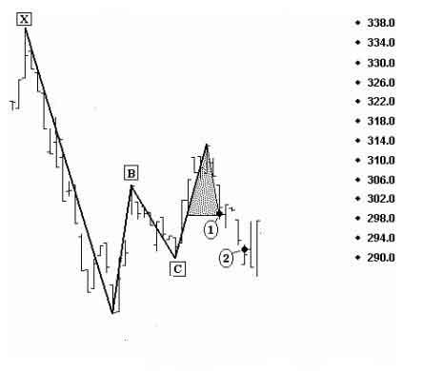
A successful bearish gartley. The first trading target was reached at 299, the .618 retracement of the C to D leg. The second target is at the .618 retracement of the A to D leg [the dot at 291]. The safest the most consistently met target is the .618 retracement level of the C to D leg. One technique is to exit partially at the 1st target then tighten stops on the remaining position and hold out for trading target two.
The power of the gartley reversal pattern lies in it’s ability to give a high probability reversal price range prior to price reaching it. About 30% will fail and some will extend 1.272 to 1.618 times of the X to A leg. The extension numbers in this example are 353-373 so using a stop loss is a MUST!
Bullish Butterfly Reversal Pattern
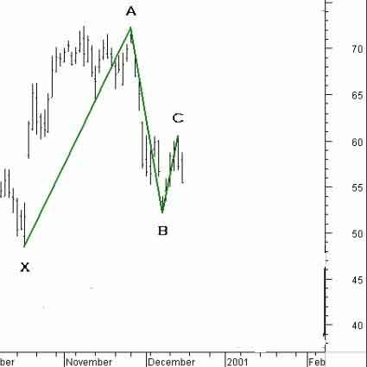
At this point on the chart what we have is a move off of a bottom [X to A] followed by a deep retracement leg [A to B] which retraced to the .786 fibonacci level. The B to C leg was shallow and with the last bar on the chart in a free fall the trader can now attempt to make a case for where this next leg down might end for a reversal.
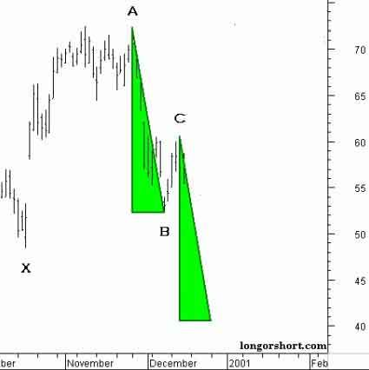
The first measuring step to try and find out where the C to D leg will reverse from is easy. Simply subtract the length of the A to B leg from the C swing high.
As in all butterfly patterns the trader is looking for the A to B leg to be equal to the C to D leg. This method shows AB=CD above 40.
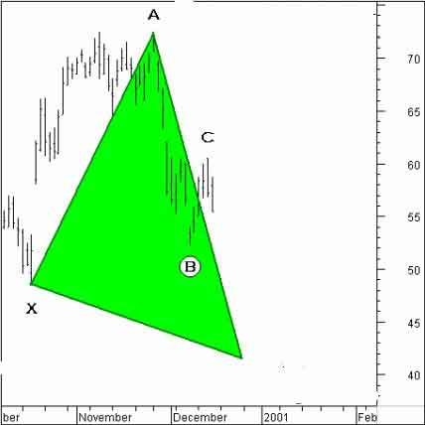
We already have the AB=CD target number around 40. Now what we want to find out is whether that target is at a harmonic number. Most successful butterfly reversals occur at either the 1.272 or 1.618 extensions of the X to A leg.
The math is easy. Find the length of X to A [72.38-48.44 =23.94]. Then multiply the the 1st harmonic number [23.94 x 1.272 = 30.45]. Now subtract from the point A swing high [72.38 – 30.45 = 41.93]. So the 1.272 extension of X to A targets under 42.
So the AB=CD target is about a point away from the 1.272 extension of X to A.
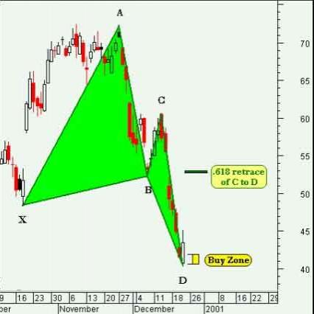
Prices decline into the buy zone and in the process forms a bullish butterfly bottom. The chart is harmonic at the 1.272 extension of X to A and AB=CD.
For traders who get long from the buy zone the first trading target to take profits at is the .618 retracement of the C to D leg.
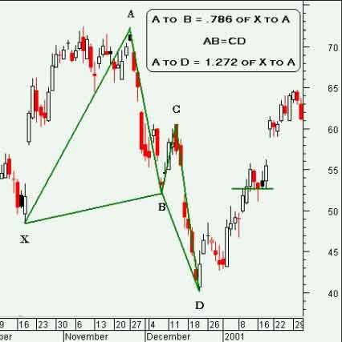
Gartley Patterns indicator ZUP_v76_5-0_mod
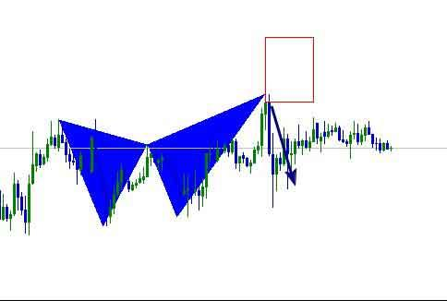
Gartley Patterns indicator Search_patterns_v6


