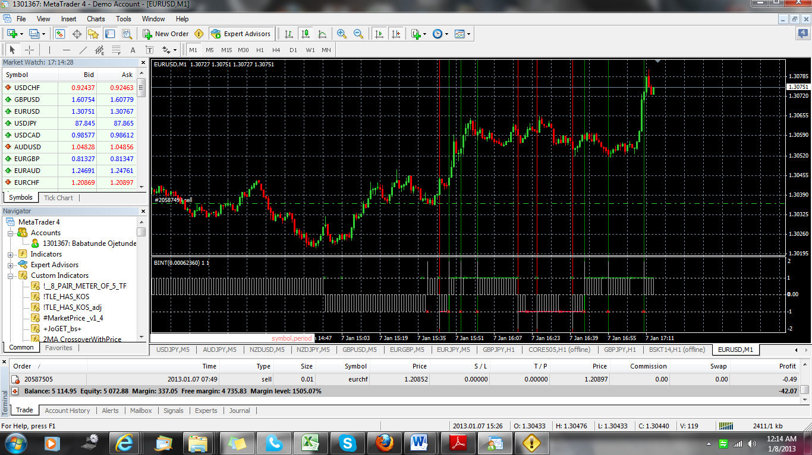

When the green line show, the star (dot like in red colour show on -1) and also a little white line move to 2 for buy alert.
When the red line show, the star (dot like in green colour show on 1) and also a little white line move to -2 for sell alert.

