Hi Everybody,
I tried to make a papertrade for the month Jan 2012. In the attachments You find everything.
Hope somebody wants to give a reaction on it, also if I made some stupid things or some things against the rules. I papertraded only for learning... so I'm very happy if I get some reactions
Well... I used metatrader....and with the function button F12 I tried to simulate the trading sessions without knowing the future.
In normal cases I only buy if price is above MA89 and sell if price is below 89. So actually do not want to take a counter trade. Okeoke….If price is in neighborhood from MA98 or 200MA. I can decide the otherway around if prices and MDAClet me so.

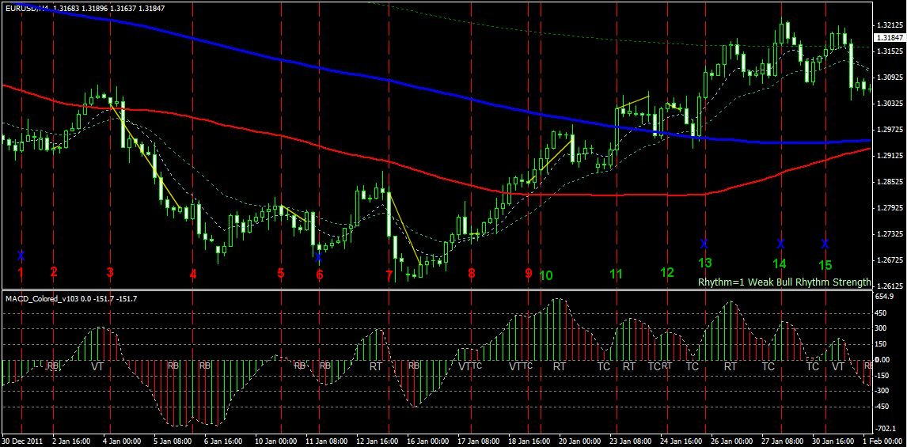

1 | 30/12 | Sell | TC | We have a trend but consolidation. Price goes away from 8MA. SL is bigger then 50 pips (to MA21) | No Trade
2 | 02/01 | Sell | TC | We have a trend but consolidation, SL = 50 / TP = 50 after 4H no profit, MDAC goes other direction => close trade | -10 pips
3 | 04/01 | Sell | RT | SL=30 / TP > 30 to MA89, after profit set trailingstop to 21, closed trade after consolidation | 238 pips
4 | 06/01 | Sell | TC | We have a trend, in consolidation SL> 50 to MA8 / TP > 30 | No Trade
5 | 10/01 | Sell | RT | Price went back to 21, with TC we can go lower. SL=30 / TP > 30, Trailingstop to MA8  Ps: in picture trade is started 4H to early…. Anyway…made 10 pips | 10 pips
6 | 11/01 | Sell | TC | Very long candle already away from MA8, SL > 50 | No Trade
7 | 13/01 | Sell |  | Break to 21, tends to go back to 89 BUT long wick! SL = 55 / TP > 55, trailingstop to MA8 or MA21, Closed after consolidation en turningpoint | 160 pips
8 | 17/01 | Sell | RT | Break to MA21 tends to go to MA89 BUT long wick , SL = 80 TP > 80 after 4H move stalls => close trade | 0 pips
9 | 18/01 | Sell | RT | Break 21, Break 89 tends to go back to 89 SL = 30 / TP = 30 = MA89 | -30 pips
10 | 19/01 | Buy |  | Break 21, Break 89 tends to go back to 89 BUT we have a trend continuation so… BUY. SL = 45 / TP = 110 to MA200, trailingstop to 8MA | 100 pips
11 | 23/01 | Buy | TC | We break the 89, tends to go back to 200 or 21, MDAC gives a TC so BUY SL = 50 = MA200 / TP = 50, trailingstop 8MA | 73 pips
12 | 24/01 | Buy | TC | MA200 broke and price tend back to 200 and coming higher… so Buy SL = 55 ? TP = 55, trailingstop 8MA, after 8H closed trade | -15 pips
13 | 25/01 | Buy | TC | Long candle (90 pips) | No Trade
14 | 27/01 | Buy | TC | Long candle (90 pips) | No Trade
15 | 30/01 | Buy | TC | SL=65 TP=M365=20 wrong R:R | No Trade
 |  |  |  | Total pips for the month jan 2012 | +/- 500 pips

