

QUICK REVIEW OF KEY CYCLICAL MACRO INDICATORS (NEXT UPDATE AT END OF THE WEEK)
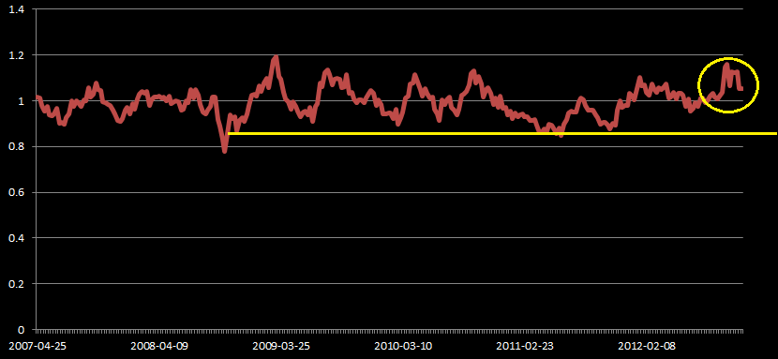

Cyclical Fundamentals are going lower as expected. Inflation is peaking and forming a double top and a triple top. This is suggesting bearish bias still in play on the EUR USD. We could expect inflation to go down the following weeks. As inflation peaks, money supply should shrink, suggesting Demand will be greater than Supply, appreciating the US Dollar.

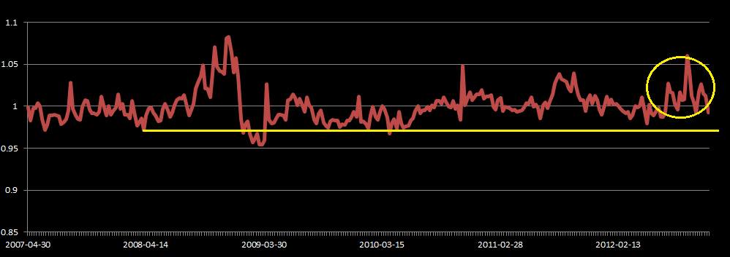

(Next update at 13th of December) on Key Cyclical Fundamentals:
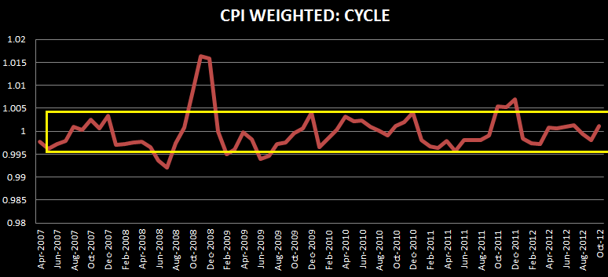
- This is the CPI weighted index. This basically means how is US inflation relative to EU? ; both weighted on another neutral country. At extreme level we could look for positions or major trend bias. At this time we are at same level as April-May, where a bearish position took place. Getting together all Cylical Bias this could mean we are near a possible bearish push.
(NEXT UPDATE AT END OF THE WEEK) US RETAIL GAS PRICES
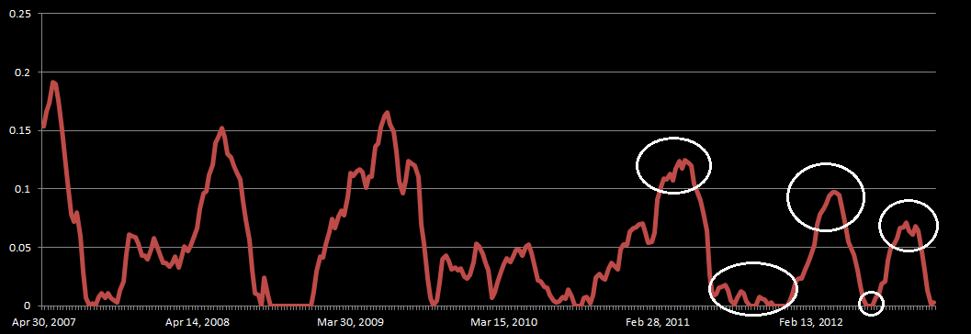
- This is just another key cyclical fundamental I watch. Retail Gas prices are released every week. This show us inflation bias con USD. As you can see price is down into zero level. This could mean two things price, could rebound (not likely to be strong, because other inflation fundies are slowing down) or retail prices could go into downtrend this means price could be “stuck” into the zero level. (Probably)
(NEXT UPDATE ON TUESDAY 27)QUICK REVIEW IN ORDER FLOW ANALYSIS:
Data is updated every Tuesday.

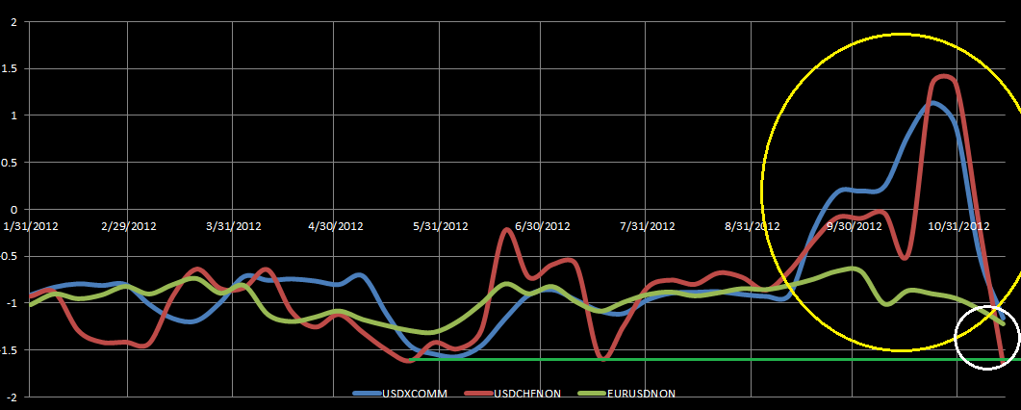
- Order Flow showed a massive peak, this was identified before, as a bearish peak. At this time all flows are going down with the downtrend bias but we are reaching previous support. This could mean a bullish opportunity for the EURUSD soon.
QUICK REVIEW IN TECHNICAL-INTERMARKET ANALYSIS:
BONDS (US 10 YEAR) (TNX)
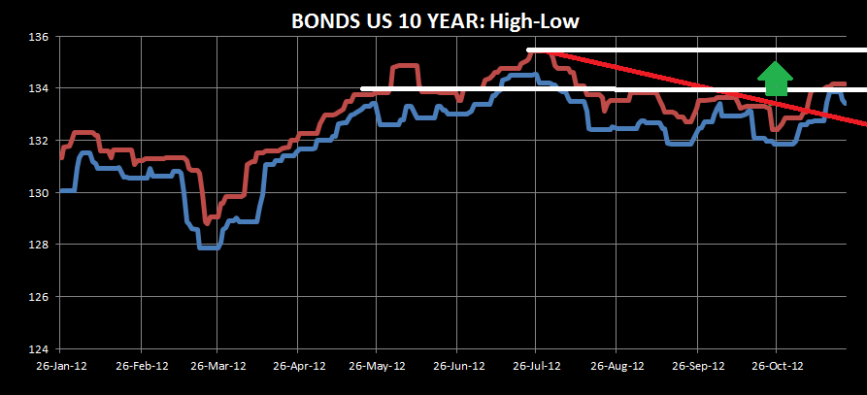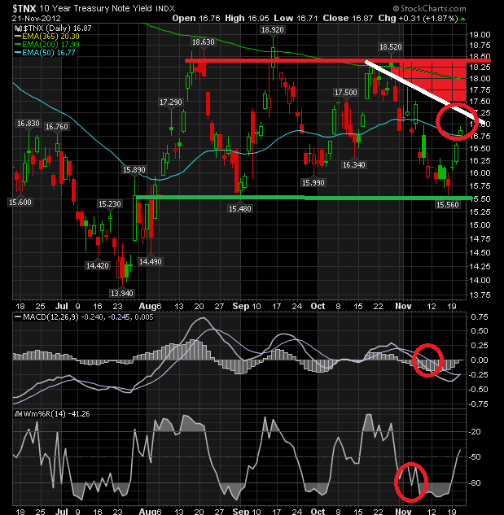
Bond US 10 YEAR Value still on the upside, this is one of the major reasons I’m not buying the euro. Price is normally bouncing from resistance line. On second chart Bonds YIELD (TNX) is reaching sell area and TechnicalS are still on the bearish side. Bonds are a major indicator of US demand.

ADDIONTAL ON BONDS:
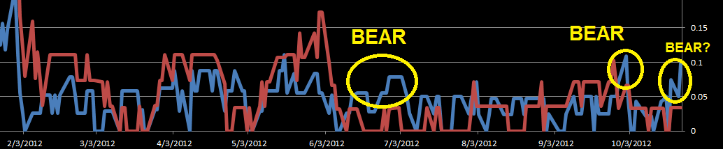
This is a new chart, this chart is based on 2 different yield maturities cycle. The blue line is the fastest and the red line the slowest. In this year, when blue line was peaking on July 2, euro spot continued the down trend, on October we saw price ranging and then went down and now Blue line is at the same position and we could imply history will repeat. Could this be bear? Adding up the analysis made above, I could imply yes.

TNX 10 YEAR CYCLE:
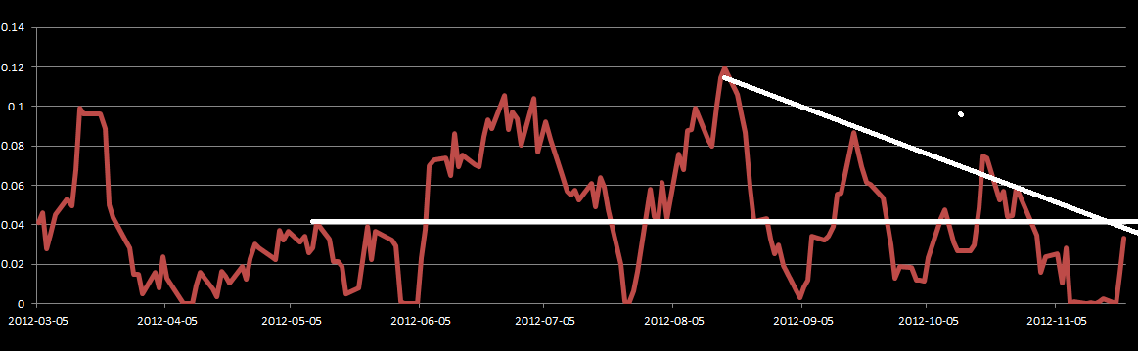
- TNX 10 YEAR CYCLE is reaching previous resistance line and downtrend line. We could see if bonds have the enough push to break this trend line this week. If now, we could get a confirmation from all the mentioned above. Bias on BONDS remain Bullish for USD, Bearish for EURO
- Note: Remember there is an inverse relationship between value and yield. More Yield will imply a major risk premium and less value on the asset. Less Yield - More value (USD) Less --EURUSD value. All equity data is based on daily close prices.
EQUITIES
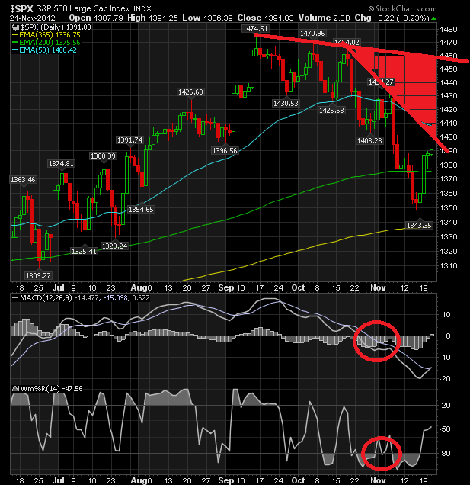
On SP 500 index, price is reaching SELL area on secondary down trend line. Technicals are still bearish. We need to begin looking for major PA patterns that will indicate and confirm this bearish bias such as Bearish Engulfing outside bar or DBHLC or a nice pin bar. Taking in consideration the Bond Market a bearish play is a probable scenario.

EQUITIES CYCLE B: PUT/CALL RATIO
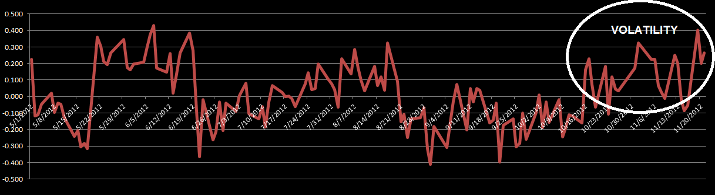
- Major volatility spikes on cycle, this means people is just waiting for something to happen. We are at extreme upper peak level. Taking in consideration equities possible sell area and bonds (yield) sell are and Bonds (Value) bullish bias plus Slow vs Fast Maturity behavior, I will remain NEUTRAL for Equities BUT waiting for confirmation for PA patterns to appear to change into bearish BIAS.
- Note: Remember when Equities are down or there is a bias to the downside this could imply a bearish bias on EURO but not always. This is on Daily time frame.

COMMODITIES GOLD, NUGT, DUST

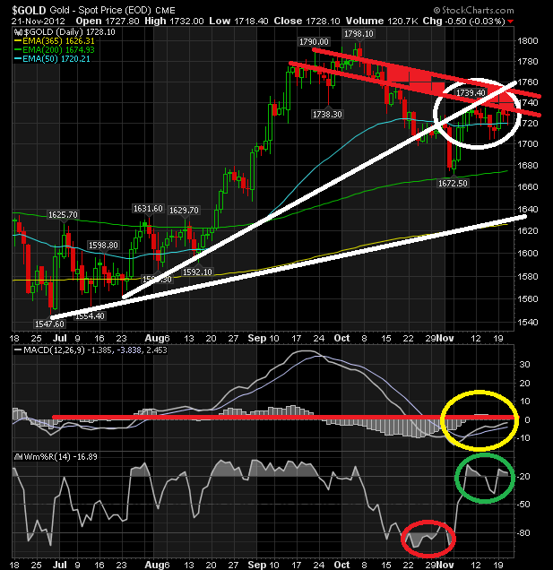
Gold index price is saying Undecided. MACD is reaching 0 level and could rebound into more bearish action but Williams R% is saying bullish presence. Now on PA we have pin bars. Also price is on secondary sell area. We cannot imply something from here, just that Commodities is getting hit by mixed signals.

NUGT Filtered PRICE:
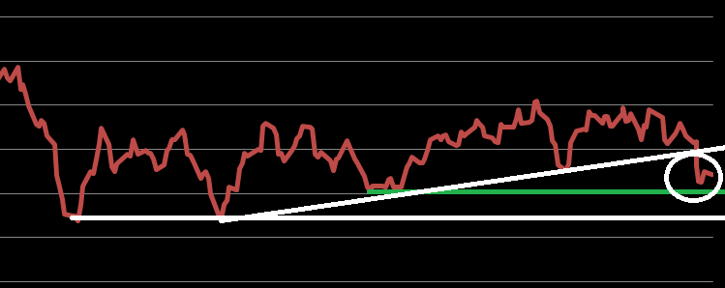
- NUGET filtered price is at or near secondary support. Price already breached major uptrend line but I just cannot say with confidence we could have more bearish movement just looking commodities market. I will remain neutral on GOLD.
- Note: As on Equities, Commodities relationship is not an iron law. If there is a bearish bias on commodities this could also imply a bearish bias con EURO. I do not post H-L statistical on commodities because we have same information as in equities and bonds. (Major equilibrium and possible trend bias)

FOREX (USDX, USDCHF and EURO)
CURRENCY METER 1
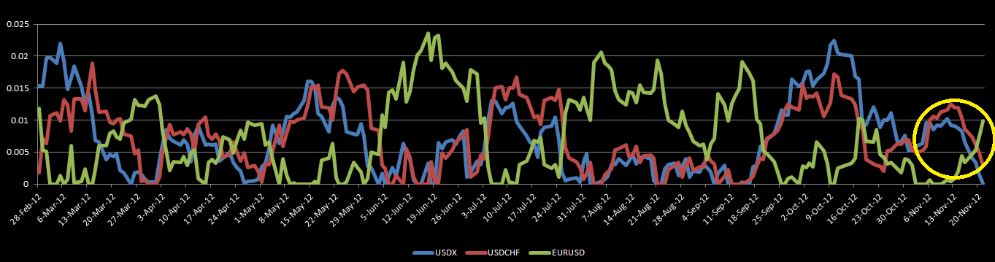
C1: EURO price is now bullish and USDCHF and USDX are bearish.
C2: Euro and USDX are still in equilibrium.
CURRENCY METER 2:
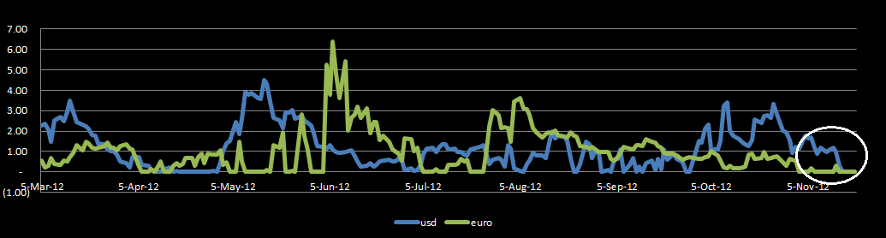

USDx
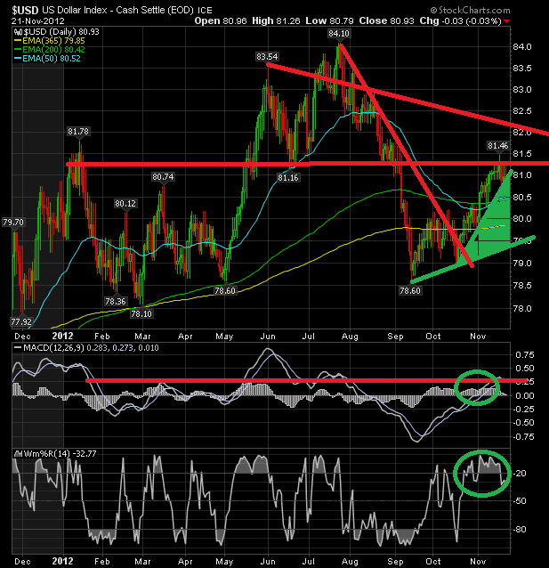
USDX is at resistance line and pulling back from it. This is not bearish because we have technical on bullish side and Bonds market supporting this move also we have equities with bearish sentiment. This is a key indicator IF we should sell EURO now, and the answer is NOT YET. We better wait for a PA pattern into the LONG AREA.

Volatility (VIX)
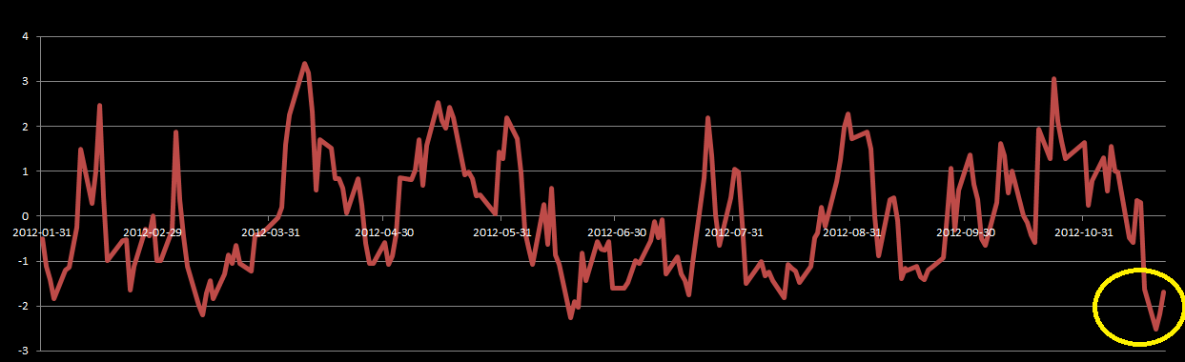
- VIX cycle at extreme level. This is saying “We are going to have movement, get your positions ready”

SUMMARY:
ASSETS | BIAS
Bonds (US) | Bullish on USD, but waiting for pullback and PA Pattern into BUY AREA to reload shorts on EURO.
Equities | Neutral but waiting to short.
Commodities | Neutral
Forex (Euro) | Bullish short term. Bearish Long Term
VIX | Signaling an entry
Trend Indicator (Fundies) | Update on December 13th. Actual is Bearish for EURUSD. (Major Trend)
Cyclical Fundies (US) (Updated) | Bullish for USD (Major trend)
Order Flow (Updated) | Neutral
NET SENTIMENT | Now this is when most people get confused. First BEARISH BIAS on Long Term is still in play, we are just waiting for our Entry near the 1.30+- Level. And the expertise comes here; There might be an entry LONG on EURO USD for the short term taking advantage of the remaining path, prices could take to reach the extreme sell area. This is Risky, Indeed. My recommendation is wait for PA bullish Pattern to appear but keep in mind SHORT AREA IS AT 1.30+-.

Note: Sentiment is based on Daily Time Frame.
Link to previous report:
http://www.forexfactory.com/showthread.php?p=6215470#post6215470
TO ALL SUBSCRIBERS
DAY BY DAY PEOPLE IS REQUESTING THIS REPORT. I REALLY LIKE THE FEEDBACK YOU ARE GIVING ABOUT THIS DOCUMENT. MANY THANKS TO ALL.
ON WEEKEND I WILL DO RESEARCH TO MAKE ANOTHER INDICATOR FOR COMMODITIES BECAUSE I FEEL WE NEED TO GET MORE BIAS ON GOLD.

ALSO SEND THIS REPORT TO YOUR FRIENDS IF YOU LIKE.
LINK TO THE SITE: http://gino32.wix.com/indepthmarketreport#!home/mainPage

GREEN PIPS ALL THE WAY
-Gino

