Quick Review of Key Cyclical Macroeconomic indicators:
- Macroeconomic cyclical indicators area playing as expected. Bearish pressure is on EURO. Updates on Macroeconomic cyclical indicators until November 13th.
Quick Review on Order Flow Analysis:
- Data is updated every Tuesday. Next update is on Tuesday 13th.
Quick review on Inter market Analysis-Technical:
Bonds (US 10 YEAR) (TNX)

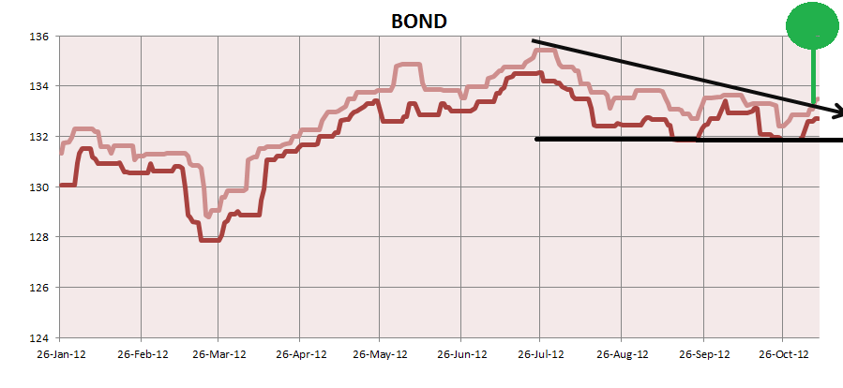
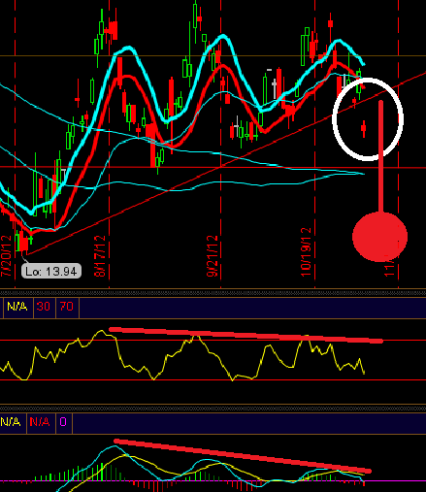

- Bond Value BROKE trend line, this could mean MAJOR BEARISH pressure on EURUSD. TNX also broke support line to the downside. MACD negative divergence and RSI giving bearish pressure on Bond Asset.
Note: Remember there is an inverse relationship between value and yield. More yield will imply a major risk premium and less value on the asset. Less Yield -- More value (USD) Less --EURUSD value. This is on Daily TF.
Bonds (H-L Statistical)
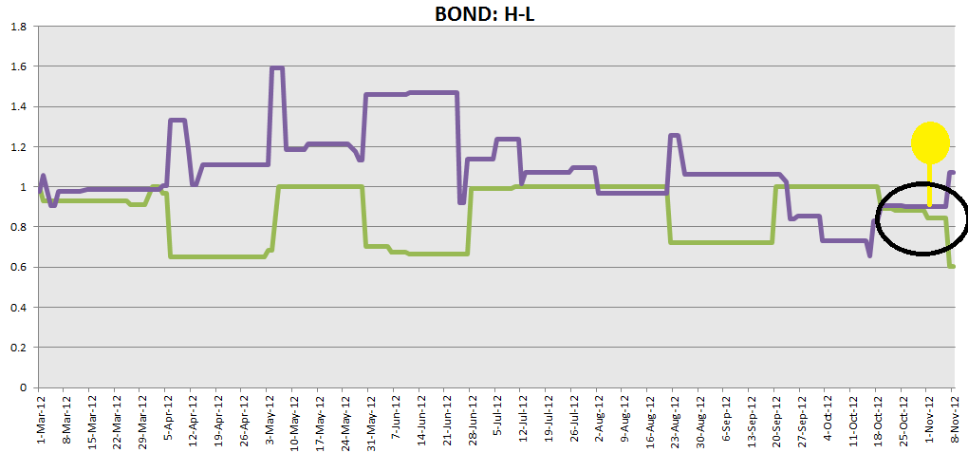
- Equilibrium price broken, H and L price diverging. This could mean rally is ready to go.

Equities (SPY (SPX ETF)) ESX

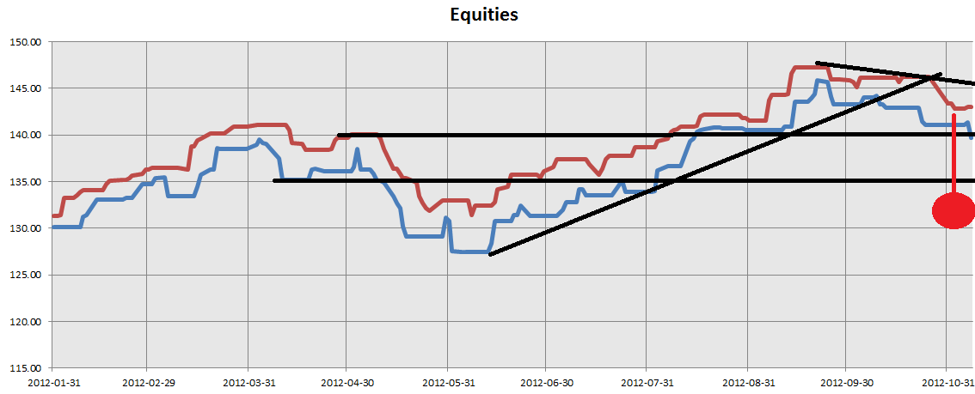
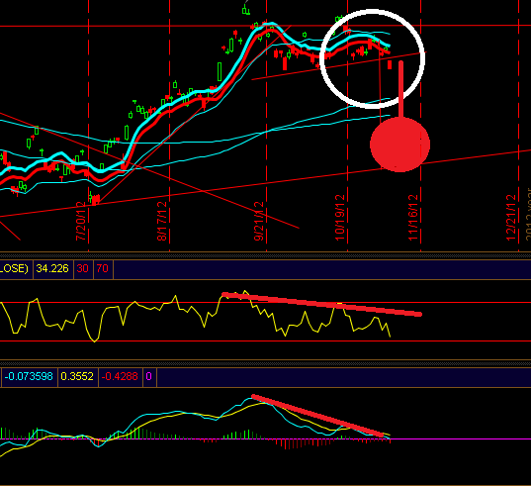
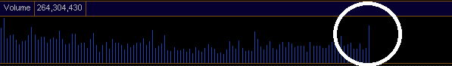
- Equities EU broke support line. Equities US breaking support. MACD negative divergence + RSI, giving serious pressure on Equities EU. Major volume on SPX, suggesting something is about to happen. This should put heavy pressure on Equities as on EUROUSD.

Equities (H-L Statistical)
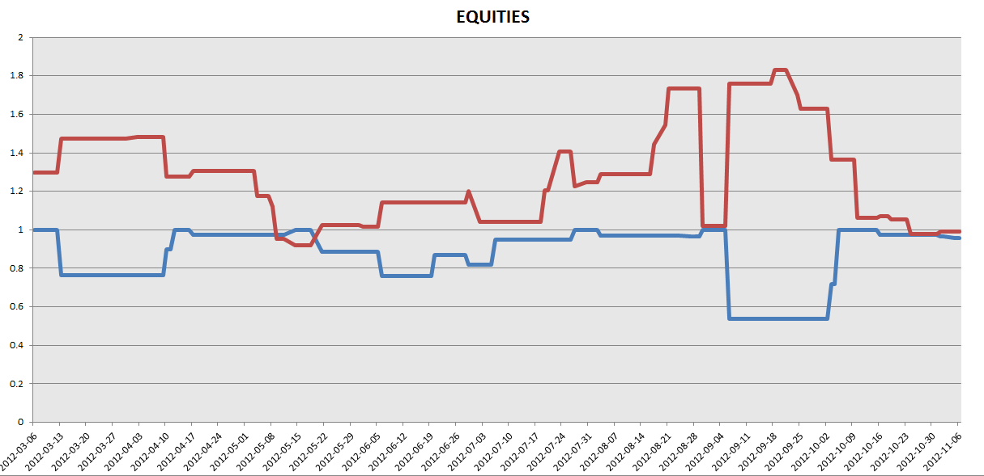
- Price is ready to break equilibrium. This could mean an imminent rally.
Equities: Put/Call Cycle
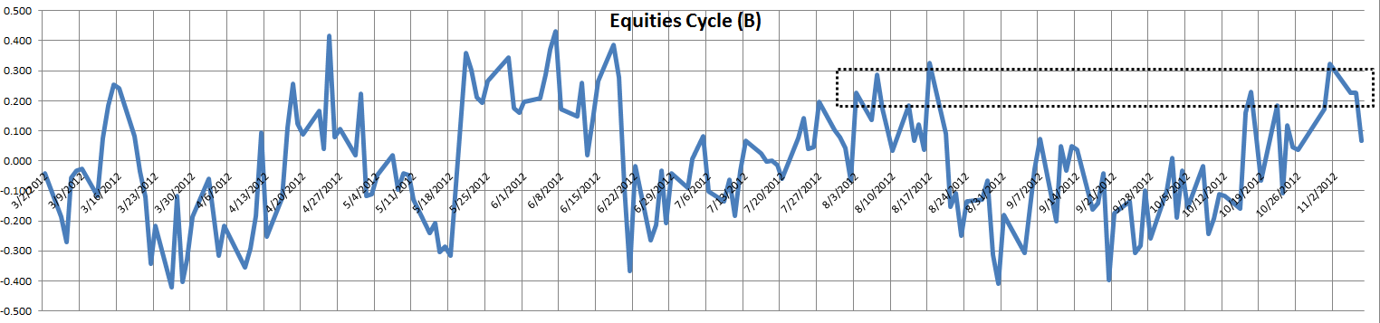
- Price already reversing to (-0.5) level (Extreme lower level). This could mean a bearish bias for equities.
Note: Remember when Equities are down or there is a bias to the downside this could imply a bearish bias on EURO but not always. This is on Daily time frame.

Commodities *(OIL) IMPORTANT
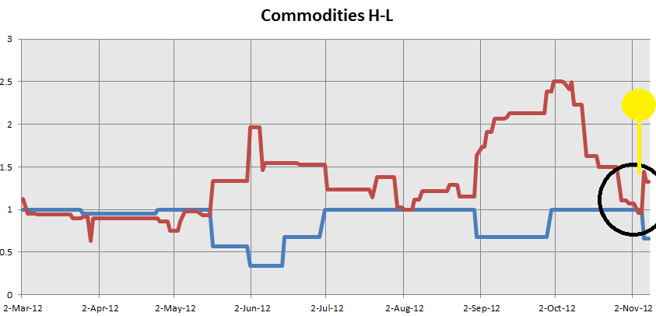
OIL (H-L) Statistical:
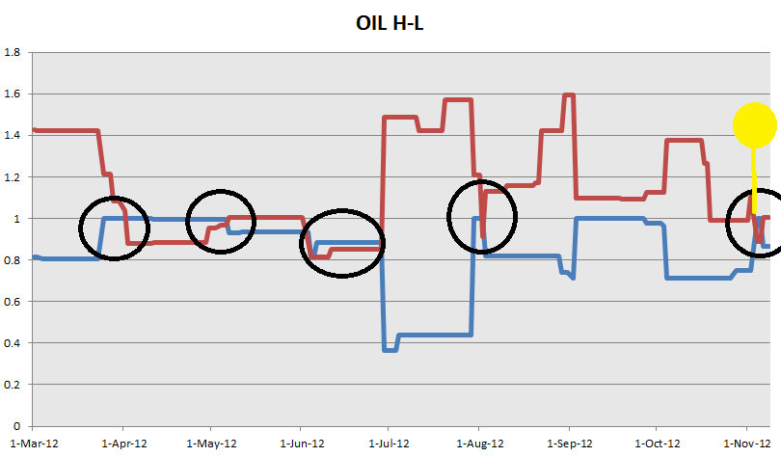
- H-L statistical on Commodities showing divergence on H-L, this is suggesting price is ready to rally.
- H-L statistical on OIL showing price at equilibrium, this suggesting Oil will speed up the trend coming.

Note: As on Equities, Commodities relationship is not an iron law. If there is a bearish bias on commodities this could also imply a bearish bias con EURO. I do not post H-L statistical on commodities because we have same information as in equities and bonds. (Major equilibrium and possible trend bias)

FOREX (USDX, USDCHF and EURO)
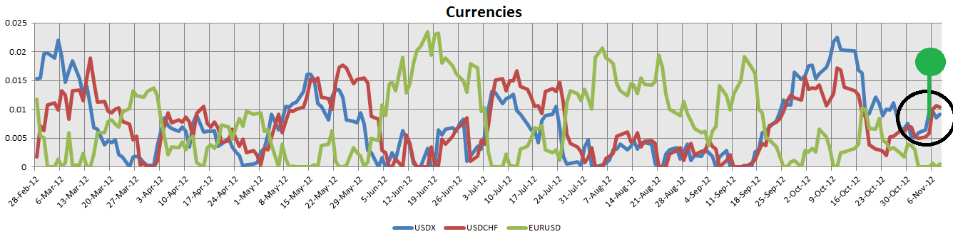
- USDX and USDCHF still have same bullish bias as yesterday. No change in currency meter. USDX and USDCHF still stronger than EUROUSD.
- EURO filtered, still has bearish bias.
- Note: Check previous report (Euro Filtered) if you missed it. (Link is in the final page)
Volatility (VIX)
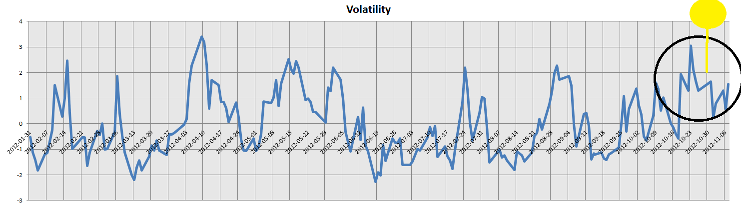
- Volatility peak still playing, yet we have not seen any major move. We could expect this peak to play hard further this week and next week.

Summary:
- Bonds (value) broke trend line to the upside
- Bonds(Yield) broke trend line to the downside
- MACD +RSI negative divergence putting heavy pressure on Bonds (Yield)
- Equities (EU) broke support to the downside, Equities (US) also broke support. MACD + RSI negative divergence on Equities US and Equities EU putting heavy pressure on Equities.
- Major volume on SPX
- Major Volume on Commodities
- Equities Put/Call peak is reversing to lower extreme level
- All normal H-L statistical equilibrium ready to trend and diverging.
- Major OIL H-L statistical at equilibrium, this could give speed to the trend.
- Currency Meter is still bullish for the USDx and USDCHF. Bearish on EURUSD.
- Volatility cycle: Ready to reverse.

GETTING TOGETHER ALL INFORMATION EXTRACTED, I HAVE A MAJOR BEARISH SENTIMENT ON EURUSD.
Link to previous report: http://www.forexfactory.com/showthread.php?p=6170036#post6170036

-Gino

