Currency Meter:C
C. Meter suggesting a bearish bias. (Red line and Blue line are over green line).

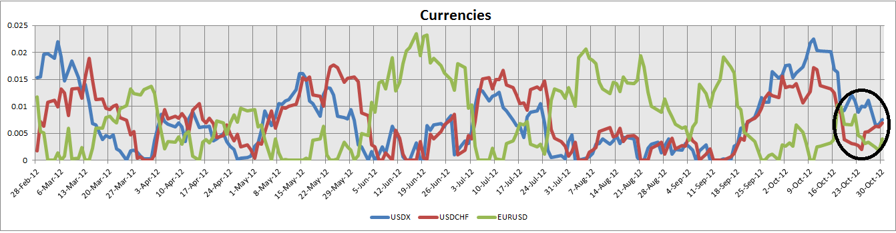
Order Flow:
Order flow showing “Weird” moves. This because EURO FX futures stalled at -1 level while the others trend to the upside. USDX futures at same level(+1) as SwissF Futures. On USDX, commercials and non-commercials at equilibrium, this suggests a possible “strong” trend “somewhere” for me is a bullish signal on USDX. (Not because of the cross over, but rather the equilibrium of both)
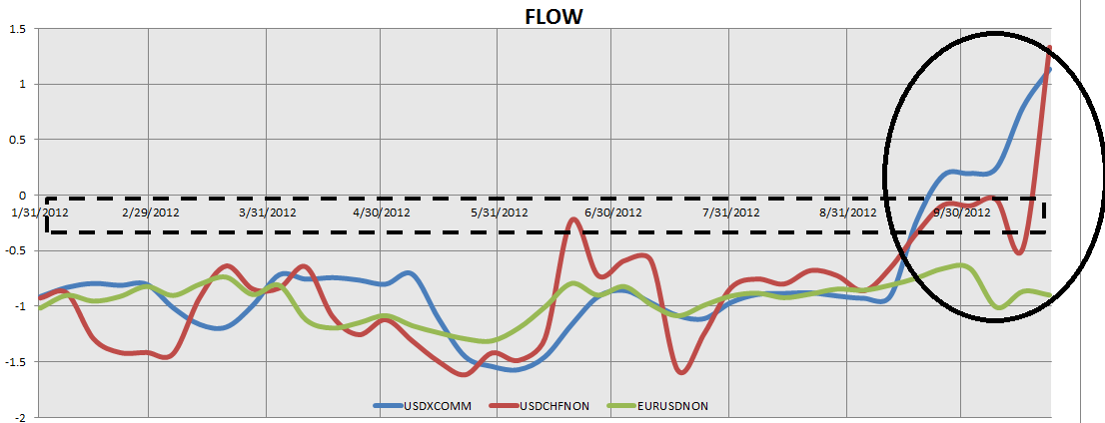
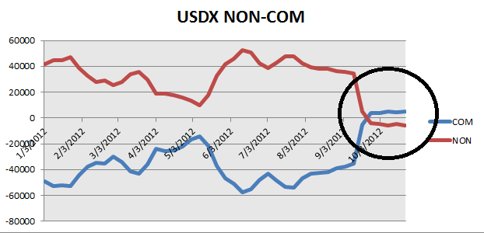
Volatility:
We are at extreme upper level on Volatility showing a major move coming.
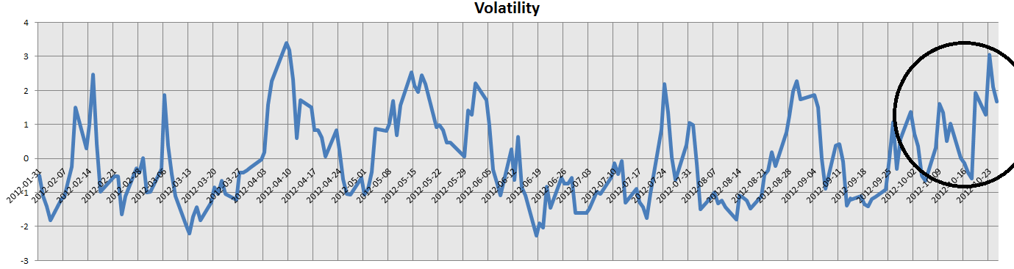
Technicals (Daily):
- Range
- Price near support.
- MACD Divergence negative (not the best one)
- RSI Divergence, also not the best one.
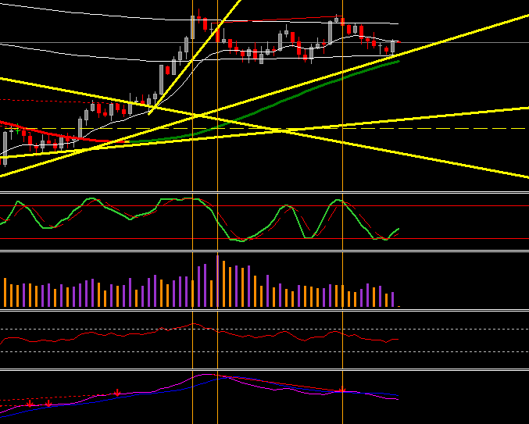
Summary:
-Order Flow showing weird activity suggesting a major move. Bullish on USDx
-Currency meter showing bearish bias on eur/usd. (Red and blue line are over green line).
-Volatility at extreme upper level, suggesting major move.
-Past Report Cyclical fundamentals showing bearish move on EURUSD.
-Commodities showing unusual volume.
-Technicals showing weakness.
*Getting all together this are my reasons for a bearish bias on EURUSD.
*This is the way I try to solve the puzzle every day, week, month…

