First I don’t use traditional fundamentals neither technical analysis for entries. I just pick trades with technical and divergences on MACD or RSI, but my triggers are statistical, cyclical, econometric, etc. All the indicators here are custom made.
FOREX Analysis on Daily:
Trend Detector: Pure EURUSD
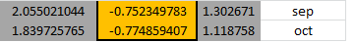
This table tells me when a trend is imminent every 13th of the month. Trend is imminent as October 13th. This indicator doesn’t tell me direction, just possible trend. (When row-column, row-row, column-column are equals at a -+5% range then possible signal)
Currency Meter: Cycle
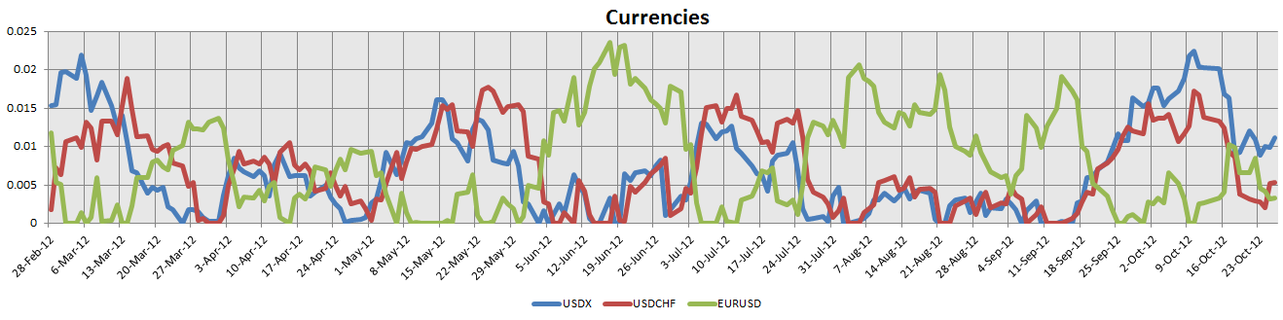
When redline and blue line is near green then possible trend coming. Direction is define by cross over. Also when market is trending, any crossover doesn’t have reversal bias. At this time red line and blue line tried to cross green line, unsuccessfully. So trend bias in this indicator is bearish for now.
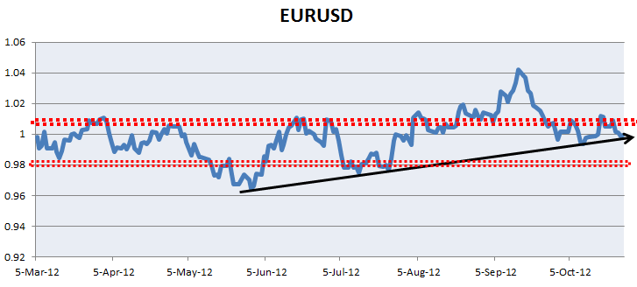
This one shows better support and resistance areas. We are at a critical support level.
Inflation Type 5 and 2: 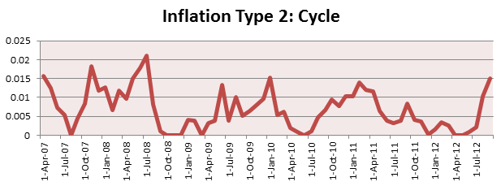
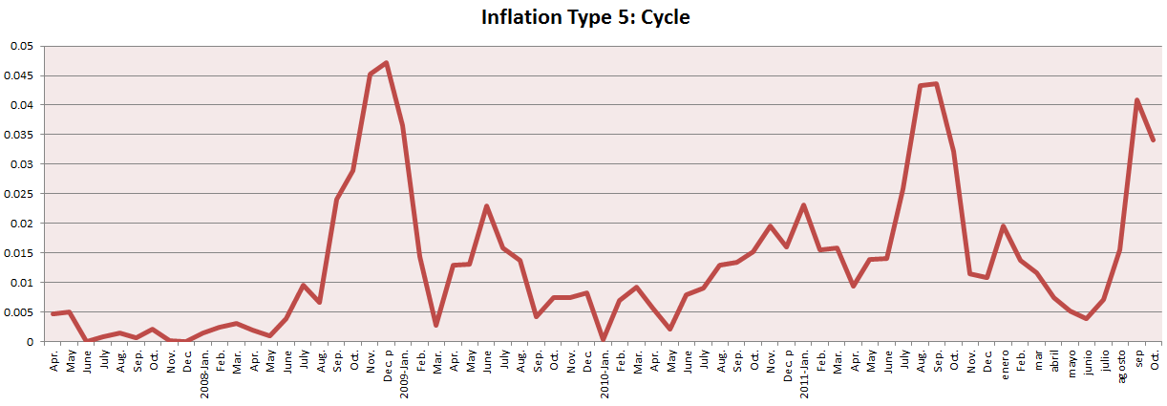
This indicator(s) shows me the cyclical inflation on US Dollar. At this time we are at inflation peak. So this tells me a bullish direction on USD.
Volatility:
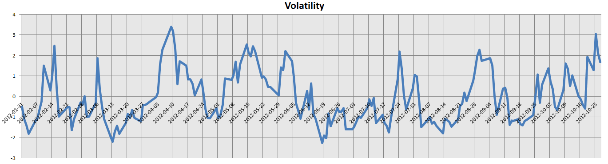
This indicator is for finding entries. When Volatility is in the upper cycle or lower cycle then there is a possible trend coming. This indicator does not tell me direction.
At this time volatility is at upper extreme level. Possible Trend
Some Technical Signals:
- USDX positive divergence on MACD
- EURUSD negative divergence on MACD
Finally, my sentiment for the EURUSD is bearish for this week. Trend is coming,

